Communication Management Plan
Let It Snow MT

Broken Unlimited LLC
123 Address Ave.
Helena, MT 59601

05/01/25

INTRODUCTION
The Communications Management Plan outlines how project information will be collected, created, stored, shared, and communicated among stakeholders. Effective communication ensures stakeholders are informed, aligned, and engaged, ensuring the success of the "Let It Snow MT" website development.

COMMUNICATIONS MANAGEMENT APPROACH
The approach focuses on establishing a structured communication framework, ensuring clarity, accessibility, and timeliness. Communication tools and methods are selected based on stakeholder preferences, project needs, and technological capabilities.

COMMUNICATIONS MANAGEMENT CONSTRAINTS
Key constraints include budgetary limits for communication tools, time zone differences among stakeholders, technology access, and confidentiality requirements for data.

STAKEHOLDER COMMUNICATION REQUIREMENTS
Stakeholders require updates on project progress, snow report integration status, testing outcomes, and deployment milestones. Requirements will be met through scheduled updates and detailed reports.

ROLES
Project Manager: Oversees communication processes and ensures adherence to the plan.
Developers: Report development progress and technical challenges.
Stakeholders: Provide feedback and approve key milestones.

PROJECT TEAM DIRECTORY
- Project Manager: Cameron Flinders
- Lead Developer: Cameron Flinders
- Stakeholder Representative: Not found yet
- Project Sponsor: Scott Flinders
COMMUNICATION METHODS AND TECHNOLOGIES
- Email: For formal updates.
- Video Conferencing: For monthly stakeholder meetings.
- Project Management Software: For task updates.
- Phones: For quick team communication.

COMMUNICATIONS MATRIX
Stakeholder Group | Communication Type | Frequency | Delivery Method | Owner
Project Team | Daily Stand-ups | Daily | Video/Chat | Project Manager
Stakeholders | Progress Reports | Weekly | Email/Report | Project Manager
End Users | Announcement | Post-Deployment | Website Update | Project Manager

COMMUNICATION FLOWCHART
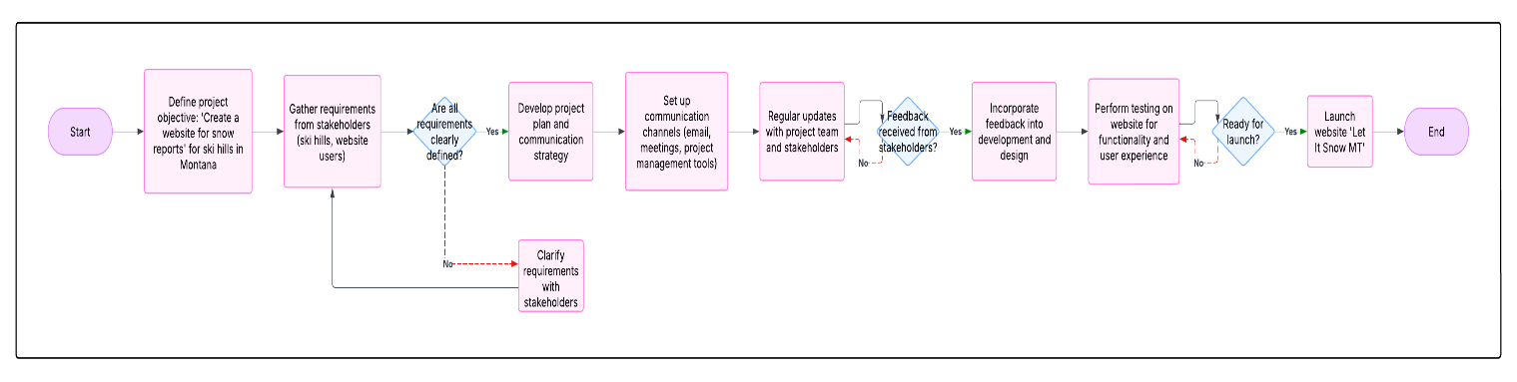

GUIDELINES FOR MEETINGS
- Clearly define meeting objectives.
- Use an agenda shared in advance.
- Encourage active participation.
- Document action items and circulate minutes post-meeting.

COMMUNICATION STANDARDS
- Use clear, concise language.
- Ensure consistency in message formatting.
- Maintain confidentiality where required.

COMMUNICATION ESCALATION PROCESS
In case of unresolved issues:
- Developer/Project Manager consults stakeholder representative.
- Final decisions rest with the Project Sponsor.

