Work Breakdown Structure
Let It Snow MT

Broken Unlimited LLC
123 Address Ave.
Helena, MT 59601

04/04/25

INTRODUCTION
The WBS for "Let It Snow MT" outlines the scope of work required to design, develop, and implement the website. It is a tool to facilitate effective communication among stakeholders, plan the project schedule, allocate resources, and estimate costs.
The WBS provides an outline of all activities to the third level, adhering to the 8–80 rule, where work packages represent manageable, actionable tasks.

OUTLINE VIEW
1. Let It Snow MT Website Project
1.1 Initiation
- 1.1.1 Research and feasibility analysis
- 1.1.2 Develop project charter
- 1.1.3 Submit project charter for approval
- 1.1.4 Approval of project charter
1.2 Planning
- 1.2.1 Define scope and functional requirements
- 1.2.2 Define project team
- 1.2.3 Conduct project kickoff
- 1.2.4 Develop project plan
- 1.2.5 Approve project plan
1.3 Execution
- 1.3.1 Collect and validate user requirements
- 1.3.2 Design system architecture and site layout
- 1.3.3 Develop front-end and back-end systems
- 1.3.4 Integrate snow report APIs for Montana ski hills
- 1.3.5 Conduct testing and quality assurance
- 1.3.6 Deploy website on live server
- 1.3.7 Conduct user training and onboarding
1.4 Control
- 1.4.1 Monitor project progress and risks
- 1.4.2 Conduct regular status meetings
- 1.4.3 Update project plan as required
1.5 Closeout
- 1.5.1 Conduct final system testing
- 1.5.2 Document lessons learned
- 1.5.3 Archive project files
- 1.5.4 Obtain final approval from sponsor

TREE STRUCTURE VIEW
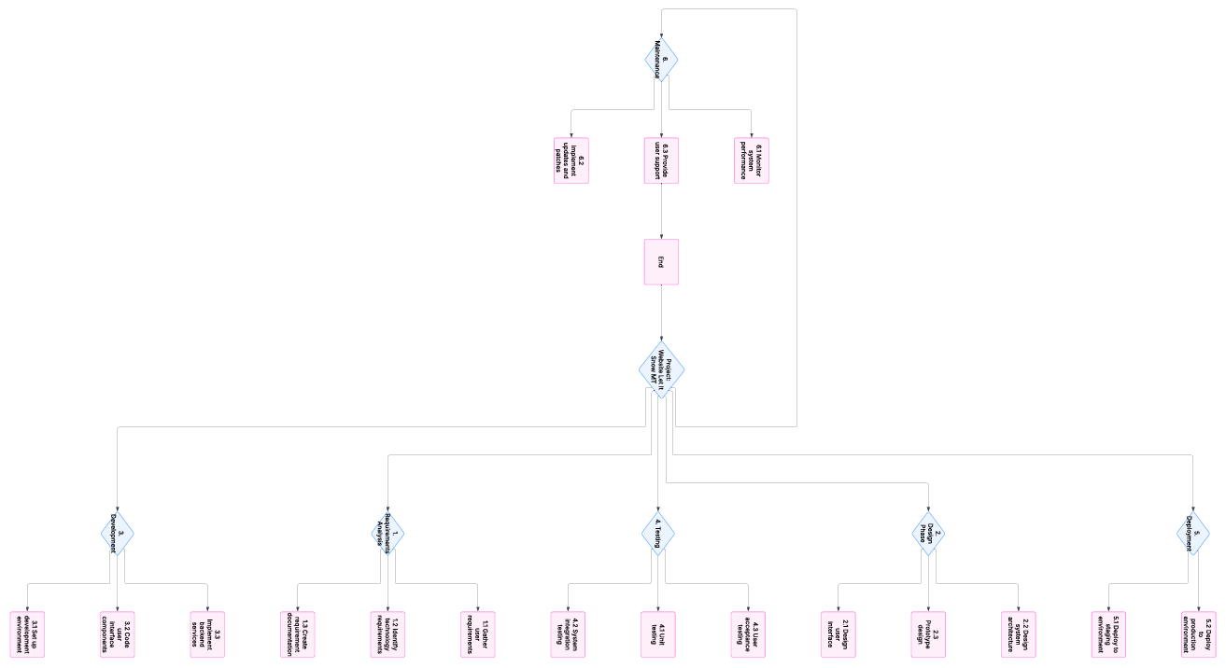

HIERARCHICAL STRUCTURE
Level | WBS Code | Element Name
1 | 1 | Let It Snow MT Website Project
2 | 1.1 | Initiation
3 | 1.1.1 | Research and feasibility analysis
3 | 1.1.2 | Develop project charter
3 | 1.1.3 | Submit project charter for approval
3 | 1.1.4 | Approval of project charter
2 | 1.2 | Planning
3 | 1.2.1 | Define scope and functional requirements
3 | 1.2.2 | Define project team
3 | 1.2.3 | Conduct project kickoff meeting
3 | 1.2.4 | Develop project plan
3 | 1.2.5 | Approve project plan
2 | 1.3 | Execution
3 | 1.3.1 | Collect and validate user requirements
3 | 1.3.2 | Design system architecture and layout
3 | 1.3.3 | Develop front-end and back-end systems
3 | 1.3.4 | Integrate snow report APIs
3 | 1.3.5 | Conduct testing and QA
3 | 1.3.6 | Deploy website on live server
3 | 1.3.7 | Conduct user training
2 | 1.4 | Control
3 | 1.4.1 | Monitor project progress
3 | 1.4.2 | Conduct regular status meetings
3 | 1.4.3 | Update project plan as required
2 | 1.5 | Closeout
3 | 1.5.1 | Conduct final system testing
3 | 1.5.2 | Document lessons learned
3 | 1.5.3 | Archive project files
3 | 1.5.4 | Obtain final approval

WBS DICTIONARY (Example Entries)
Level | WBS Code | Element Name | Definition
1 | 1 | Let It Snow MT Website Project | All work required to create the website project
2 | 1.1 | Initiation | Work involved to initiate the project
3 | 1.1.1 | Research and feasibility analysis | Analyze project feasibility and gather research
3 | 1.2.2 | Assemble project team | Identify and onboard team members
3 | 1.3.4 | Integrate snow report APIs | Integrate APIs for live Montana ski hill reports

