Assignment Activity Unit 5
Frank Lin
University of the People
MSIT 5910-01 - AY2027-T1
Dr. Stella T. Whyte
October 7, 2026

Introduction
This phase of my capstone project focuses on implementing and testing the main functions that support the Employee Phishing Awareness and Response project. The purpose is to demonstrate that the core parts of the system can work correctly in practice. This includes implementing the assessment scoring logic, testing individual functions to make sure they produce accurate results, and using version control to manage changes throughout development.

Part A: Core Logic Implementation and Output Validation
The core logic of my project focuses on calculating participant scores before and after the phishing awareness training. The main purpose is to provide a measurable way to determine if the training helped improve the participant's understanding of phishing. The program compares each participant's answers to the item bank. This records whether each mock email is phishing or legitimate, and then calculates the percentage of questions they answered correctly. The same process is completed for the pre-assessment and post-assessment. After both scores are calculated, the program compares them and shows how much each participant improved. For example, if a participant scores 60% before the training and 90% after the training, the program will show an improvement of 30 percentage points. It also checks if the participant chose a safe action, such as reporting the message, and shows the results for each of the five phishing indicators. Phishing awareness training can be more effective when feedback is provided to all participants instead of only those who make a mistake during a simulation (Garcia Vargas, 2025).
This supports the main objective of my project because the goal is not only to provide phishing awareness training, but also to determine whether the training improves employee understanding. According to Summers (2020), verification and validation help confirm that a system meets its defined requirements and functions as intended. Applying these processes will allow me to test the training and assessment components and determine if they are giving the expected results.
Another part of the implementation is validating the information before it is processed. As the project is designed to avoid storing unnecessary personal information, the program refuses any file that contains a name or email column. Real responses will only be collected after participants give informed consent. This means that participants understand what the study involves and agree to take part voluntarily (Palmer, 2015). A separate validation module also checks every response before it is scored. It skips rows with a bad participant ID, an unknown question, or an unknown action and lists each problem as a warning (see Figure 1). Only participants who completed both assessments are compared (see Figure 2). Figure 3 shows the output using the synthetic sample data, where the average score improved by 28.12 percentage points.
Figure 1 Validation Function That Checks Each Response Before Scoring
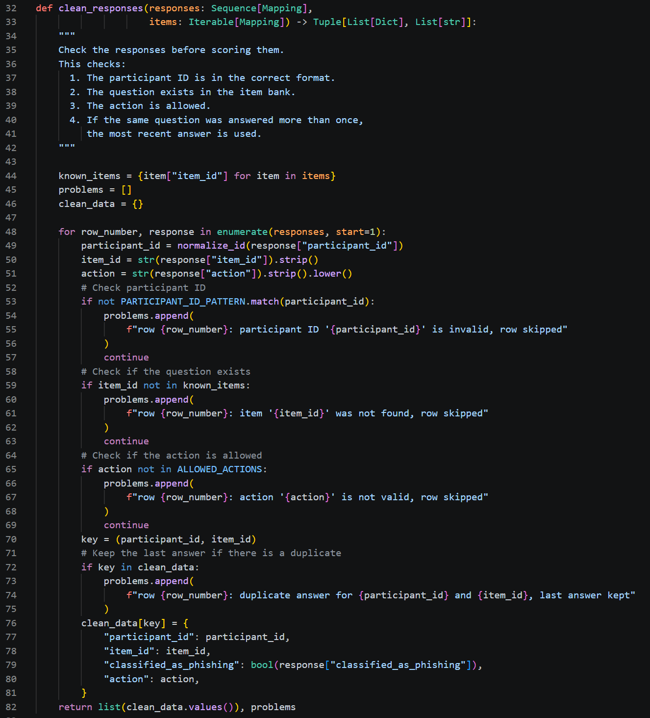

Figure 2 Summary Function Comparing Only Participants Who Completed Both Assessments

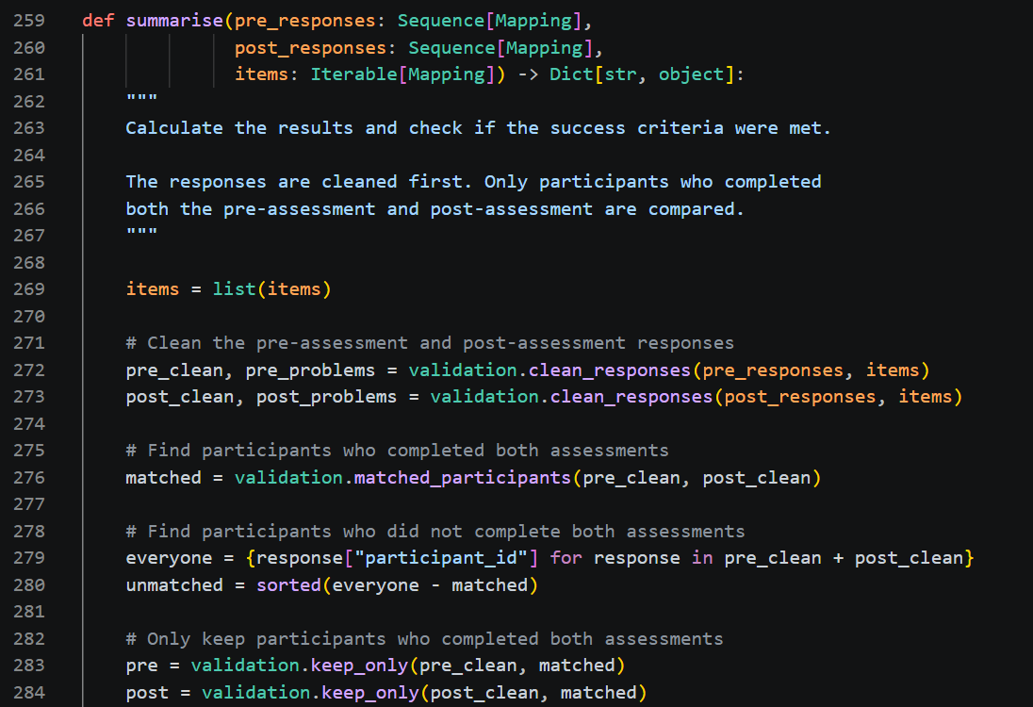

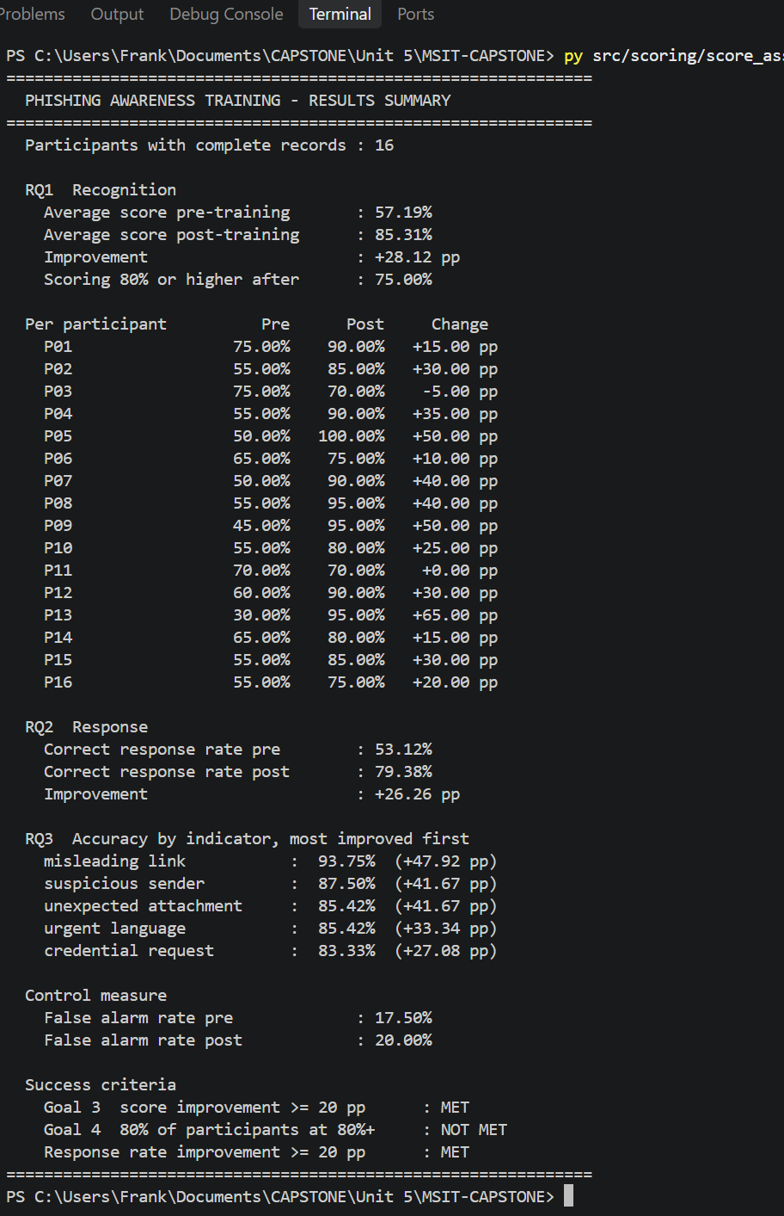
Figure 3 Program Output Using the Synthetic Sample Data
Figure 4 Program Output Using the Messy Sample File With Warnings
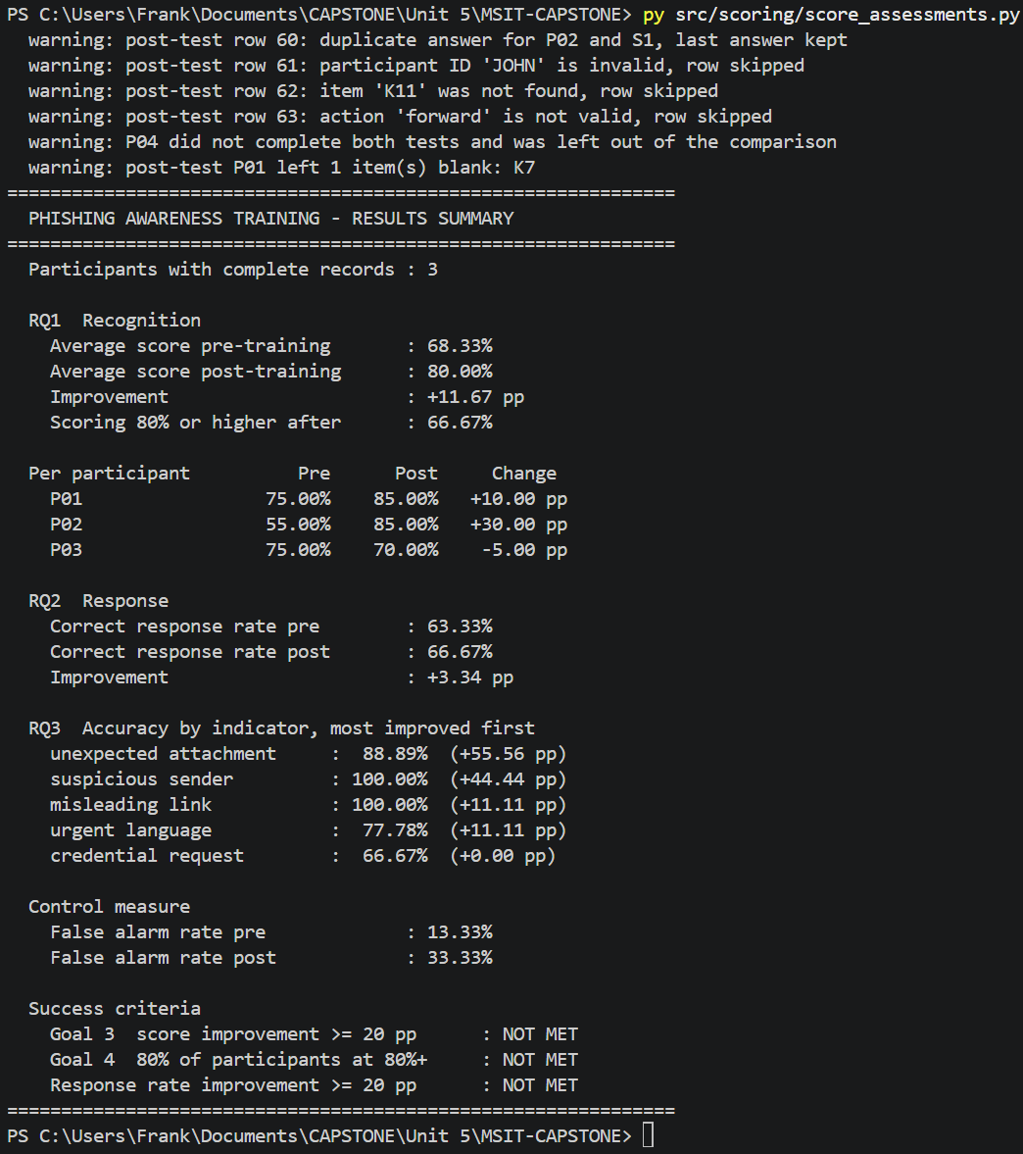

One challenge I had to consider was ensuring that valid responses could still be processed while invalid responses were stopped before reaching the scoring function. I handled this by keeping the validation and scoring functions separate. This also made each component easier to test. Another challenge I encountered was dealing with problems that can occur with survey data. For example, a participant may submit the form twice, leave a question blank, or only partially complete assessments. To test this, I created a messy sample file that included these issues. Figure 4 shows that the program was able to identify the problems while still processing and scoring the valid responses.
Part B: Unit Testing of Functional Modules
Unit testing was used to test the main functions of the assessment program and ensure that each function works correctly independently. I used PyTest because it makes it easy to compare the expected result against the result produced by the program. I also used the pytest-cov plugin to measure how much of the code the tests actually run. The project now has 46 tests. The tests in test_scoring_rules.py are black-box tests because they only look at inputs and expected outputs, such as every score from 0% to 100% in steps of 20%, negative improvement, and a blank answer (see Figure 5). The tests in test_validation.py and test_metrics.py are white-box tests because each one targets a specific rule inside the code. Another file tests the program as a whole, including a file that contains an email address. Figure 6 shows all 46 tests passing with 99% line coverage.

Figure 5 Black-Box Boundary Tests for Each Possible Score
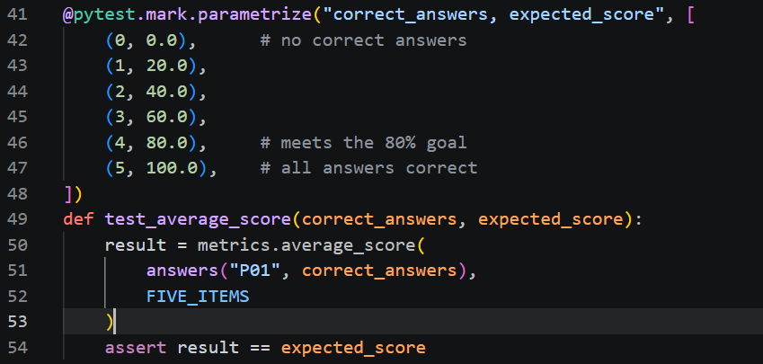

Figure 6 All 46 Tests Passing With Coverage Report
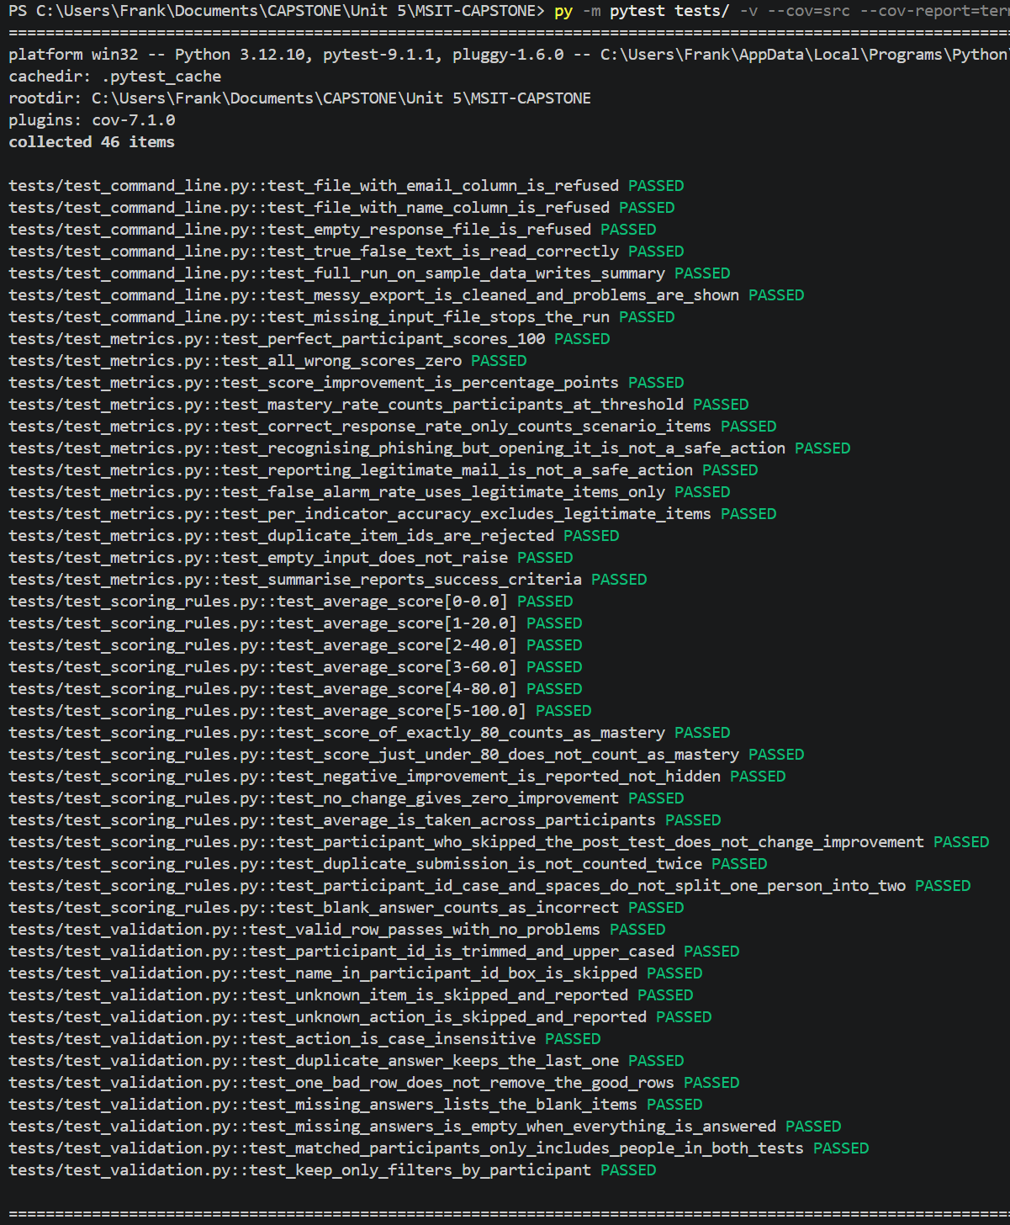

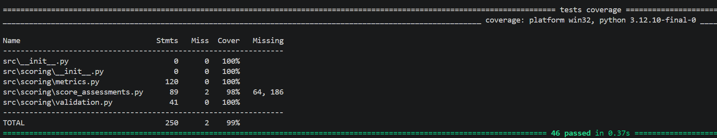
The unit tests also showed weak areas where the program needed to be improved. I wrote the new tests and ran them against the original Unit 3 code, and three of them failed (see Figure 7). First, a participant who only completed the pre-assessment was still included. This made the improvement look like 53.33 percentage points instead of 40. Second, a form submitted twice was counted twice. Third, a blank answer was skipped instead of counted as wrong meaning four correct answers out of five could still score 100%. The clean sample data never showed these because it had no gaps or duplicates. This was corrected by comparing participants who completed both assessments, keeping the last answer for each question, and scoring everyone out of the full item bank. After these corrections all of the tests had successfully passed.

Figure 7 New Tests Run Against the Original Unit 3 Scoring Code
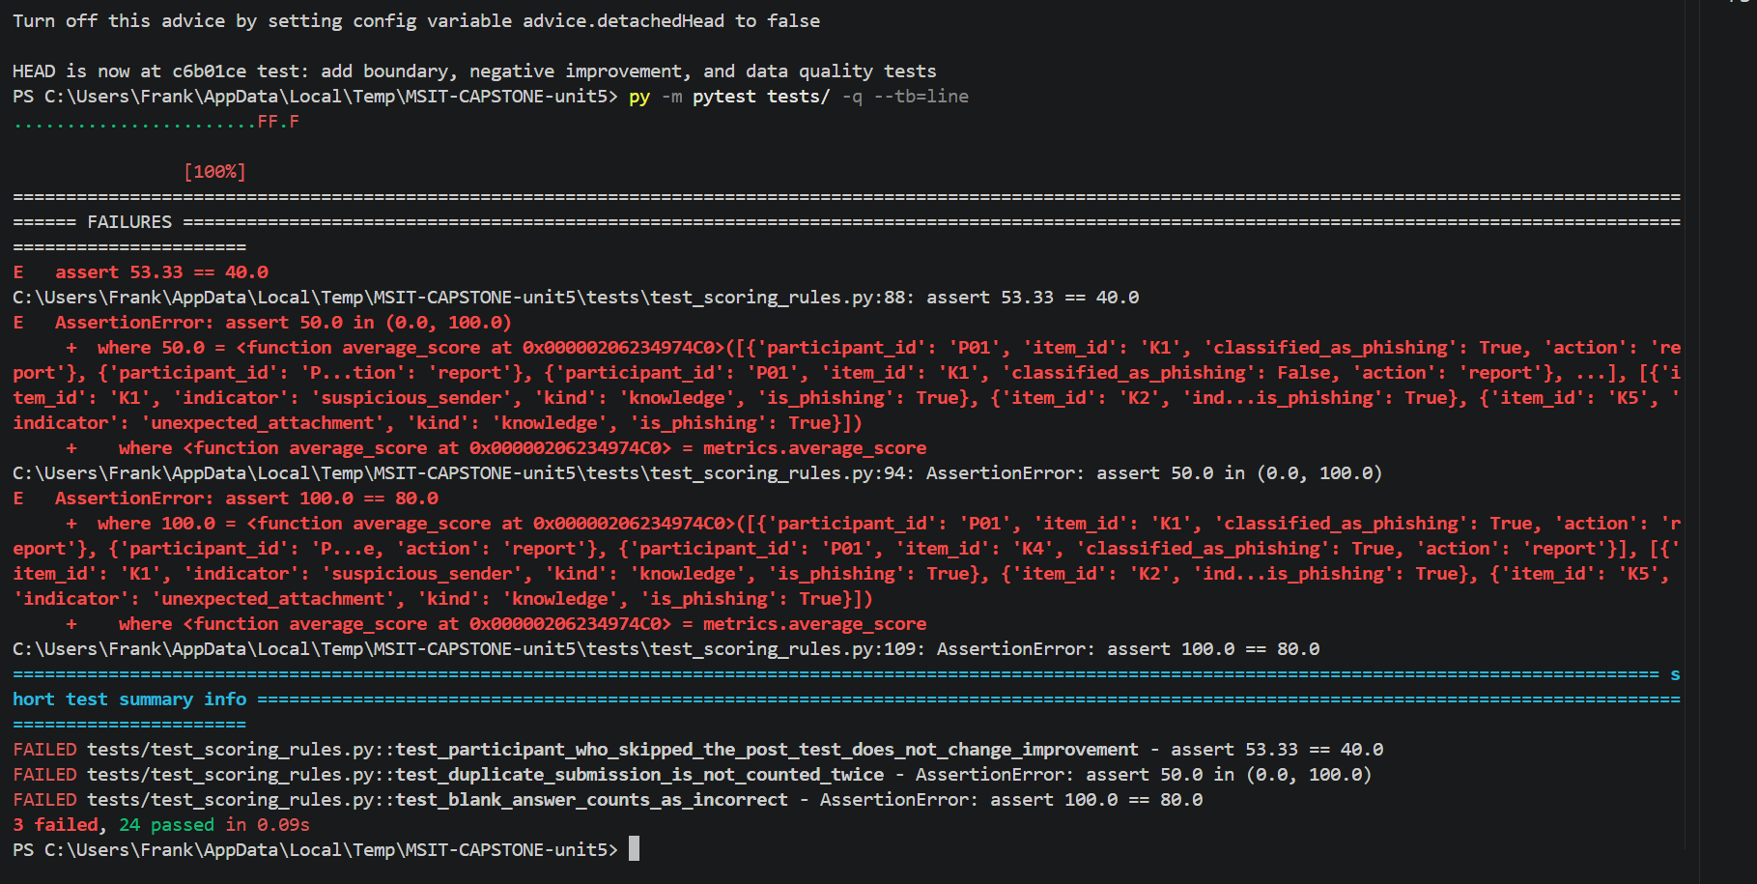
There are several types of unit testing. Black-box testing focuses mainly on the inputs and outputs. White-box testing looks at the internal logic of the program, and gray-box testing is a mix of both (GeeksforGeeks, 2025). Positive testing checks that valid information produces the correct result. Negative testing checks how the program responds when invalid information is entered. Boundary testing looks at the edges, such as a participant receiving exactly 0%, 80%, or 100%. Each of my tests has an input and an expected result. Unit testing improves reliability because problems can be found in smaller parts of the program before they affect the entire system. Amazon Web Services (n.d.) explains that unit testing focuses on individual components of an application so that they can be tested independently. This also supports modular development because I can change one module, such as the validation rules, and run the tests to make sure the scoring module still functions properly.

Part C: Version Control Management
Git and GitHub are used to keep track of changes made throughout the development of the project. The repository is public at https://github.com/flinny97/MSIT-CAPSTONE. I am using two main branches named development and main. The development branch is where changes, testing, and new functions are worked on first. The main branch is used for the stable version of the project. For this unit I also created a short feature branch called feature/unit5-validation-testing. This was merged into development and then into main through pull requests. The GitHub Actions workflow from Unit 4 runs the tests on each pull request, so code only reaches main after the tests pass. I chose this structure because it allows me to continue making changes without affecting the stable version of the project. It also creates a clear history of what was changed and when it was added (see Figure 8).
Figure 8 Commit History Showing the Feature Branch on Top of Main
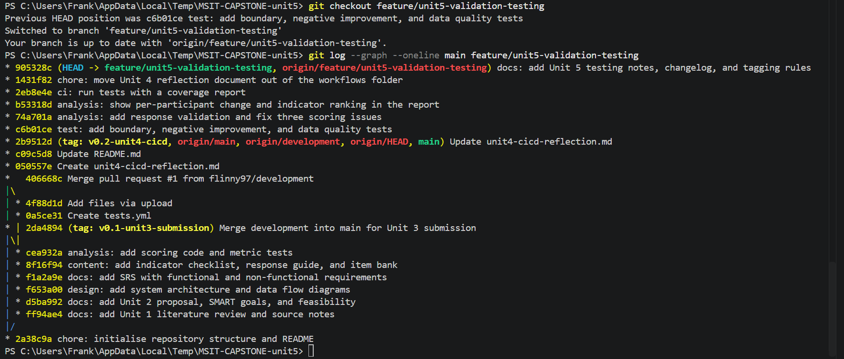
Tags and releases are used to identify major milestones in the project. A tag marks a specific commit. An annotated tag also stores who created it and when, along with a message describing it (Chacon & Straub, 2014). A release is built on a tag and adds notes that explain what was completed (GitHub, n.d.). I kept the tag I created in Unit 3 and followed the same naming pattern. The tag v0.1-unit3-submission represents initial development, v0.2-unit4-cicd marks the point where automated testing was added, and v0.3-unit5-testing marks the point where the core logic and unit testing were completed (see Figures 9 and 10). A final v1.0-final tag will be created once the project reaches its final stable version. For example, if a later change breaks the scoring, I can compare the code to v0.3 instead of looking through every commit. Releases also make it easy to see where the project was at each milestone.
Figure 9 GitHub Releases Page Showing v0.1, v0.2, and v0.3
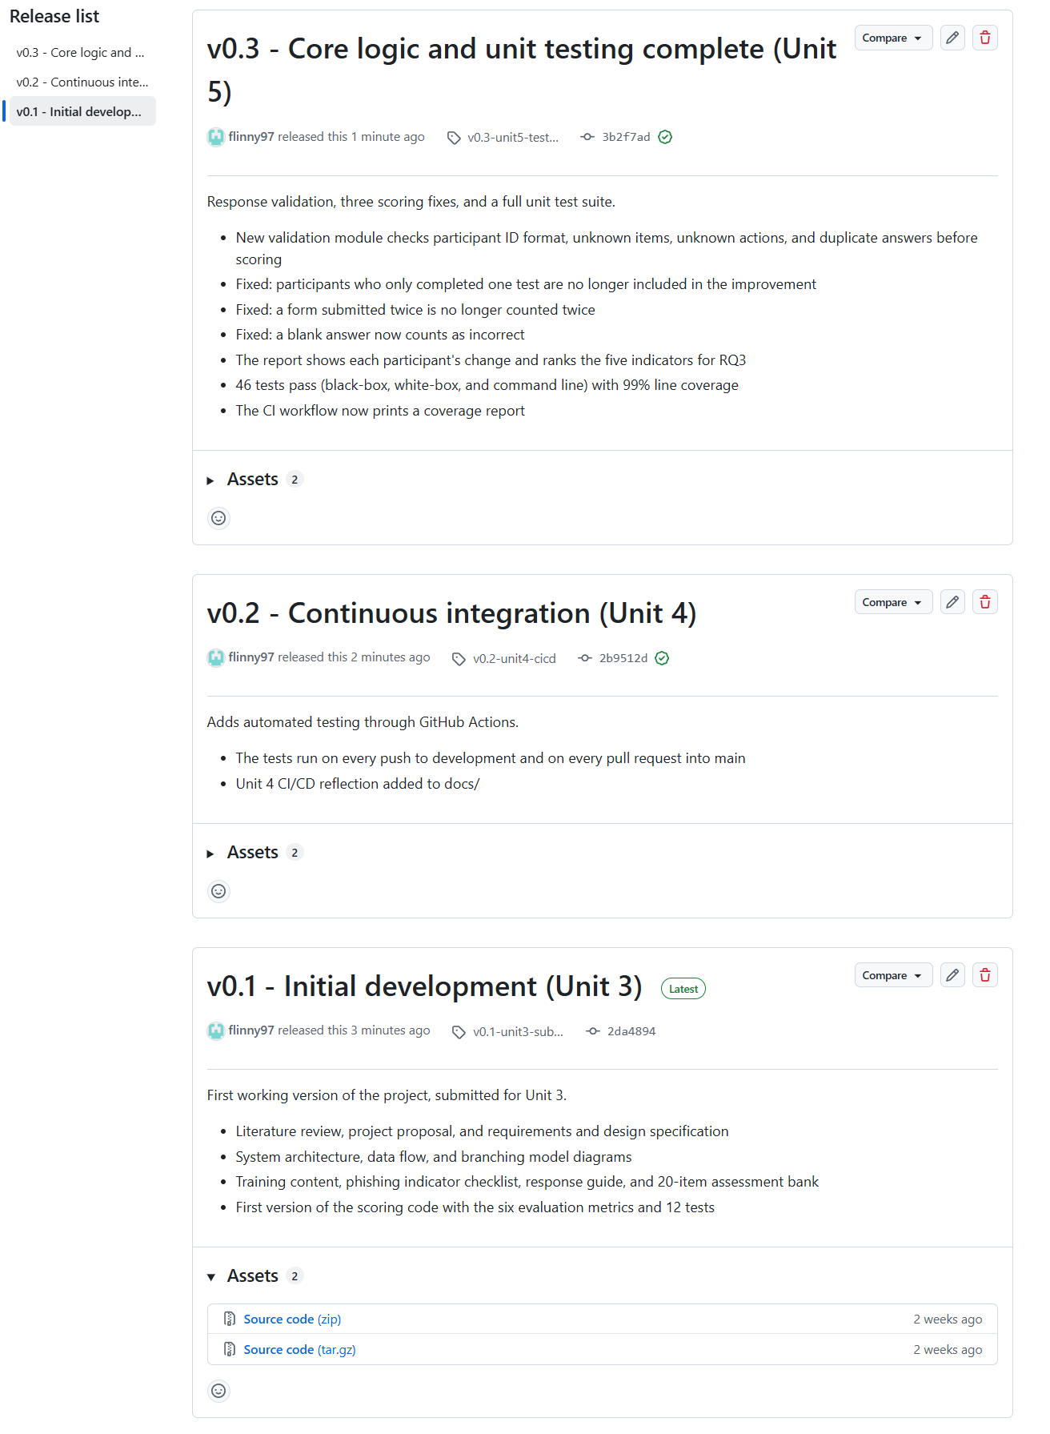
Figure 10 Tags and Branches in the Repository
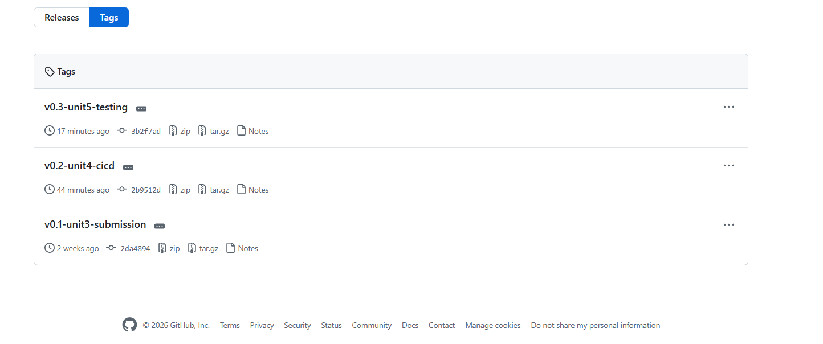
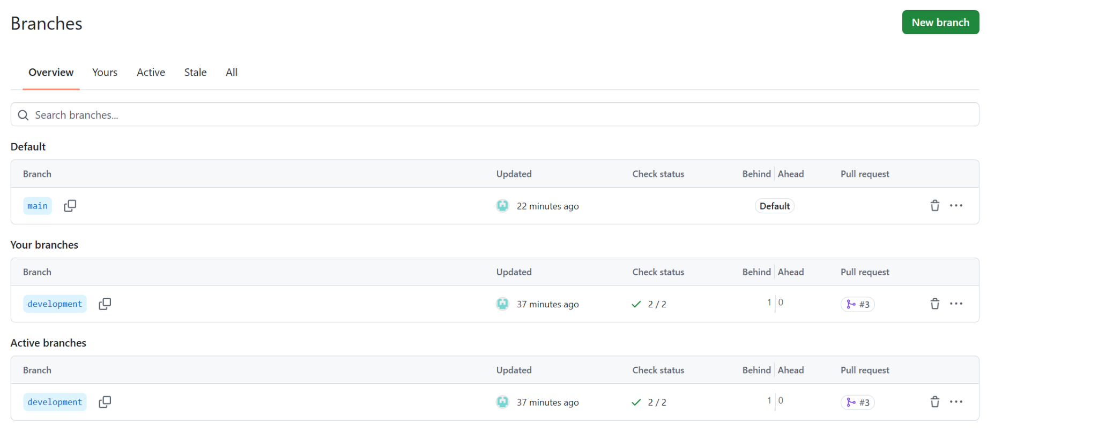

References
Amazon Web Services. (n.d.). What is unit testing? https://aws.amazon.com/what-is/unit-testing/
Chacon, S., & Straub, B. (2014). Pro Git (2nd ed.). Apress. https://git-scm.com/book/en/v2
Garcia Vargas, S. (2025, November 3). Falling for “fake” phishing: USF study finds smarter way to train employees to thwart phishing scams. University of South Florida Muma College of Business. https://www.usf.edu/business/news/2025/11-3-usf-study-smarter-way-train-employees-against-phishing-scams.aspx
GeeksforGeeks. (2025, July 22). Unit testing. https://www.geeksforgeeks.org/software-testing/unit-testing-software-testing/
GitHub. (n.d.). About releases. GitHub Docs. https://docs.github.com/en/repositories/releasing-projects-on-github/about-releases
Palmer, B. W. (2015, September 1). Study participants and informed consent. Monitor on Psychology, 46(8). https://www.apa.org/monitor/2015/09/ethics
Summers, B. L. (2020). Effective methods for software engineering. Auerbach Publishers, Incorporated.

