Improving Employee Phishing Awareness and Response
A Capstone Project Report of MSIT 5910

Submitted by:

Frank Lin (ID: S555272)

For the partial fulfilment of the requirements for the degree of
Master of Science in Information Technology

Supervised by:
Dr. Stella T. Whyte

Department of CS & MSIT
University of the People, Pasadena, CA 91101, United States
AY2027-T1, October 2026

ABSTRACT
Phishing remains one of the most common forms of cybercrime and continues to succeed in organizations that already use email filtering and annual awareness training. This project focuses on a specific gap in that practice. Most awareness programs record that an employee completed training without testing whether that employee can actually recognize a phishing message or knows what to do with one. Recent research reports no significant relationship between annual training completion and phishing susceptibility (Ho et al., 2025). This project develops a short phishing awareness training package and evaluates it using matched pre-training and post-training assessments. The system is built as four modules that handle training delivery, assessment collection, data storage and security, and analysis and reporting. These sit in a three-layer architecture, and the security and privacy controls apply across every layer instead of inside one module. Three research questions guide the evaluation. They cover recognition accuracy, response accuracy, and which of the five phishing indicators improve the most. Six metrics are calculated from paired assessment records, including a false alarm rate that checks whether the training simply makes participants suspicious of every message. At this stage the training content, the item bank, the scoring code, and the evaluation pipeline have been built and verified using synthetic test data. Participant recruitment is scheduled for later units. The contribution of this project is a practical way to measure whether training changed what employees can do instead of assuming that it worked.

ACKNOWLEDGEMENT

I would like to thank my instructor, Dr. Stella T. Whyte, for guiding me through the creation of this capstone project. Her direction at each stage helped me turn an early idea into a defined project with clear objectives and a realistic plan. I would also like to thank the Department of CS & MSIT and University of the People for the structure and resources that made this project possible.

LIST OF TABLES
Table 1. Development Stages Across Units
Table 2. Functional Requirements From Unit 3 and How They Were Implemented
Table 3. System Evaluation Results
Table 4. Project Metrics From the Synthetic Test Run (n = 16)
Table 5. Environment Variables Used by the App

LIST OF FIGURES
Figure 1. Validation Function That Checks Each Response Before Scoring
Figure 2. Summary Function Comparing Only Participants Who Completed Both Assessments
Figure 3. New Tests Run Against the Original Unit 3 Scoring Code
Figure 4. All 46 Unit 5 Tests Passing With Coverage Report
Figure 5. Training Lesson Page
Figure 6. Pre-Assessment Question With an Example Email
Figure 7. JavaScript Sending Answers From the Page to the API
Figure 8. Results Route Connecting the API, Database, and Scoring Module
Figure 9. Bridge Between the Saved Answers and the Unit 5 Scoring Code
Figure 10. Pre-Assessment Showing the Missing Question Message
Figure 11. Researcher Dashboard Using Synthetic Test Data
Figure 12. All 69 Tests Passing With Coverage
Figure 13. Average and 95th Percentile Response Time for Each API Route
Figure 14. Accuracy for Each Phishing Indicator Before and After Training, Synthetic Data

SYMBOLS AND ABBREVIATIONS
Abbreviation | Meaning
ACM | Association for Computing Machinery
API | Application Programming Interface
CI/CD | Continuous Integration and Continuous Deployment
FR | Functional Requirement
ISO/IEC | International Organization for Standardization and International Electrotechnical Commission
JSON | JavaScript Object Notation
M1 to M4 | The four system modules: Training Delivery, Assessment Collection, Data Storage and Security, Analysis and Reporting
ms | Milliseconds
NIST | National Institute of Standards and Technology
pp | Percentage points
RQ | Research Question
SQL | Structured Query Language (SQLite is the database used)
WSGI | Web Server Gateway Interface

CONTENTS

Abstract 3
Acknowledgement 4
List of Tables 4
List of Figures 4
Symbols and Abbreviations 4
Introduction 6
Sub Heading 1 6
Sub-sub heading 6
Sub Heading 2 6
Literature Review 7
Sub Heading 1 7
Sub-sub heading 7
Sub Heading 2 7
Methodology 8
Sub Heading 1 8
Sub-sub heading 8
Sub Heading 2 8
Results 8
Sub Heading 1 9
Sub-sub heading 9
Sub Heading 2 9
Discussion 9
Sub heading 1 10
Sub-sub heading 10
Subheading 2 10
Conclusion 10
Sub heading 1 11
Sub-sub heading 11
Subheading 2 11
References 11
Sub heading 1 12
Sub-sub heading 12
Sub heading 2 12
Appendices: 12
Sub heading 1 12
Sub-sub heading 12
Subheading 2 12

RESULTS

This section presents the results of building and testing the phishing awareness training system during Units 4, 5, and 6. It covers the core algorithm, how the modules were integrated into one application, and the metrics used to evaluate the system. All participant results in this chapter come from synthetic test data. Real participants have not taken part yet, so these results show that the system works as designed rather than how well the training works.

4.1 Implementation Overview
The goal of my project is to help employees recognize phishing emails and choose the right response, and to measure whether training actually improves these skills. The project is guided by three research questions. RQ1 asks whether participants get better at telling phishing and legitimate messages apart. RQ2 asks whether they get better at choosing the correct response, such as reporting the message. RQ3 asks which of the five phishing indicators improve the most and which ones remain difficult.
The system follows the three-layer design from Unit 3. The presentation layer contains the participant pages and the researcher dashboard. The application layer contains three modules. M1 Training Delivery presents the lesson, M2 Assessment Collection runs the two assessments, and M4 Analysis and Reporting calculates the results. The data layer contains M3 Data Storage and Security, which stores every record by participant ID instead of by name.
The system was built in stages, and each finished stage was tagged in Git (see Table 1). In Unit 4, I added a GitHub Actions workflow that runs the tests automatically on every push to the development branch and every pull request into main. In Unit 5, I built the core algorithm. This included a validation module that checks every response before it is scored and fixes for three scoring problems found by unit testing. In Unit 6, I connected all four modules into a Flask web application with an SQLite database, a JSON API, and a researcher dashboard.

Table 1 Development Stages Across Units
Unit | Main work | Tests | Git tag
3 | Requirements, design, and the first scoring code | 12 | v0.1-unit3-submission
4 | GitHub Actions workflow that runs the tests automatically | 12 | v0.2-unit4-cicd
5 | Validation module, three scoring fixes, and new unit tests | 46 | v0.3-unit5-testing
6 | Web application that connects M1 to M4 | 69 | v0.4-unit6-integration (planned)

I chose Python because the scoring code from Unit 3 was already written in it. Flask was added in Unit 6 because it is small and easy to connect to existing Python code. SQLite was chosen because it is included with Python and keeps the whole database in one file, which suits a pilot of 10 to 20 participants. PyTest and pytest-cov were used for testing, and Git and GitHub were used for version control.
Two parts of the final system are different from the Unit 3 plan. The plan described 20 questions in each assessment, but the final version uses 10 questions in each test. Each test has four recognition questions, four response questions, and two legitimate emails. Each question also asks how sure the participant is on a scale from 1 to 5. The second difference is that the database is not encrypted yet. This is discussed as a limitation in Chapter 5.
Table 2 compares the final system to the functional requirements from Unit 3. Six of the eight requirements are fully met. FR2 is only partly met because of the shorter assessments. FR5 is also partly met. The recognition questions record whether the participant spotted the phishing email, and the response questions record the action they would take. However, no single question records both.

Table 2 Functional Requirements From Unit 3 and How They Were Implemented

Requirement | Status | How it was implemented
FR1 Participant ID and consent | Met | The consent page records the ID and consent before any question is shown
FR2 Pre-assessment | Partly met | 10 questions instead of 20
FR3 Training module | Met | The lesson covers all five indicators and the Stop, Verify, Report steps
FR4 Matched post-assessment | Met | Same length, question types, and indicators as the pre-assessment
FR5 Classification and action | Partly met | Recognition questions record the classification and response questions record the action
FR6 ID only, no names or emails | Met | The ID check refuses emails, and no table has a name column
FR7 Six metrics and success criteria | Met | The Unit 5 scoring code, reached through the bridge
FR8 Results by indicator | Met | The dashboard table and the indicator chart

4.2 Output and Screenshots

4.2.1 Core Algorithm Implementation
The core algorithm takes each participant's answers and turns them into the six evaluation metrics from Unit 2. Three of them measure scores, which are average score, percentage-point improvement, and mastery rate. The other three are the correct response rate, the false alarm rate, and accuracy for each indicator. The algorithm works in two steps. First, the validation module checks every response before it is scored (see Figure 1). It skips rows with an invalid participant ID, an unknown question, or an unknown action. Each problem is listed as a warning, and if a participant answers the same question twice, only the last answer is kept.

Figure 1 Validation Function That Checks Each Response Before Scoring
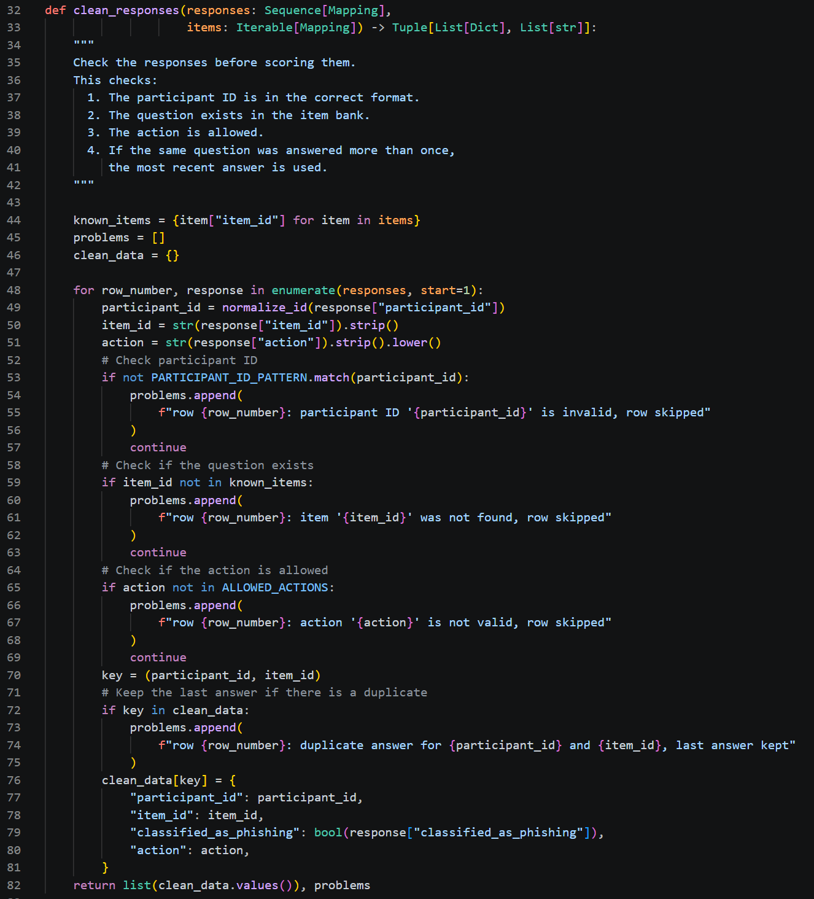
Second, the summarise function calculates all six metrics for participants who completed both assessments (see Figure 2). A participant who only took one test is left out of the comparison and reported separately. A blank answer counts as incorrect, so every score is calculated out of the full set of questions.
For example, if a participant answers 6 of 10 questions correctly before training and 9 of 10 after, the program shows an improvement of 30 percentage points. The mastery rate counts how many participants scored 80% or higher after training, which is SMART goal 4. Per-indicator accuracy groups the questions by warning sign, so the results show which sign was the hardest. The false alarm rate only uses the legitimate emails, and the correct response rate only uses the response questions.
Figure 2 Summary Function Comparing Only Participants Who Completed Both Assessments

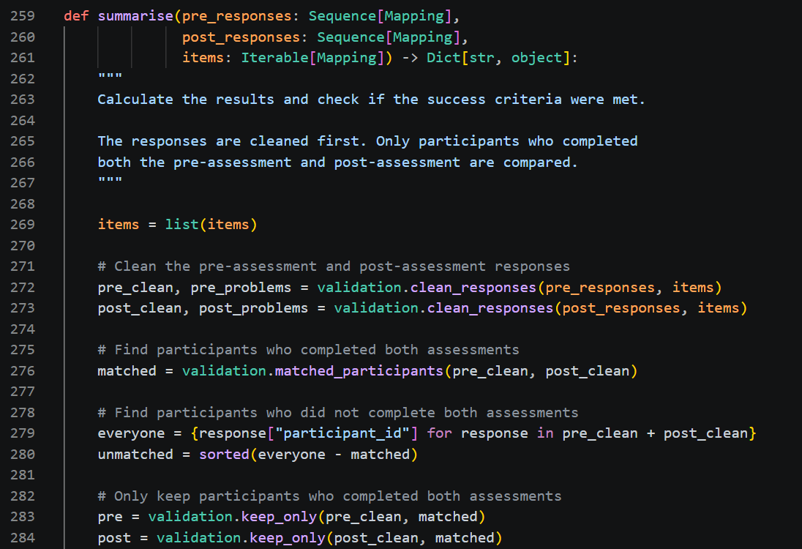
These rules came from unit testing in Unit 5. I wrote new tests and ran them against the original Unit 3 code, and three of them failed (see Figure 3). A participant who skipped the post-assessment made the improvement look like 53.33 percentage points instead of 40. A form submitted twice was counted twice, and a blank answer was skipped instead of counted as wrong. After the fixes, all 46 tests passed with 99% line coverage (see Figure 4). The clean sample data never showed these problems because it had no gaps or duplicates. This showed me that testing with messy data is just as important as testing with clean data.

Figure 3 New Tests Run Against the Original Unit 3 Scoring Code

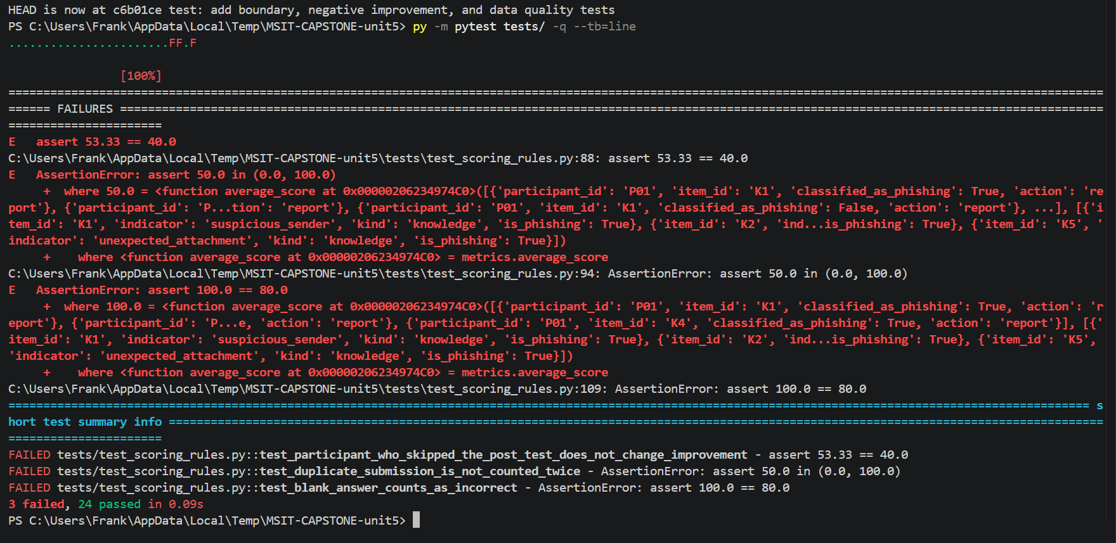
Figure 4 All 46 Unit 5 Tests Passing With Coverage Report

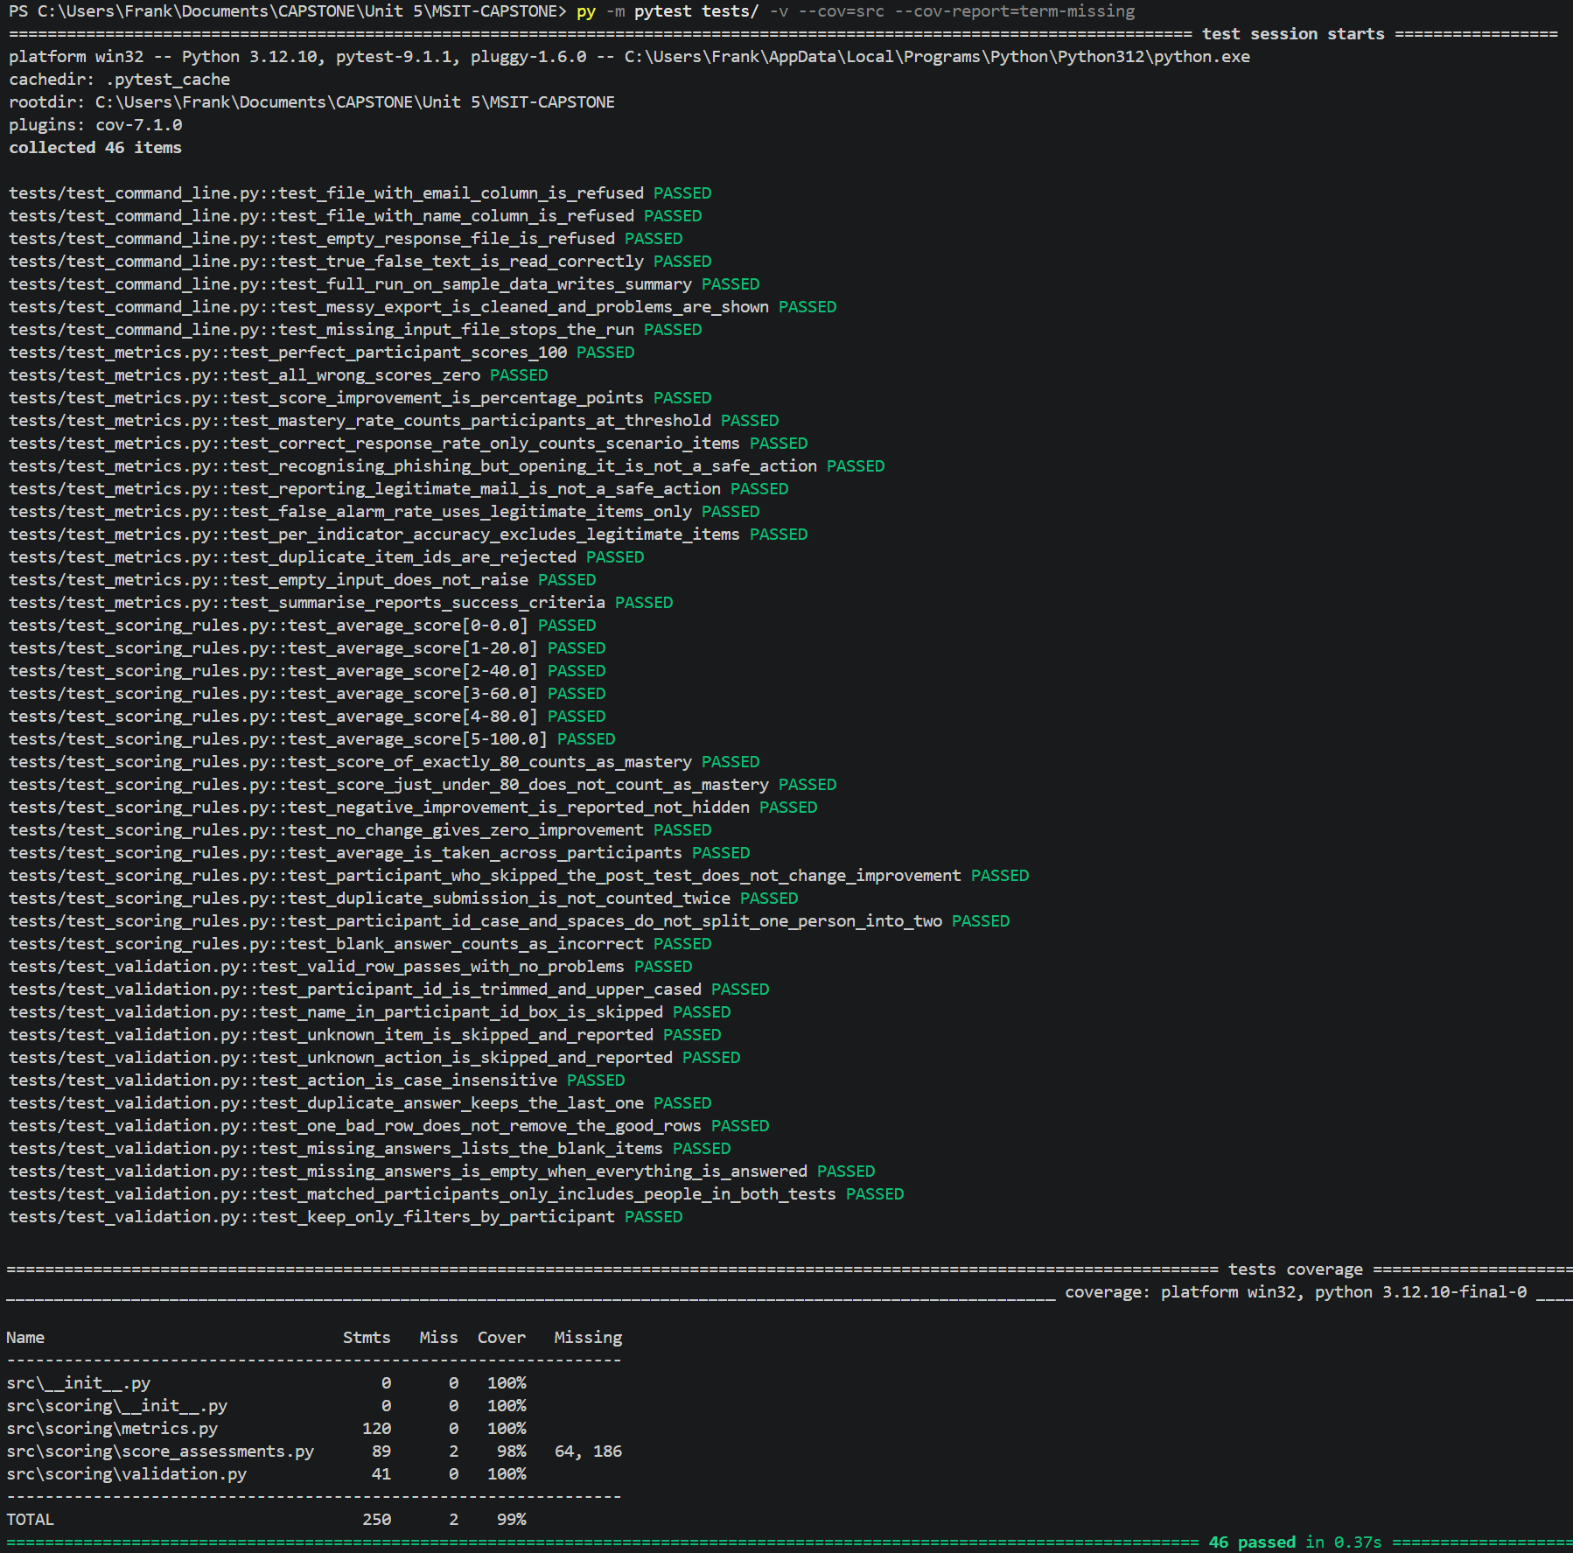

4.2.2 System Integration Summary
In Unit 6, the scoring code was connected to a web application so participants can complete the whole process in a browser. The participant flow has five steps. The participant gives consent with an assigned ID and takes the pre-assessment. They then read the training lesson, take the post-assessment, and rate how easy the training was to use. The researcher can then open a dashboard to see the results.
The training lesson and the questions come from my Unit 6 training packet. The lesson is stored as a text file and has six parts (see Figure 5). The first five cover the warning signs, and the sixth explains that not every email is phishing. It ends with the Stop, Verify, Report steps and a quick checklist. The questions are stored in a JSON file with the correct answer, the warning sign, and the question type for each one. Three questions in each test include a screenshot of an example email, with any names blurred (see Figure 6). The correct answers stay on the server and are never sent to the browser, so a participant cannot find them by viewing the page source.

Figure 5 Training Lesson Page

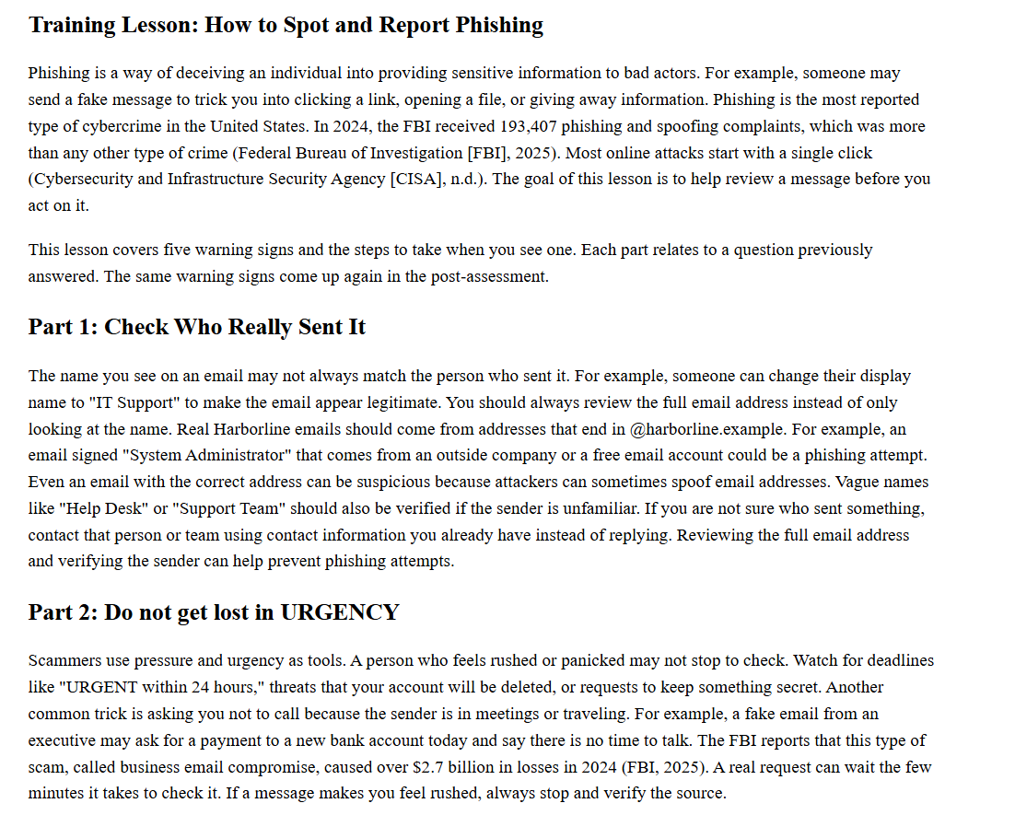
Figure 6 Pre-Assessment Question With an Example Email

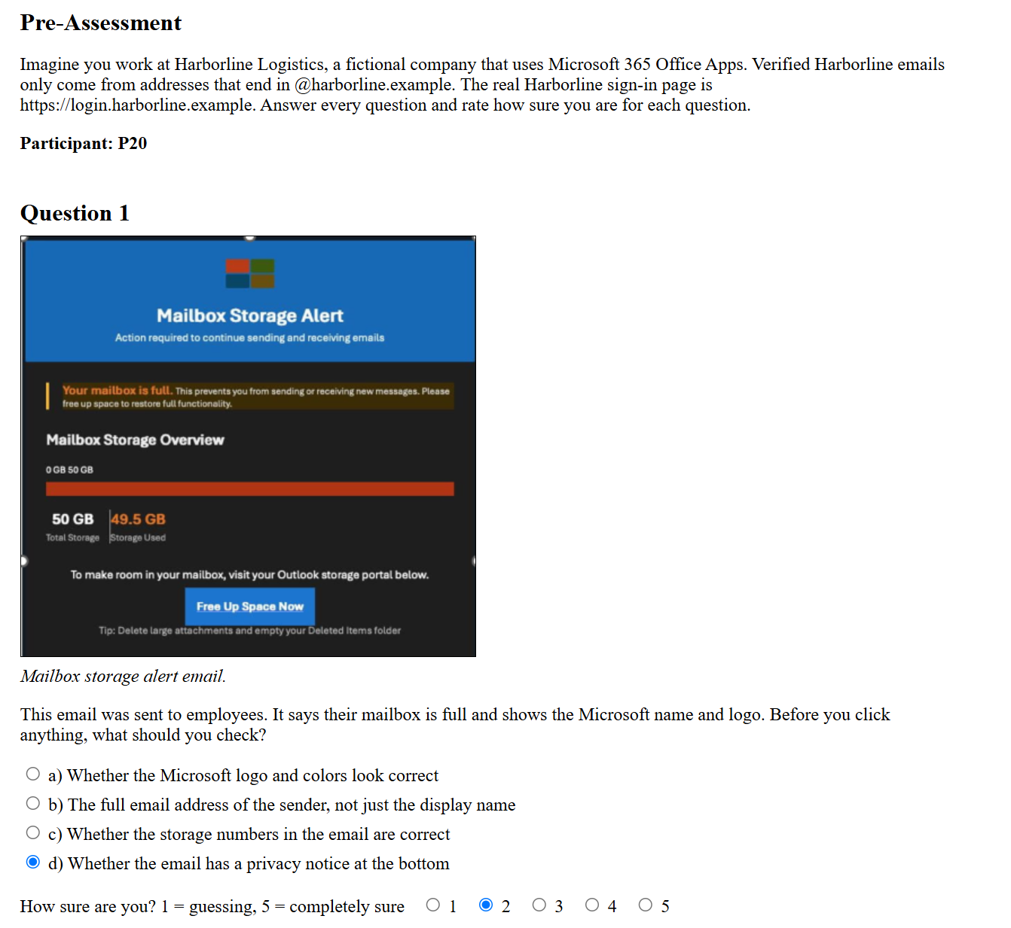
Each layer only talks to the layer next to it. The browser sends JSON requests to the API, and the API reads and writes the database. The results route then passes the saved answers to the scoring module. Figure 7 shows the JavaScript that sends a participant's answers to the API. Figure 8 shows the results route, which reads completed tests from the database and passes them to the scoring code.
Figure 7 JavaScript Sending Answers From the Page to the API

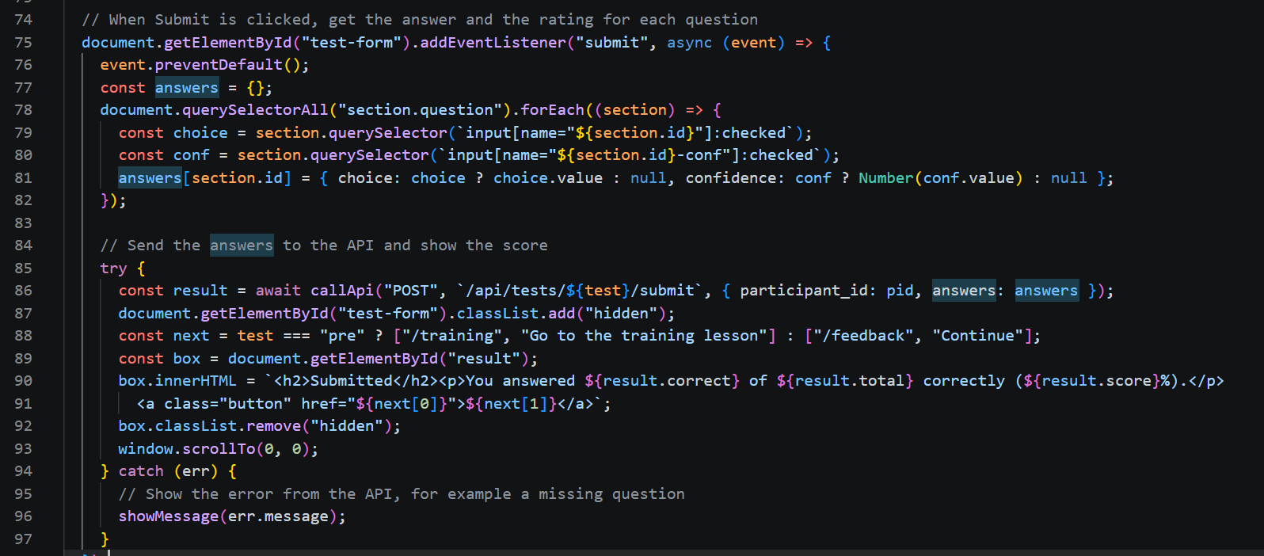
Figure 8 Results Route Connecting the API, Database, and Scoring Module

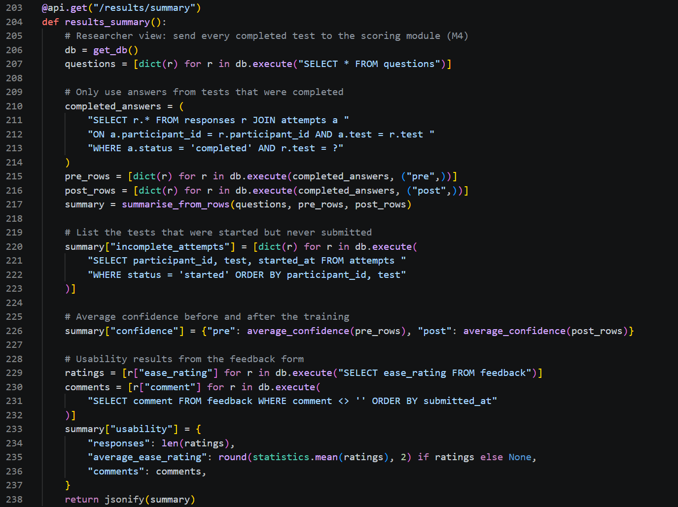
The Unit 5 scoring code expected each answer as phishing or not phishing with an action, but the new assessment uses multiple choice. Instead of writing the scoring a second time, I added a small bridge that turns each saved answer into the format the Unit 5 code already understands (see Figure 9). For example, a wrong answer on a legitimate email is treated as a false alarm. A correct answer on a response question is treated as choosing the safe action. This means the dashboard results come from the same tested code as before.

Figure 9 Bridge Between the Saved Answers and the Unit 5 Scoring Code
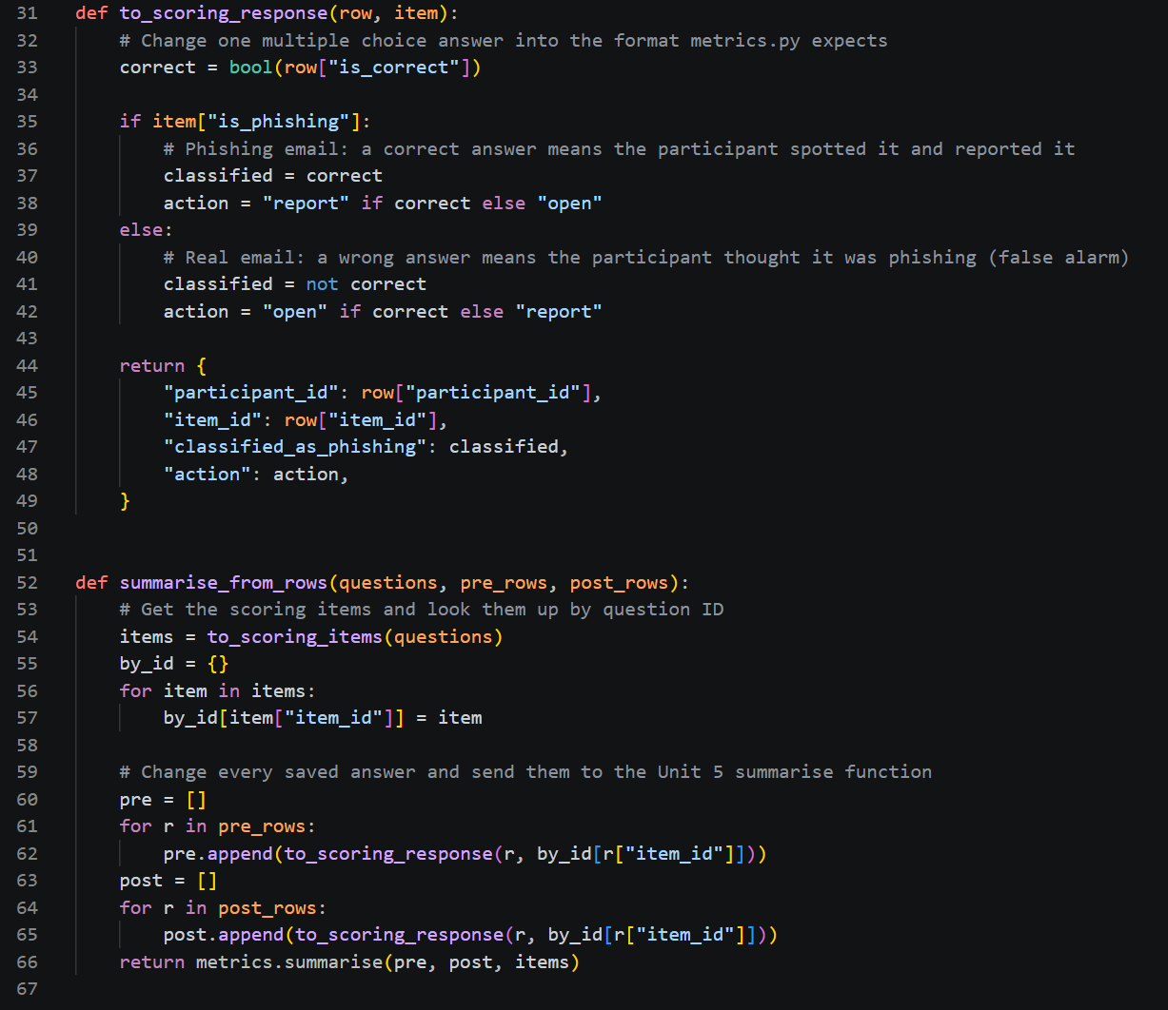
The web application also handles the incomplete assessment problem raised in my Unit 5 feedback. A test is only saved when every question has an answer and a confidence rating. Otherwise, nothing is saved and the participant sees which question is missing (see Figure 10). A test that was started but never submitted stays marked as started, so it is left out of the results and listed separately. The post-assessment also cannot start until the pre-assessment is finished, and a test cannot be submitted twice.

Figure 10 Pre-Assessment Showing the Missing Question Message
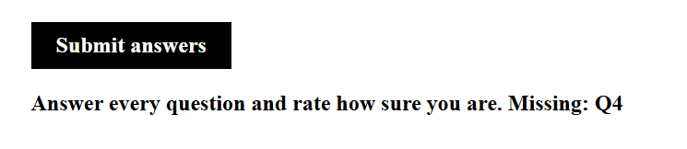
Figure 11 shows the researcher dashboard after a test run with synthetic data. Sixteen made-up participants finished both tests. P17 only finished the pre-assessment, and P18 started the post-assessment but never submitted it. The dashboard correctly left both of them out of the comparison and listed P18 as an unfinished test. The integration added 23 new tests, which brought the total to 69. All of them passed with 98% line coverage (see Figure 12). The GitHub Actions workflow from Unit 4 will run the same tests automatically when the Unit 6 code is pushed.
Figure 11 Researcher Dashboard Using Synthetic Test Data

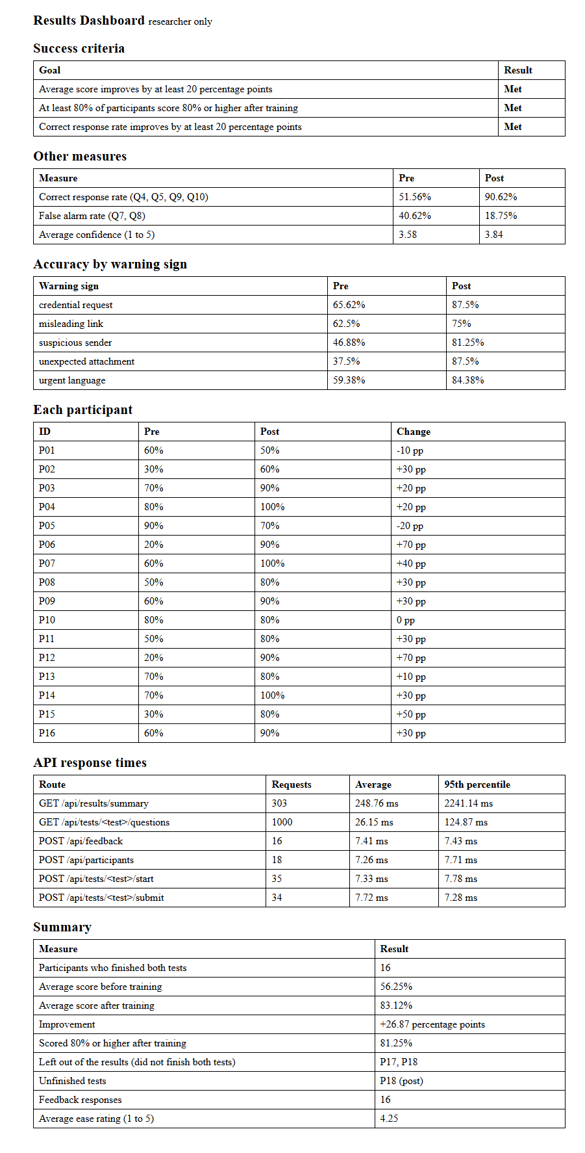

Figure 12 All 69 Tests Passing With Coverage

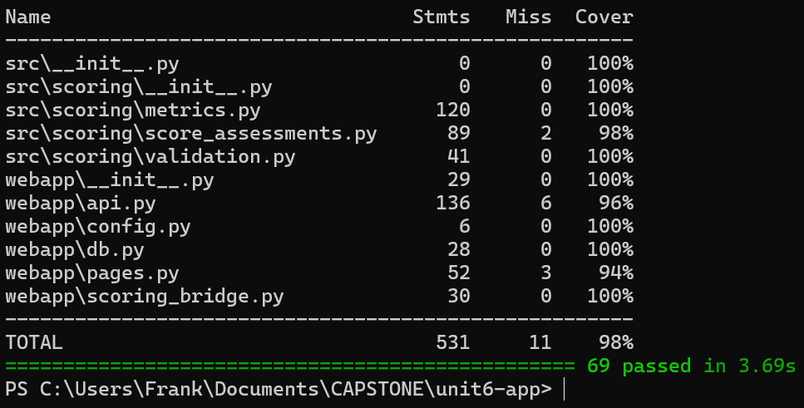

4.3 Evaluation Metrics

The system was evaluated in two ways. The first looks at the system itself, using three quantitative metrics and one qualitative metric (see Table 3). The second runs the full assessment process with synthetic participants and checks that the six project metrics are calculated and reported correctly (see Table 4).
Scoring accuracy was measured with the automated tests, which compare the output to results counted by hand. Latency was measured by a timer that saves how long every API request takes, and the dashboard shows the results for each route (see Figure 11). Throughput was measured with a load test that sent 1,000 requests for the questions and 300 requests for the results summary, 10 at a time. Usability was assessed by reviewing the interface against three of Nielsen's (2024) usability heuristics, which were error prevention, plain language, and minimalist design. The latency and throughput tests were run on a local computer, not on the hosting platform.
Table 3 System Evaluation Results

Metric | Type | Result
Scoring accuracy | Quantitative | 69 of 69 tests passed, 98% line coverage
Latency, saving answers | Quantitative | 7.72 ms average, 7.28 ms 95th percentile
Latency, loading questions | Quantitative | 26.15 ms average, 124.87 ms 95th percentile
Latency, results summary | Quantitative | 250.38 ms average, 2,241.14 ms 95th percentile
Throughput | Quantitative | 65 requests per second for questions, 33 for the results summary, no failed requests
Usability | Qualitative | 3 heuristics reviewed, 2 weak spots found

Table 4 shows the six project metrics from the synthetic test run. These numbers were generated by a script, not collected from people. The script was set up to give better answers after training, so an improvement was expected. The purpose of this run was to prove that the full process works from the first click to the final report.

Table 4 Project Metrics From the Synthetic Test Run (n = 16)

Measure | Pre | Post | Change
Average score | 56.25% | 83.12% | +26.87 pp
Correct response rate | 51.56% | 90.62% | +39.06 pp
False alarm rate | 40.62% | 18.75% | -21.87 pp
Mastery rate (80% or higher) | Not calculated | 81.25% | Not applicable
Average confidence (1 to 5) | 3.58 | 3.84 | +0.26

The synthetic run met all three success criteria from Unit 2. The average score rose by more than 20 percentage points, and 81.25% of participants scored 80% or higher after training. The correct response rate also rose by more than 20 percentage points. Since the data was synthetic, the size of the improvement does not mean much. This run mainly shows that the system calculated every metric correctly and left out the incomplete tests.
Average confidence rose from 3.58 to 3.84 out of 5. Confidence was added because a participant can choose the right answer while still guessing. In the pilot, comparing confidence with accuracy will show whether participants are sure for the right reasons. A participant who is very confident but wrong would point to an area where the training needs to be clearer.

DISCUSSION

5.1 Interpretation of Results
5.1.1 Evaluation Metrics and Results

The system metrics show that the application is accurate and fast enough for its purpose. All 69 tests passed. This means the scores matched the hand-counted results in every tested case. This includes the edge cases from Unit 5, such as blank answers and duplicate forms. Line coverage of 98% shows that almost every line of the scoring and web code was run during testing. Coverage does not prove the code is correct. It shows that very little code was left untested.
Figure 13 compares the average and 95th percentile response time for each route. Every action that saves participant data was answered in about 8 milliseconds or less. Loading the questions averaged 26.15 milliseconds during the load test, which a participant would not notice. The results summary was the slowest at 250.38 milliseconds on average because it runs the full scoring module every time the dashboard opens. Most of its requests were made during the load test with 10 requests at a time, so 95% of them finished within about 2.2 seconds. This is still suitable for this project because only the researcher opens the dashboard and participants never have to wait. The load test also showed 65 question requests per second with no failed requests. For example, if all 20 participants submitted a test at the same moment, the server would only receive 20 requests.

Figure 13 Average and 95th Percentile Response Time for Each API Route

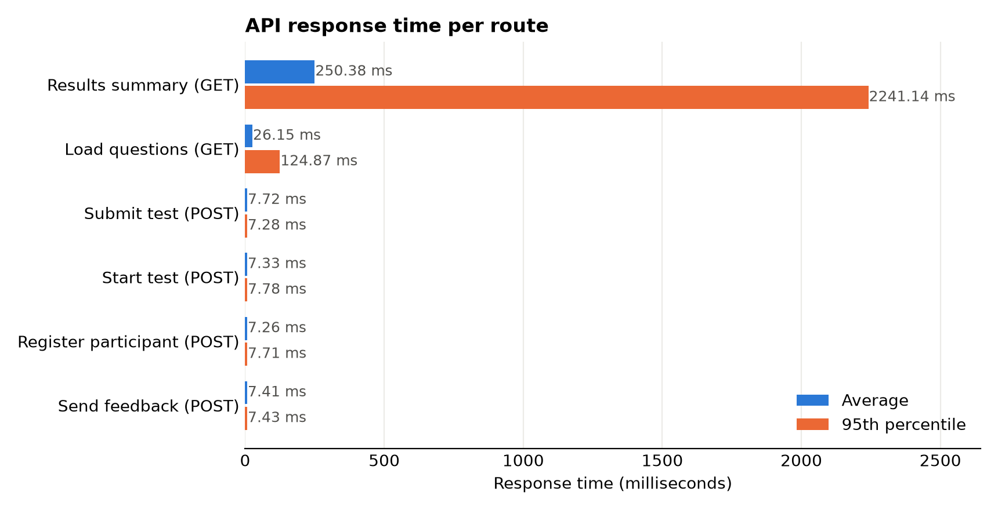
Figure 14 shows the accuracy for each phishing indicator in the synthetic run. This chart is the same type of output that will answer RQ3 once real data is collected. In the synthetic run, unexpected attachments started with the lowest accuracy at 37.5% and improved the most. Misleading links improved the least, from 62.5% to 75%. These numbers are not findings about the training because they were generated by a script. They do show that the dashboard can point out which indicators remain difficult.
The correct response rate and the false alarm rate are just as important as the average score. The correct response rate connects to RQ2 because it shows whether participants would report or verify a suspicious email instead of opening it. The false alarm rate shows how often a legitimate email was marked as phishing. Training that makes people suspicious of every email is not a success because it moves the cost to the help desk support instead of reducing risk. In the synthetic run, the false alarm rate dropped from 40.62% to 18.75%. In the pilot, this measure will show if participants learned to tell the difference or became more suspicious.

Figure 14 Accuracy for Each Phishing Indicator Before and After Training, Synthetic Data

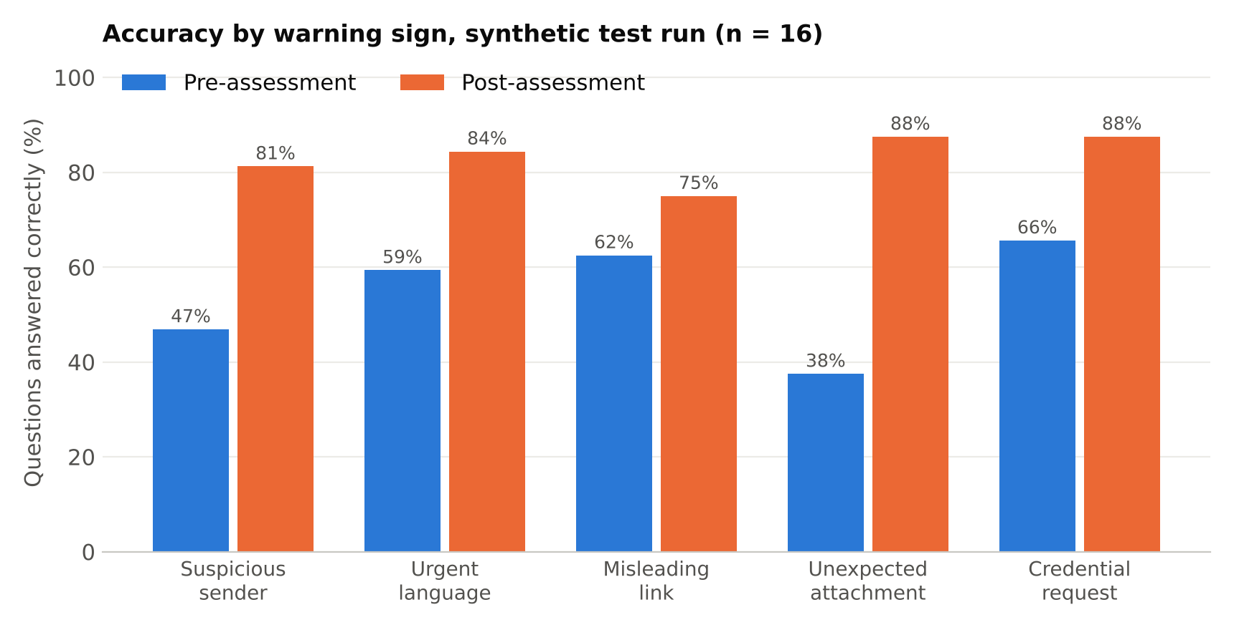
The usability review found that the interface follows all three heuristics, with two weak spots. Error prevention is strong because the post-assessment stays locked until the pre-assessment is done. A test also cannot be submitted twice. The error messages use plain language and name the exact problem. This follows Nielsen's (2024) advice that error messages should help users recover. The design is also minimal, with black text, simple tables, and one main button on each page. The two weak spots were the lack of a progress counter and the missing question not being highlighted. Both are small changes, and I plan to fix them before the pilot.

5.1.2 Deployment Approach and Configuration Summary

I plan to deploy the system on PythonAnywhere using a free account. I compared three options. An on-premise server would give me full control, but I would have to maintain it and remote participants may not be able to reach it. Docker would make the app portable, but it still needs a server to run on. PythonAnywhere can host one Flask website with an SQLite database on a free account (giles, 2025). It costs nothing to setup, and participants only require a link. The main drawbacks are that the free site has to be renewed once a month (PythonAnywhere, n.d.) and SQLite does not scale well there (giles, 2025). These limits do not affect a pilot of 10 to 20 participants.
Deployment includes every step needed to make software available to users, and DevOps uses automation to make that process smoother (Sumo Logic, n.d.). Common strategies include big bang, rolling, and blue-green deployments (ByteByteGo, n.d.). I will use a big bang approach. This is the process in which the whole site is updated at once only between pilot sessions. This avoids changing the system while someone is in the middle of a test. Each version that is deployed will have a Git tag. This is so I can roll back to the last working version if an update causes a problem.
Configuration is handled through environment variables. The app reads five settings this way, including the database location and the secret key (see Table 5). Each one has a safe default, so the app runs on a laptop with no extra setup. On the server, the secret key is changed and debug mode stays off. The secret key is never stored in GitHub, and the .env.example file lists each setting so the setup can be repeated. Setting up the app only takes a few commands to clone the repository, install the requirements, run the tests, and start the app. The database is created automatically the first time the app starts.

Table 5 Environment Variables Used by the App

Variable | Purpose | Value on the server
CAPSTONE_DB_PATH | Location of the database file | Default
CAPSTONE_SCREENSHOT_DIR | Folder with the question images | Default
CAPSTONE_SECRET_KEY | Signs session data | A new random value
CAPSTONE_DEBUG | Debug mode | 0 (off)
PORT | Port for running locally | Not used

The deployment will follow a short checklist. First, I will create the free account and clone the repository from GitHub in a Bash console. Next, I will install the requirements and set the environment variables in the WSGI file that PythonAnywhere uses to start the app. The screenshots for the questions will be uploaded separately because they are kept out of GitHub. After the site is reloaded, I will complete one full test run myself and check that it appears on the dashboard. Finally, I will delete that test data and tag the deployed version.

5.2 Comparison with Literature Findings

The design of this project responds to several findings from the literature review in Unit 1. Ho et al. (2025) studied about 19,500 employees over eight months. They found no significant relationship between completing annual training and being less likely to fall for phishing. This is why my system does not treat completion as success. Instead, it measures whether each participant can recognize phishing and choose the right response before and after training. The dashboard reports scores for each participant and each indicator, not just who finished the lesson.
Lain et al. (2024) found that a plain reminder performed about as well as full training content. This suggests that a longer lesson is not always better. My training lesson is short and focuses on the five indicators and the Stop, Verify, Report steps. It also means the project should not assume that the lesson itself causes any improvement. A future comparison between the lesson and a short reminder would help answer that question.
Garcia Vargas (2025) reported that phishing training can be more effective when feedback is given to all participants instead of only those who make a mistake. My system shows every participant their score after each test. It does not yet show which questions were wrong or why. Adding feedback for each question after the post-assessment would bring the system closer to this approach.
Althobaiti and Alsufyani (2024) reviewed 163 research articles and found that most research focuses on detection and awareness when to compared to mitigation which receives less attention. My project measures response as well as recognition. The correct response rate shows whether participants choose a safe action, such as reporting the email or calling a vendor using a number already on file. This connects awareness to what employees actually do next.
Subhashini et al. (2024) showed that technical tools can detect phishing websites with 98.89% accuracy. This is very high, but it is not perfect, and the messages that are missed still reach people. My project does not replace technical controls. It focuses on the human decision that happens after a message gets past those controls.
The evaluation methods also follow the literature. The quantitative metrics also relate to characteristics in the ISO/IEC 25010 product quality model, such as performance efficiency and reliability (International Organization for Standardization, 2023). NIST guidance on building a learning program also addresses the challenge of measuring the impact of training (Merritt et al., 2024). My system makes that measurement part of the training process instead of a separate task.
My changes were merged into a shared GitHub repository and the tests ran automatically. The GitHub Actions workflow from Unit 4 runs every test on each pull request. I used Git tags to mark each unit so any version can be compared or restored. Bugs reported by users typically mean a problem slipped past testing. Running the tests on pull requests is one of the methods used for catching those problems.

5.3 Implications and Limitations

The results have a few practical implications. One implication is that a useful phishing training and measurement tool does not need expensive software. This system was built with free tools and can be hosted for free. Measuring recognition and response before and after training also gives organizations better evidence than completion records alone. Another implication is that privacy can be built into the design from the start. The system only stores participant IDs, refuses email addresses in the ID field, and never sends the correct answers to the browser.
The design also supports the ethics plan from Unit 2. The ACM Code of Ethics asks computing professionals to avoid harm and respect privacy (Association for Computing Machinery, 2018). The example emails contain no working links or attachments, and the app only collects the data needed to calculate the metrics. The consent page also tells participants they can stop at any time, and an unfinished test is never counted.
The project also has several limitations. The most important is that all participant results so far are synthetic. Real participants have not been recruited, so the project cannot yet answer whether the training improves recognition or response. The synthetic results only show that the system calculates and reports the metrics correctly. The synthetic answers were also random within a set skill level, so they do not show realistic patterns, such as one warning sign being much harder for most people.
The planned sample of 10 to 20 participants is small, and there is no control group. Without a control group, an improvement could come from taking the same type of test twice instead of from the training. The assessments use 10 questions each instead of the 20 planned in Unit 3, which makes each score more sensitive to a single answer. For example, one question is worth 10 percentage points. Multiple-choice questions also measure what someone would do in a test, which may be different from what they actually do with a real email in their inbox.
There are also technical limitations. The SQLite database is not encrypted yet, and the researcher dashboard does not require a login. This means the Unit 3 requirement for encrypted storage and least-privilege access is not fully met. The data only contains participant IDs, but these controls should be added before real data is collected. The latency and throughput results were measured on a local computer, so the hosted site may be slower. Finally, the usability review was done by me as the developer, which may not reflect how participants experience the system.

5.4 Future Work

Several improvements and research directions would build on this project. The first step is to run the pilot with real participants and compare the results to the success criteria. This will give the first real answers to RQ1, RQ2, and RQ3.
Future research should include a control group that takes both assessments without the training. This would show how much of the improvement comes from the training itself. Another useful study would compare the full lesson to a short reminder, since Lain et al. (2024) found that a plain reminder performed about as well as full training. A delayed post-assessment a few weeks later would also show whether the improvement lasts. Ho et al. (2025) found no clear link between yearly training and lower susceptibility, so retention over time is an important question.
A future version could also test participants with safe simulated emails in a real inbox, with their consent. This would measure actual behavior instead of test answers. Feedback for each question should be given to all participants, based on the findings from Garcia Vargas (2025). If the project grows beyond a small pilot, the database should be moved from SQLite to a database server. The results summary should also be saved instead of recalculated every time the dashboard opens.
It would also help to test the system with a wider group of participants, such as people in different job roles and with different levels of computer experience. The interface should also be checked for accessibility, such as screen reader support, before it is used with a larger group.

CONCLUSION
6.1 Main Findings and Implications
This project set out to build a way to train employees to recognize and respond to phishing, and to measure whether the training works. Across Units 4, 5, and 6, I built a complete system that does this. Participants can complete the whole process in a browser, from consent to feedback. The researcher can see all six evaluation metrics on one dashboard.
The main finding at this stage is that the system works correctly and is ready for a pilot. All 69 automated tests passed, and every action that saves participant data was answered in under 8 milliseconds. In a full run with 16 synthetic participants, the results were calculated correctly and the incomplete tests were left out. The question of how well the training works is still open because real participants have not taken part yet. The main implication is that a small organization can measure phishing awareness with free tools instead of relying on completion records.
For organizations, the results also suggest a different way to look at training records. A completion record only shows that someone finished a course. Pre-assessment and post-assessment scores show what the person can actually do, and the indicator results show where the next training should focus. This kind of evidence is more useful when deciding whether a training program is worth repeating.

6.2 Contributions
The project makes three main contributions. It provides a short training lesson and matched assessments that cover the five phishing indicators and safe responses. It also provides a tool that measures what participants can do, not just whether they completed the training. This includes recognition, response, false alarms, and accuracy for each indicator. The last contribution is showing how privacy can be part of the design, with participant IDs instead of names. The code and tests from Units 3 to 5 are already public on GitHub, and the Unit 6 code will be added so others can reuse or improve it.

Lessons Learned and Challenges

The biggest lesson I learned is that testing with clean data is not enough. I see this often in my career in IT, data coming from different systems is rarely as clean as a sample file used for testing. In Unit 5, my clean sample data passed every check, but messy data showed three scoring problems that would have made the results inaccurate. Another lesson was the value of keeping modules separate. Because the scoring code was already tested, I could connect it to the web application with a small bridge instead of rewriting it. Automating the tests in Unit 4 meant that every change in Unit 6 was checked against all of the earlier work.
I also learned that small configuration choices make a big impact later. Reading every setting from an environment variable meant the tests could use a temporary database without touching the real one. The same choice will make deployment easier because nothing in the code has to change for the server.
A challenge was changing the assessment format to multiple choice and keeping the same scoring code. Another challenge was deciding how to handle incomplete tests without losing good data. I solved this by only saving a test when it is complete and keeping unfinished tests visible to the researcher. Finding phishing examples that were safe to show participants also required care. Names and email addresses must be blurred. Recruiting volunteers on time remains the main risk, as I identified in Unit 2.

Next Improvements

Before the pilot, I plan to make five improvements. I will add a progress counter and highlight any missing question on the test page. I will add a login to the researcher dashboard and encrypt the database to meet the security requirement from Unit 3. I will also show feedback for each question after the post-assessment. Next, I will deploy the system to PythonAnywhere and repeat the latency test on the hosted site. Finally, I will delete the synthetic test data and recruit real participants so the project can answer its research questions.

REFERENCES
Althobaiti, K., & Alsufyani, N. (2024). A review of organization-oriented phishing research. PeerJ Computer Science, 10, e2487. https://doi.org/10.7717/peerj-cs.2487
Association for Computing Machinery. (2018). ACM code of ethics and professional conduct. https://www.acm.org/code-of-ethics
ByteByteGo. (n.d.). Top 5 most-used deployment strategies. https://bytebytego.com/guides/top-5-most-used-deployment-strategies/
Garcia Vargas, S. (2025, November 3). Falling for “fake” phishing: USF study finds smarter way to train employees to thwart phishing scams. University of South Florida Muma College of Business. https://www.usf.edu/business/news/2025/11-3-usf-study-smarter-way-train-employees-against-phishing-scams.aspx
giles. (2025, December 15). A beginner's guide to building a simple database-backed Flask website on PythonAnywhere. PythonAnywhere Blog. https://blog.pythonanywhere.com/121
Ho, G., Mirian, A., Luo, E., Tong, K., Lee, E., Liu, L., Longhurst, C. A., Dameff, C., Savage, S., & Voelker, G. M. (2025). Understanding the efficacy of phishing training in practice. In 2025 IEEE Symposium on Security and Privacy (SP) (pp. 76–93). IEEE. https://doi.org/10.1109/SP61157.2025.00076
International Organization for Standardization. (2023). Systems and software engineering — Systems and software Quality Requirements and Evaluation (SQuaRE) — Product quality model (ISO/IEC 25010:2023). https://www.iso.org/standard/78176.html
Lain, D., Jost, T., Matetić, S., Kostiainen, K., & Capkun, S. (2024). Content, nudges and incentives: A study on the effectiveness and perception of embedded phishing training. In Proceedings of the 2024 ACM SIGSAC Conference on Computer and Communications Security (pp. 4477–4491). Association for Computing Machinery. https://doi.org/10.1145/3658644.3690348
Merritt, M., Hansche, S., Ellis, B., Sanchez-Cherry, K., Snyder, J. N., & Walden, D. (2024). Building a cybersecurity and privacy learning program (NIST Special Publication 800-50, Rev. 1). National Institute of Standards and Technology. https://doi.org/10.6028/NIST.SP.800-50r1
Nielsen, J. (2024, January 30). 10 usability heuristics for user interface design. Nielsen Norman Group. https://www.nngroup.com/articles/ten-usability-heuristics/
PythonAnywhere. (n.d.). Free accounts features. PythonAnywhere Help. https://help.pythonanywhere.com/pages/FreeAccountsFeatures/
Subhashini, N., Banerjee, A., Kumar, A., Muthulakshmi, S., & Revathi, S. (2024). Deep learning based phishing website detection. TELKOMNIKA (Telecommunication Computing Electronics and Control), 22(1), 113–121. https://doi.org/10.12928/TELKOMNIKA.v22i1.25516
Sumo Logic. (n.d.). What is software deployment? https://www.sumologic.com/glossary/software-development

