Assignment Activity Unit 6
Frank Lin
University of the People
MSIT 5910-01 - AY2027-T1
Dr. Stella T. Whyte
October 14, 2026

Introduction
This phase of my capstone project focuses on combining the separate components of my Employee Phishing Awareness and Response project into one working web application. Participants can now complete the whole process in a browser, from consent to feedback. The researcher can then review the results on a dashboard.

Part A: System Integration & Feature Completion
My application uses Flask and SQLite and follows the three-layer design from Unit 3. The web pages represent the presentation layer. The training lesson (M1), assessments (M2), and scoring module (M4) form the application layer. The SQLite database (M3) is the data layer. The web pages do not connect to the database directly. They send requests through the API, which validates the input before any information is saved.
The first example demonstrates the consent and registration process. The register_participant function only accepts valid participant IDs, such as P01, and rejects invalid entries, including email addresses (see Figure 1). This helps prevent personal information from being stored in the participant ID field, which supports requirement FR6 from Unit 3. Figure 2 shows the output when an email address is entered instead of a valid participant ID.

Figure 1 register_participant Function Checking the Participant ID
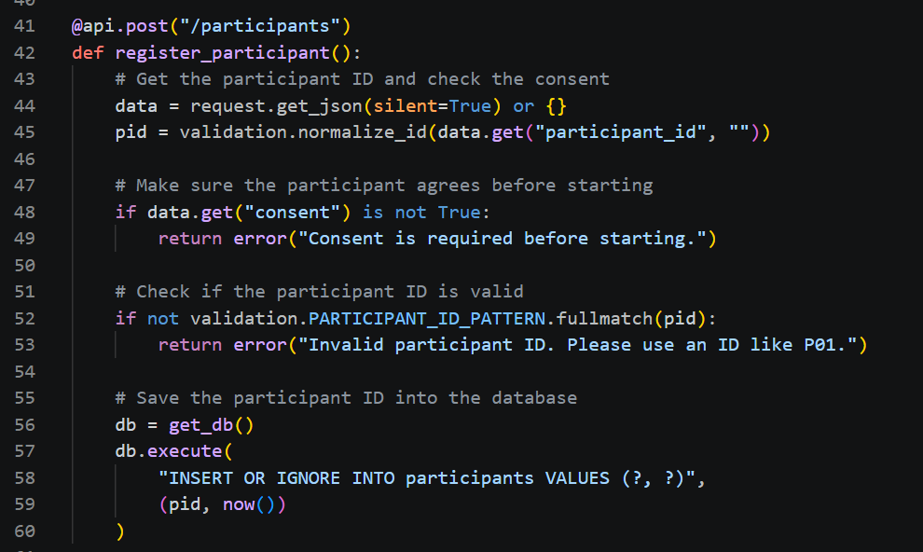
Figure 2 Consent Page Refusing an Email Address
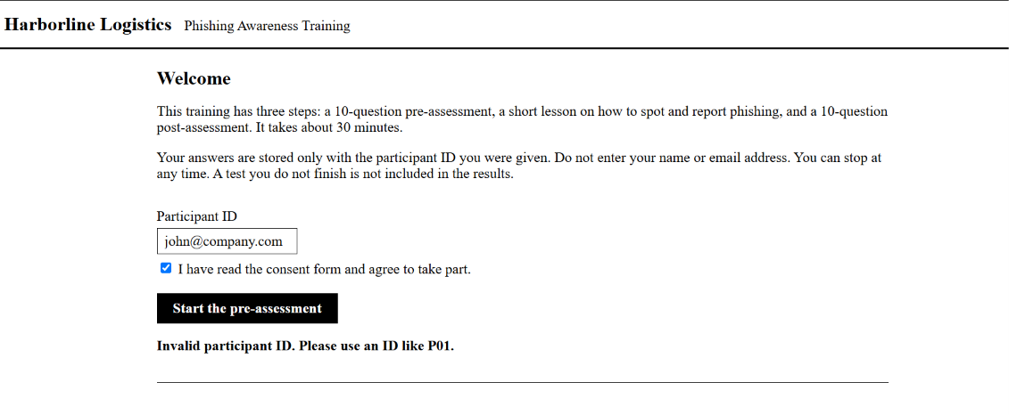
The second example demonstrates the assessment submission process (see Figure 3). My Unit 5 feedback pointed out that incomplete assessments needed to be handled so every question now requires an answer and a confidence rating. If any information is missing, the system does not save the submission and tells the participant which question needs to be corrected (see Figure 4). When all questions are completed, the assessment is saved and the participant's score is displayed (see Figure 5).
Figure 3 submit_test Function Rejecting Incomplete Tests
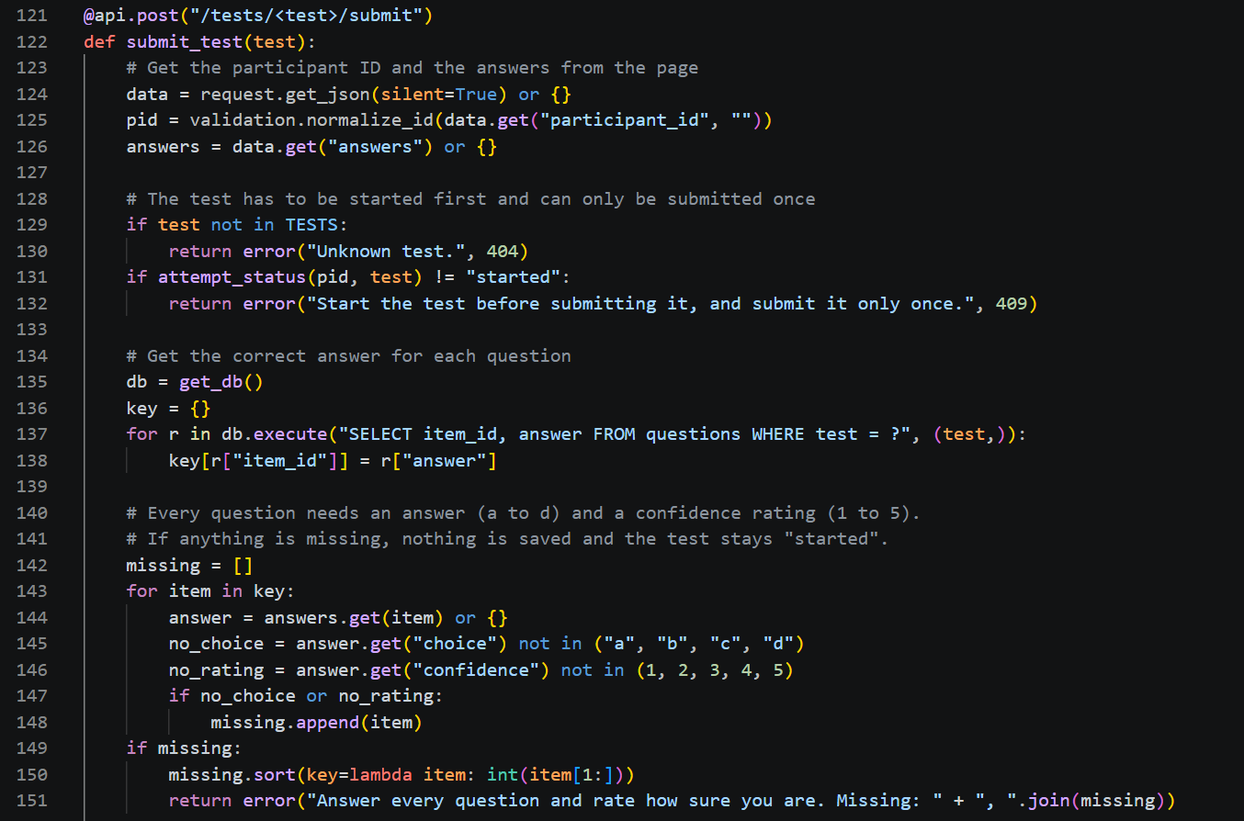

Figure 4 Missing Question Message on the Pre-Assessment

Figure 5 Score Shown After a Completed Test
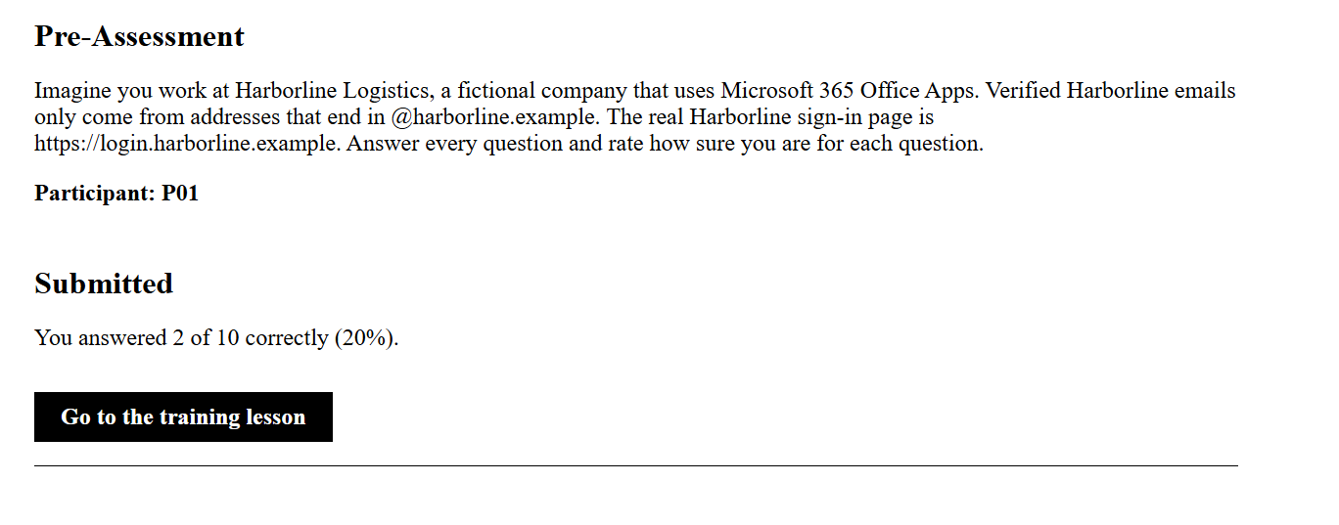
Main Logic of Each Module
M1 handles the training lesson by reading the content from a file and displaying it on a web page (see Figure 6). This allows me to update the training material without having to change the code. M2 handles the assessment process shown in Figures 3 to 5 and prevents participants from accessing the post-assessment until they complete the pre-assessment. M3 stores the information in six database tables. Participant IDs are used to connect the relevant records instead of storing names or email addresses (see Figure 7). M4 uses the scoring logic developed in Unit 5 without making changes to the original functions. A separate function converts each multiple-choice answer into the format expected by the scoring module. The scores still come from tested code (see Figure 8).

Figure 6 M1 Code Building the Training Page
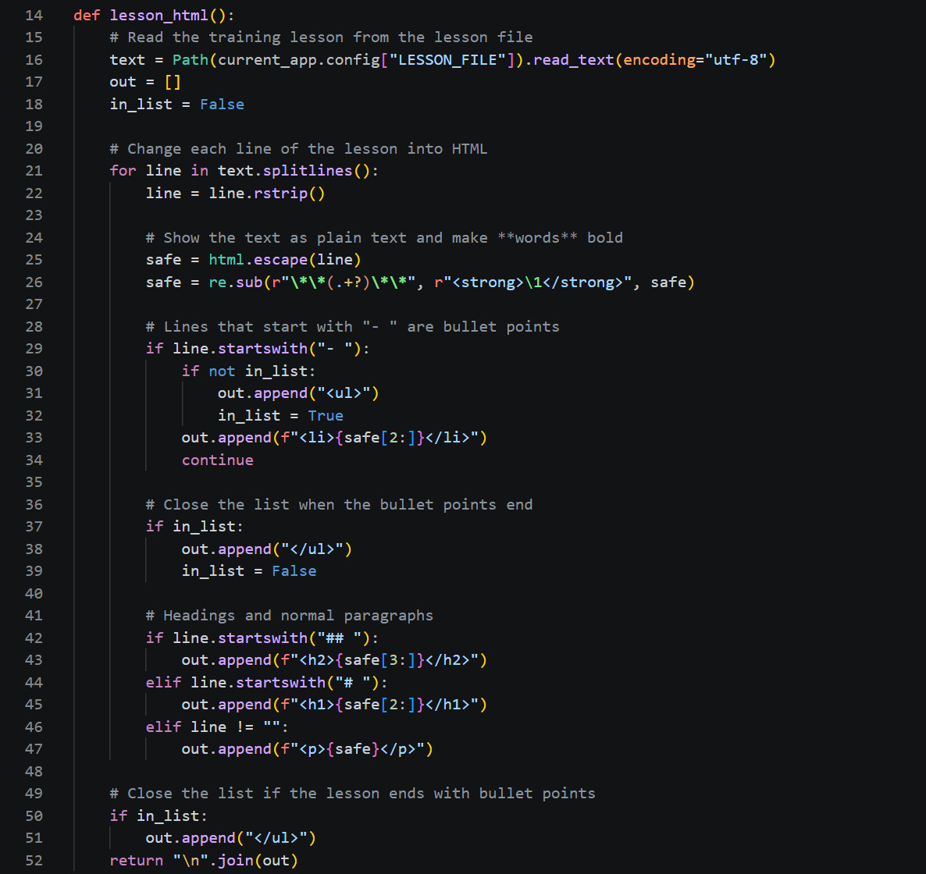
Figure 7 M3 Database Tables Keyed by Participant ID
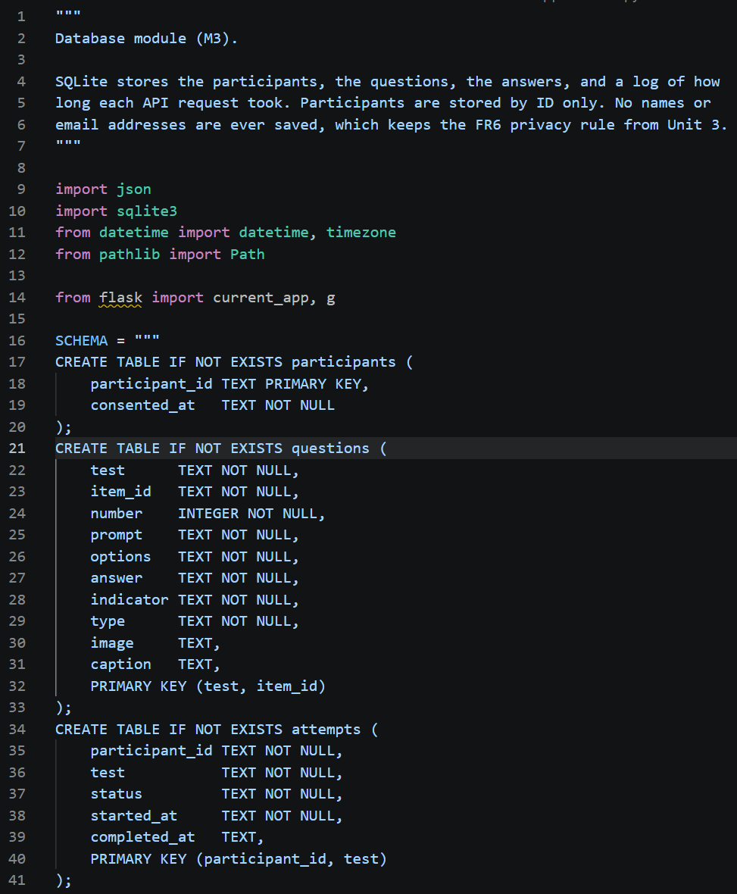
Figure 8 M4 Bridge to the Unit 5 Scoring Code
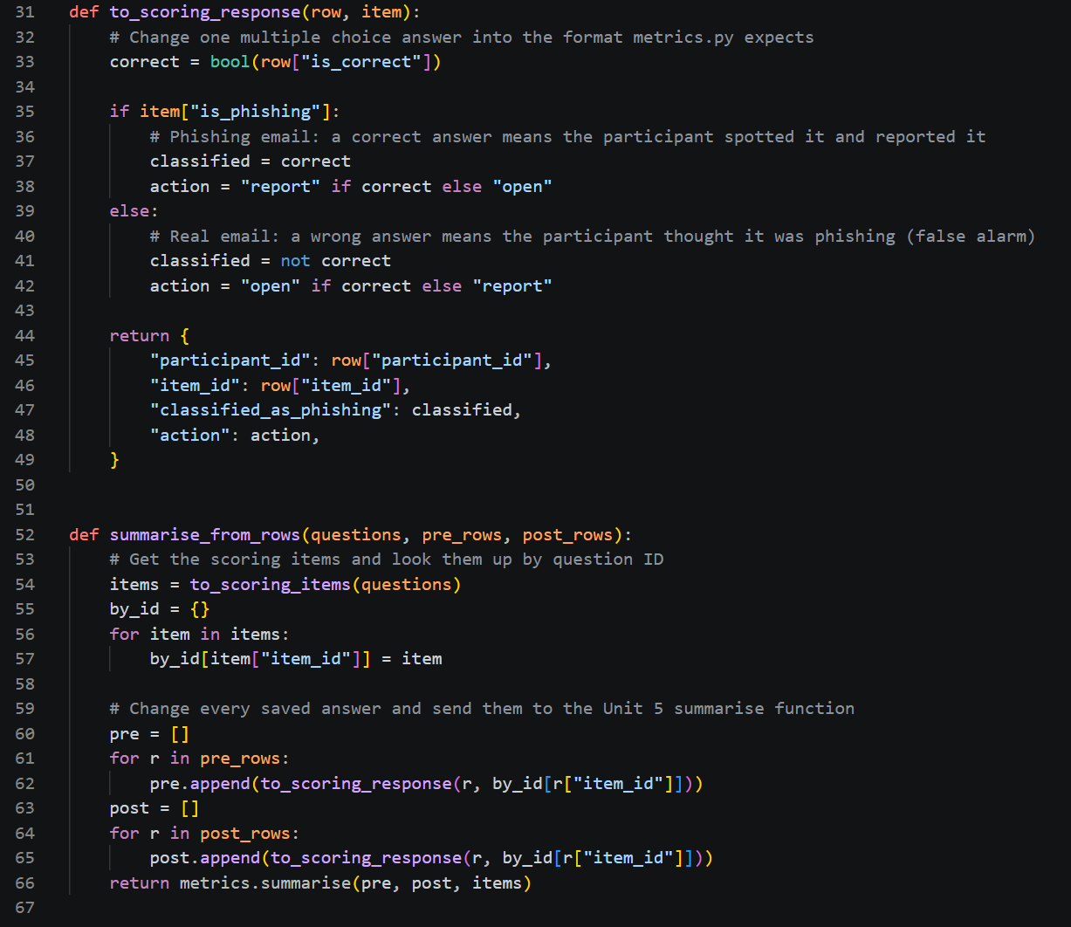
Communication Between Modules
Figure 9 shows how the user interface communicates with the backend. When a participant submits an assessment, JavaScript sends their answers to the API using a fetch request. Figure 10 shows how the results route retrieves completed assessments from the database and sends the information to the scoring module. The results are then returned in JSON format and displayed on the researcher dashboard (see Figure 11). For example, participants P17 and P18 are excluded from the final comparison because they did not complete both the pre-assessment and post-assessment.
Figure 9 JavaScript Sending Answers to the API
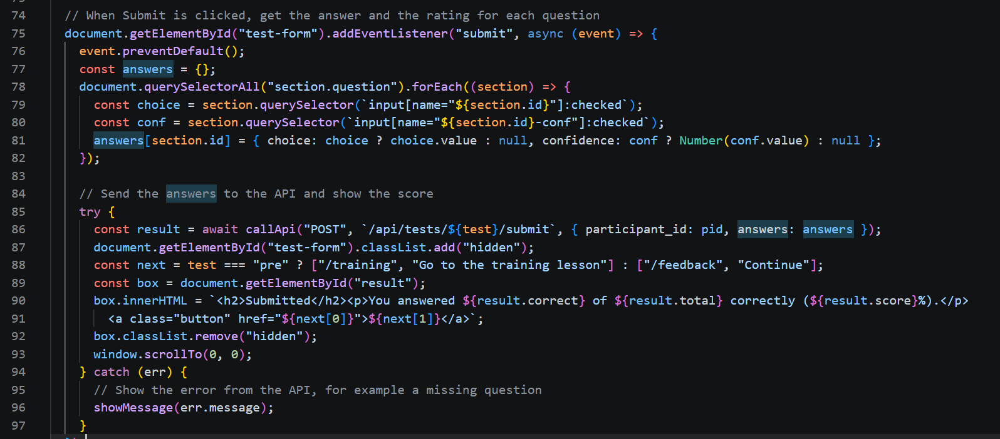

Figure 10 Results Route Linking the API, Database, and Scoring
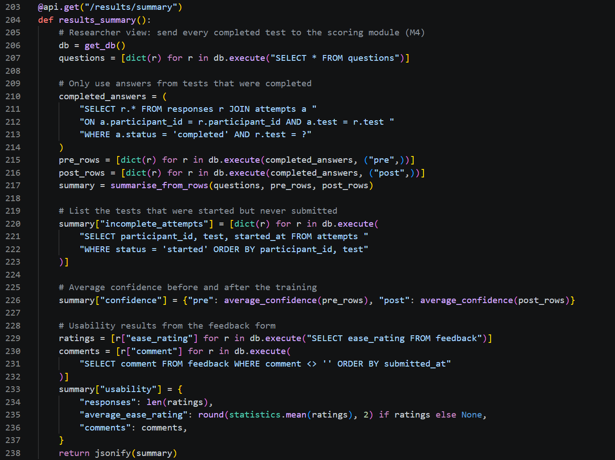
Figure 11 Researcher Dashboard With Synthetic Data
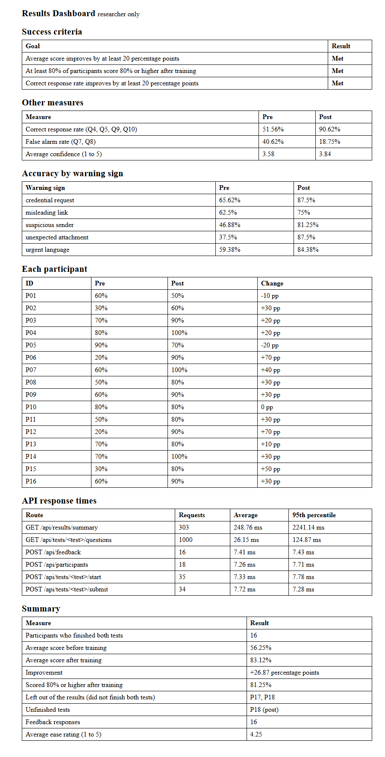
Part B: System Evaluation & Metrics Reporting
I evaluated the system with three quantitative metrics and one qualitative metric. Quantitative metrics use numbers from tests, while qualitative metrics look at the subjective side, such as how easy the system is to use (Brereton, 2023).
Quantitative Metrics
The first metric is scoring accuracy. The automated tests compare the program's output to results I counted by hand. The suite grew from 46 tests in Unit 5 to 69, and all of them passed with 98% line coverage (see Figure 12).
Figure 12 All 69 Tests Passing With Coverage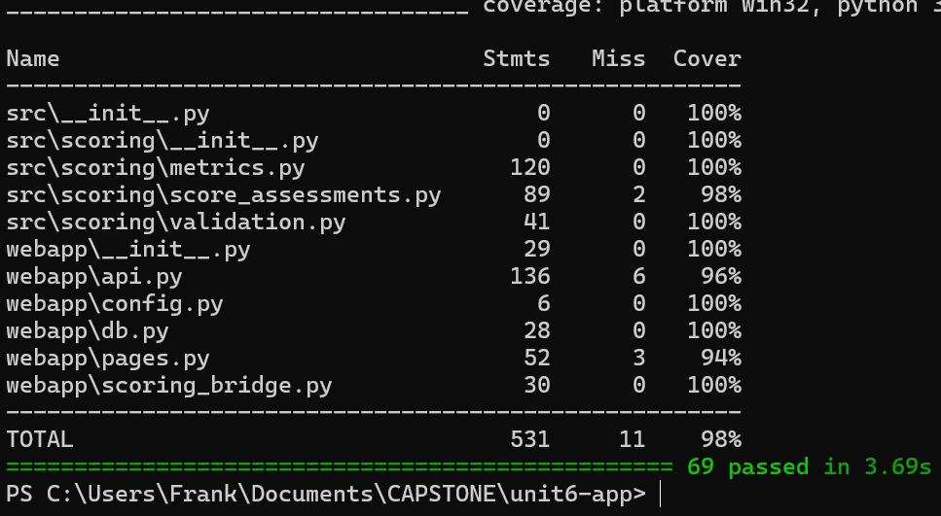
The second metric is latency. Latency is how long the server takes to answer a request. The app times every API call and saves it to the database, and the dashboard shows the average and 95th percentile for each route (see Figure 11). The third metric is throughput. A load test sent requests 10 at a time and counted how many were answered each second (see Figure 13).
Figure 13 Load Test Throughput Output
Qualitative Metric
For usability, I reviewed the interface against error prevention, plain language, and minimalist design. For example, the post-assessment stays locked until the pre-assessment is done. Error messages should also use plain language and help the user recover (Nielsen, 2024). The messages in Figures 2 and 4 display the problem. The review found two weak spots. The test page has no progress counter, and a missing question is not highlighted. The feedback form in Figure 14 will collect ease ratings during the pilot. My test run used synthetic ratings, so I did not report them as findings.
Figure 14 Feedback Form for the Ease Rating


Results
Table 1 Evaluation Results
Metric | Type | Result
Scoring accuracy | Quantitative | 69 of 69 tests passed, 98% coverage
Latency | Quantitative | Saving answers 7.72 ms average (7.28 ms 95th percentile). Results summary 250.38 ms (2,241.14 ms)
Throughput | Quantitative | 65 requests per second for questions, 33 for results, no failures
Usability | Qualitative | 3 heuristics reviewed, 2 weak spots found

Figure 15 API Response Time by Route
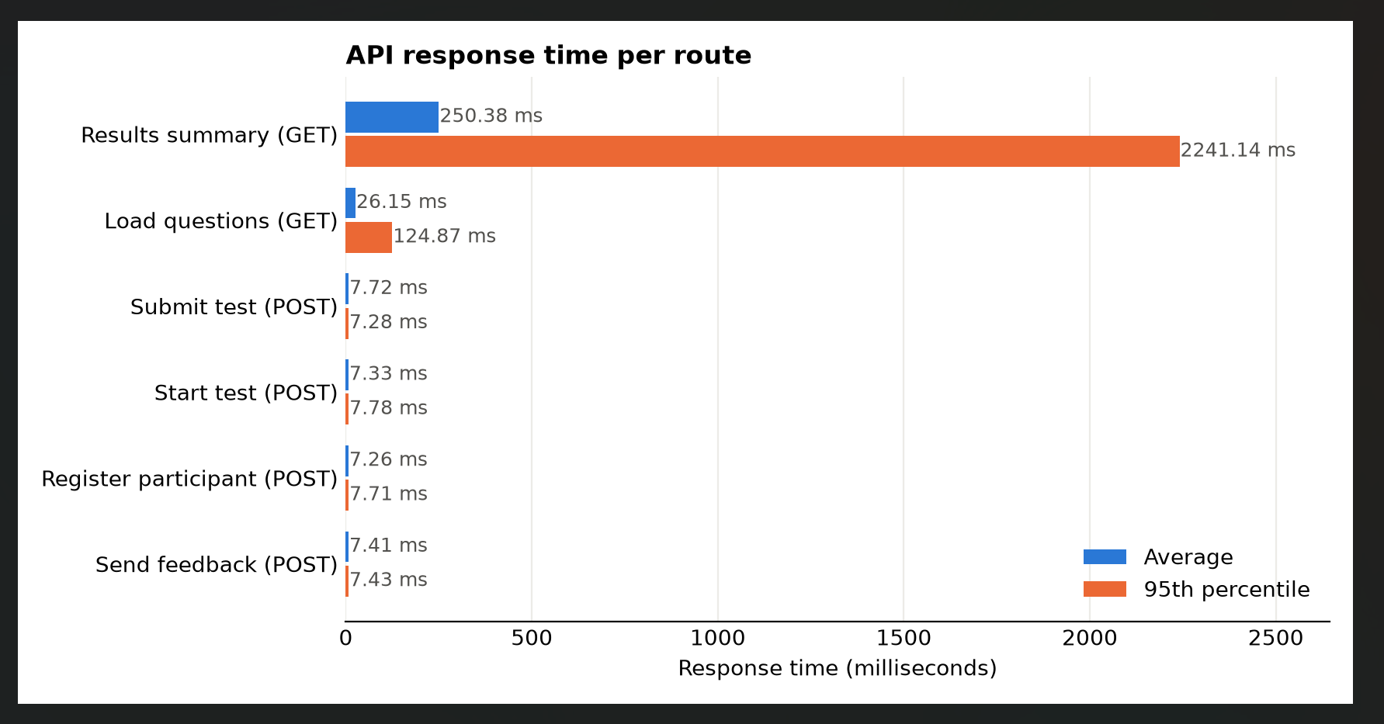
Table 1 and Figure 15 show that every action that saves participant data was answered in about 8 milliseconds or less. Loading the questions averaged 26 milliseconds. The results route was the slowest because it runs the full scoring module every time, and most of its requests were made during the load test with 10 requests at a time. Its average was 250 milliseconds, and 95% of its requests finished within about 2.2 seconds. This is fine for this project because only the researcher opens the dashboard. The load test also showed 65 question requests per second with no failures. If the group grows, saving the summary instead of recalculating it each time would be the first update.
Part C: Deployment & Configuration Planning Overview
Deployment includes all of the steps needed to make software available to its users (Sumo Logic, n.d.). I considered three methods. An on-premise server gives full control, but I would have to maintain it myself. Remote participants may also not be able to reach it. A cloud platform such as PythonAnywhere offers a free account that can host one Flask website with an SQLite database (giles, 2025). Docker packages the app with everything it needs so it runs the same anywhere, but it still needs a server.
I selected PythonAnywhere because it is free. Participants only need a link. The free site has to be renewed once a month (PythonAnywhere, n.d.). SQLite there is slow and does not scale well for larger sites (giles, 2025). These limits are appropriate for a small pilot. Common deployment strategies include big bang, rolling, and blue-green releases (ByteByteGo, n.d.). I will use big bang and only update the site between pilot sessions. If an update causes a problem, I can roll back to the last Git tag.
Configuration Management
Configuration management keeps settings separate from the code. Storing settings in environment variables lets them change between deployments without changing the code. They are also unlikely to be committed by accident. My config.py file reads every setting this way and falls back to a safe default (see Figure 16). This lets the same code run on my laptop, in GitHub Actions, and on PythonAnywhere. Git tags mark known good versions, and the workflow will run all 69 tests before anything reaches main. This catches a broken change before it is deployed.
Figure 16 Settings Read From Environment Variables
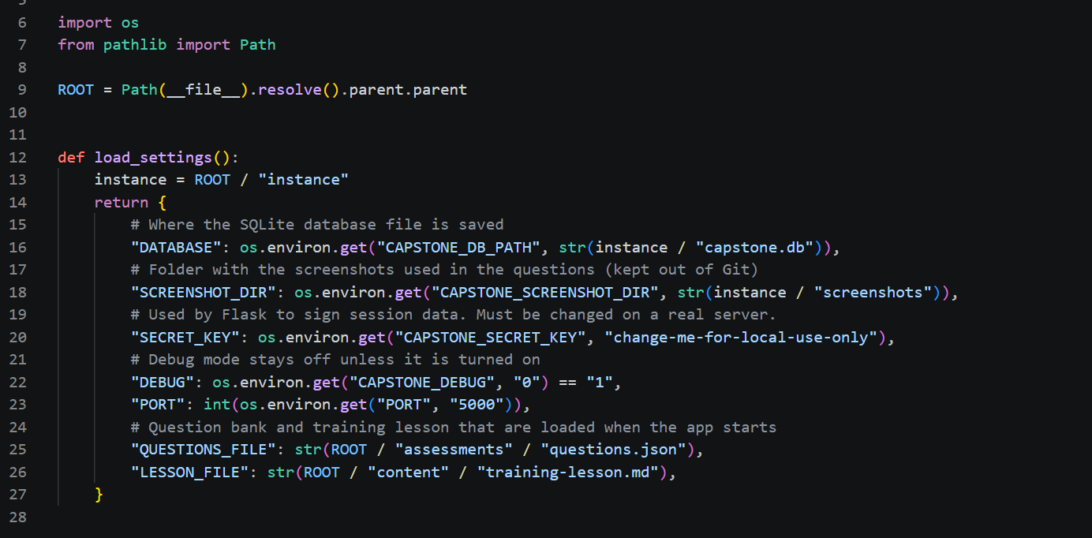
Configuration and Setup Requirements
Tables 2 to 4 list the prerequisites, environment variables, and commands. The database is created automatically when the app first starts. Before the pilot, I will delete the synthetic test data so only real responses are collected.
Table 2 System Prerequisites
Item | Requirement
Operating system | Windows, macOS, or Linux
Python | Version 3.11
Libraries | Flask, pytest, and pytest-cov (requirements.txt)
Database | SQLite, included with Python
Tools | Git and a web browser

Table 3 Environment Variables
Variable | Default | Purpose
CAPSTONE_DB_PATH | instance/capstone.db | Database file
CAPSTONE_SCREENSHOT_DIR | instance/screenshots | Question images
CAPSTONE_SECRET_KEY | Local placeholder | Session signing, changed on the server
CAPSTONE_DEBUG | 0 | Debug mode, off on the server
PORT | 5000 | Local port

Table 4 Install, Build, and Deployment Commands
Step | Command
Get the code | git clone https://github.com/flinny97/MSIT-CAPSTONE.git
Set up | py -m venv .venv and .venv\Scripts\activate
Install | py -m pip install -r requirements.txt
Build check | py -m pytest tests/ --cov=src --cov=webapp
Run locally | py app.py (http://127.0.0.1:5000)
Tag release | git tag -a v0.4-unit6-integration -m "Unit 6" then git push origin --tags
Deploy | git pull on PythonAnywhere, set variables in the WSGI file, then Reload

References
Brereton, J. (2023, November 27). Qualitative vs quantitative metrics: A comprehensive comparison. LaunchNotes. https://www.launchnotes.com/blog/qualitative-vs-quantitative-metrics-a-comprehensive-comparison
ByteByteGo. (n.d.). Top 5 most-used deployment strategies. https://bytebytego.com/guides/top-5-most-used-deployment-strategies/
giles. (2025, December 15). A beginner's guide to building a simple database-backed Flask website on PythonAnywhere. PythonAnywhere Blog. https://blog.pythonanywhere.com/121
Nielsen, J. (2024, January 30). 10 usability heuristics for user interface design. Nielsen Norman Group. https://www.nngroup.com/articles/ten-usability-heuristics/
PythonAnywhere. (n.d.). Free accounts features. PythonAnywhere Help. https://help.pythonanywhere.com/pages/FreeAccountsFeatures/
Sumo Logic. (n.d.). What is software deployment? https://www.sumologic.com/glossary/software-development

