Brain Barns

Description:
- Create a series of “campuses” where software and technology companies choose to locate.
- Provide tenant companies with benefits such as:
  - Shared resources, e.g. conference room, high speed internet, tech support, administrative services, business advice and marketing services, etc.
  - Proximity to other tech companies.
  - Built in networking (of the people variety)
  - Reduced facilities and infrastructure cost.
- Support growing businesses and their recruiting goals via high profile work venues.
- Provide owners of selected office buildings with focused marketing opportunities.
- Make Vermont technology companies more visible both within the state and outside the state.

Outcomes:
- Create the first Brain Barn facility, proving the sustainability of the model over the first 2 years.
- Attract 5 or more companies to locate in the first Brain Barn over the same period.
- Identify locations of future facilities throughout the state based on demand and available resources

Potential Partners:
- Vermont Department of Economic Development
- Office building owners and/or developers.
- Business support service providers and consultants.
- Startup and established software and technology companies.

Ballpark Cost:
- $475,000 for establishing first Brain Barn location
  - $150,000 Full time coordinator position ($75,000/year for 2 years)
  - $150,000 for promotion and supporting development.
  - $175,000 for rent and asset purchase

1.0 Executive Summary

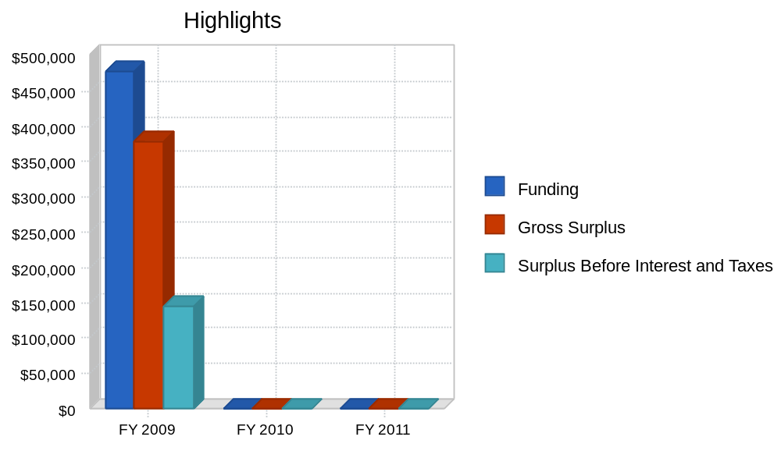

1.1 Organization Summary
The Vermont Brain Barns Inc. is a non-profit organization dedicated to the creation of intellectual environments that foster STEM initiatives. The participants of the Brain Barns are companies, students, and individuals in the technology sector that are growing rapidly and seeking to expand their community connections. Through a shared space environment these companies can create opportunities for internship, marketing, and sales organizations to be developed. These partnering efforts will allow for a broader scope of Tech offerings created in each Brain Barn.

2.0 Services
The Vermont Brain Barns Inc. will offer the following consulting services:
- Office Space Procurement: Assist in placement of participating companies within a regional Brain Barn and match for projected growth needs.
- Technology Sales Suppport: Provide sales support staff on the areas of sales, marketing, and lead generation for new business opportunity.
- Needs Analysis: Determine what technology gaps exist in decision making process, recommend changes.
- Coaching: Guide the owner through various scenarios, help them purchase tools and technology, build on technological synergies with client's customers, push owner to test the limits of their technological capabilities and potential.
- Procurement Sourcing: Establish long-term channels and determine technology suppliers. Manage sourcing and recommend upgrades on a quarterly basis.

3.0 Market Analysis Summary
The target market lives and owns a business located in Vermont, and may have been in business for one or more years. The clients are chosen according to their need for growth with specific focus on the Technical needs within the required space, and their inability to reach higher levels of productivity through technological innovation of both processes and methods. These potential customers may operate companies that produce software applications, or Technology related services and products. The product is not what matters as we isolate this market, it is the processes that we are interested in fixing.
Each of our clients will reside within a SBA qualified empowerment zone. This will hold us to the parameters stipulated by the grant authorization office, and ensure that we are serving those most in need of business training and advice. It will also give us the opportunity to build ties in communities in which commerce growth could be substantial.

4.0 Strategy and Implementation Summary
The Vermont Brain Barns strategic focus is centered around helping small rural businesses find specialized funding and helping them use that funding to enhance their business through technology. If the company will not benefit from VBB services, as per the evaluation, VBB will not offer its services to those clients.

4.1 Competitive Edge
The Vermont Brain Barns' competitive edge is in its ability to leverage our relationships in the Technology community throughout the State of Vermont. Our partnership with The Vermont Software Developers' Alliance has shown us that Technology companies are enthusiastic about the creation of "Brain Communities" within these Brain Barns.

4.2 Marketing Strategy
The Vermont Brain Barns plans to market its services through strategic partnerships with multiple non-profit organizations that have a focus on the Technology sector of Vermont. A website for the VBB will be created to market to company participants, new hires searching for positions, students searching for internship opportunities, and start-up entrepreneurs seeking a broader technology community scope. E-mail campaigns and outreach will be ongoing to promote Barin Barn participation.

4.3 Fundraising Strategy
Fundraising and revenue will be generated through a combination of Federal grants and local WETF grants. In addition, clients will be expected to pay for a % of the costs involved, depending on their financial status. The largest expected revenue generator is through the Federal Partnership Program sponsored by the USDA. Under this program, The Vermont Brain Barns may qualify for a Vermont State grant of up to $50,000, and a matching Federal Grant of up to $125,000. In addition, smaller business development grants at the State and Federal level will help continue funding for the organization.
Federal and State grants alone, or even combined with small business client revenue is still not enough to allow the company to achieve its mission. A low cost monthly retainer fee will be required of all rural participants. Depending upon the client, this fee might range from between $50-100 monthly with additional revenue being a % of sales generated by the VBB affiliate program. In exchange for this low monthly fee, the client will have 100% access to Brain Barn services, and they will often find that the cost savings, and revenue developed through a relationship with The VBB will more than pay for the low monthly retainer. The retainer may go up or down depending on the level of funding achieved each year by VBB.

4.4 Milestones

Table: Milestones

Milestones
Milestone | Start Date | End Date | Budget | Manager | Department
Creation of Vermont Brain Barns Inc. | 5/7/2008 | 8/5/2008 | $0 | VBB Committee | Admin
First Brain Barn Location secured | 5/7/2008 | 8/5/2008 | $0 | Patrick Martell | Admin
First VBB Company moves in | 5/7/2008 | 8/5/2008 | $0 | Property Mgr. | Admin
Totals |  |  | $0

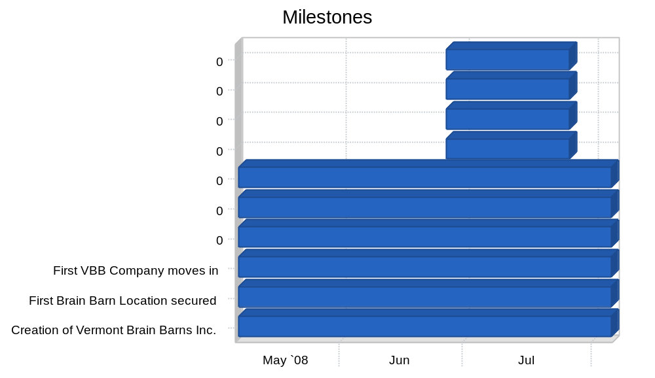

5.0 Management Summary
The Vermont Brain Barns management team will consist of Patrick Martell of the Vermont Software Developers' Alliance in it's start-up phase, with 3 new employees to be identified and hired in the Fall of 2008. The VBB Board of Directors will be identified during the summer of 2008.

6.0 Financial Plan
See the VBB Financial plan attached for review.

Table: Financials

Financials
 | FY 2009 | FY 2010 | FY 2011
Beginning Balance
Opening Balance Cash & Checking | $0 | $46,087 | $46,087
Plus Money Received
New Investment | $0 | $0 | $0
New Loans | $25,000 | $0 | $0
Funding | $478,000 | $0 | $0
Other | $29,100 | $0 | $0
Subtotal Money Received | $532,100 | $0 | $0
Less Money Spent
Direct Costs
Direct Cost | $99,000 | $0 | $0
Other Costs of Funding | $0 | $0 | $0
Normal Operating Expenses
Payroll and Payroll Taxes, Benefits, Etc. | $105,968 | $0 | $0
Rent and Utilities | $23,400 | $0 | $0
Funding and Marketing Expenses | $104,542 | $0 | $0
Other Operating Expenses | $0 | $0 | $0
Other Outflows
Payments of Taxes | $0 | $0 | $0
Debt Payments | $0 | $0 | $0
Purchase of Assets | $153,103 | $0 | $0
Other | $0 | $0 | $0
Subtotal Money Spent | $486,013 | $0 | $0
Ending Balance
Ending Balance Cash and Checking | $46,087 | $46,087 | $46,087
Surplus Before Interest and Taxes
Funding | $478,000 | $0 | $0
Less Cost of Funding | ($99,000) | $0 | $0
Gross Surplus | $379,000 | $0 | $0
Less Operating Expenses | ($233,910) | $0 | $0
Surplus Before Interest and Taxes | $145,090 | $0 | $0
Net Cash Flow | $46,087 | $0 | $0

