AEG BOX TEST-SUITE

SPECIFICATION

I. D. Flintoft, L Dawson, J. F. Dawson, A C Marvin

Department of Electronics, University of York

Document History

Edition | Date | Modifications / Comments | Author
1 |  | First Issue | I. D. Flintoft

Acronyms and Abbreviations

Acronym | Definition
AMELET | In French “Atelier de Modélisation Electromagnétique pour les Transports”
ASTM | ASTM International, originally known as the American Society for  Testing and Materials
CFC | Carbon Fibre Composite
CM | Common Mode
DM | Differential Mode
FEM | Finite Element Method
FD | Frequency Domain
FDTD | Finite Difference Time Domain
MoM | Method of Moments
MTLN | Multi-conductor Transmission Line Network
NRC | Nested reverberation chamber
PEC | Perfect Electric Conductor
POE | Point of Entry (of EM energy)
PW | Plane Wave
PWB | PoWer Balance
RAM | Radio Absorptive Material
Q | Ouality Factor
RMS | Root-Mean-Square
STP | Surface Test Point
TC | Test Case
TD | Time Domain
TL | Transmission Line
TLM | Transmission Line Matrix

Table of contents

1. Introduction 3
2. Description of the Test Object 3
3. Test Object Configurations 4
3.1. Internal Wires 4
3.1.1. No Wires (Tag: NW) 4
3.1.2. Wire Probes (Tag: PAPB) 4
3.1.3. Straight Wire (Tag: SWAB) 6
3.1.4. Curved Wire (Tag: CWAB) 6
3.2. Front Panel Plates 6
3.2.1. Open Face (Tag: OF) 6
3.2.2. Closed (Tag: CF) 6
3.2.3. Isotropic Perforated Plate (Tag: PP) 6
3.2.4. Anisotropic Perforated Plate (Tags: GHSP, GOSP) 8
3.2.5. Single Slot Aperture (Tag: GS30, GS50) 10
3.2.6. Two Generic Apertures (Tag: GP) 11
3.1. Block of Absorber 11
3.1.1. No absorber (Tag: A0) 14
3.1.2. Absorber in Centre Tag: A1) 14
3.1.3. Absorber in Corner (Tag: A2) 14
4. Source configuration 14
4.1. Unit Plane Wave Illumination (Tag: UPW) 14
4.2. Multi Plane Waves Illumination (Tag: MPW) 14
5. Observables 15
5.1. Power in Load at Port A 15
5.2. Electric Fields in Apertures 16
5.3. Power Density in Cavity 16
6. Overall Test-case Configurations 17

Introduction
This document is based on the preliminary specification of numerical test-cases document (latest version v18) which was written under the direction of UOY with contributions from ONERA and IDS-UK. This document only concerns NTC2 and has been written under the direction of UOY. The most important changes have been marked in blue colour and are summarised here:

- Material on probe calibration and probe 3 which are not directly relevant to the test case has been removed.
- Some of the sections have been reordered.
- The configuration “tags” have been made explicit in the headings and captions.
- Extra information on the use of the antenna factor for codes without wire models is included.
- The meaning and use of the observables related to statistical codes has been clarified and extended.
- The associated data measurement data files and model support files has been reorganised.
- Priority of implementation and simulation of test-cases is now provided..

Description of the Test Object
The small 3D object is based on a physical 600 mm × 500 mm × 300 mm brass box with three removable faces – see Figure 1. For this test-case two of the faces (top and side) are permanently closed and the front face is left open or covered with a plate with different characteristics. The open face has a 30 mm wide flange around the edge with holes spaced at 26 mm to 28 mm for fixing the covering plate using self-tapping screws. The box has three holes for N-type connectors on the top, labelled A, B and C in Figure 2. The probe antennas and wire structures are connected to these three ports. Note that port C is not used in this test case.

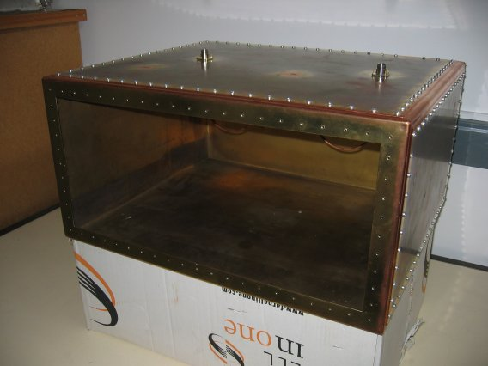
Figure 1: Photograph of the hardware that the small 3D object is based on.
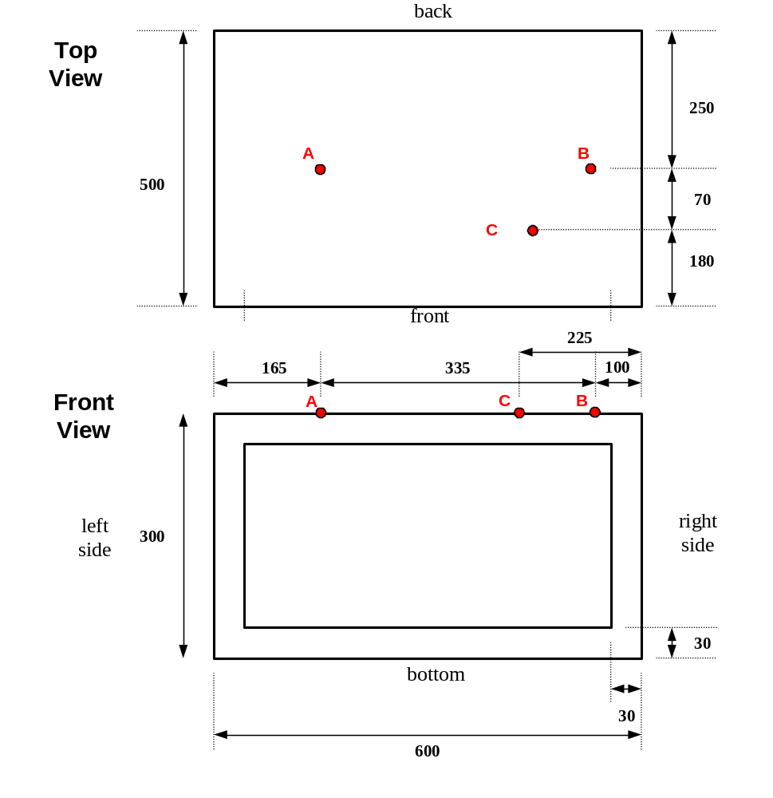
Figure 2: Small 3D object geometry showing the location of the three N-type ports, A, B and C (unused).

Test Object Configurations

Internal Wires
Four configurations of internal probes and wires are considered as detailed below.

No Wires (Tag: NW)
No wires or probes are included.

Wire Probes (Tag: PAPB)
Probes with characteristics given in Table 1 are considered. Probes 1 and 2 are nominally identical. Probes 1 and 2 are inserted at ports A and B of the box.
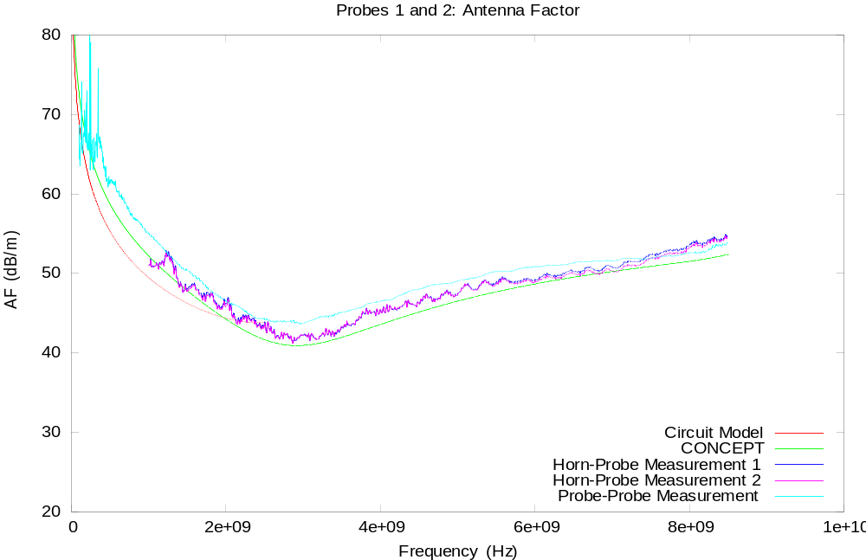
Figure 3: Antenna factor for probes 1 and 2.

Probe | #1 | #2
Length (mm) | 22 | 22
Diameter (mm) | 3 | 3
Table 1: Probe characteristics (Tag: PAPB).

To mitigate against issues with wire models the monopoles were calibrated to give the electric field strength which can be compared directly to the modelled fields without the use for a wire model for the probe. The probes were calibrated using two different methods supported by MoM simulations and a circuit model. The probe characteristics are presented as an antenna factor, which for an antenna in reception mode is defined by

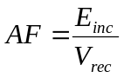

where E_{inc} is the incident electric field strength and V_{rec} is the voltage received at the antenna port. The antenna factor is related to the antenna gain by

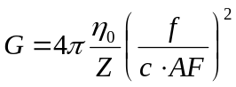

where Z antenna port impedance, f the frequency and c the speed of light in vacuum. The measured and modelled antenna factors and gain of the probes are shown in Figure 3. The data for the antenna factor is available in the file probe1-af.dat. The power received in the load is related to the electric field at the location of the probe feed point, E_{probe} (RMS value), by
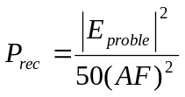.

Straight Wire (Tag: SW)
The straight-wire geometry (Figure 4) is formed by soldering a horizontal brass rod, 3.5 mm in diameter, between probes 1 and 2 in ports A and B.
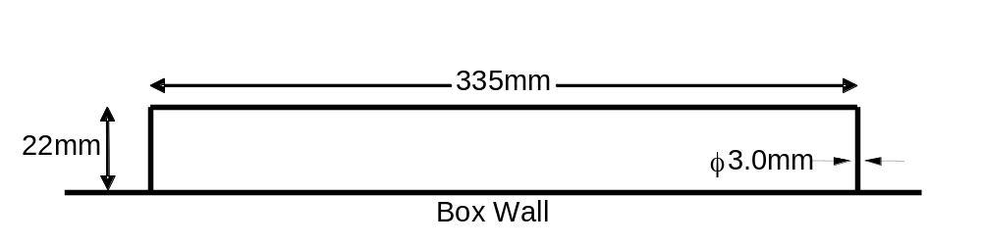
Figure 4: Straight wire geometry (Tag: SWAB).

Curved Wire (Tag: CW)
The curved wire (Figure 5) is composed of three semi-circles with two straight extension sections. Ends are soldered into N-Type bulkhead connectors in box ports A and B.

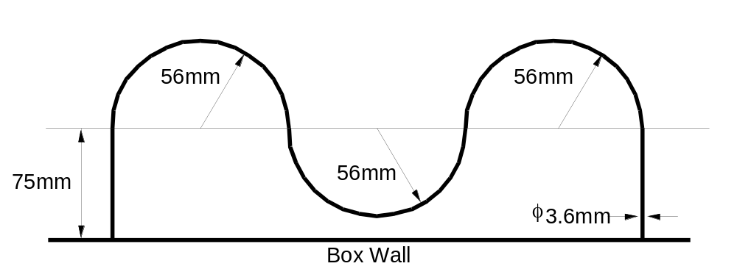
Figure 5: Curved wire geometry (Tag: CWAB).

Front Panel Plates
Eight configurations of the front face of the box are considered as detailed below.

Open Face (Tag: OF)
The front panel is left open.

Closed (Tag: CF)
The front panel is completed closed by a PEC sheet.

Isotropic Perforated Plate (Tag: PP)
A brass plate with a periodic array of circular holes is used for the two-sided impedance boundary measurements. The plate is 0.3 mm thick with 3 mm diameter holes on a regular square grid with spacing 10 mm. The perforation occupies a square of side length 200 mm centred on the front face of the box wall – see Figure 6.

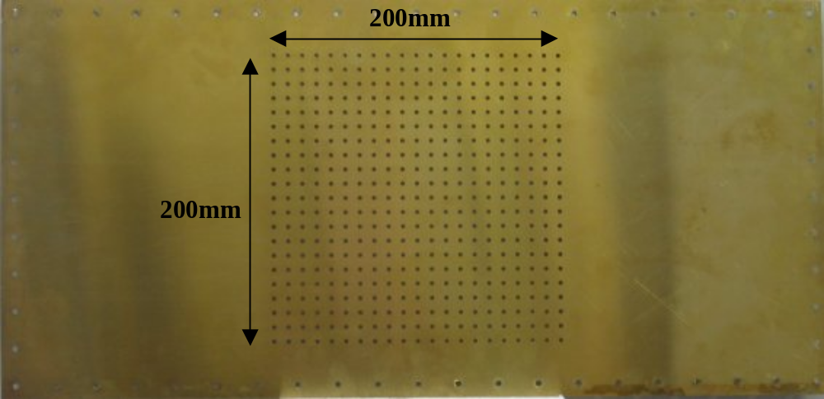
Figure 6: Perforated plate for front wall of box (Tag: PP).

The scattering parameters of the unit cell of the plate, referenced to the plate surface, have been determined by modelling a single cell in the UOY TLM code with periodic boundary conditions. The shielding effectiveness determined from the model is shown in Figure 16, compared to measurements in the ASTM cell and NRC. The model prediction is about 2.5 dB higher than the measurements (presumably due to variations in the shape and diameter of the holes in the physical plate). A correction factor has been inserted in the model to account for this and the S11 modified appropriately to ensure passivity is maintained. The resulting measurement matched data is shown in Figure 7.

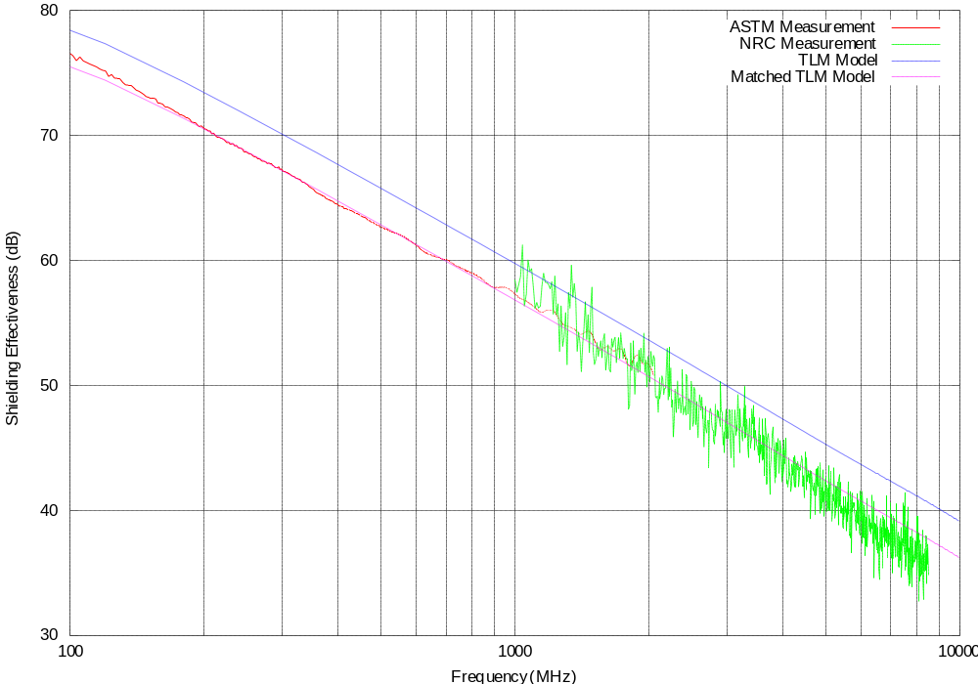
Figure 7: Measured and modelled shielding effectiveness of perforated plate.

Anisotropic Perforated Plate (Tags: GHSP, GOSP)
A brass plate with a periodic array of rectangular slots, both horizontally and at an oblique angle to the horizontal are to be used for two-sided impedance boundary measurements. In both cases, the plate is 0.3 mm thick with each slot 20 mm long and 1 mm wide.

- In the horizontal case, there are 6 slots horizontally by 20 slots vertically on a rectangular grid measuring (from the centre of the slot) 10 mm vertically and 30 mm horizontally – see Figure 8. The slot array is centered on the front face of the box.
- For the oblique angle case, there are 8 slots horizontally by 12 slots vertically, with each slot angled at 30 degrees to the horizontal on a regular rectangular grid with spacing 15 mm vertically and 25 mm horizontally – see Figure 9. The slot array is centered on the front face of the box.

In each case, the scattering parameters of the unit cell of the plates have been determined by modelling a single cell in TLM with periodic boundary conditions. These results are shown in Figure 10 and Figure 11 for the horizontal and oblique cases respectively and depict the transmission losses based on an infinite sheet. For the horizontal case, the results are for illumination both parallel and perpendicular to the slots. For the oblique case, the results are for a vertically polarized illuminating electric field, with both co- and cross-polar responses depicted, illustrating the effect of the introduction of a cross-polar component by the slots.

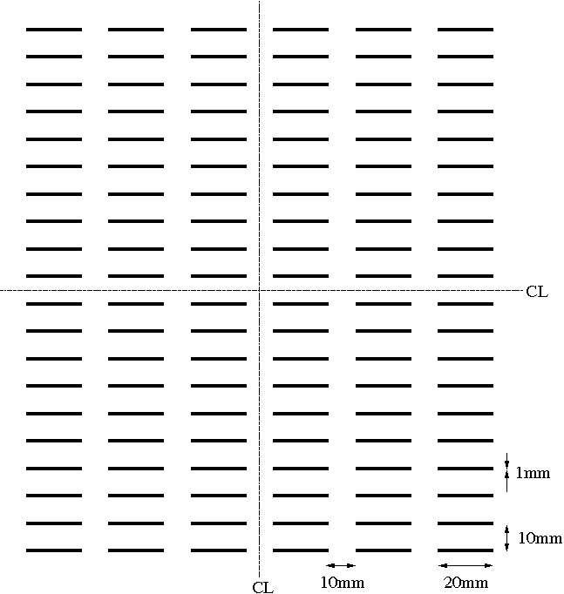
Figure 8: Perforated plate with horizontal slots for front wall of box (Tag: GHSP).

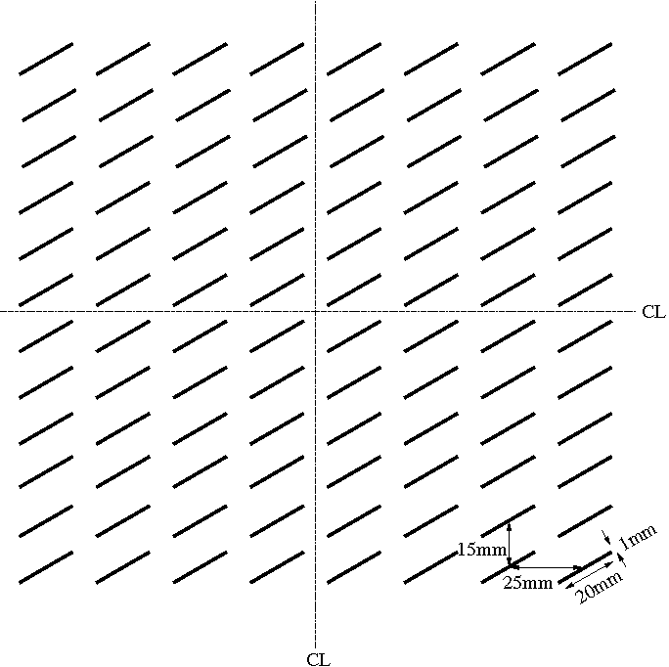
Figure 9: Perforated plate with oblique slots for front wall of box (Tag: GOSP).
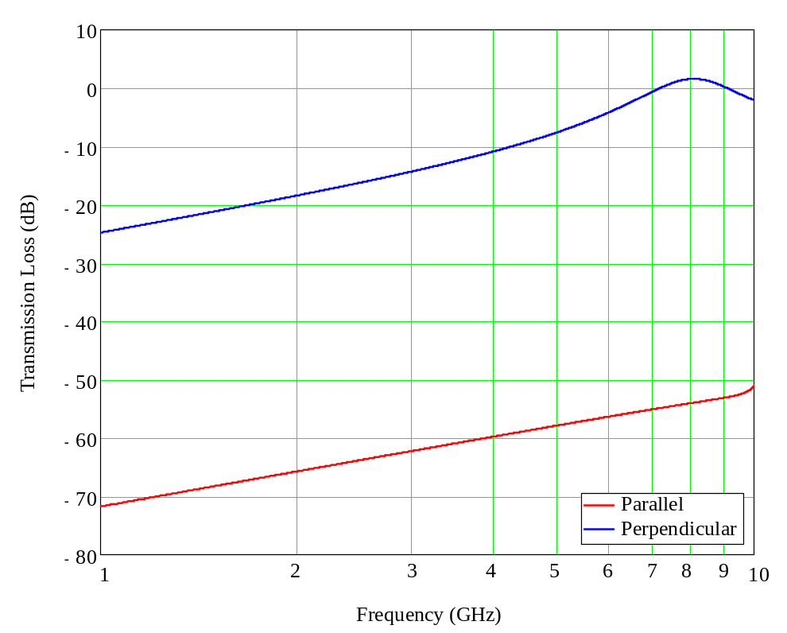
Figure 10: Modelled transmission loss of perforated plate with horizontal slots.

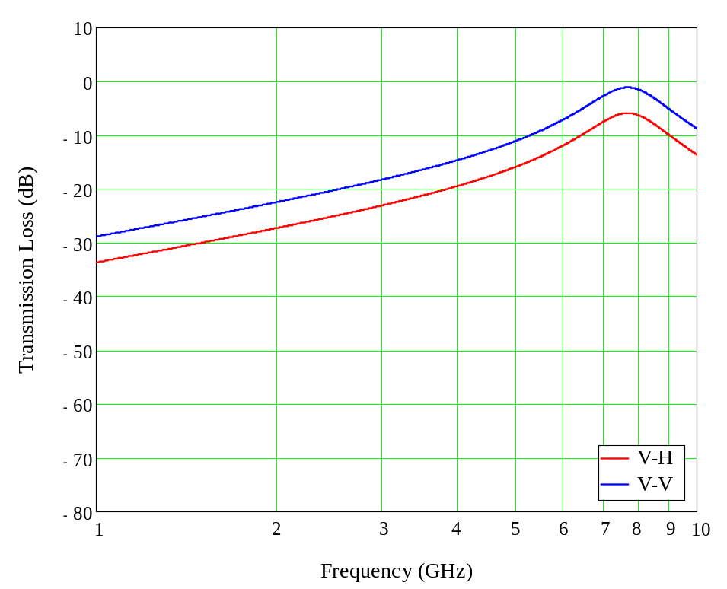
Figure 11: Modelled shielding effectiveness of perforated plate with oblique slots.

Single Slot Aperture (Tag: GS30, GS50)
Following the examples with periodic apertures, it is also of interest to model other aperture configurations on the front plate. It is therefore proposed to assess field to cavity coupling through various generic apertures on the metallic front plate. In the first instance, a rectangular aperture (200 mm x 40 mm) will be modelled in two configurations, as depicted in Figure 12and Figure 13, rotated anti-clockwise by 30° and rotated clockwise by 50° respectively.

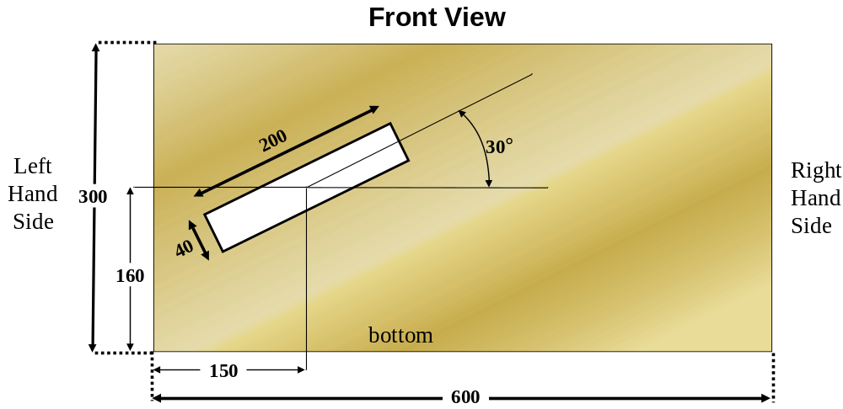
Figure 12 Front plate with a single rectangular aperture rotated by 30° anticlockwise, all values are in mm. (Tag:GS30).
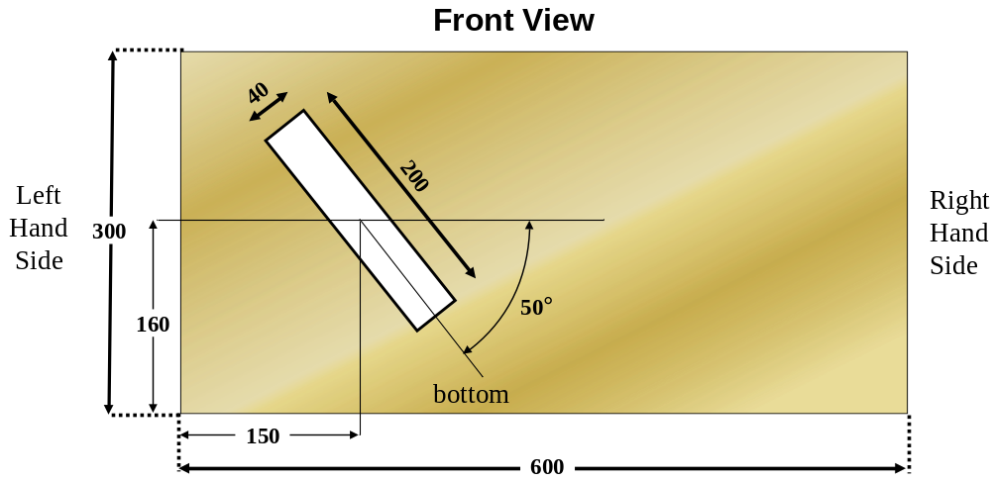
Figure 13: Front plate with a single slot rectangular aperture rotated by 50° clockwise, all values are in mm (Tag: GS50).
Because these scenarios have not been measured in an experimental setup, they will be used for code cross validation purposes.

Two Generic Apertures (Tag: GP)
In some specific configurations of 3D solvers validation (asymptotic methods), it will be interesting to analyze field to cavity EM coupling through generic apertures on the metallic front plate a square aperture (180mmx180mm) and a circular aperture (diameter=100cm), as shown in Figure 14.
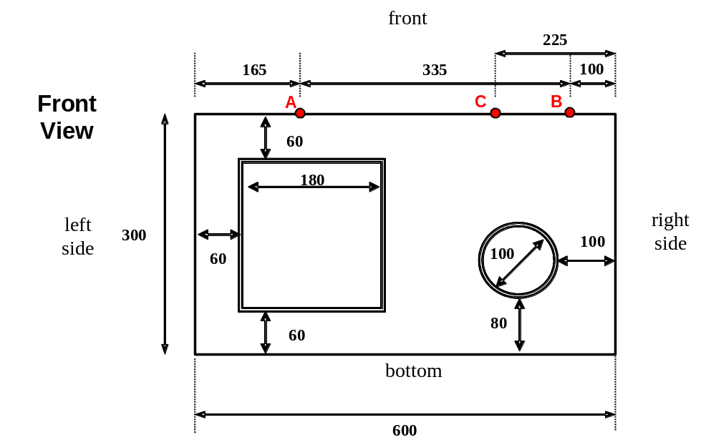
Figure 14: Front plate with 2 generic apertures (Tag: GA).
Since this configuration of front plate has not been studied from the experimental point of view, only numerical cross validation between different 3D solvers will be considered.

Block of Absorber

A cubic piece of Eccosorb LS22 absorber with a side length of 110 mm has been constructed from a number of layers of LS22. The material is characterized by the manufacturer from 500 MHz to 18 GHz via the real and imaginary parts of the complex relative permittivity:

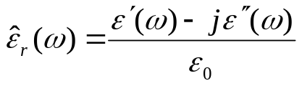

Figure 15 shows Re(ε_{r}) and Im(ε_{r}) from the manufacturer’s data sheet.

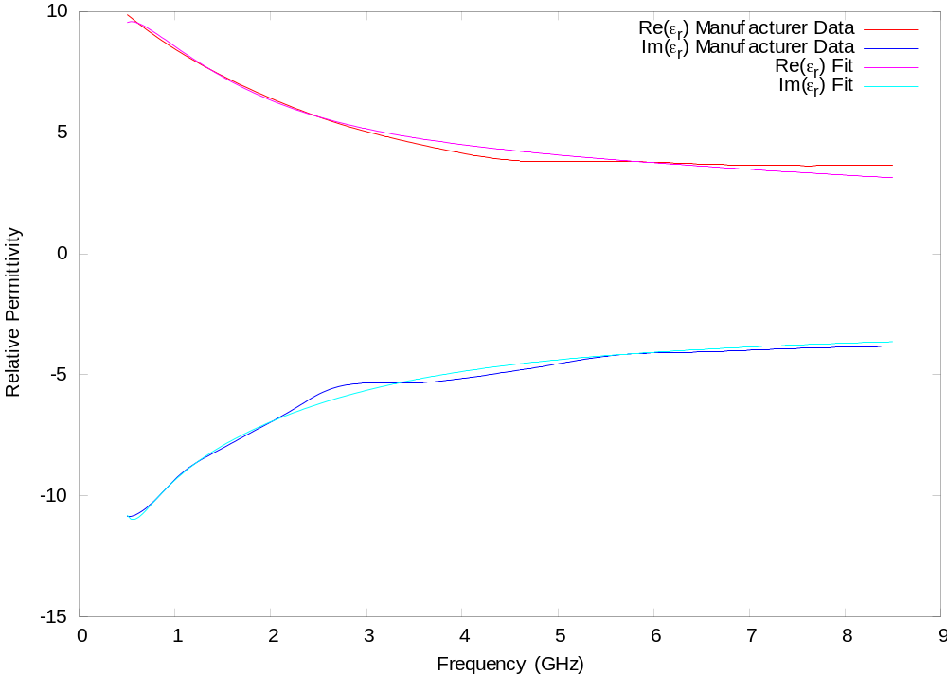
Figure 15: Properties of Eccosorb LS22 (manufacturer’s data).

As part of another project UOY have modelled a measurement system which uses the LS22 RAM and have obtain good agreement with the measurements in the 1-8 GHz region.

The material parameters can be fitted to a low order pole-residue or rational function model using vector fitting algorithms. Both UoN and UoY have provided models as described below.

The UoN material model uses the following representation for frequency dependent materials

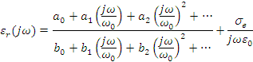
where the a, b and σ_{e} coefficients are chosen so as to best fit measured data whilst ensuring the stability of the material model. ω₀ is a normalisation constant. The expansion may be up to any order. For a material model of the above form to be stable we ensure that the poles of the rational function lie in the left hand side of the s (=jω) plane. We also require there to be no gain in the material at any frequency i.e. Im{}<0 for all ω. An additional constraint that we impose is the requirement that Re{}≥ 1 as ω->∞. Table 2 below gives the parameters for 3rd and 4th order models of the LS22 material derived from the manufacturer’s data.

UOY have also fitted the LS22 to a 3 pole filter which can be represented as a pole-residue, rational function or Debye model as shown in Table 3 to Table 5.

 | 3rd Order Model | 4th Order Model
Frequency Range (MHz) | 500 - 18000 | 500 - 18000
ω₀ | 113097335526.000 | 113097335526.000
a₀ | 0.11946225E+02 | 0.98009577E+01
a₁ | 0.90833825E+02 | 0.80659205E+02
a₂ | 0.92859995E+02 | 0.39888149E+03
a₃ | 0.16674090E+02 | 0.56452642E+03
a₄ | N/A | 0.11953590E+03
b₀ | 0.10000000E+01 | 0.10000000E+01
b₁ | 0.16414886E+02 | 0.12611766E+02
b₂ | 0.33227125E+02 | 0.77676567E+02
b₃ | 0.16598604E+02 | 0.17055889E+03
b₄ | N/A | 0.11890968E+03
σ_{e} (S/m) | 0.317084728062793 | 0.366441872369083
Table 2: UON LS22 Model.

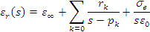
ε∞ | 1
r₁ | 3.74621e+11 + 0.00000e+00 j
r₂ | 2.01957e+10 + 0.00000e+00 j
r₃ | 5.88270e+10 + 0.00000e+00 j
p₁ | -9.92819e+10 + 0.00000e+00 j
p₂ | -6.42319e+09 + 0.00000e+00 j
p₃ | -2.90589e+09 + 0.00000e+00 j
σ_{e} (S/m) | 0
Table 3: UOY 3rd order pole residue model for LS22.

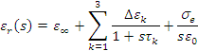
ε∞ | 1
Δε₁ | 3.77330e+00
Δε₂ | 3.14418e+00
Δε₃ | 2.02441e+01
τ₁ | 1.00723e-11
τ₂ | 1.55686e-10
τ₃ | 3.44129e-10
σ_{e} (S/m) | 0
Table 4: UOY 3rd order Debye model for LS22.
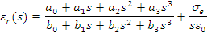
a₀ | 5.2186e+31
a₁ | 1.2722e+22
a₂ | 5.6225e+11
a₃ | 1
b₀ | 1.8531e+30
b₁ | 9.4487e+20
b₂ | 1.08611e+11
b₃ | 1.00000e+00
σ_{e} (S/m) | 0
Table 5: UOY 3rd order rational function model for LS22.

Three configurations of the absorber are considered as detailed below.

No absorber (Tag: A0)
The absorber is not used.

Absorber in Centre Tag: A1)
With regard to Figure 2, the absorber is placed centered on the floor of the box.

Absorber in Corner (Tag: A2)
With regard to Figure 2, the absorber is located on the floor of the box in the back left hand corner, touching the walls.

Source configuration

Unit Plane Wave Illumination (Tag: UPW)
The box is illuminated in the direction of the open/test face using a monochromatic, linearly polarized plane wave of frequency 30MHz to 6 GHz. The electric field is polarized vertically with regard to the bottom of the box, as shown on the CONCEPT (computer code developed by TUHH) mesh in Figure 16.

Multi Plane Waves Illumination (Tag: MPW)
The objective of this source configuration is to take into account several plane waves illuminating the box in order to validate the computation of short-circuited EM fields on apertures by asymptotic codes or other 3D Maxwell’s-equation based codes for scenarios of numerical coupling between 3D solvers (solving external problems) and energy balance techniques (solving internal high frequency phenomena);

In this configuration, the illumination will be constituted of 2 monochromatic, linearly polarized plane waves of frequency 1GHz to 6GHz:
- the previously described plane wave (normal incidence versus front plate, vertical E-field),
- a plane wave with no elevation angle and an incidence of 60 degrees (angle between the projection of k in the (0,x, y) plane and the (x) axis), horizontally polarized. k and E are in the (0,x,y) plane.

These 2 incident plane waves are drawn in Figure 17.

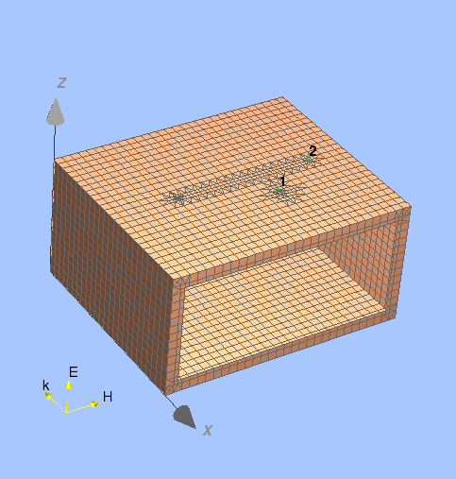
Figure 16: Unit plane wave excitation of small 3D box (Tag: UPW).
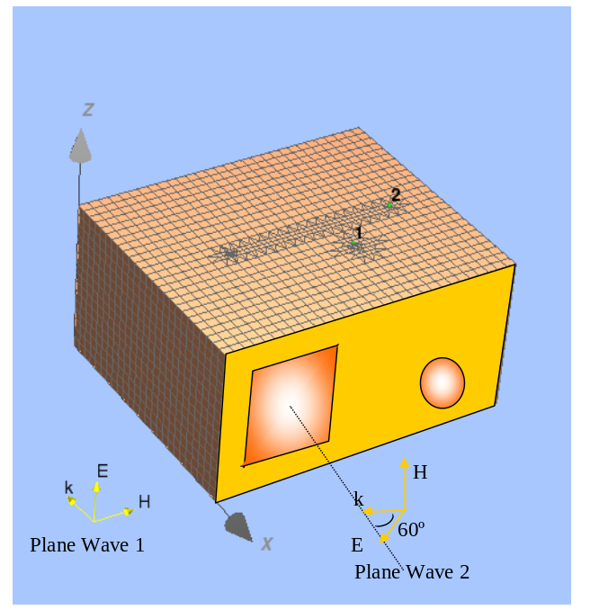
Figure 17: Multi-plane wave excitation (Tag: MPW).

Observables

Power in Load at Port A
For the configurations considered that are field-to-probe or field-to-wire couplings the observable is the power received in the load at port A. The results are all presented as a reception aperture into the 50 Ω load at this port:

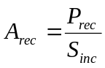
where

A_{rec} - reception aperture (m²)
P_{rec} - power received at probe antenna or end of wire (W)
S_{inc} - power density of incident field (W/m²)

The incident power density is measured at the location of the centre of the front face of the box with the box removed. For numerical simulations this should correspond to the power density of the incident plane wave. The ports that are not observed should be terminated in 50Ω loads and the observation port should also have an impedance of 50 Ω. If no wire model of the probe is available the antenna factor of the probe may be used to determine the received power from the electric field at the location of the probe as described in Section 3.1.2.

If a model of an illuminating antenna is used to provide the excitation then the receiving aperture is given by:

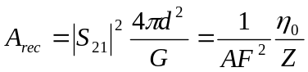
where

d – distance from the front of the box to the reference plane of illuminating antenna
G – power gain of the illuminating antenna (-)
AF – antenna factor of the illuminating antenna (/m)
Z – source impedance of the illuminating antenna (Ω)
η₀ – impedance of free space (Ω)
S₂₁ – the transmission between the illuminating antenna and the internal probe.

Electric Fields in Apertures

For tools that solve the external scattering problem and internal coupling problem separately the fields applied to the apertures by the illuminating plane wave(s) are of interest. In this case the normal electric field and tangential magnetic field at the centres of the short-circuited apertures may be observed as a function of frequency.

Power Density in Cavity
The mean power density inside the cavity may be observed in the high-frequency statistical regime. For deterministic tools this can be estimated by calculating the average squared electric field strength, <|E(f)|²>, within the open volume of the enclosure and using the power balance relationships

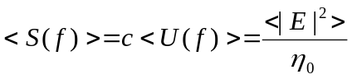
where

<S> mean power density in enclosure (W/m²)
<U> mean energy density in enclosure (J/m³)
<|E|²> mean squared electric field (V²/m²)
c velocity of light in vacuum (m/s)
η₀ intrinsic impedance of free space (Ω)

The mean-squared electric field, <|E(f)|²>, can be estimate by position stirring, frequency stirring (or a combination of both) the sampled fields inside the cavity. Details of this are beyond the scope of this specification.

Overall Test-case Configurations

The configurations considered are identified using a tag of the format XX-YYYY-ZZ where:

- XX represents the state of the panel in the box wall:
  - OF = Open Face;
  - PP = Perforated Plate;
  - CF = Closed Face;
  - GP = Plate with two Generic apertures;
  - GHSP = Plate with periodic horizontal slots;
  - GOSP = Plate with periodic oblique slots;
  - GS30 = Plate with Generic Slot rotated by 30° anticlockwise;
  - GS50 = Plate with Generuc Slot rotated by 50° clockwise;
- YYYY represents the state of the probes or wire in the box:
  - PAPB = short probe on ports A and B;
  - SW = straight wire between ports A and B;
  - CW = curved wire between ports A and B;
  - NW = no wire;
- ZZ represents the state of the absorber in the box:
  - A0 = no absorber;
  - A1 = absorber in the back left corner;
  - A2 = absorber in the centre;

The exact geometries for the probes, wire and absorber are defined in Section 3 above. The configurations that are part of this test case are given in Table 6. The source for all these configurations is the unit plane wave (UPW) defined in Section 4.1. The observable for all the configurations is the power in the load at port A, ratioed to the incident power density of the plane wave as defined in Section 5.1.

Configuration Tag | Front Panel | Probes/Wire | Absorber | Measurement Available
GHSP-PAPB-A0 | Periodic horizontal slots | Probe A and B | None | N
GHSP-PAPB-A0 | Periodic oblique slots | Probe A and B | None | N
GHSP-SW-A0 | Periodic horizontal slots | Straight Wire | None | N
GHSP-SW-A0 | Periodic oblique slots | Straight Wire | None | N
GS30-PAPB-A0 | 1 slot at 30° anticlockwise | Probe A and B | None | N
GS50-PAPB-A0 | 1 slot at 50° clockwise | Probe A and B | None | N
GS30-SW-A0 | 1 slot at 30° anticlockwise | Straight Wire | None | N
GS50-SW-A0 | 1 slot at 50° clockwise | Straight Wire | None | N
OF-PAPB-A0 | Open | Probe A and B | None | Y
OF-PAPB-A1 | Open | Probe A and B | In corner | Y
OF-PAPB-A2 | Open | Probe A and B | In centre | Y
PP-PAPB-A0 | Perforated Plate | Probe A and B | None | Y
PP-PAPB-A1 | Perforated Plate | Probe A and B | In corner | Y
PP-PAPB-A2 | Perforated Plate | Probe A and B | In centre | Y
OF-SW-A0 | Open | Straight Wire | None | N
OF-SW-A1 | Open | Straight Wire | In corner | N
OF-SW-A2 | Open | Straight Wire | In centre | Y
PP-SW-A0 | Perforated Plate | Straight Wire | None | Y
PP-SW-A1 | Perforated Plate | Straight Wire | In corner | N
PP-SW-A2 | Perforated Plate | Straight Wire | In centre | Y
OF-CW-A0 | Open | Curved Wire | None | Y
OF-CW-A1 | Open | Curved Wire | In corner | N
OF-CW-A2 | Open | Curved Wire | In centre | Y
PP-CW-A0 | Perforated Plate | Curved Wire | None | N
PP-CW-A1 | Perforated Plate | Curved Wire | In corner | N
PP-CW-A2 | Perforated Plate | Curved Wire | In centre | N
Table 6: Small 3D object test configurations.

Two further test cases are specified in Table 7. Both these test cases imply cross validation between different numerical 3D solvers since no measurements are available. For these configurations the source excitation is the multi plane wave configuration made of the superposition of two plane waves (MPW) defined in 4.2. The observable is the defined in Sections 5.2 and 5.3.

Configuration | Front Panel | Probes/Wire | Absorber | Observation Port
CF-NW-A0 | Closed | None | None | Short-circuited E & H fields at the centre of the two generic apertures
GP-NW-A0 | Generic Apertures | None | None | Mean Power density inside the box
Table 7: Test configurations for numerical cross-validations.

