AEG Box Testsuite
Anechoic Chamber Measurements

(May 2009)

Ian Flintoft

John Dawson

Andy Marvin

Stuart Porter

AEG Box Test Suite by I. D. Flintoft, L. Dawson, J. F. Dawson and A. C. Marvin is licensed under a Creative Commons Attribution 4.0 International License. Based on a work at https://bitbucket.org/uoyaeg/aegboxts.

If you use or make derivatives of the test suite please attribute the original work to I. D. Flintoft, L. Dawson, J. F. Dawson and A. C. Marvin, Applied Electromagnetics Group, Department of Electronics, University of York, UK.

Contents

1. Probe Calibration 3
2. Validation Box 7
3. LS22 RAM Model 8
4. Ferroxcube 4S10 Ferrite Tile Model 10
5. Perforated Plate Model 10
6. Curved Wire 12
7. Probe-Probe Coupling Measurements 13
7.1. Probe-Probe In Empty Box 13
7.2. Probe-Probe With Absorber In Box Corner 13
7.3. Probe-Probe With Absorber In Box Centre 13
7.4. Data Sets 13
8. Field-to-Probe Coupling Measurements 15
8.1. Field-Probe In Empty Box 15
8.2. Field-Probe With Absorber In Box Corner 16
8.3. Field-Probe With Absorber In Box Centre 16
8.4. Data Sets 16
9. Field-to-Probe with Perforated Plate Coupling Measurements 17
9.1. Field-Probe In Empty Box 17
9.2. Field-Probe With Absorber In Box Corner 17
9.3. Field-Probe With Absorber In Box Centre 17
9.4. Data Sets 17
10. Probe-to-Straight-Wire Coupling Measurements 19
10.1. Probe-to-Straight-Wire In Empty Box 19
10.2. Probe-to-Straight-Wire with Absorber in Box Corner 19
10.3. Probe-to-Straight-Wire with Absorber in Box Centre 19
10.4. Data Sets 19
11. Field-to-Straight-Wire Coupling Measurements 21
11.1. Field-to-Straight-Wire In Empty Box 21
11.2. Field-to-Straight-Wire with Absorber in Box Centre 21
11.3. Field-to-Straight-Wire in Empty Box with Perforated Plate 21
11.4. Field-to-Straight-Wire with Absorber in Box Centre and Perforated Plate 21
11.5. Data Sets 21
12. Probe-to-Curved-Wire Coupling Measurements 23
12.1. Probe-to-Curved-Wire In Empty Box 23
12.2. Probe-to-Curved-Wire with Absorber in Box Centre 23
12.3. Data Sets 23
13. Field-to-Curved-Wire Coupling Measurements 25
13.1. Field-to-Curved-Wire In Empty Box 25
13.2. Field-to-Curved-Wire with Absorber in Box Centre 25
13.3. Data Sets 25
14. Ferrite Measurements 26
15. Panel Joint Measurements 26

Probe Calibration

The validation measurements are either field-to-probe or probe-to-probe measurements where the probe was a short monopole antenna in the wall of the enclosure. The monopoles were calibrated to give the electric field strength which can be compared directly to the modelled fields without the use for a wire model for the probe. Three probes with characteristics given in Table 1 were used in the measurements. Probes 1 and 2 are nominally identical.

Probe | #1 | #2 | #3
Length (mm) | 22 | 22 | 42
Diameter (mm) | 3 | 3 | 3
Table 1: Probe characteristics.

The probes were calibrated using two different methods supported by MoM simulations and a circuit model.

Probe-to-probe coupling characterisation on inverted box lid embedded on extended ground plane

Measurement of the coupling between two identical probes in the inverted lid of the validation enclosure in an anechoic environment using network analyser – see Figure 1. The ground plane was extended to reduce any finite ground effect. Assuming probes 1 and 2 are identical the antenna factor is determined from the known probe separation. Probe 2 was then replaced with probe 3 and the now known antenna factor of probe 1 used to determine that of probe 3. Ports A and C, which have a separation of 222 mm, where used for these measurements.

Horn-to-probe coupling characterisation on inverted box lid embedded on extended ground plane

Horn-to-probe coupling measurement above large ground plane surrounded by absorber (Figure 1, right). The antenna factor of the probes was determined from the separation and known gain of the horn antenna.

Phase calibration of connector using shorted probe

To determine the phase delay between the reference plane of the probe connector and the base of the monopole the probe was shorted to the ground plane using metal foil and S11 measures relative to the reference plane.

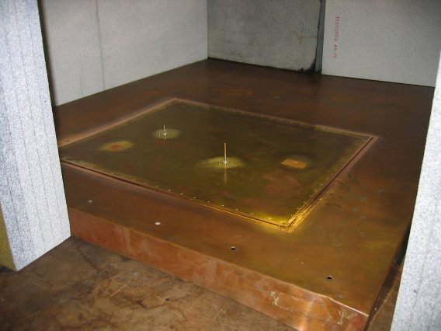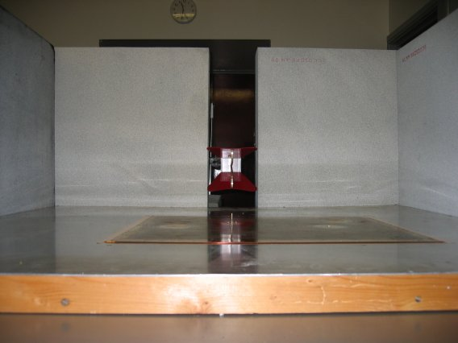
Figure 1: Probe calibration measurements – probe-to-probe (left) and horn-to-probe (right).

Simulations

CONCEPT MoM simulation of probe above an infinite ideal ground plane illuminated by a plane wave field. Antenna factor determined from received voltage in 50 ohm load a base of monopole.

Antenna Factor

The probe characteristics are presented as an antenna factor, which for an antenna in reception mode is defined by

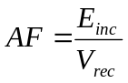

where E_{inc} is the incident electric field strength and V_{rec} is the voltage received at the antenna port. The antenna factor is related to the antenna gain by

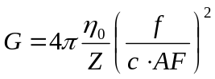

where Z antenna port impedance, f the frequency and c the speed of light in vacuum.

The measured and modelled antenna factors and gain of probes 1-3 are shown in Figure 2 to Figure 5. The electrical delay of the N-type connector is derived from the phase of S11 of the shorted probe shown in Figure 6.

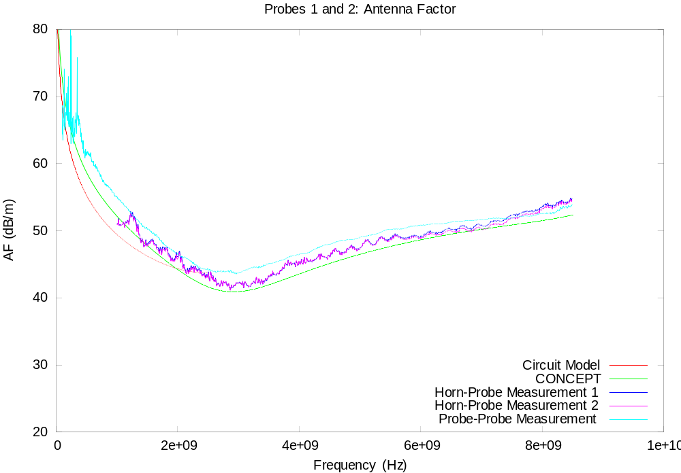
Figure 2: Antenna factor for probes 1 and 2.

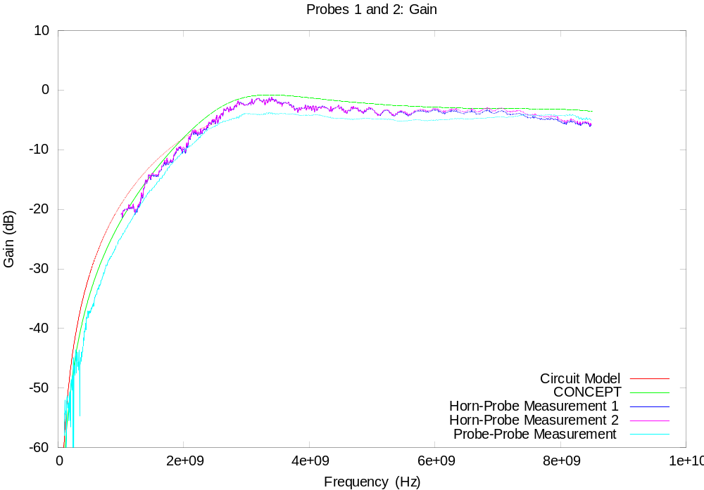
Figure 3: Gain for probes 1 and 2.

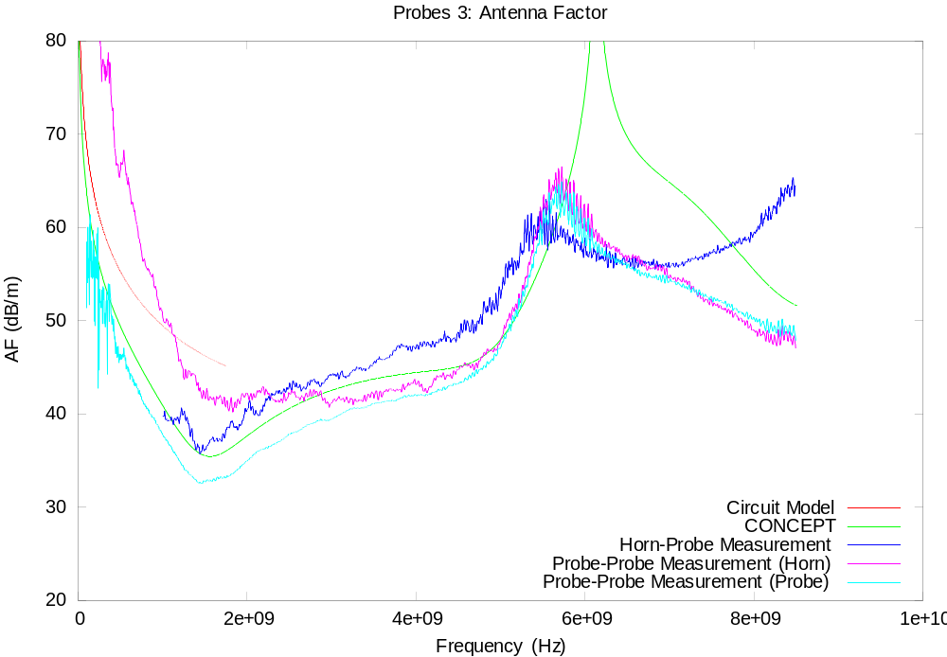
Figure 4: Antenna factor for probe 3.

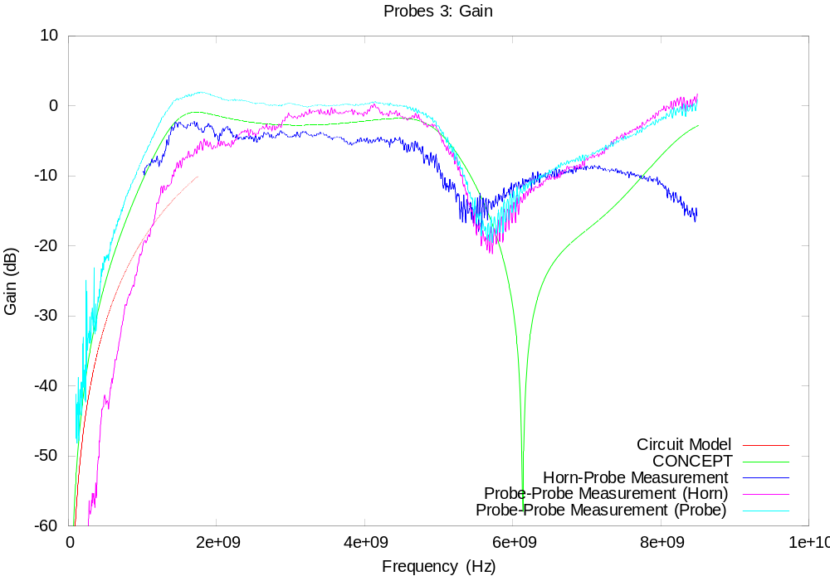
Figure 5: Gain for probe 3.

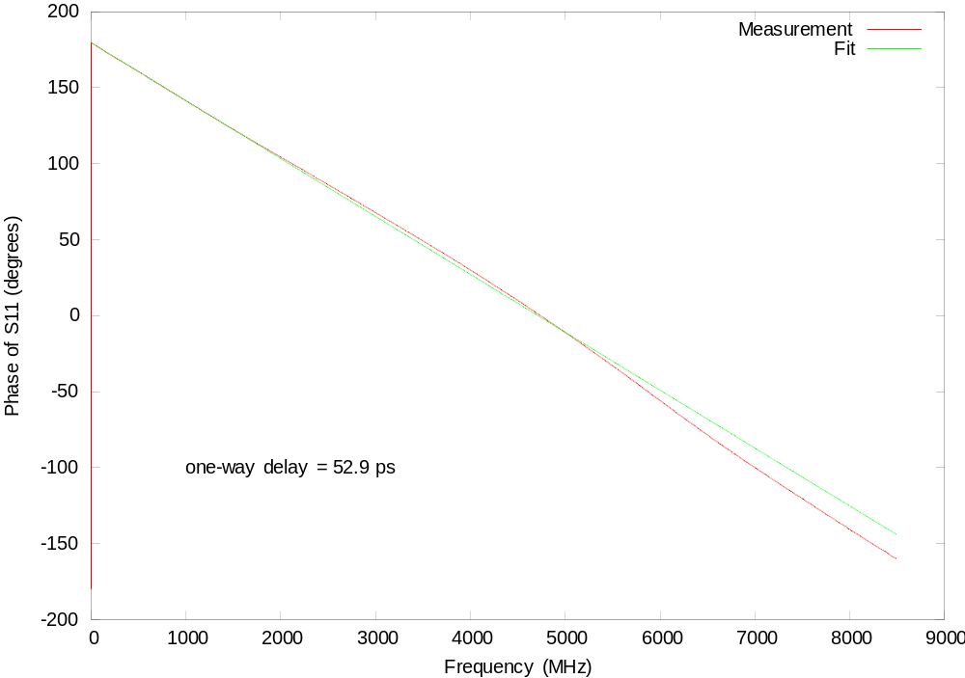
Figure 6: Phase calibration of probe connector using shorted probe.

Data Sets

The probe-to-probe measurements are assumed to be the most reliable and this data was smoothed to give the provided antenna factors in Table 2. The one-way delay between the reference plane of the connector and the base of the monopole is 52.9 ps. This delay is calibrated out of all subsequent scattering parameters in this report.

File | Contents
probe1-af.dat | Antenna factor of probe 1 and 2 in dB/m
probe2-af.dat | Antenna factor of probe3 in dB/m
Table 2: Data sets for probe calibration.

Validation Box

The validation box is a 600 mm × 500 mm × 300 mm brass box with three removable faces – see Figure 7. For these measurements two of the faces (top and side) are permanently closed and the front face is left open or covered with a plate with different characteristics. The open face has a 30 mm wide flange around the edge with holes spaced at 26 mm to 28 mm for fixing the covering plate using self-tapping screws. The box has three holes for N-type connectors on the top, labelled A, B and C in Figure 8. The probe antennas and wire structures are connected to these three ports.

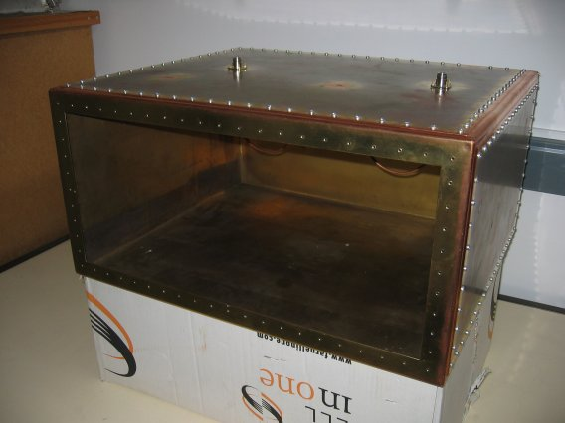
Figure 7: The validation box.
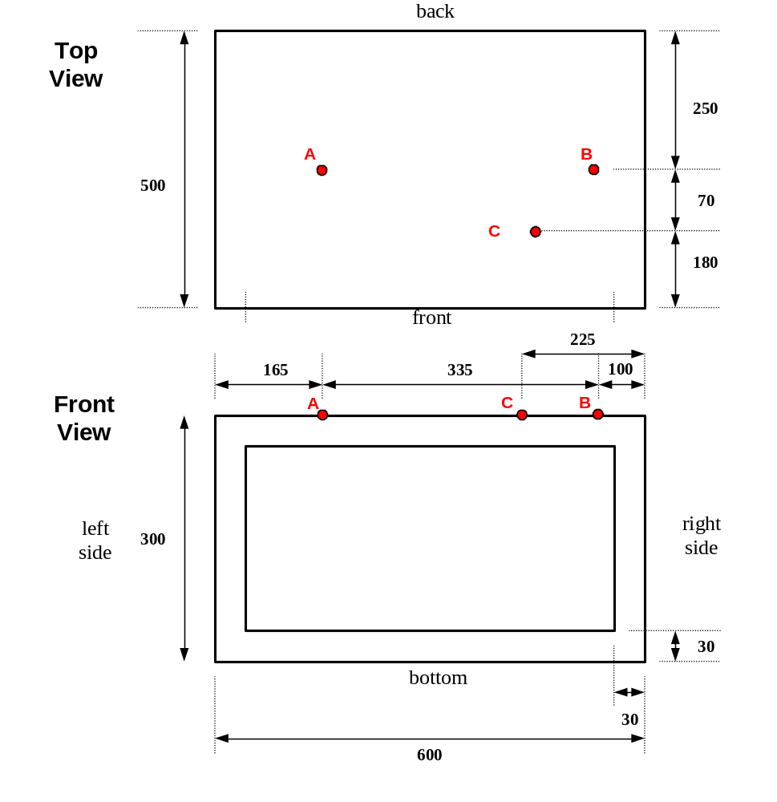
Figure 8: Validation box geometry showing the location of the three N-type ports, A, B and C.

LS22 RAM Model

A cubic piece of Eccosorb LS22 absorber with a side length of 110 mm has been constructed from a number of layers of LS22. The material is characterised by the manufacturer from 500 MHz to 18 GHz via the real and imaginary parts of the complex relative permittivity:

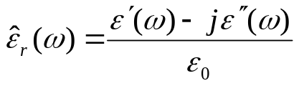

Figure 9 shows Re(ε_{r}) and Im(ε_{r}) from the manufacturer’s data sheet.

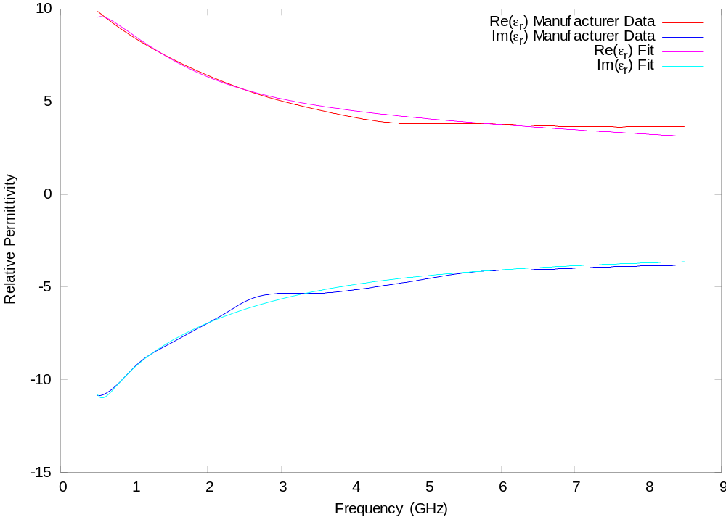
Figure 9: Properties of Eccosorb LS22 (manufacturer’s data).

As part of another project York have modelled a measurement system which uses the LS22 RAM and have obtain good agreement with the measurements in the 1-8 GHz region.

The material parameters can be fitted to a low order pole-residue or rational function model using vector fitting algorithms.

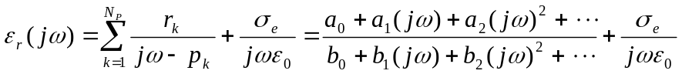

For example a four pole fit using σ_{e}=1 gives the parameters shown in Table 3 and the fit illustrated on Figure 9.

i | a_{i} | b_{i} | k | p_{k} | ^{r}_{k}
0 | - 1.428e+40 | 1.559e+39 - 2.306e+21i | 1 | -1.9859e+08 + 1.2753e+09i | -3.5433e+10 + 7.1934e+09i
1 | - 6.515e+31 - 8.444e+14i | + 5.436e+29 | 2 | -1.9859e+08 - 1.2753e+09i | -3.5433e+10 - 7.1934e+09i
2 | 2.475e+21 | + 9.788e+20 | 3 | -1.0061e+10 | 6.4706e+10
3 | 3.542e+11 | + 1.035e+11 | 4 | -9.3054e+10 | 3.6033e+11
4 | - | 1 | - | - | -
Table 3: Pole-residue (N_{P}=4) and rational function model for LS22 with σ_{e}=1.

If the conductivity term is not explicitly included higher orders are needed to obtain a fit with comparable accuracy.

Data Sets

The data-sets for the LS22 absorber are in Table 4.

File | Contents
ls22-perm.dat | Manufacturer’s complex permittivity data
ls22-pr-4.dat | 4-pole fit pole residue model
ls22-rf-4.dat | 4-pole fit rational function model
Table 4: Data sets for LS22.

Ferroxcube 4S10 Ferrite Tile Model

For validation of a one-sided frequency-dependent impedance boundary ferrite tiles were considered. Ferroxcube 100mm square Type PLT100/100/6-4S10 tiles using 4S10 material are available with a reflectivity profile shown in Figure 10.

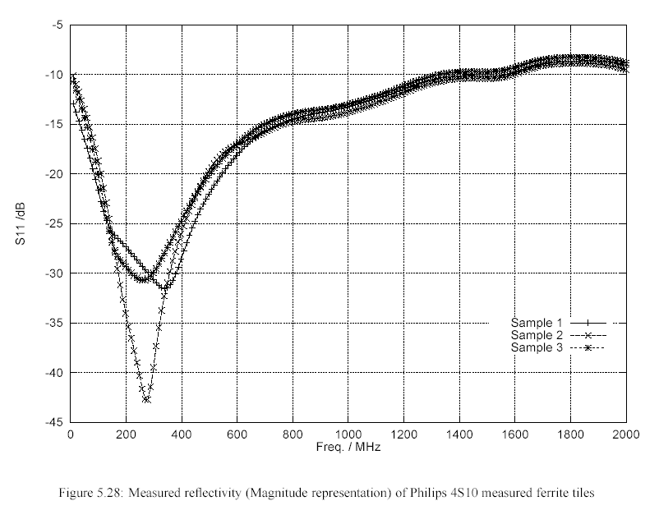
Figure 10: Measured S11 of three different S410 tiles.

File | Contents
s410-s11.dat | Typical measured complex S11 data
Table 5: Data sets for S410.

Due to dynamic range issues these measurements were not persued.

Perforated Plate Model

A brass plate with a periodic array of circular holes is used for the two-sided impedance boundary measurements. The plate is 0.3 mm thick with 3 mm diameter holes on a regular square grid with spacing 10 mm. The perforation occupies a square of side length 200 mm centred on the front face of the box wall – see Figure 11.
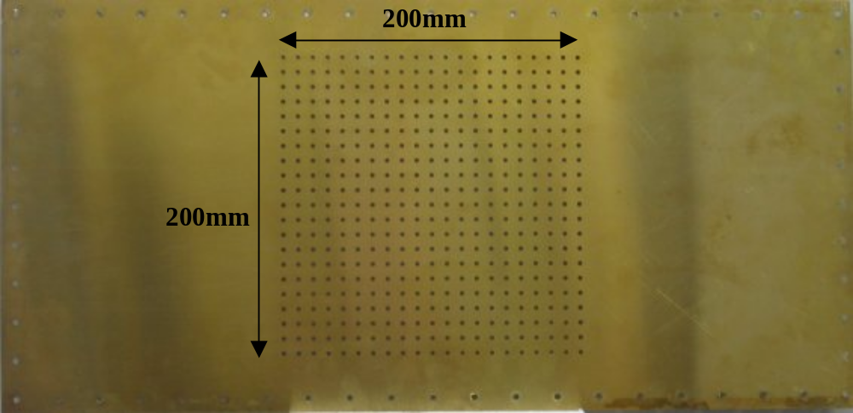
Figure 11: Perforated plate for front wall of box.

The scattering parameters of the unit cell of the plate, referenced to the plate surface, have been determined by modelling a single cell in TLM with periodic boundary conditions. The shielding effectiveness determined from the model is shown in Figure 12, compared to measurements in the ASTM cell and NRC. The model prediction is about 2.5 dB higher than the measurements (presumably due to variations in the shape and diameter of the holes in the physical plate). A correction factor has been inserted in the model to account for this and the S11 modified appropriately to ensure passivity is maintained. The resulting measurement matched data is shown in Figure 12.

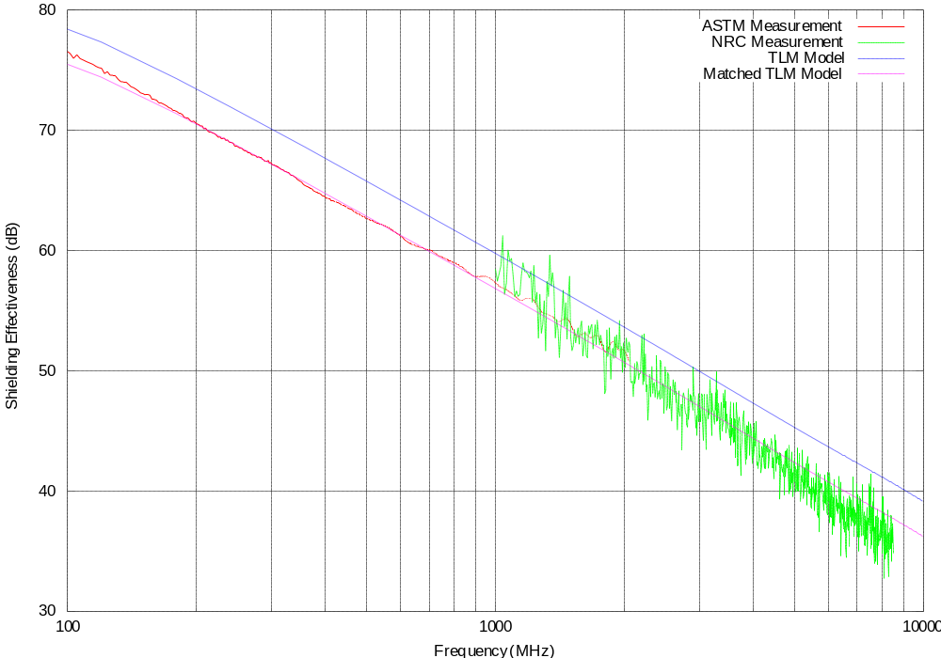
Figure 12: Measured and modelled shielding effectiveness of perforated plate.

File | Contents
pp10-sparam2.dat | Matched S parameters for perforated plate
pp10-zparam2.dat | Matched Z parameters for perforated plate
Table 6: Data sets for perforated plate.

Wires

The straight-wire geometry (Figure 13) is formed by soldering a horizontal brass rod, 3.5 mm in diameter, between probes 1 and 2 in ports A and B.

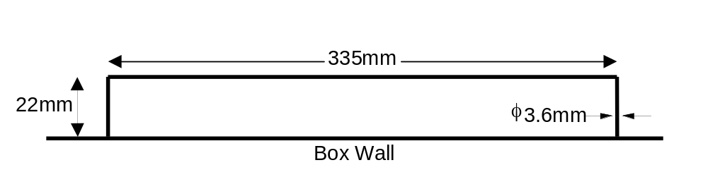
Figure 13: Straight wire geometry.

The curved wire (Figure 14) is composed of three semi-circles with two straight extension sections. Ends are soldered into N-Type bulkhead connectors in box ports A and B.

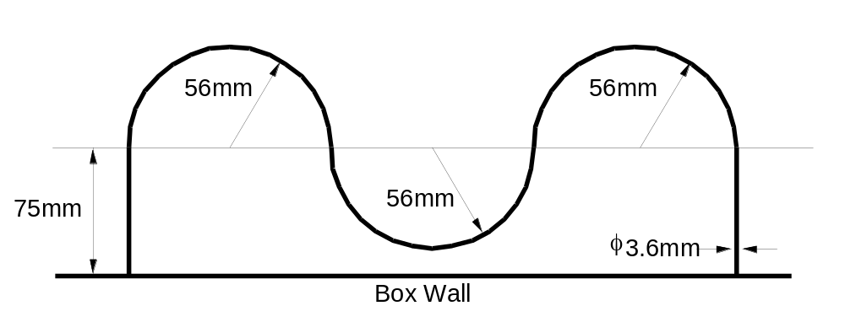
Figure 14: Curved wire geometry.

Probe-Probe Coupling Measurements

Environment: Anechoic chamber.
Frequency range: 200 MHz to 6 GHz.
Outputs: Calibrated and phase corrected 50 ohm scattering matrix between probe antennas.

Probe-Probe In Empty Box

Geometry:

- Probe 1 on box port A
- Probe 2 on box port B
- Port C unused
- Box front open
- Port 1 of N/A on port A of box
- Port 2 of N/A on port B or box

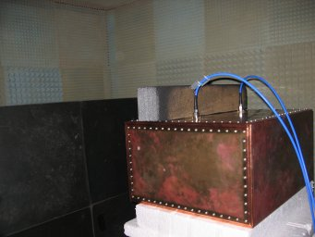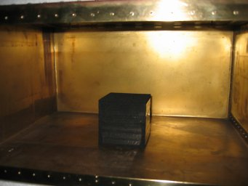
Figure 15: Validation box in chamber (left) and cube of LS22 in centre of box (right).

Probe-Probe With Absorber In Box Corner

Geometry:

- As 7.1 with cube of LS22 in bottom left back corner of box.

Probe-Probe With Absorber In Box Centre

Geometry:

- As 7.1 with cube of LS22 centred on bottom of box.

Data Sets

Figure 16 and Figure 17 show the magnitude of S21 and distribution of the Q-factor of the resonant peaks for the three data-sets in this section.

Measurement | File | Contents
7.1 | p1a-p2b-empty.dat | S matrix for probe 1 on box port A and probe 2 on box port B.
7.2 | p1a-p2b-ls22corner.dat | S matrix for probe 1 on box port A and probe 2 on box port B with cube of LS22 in bottom-rear-left corner of box.
7.3 | p1a-p2b-ls22centre.dat | S matrix for probe 1 on box port A and probe 2 on box port B with cube of LS22 centred on bottom of box.
Table 7: Data sets for probe-probe coupling measurements.

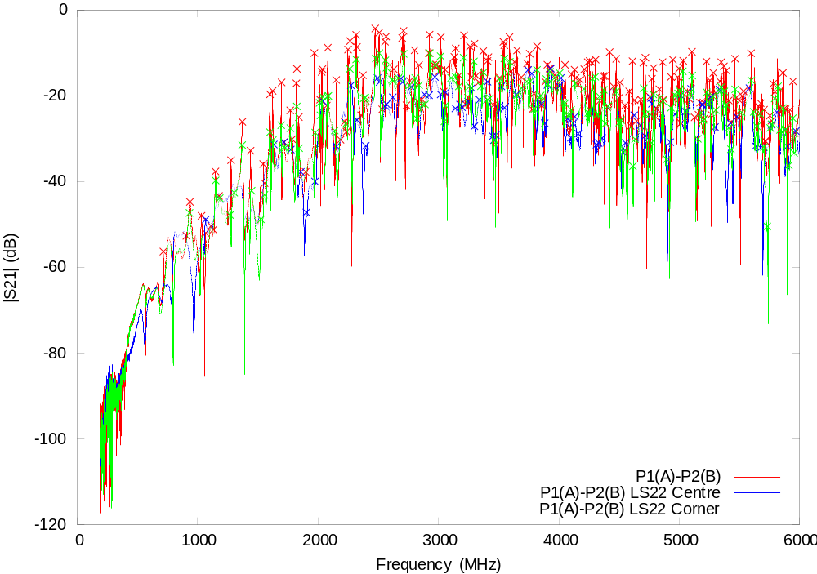
Figure 16: Magnitude of S21 for probe-to-probe measurements.

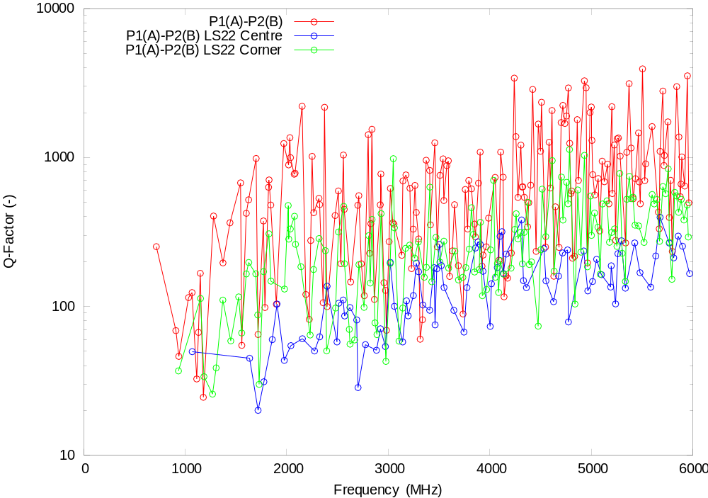
Figure 17: Q-factor distribution for probe-probe measurements.

Field-to-Probe Coupling Measurements

Environment: Anechoic chamber.
Frequency range: 1 GHz to 6 GHz.
Outputs: Calibrated reception aperture at probe antenna port.

Results presented as reception aperture:

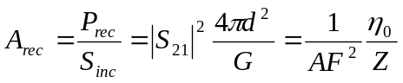
A_{rec} - reception aperture (m²)
P_{rec} - power received at probe antenna (W)
S_{inc} - power density of incident field (W/m²)
d – distance from front of box to aperture of horn antenna (1.5 m)
G – power gain of horn antenna (-)
AF – antenna factor (/m)
Z – impedance of test set (Ω)

In decibels reception aperture is related to antenna factor by:

A (dB m²) = 8.77 - AF (dB /m)

Field-Probe In Empty Box

Geometry:

- Probe 1 on box port A
- Probe 2 on box port B
- Port C unused
- Box front open
- Port 1 of N/A on horn antenna
- Port 2 of N/A on port A of box
- Port B or box terminated

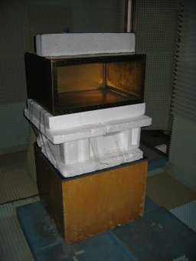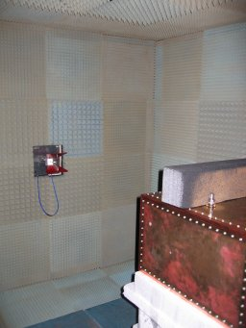
Figure 18: Configuration for field-to-probe measurements.

Field-Probe With Absorber In Box Corner

Geometry:

- As 8.1with cube of LS22 in bottom left back corner of box.

Field-Probe With Absorber In Box Centre

Geometry:

- As 8.1 with cube of LS22 centred on bottom of box.

Data Sets

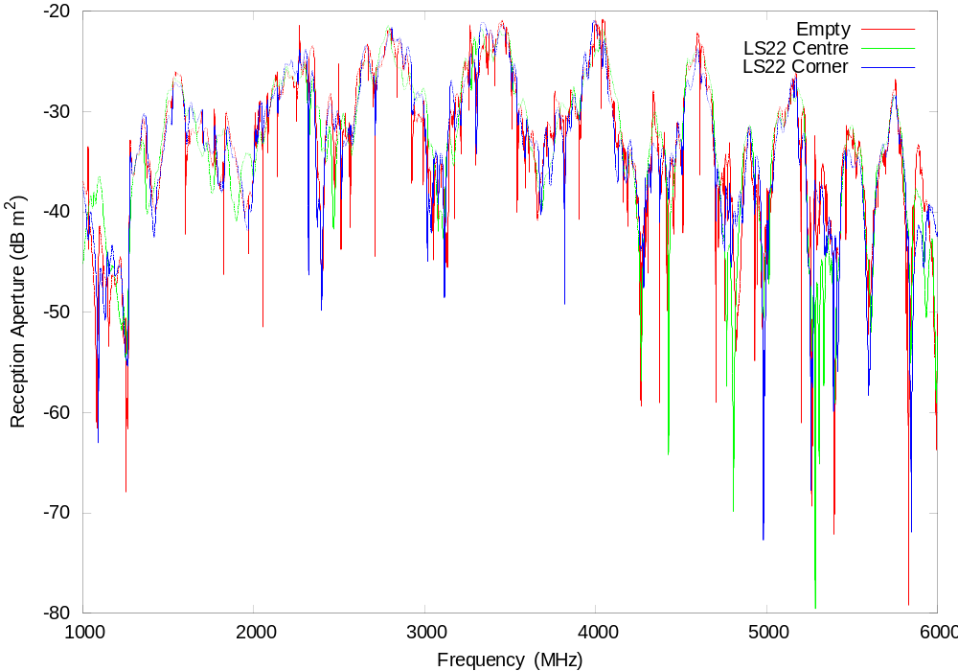
Figure 19: Reception aperture for horn to probe measurements.

Measurement | File | Contents
8.1 | horn-p1a.dat | Aperture in dB m² for probe 1 on box port A. Probe 2 on port B terminated in 50Ω load.
8.2 | horn-p1a-ls22corner.dat | Aperture in dB m² for probe 1 on box port A with cube of LS22 in bottom-rear-left corner of box. Probe 2 on port B terminated in 50Ω load.
8.3 | horn-p1a-ls22centre.dat | Aperture in dB m² for probe 1 on box port A with cube of LS22 centred on bottom of box. Probe 2 on port B terminated in 50Ω load.
Table 8: Data sets for field-to-probe coupling measurements.

Field-to-Probe with Perforated Plate Coupling Measurements

Environment: Anechoic chamber.
Frequency range: 1 GHz to 6 GHz.
Outputs: Calibrated reception aperture at probe antenna port.

Field-Probe In Empty Box

Geometry:

- Probe 1 on box port A
- Probe 2 on box port B
- Port C unused
- Box front covered with perforated plate
- Port 1 of N/A on horn antenna
- Port 2 of N/A on port A of box
- Port B or box terminated

Field-Probe With Absorber In Box Corner

Geometry:

- As 9.1 with cube of LS22 in bottom left back corner of box.

Field-Probe With Absorber In Box Centre

Geometry:

- As 9.1 with cube of LS22 centred on bottom of box.

Data Sets

Measurement | File | Contents
9.1 | horn-p1a-pp10.dat | Aperture in dB m² for probe 1 on box port A. Probe 2 on port B terminated in 50Ω load.
9.2 | horn-p1a-pp10-ls22corner.dat | Aperture in dB m² for probe 1 on box port A with cube of LS22 in bottom-rear-left corner of box. Probe 2 on port B terminated in 50Ω load.
9.3 | horn-p1a-pp10-ls22centre.dat | Aperture in dB m² for probe 1 on box port A with cube of LS22 centred on bottom of box. Probe 2 on port B terminated in 50Ω load.
Table 9: Data sets for perforated plate field-to-probe coupling measurements.

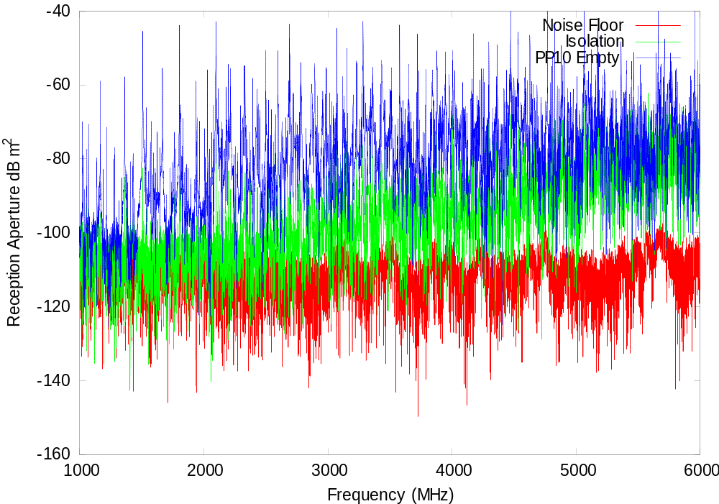
Figure 20: Field-to-probe through perforated plate with empty box.
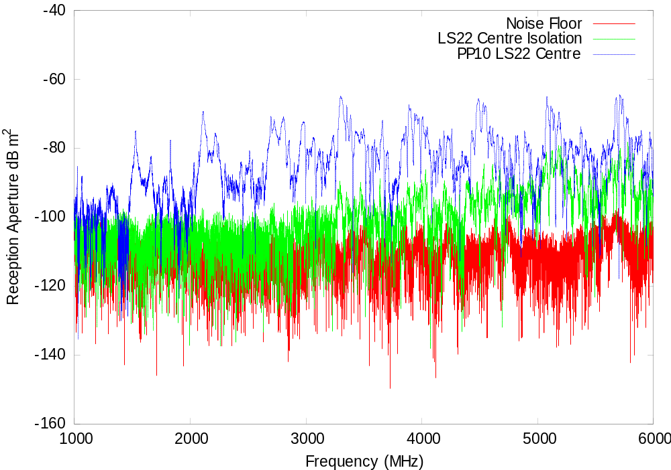
Figure 21: Field-to-probe through perforated plate with cube of LS22 in centre of box floor.

Probe-to-Straight-Wire Coupling Measurements

Environment: Anechoic chamber.
Frequency range: 200 MHz to 6 GHz.
Outputs: Calibrated S-matrix.

Probe-to-Straight-Wire In Empty Box

Geometry:

- Wire between probes 1 and 2 on ports A and B
- Probe 3 on box port C
- Port 1 of N/A on port C
- Port 2 of N/A on Port A
- Port B or box terminated

Probe-to-Straight-Wire with Absorber in Box Corner

Geometry:

- As 10.1with cube of LS22 in bottom left back corner of box.

Probe-to-Straight-Wire with Absorber in Box Centre

Geometry:

- As 10.1 with cube of LS22 centred on bottom of box.

Data Sets

Measurement | File | Contents
10.1 | p3c-wire_p1a-empty.dat | S matrix for probe 3 on box port C and probe 1 on box port A.
10.2 | p3c-wire_p1a-ls22corner.dat | S matrix for probe 3 on box port C and probe 1 on box port A with cube of LS22 in bottom-rear-left corner of box.
10.3 | p3c-wire_p1a-ls22centre.dat | S matrix for probe 3 on box port C and probe 1 on box port A with cube of LS22 centred on bottom of box.
Table 10: Data sets for perforated plate field-to-probe coupling measurements.

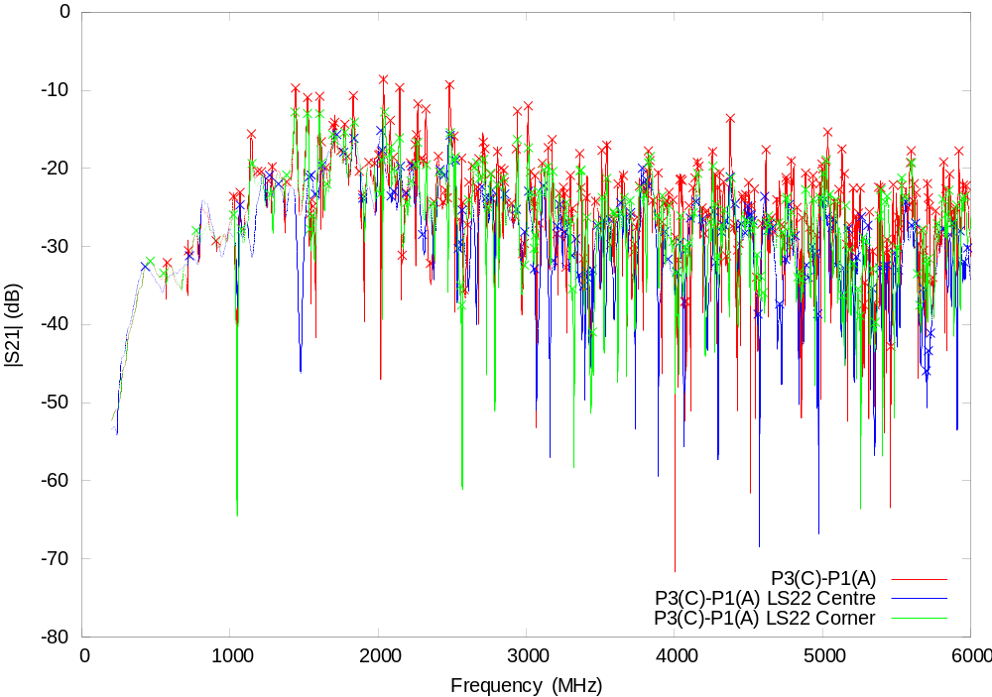
Figure 22: |S21| for probe to straight wire coupling.
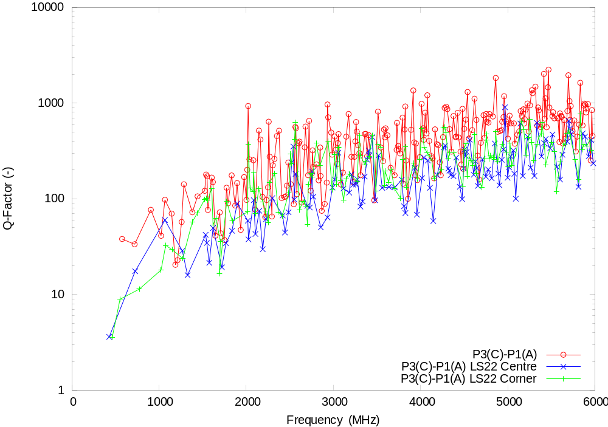
Figure 23: Q factor distribution for probe to straight wire coupling.

Field-to-Straight-Wire Coupling Measurements

Environment: Anechoic chamber.
Frequency range: 1 GHz to 6 GHz.
Outputs: Calibrated reception aperture end of wire.

Field-to-Straight-Wire In Empty Box

Geometry:

- Wire between probe 1 and probe 2 on box ports A and B
- Probe 3 on box port C
- Port 1 of N/A on port C
- Port 2 of N/A on Port A
- Port B or box terminated

Field-to-Straight-Wire with Absorber in Box Centre

Geometry:

- As 11.1 with cube of LS22 centred on bottom of box.

Field-to-Straight-Wire in Empty Box with Perforated Plate

Geometry:

- As 11.1 with perforated plate in front of box.

Field-to-Straight-Wire with Absorber in Box Centre and Perforated Plate

Geometry:

- As 11.2 with perforated plate in front of box.

Data Sets

Measurement | File | Contents
11.1 | horn-p1a-wire-empty.dat | Aperture in dB m² for probe 1 on box port A. Probe 2 on port B terminated in 50Ω load.
11.2 | horn-p1a-wire-ls22centre.dat | Aperture in dB m² for probe 1 on box port A. Probe 2 on port B terminated in 50Ω load. Cube of LS22 in centre of box floor.
11.3 | horn-p1a-wire-pp10-empty.dat | Aperture in dB m² for probe 1 on box port A. Probe 2 on port B terminated in 50Ω load. Perforated plate in front aperture of box.
11.4 | horn-p1a-wire-pp10-ls22centre.dat | Aperture in dB m² for probe 1 on box port A. Probe 2 on port B terminated in 50Ω load. Cube of LS22 in centre of box floor and perforated plate in front aperture of box.
Table 11: Data sets for perforated plate field-to-probe coupling measurements.

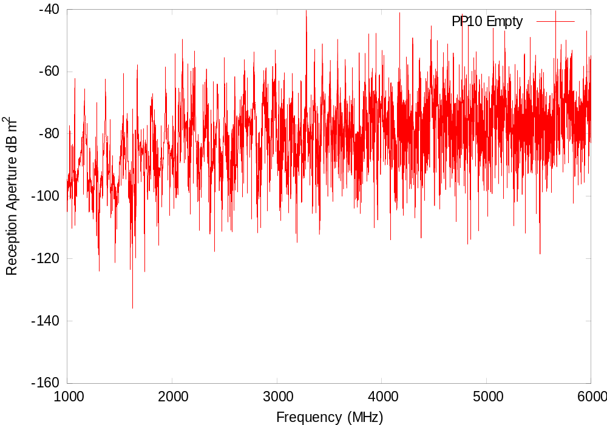
Figure 24: Field-to-straight-wire with empty box.

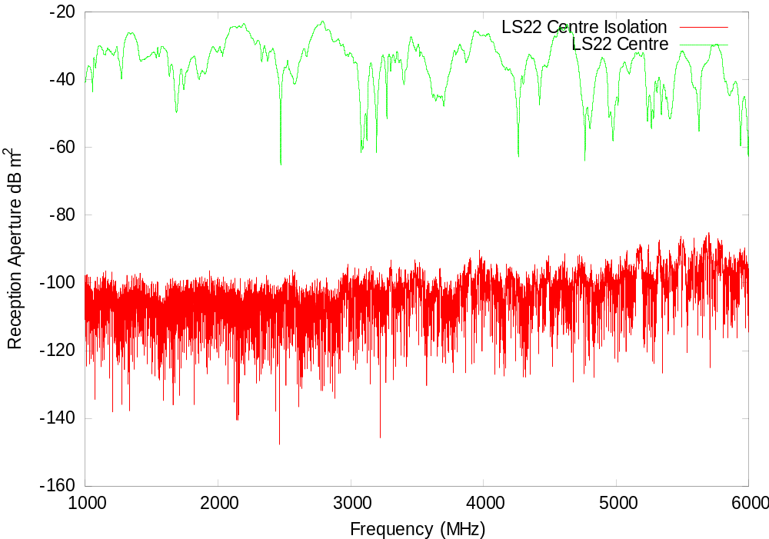
Figure 25: Field-to-straight-wire with cube of LS22 in centre of box floor.
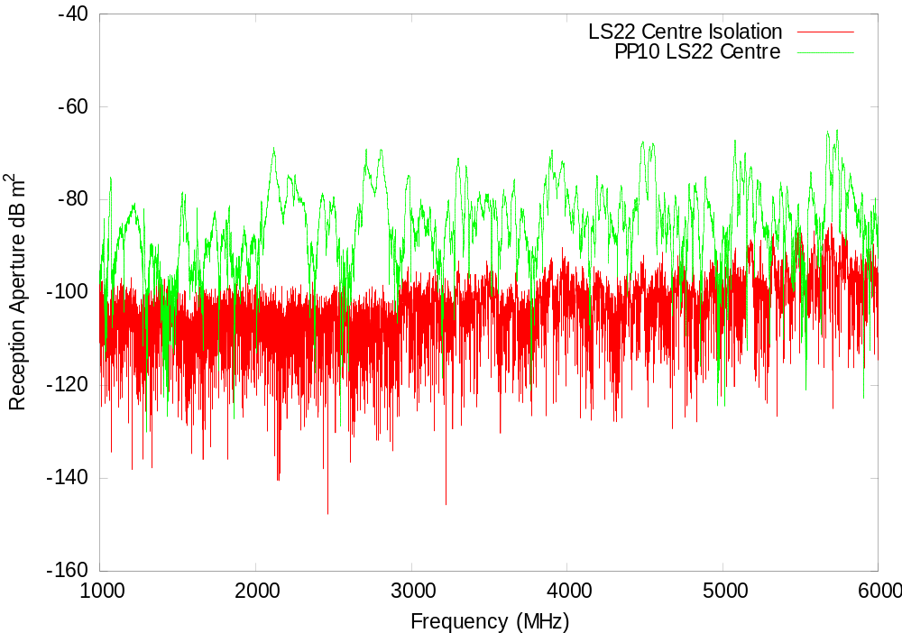
Figure 26: Field-to-straight-wire through perforated plate with cube of LS22 in centre of box floor.

Probe-to-Curved-Wire Coupling Measurements

Environment: Anechoic chamber.
Frequency range: 200 MHz to 6 GHz.
Outputs: Calibrated S-matrix.

Probe-to-Curved-Wire In Empty Box

Geometry:

- Wire between port A and port B
- Probe 3 on box port C
- Port 1 of N/A on port C
- Port 2 of N/A on Port A
- Port B or box terminated

Probe-to-Curved-Wire with Absorber in Box Centre

Geometry:

- As 12.1 with cube of LS22 centred on bottom of box.

Data Sets

Measurement | File | Contents
12.1 | p3c-p1a-curvedwire-empty.dat | S matrix for probe 3 on box port C and probe 1 on box port A. Port B terminated.
12.2 | p3c-p1a-curvedwire-ls22centre.dat | S matrix for probe 3 on box port C and probe 1 on box port A. Port B terminated. Cube of LS22 in centre of box floor.
Table 12: Data sets for probe to curved wire coupling measurements.

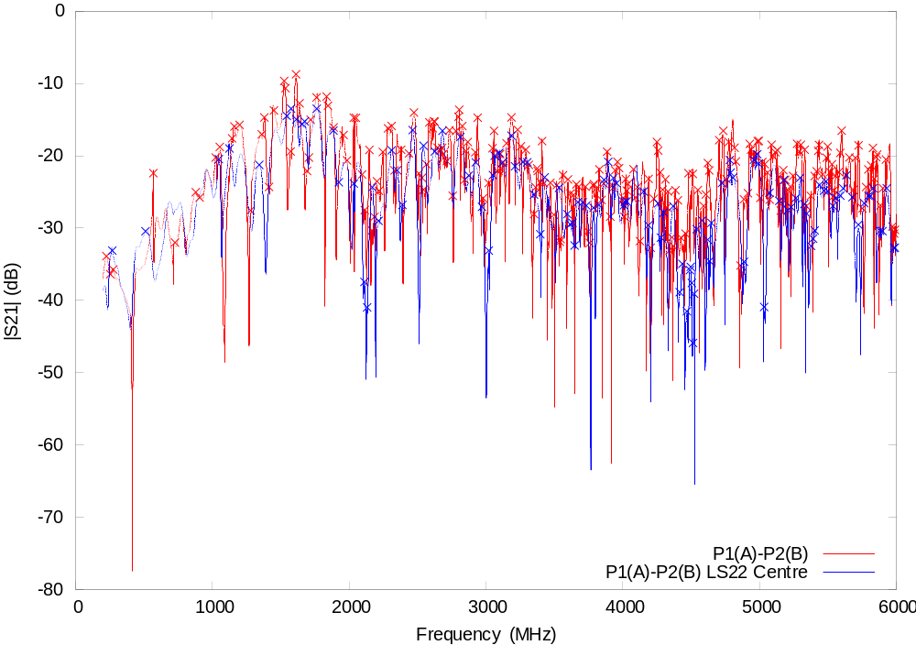
Figure 27: Magnitude of S21 for probe-to-curved-wire measurements.

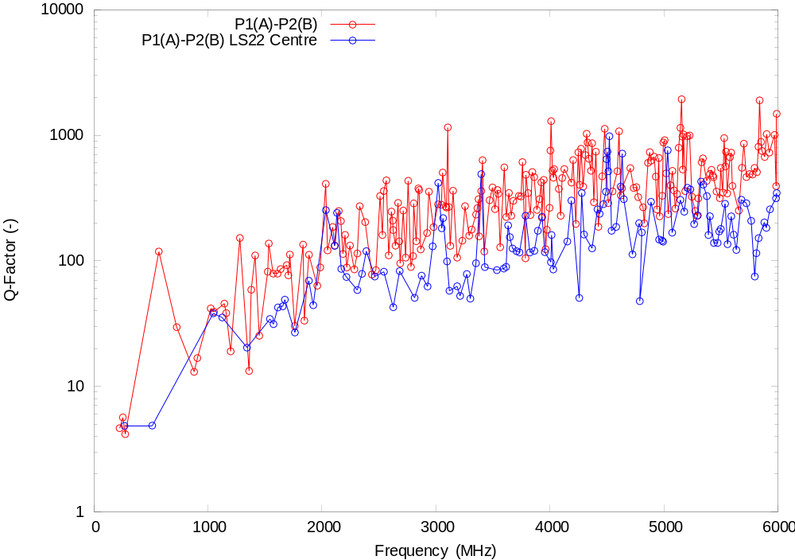
Figure 28 Q-Factor distribution for probe-to-curved-wire measurements.

Field-to-Curved-Wire Coupling Measurements

Environment: Anechoic chamber.
Frequency range: 1 GHz to 6 GHz.
Outputs: Calibrated reception aperture end of wire.

Field-to-Curved-Wire In Empty Box

Geometry:

- Wire between port A and B
- Probe 3 on box port C
- Port 1 of N/A on port C
- Port 2 of N/A on Port A
- Port B or box terminated

Field-to-Curved-Wire with Absorber in Box Centre

Geometry:

- As 13.1 with cube of LS22 centred on bottom of box.

Data Sets

Measurement | File | Contents
13.1 | horn-p1a-curvedwire-empty.dat | Aperture in dB m² for probe 1 on box port A. Probe 2 on port B terminated in 50 Ω load.
13.2 | horn-p1a-wire-iso-ls22centre.dat | Aperture in dB m² for probe 1 on box port A. Probe 2 on port B terminated in 50 Ω load. Cube of LS22 in centre of box floor.
Table 13: Data sets for perforated plate field-to-probe coupling measurements.

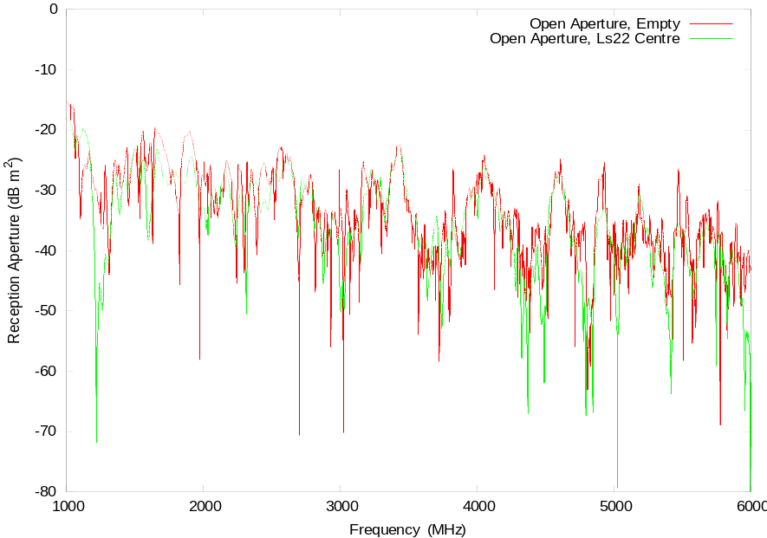
Figure 29: Reception aperture for curved wire measurements.

Ferrite Measurements

Dynamic range problem at 200 MHz. Maybe a GTEM field to horizontal wire measurement?

Panel Joint Measurements

TBD.

