You, Y’all, We: A Framework for Cooperative Learning

As music theorists increasingly embrace peer-group learning strategies, frameworks are needed to structure lesson time. Such a framework appears in a recent [book](http://books.wwnorton.com/books/Building-a-Better-Teacher/) and [article](http://www.nytimes.com/2014/07/27/magazine/why-do-americans-stink-at-math.html) on mathematics pedagogy by Elizabeth Green, who compares two approaches. “I, We, You” is the traditional lecture format: the teacher demonstrates a concept (“I”), leads the class through a sample exercise (“we”), and then assigns homework for individual completion (“you”). Students learn “answer-getting” but not necessarily why a procedure leads to the correct answer, and they do not receive feedback until work has already been graded. By contrast, Green advocates for “You, Y’all, We”: students consider a problem individually (“you”), collaborate in peer groups (“y’all”), and then discuss the problem as a whole class (“we”). The learning process centers around active student involvement. This teaches “sense-making,” as students’ solutions are grounded in their own experience and thus make more intuitive sense. (The framework is attributed to math pedagogy scholar [Magdalene Lampert](http://openlibrary.org/books/OL9606683M/Teaching_Problems_and_the_Problems_of_Teaching) and, as implicit in its very name, resonates with [Frank Lyman’s](http://www.worldcat.org/title/mainstreaming-digest-a-collection-of-faculty-and-student-papers/oclc/63759678) well-known “think–pair–share.”)

In the mathematics community Green’s article elicited a [range of responses](http://www.ams.org/notices/201505/rnoti-p508.pdf), including the [criticism](http://math.berkeley.edu/~wu/AMSNotices_2014.pdf) that “You, Y’all, We” is no panacea for underlying pedagogical deficiencies. “I, We, You” and “You, Y’all, We” nonetheless offer a useful heuristic for measuring differences between teacher-driven and student-driven learning. My own teaching already involved aspects of “You, Y’all, We”—I suspect the same is true of many theorists—and after reading Green’s article I attempted to employ the framework more explicitly.

This essay describes how, in the 2014–15 academic year, I incorporated “You, Y’all, We” into two core theory classes, one graduate and one undergraduate, to facilitate creative and involved classroom discussion among student participants. The framework served my goals of emphasizing process over results, providing immediate and specific feedback, and maximizing student involvement. Below I outline three in-class situations structured by “You, Y’all, We.” I conclude by identifying intersections of “You, Y’all, We” with other pedagogical approaches.

Graduate Theory & Analysis

Graduate Theory & Analysis is a required MM-level course that covers advanced tonal theory and form. In fall 2014 I used William Caplin’s [*Analyzing Classical Form*](http://www.music.mcgill.ca/acf/) as a textbook. Individual chapters deal with topics such as sentences and periods, phrase expansion, and sections of sonata form. For the first day with a given chapter, I summarize the main points and play through selected analytical examples. On subsequent days students prepare formal and harmonic analyses of assigned excerpts for class discussion, where multiple interpretations can be debated. Students work collaboratively within the “You, Y’all, We” framework to evaluate interpretations based on the application of terminology, performance implications, and the ways they affect listening. Graded assignments follow thereafter.

My approach builds on [Zbikowski and Long’s](http://zbikowski.uchicago.edu/pdfs/Zbikowski_Long_1994.pdf) model for cooperative learning through peer-group interaction. I randomly place students into study groups of five; membership rotates every month. In preparation for an analytical discussion, students listen to an assigned passage and attempt an initial analysis (“you”). In class, students meet in study groups to discuss their analyses and pinpoint conflicts (“y’all”). Using the [Random Master](http://altatech.webstarts.com/about.html) iPad app, I randomly select one group to put an analysis on the board and relate points of contention that arise in discussion. The remaining groups and I offer feedback and critique (“we”).

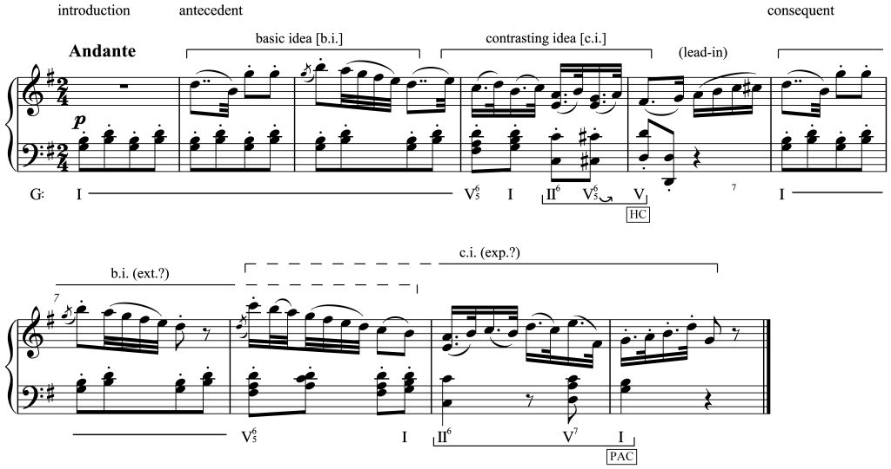

An example from [Haydn’s Symphony No. 101](http://imslp.org/wiki/Symphony_No.101_in_D_major,_Hob.I:101_(Haydn,_Joseph)) illustrates the type of class debate possible. (The exercise appears in Caplin’s textbook; all annotations are mine.) My students accounted for the expanded five-measure consequent in two ways. Some students heard its basic idea as being extended, with the melodic motive of measure 7 repeated and varied in measure 8. Others heard its contrasting idea as being expanded, with the harmonic progression of measures 4–5 stretched out across measures 8–10. Although the latter interpretation is more consistent with Caplin’s harmonic emphasis, the conflict between interpretations contributes to the specific experience of the passage. As in the original [*Classical Form*](http://openlibrary.org/books/OL679075M/Classical_form), Caplin’s notational system can be used creatively to highlight the ambiguity.

I assess study-group discussion differently than graded assignments. Class participation essentially involves an attendance grade, with students receiving credit whether they lead the group discussion, offer occasional suggestions, or simply listen attentively. The goal of group discussion is to practice the analytical method and make mistakes with impunity, and therefore at this stage the accuracy of student work is not evaluated. (Individual instructors might prefer alternative assessment strategies, such as having students perform self and peer evaluations at regular intervals, rating each group member’s preparedness.) Every few weeks students receive graded assignments with new excerpts for individual completion. The format is identical to the study-group analyses: score annotations in Caplin’s style, now with optional written commentary. These assignments provide an incentive for students to prepare for daily class discussion. Students follow the textbook’s trajectory and gradually analyze longer and more complex excerpts, beginning with eight-measure themes and concluding with full movements.

There are several benefits to the “You, Y’all, We” approach. First, because of the emphasis on small groups, every student is able to participate in the discussion, even when the enrollment is large. Individuals may also feel more comfortable making contributions within these smaller groups. Second, students’ accountability to their peers increases the likelihood that they will come to class prepared. On the other hand, students who arrive unprepared are not completely shut out. If there were no “y’all” phase, unprepared students would be unable to follow the discussion and would gain little from class time. The “y’all” phase allows unprepared students to look through the excerpt, evaluate peer arguments, and formulate ideas, even though they lose the analytical practice (“you”) necessary to succeed on the graded assignments. Third, students control the course of discussion by determining which points are particularly challenging or interesting. At the “y’all” phase students deal with minor details that can be ignored at the “we” phase (“Is this a V6 or a V6/5 chord?”), leaving time for the full class to debate more contentious issues. Fourth, students not only receive immediate feedback but also participate in generating feedback. Finally, the approach emphasizes multiple interpretations. By debating alternative possibilities, the students (and I) learn to hear excerpts in new ways, identify ambiguities and their performance implications, and occasionally modify the analytical system to provide novel solutions. (The framework suits equally well the use of [Hepokoski and Darcy’s](http://openlibrary.org/works/OL4294182W/Elements_of_sonata_theory) sonata theory, which by its very nature encourages both debate of analytical ambiguities and attention to hermeneutic implications.)

Theory 2

In undergraduate teaching I also prefer to work through analysis in class discussion rather than assigning it for graded homework. For my honors section of Theory 2 in spring 2015, I used Miguel Roig-Francolí’s [*Harmony in Context*](http://highered.mheducation.com/sites/0073137944/information_center_view0/index.html), a textbook that particularly invites debate. For example, in the chapter on period types, the first student exercise does not conform exactly to any of the book’s categories. Students cannot simply “match” the excerpt to a corresponding chapter example; they must think creatively. (The example, from [Haydn’s String Quartet, op. 76, no. 3](http://imslp.org/wiki/String_Quartets,_Op.76_%28Haydn,_Joseph%29), is reproduced below. The Roman numerals appear in the Roig-Francolí text; the phrase designations *A*, *B*, and *C* do not.)

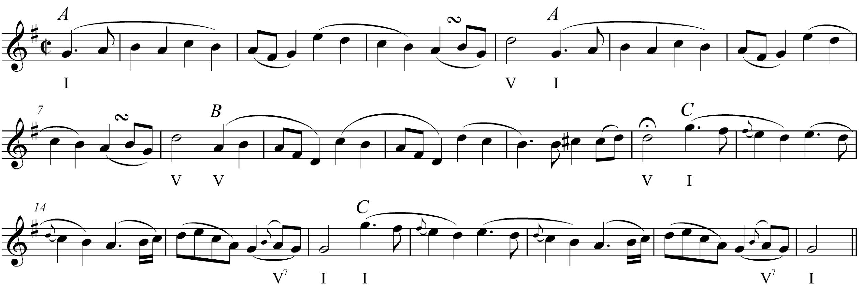

To encourage multiple interpretations, I instruct students to brainstorm as many analyses as possible, rather than settling on the first interpretation that “works.” In class, students collect thoughts while singing through the melody (“you”), discuss potential analyses in pairs (“y’all”), and present the analyses to the class for debate (“we”). Although the instructor’s manual considers the excerpt a three-phrase period with written-out repeats (*AABCC*), my students conceived of alternatives that revealed additional nuances in the formal structure. One group proposed that the *B* phrase be heard as a post-cadential extension to the HC in m. 8, rather than an independent phrase. The specific tension between the two interpretations highlights the qualitatively different experience of a phrase that prolongs dominant harmony as compared with phrases that move from tonic to dominant. Another group proposed that the *C* phrase be heard as a modified repetition of *A*, as both contain the same stepwise descent from E5 to A4 in the same metrical (but not hypermetrical) position. This tension reveals that “parallel” and “contrasting” phrases lie on two ends of a continuum (or [spectrum](http://upers.kuleuven.be/sites/upers.kuleuven.be/files/page/files/2012_1_6.pdf)), with numerous possibilities in between. Students were invited to think about both how the tensions among alternatives generate the experience of listening to the passage, and how performers could bring out these tensions and alternatives.

“You, Y’all, We” is well suited to analysis, but it can structure other music theory activities as well. In my final example I incorporate “You, Y’all, We” into a lesson on composing modulating progressions. This case furthermore demonstrates how “You, Y’all, We” can interact with [inquiry-based](http://flipcamp.org/engagingstudents/shafferpt3.html) or [problem-based learning](http://flipcamp.org/engagingstudents2/essays/dukerShafferStevens.html), where students must determine the process for solving a problem in addition to its solution.

The day after introducing pivot chords, I assign students an in-class task: compose a four-voice progression that modulates from B-flat major to E-flat major. I provide no further instructions. First, students individually list all possible pivot chords (“you”). They then write progressions collaboratively in pairs (“y’all”). Finally, they put their progressions on the board, whereupon I play them for class critique (“we”).

Students discover common problems when they judge progressions by ear. With impossible pivots (e.g., V = ii) or a lack of well-formed syntax (e.g., I–V–I in the new key directly following the pivot), students may respond that modulations sound disjointed or arbitrary, leading them to inspect the progressions for potential issues. Even progressions that “work” on paper may not sound convincing. In my honors class one progression tonicized the original tonic immediately after the pivot. Students responded that it sounded like it modulated later than notated and thereby discovered that the particular tonicization was a weak choice. Through this exercise students identify compositional errors and offer suggestions for improvement. The following day’s lesson proceeds logically: I discuss establishing the home key, moving to a pivot, and confirming the new key. Students discover the principles of this lesson in advance.

Conclusion

“You, Y’all, We” offers a framework for structuring cooperative learning in three stages: initial independent work (“you”), peer-group discussion (“y’all”), and class debate and critique (“we”). This framework is not beholden to any particular teaching style and can be integrated into a variety of pedagogical approaches. [Zbikowski and Long’s](http://zbikowski.uchicago.edu/pdfs/Zbikowski_Long_1994.pdf) cooperative learning model emphasizes peer learning, especially in situations where each group member has a designated contributive role. All their examples involve a “y’all” phase and could be adapted to consistently incorporate “you” and “we.” [Flipped](http://flipcamp.org/engagingstudents/shafferpt1.html) or [inverted teaching](http://www.mtosmt.org/issues/mto.15.21.1/mto.15.21.1.duker_gawboy_hughes_shaffer.html) also shares an emphasis on in-class activity. “You, Y’all, We” can be used to structure individual meetings of a flipped class, but it can also be used in classes (like mine) that are not flipped. Other methods that can interact with “You, Y’all, We” include the [conceptual workshop](http://flipcamp.org/engagingstudents/colletti.html), [peer instruction](http://flipcamp.org/engagingstudents/hughes.html), the [panel discussion format](http://jmtp.ou.edu/journal-article/contention-classroom-encouraging-debate-and-alternate-readings-undergraduate-theory), and [spectrum reasoning](http://upers.kuleuven.be/sites/upers.kuleuven.be/files/page/files/2012_1_6.pdf), all of which emphasize student discussion and peer learning. [Leigh VanHandel](http://jmtp.ou.edu/journal-article/what-can-music-theory-pedagogy-learn-mathematics-pedagogy) has shown how ideas developed in math pedagogy can be beneficially adapted to music theory pedagogy; “You, Y’all, We” provides an additional example.

The explicit three-stage structure of “You, Y’all, We” offers specific advantages for class discussion. The “you” stage allows students to reflect on their own before they engage with peer groups, ensuring that they already have ideas to present (or questions to ask). The “y’all” stage involves all students in discussion, as opposed to large-group discussions where some students may not have the opportunity or desired comfort level to speak up. Finally, the “we” stage brings groups into contact with each other, sharing and critiquing alternative possibilities. With this framework, class participation is inclusive, feedback is immediate, and competing viewpoints are easily shared. Above all, the method fosters critical thinking, as students do not merely make analytical decisions through labeling, but they are encouraged to argue *why* they have made those decisions, relying on supporting evidence based on listening, performance, or terminological precision (or a combination of all three). “You, Y’all, We” offers a model of cooperative learning that highlights the very ambiguities and multiplicities inherent in theorizing about music.

**Bibliography**

Bribitzer-Stull, Matthew. 2003. [“Contention in the Classroom: Encouraging Debate and Alternate Readings in the Undergraduate Theory Class.”](http://jmtp.ou.edu/journal-article/contention-classroom-encouraging-debate-and-alternate-readings-undergraduate-theory) *Journal of Music Theory Pedagogy* 17: 21–45.

Caplin, William E. 1998. [*Classical Form: A Theory of Formal Functions for the Instrumental Music of Haydn, Mozart, and Beethoven.*](http://openlibrary.org/books/OL679075M/Classical_form) New York: Oxford University Press.

Caplin, William E. 2013. [*Analyzing Classical Form: An Approach for the Classroom.*](http://www.music.mcgill.ca/acf/) New York: Oxford University Press.

Colletti, Carla R. 2013. [“The Silent Professor: Enhancing Student Engagement through the Conceptual Workshop.”](http://flipcamp.org/engagingstudents/colletti.html) In *Engaging Students: Essays in Music Pedagogy*, vol. 1.

Duker, Philip, Anna Gawboy, Bryn Hughes, and Kris P. Shaffer. 2015. [“Hacking the Music Theory Classroom: Standards-Based Grading, Just-in-Time Teaching, and the Inverted Class.”](http://www.mtosmt.org/issues/mto.15.21.1/mto.15.21.1.duker_gawboy_hughes_shaffer.html) *Music Theory Online* 21, no. 1.

Duker, Philip, Kris Shaffer, and Daniel Stevens. 2014. [“Problem-Based Learning in Music: A Guide for Instructors.”](http://flipcamp.org/engagingstudents2/essays/dukerShafferStevens.html) In *Engaging Students: Essays in Music Pedagogy*, vol. 2.

Green, Elizabeth. 2014. [*Building a Better Teacher: How Teaching Works (and How to Teach It to Everyone).*](http://books.wwnorton.com/books/Building-a-Better-Teacher/) New York: Norton.

Green, Elizabeth. 2014. [“Why Do Americans Stink at Math?”](http://www.nytimes.com/2014/07/27/magazine/why-do-americans-stink-at-math.html) *New York Times Magazine* (July 23).

Hepokoski, James, and Warren Darcy. 2006. [*Elements of Sonata Theory: Norms, Types, and Deformations in the Late-Eighteenth Century Sonata.*](http://openlibrary.org/works/OL4294182W/Elements_of_sonata_theory) New York: Oxford University Press.

Hughes, Bryn. 2013. [“Just-in-Time Teaching and Peer Instruction.”](http://flipcamp.org/engagingstudents/hughes.html) In *Engaging Students: Essays in Music Pedagogy*, vol. 1.

Lampert, Magdalene. 2001. [*Teaching Problems and the Problems of Teaching.*](http://openlibrary.org/books/OL9606683M/Teaching_Problems_and_the_Problems_of_Teaching) New Haven: Yale University Press.

Lyman, Frank T. 1981. [“The Responsive Classroom Discussion: The Inclusion of All Students.”](http://www.worldcat.org/title/mainstreaming-digest-a-collection-of-faculty-and-student-papers/oclc/63759678) In *Mainstreaming Digest: A Collection of Faculty and Student Papers*, ed. Audrey Springs Anderson (College Park: University of Maryland), 109–13.

Roig-Francolí, Miguel A. 2011. [*Harmony in Context.*](http://highered.mheducation.com/sites/0073137944/information_center_view0/index.html) 2nd ed. New York: McGraw-Hill.

Salley, Keith. 2012. [“On Fostering Critical Thinking in the Music Theory Classroom through Comparative Analysis and Debate.”](http://upers.kuleuven.be/sites/upers.kuleuven.be/files/page/files/2012_1_6.pdf) *Dutch Journal of Music Theory* 17, no. 1: 46–54.

Saul, Mark, ed. 2015. [“Response to the Elizabeth Green Article.”](http://www.ams.org/notices/201505/rnoti-p508.pdf) *Notices of the American Mathematical Society* 62, no. 5: 508–14.

Shaffer, Kris. 2013. [“The Basic Flip.”](http://flipcamp.org/engagingstudents/shafferpt1.html) In *Engaging Students: Essays in Music Pedagogy*, vol. 1.

Shaffer, Kris. 2013. [“Inquiry-Based Learning.”](http://flipcamp.org/engagingstudents/shafferpt3.html) In *Engaging Students: Essays in Music Pedagogy*, vol. 1.

VanHandel, Leigh. 2012. [“What Can Music Theory Pedagogy Learn from Mathematics Pedagogy?”](http://jmtp.ou.edu/journal-article/what-can-music-theory-pedagogy-learn-mathematics-pedagogy) *Journal of Music Theory Pedagogy* 26: 191–213.

Wu, Hung-Hsi. 2014. [“Building Better Mathematics Teachers.”](http://math.berkeley.edu/~wu/AMSNotices_2014.pdf)

Zbikowski, Lawrence M., and Charles K. Long. 1994. [“Cooperative Learning in the Music Theory Classroom.”](http://zbikowski.uchicago.edu/pdfs/Zbikowski_Long_1994.pdf) *Journal of Music Theory Pedagogy* 8: 135–57.

Copyright Notice

This work is copyright ©2015 Christopher Segall and licensed under a [Creative Commons Attribution-ShareAlike 3.0 Unported License](http://creativecommons.org/licenses/by-sa/3.0/).