**Splunk Registration Issue and Workarounds**

**Issue:** In the first activity of Day 2 of SIEMS 2 (Week 20), if you receive issues when registering for a free Splunk Account, the following document can provide fixes or workarounds.

1) **Issue 1**

**Issue:** A US export error (or similar other error) appears after trying to register

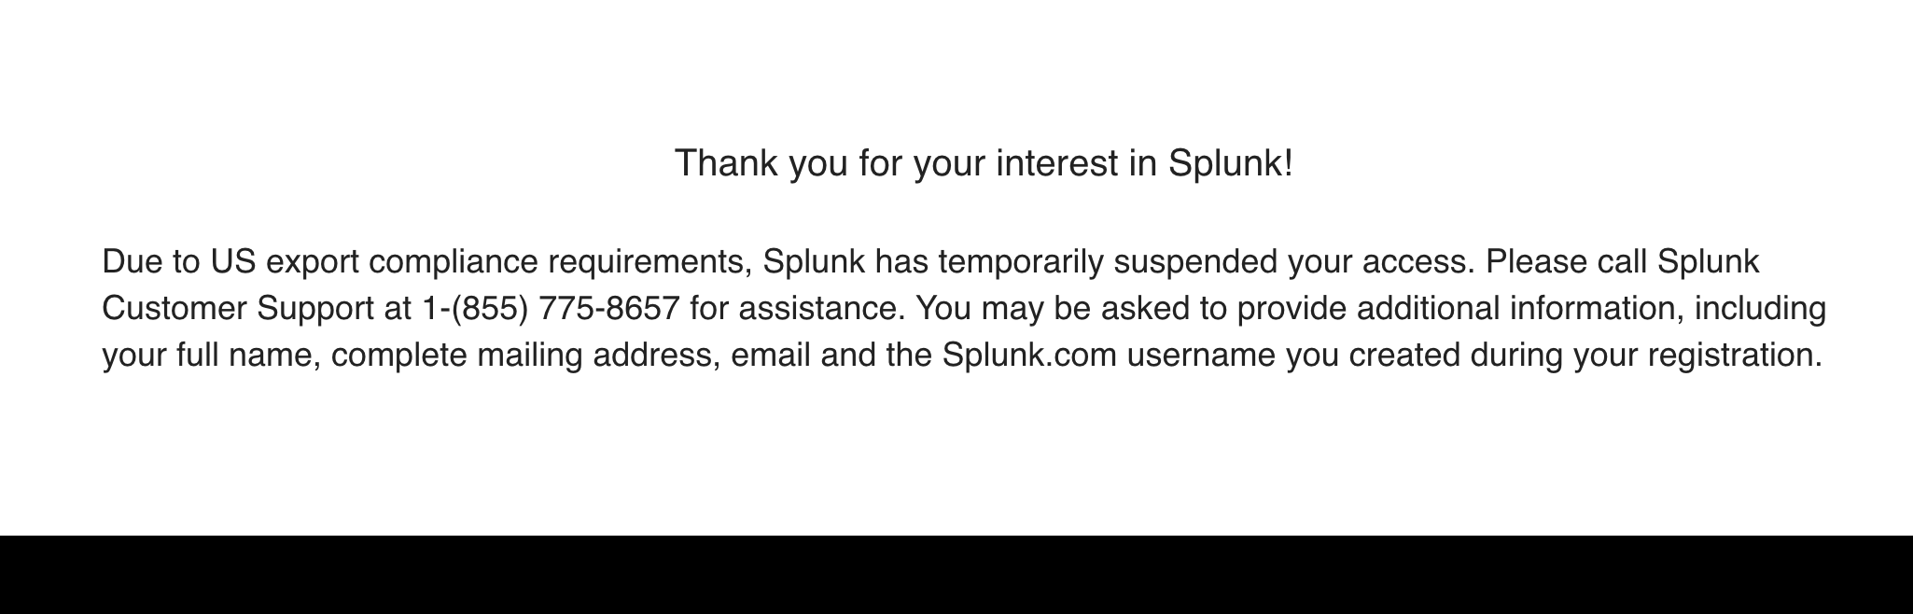

**Workaround/Fix:**

* Log in to your Pen Testing Azure Lab that was used in the previous lesson.
* Open a web browser in the main Pen Testing Azure Lab and access the same Splunk registration webpage at <https://www.splunk.com/page/sign_up/es_sandbox?redirecturl=/getsplunk/es_sandbox>.
* Complete the registration on the right side of the page: **Start Your Free Trial**
* You should receive an email within minutes.
* Log out of your Pen Testing Lab
* Access your Splunk account with the link and account sent to your email from your regular PC.
  + **Note:** If registration works fine and you **do not** receive an email within five minutes after registering, proceed to Issue 2 below.

=========================================================================

2) **Issue 2**

**Issue:** No email received after successfully registering

If within five minutes after registering, you do not receive an email with your Splunk link, username or password, follow these steps:

**Workaround/Fix:**

* Access the following temporary email webpage: <https://10minutemail.com/>
* When pulling up the page, it will provide you an email address for 10 minutes.

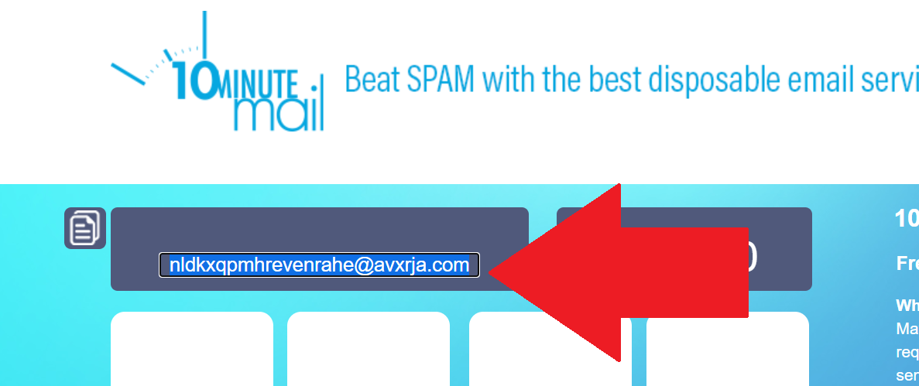

* Use the email provided to register for a Splunk account at<https://www.splunk.com/page/sign_up/es_sandbox?redirecturl=/getsplunk/es_sandbox>.
* Within five minutes, you should receive an email on the 10minutemail webpage.

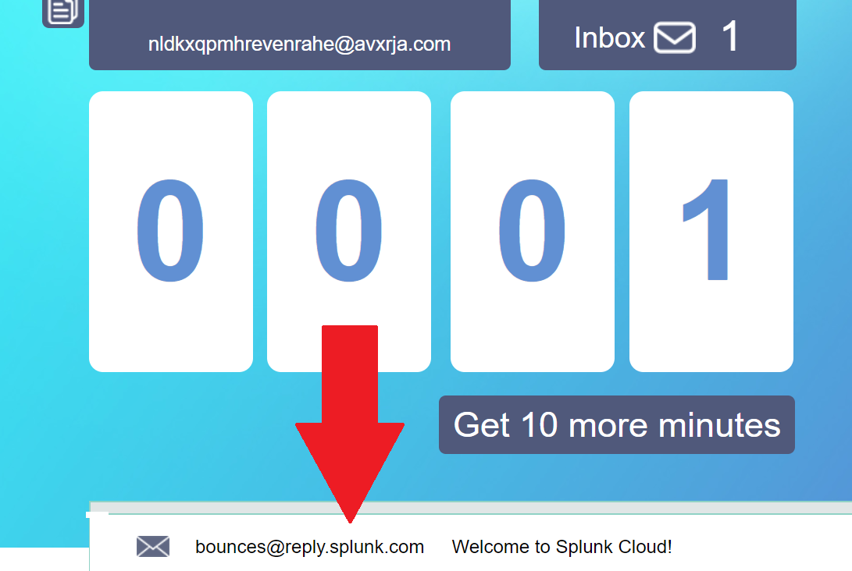

* Follow the steps to log in with your email.

© 2023 edX Boot Camps LLC. Confidential and Proprietary. All Rights Reserved.