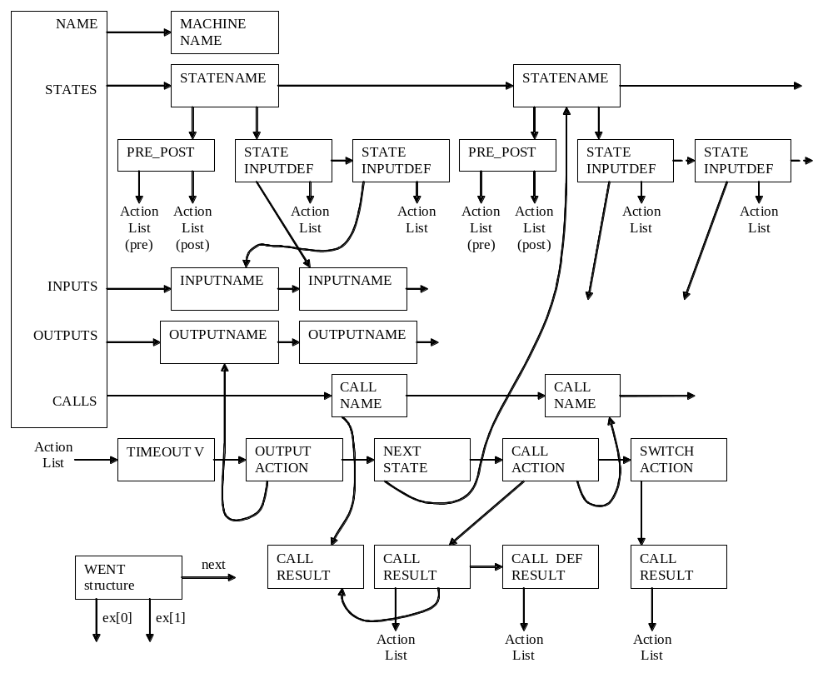call_name ex[0] always points to linked list of call_results;
These call_results never contain any ex[0] or ex[1].
call_action ex[0] points to linked list of call_results;
These call_results have action lists on ex[0],
while ex[1] points to the call_name list corresponding call_results entry.
call_action ex[1] points to call_name on calls list.

