|  |  |  |
| --- | --- | --- |
| 浙江大学信息与电子工程学院 | **集成电路原理与设计** | 2023年5月 |
| 2022-2023学年春夏学期 |



**Exercise 9**

* 1. Consider a 5 mm-long, 4 λ-wide metal2 wire in a 0.6 μm process. The sheet resistance is 0.08 Ω/□ and the capacitance is 0.2 fF/μm. Construct 3-segment L-model and 3-segment π-model for the wire. (Please present models and calculate delay).

Answer

$R=R_{□}\frac{l}{w}$

The wire width is 1.2𝜇m so the wire is 5000𝜇m/1.2𝜇m= 4167 squares in length

So, the total resistance is (0.08 $Ω/$ sq) $×$ 4167 sq) = 333 $Ω$ The total capacitance is (0.2 fF/ $μ\text{m}$) $×$ 5000 $μ$ m) = 1 pF

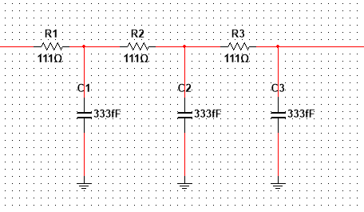

3-segment L-model

+ =

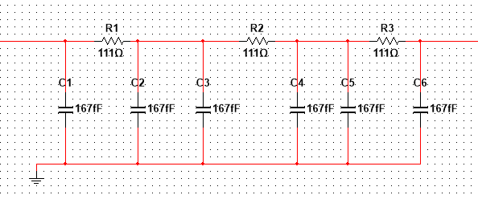

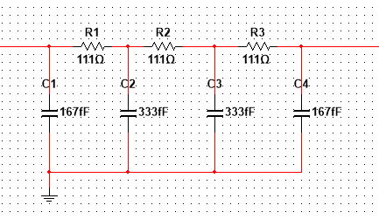

3-segment 𝝅-model

=

* 1. Assume an inverter is designed with a PMOS/NMOS ratio of 3.6 and the NMOS transistor is minimum size. (W = 0.375 $μ$ m, L = 0.25 $μ$ m, W/L =1.5). 𝑉𝑀=1.25V, 𝑉𝐷𝐷=2.5V. Please describe the voltage transfer characteristic and noise margins of CMOS inverter. (use $V_{IL}$, $V_{IH}$, ${NM}_{H}$, ${NM}_{L}$ and g). The parameters shown in table 9.1.

Table9.1

|  |  |  |  |  |  |
| --- | --- | --- | --- | --- | --- |
|  | VT0 (V) | γ  (V1/2) | VDSAT  (V) | K  (μA/V2) | λ  (V-1) |
| NMOS | 0.7 | 0.45 | 0.83 | 134 | 0.1 |
| PMOS | -0.8 | -0.4 | -1 | -50 | -0.2 |

$$K=\frac{1}{2}μC_{OX}$$

Answer

$$I_{D}\left(V_{M}\right)=K_{N}({\frac{W}{L})}_{N}{(V_{GS}-V_{THN})}^{2}\left(1+λ_{n}V_{M}\right)=68.4×{10}^{-6}A$$

$$g=\frac{-1}{I_{D}(V_{M})}×\frac{k_{n}{\frac{w}{l}}_{n}V_{DSATn}+k_{p}{\frac{w}{l}}_{p}V_{DSATp}}{λ_{n}-λ_{p}}=-24.93$$

$$V_{IH}=V_{M}-\frac{V_{M}}{g}=1.3$$

$V_{IL}=V_{M}+\frac{V_{DD}-V_{M}}{g}=1.2$

${NM}_{H}=V_{DD}-V_{IH}=1.2$ ${NM}_{L}=V_{IL}=1.2$