《量子信息基础》2021.3.22随堂作业：

- (1) Write down the indices of the following 9 crystal planes in the cubic lattice system.
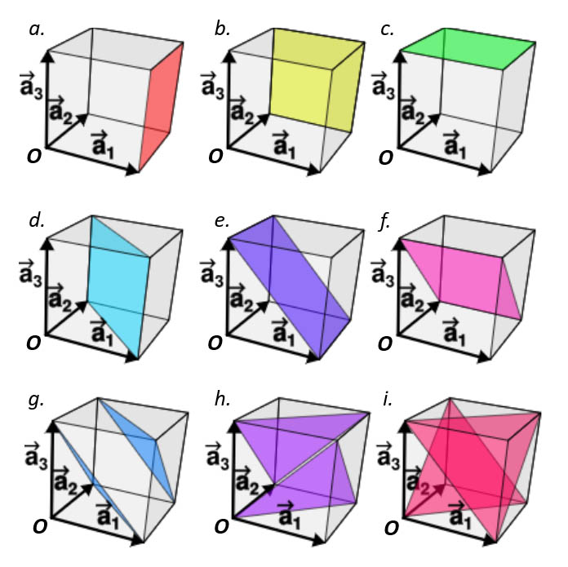
a. (1, 0, 0); b. (0, 1, 0); c. (0, 0, 1);
d. (1, 1, 0); e. (1, 0, 1); f. (0, 1, 1);
g. (1, 1, 1); h. ($\overline{1}$, 1, 1); i. (1, $\overline{1}$, 1).
以上每个写对给2分
(2) Write down the indices of the shortest lattice vector which starts from the point O and ends at the crystal planes with colors in the above figure.
a. (1, 0, 0); b. (0, 1, 0); c. (0, 0, 1);
d. (1, 1, 0); e. (1, 0, 1); f. (0, 1, 1);
g. ($\frac{1}{3}$, $\frac{1}{3}$, $\frac{1}{3}$); ($\frac{2}{3}$, $\frac{2}{3}$, $\frac{2}{3}$); h. ($-\frac{1}{3}$, $\frac{1}{3}$, $\frac{1}{3}$); (0, 0, 0); i. ($\frac{1}{3}$, $-\frac{1}{3}$, $\frac{1}{3}$); (0, 0, 0).
以上每个写对给2分
如果写成下面这样也算对
g. (1, 1, 1); h. ($\overline{1}$, 1, 1); i. (1, $\overline{1}$, 1).

- (1) Write down the reciprocal vector $\overset{⃑}{G}$ of the 1D and 2D lattice of
$$\overset{⃑}{R}=u\overset{⃑}{a}$$
$$\overset{⃑}{R}=u{\overset{⃑}{a}}_{1}+v{\overset{⃑}{a}}_{2}$$

在一维情况下，令${\overset{⃑}{a}}_{1}=a\overset{⃑}{i}$，${\overset{⃑}{a}}_{2}=\overset{⃑}{j}$，${\overset{⃑}{a}}_{3}=\overset{⃑}{k}$
$$\overset{⃑}{b}=\frac{2π}{a}\overset{⃑}{i}, \overset{⃑}{G}=u\overset{⃑}{b}$$
以上写对给10分
在二维情况下，令${\overset{⃑}{a}}_{1}=a_{1}\overset{⃑}{i}$，${\overset{⃑}{a}}_{2}=a_{2}\overset{⃑}{j}$，${\overset{⃑}{a}}_{3}=\overset{⃑}{k}$

$${\overset{⃑}{b}}_{1}=\frac{2π}{a_{1}}\overset{⃑}{i}$$
$${\overset{⃑}{b}}_{2}=\frac{2π}{a_{2}}\overset{⃑}{j}$$
$$\overset{⃑}{G}=u{\overset{⃑}{b}}_{1}+v{\overset{⃑}{b}}_{2}$$
以上写对给10分

(2) Prove that in the Bloch’s theorem, where $\overset{⃑}{G}$ is the 1D reciprocal vector.
$$u_{k}\left(x\right)=\sum_{h}{A_{h}e^{iGx}}$$
$$G=\frac{2π}{a}h, h=0, ±1, ±2, …$$
Comparing to,
$$\overset{⃑}{G}=u\frac{2π}{a}\overset{⃑}{i}$$
QED.
以上写对给10分

- (Text book* Problem 6.5)
Show that Equation 6.12 follows from Equation 6.11. Hint: First write $ψ\left(x\right)=e^{iqx}u\left(x\right)$ , which is certainly true for some $u\left(x\right)$, and then show that $u\left(x\right)$ is necessarily a periodic function of x.

从6.11式出发
$$ψ_{q}\left(x-a\right)=e^{-iqa}ψ_{q}\left(x\right)$$
我们发现波矢为$\overset{⃑}{q}$的平面波$φ_{q}\left(x\right)=e^{iqx}$ 满足布洛赫定理:
$$φ_{q}\left(x-a\right)=e^{iq\left(x-a\right)}=e^{iqx}e^{-iqa}=e^{-iqa}φ_{q}\left(x\right)$$
写出平面波满足布洛赫定理给7分

我们还发现波矢为$\overset{⃑}{q}+\overset{⃑}{G}$的平面波满足布洛赫定理，其中$\overset{⃑}{G}=\frac{2π}{a}h,$是一维周期性晶格的倒格矢
$$φ_{q+G}\left(x-a\right)=e^{i\left(q+G\right)\left(x-a\right)}=e^{-i\left(q+G\right)a}φ_{q+G}\left(x\right)=e^{-iqa}φ_{q+G}\left(x\right)$$
写出倒格矢周期性叠加的平面波满足布洛赫定理给10分

令布洛赫波$φ_{q}\left(x\right)$ 为平面波$φ_{q+G}\left(x\right)=e^{i\left(q+G\right)x}$的线性叠加
$$ψ_{q}\left(x\right)=e^{iqx}u_{q}\left(x\right)=e^{iqx}\sum_{h}{A_{h}e^{iGx}}=\sum_{h}{A_{h}e^{i\left(q+G\right)x}}$$
写出关于u(x)的布洛赫定理给10分

其中
$$u_{q}\left(x\right)=\sum_{h}{A_{h}e^{iGx}}$$
写出关于u(x)的表达式给7分

* David J. Griffiths, and Darrell F. Schroeter, Introduction to Quantum Mechanics (3rd Edition), Cambridge University Press (2018).

