《量子信息基础》2021.3.8随堂作业：

- <即教材*问题1.5> 40分
Consider the wave function
$Ψ\left(x,t\right)=Ae^{-λ\left|x\right|}e^{-iωt}$
where $A$, λ, and $ω$ are positive real constants.
- Normalize $Ψ$.

$$\int{{\left|Ψ\left(x,t\right)\right|}^{2}dx}=\int{{\left|Ae^{-λ\left|x\right|}e^{-iωt}\right|}^{2}dx}={\left|A\right|}^{2}\int_{-∞}^{∞}{e^{-2λ\left|x\right|}dx}=2{\left|A\right|}^{2}\int_{0}^{∞}{e^{-2λx}dx}=\frac{{\left|A\right|}^{2}}{λ}=1$$
推导思路正确5分
$$∴A=\sqrt{λ}$$
给出正确答案5分

- Determine the expectation values of $x$ and $x^{2}$.

$$〈x〉=\int_{-∞}^{+∞}{x{\left|Ψ\left(x,t\right)\right|}^{2}dx}=\int_{-∞}^{∞}{x{\left|Ae^{-λ\left|x\right|}\right|}^{2}dx}={\left|A\right|}^{2}\int_{-∞}^{∞}{xe^{-2λ\left|x\right|}dx}=λ\int_{-∞}^{∞}{xe^{-2λ\left|x\right|}dx}$$
⸪ $xe^{-2λ\left|x\right|}$是奇函数 ⸫$〈x〉=0$
给出正确推导和答案给5分，只给出推导或者答案给3分

$$〈x^{2}〉=\int_{-∞}^{+∞}{x^{2}{\left|Ψ\left(x,t\right)\right|}^{2}dx}={\left|A\right|}^{2}\int_{-∞}^{∞}{x^{2}e^{-2λ\left|x\right|}dx}=2λ\int_{0}^{∞}{x^{2}e^{-2λx}dx}=-\int_{0}^{∞}{x^{2}de^{-2λx}}=-{\left.x^{2}e^{-2λx}\right|}_{0}^{∞}+\int_{0}^{∞}{e^{-2λx}dx^{2}}=\int_{0}^{∞}{2xe^{-2λx}dx}=-\frac{1}{λ}\int_{0}^{∞}{xde^{-2λx}}=-\frac{1}{λ}{\left.xe^{-2λx}\right|}_{0}^{∞}+\frac{1}{λ}\int_{0}^{∞}{e^{-2λx}dx}=-\frac{1}{2λ^{2}}\int_{0}^{∞}{de^{-2λx}}=\frac{1}{2λ^{2}}$$
给出正确推导和答案给5分，只给出推导或者答案给3分

- Find the standard deviation of $x$. Sketch the graph of ${\left|Ψ\right|}^{2}$, as a function of $x$, and mark the points $\left(〈x〉-σ\right)$ and $\left(〈x〉+σ\right)$, to illustrate the sense in which $σ$ represents the “spread” in $x$.

$$σ=\sqrt{〈x^{2}〉-{〈x〉}^{2}}=\frac{1}{\sqrt{2}λ}$$
给出正确答案给5分
${\left|Ψ\right|}^{2}$的图像如下图所示：
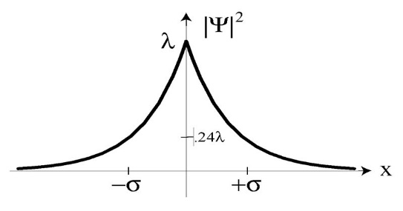
给出正确曲线和$\left(〈x〉±σ\right)$位置给5分
只给出一项给3分

- What is the probability that the particle would be found outside this range?
$$P=2\int_{σ}^{∞}{{\left|Ψ\left(x,t\right)\right|}^{2}dx}=2λ\int_{σ}^{∞}{e^{-2λx}dx}=-\int_{σ}^{∞}{de^{-2λx}}=e^{-2λσ}=e^{-\sqrt{2}}=0.2431$$

给出推导给5分
给出结果$e^{-\sqrt{2}}$或者$0.2431$给5分

- <PPT最后一页> 30分
A photon propagates in the $z$ direction and passes a linear optical polarizer which is oriented in the $x$ direction (see figure below). The state in Figure (a) is $ψ_{a}$ while the state in Figure (b) is $ψ_{b}$.
- Write done the formula of $ψ_{c}$, assuming the light beam is polarized with an angle of α to the $x$ axis.
$${ψ }_{α}=\cos{α}∙{ψ }_{x}+\sin{α}∙{ψ }_{y}$$
给出正确答案给10分
- How much is the probability that a single photon could pass the polarizer in (c)?
$$P={\left|\cos{α}\right|}^{2}$$
给出正确答案给10分

- How does the system maintain the normalization condition?
$${\left|\cos{α}\right|}^{2}+{\left|\sin{α}\right|}^{2}=1$$
给出正确答案给10分

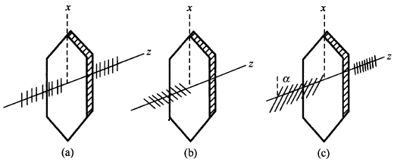

- <即教材*问题1.15> 40分
Show that
$\frac{d}{dt}\int_{-∞}^{∞}{Ψ_{1}^{*}Ψ_{2}dx}=0$
for any two (normalizable) solutions to the Schrödinger equation (with the same $V\left(x\right)$), $Ψ_{1}$and $Ψ_{2}$.

$$\frac{d}{dt}\int_{-∞}^{∞}{Ψ_{1}^{*}Ψ_{2}dx}=\int_{-∞}^{∞}{\frac{∂Ψ_{1}^{*}}{∂t}Ψ_{2}+Ψ_{1}^{*}\frac{∂Ψ_{2}}{∂t}dx}$$
推导到这步给5分
复共轭函数的薛定谔方程
$$-iℏ\frac{∂Ψ_{1}^{*}}{∂t}=-\frac{ℏ^{2}}{2m}\frac{∂^{2}Ψ_{1}^{*}}{∂x^{2}}+VΨ_{1}^{*}$$
$$iℏ\frac{∂Ψ_{2}}{∂t}=-\frac{ℏ^{2}}{2m}\frac{∂^{2}Ψ_{2}}{∂x^{2}}+VΨ_{2}$$
给出正确的复共轭函数薛定谔方程给5分
$$\frac{d}{dt}\int_{-∞}^{∞}{Ψ_{1}^{*}Ψ_{2}dx}=\int_{-∞}^{∞}{\left[\frac{ℏ}{2im}\frac{∂^{2}Ψ_{1}^{*}}{∂x^{2}}-\frac{V}{iℏ}Ψ_{1}^{*}\right]Ψ_{2}+Ψ_{1}^{*}\left[-\frac{ℏ}{2im}\frac{∂^{2}Ψ_{2}}{∂x^{2}}+\frac{V}{iℏ}Ψ_{2}\right]dx}$$
$$\frac{d}{dt}\int_{-∞}^{∞}{Ψ_{1}^{*}Ψ_{2}dx}=\int_{-∞}^{∞}{\frac{ℏ}{2im}\frac{∂^{2}Ψ_{1}^{*}}{∂x^{2}}Ψ_{2}-Ψ_{1}^{*}\frac{ℏ}{2im}\frac{∂^{2}Ψ_{2}}{∂x^{2}}dx}$$
推导到这步给5分
$$\frac{d}{dt}\int_{-∞}^{∞}{Ψ_{1}^{*}Ψ_{2}dx}=\frac{ℏ}{2im}\int_{-∞}^{∞}{\frac{∂}{∂x}\left(\frac{∂Ψ_{1}^{*}}{∂x}Ψ_{2}-Ψ_{1}^{*}\frac{∂Ψ_{2}}{∂x}\right)dx}$$
推导到这步给5分
$$\frac{d}{dt}\int_{-∞}^{∞}{Ψ_{1}^{*}Ψ_{2}dx}=\frac{ℏ}{2im}{\left.\left(\frac{∂Ψ_{1}^{*}}{∂x}Ψ_{2}-Ψ_{1}^{*}\frac{∂Ψ_{2}}{∂x}\right)\right|}_{-∞}^{∞}$$
推导到这步给5分
$$\frac{d}{dt}\int_{-∞}^{∞}{Ψ_{1}^{*}Ψ_{2}dx}=0$$
给出正确答案5分

* David J. Griffiths, and Darrell F. Schroeter, Introduction to Quantum Mechanics (3rd Edition), Cambridge University Press (2018).

