- State diagram
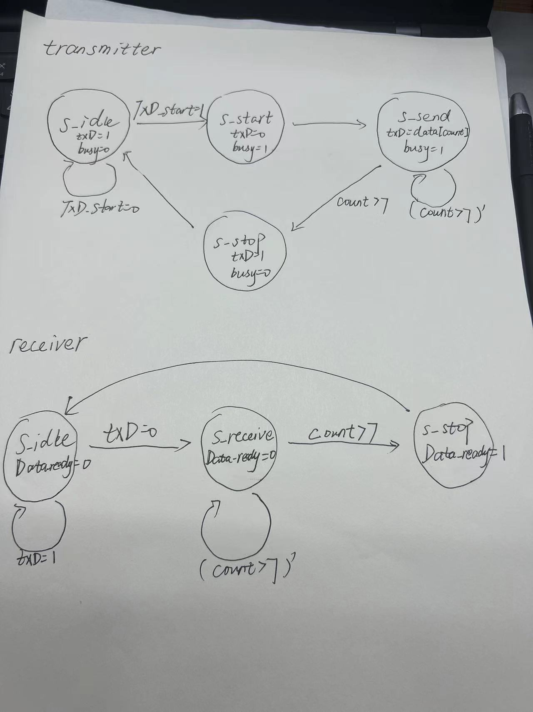
二、the simulation results
1.simulation results for transimitter
eg1.TxD_data=01010101
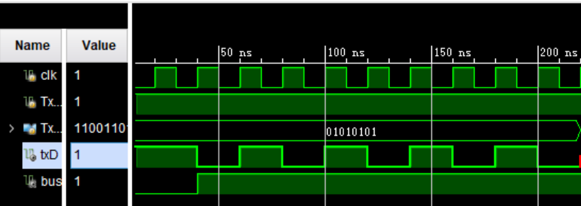
eg2.TxD_data=11001101
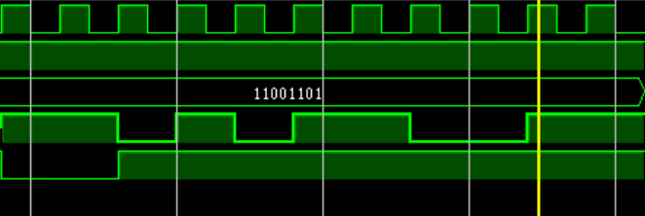
2.simulation results for RS232
eg1.datain=01010101
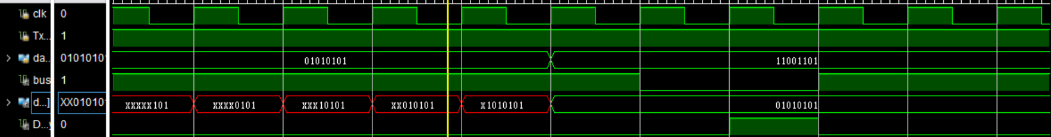
eg2.datain=11001101
eg3.datain=11111111
eg4.datain=00101010
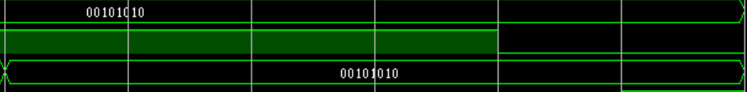
三、source code
1.design source
a)transister
module transmitter(
input clk,
input TxD_start,
input [7:0]TxD_data,
output reg txD,
output reg busy
);
parameter s_idle=0;
parameter s_start=1;
parameter s_send=2;
parameter s_stop=3;
reg [1:0]state;
reg [3:0]count;
always @(posedge clk) begin
case(state)
s_idle:begin
txD=1;
busy=0;
if(TxD_start) state=s_start;
end
s_start:begin
txD=0;
busy=1;
count=0;
state=s_send;
end
s_send:begin
txD=TxD_data[count];
busy=1;
if(count<=7) count=count+1'b1;
else state=s_stop;
end
default:begin
txD=1;
busy=0;
state=s_idle;
end
endcase
end

endmodule
b)receiver
module receiver(
input clk,
input RxD,
output reg [7:0]data,
output reg Data_ready
);
parameter s_idle=0;
parameter s_receive=1;
parameter s_stop=2;
reg [1:0]state;
reg [3:0]count;
always @(posedge clk)begin
case(state)
s_idle:begin
Data_ready=0;
count=0;
if(!RxD) state=s_receive;
end
s_receive:begin
Data_ready=0;
data[count]=RxD;
if(count<=7) count=count+1'b1;
else state=s_stop;
end
default:begin
Data_ready=1;
state=s_idle;
end
endcase
end
endmodule
c)RS232
module RS232(
input clk,
input TxD_start,
input [7:0]datain,
output busy,
output [7:0]dataout,
output Data_ready
);

wire xD;
transmitter t0(
.clk(clk),
.TxD_start(TxD_start),
.TxD_data(datain),
.busy(busy),
.txD(xD)
);
receiver r1(
.clk(clk),
.RxD(xD),
.Data_ready(Data_ready),
.data(dataout)
);
endmodule
2.simulation source
a)transmitter
module tranmitter_tb( );
reg clk;
reg TxD_start;
reg [7:0]TxD_data;
wire txD;
wire busy;
transmitter t1(
.clk(clk),
.TxD_start(TxD_start),
.TxD_data(TxD_data),
.txD(txD),
.busy(busy)

);
initial begin
clk=1;
TxD_start=0;
end
always #10 clk=~clk;
initial begin

TxD_start=1;
TxD_data=8'b01010101;
#220
TxD_data=8'b11001101;
#240 $stop;
end
endmodule
b)RS232
module RS232_tb();
reg clk;
reg TxD_start;
reg [7:0]datain;
wire busy;
wire [7:0]dataout;
wire Data_ready;
RS232 r1(
.clk(clk),
.TxD_start(TxD_start),
.datain(datain),
.busy(busy),
.dataout(dataout),
.Data_ready(Data_ready)
);
initial begin
clk=1;
TxD_start=0;
end
always #10 clk=~clk;
initial begin
TxD_start=1;
datain=8'b01010101;
#220
datain=8'b11001101;
#220
datain=8'b11111111;
#220
datain=8'b00101010;
end
endmodule

