2024 May/June Paper 12

The total mass of steel contains recycled steel and new steel.

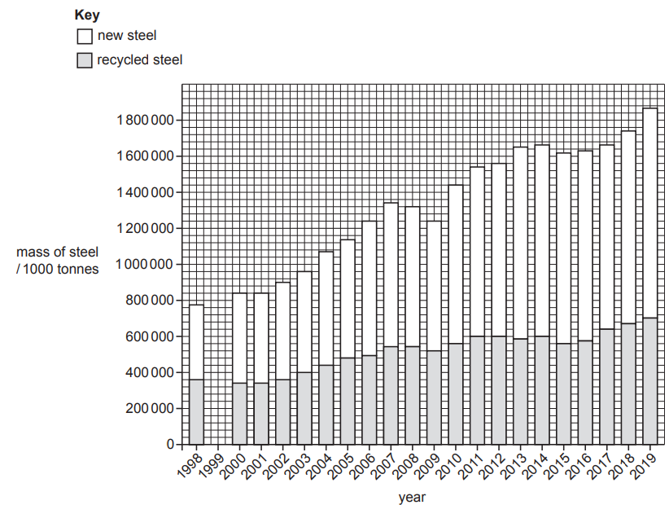

1. Use the data in the table to complete the graph.

1. Describe the trend in the production of recycled steel between 2000 and 2019. ...................................................................................................................................................................................................................................................................................................................................................................................................................................................................................................................................................................... [2]
2. Calculate the percentage of steel production from recycled steel in 1999. Give your answer to one decimal place.

.......................................................% [1]

The graph shows the global availability of drinking water supplies in 2015–2020.

1. State the percentage of the world population who had access to safely managed water in 2020.

.......................................................% [1]

1. Suggest three reasons why some people do not have access to safely managed water.

1....................................................................................................................................................................................................................................2....................................................................................................................................................................................................................................3................................................................................................................................................................................................................................[3]

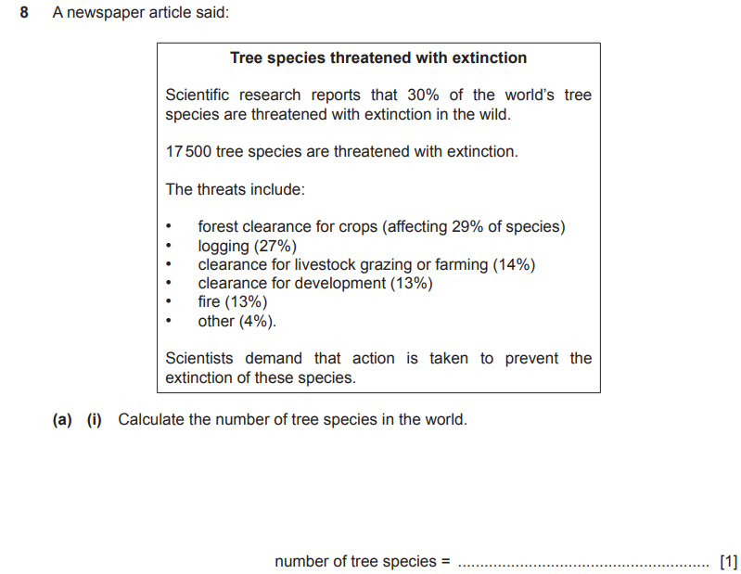

4

ANSWERS

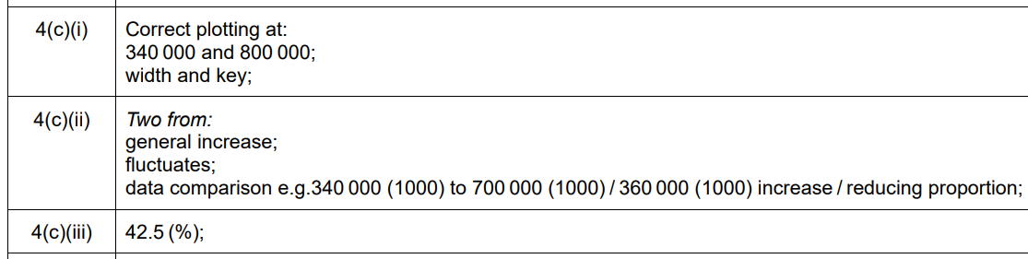

2024 MAY/JUNE PAPER 22

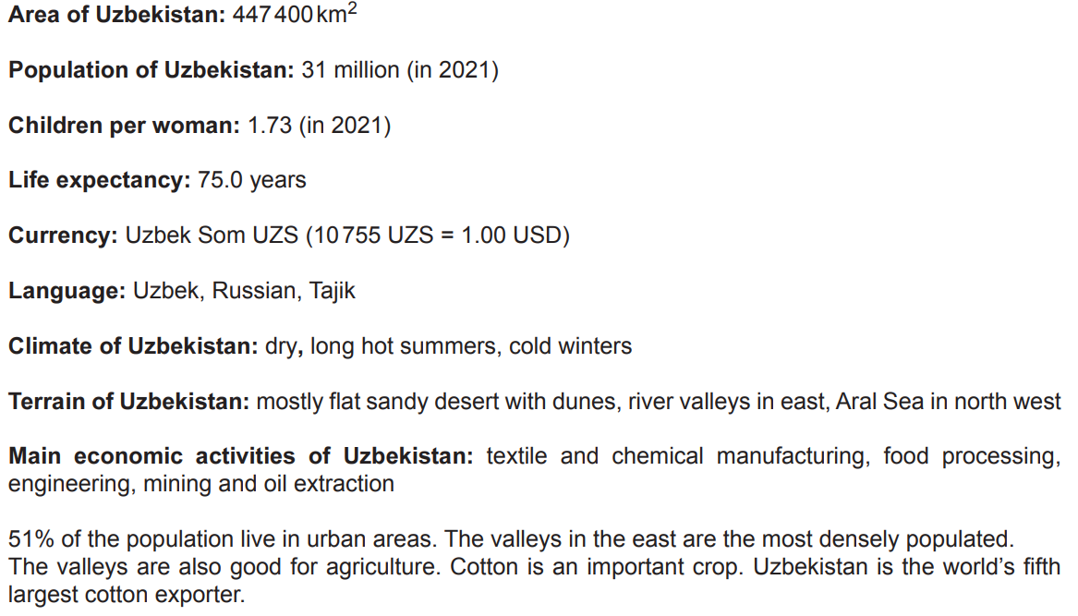

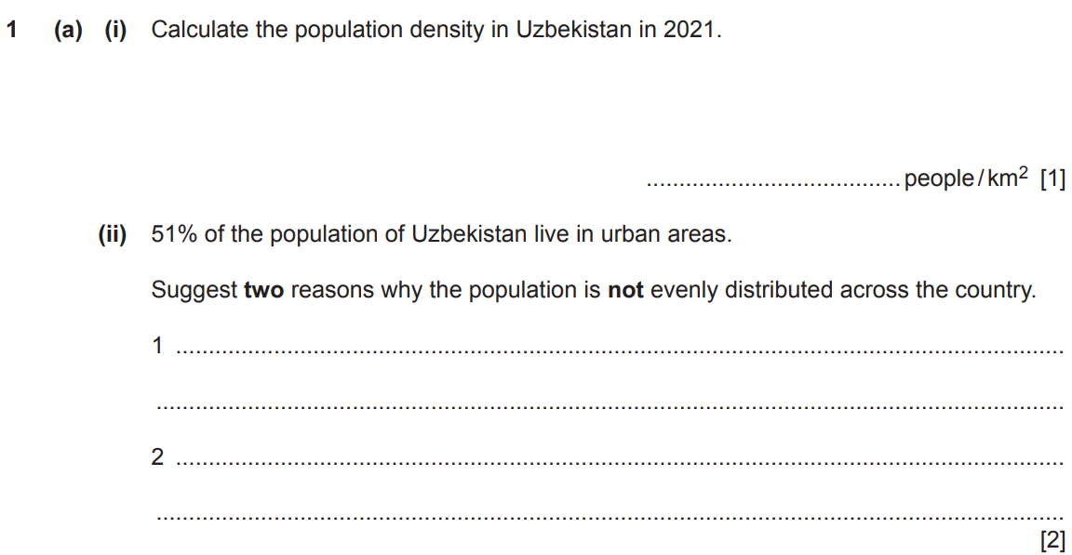

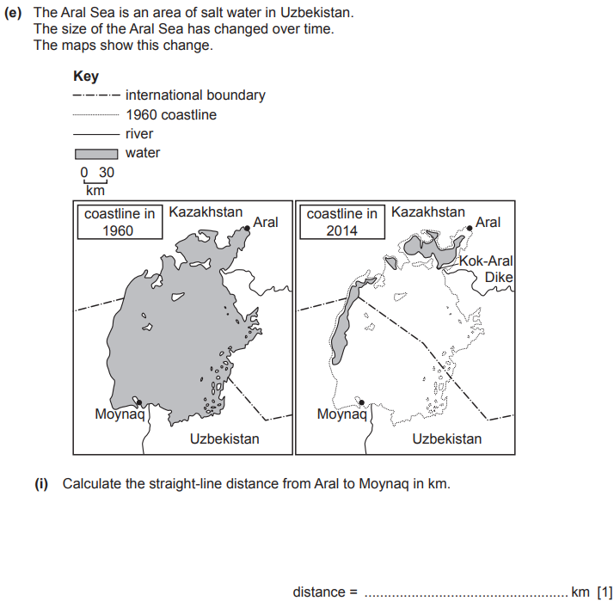

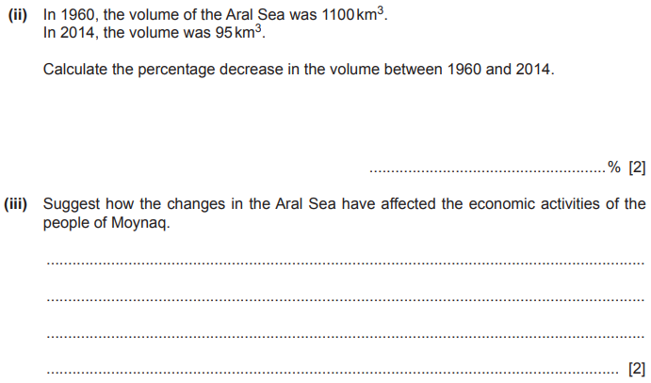

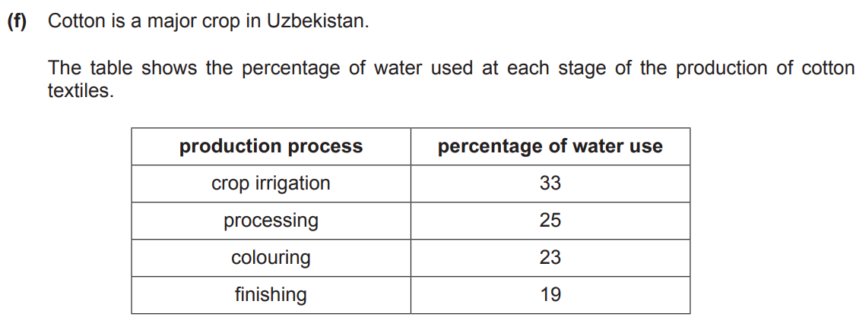

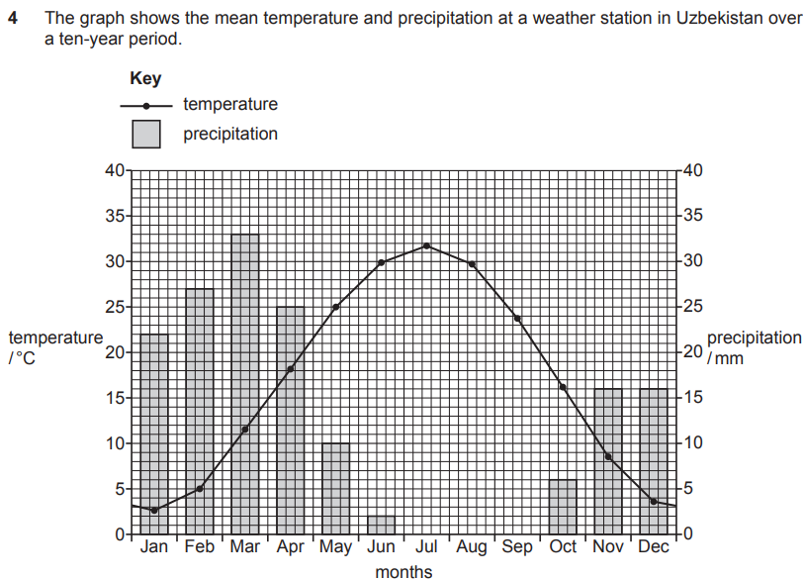

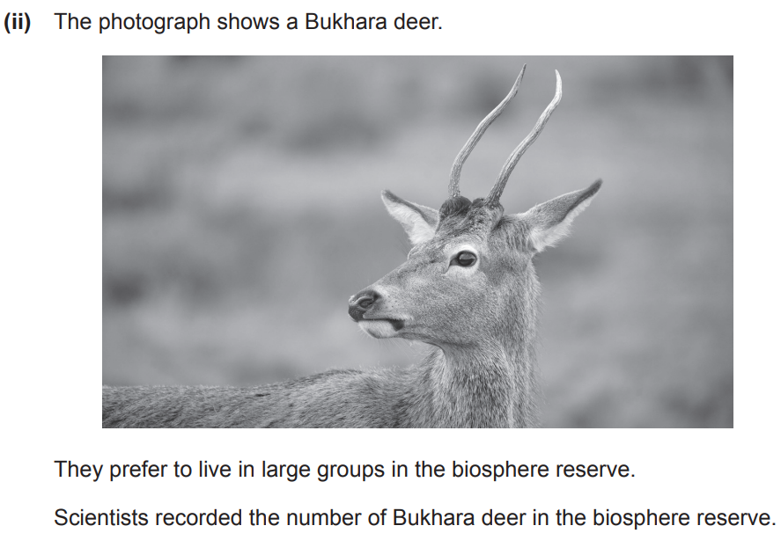

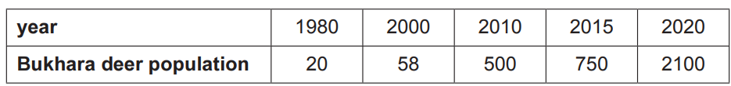

4

S23 P22

4

W24 P22

4



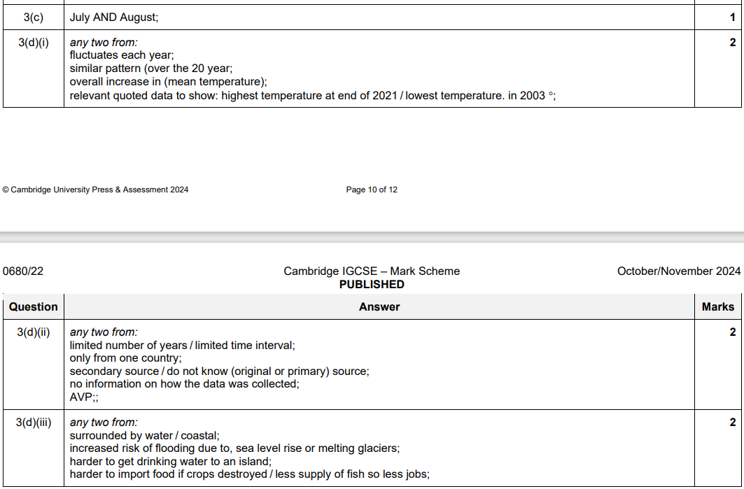

S23 P22



