QUESTIONNAIRE

S24 P22

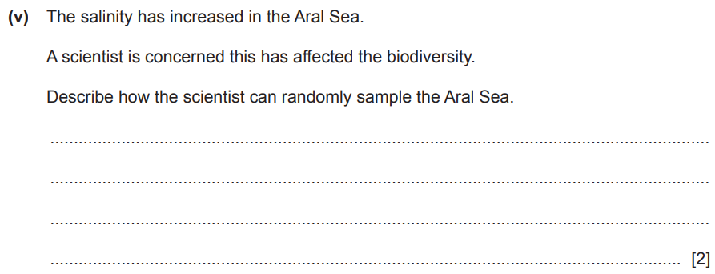

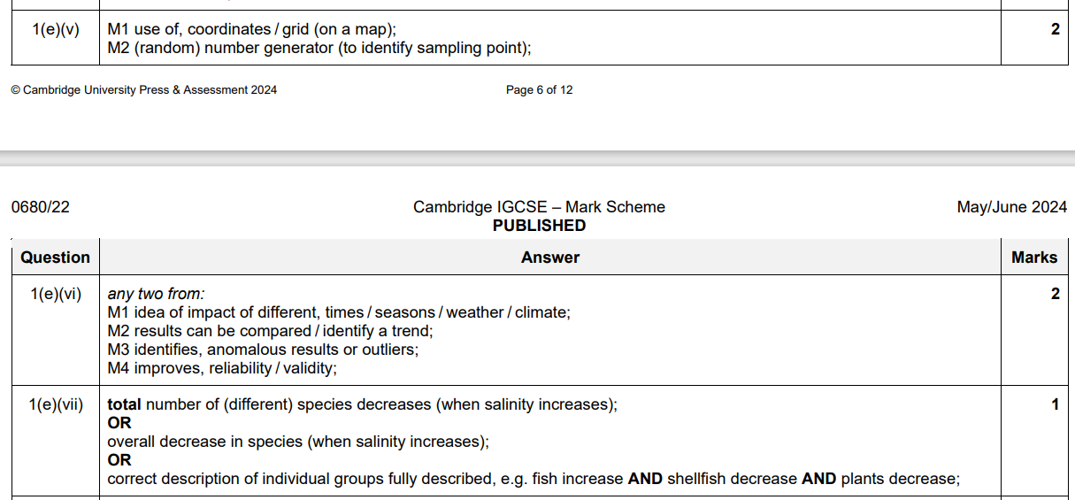

S22P22

S23 PAPER 23

1. Suggest why the student decides to use Plan B. ................................................................................................................................................................................................................................................................................ [1]
2. Suggest a method the student can use to select the nine trees at random. ...................................................................................................................................................................................................................................................................................................................................................................................................................................................................................................................................................................... [2]

vi) Describe how the student can use a quadrat to record the number of different plant species. ............................................................................................................................................................................................................................................................................................................................................................................................................................................................................................................................................................................................................................................................................................................................................................................................................................................................................................................................................................................................................. ........................................................................................................................................... ........................................................................................................................................... ..................................................................................................................................... [5]

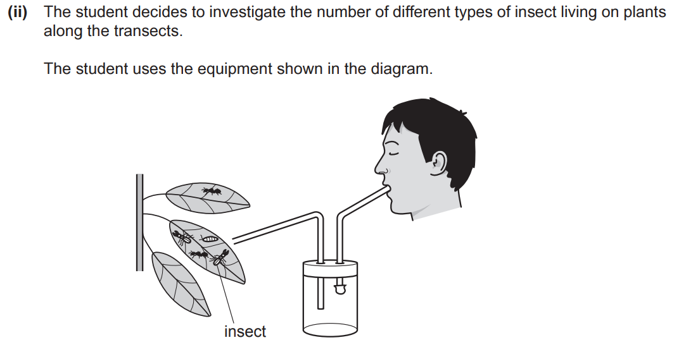

State the name of the equipment used by the student. ..................................................................................................................................... [1]

1. The student wants to compare the number of different types of insect on the leaves of plants at the beginning and end of each transect. Suggest how the student can ensure that the comparison is fair. ........................................................................................................................................... ........................................................................................................................................... ........................................................................................................................................... ..................................................................................................................................... [2]
2. A screenshot of a test

   AI-generated content may be incorrect.

W24 P22

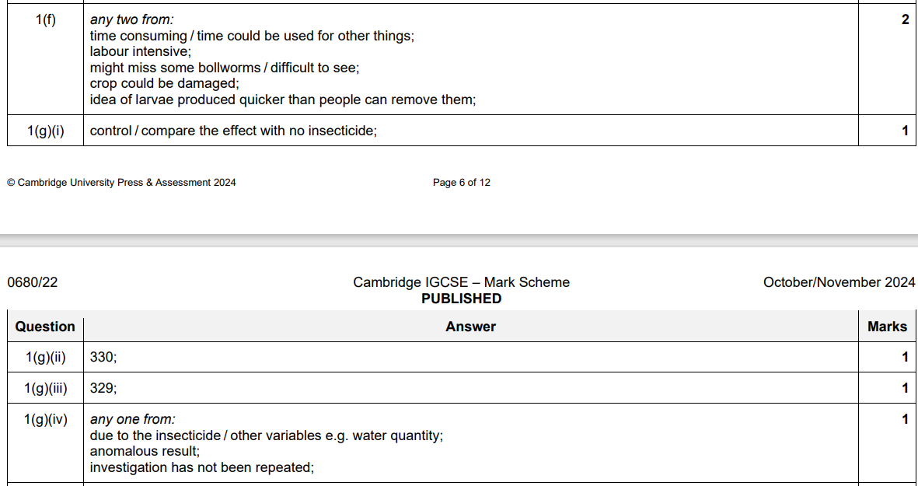

S23 P22

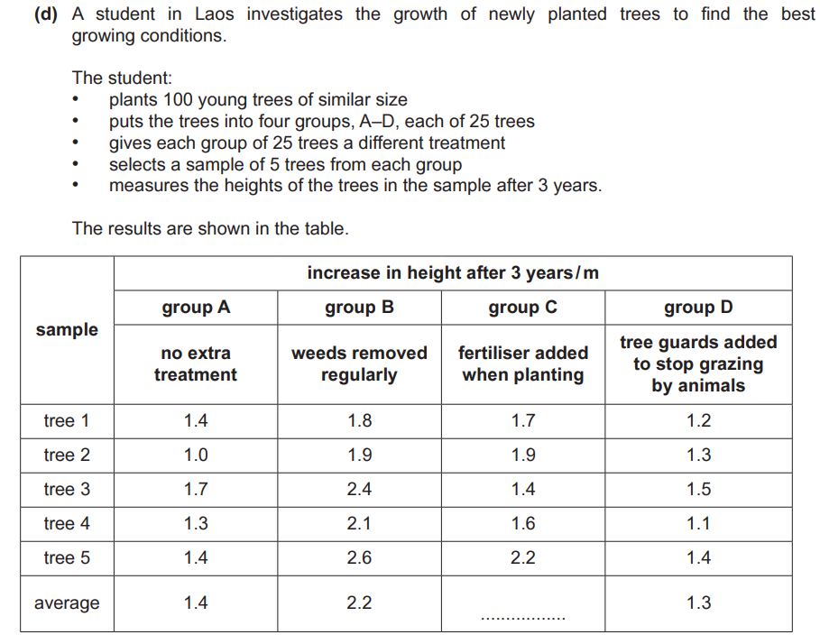

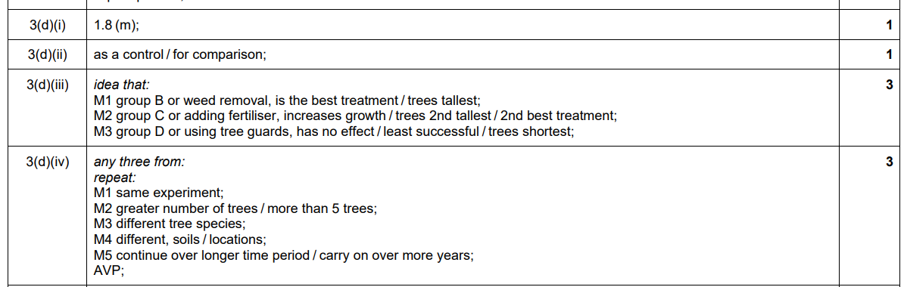

S22 P22



