Low confirmed post-treatment failure after a pretomanid-free bedaquiline-delamanid-linezolid strategy with or without moxifloxacin for rifampicin-resistant tuberculosis in China
Preferred category: TBScience abstract
Approximate abstract word count: 295
Polished Abstract
Background: Pretomanid-containing short-course regimens have reshaped treatment expectations for rifampicin-resistant tuberculosis (RR-TB), but pretomanid remains unavailable in some settings. We evaluated post-treatment outcomes of a pretomanid-free strategy based on bedaquiline, delamanid and linezolid, with or without moxifloxacin (BDL/M), in an ongoing strategy-guided clinical study in China.
Methods: We conducted an interim descriptive analysis of protocol-consistent participants managed with BDL or BDLM. Because composite unfavorable outcomes may overstate biological treatment failure when follow-up attrition is substantial, we reconstructed strict post-treatment endpoints that separated confirmed failure/relapse from loss to follow-up and withdrawal. For this analysis, the primary endpoint was confirmed failure/relapse by 6 months after treatment completion; the secondary endpoint was confirmed failure/relapse by 12 months. Month-2 culture conversion and end-of-treatment culture status were also summarized.
Results: Among 122 entered records, 121 unique participants remained after deduplication; 108 protocol-consistent participants were included (49 BDL, 59 BDLM). Among evaluable participants, month-2 culture conversion was 90/101 (89.1%; 95% CI 81.3-94.4), and end-of-treatment culture negativity was 78/78 (100.0%; 95% CI 95.4-100.0). Confirmed failure/relapse occurred in 2/108 participants by 6 months after treatment completion (1.9%; 95% CI 0.2-6.5) and remained 2/108 by 12 months (1.9%; 95% CI 0.2-6.5). At 6 months, 17/108 participants (15.7%) were classified as lost to follow-up and 8/108 (7.4%) as withdrawn; at 12 months, these proportions were 36/108 (33.3%) and 8/108 (7.4%), respectively. Both confirmed failure/relapse events occurred in the BDL group; none were observed in the BDLM group, although treatment allocation was strategy-guided rather than randomized.
Conclusions: In this interim analysis from a pretomanid-unavailable setting, a pretomanid-free BDL/M strategy showed strong early microbiological response and a low rate of confirmed post-treatment failure/relapse. Apparent long-term unfavorable outcomes were driven primarily by follow-up attrition rather than confirmed biological recurrence. Participants classified as lost to follow-up at 12 months remain under active tracing.

Preferred Figure
Key efficacy signals of a pretomanid-free BDL/M strategy for RR-TB in China
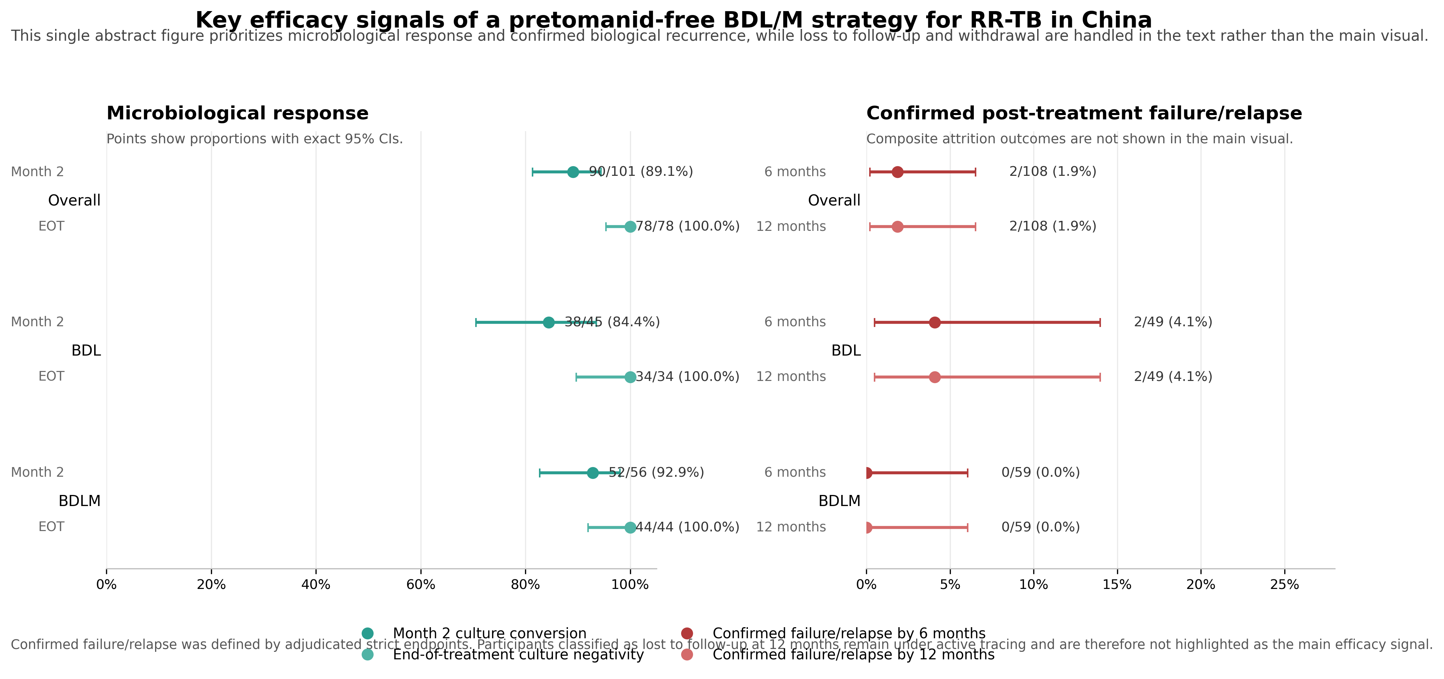
Figure. Key efficacy signals of a pretomanid-free BDL/M strategy for rifampicin-resistant tuberculosis in China. Left panel shows month-2 culture conversion and end-of-treatment culture negativity; right panel shows confirmed failure/relapse by 6 and 12 months after treatment completion. Points represent proportions and whiskers exact 95% confidence intervals. Loss to follow-up and withdrawal are described in the text; participants classified as lost to follow-up at 12 months remain under active tracing.

Submission Notes
- Keep the main efficacy phrase as 'confirmed failure/relapse'.
- Avoid causal claims between BDL and BDLM because treatment allocation was strategy-guided rather than randomized.
- If the abstract system has a strict word cap, shorten the Methods paragraph first.

