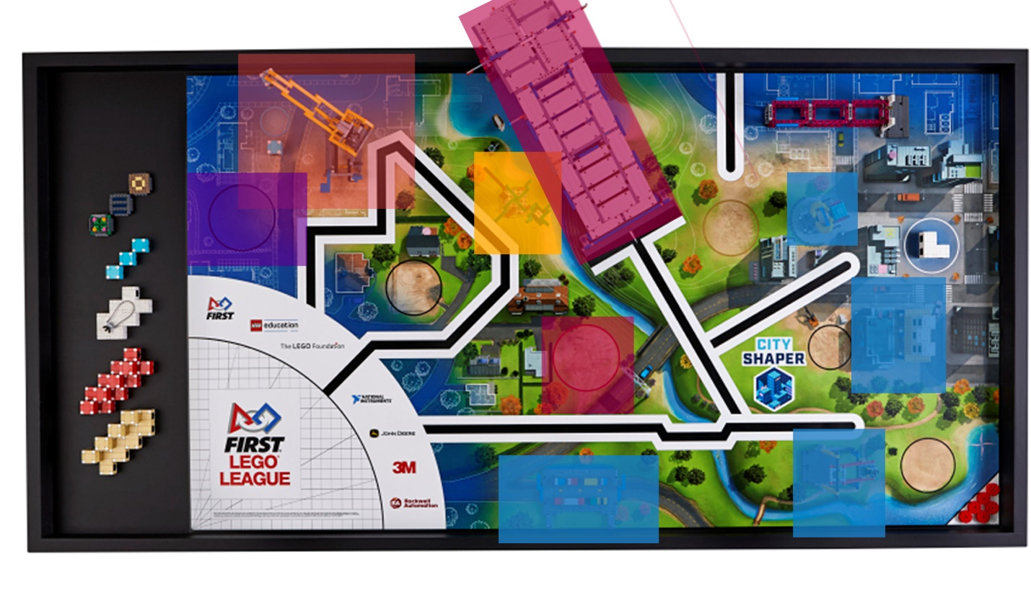

**Zone 1: Pushes Both Levers Under the Crane Model causing the Model to Rotate and Drops the Top Block on the Lower Block-31 Seconds**

**Zone 2: Lifts up the Traffic Jam Model Using the Arm, Trips the Swing Mission Using a Flexible Tubing, and Uses the Attachment on the Back on the Robot to knock Down Three Beams. It also flips over the Elevator -51 Seconds**

**Zone 3: The Funnel on the Tree Attachment leads it into the Tree Mission Model while Another Arm on the Robot puts the Bat onto the Tree -16 Seconds**

**Zone 4: The Robot pushes the Blocks into the Black Circle. The Innovative Architecture is on the Attachment above the Blocks- 13 Seconds**

**Zone 5: The Robot carries the Red Blocks to the Red Circle, the Robot Arm lifts the Attachment, releasing the Blocks in the Red Circle. The Robot Squares Up against the Line and turns. Then it turns the robot’s Arm and Pushes the Attachment Off. The Robot turns 180 degrees and then Drives Up the Ramp- 46 Seconds**