FERNANDO LUCATELLI NUNES
Ph.D. in Mathematics

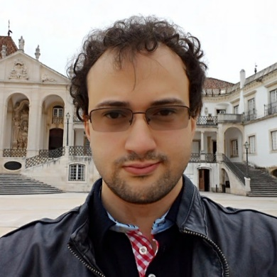
My research interests and contributions have revolved around the theory and applications of low and higher dimensional categorical structures, mostly with a viewpoint from two and three-dimensional universal algebra.
Currently, I am studying Computer Sciences at the Software Technology Group of the Utrecht University, under supervision of Professor Matthijs Vákár.

- Research
- Talks
- Academic positions/stays
- Organization of seminars/events
- Mathematical Genealogy
- Further information

Past Academic Positions:
- Since Dec/2018: Research Fellow, Junior Researcher. University of Coimbra. Portugal.
  - Member of the Centre for Mathematics, University of Coimbra
  - Research Group: Algebra, Logic and Topology
  - 03/2020-12/2020: Faculty Member of the Joint PhD Program in Mathematics University of Coimbra|University of Porto

- 04/11/2019-18/11/2019: Visiting Researcher. University of Cape Town. Cape Town, South Africa.
  - Keywords: Grothendieck descent theory and Janelidze-Galois theory

- 06/2018-01/2019: Invited Assistant Professor. University of Coimbra. Portugal.
  - Undergraduate Program in Mathematics
  - Topology and Linear Analysis

- 07/05/2018-22/05/2018: Visiting Researcher. Institut de Recherche en Mathématique et Physique, Université catholique de Louvain. Louvain-la-Neuve, Belgium.
  - Supported by the Institut de Recherche en Mathématique et Physique and by the Center for Mathematics, University of Coimbra

- 04/2018-12/2018: Postdoctoral Fellow. Centre for Mathematics, University of Coimbra. Portugal.
  - Research Group: Algebra, Logic and Topology

- 09/2012-01/2018: PhD student in Pure Mathematics. UC|UP joint PhD Program in Mathematics. University of Coimbra. Portugal.
  - Thesis: Pseudomonads and Descent
  - Supervisor: Professor Dr. Maria Manuel Clementino
  - 18/11/2018-24/01/2018: PhD student at Center for Mathematics, University of Coimbra
  - Research Group: Algebra, Logic and Topology

