FERNANDO LUCATELLI NUNES
Ph.D. in Mathematics

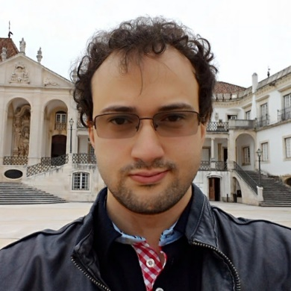
My research interests and contributions have revolved around the theory and applications of low and higher dimensional categorical structures, mostly with a viewpoint from two and three-dimensional universal algebra.
Currently, I am studying Computer Sciences at Utrecht University, under supervision of Professor Matthijs Vákár.

- Research
- Talks
- Academic positions/stays
- Organization of seminars/events
- Mathematical Genealogy
- Further information

Organization of Seminars:
- 12/2019 -12/2020: I was the organizer of the Algebra, Logic and Topology Seminar of the Center for Mathematics, University of Coimbra. Portugal.
(Co)organization of Events:
- XII Portuguese Category Seminar. University of Coimbra, Portugal. 2019.
- Workshop on Algebra, Logic and Topology. University of Coimbra, Portugal. 2018.

