FERNANDO LUCATELLI NUNES
Ph.D. in Mathematics

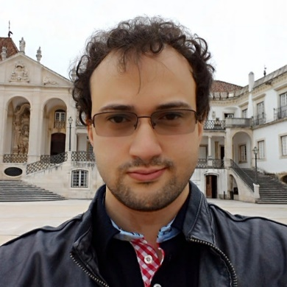
My research interests and contributions have revolved around the theory and applications of low and higher dimensional categorical structures, mostly with a viewpoint from two and three-dimensional universal algebra.
Currently, I am studying Computer Sciences at Utrecht University, under supervision of Professor Matthijs Vákár.

- Research
- Talks
- Academic positions/stays
- Organization of seminars/events
- Mathematical Genealogy
- Further information

- I earned my Ph.D. (in Mathematics) with summa cum laude from University of Coimbra and University of Porto (UC|UP joint PhD Program in Mathematics), in 2018.
  - Thesis: Pseudomonads and Descent
  - Keywords: Pseudomonads; Coherence; Adjoint Triangles; Biadjunction; Categorical Structures; Bicategories.
  - Supervisor: Professor Dr. Maria Manuel Clementino.

