FERNANDO LUCATELLI NUNES
Ph.D. in Mathematics

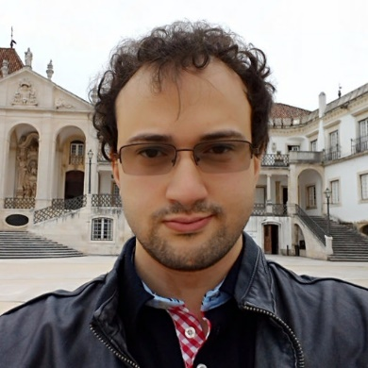
My research interests and contributions have revolved around the theory and applications of low and higher dimensional categorical structures, mostly with a viewpoint from two and three-dimensional universal algebra.
Currently, I am studying Computer Sciences at Utrecht University, under supervision of Professor Matthijs Vákár.

- Research
- Talks
- Academic positions/stays
- Organization of seminars/events
- Mathematical Genealogy
- Further information

Talks:
Conferences:
- Eilenberg-Moore, Kleisli and descent factorization. One-day conference on Categorical Structures in Algebra, Topology and Logic. Stellenbosch University. South Africa. 2019.
- Lax comma 2-categories. XII Portuguese Category Seminar. University of Coimbra, Portugal. 2019.
- Descent and Monadicity. CT 2019, International Conference on Category Theory 2019.University of Edinburgh. Scotland. 2019.
- Aspects of Descent via Bilimits. Plenary talk. CT 2018, International Conference on Category Theory 2018. University of Azores. Portugal. 2018.
- Biadjoint Triangles and Applications. 103rd Peripatetic Seminar on Sheaves and Logic (PSSL). Masaryk University. Brno. Czech Republic. 2018.
- Non-canonical isomorphisms. 102nd Peripatetic Seminar on Sheaves and Logic (PSSL). Universidade de Santiago de Compostela. Spain. 2018.
- Biadjoint Triangles. 5th Workshop on Categorical Methods in Non-Abelian Algebra. Université catholique de Louvain. Louvain-la-Neuve, Belgium. 2017.
- Freely generated n-categories and coinserters. XI Portuguese Category Seminar. University of Coimbra. Portugal. 2017.
- Bilimits Commutativity and Descent. 4th Workshop on Categorical Methods in Non-Abelian Algebra. University of Coimbra. Portugal. 2016.
- Kan extensions and descent theory. CT 2015, International Conference on Category Theory 2015. University of Aveiro. Portugal. 2015.
Seminars:
- Functorial Semantics and Descent II. Algebra, Logic and Topology Seminar. Centre for Mathematics, University of Coimbra. Portugal. 2019.
- On monadicity and descent. (Informal) Seminar of the Category Theory Group at the University of Coimbra. University of Coimbra. Portugal. 2019.
- Functorial Semantics and Descent. Algebra, Logic and Topology Seminar. Centre for Mathematics, University of Coimbra. Portugal. 2018.
- Towards semi left exactness and Janelidze-Galois within the lax idempotent context. Algebra, Logic and Topology Seminar. Centre for Mathematics, University of Coimbra. Portugal. 2018.
- The deficiency of categories. Algebra, Logic and Topology Seminar. Centre for Mathematics, University of Coimbra. Portugal. 2016.
- Biadjoint triangles, descent and coherence. Algebra, Logic and Topology Seminar, CMUC. University of Coimbra. Portugal. 2015.
- Dinâmica Topológica e Aplicações à Teoria dos Números. Math Seminar. University of Brasília. Brazil. 2010.
- Demonstração Dinâmica do Teorema de Van der Waerden. Math Seminar. University of Brasília. Brazil. 2010.
PhD seminars (for PhD students):
- Kan construction of adjunctions. Research Seminar Program. University of Porto. Porto, Portugal. 2016.
- Homotopy Excision. Research Seminar Program. University of Coimbra. Portugal. 2016.
- Every prespectrum represents a homology theory. Joint PhD Program UC-UP Seminar. Universidade de Coimbra. Portugal. 2013.

