一．问题重述：
有一家电商公司，该公司有三个仓库和一组顾客。每个仓库和顾客的坐标已知，每个仓库有一定数量的商品库存，而每个顾客有购物需求。同时，配送车辆有最大载重和最大行驶距离的限制。设计一个程序，使用粒子群算法求解最优的配送方案，以满足所有顾客的购物需求，并最小化总成本。
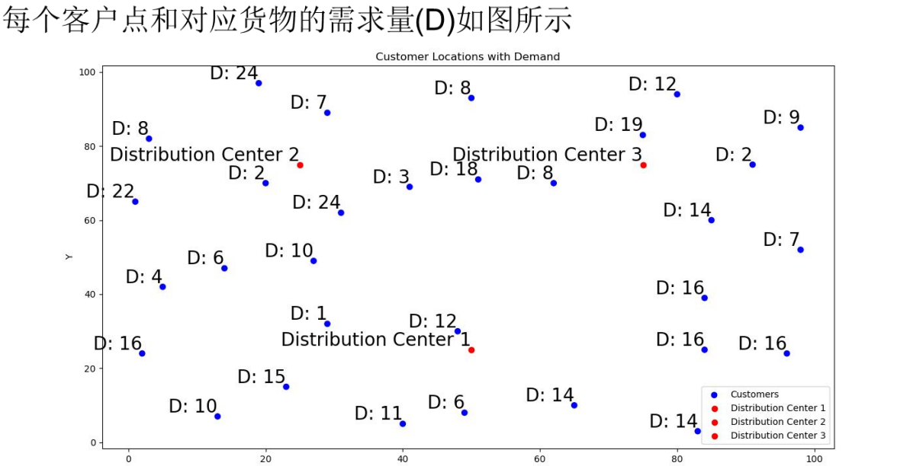
场景：
单向：纯取货/纯送货；
多配送中心：存在三个仓库；
单车型：只考虑一种车型，
需求不可拆分：客户需求只能由一辆车满足；
车辆封闭：完成配送任务的车辆需回到配送中心；
车辆充足：不限制车辆数量，即配送车辆需求均能满足；
非满载：任意客户点的需求量小于车辆最大载重；
最小化车辆行驶成本

已知条件(参数设置与例题相同)：
配送中心位置、客户点位置、客户点需求、车辆最大载重、车辆
最大行驶距离、车辆启动成本、车辆单位距离行驶成本

假设
- 每个仓库的商品库存足够充足。
- 车辆启动成本为定值，只最小化行驶成本。
- 假设最大载重50，最大行驶距离200，单位距离成本1

问题分析
思路：
①首先先将客户点分配给仓库，转化为单配送中心问题；
②再对每一个仓库的路径进行优化

问题建模

符号定义
W={$w_{1}$,$w_{2}$,$w_{3}$ }：仓库集合。

C={$c_{1}$,$c_{2}$,...,$c_{N}$}：顾客集合，N 为顾客总数。

$C_{k}$：分配给仓库 $w_{k }$ 的顾客子集。

$V_{k}$：为仓库 $w_{k}$ 服务的车辆集合。

$N_{k}$=$C_{k}$∪{$w_{k}$}：仓库 $w_{k }$及其服务的顾客构成的节点集合。

($x_{wk} ,{ y}_{wk}$)：仓库 $w_{k }$的坐标。

($x_{ci}$, $x_{yi}$)：顾客 $c_{i}$ 的坐标

$d_{i}$ ：顾客 $c_{i}$ 的需求量

Q：车辆的最大载重。

$D_{max}$：车辆的最大行驶距离。

$C_{cost}$：车辆单位距离的行驶成本。

$dist_{ij}$：节点 𝑖 和节点 j 之间的欧几里得距离

2.决策变量
$x_{ijk}$：如果车辆 k 从节点 i 行驶到节点 j，则 $x_{ijk}$ = 1；否则为 0。
$y_{ik}$：如果顾客 i 由车辆 k 服务，则 $y_{ik}$ = 1；否则为 0。

3.目标函数
最小化所有车辆的总行驶成本
$$min Z=C_{cost}×\sum_{k∈V}{\sum_{i∈N_{k}}{\sum_{j∈N_{k}}{dist}}}(i,j)×x_{ijk}$$

约束条件
1.每个顾客必须被且仅被一辆车服务一次：
$$\sum_{k∈V_{k}}{y_{ik}}=1, ∀i∈C_{k}$$

2.车辆路径的连续性：如果一辆车到达了一个顾客点，它必须离开。
$$\sum_{i∈N_{k}}{x_{ijk}}=y_{jk}, ∀j∈C_{k},∀k∈V_{k}$$
$$\sum_{j∈N_{k}}{x_{ijk}}=y_{ik}, ∀i∈C_{k},∀k∈V_{k}$$

3.车辆载重约束：每辆车服务的总需求量不能超过其最大载重 Q。
$$\sum_{i∈C_{k}}{d_{i}}×y_{ik}≤Q, ∀k∈V_{k}$$

4.车辆最大行驶距离约束：每辆车的总行驶距离不能超过 $D_{max}$。
$$\sum_{i∈N_{k}}{\sum_{j∈N_{k}}{dist}}(i,j)×x_{ijk}≤D_{max}, ∀k∈V_{k}$$

5.车辆从仓库出发并最终返回仓库：
$$\sum_{j∈C_{k}}{x_{w_{k},j,k}}=1, ∀k∈V_{k}$$
$$\sum_{i∈C_{k}}{x_{i,w_{k},k}}=1, ∀k∈V_{k}$$

6.消除子回路约束：防止车辆在顾客点之间形成不经过仓库的闭环。
$$u_{i}−u_{j}+N×x_{ijk}≤N−1, ∀i,j∈C_{k},i≠j,∀k∈V_{k}$$

其中 $u_{i}$ 代表顾客i 在路径中的访问顺序

模型求解（PSO）
- 数据处理
根据图片，得出三个仓库与每个客户点的大概坐标，求出距离矩阵$dist_{ij}$。

- 客户点分配
将客户点分配给了最近的仓库。

- 解的表示
一个粒子代表一个完整的配送方案。对于单个仓库的问题，我们用一个一维数组来表示，数组长度等于该仓库服务的顾客数量。数组中的每个元素是一个顾客的ID，数组的顺序就是车辆访问这些顾客的顺序。

- 适应度函数
以目标函数，即总成本作为适应度函数。

适应度计算流程：
输入：一个粒子（即一个顾客序列），例如 [5, 10, 2, 8]。

路径构建：按照序列顺序，逐个将顾客加入当前车辆的路径中。

初始化：创建一辆空车，从仓库出发。

遍历序列（采用贪心策略）：
取下一个顾客（如 5）。检查将 5 加入当前车辆后，检查其是否满足载重约束和最大行驶距离约束。如果满足，则将 5 加入当前路径。如果不满足，则当前车辆路径结束（返回仓库），并派一辆新车从仓库出发去服务 5。

计算总成本：将所有车辆的路径的距离相加，再乘以单位成本。

返回总成本作为该粒子的适应度值。

- PSO算法流程

- 初始化：

随机生成 M 个粒子。每个粒子是其所分配顾客的一个随机排列。

为每个粒子初始化一个随机的速度。

计算每个粒子的适应度值。

记录每个粒子的历史最优位置 pbest 和对应的最优适应度。

记录整个种群的历史最优位置 gbest 和对应的最优适应度。

- 迭代更新（重复 T 次，T是最大迭代次数）：

对于每个粒子：
根据速度公式更新速度

$$v_{i}^{t+1}=w⋅v_{i}^{t}+c_{1}⋅r_{1}⋅(pbest_{i}−x_{i}^{t})+c_{2}⋅r_{2}⋅(gbest−x_{i}^{t})$$

这里的加减法是针对序列的。我们使用交换序列的概念。速度被定义为一系列的交换操作。例如，速度 v = ((1,3), (2,5)) 表示交换位置1和3，再交换位置2和5。
更新位置：将更新后的速度（交换序列）应用到当前粒子的位置上，得到新位置。
计算新位置的适应度。

更新 pbest：如果新位置的适应度比 pbest 更好，则更新 pbest。

更新 gbest：在所有粒子更新完毕后，找到当前种群中最好的粒子，如果其适应度优于 gbest，则更新 gbest。

输出：迭代结束后，gbest 就是找到的最优解，即最优的顾客访问序列。通过之前的路径构建方法，可以将其解码为具体的车辆路径方案。

模型求解（Gurobi）与优化
基于整数线性规划，使用Gurobi求解器，求解器参数设置时间限制 120 秒、允许 2% 的优化间隙，以加快求解。

- 数据处理
根据图片，得出三个仓库与每个客户点的大概坐标，求出距离矩阵$dist_{ij}$。

- 客户点分配
将客户点分配给了最近的仓库。

- 建模优化
由于车辆数量不限，在求解过程中计算时间较长，这里我们对每个仓库的车辆数目做了一个估计。将每个仓库分配的客户点的需求求和，再除以每辆车的载重上限（50）并向上取整，来优化求解速度。

- 求解器通过分支定界法寻找最优解。

七．结果分析与对比
粒子群算法 (PSO)：
粒子群算法本质是一种启发式算法。他的参数较少，同时实现相对简单，对于大规模问题能在较短时间内给出一个高质量的近似解。但是不一定能够找到最优解，且解具有随机性，可以在多次运行后取最好的结果。也可以通过调参来优化求解结果。
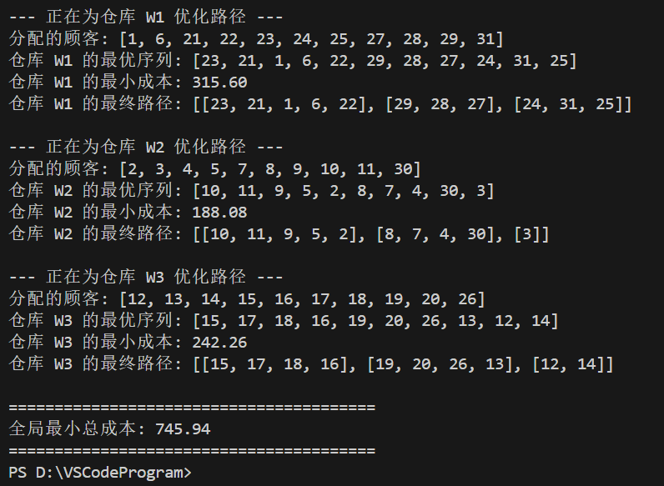
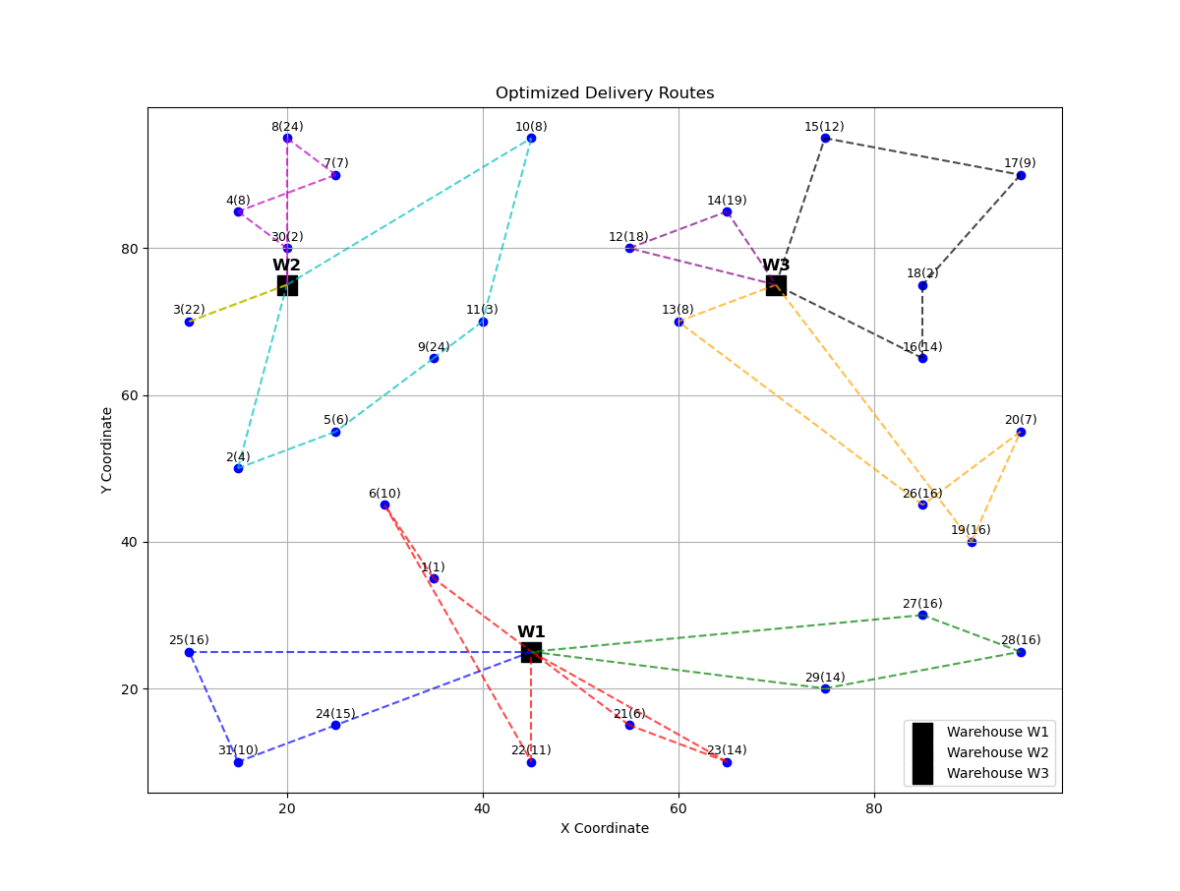

求解器求解 (Gurobi)：
作为传统算法，它能找到的解是一定是全局最优解，或在给定时间内找到的解与最优解的差距有多小。不过，对于大规模问题，求解时间可能非常长甚至无法在求出最优解。
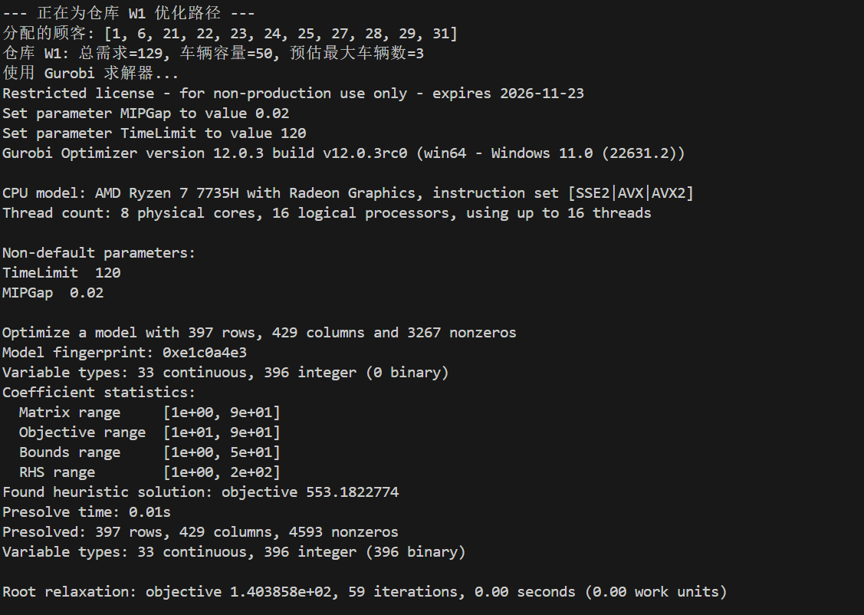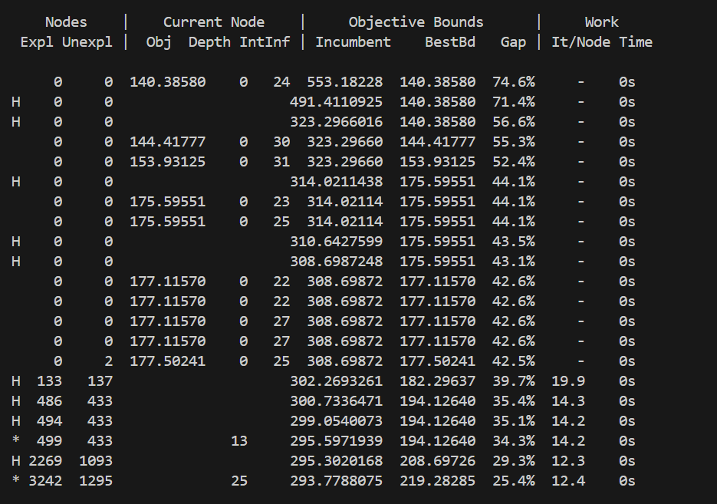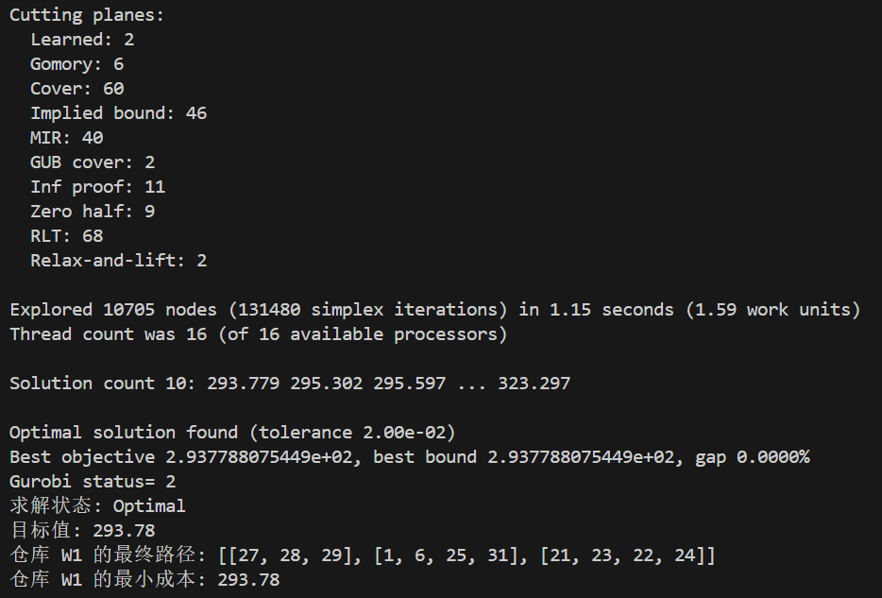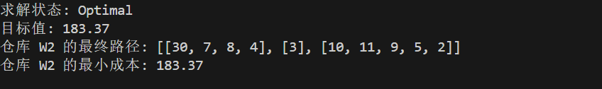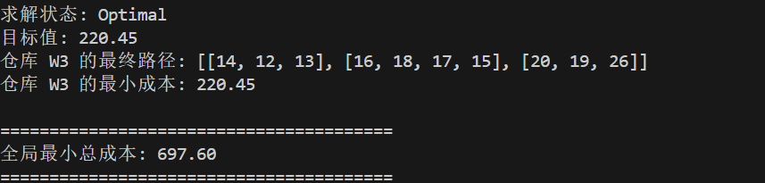
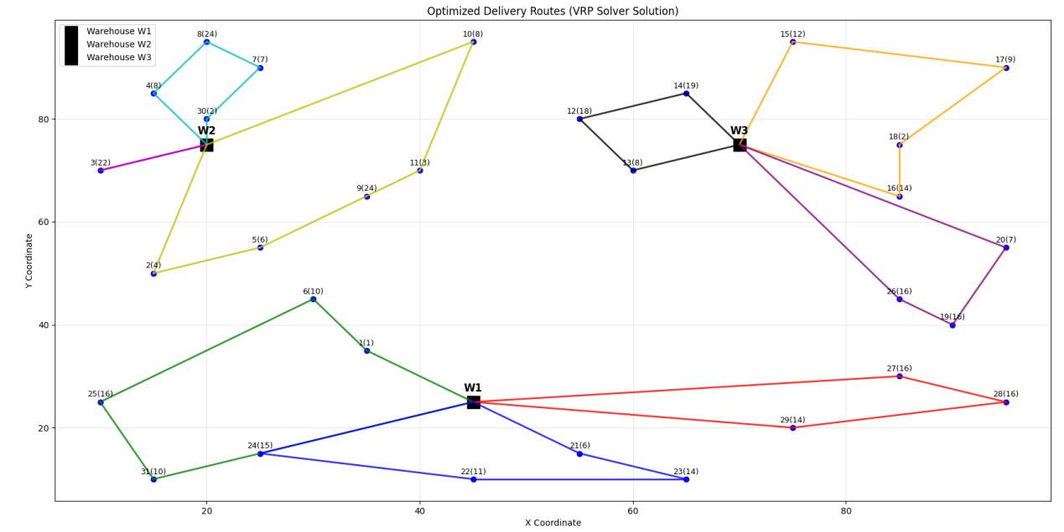
利用求解器求解的结果比使用PSO时得到的结果更好。由于仓库点和客户点数量较少，其次使用求解器时简化和修改了小部分建模，优化了算法。因此求解器的运行时间较使用PSO时并无明显差别。

附录

1.PSO
import numpy as np
import random
import matplotlib.pyplot as plt
import math

# --- 1. 参数设置 (提取图片) ---
# 仓库参数
WAREHOUSES = {
'W1': {'loc': (45, 25), 'stock': 100},
'W2': {'loc': (20, 75), 'stock': 100},
'W3': {'loc': (70, 75), 'stock': 100}
}

# 顾客参数
CUSTOMERS = [
{'id': 1, 'loc': (35, 35), 'demand': 1}, {'id': 2, 'loc': (15, 50), 'demand': 4}, {'id': 3, 'loc': (10, 70), 'demand': 22},
{'id': 4, 'loc': (15, 85), 'demand': 8}, {'id': 5, 'loc': (25, 55), 'demand': 6}, {'id': 6, 'loc': (30, 45), 'demand': 10},
{'id': 7, 'loc': (25, 90), 'demand': 7}, {'id': 8, 'loc': (20, 95), 'demand': 24}, {'id': 9, 'loc': (35, 65), 'demand': 24},
{'id': 10, 'loc': (45, 95), 'demand': 8}, {'id': 11, 'loc': (40, 70), 'demand': 3}, {'id': 12, 'loc': (55, 80), 'demand': 18},
{'id': 13, 'loc': (60, 70), 'demand': 8}, {'id': 14, 'loc': (65, 85), 'demand': 19}, {'id': 15, 'loc': (75, 95), 'demand': 12},
{'id': 16, 'loc': (85, 65), 'demand': 14}, {'id': 17, 'loc': (95, 90), 'demand': 9}, {'id': 18, 'loc': (85, 75), 'demand': 2},
{'id': 19, 'loc': (90, 40), 'demand': 16}, {'id': 20, 'loc': (95, 55), 'demand': 7}, {'id': 21, 'loc': (55, 15), 'demand': 6},
{'id': 22, 'loc': (45, 10), 'demand': 11}, {'id': 23, 'loc': (65, 10), 'demand': 14}, {'id': 24, 'loc': (25, 15), 'demand': 15},
{'id': 25, 'loc': (10, 25), 'demand': 16}, {'id': 26, 'loc': (85, 45), 'demand': 16}, {'id': 27, 'loc': (85, 30), 'demand': 16},
{'id': 28, 'loc': (95, 25), 'demand': 16}, {'id': 29, 'loc': (75, 20), 'demand': 14}, {'id': 30, 'loc': (20, 80), 'demand': 2},
{'id': 31, 'loc': (15, 10), 'demand': 10}
]

# 车辆参数
VEHICLE_CAPACITY = 50 # 最大载重
MAX_DISTANCE = 200 # 最大行驶距离
COST_PER_KM = 1.0 # 单位距离成本

# PSO 参数
POP_SIZE = 50 # 粒子群大小
MAX_ITER = 200 # 最大迭代次数
W = 0.7 # 惯性权重
C1 = 1.5 # 个体学习因子
C2 = 1.5 # 社会学习因子

# --- 2. 辅助函数 ---
def calculate_distance(p1, p2):
"""计算两点之间的欧几里得距离"""
return math.sqrt((p1[0] - p2[0])**2 + (p1[1] - p2[1])**2)

def assign_customers_to_warehouses(customers, warehouses):
"""将顾客分配给最近的仓库"""
assigned = {w_id: [] for w_id in warehouses}
for customer in customers:
min_dist = float('inf')
closest_warehouse = None
for w_id, w_data in warehouses.items():
dist = calculate_distance(customer['loc'], w_data['loc'])
if dist < min_dist:
min_dist = dist
closest_warehouse = w_id
assigned[closest_warehouse].append(customer)
return assigned

# --- 3. PSO 核心算法 ---
class PSO:
def __init__(self, customers, warehouse_loc):
self.customers = customers
self.warehouse_loc = warehouse_loc
self.num_customers = len(customers)
self.customer_ids = [c['id'] for c in customers]
self.customer_map = {c['id']: c for c in customers}

# 初始化粒子群
self.particles = []
self.velocities = []
self.pbest_positions = []
self.pbest_scores = []

for _ in range(POP_SIZE):
# 粒子位置是顾客ID的一个随机排列
position = random.sample(self.customer_ids, self.num_customers)
self.particles.append(position)
self.pbest_positions.append(position[:])

# 速度是交换序列
velocity = []
self.velocities.append(velocity)

# 计算初始适应度
score = self.calculate_fitness(position)
self.pbest_scores.append(score)

# 初始化全局最优
min_idx = np.argmin(self.pbest_scores)
self.gbest_position = self.pbest_positions[min_idx][:]
self.gbest_score = self.pbest_scores[min_idx]

def calculate_fitness(self, position):
"""计算适应度（总成本）"""
routes = self.decode_position_to_routes(position)
total_cost = 0
for route in routes:
if not route: continue
# 路径
full_path = [self.warehouse_loc] + [self.customer_map[c_id]['loc'] for c_id in route] + [self.warehouse_loc]
route_distance = sum(calculate_distance(full_path[i], full_path[i+1]) for i in range(len(full_path)-1))
total_cost += route_distance * COST_PER_KM
return total_cost

def decode_position_to_routes(self, position):
"""将粒子位置（顾客序列）解码为满足约束的车辆路径"""
routes = []
current_route = []
current_load = 0
current_distance = 0
last_loc = self.warehouse_loc

for customer_id in position:
customer = self.customer_map[customer_id]
customer_loc = customer['loc']
demand = customer['demand']

# 计算如果加入此客户，距离和载重是否超限
dist_to_customer = calculate_distance(last_loc, customer_loc)
dist_back_to_warehouse = calculate_distance(customer_loc, self.warehouse_loc)

potential_load = current_load + demand
potential_distance = current_distance + dist_to_customer + dist_back_to_warehouse

if potential_load <= VEHICLE_CAPACITY and potential_distance <= MAX_DISTANCE:
# 可以加入当前路径
current_route.append(customer_id)
current_load = potential_load
current_distance += dist_to_customer
last_loc = customer_loc
else:
# 无法加入，当前路径结束，开始新路径
if current_route:
routes.append(current_route)
current_route = [customer_id]
current_load = demand
current_distance = calculate_distance(self.warehouse_loc, customer_loc)
last_loc = customer_loc

if current_route:
routes.append(current_route)

return routes

def run(self):
"""运行PSO算法"""
for _ in range(MAX_ITER):
for i in range(POP_SIZE):
# 更新速度 (基于交换序列)
r1, r2 = random.random(), random.random()

# pbest部分的速度
pbest_vel = self.get_swap_sequence(self.particles[i], self.pbest_positions[i])
# gbest部分的速度
gbest_vel = self.get_swap_sequence(self.particles[i], self.gbest_position)

# 合并速度 (简化：按概率选择执行)
new_velocity = []
if random.random() < C1 * r1:
new_velocity.extend(pbest_vel)
if random.random() < C2 * r2:
new_velocity.extend(gbest_vel)
if random.random() < W and self.velocities[i]:
new_velocity.extend(self.velocities[i])

self.velocities[i] = new_velocity

# 更新位置
new_position = self.apply_swap_sequence(self.particles[i], new_velocity)
self.particles[i] = new_position

# 评估新位置
current_score = self.calculate_fitness(new_position)

# 更新个体最优
if current_score < self.pbest_scores[i]:
self.pbest_scores[i] = current_score
self.pbest_positions[i] = new_position[:]

# 更新全局最优
if current_score < self.gbest_score:
self.gbest_score = current_score
self.gbest_position = new_position[:]

return self.gbest_position, self.gbest_score

def get_swap_sequence(self, pos1, pos2):
"""计算从pos1变换到pos2所需的交换序列"""
seq = []
temp_pos = pos1[:]
for i in range(len(pos1)):
if temp_pos[i] != pos2[i]:
# 找到pos2[i]在temp_pos中的位置
j = temp_pos.index(pos2[i])
# 交换
temp_pos[i], temp_pos[j] = temp_pos[j], temp_pos[i]
seq.append((i, j))
return seq

def apply_swap_sequence(self, position, swap_sequence):
"""将交换序列应用到位置上"""
new_position = position[:]
for swap in swap_sequence:
i, j = swap
new_position[i], new_position[j] = new_position[j], new_position[i]
return new_position

# --- 4. 主程序与可视化 ---
def main():
# 分配顾客
assigned_customers = assign_customers_to_warehouses(CUSTOMERS, WAREHOUSES)

all_final_routes = []
total_min_cost = 0

# 对每个仓库的子问题进行优化
for w_id, customers in assigned_customers.items():
if not customers:
continue

print(f"\n--- 正在为仓库 {w_id} 优化路径 ---")
print(f"分配的顾客: {[c['id'] for c in customers]}")

warehouse_loc = WAREHOUSES[w_id]['loc']
pso_solver = PSO(customers, warehouse_loc)

best_position, best_score = pso_solver.run()

print(f"仓库 {w_id} 的最优序列: {best_position}")
print(f"仓库 {w_id} 的最小成本: {best_score:.2f}")

# 解码最终路径
final_routes = pso_solver.decode_position_to_routes(best_position)
print(f"仓库 {w_id} 的最终路径: {final_routes}")

all_final_routes.append({'warehouse': w_id, 'routes': final_routes})
total_min_cost += best_score

print(f"\n========================================")
print(f"全局最小总成本: {total_min_cost:.2f}")
print(f"========================================")

# 可视化结果
visualize_solution(WAREHOUSES, CUSTOMERS, all_final_routes)

def visualize_solution(warehouses, customers, all_routes):
"""可视化最终的配送方案"""
plt.figure(figsize=(12, 10))
colors = ['r', 'g', 'b', 'c', 'm', 'y', 'k', 'orange', 'purple', 'brown', 'pink', 'gray', 'olive', 'cyan']

# 绘制仓库
for i, (w_id, w_data) in enumerate(warehouses.items()):
plt.scatter(w_data['loc'][0], w_data['loc'][1], c='black', marker='s', s=200, label=f'Warehouse {w_id}')
plt.text(w_data['loc'][0], w_data['loc'][1] + 2, w_id, ha='center', fontsize=12, fontweight='bold')

# 绘制顾客
for customer in customers:
plt.scatter(customer['loc'][0], customer['loc'][1], c='blue', marker='o')
plt.text(customer['loc'][0], customer['loc'][1] + 1, f"{customer['id']}({customer['demand']})", ha='center', fontsize=9)

# 绘制路径
route_idx = 0
for w_routes in all_routes:
w_id = w_routes['warehouse']
w_loc = warehouses[w_id]['loc']
for route in w_routes['routes']:
if not route: continue

color = colors[route_idx % len(colors)]

# 构建完整路径点
full_path_locs = [w_loc]
for c_id in route:
full_path_locs.append(next(c['loc'] for c in customers if c['id'] == c_id))
full_path_locs.append(w_loc)

# 绘制路径线
for i in range(len(full_path_locs) - 1):
plt.plot([full_path_locs[i][0], full_path_locs[i+1][0]],
[full_path_locs[i][1], full_path_locs[i+1][1]],
color=color, linestyle='--', alpha=0.7)

route_idx += 1

plt.title('Optimized Delivery Routes')
plt.xlabel('X Coordinate')
plt.ylabel('Y Coordinate')
plt.grid(True)
plt.legend()
plt.show()

if __name__ == '__main__':
main()

- Gurobi
import pulp
import math
import matplotlib.pyplot as plt
import numpy as np

# --- 1. 参数设置 ---
WAREHOUSES = {
'W1': {'loc': (45, 25), 'stock': 100},
'W2': {'loc': (20, 75), 'stock': 100},
'W3': {'loc': (70, 75), 'stock': 100}
}
CUSTOMERS = [
{'id': 1, 'loc': (35, 35), 'demand': 1}, {'id': 2, 'loc': (15, 50), 'demand': 4}, {'id': 3, 'loc': (10, 70), 'demand': 22},
{'id': 4, 'loc': (15, 85), 'demand': 8}, {'id': 5, 'loc': (25, 55), 'demand': 6}, {'id': 6, 'loc': (30, 45), 'demand': 10},
{'id': 7, 'loc': (25, 90), 'demand': 7}, {'id': 8, 'loc': (20, 95), 'demand': 24}, {'id': 9, 'loc': (35, 65), 'demand': 24},
{'id': 10, 'loc': (45, 95), 'demand': 8}, {'id': 11, 'loc': (40, 70), 'demand': 3}, {'id': 12, 'loc': (55, 80), 'demand': 18},
{'id': 13, 'loc': (60, 70), 'demand': 8}, {'id': 14, 'loc': (65, 85), 'demand': 19}, {'id': 15, 'loc': (75, 95), 'demand': 12},
{'id': 16, 'loc': (85, 65), 'demand': 14}, {'id': 17, 'loc': (95, 90), 'demand': 9}, {'id': 18, 'loc': (85, 75), 'demand': 2},
{'id': 19, 'loc': (90, 40), 'demand': 16}, {'id': 20, 'loc': (95, 55), 'demand': 7}, {'id': 21, 'loc': (55, 15), 'demand': 6},
{'id': 22, 'loc': (45, 10), 'demand': 11}, {'id': 23, 'loc': (65, 10), 'demand': 14}, {'id': 24, 'loc': (25, 15), 'demand': 15},
{'id': 25, 'loc': (10, 25), 'demand': 16}, {'id': 26, 'loc': (85, 45), 'demand': 16}, {'id': 27, 'loc': (85, 30), 'demand': 16},
{'id': 28, 'loc': (95, 25), 'demand': 16}, {'id': 29, 'loc': (75, 20), 'demand': 14}, {'id': 30, 'loc': (20, 80), 'demand': 2},
{'id': 31, 'loc': (15, 10), 'demand': 10}
]
VEHICLE_CAPACITY = 50
MAX_DISTANCE = 200
COST_PER_KM = 1.0

# 求解器参数
SOLVER_TIME_LIMIT = 120 # 增加时间限制
MIP_GAP = 0.02 # 允许2%的求解间隙

# --- 2. 辅助函数 ---
def calculate_distance(p1, p2):
return math.sqrt((p1[0] - p2[0])**2 + (p1[1] - p2[1])**2)

def assign_customers_to_warehouses(customers, warehouses):
assigned = {w_id: [] for w_id in warehouses}
for customer in customers:
closest_warehouse = min(warehouses.keys(), key=lambda w: calculate_distance(customer['loc'], warehouses[w]['loc']))
assigned[closest_warehouse].append(customer)
return assigned

# --- 3. 求解器核心算法 ---
def solve_vrp_for_warehouse(warehouse_id, warehouse_loc, customers):
# 创建客户ID列表和映射
customer_ids = [c['id'] for c in customers]
customer_data = {c['id']: c for c in customers}

# 估算需要的车辆数
total_demand = sum(c['demand'] for c in customers)
max_vehicles = max(2, math.ceil(total_demand / VEHICLE_CAPACITY))
print(f"仓库 {warehouse_id}: 总需求={total_demand}, 车辆容量={VEHICLE_CAPACITY}, 预估最大车辆数={max_vehicles}")

# 节点定义：仓库为0，客户为1,2,3...
nodes = [0] + list(range(1, len(customer_ids) + 1)) # 0是仓库，1到n是客户
depot = 0
customer_nodes = list(range(1, len(customer_ids) + 1))

# 位置和距离映射
node_locations = {0: warehouse_loc}
for i, c_id in enumerate(customer_ids):
node_locations[i+1] = customer_data[c_id]['loc']

# 距离矩阵
dist_matrix = {}
for i in nodes:
for j in nodes:
if i != j:
dist_matrix[(i, j)] = calculate_distance(node_locations[i], node_locations[j])

# 需求映射
demands = {0: 0} # 仓库需求为0
for i, c_id in enumerate(customer_ids):
demands[i+1] = customer_data[c_id]['demand']

# 定义变量
x = {}
u = {}

for k in range(max_vehicles):
for i in nodes:
for j in nodes:
if i != j:
x[(i, j, k)] = pulp.LpVariable(f"x_{i}_{j}_{k}", cat='Binary')
if i != 0: # depot doesn't have load variable
u[(i, k)] = pulp.LpVariable(f"u_{i}_{k}", lowBound=0, upBound=VEHICLE_CAPACITY, cat='Continuous')

# 创建问题
prob = pulp.LpProblem(f"VRP_{warehouse_id}", pulp.LpMinimize)

# 目标函数：最小化总距离
prob += pulp.lpSum(dist_matrix[(i, j)] * x[(i, j, k)] for i in nodes for j in nodes for k in range(max_vehicles) if i != j)

# 每个客户必须被访问一次
for j in customer_nodes:
prob += pulp.lpSum(x[(i, j, k)] for i in nodes for k in range(max_vehicles) if i != j) == 1

# 每个客户必须离开一次
for i in customer_nodes:
prob += pulp.lpSum(x[(i, j, k)] for j in nodes for k in range(max_vehicles) if i != j) == 1

# 每辆车从仓库出发最多一次
for k in range(max_vehicles):
prob += pulp.lpSum(x[(0, j, k)] for j in customer_nodes) <= 1

# 每辆车回到仓库最多一次
for k in range(max_vehicles):
prob += pulp.lpSum(x[(i, 0, k)] for i in customer_nodes) <= 1

# 流量平衡：如果车辆k访问客户i，则必须离开客户i
for i in customer_nodes:
for k in range(max_vehicles):
prob += pulp.lpSum(x[(j, i, k)] for j in nodes if j != i) == pulp.lpSum(x[(i, j, k)] for j in nodes if j != i)

# 容量约束
for k in range(max_vehicles):
prob += pulp.lpSum(demands[j] * x[(i, j, k)] for i in nodes for j in customer_nodes if i != j) <= VEHICLE_CAPACITY

# 距离约束
for k in range(max_vehicles):
prob += pulp.lpSum(dist_matrix[(i, j)] * x[(i, j, k)] for i in nodes for j in nodes if i != j) <= MAX_DISTANCE

# 子回路消除约束
for k in range(max_vehicles):
for i in customer_nodes:
for j in customer_nodes:
if i != j:
prob += u[(i, k)] - u[(j, k)] + VEHICLE_CAPACITY * x[(i, j, k)] <= VEHICLE_CAPACITY - demands[j]

# 使用Gurobi求解器
import gurobipy as gp
from gurobipy import GRB
print("使用 Gurobi 求解器...")
solver = pulp.GUROBI(msg=1, timeLimit=SOLVER_TIME_LIMIT, MIPGap=MIP_GAP)

# 求解
prob.solve(solver)

print(f"求解状态: {pulp.LpStatus[prob.status]}")
if pulp.LpStatus[prob.status] in ['Optimal', 'Feasible']:
print(f"目标值: {pulp.value(prob.objective):.2f}")
else:
print("求解失败或不可行")
return [], 0

# 重构路径
routes = []
for k in range(max_vehicles):
route = []
# 找到从仓库出发的路径
for j in customer_nodes:
if pulp.value(x[(0, j, k)]) > 0.5:
current = j
route.append(customer_ids[current-1]) # 将节点编号转换为客户ID
break

if route: # 如果这辆车有从仓库出发的路径
# 追踪路径直到回到仓库
while True:
next_node = None
for j in nodes:
if j != current and pulp.value(x[(current, j, k)]) > 0.5:
next_node = j
break

if next_node is None or next_node == 0: # 回到仓库或没有下一个节点
break

route.append(customer_ids[next_node-1]) # 将节点编号转换为客户ID
current = next_node

if route:
routes.append(route)

objective_value = pulp.value(prob.objective) if pulp.value(prob.objective) is not None else 0
return routes, objective_value

# --- 4. 主程序与可视化 ---
def main():
# 分配顾客
assigned_customers = assign_customers_to_warehouses(CUSTOMERS, WAREHOUSES)

all_final_routes = []
total_min_cost = 0

# 对每个仓库的子问题进行优化
for w_id, customers in assigned_customers.items():
if not customers:
continue

print(f"\n--- 正在为仓库 {w_id} 优化路径 ---")
print(f"分配的顾客: {[c['id'] for c in customers]}")

warehouse_loc = WAREHOUSES[w_id]['loc']
routes, cost = solve_vrp_for_warehouse(w_id, warehouse_loc, customers)

print(f"仓库 {w_id} 的最终路径: {routes}")
print(f"仓库 {w_id} 的最小成本: {cost:.2f}")

all_final_routes.append({'warehouse': w_id, 'routes': routes})
total_min_cost += cost if cost is not None else 0

print(f"\n========================================")
print(f"全局最小总成本: {total_min_cost:.2f}")
print(f"========================================")

# 检查是否所有客户都被访问
all_visited_customers = []
for route_info in all_final_routes:
for route in route_info['routes']:
all_visited_customers.extend(route)

all_customer_ids = [c['id'] for c in CUSTOMERS]
unvisited_customers = [cid for cid in all_customer_ids if cid not in all_visited_customers]

# 可视化结果
visualize_solution(WAREHOUSES, CUSTOMERS, all_final_routes)

def visualize_solution(warehouses, customers, all_routes):
"""可视化最终的配送方案"""
plt.figure(figsize=(12, 10))
colors = ['r', 'g', 'b', 'c', 'm', 'y', 'k', 'orange', 'purple', 'brown', 'pink', 'gray', 'olive', 'cyan']

# 绘制仓库
for i, (w_id, w_data) in enumerate(warehouses.items()):
plt.scatter(w_data['loc'][0], w_data['loc'][1], c='black', marker='s', s=200, label=f'Warehouse {w_id}')
plt.text(w_data['loc'][0], w_data['loc'][1] + 2, w_id, ha='center', fontsize=12, fontweight='bold')

# 绘制顾客
for customer in customers:
plt.scatter(customer['loc'][0], customer['loc'][1], c='blue', marker='o')
plt.text(customer['loc'][0], customer['loc'][1] + 1, f"{customer['id']}({customer['demand']})", ha='center', fontsize=9)

# 绘制路径
route_idx = 0
for w_routes in all_routes:
w_id = w_routes['warehouse']
w_loc = warehouses[w_id]['loc']
for route in w_routes['routes']:
if not route: continue

color = colors[route_idx % len(colors)]

# 构建完整路径点
full_path_locs = [w_loc]
for c_id in route:
full_path_locs.append(next(c['loc'] for c in customers if c['id'] == c_id))
full_path_locs.append(w_loc)

# 绘制路径线
for i in range(len(full_path_locs) - 1):
plt.plot([full_path_locs[i][0], full_path_locs[i+1][0]],
[full_path_locs[i][1], full_path_locs[i+1][1]],
color=color, linestyle='-', alpha=0.8, linewidth=2)

route_idx += 1

plt.title('Optimized Delivery Routes (VRP Solver Solution)')
plt.xlabel('X Coordinate')
plt.ylabel('Y Coordinate')
plt.grid(True, alpha=0.3)
plt.legend()
plt.tight_layout()
plt.show()

if __name__ == '__main__':
main()

