George Lapin

AEW Math Workshop #2: Probability

1. Four children were born at City Hospital yesterday. Assume each child is equally likely to be a boy or a girl. Which of the following outcomes is most likely?

(A) all 4 are boys (B) all 4 are girls (C) 2 are girls and 2 are boys (D) 3 are of one gender and 1 is of the other gender (E) all of these outcomes are equally likely**2014**

1. Each spinner is divided into $3$ equal parts. The results obtained from spinning the two spinners are multiplied. What is the probability that this product is an even number?

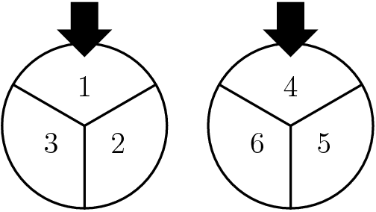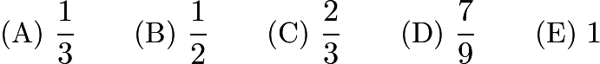

1. How many positive 5-digit odd integers are palindromes?

500

1. Assume every 7-digit [whole number](https://artofproblemsolving.com/wiki/index.php/Whole_number) is a possible telephone number except those that begin with $0$ or $1$ . What [fraction](https://artofproblemsolving.com/wiki/index.php/Fraction) of telephone numbers begin with $9$ and end with $0$ ?



1. The $600$ students at King Middle School are divided into three groups of equal size for lunch. Each group has lunch at a different time. A computer randomly assigns each student to one of three lunch groups. The probability that three friends, Al, Bob, and Carol, will be assigned to the same lunch group is approximately

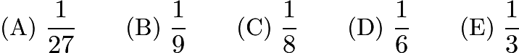

1. How many positive cubes divide $3! \cdot 5! \cdot 7!$ ?

$\textbf{(A) } 2\qquad \textbf{(B) } 3\qquad \textbf{(C) } 4\qquad \textbf{(D) } 5\qquad \textbf{(E) } 6$

1. Bob and Alice each have a bag that contains one ball of each of the colors blue, green, orange, red, and violet. Alice randomly selects one ball from her bag and puts it into Bob's bag. Bob then randomly selects one ball from his bag and puts it into Alice's bag. What is the probability that after this process the contents of the two bags are the same?

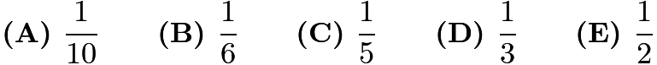

1. Team A and team B play a series. The ﬁrst team to win three games wins the series. Each team is equally likely to win each game, there are no ties, and the outcomes of the individual games are independent. If team B wins the second game and team A wins the series, what is the probability that team B wins the ﬁrst game?

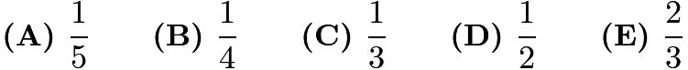

1. A player pays $\textdollar 5$ to play a game. A die is rolled. If the number on the die is odd, the game is lost. If the number on the die is even, the die is rolled again. In this case the player wins if the second number matches the ﬁrst and loses otherwise. How much should the player win if the game is fair? (In a fair game the probability of winning times the amount won is what the player should pay.)

$\textbf{(A) } \textdollar12\qquad\textbf{(B) } \textdollar30\qquad\textbf{(C) } \textdollar50\qquad\textbf{(D) } \textdollar60\qquad\textbf{(E) } \textdollar 100\qquad$

1. Pat is to select six cookies from a tray containing only chocolate chip, oatmeal, and peanut butter cookies. There are at least six of each of these three kinds of cookies on the tray. How many different assortments of six cookies can be selected?

$\mathrm{(A) \ } 22\qquad \mathrm{(B) \ } 25\qquad \mathrm{(C) \ } 27\qquad \mathrm{(D) \ } 28\qquad \mathrm{(E) \ } 729$

1. Two tour guides are leading six tourists. The guides decide to split up. Each tourist must choose one of the guides, but with the stipulation that each guide must take at least one tourist. How many different groupings of guides and tourists are possible?

$\text{(A)}\ 56 \qquad \text{(B)}\ 58 \qquad \text{(C)}\ 60 \qquad \text{(D)}\ 62 \qquad \text{(E)}\ 64$

1. The $5\times 5$ grid shown contains a collection of squares with sizes from $1\times 1$ to $5\times 5$. How many of these squares contain the black center square?

$\mathrm{(A) \ } 12 \qquad \mathrm{(B) \ } 15 \qquad \mathrm{(C) \ } 17 \qquad \mathrm{(D) \ }  19\qquad \mathrm{(E) \ } 20$

1. Chloe chooses a real number uniformly at random from the interval $[0, 2017]$ . Independently, Laurent chooses a real number uniformly at random from the interval $[0, 4034]$ . What is the probability that Laurent's number is greater than Chloe's number?

