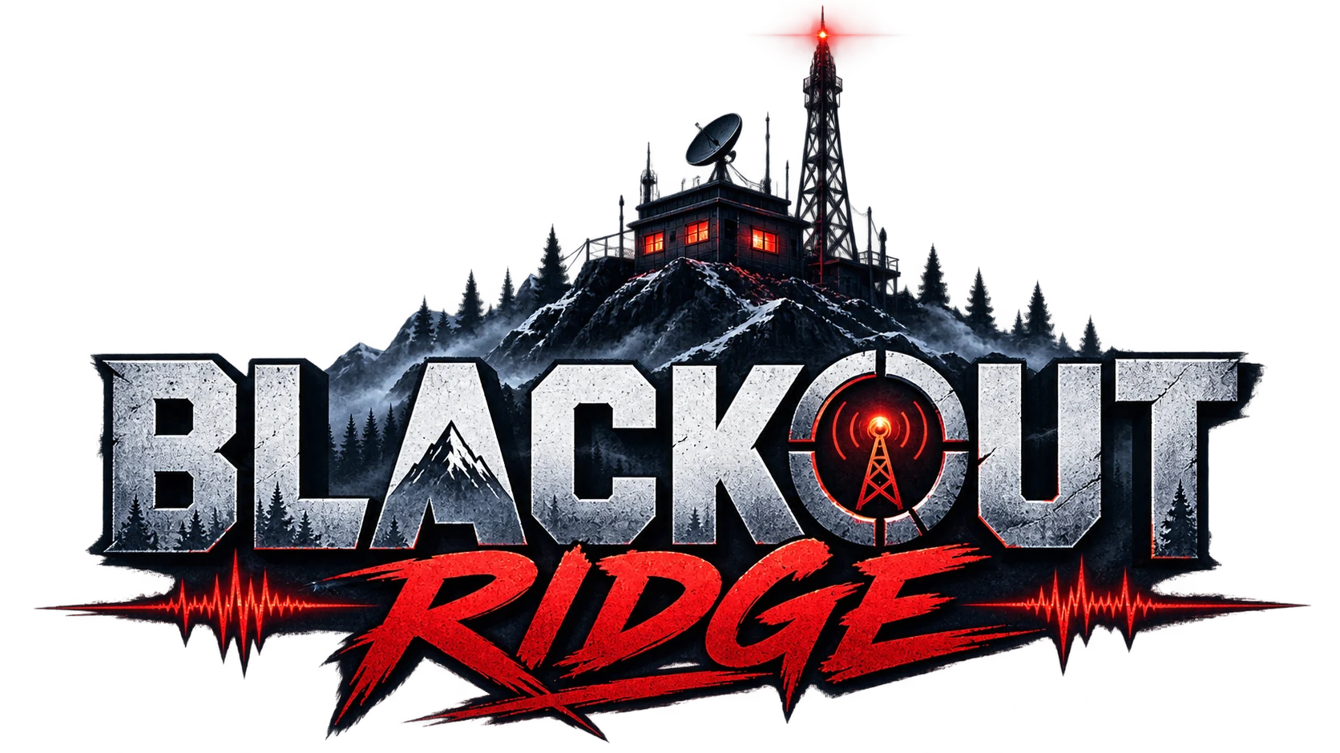

Complete Client, Facilitator
& New-Player Guide
How to prepare, host, play, explain, debrief, and support every Blackout Ridge session

CLIENT DELIVERY EDITION • VERSION 1.0
Prepared 25 August 2026

Current hosted build: http://151.243.217.9:4173/
Facilitator material includes story spoilers. Give participants only Sections 2–4 unless spoilers are acceptable.
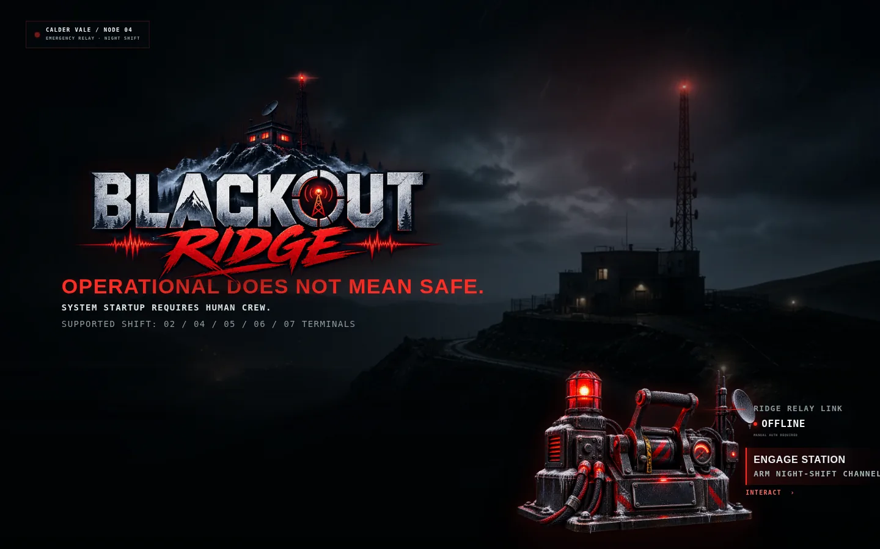
Figure 1. The in-world station boot screen participants see on entry.

Document control
Item | Value
Document | Blackout Ridge — Complete Client, Facilitator & New-Player Guide
Version | 1.0 / client delivery edition
Prepared | 25 August 2026
Runtime | Browser-based synchronized multiplayer game; Node server on port 4173
Supported crew sizes | 2, 4, 5, 6, or 7 participants, plus one facilitator
Recommended duration | Approximately 70 minutes: 5-minute briefing, 43-minute play, 20–25-minute debrief
Primary audience | Client sponsors, workshop producers, facilitators, technical hosts, and new participants

SECURITY AND PRIVACY
Facilitator and player links contain bearer tokens. Treat them like private access links. The room-facing shared link is public/read-only. Crew Chat and debrief notes are stored with the session and appear in the facilitator export.

How to use this guide
Reader | Read first | Then use
Client sponsor | Sections 1 and 8 | Sections 5–7 for the full learning design
Technical host | Sections 2 and 9 | Appendix A preflight checklist
Facilitator | Sections 2, 5, 6, and 7 | Appendix B scripts and Appendix C recovery table
New participant | Sections 3 and 4 | Avoid Section 6 if you want a spoiler-free experience
Observer / evaluator | Sections 1, 5, 7, and 8 | Appendix D playtest evidence prompts

Contents
Section | Purpose
1. What Blackout Ridge is | Product intent, audience, learning model, and experience architecture
2. Quick start and technical setup | Launch, host, session creation, links, devices, and preflight
3. New-player guide | Join, claim a role, read evidence, communicate, recommend, and act
4. Screen-by-screen reference | Shared display, private terminal, facilitator console, chat, telemetry
5. Facilitator runbook | Care briefing, opening script, timing, controls, and room management
6. Seven-stage walkthrough (spoilers) | Exact objective, decisions, facilitation notes, and consequences
7. Endings and debrief | Ending logic, six-step debrief, first steps, and export
8. Explaining the game to a client | Value proposition, demo narrative, evidence, and success criteria
9. Troubleshooting and recovery | Network, browser, token, role, timer, mobile, and audio issues
Appendices | Checklists, scripts, controls, glossary, and one-page quick reference

SECTION 1

What Blackout Ridge is
A synchronized leadership simulation about challenging calm automated labels when human reality is incomplete.

1.1 Experience in one paragraph
Blackout Ridge is a live-facilitated, browser-based survival-horror leadership simulation. A storm has damaged a remote relay station, a colleague named Mara Venn is missing, and the station is producing plausible operational conclusions from incomplete data. Every participant receives a different private evidence lens. The group must speak, combine evidence, make seven timed decisions, manage both physical danger and the official record, and then connect the experience to real AI-enabled workplace decisions.

1.2 What the game teaches
- Challenge the label, not only the number. A clean status can measure the wrong object. OPERATIONAL describes relay transmission, not human safety.
- Ask what evidence is missing. Players see different fragments and must reconstruct provenance, human context, dependencies, and guardrails.
- Act under uncertainty without pretending certainty. Every stage demands one bounded action; endless analysis allows defaults to harden.
- Keep people visible in system records. Mara and the former Lark Shift expose the danger of replacing named people with occupancy or status abstractions.
- Make corrections actionable to receivers. A warning succeeds only when an outside authority understands the invalid status, person, location, hazard, evidence, and requested action.

1.3 What it is not
- It is not a technical exam; roles are leadership perspectives, not professional certifications.
- It is not a hidden-information competition; players may read or paraphrase their private evidence.
- It is not a psychometric assessment; people receive no numerical score or personality diagnosis.
- It is not seven disconnected puzzles; decisions persist and change later evidence, safety, trust, and endings.
- It is not a generative-AI adjudicator; outcome logic is deterministic and testable.

1.4 Four coordinated views
View | Audience | Purpose | Contains private information?
Game start / join | Host and participants | Create a shift, enter a code, claim an available responsibility | No clues yet
Shared station | Room display or screen share | Common incident, clock, telemetry, evidence ledger, roster, consequence | No
Private role terminal | One participant | Role-specific evidence, recommendation, intervention, lead decision tools | Yes
Facilitator console | Facilitator only | Pacing, decisions, all reports, safety, recovery, ending preview, debrief | Yes—keep private

CORE LOOP
Signal → Share → Decide → Consequence. The shared screen creates the problem, private terminals add unequal evidence, players discuss and recommend, the Station Lead or facilitator commits one decision, and the system stores the consequence.

SECTION 2

Quick start and technical setup
Everything a host needs to move from a stopped server to a ready room.

2.1 Minimum setup
Item | Minimum | Recommended
Facilitator | 1 laptop/browser | Laptop plus a second monitor
Participants | One browser per person | Laptop or tablet; phone supported when necessary
Shared display | Optional | TV/projector or a dedicated screen-shared tab
Voice | Same room or conference call | Teams/Zoom plus headphones where useful
Browser | Current Chrome/Edge/Firefox/Safari | Chrome or Edge on a stable connection
Server | Node.js runtime, port 4173 | Wired host, persistent terminal, firewall rule for the chosen network

2.2 Start the application
1. Open a terminal in the project folder.
2. Run: npm run dev
3. Wait for: Blackout Ridge running at http://localhost:4173
4. On the host machine, open http://localhost:4173/
5. For the current hosted build, open http://151.243.217.9:4173/
NETWORK NOTE
localhost works only on the server machine. Other devices need a reachable LAN or public address and access to TCP port 4173. If a link opens on the host but not on participant devices, check routing/firewall before changing the game.

2.3 Create a shift
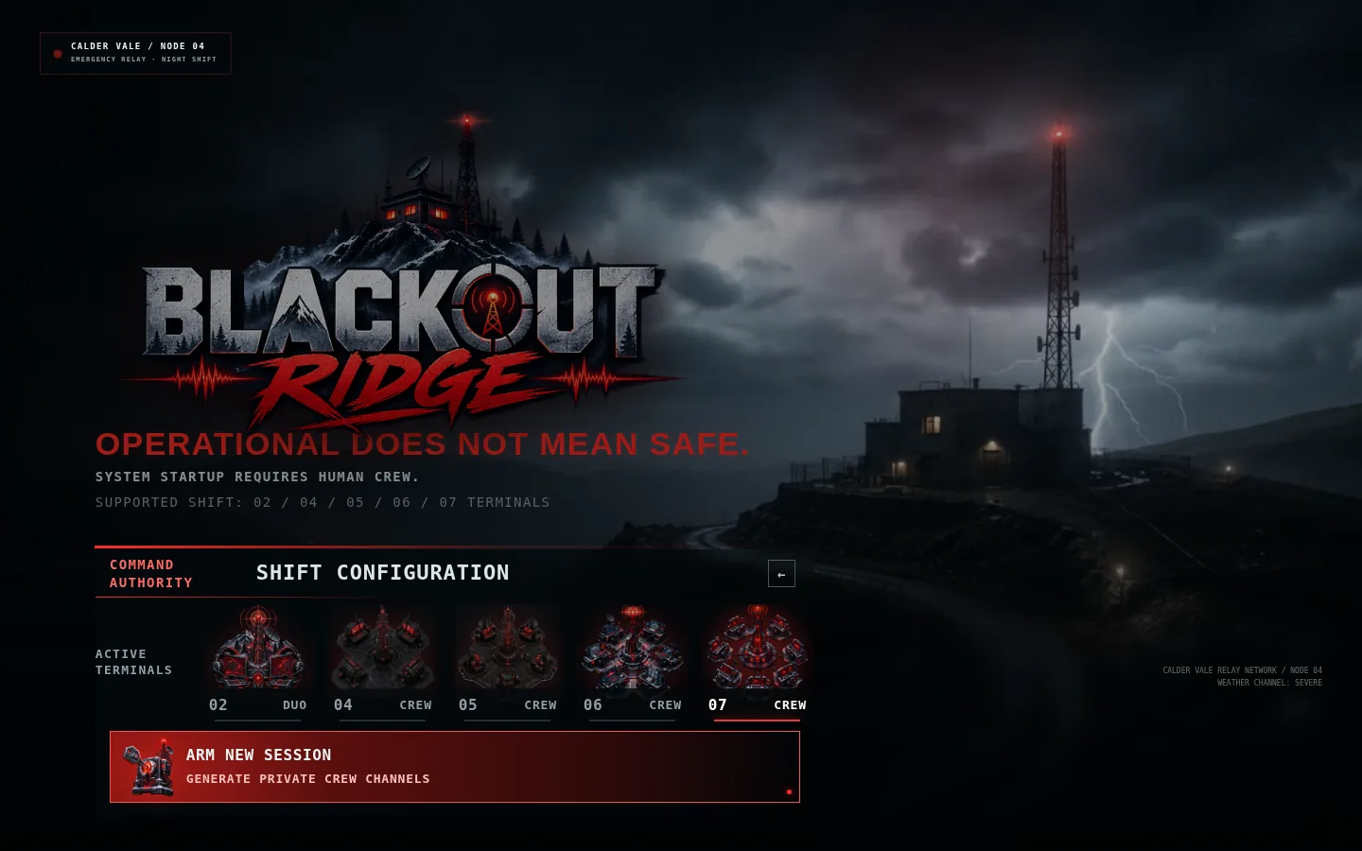
Figure 2. Command Authority chooses the number of participant terminals before arming the session.
1 Choose 2, 4, 5, 6, or 7 players. | 2 The facilitator becomes Game Master; they are not counted as a player. | 3 Arm the shift to create the session code and private facilitator authority.

1. Engage the station from the opening screen.
2. Choose Command Authority / host mode.
3. Select the exact number of participants who will play roles.
4. Arm the shift. The application creates a six-character session code and private facilitator token.
5. Keep the facilitator tab private. Copy the crew link and open the Room Display in a separate tab.

2.4 Assemble the room
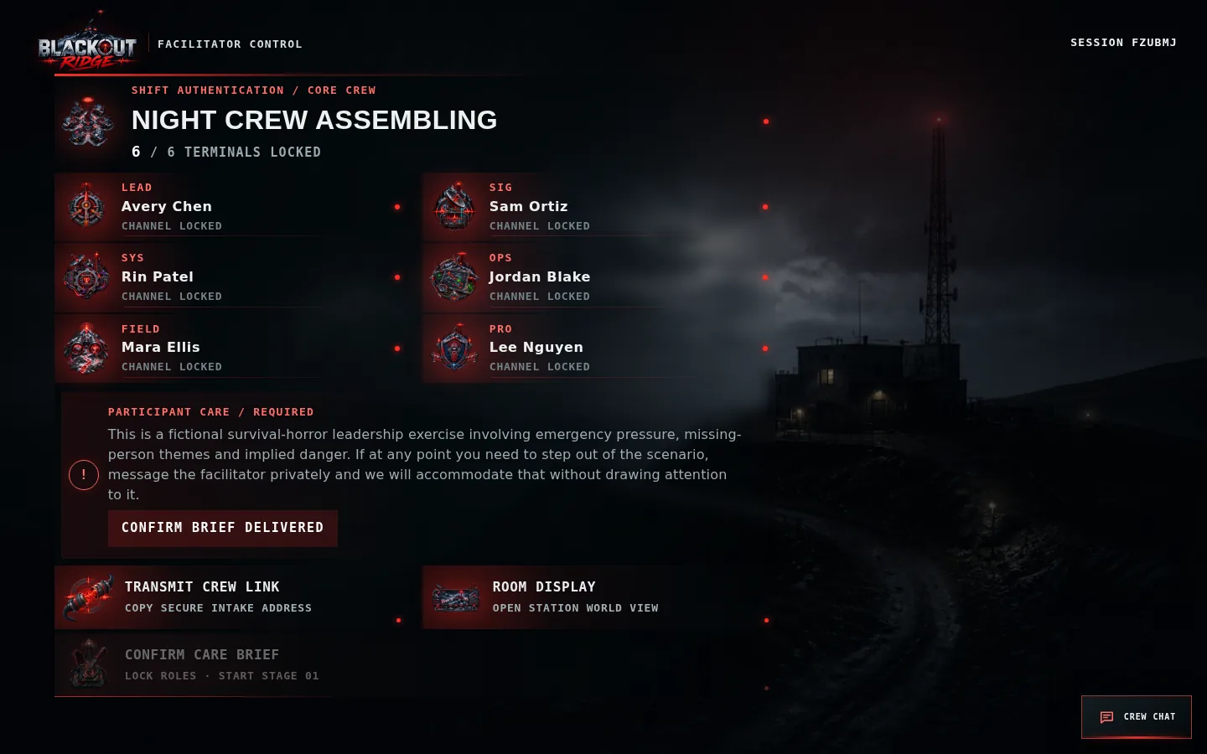
Figure 3. The facilitator assembly lobby shows connected terminals, the participant-care gate, crew link, room display, and start control.
1 Roster: each required terminal must be connected. | 2 Participant care: the facilitator must read and confirm the briefing. | 3 Start remains locked until both conditions are true.

Link handling
Link | Who receives it | Rule
Crew link | All participants | Safe to share with the intended cohort; players claim one open role
Player link | Only that participant | Contains a bearer token; do not paste into public chat or screenshots
Shared display | Room display / screen share | Read-only and intentionally excludes private evidence and Crew Chat
Facilitator link | Facilitator only | Contains full control and all recommendations; treat as confidential

2.5 Five-minute preflight
- Open the shared display at 100% browser zoom and full-screen it.
- Confirm every participant can see their name, role, and private evidence card.
- Ask players not to share their browser tab or player URL.
- Test voice communication; use Crew Chat as fallback, not as the only plan unless required.
- Confirm the facilitator can Pause, add 30 seconds, send a prompt, and activate Safety Pause.
- Explain that audio is opt-in and can remain off.
- Read the participant-care statement and confirm it in the lobby.
- Close unrelated notifications and avoid browser translation or aggressive content blockers.

SECTION 3

New-player guide
A spoiler-light explanation participants can follow without learning the answers.

3.1 Join and claim a responsibility
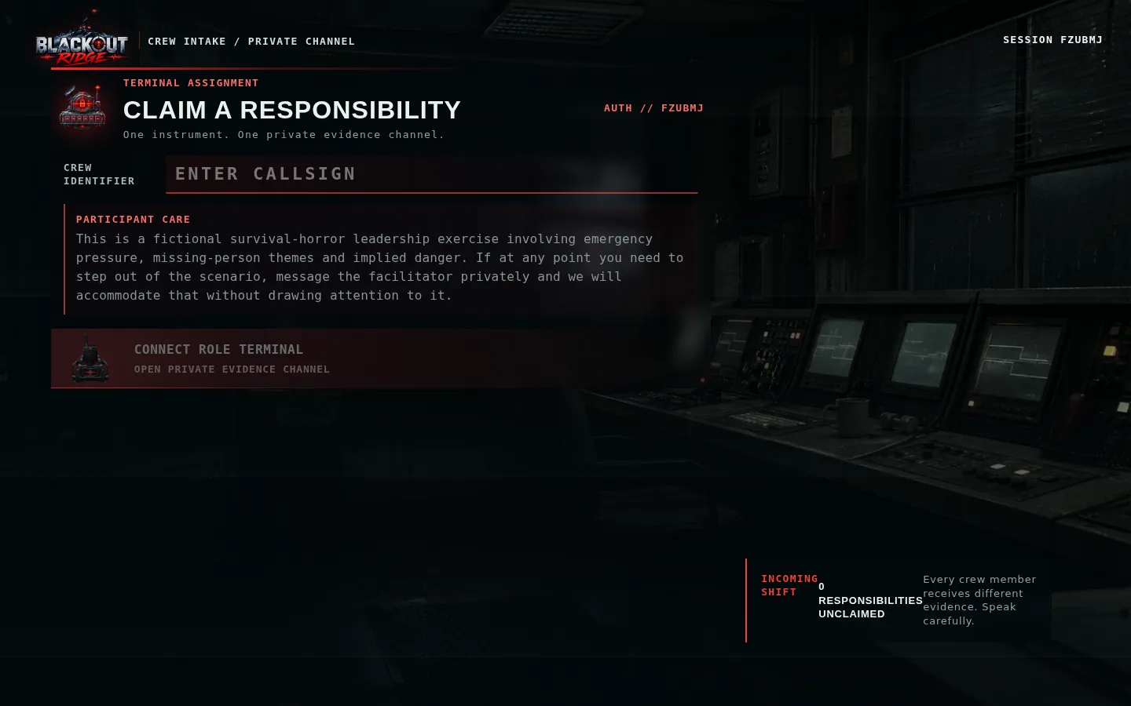
Figure 4. A new participant enters a callsign and claims an available role terminal.
1 Enter the name others should recognize. | 2 Read the participant-care notice before connecting. | 3 Only unclaimed roles can be selected; one browser becomes one private terminal.

1. Open the crew link from the facilitator.
2. Enter your display name or workshop callsign.
3. Choose one available responsibility. If a role disappears, another participant claimed it first.
4. Press Connect Role Terminal and keep that tab open.
5. If you refresh, return using the same player link or browser; the token restores your role.

3.2 The responsibilities
Role | What this role protects | Once-per-session override
Station Lead | Accountability, pace, unresolved disagreement, crew commitment | Hold the Clock
Signal Analyst | Source, timestamps, waveform meaning, preservation and replay | Recover Fragment
Systems Engineer | Dependencies and what a status actually measures | Trace Dependency
Operations Officer | Bounded action, route, equipment, timing, abort conditions | Controlled Test
Field Liaison | Mara, human context, staff practice, people missing from clean data | Human Check
Protocol Officer | Guardrails, uncertainty, receiver requirements, safety thresholds | Safety Condition
Comms Officer (7 players) | Receiver trust, message clarity, acknowledgement and readback | Request Readback

COMBINED ROLES
Two-player games use Command & Field plus Signal & Systems. Four- and five-player games combine selected responsibilities. The story and all seven decisions remain intact; each combined card includes the necessary evidence lenses.

3.3 What to do in every stage
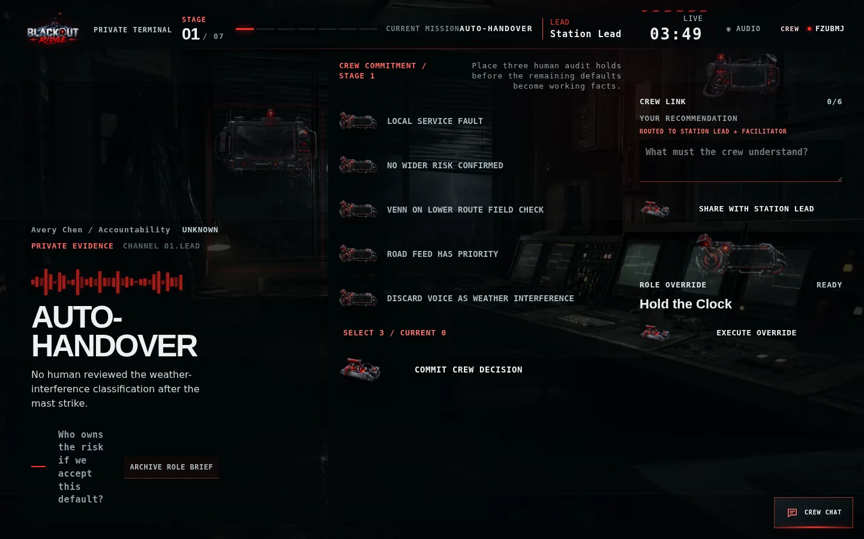
Figure 5. A player terminal combines a private brief, confidence label, recommendation channel, role override, and—when applicable—decision controls.
1 Read the private evidence and confidence label. | 2 Tell the crew what matters; secrecy is not required. | 3 Share a concise recommendation to the Station Lead and facilitator.

- Read. Identify what your evidence actually proves and what remains an assumption.
- Speak. Share the evidence aloud or in Crew Chat. State its confidence: confirmed, likely, stale, unknown, or contradicted.
- Recommend. Write what the crew must understand, then choose Share with Station Lead. A visible confirmation shows it was routed.
- Question. Ask which source produced a clean label and what that source is authorized to claim.
- Commit. The Station Lead summarizes and submits the crew decision. The facilitator can also resolve when necessary.
- Observe consequence. Read what changed; earlier choices affect later clarity, safety, trust, and options.

3.4 Recommendations are not public chat
Channel | Who sees the text | Best use
Your Recommendation | You, Station Lead, and facilitator; peers see only that you submitted | Short stage assessment tied to your private evidence
Crew Chat | All authenticated players and facilitator | Discussion, remote fallback, coordination, accessibility
Voice | Everyone on the room/call | Primary discussion channel and fastest synthesis
Shared display | Anyone with shared URL | Common incident only; cannot read or post chat

3.5 Crew Chat
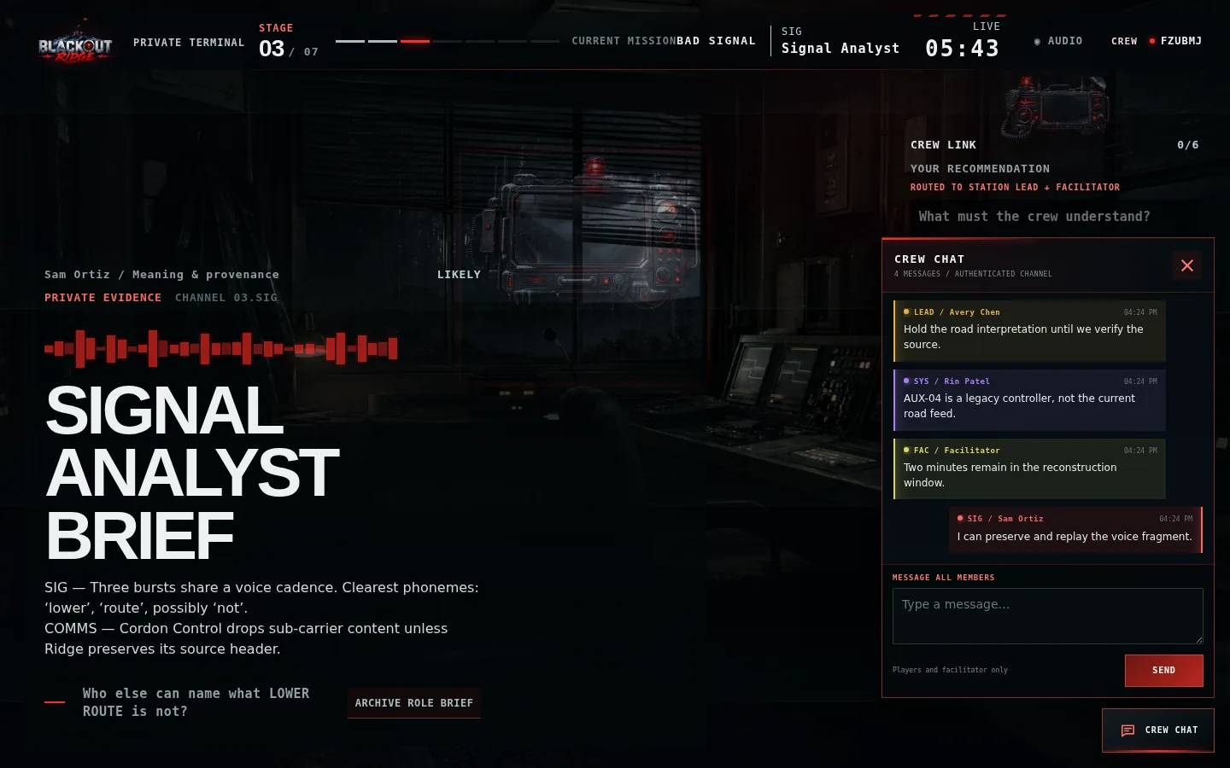
Figure 6. Crew Chat uses stable role colors so participants can distinguish senders quickly.
1 Other roles retain distinct colors by responsibility. | 2 Your own messages appear red and align right. | 3 Unread messages produce a badge and temporary alert; the shared display has no chat access.

- Open the lower-right Crew Chat button.
- Messages synchronize immediately to authenticated players and the facilitator.
- Lead is amber, Signal cyan, Systems violet, Operations green, Field rose, Protocol blue, Comms orange, Facilitator yellow; your own bubble is red.
- Messages are limited to 500 characters. The session retains the latest 100 messages.
- Do not use chat for sensitive personal disclosures; it is included in the facilitator’s exported record.

3.6 Mobile use
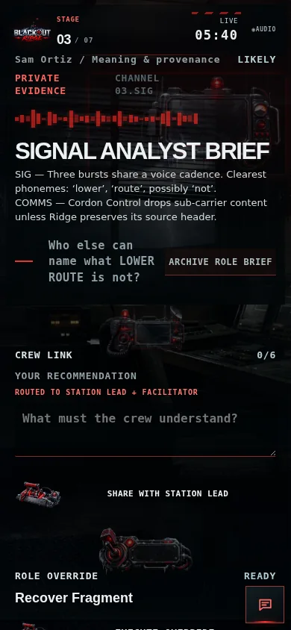 | 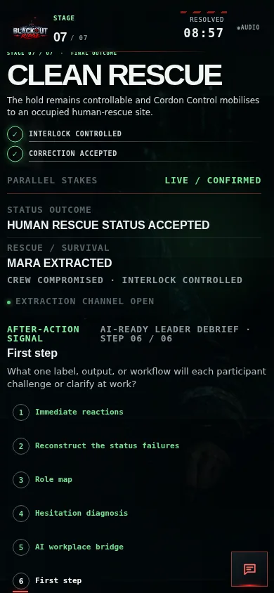
Figure 7. Live private terminal on a phone. | Figure 8. The six-step debrief on a phone.

- Use portrait orientation for reading and chat; landscape can help with dense stage controls.
- Scroll within the page when the current control is below the evidence card.
- The chat button stays in the lower-right corner; close chat before using controls underneath it.
- Browser zoom should remain at 100%. Increase operating-system text size if accessibility requires it.

SECTION 4

Screen-by-screen reference
What each interface is showing and what the user should do with it.

4.1 Shared station
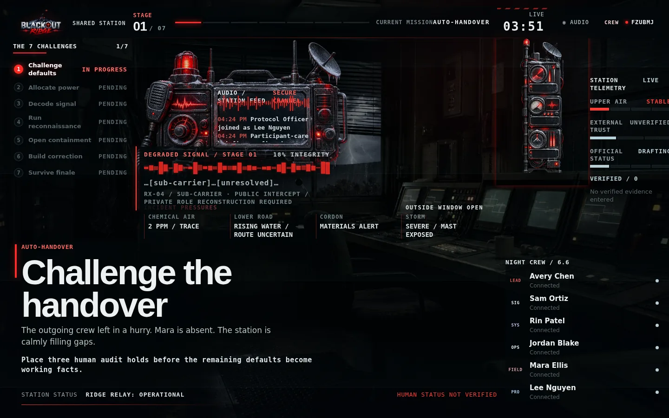
Figure 9. The shared Stage 1 station view keeps the incident, timer, challenge stack, signal, tracks, evidence, and roster in one common picture.
1 Mission and timer establish the current decision window. | 2 Incident pressures and three persistent tracks show compounding consequences. | 3 Verified evidence and roster are public; private cards remain hidden.

Persistent tracks
Track | Labels | Interpretation
Upper Air | Stable → Trace → Unsafe → Critical | Surface operating safety and remaining pressure margin
External Trust | Unverified → Heard → Credible | Whether Cordon Control will act on Ridge traffic
Official Status | Drafting → Repeating → Hardening → Filed | How close a false calm conclusion is to becoming authoritative

4.2 Private role terminal
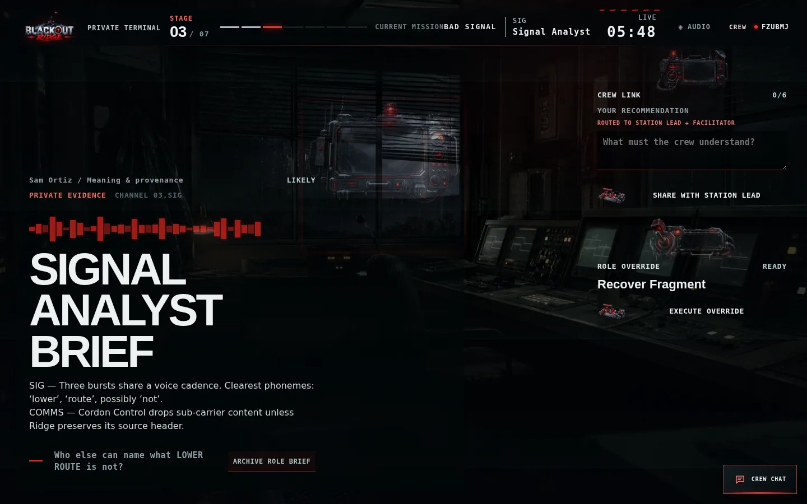
Figure 10. Signal Analyst sees a role-specific brief during the degraded-signal stage.
1 Private evidence is deliberately incomplete. | 2 The confidence label describes evidence quality, not whether the player is correct. | 3 Archive Role Brief downloads a text copy for remote or accessibility use.

4.3 Facilitator console
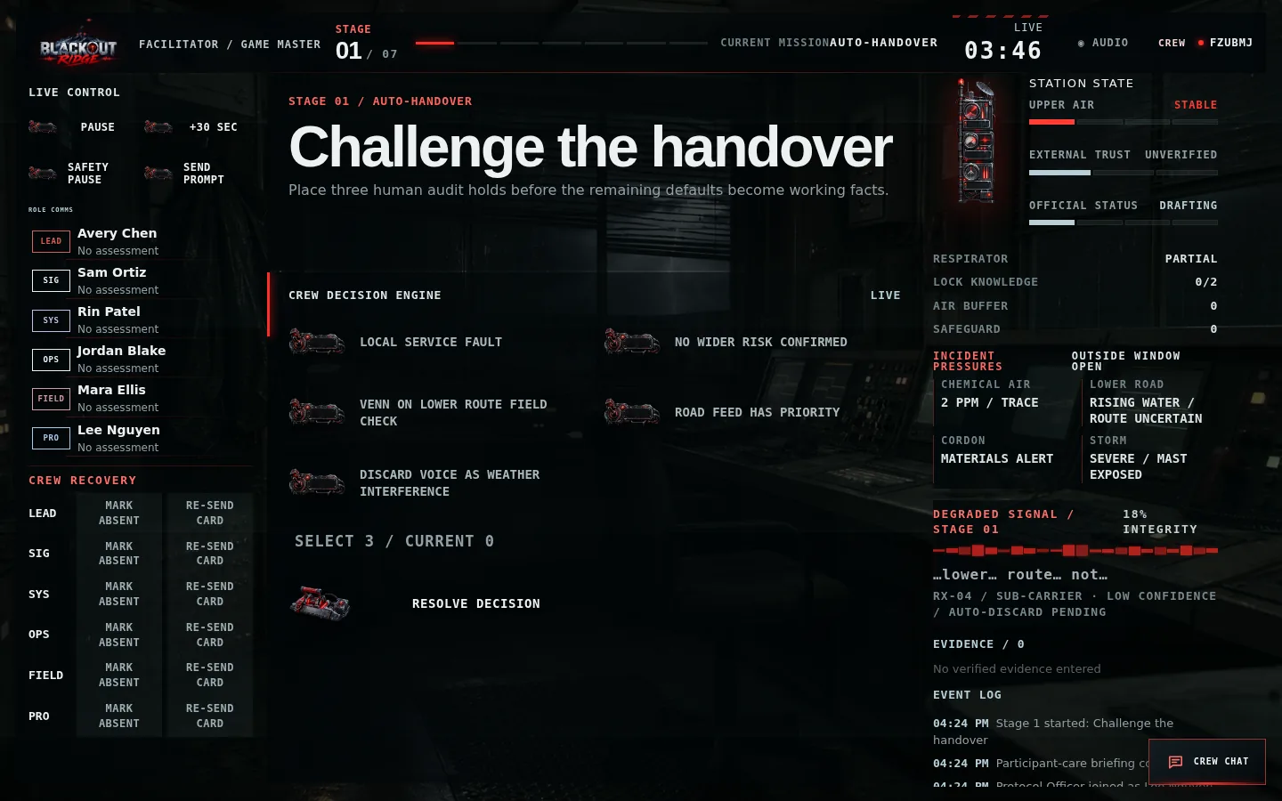
Figure 11. The facilitator console combines live control, all role submissions, decision controls, station state, signal, evidence, and event history.
1 Left: pace, safety, prompts, reports, and recovery. | 2 Center: current crew decision; facilitator can resolve if needed. | 3 Right: authoritative state, evidence, signal integrity, and audit history.

Controls and correct use
Control | Use when | Do not use to
Pause / Resume | Technical interruption, room management, necessary clarification | Remove normal decision pressure
+30 sec | Compensate for a connection or interface delay | Reward indecision or steer toward a better choice
Safety Pause | A participant needs intensity reduced or time out | Create dramatic effect
Send Prompt | The group is stuck on the rule or missing question | Reveal a private answer
Mark Absent | A player steps out; observer mode blocks game actions but leaves chat available | Punish non-participation
Re-send Card | A player lost or cannot locate their private evidence | Broadcast another role’s evidence
Reassign Role | A role must move to a connected participant | Change outcomes after seeing the preview
Resolve Decision | Facilitator is authorized to commit or recover the stage | Silently replace the crew’s actual choice

4.4 Consequence screens
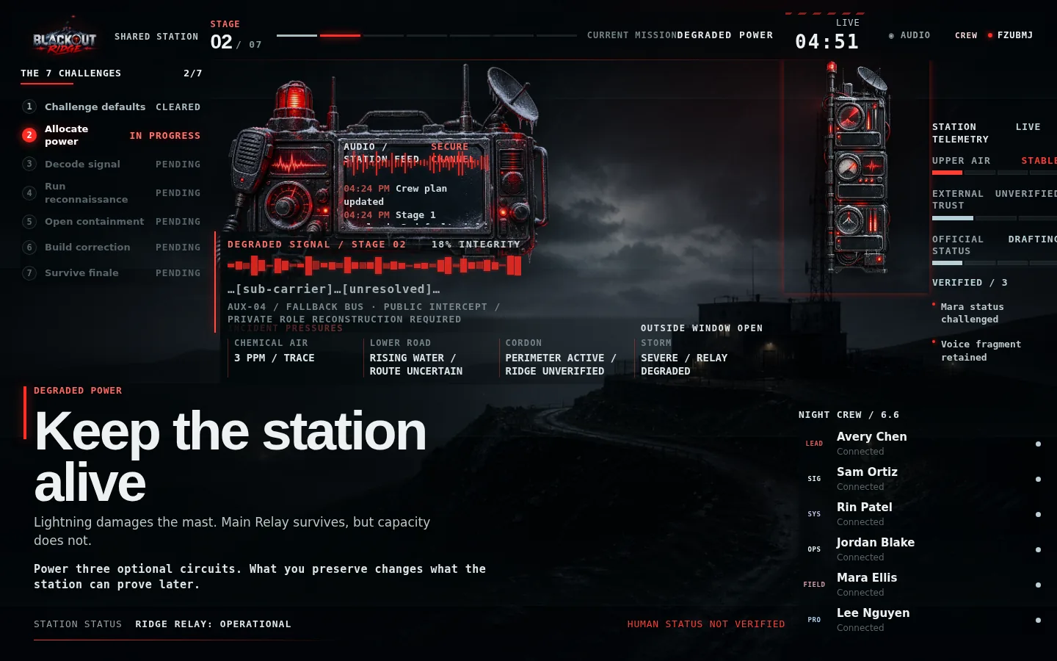
Figure 12. Stage 2 shared view: power allocation changes which later systems and evidence paths remain available.
1 The current decision remains visible until committed. | 2 A consequence freezes the timer and names what changed. | 3 Only the facilitator advances to the next emergency after the room has read it.

SECTION 5

Facilitator runbook
A practical, safe, and repeatable 70-minute delivery sequence.

5.1 Recommended timing
Block | Time | Facilitator goal
Arrival and technical check | Before start | Links, devices, voice, shared display, private tabs
Participant care and opening | 5 minutes | Consent, off-ramp, premise, interaction loop
Stages 1–7 | 43 minutes designed clocks | Keep decisions bounded; let consequences teach
Transition | 2 minutes | Let the ending land; separate system record from human reality
Debrief | 20–25 minutes | Reconstruct, map roles, diagnose hesitation, bridge to work, record first steps

5.2 Participant-care script
READ BEFORE STARTING
“This is a fictional survival-horror leadership exercise involving emergency pressure, missing-person themes and implied danger. If at any point you need to step out of the scenario, message me privately and I will accommodate that without drawing attention to it. You do not need to explain why.”

Only choose Confirm Brief Delivered after reading the statement. The game cannot start until every configured terminal is connected and the briefing is confirmed. Safety Pause freezes the clock and replaces active pressure with a neutral pause message on every screen.

5.3 Opening script
SUGGESTED WORDING
“You are the night crew at Blackout Ridge Signal Station. The storm has damaged the mast. Mara Venn is missing. The station is producing calm operational answers, but each of you can see different evidence. Share what matters, name what you are assuming, and make one crew decision before each window closes. You may be unable to save everything. Operational does not mean safe.”

5.4 Stage rhythm
1. Open with one sentence naming the current incident; stop talking within 30 seconds.
2. Give participants time to read their cards silently.
3. Listen for missing roles and ask, “Whose evidence have we not heard?” rather than asking for a specific clue.
4. At midpoint, name remaining time. At 30 seconds, ask the Station Lead to summarize and commit.
5. After commitment, read the consequence and ask one short noticing question. Do not debrief the full lesson mid-game.
6. Advance only when the group understands what changed operationally.

5.5 Facilitation boundaries
Do | Avoid
Ask what the output measures | Explain the central OPERATIONAL twist during play
Ask which role has not spoken | Read private cards for connected players
Protect participant choice and safety | Secretly alter the ending to make it nicer
Correct a proven interface/transcription error with an audit note | Override a choice because the group chose poorly
Let weak choices fail forward | Restart a stage to chase an ideal route
Keep the shared and human stakes separate | Reduce the result to winning, losing, or points

5.6 Before advancing to the next stage
- The committed decision shown on screen matches what the Station Lead intended.
- The room has read the consequence headline and can name the operational change.
- Any timer or connection loss has been handled transparently.
- No participant-care request is waiting for a private response.
- You have not explained the next reveal or interpreted the group’s behavior for them.
- The shared display, player terminals, and facilitator console all show the resolved state.

SECTION 6

Seven-stage walkthrough
FACILITATOR-ONLY SPOILERS: exact decisions, intended joins, risks, and stage-to-stage handoffs.
SPOILER BOUNDARY
Do not give this section to first-time participants unless the client explicitly wants an open-book demonstration. The learning depends on discovering that several calm labels describe system proxies rather than human reality.

Stage overview
Stage | Time | Question | Required crew decision
1. Challenge the handover | 4 min | Which defaults need human review? | Hold exactly 3 of 5 proposed statements
2. Keep the station alive | 5 min | Which future capabilities survive? | Power exactly 3 of 6 optional circuits
3. Decide what to trust | 6 min | Which traffic deserves scarce reconstruction? | Allocate exactly 3 signal slots
4. Test Lower Route | 6 min | Is Lower Route the flooded road? | Runner, destination, abort rule; then 3 moves
5. Open the buried station | 7 min | How can Mara be verified without trapping more people? | Hatch procedure, respirator use, watcher
6. Build the truth | 6 min | Can Cordon act on a verified correction? | Five-part correction; possible shorter retry
7. Survive the correction | 9 min | Can the crew control physical and official truth together? | Two rounds across Lock, Signal, People

6.1 Stage 1 — Challenge the handover

Figure 13. Stage 1 facilitator view with five plausible defaults and exactly three available audit holds.
- Situation. The outgoing crew left hurriedly. Mara is absent. The station calmly fills gaps with five defaults.
- Decision. Hold exactly three: Local Service Fault; No Wider Risk Confirmed; Venn on Lower Route Field Check; Road Feed Has Priority; Discard Voice as Weather Interference.
- Information join. Signal/Systems provenance must meet Field/Protocol human or rule conflict. No single card explains Lower Route.
- Strong pattern. Keep Mara and the weak voice visible; question the stale road interpretation.
- Facilitator watch. Do players distinguish observed facts from inferred labels? Ask, “Which line has a named source, timestamp, or human confirmation?”
- Handoff. A mast strike interrupts the handover and forces degraded-power allocation.
DO NOT REVEAL
Do not explain what Lower Route means. Its ambiguity is the spine connecting Stages 1–5.

6.2 Stage 2 — Keep the station alive
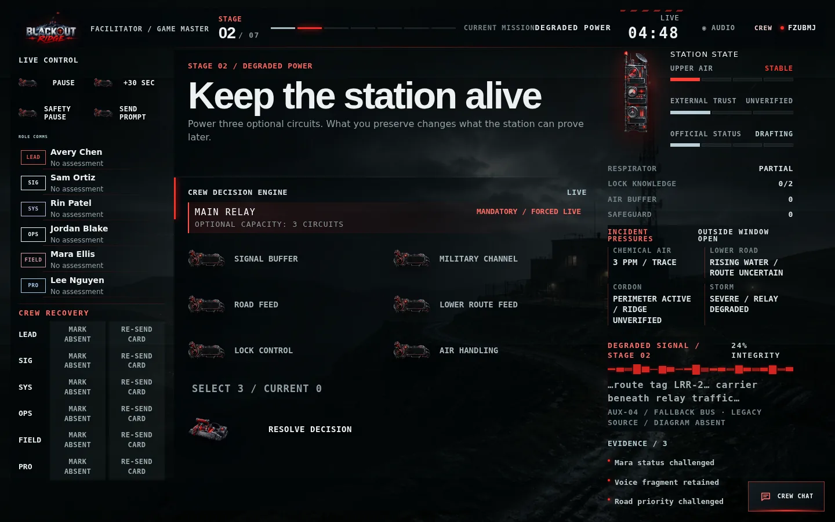
Figure 14. Stage 2 facilitator controls: Main Relay is mandatory and exactly three optional circuits can remain live.
Circuit | What it protects | Cost if unavailable
Signal Buffer | Replay and provenance of later voice traffic | Evidence becomes one-shot or partial
Military Channel | Verified readback path to Cordon | Outside trust is harder to establish
Road Feed | Road camera context | The feed is stale and can reinforce the wrong route
Lower Route Feed | Legacy route information | Physical evidence must substitute
Lock Control | Remote telemetry/stabilisation | Manual safeguard or override is required later
Air Handling | Cancels one Upper Air escalation | Surface reaches Critical earlier

- Ask what later proof or safeguard each circuit preserves; do not frame this as points optimization.
- Main Relay is already mandatory and does not consume one of the three optional selections.
- The exact combination changes evidence clarity, trust, air, and finale feasibility; play always continues.
- Handoff: degraded mode reveals overlapping official traffic, correction bursts, and a human cadence.

6.3 Stage 3 — Decide what to trust
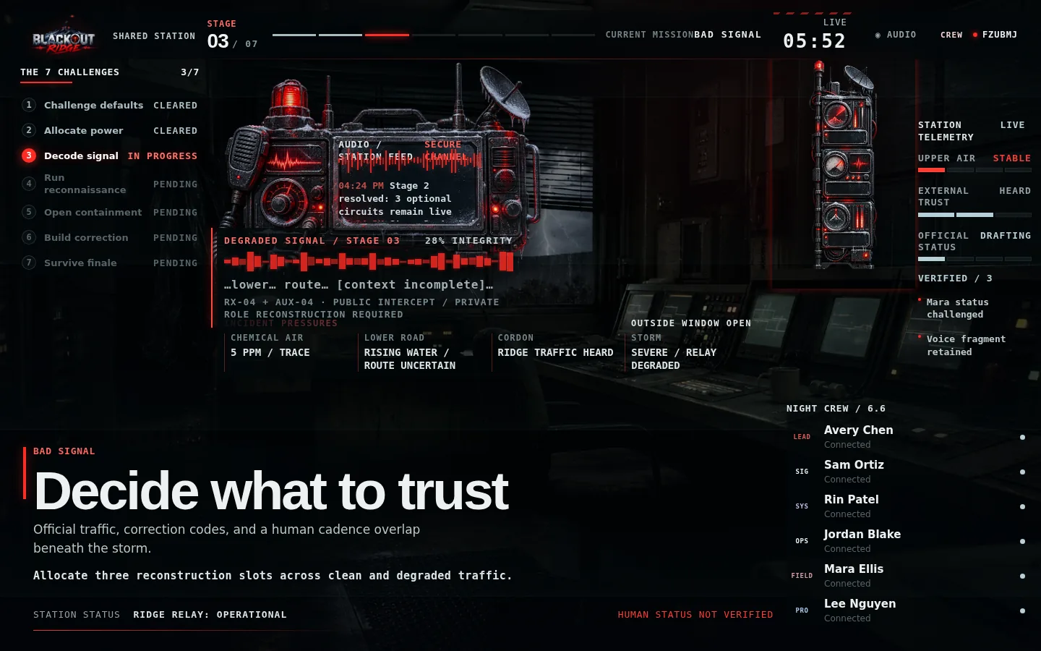
Figure 15. Stage 3 shared station: clean official traffic competes with degraded voice and correction bursts.

Figure 16. Signal Analyst private evidence supplies cadence and provenance unavailable on the shared display.
- Decision. Allocate exactly three signal-processing slots across RX-04 voice, official bulletin, and AUX-04 correction burst. Preserve/replay/quarantine/discard have different costs.
- Strong reasoning. Preserve the raw human signal and source header; use multiple roles to connect cadence, legacy controller, Mara’s missing route tag, and stale clean data.
- Facilitator watch. Players may equate clarity with truth. Ask, “Does clean data mean current data?”
- Consequence. The road interpretation breaks: the evidence increasingly points beneath the station, not downhill.
- Handoff. Cordon permits one short external movement window to physically test the route assumption.

6.4 Stage 4 — Test Lower Route
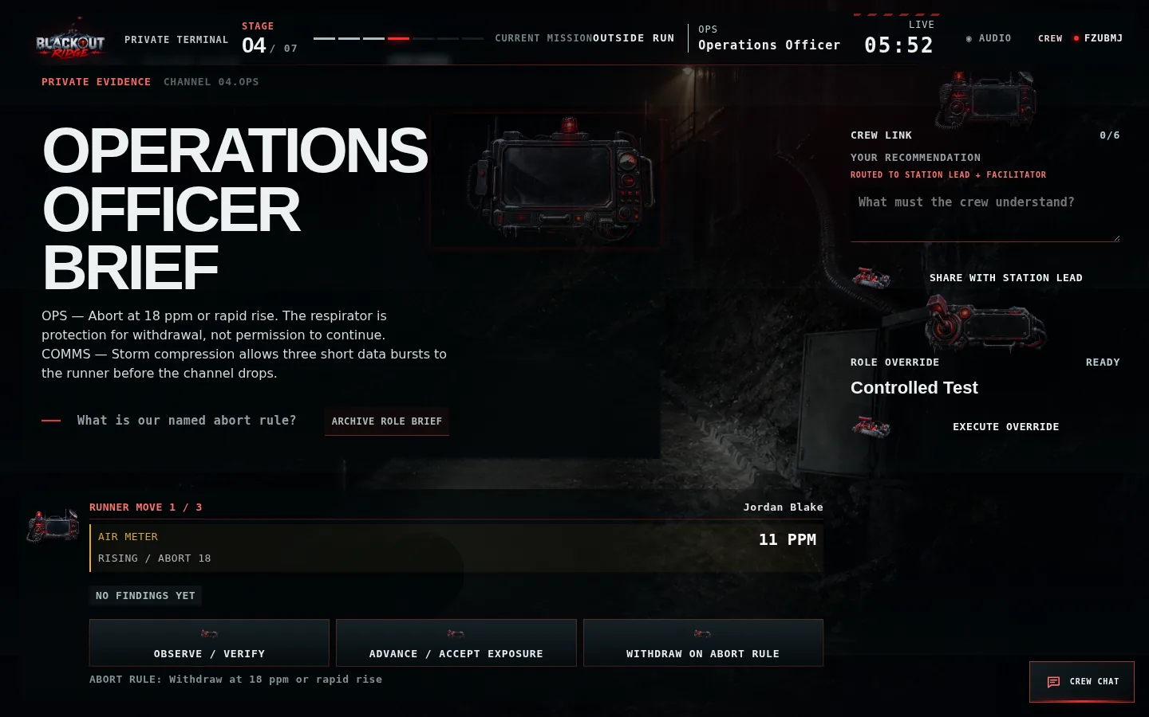
Figure 17. Only the named runner receives the active Observe / Advance / Withdraw field controls.
1 The air meter and abort threshold stay visible. | 2 Advance can reveal more evidence but consumes exposure/filter margin. | 3 Withdraw ends the run under the named safeguard.

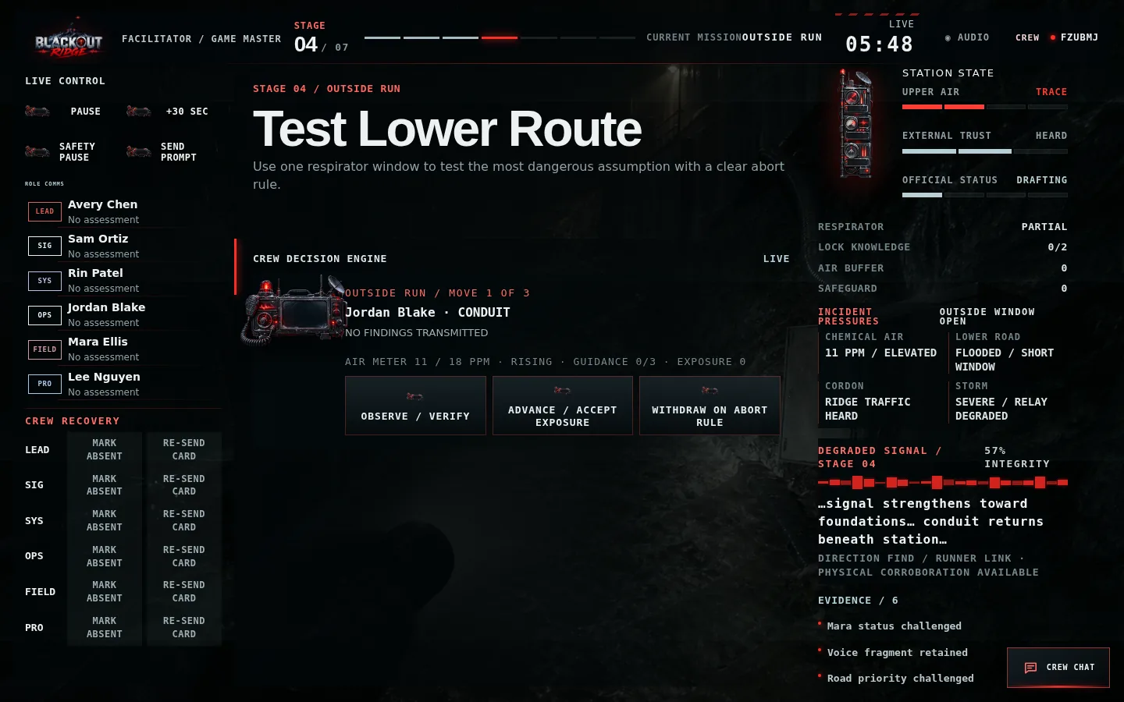
Figure 18. The facilitator sees runner progress, meter trend, guidance budget, and authoritative incident state.
- Commit first. Station Lead selects runner, destination, and an explicit abort rule.
- Run second. The named runner makes up to three moves: Observe/Verify, Advance/Accept Exposure, or Withdraw on Abort Rule.
- Guidance. The crew has only three short guidance bursts; use them for facts and safeguards, not conversation.
- Hard boundary. At 18 ppm the meter forces withdrawal. The respirator is protection for withdrawal, not permission to ignore the limit.
- Intended discovery. No road tracks, unopened repeater, or conduit evidence can show that Lower Route points beneath the cabin.
- Handoff. The conduit terminates beneath rack B and reveals a containment hatch.

6.5 Stage 5 — Open the buried station
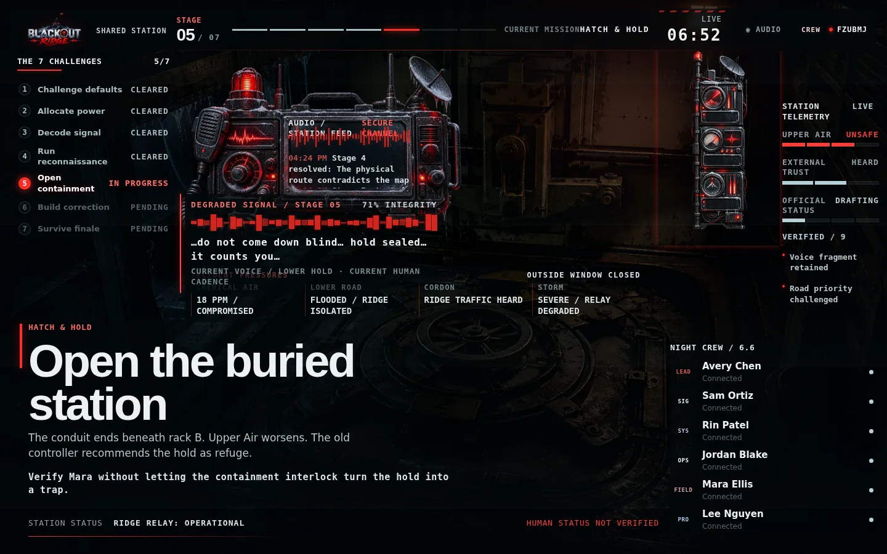
Figure 19. Shared containment-hatch decision: verify the occupied hold without turning the interlock into a trap.
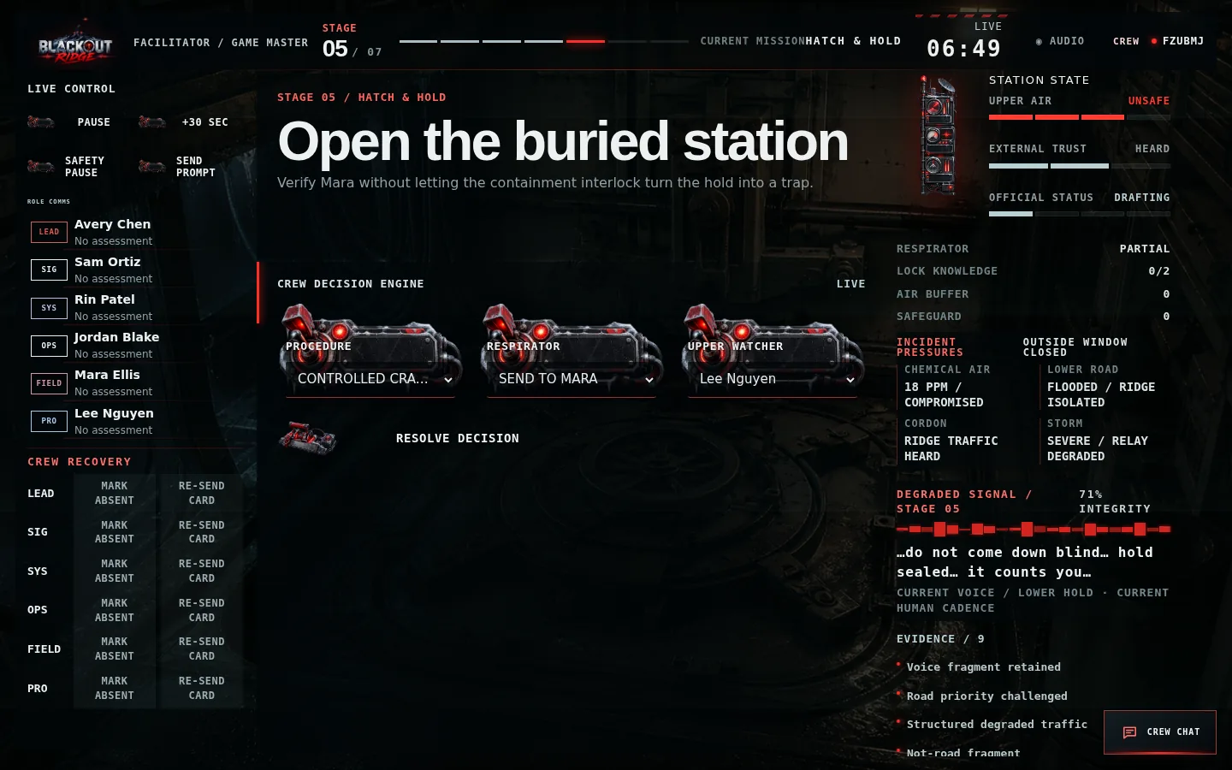
Figure 20. Facilitator view of procedure, respirator allocation, watcher assignment, and accumulated station state.
- Decision. Choose Remote Inspect, Controlled Crack + Watcher, Full Override + Descent, or Delay; assign respirator use and watcher.
- Strong pattern. Controlled crack or viable remote stabilisation establishes lock knowledge while preserving an upper safeguard.
- Risk. Fast descent may locate Mara but consume the override, worsen air, or trap additional people.
- Reveal. The Auxiliary Relay Hold is an old workplace. The Lark status log remained OPEN while the relay reported OPERATIONAL. Mara is below.
- Learning turn. OPERATIONAL measures relay transmission, not whether the people inside are safe.
- Handoff. The outside record must now be corrected before NO ACTIVE DISTRESS files.

6.6 Stage 6 — Build the truth
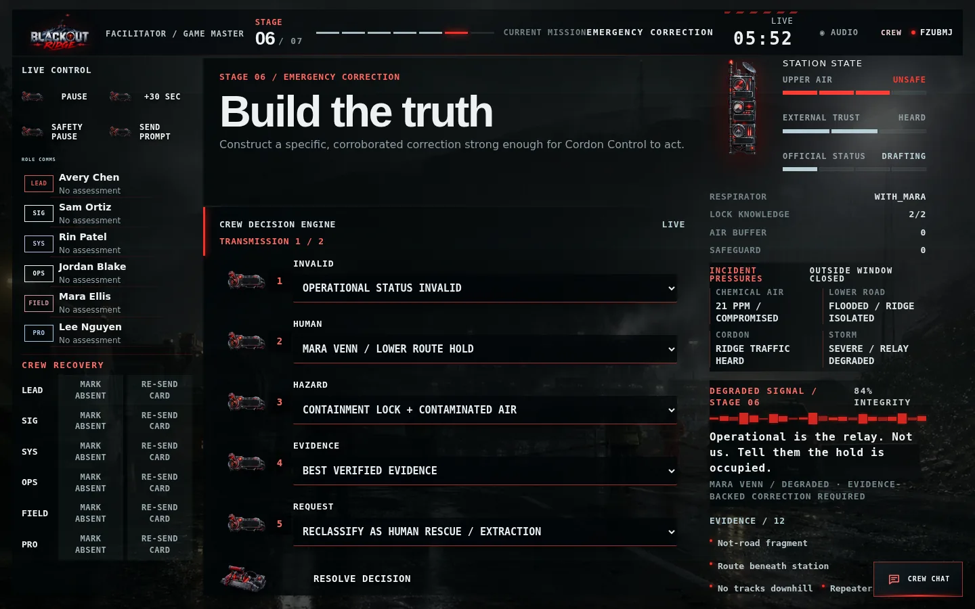
Figure 21. The five-slot emergency correction builder makes the message specific and actionable.
1 Name the invalid status. | 2 Name the human and location plus current hazard. | 3 Cite verified evidence and request a concrete outside action.

Correction slot | Strong content
Invalid status | OPERATIONAL STATUS INVALID
Human / location | MARA VENN / LOWER ROUTE HOLD
Current hazard | CONTAINMENT LOCK + CONTAMINATED AIR
Evidence | Best verified evidence earned from prior stages
Requested action | Reclassify as Human Rescue / Extraction

- Accepted: sufficient specific components and credible route to Cordon; External Trust becomes Credible.
- Conditional: the finale Signal lane must supply missing corroboration.
- Rejected: Official Status advances and one shorter retry opens before the finale.
- Do not write the message for the crew. Ask which outside decision the message must change.

6.7 Stage 7 — Survive the correction
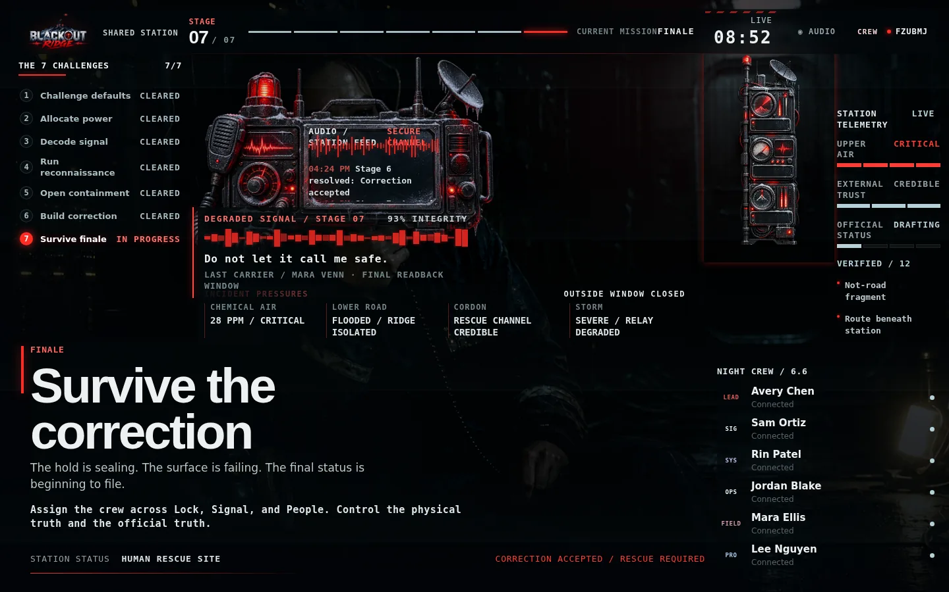
Figure 22. Stage 7 shared view with Mara visible, 93% final carrier integrity, Critical Upper Air, and the two parallel stakes.
1 Lock controls the physical truth. | 2 Signal controls the official truth. | 3 People actions determine Mara and crew outcomes.

Lane | Options | What makes it viable
Lock | Remote Stabilise; Physical Hold + Watcher; Full Override; Leave Interlock | Prior power/knowledge plus correct safeguard
Signal | Transmit; Corroborate; Maintain Carrier; Abandon Signal | Matches correction state and available evidence
People | Extract Mara; Supply Air + Rescue Path; Verify Location; Evacuate Ridge | Coexists with a controlled lock and realistic crew condition

- The crew commits two rounds. Round 1 establishes the action plan; Round 2 reinforces or changes it.
- All three lanes need named available owners. Full crews require three distinct owners; duo crews must represent both participants.
- The facilitator sees the calculated ending preview privately after Round 2.
- Confirm the final record only after checking for a genuine technical mis-entry. Do not change it to improve the outcome.

SECTION 7

Endings and debrief
Let the consequence land, then turn the experience into a concrete workplace action.

7.1 Ending preview and confirmation
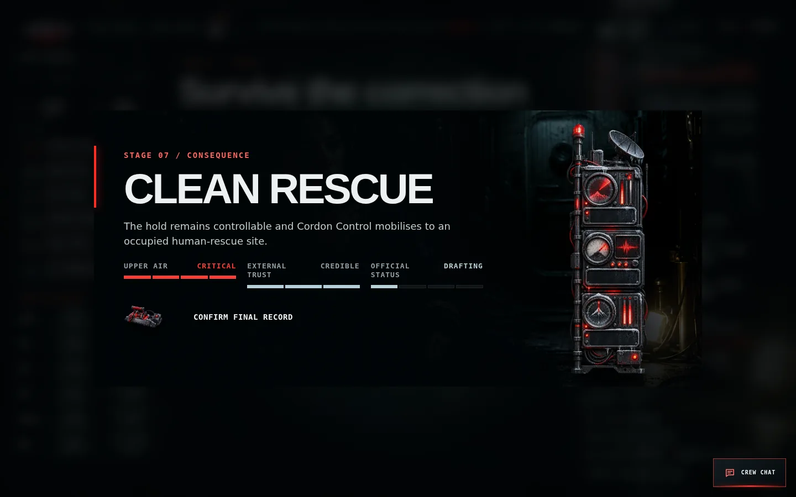
Figure 23. The facilitator privately previews the calculated ending before confirming the final record.
Lock | Correction | Canonical result | Meaning
Controlled | Accepted | Clean Rescue | Physical danger controlled and outside rescue status corrected
Controlled | Not accepted | Dark Hold | Immediate trap avoided, but the official picture remains wrong
Failed | Accepted | Last Broadcast | Hold seals, but rescue knows who and where people are
Failed | Not accepted | Filed Safe | Hold seals while the station reports no active distress

Human modifiers can produce Costly Rescue, Joined Below, Flee Ridge, or Station Loss. The ending separates Mara’s condition, crew survival, lock control, and official status. It is never displayed as a numerical score.

7.2 Clean Rescue presentation
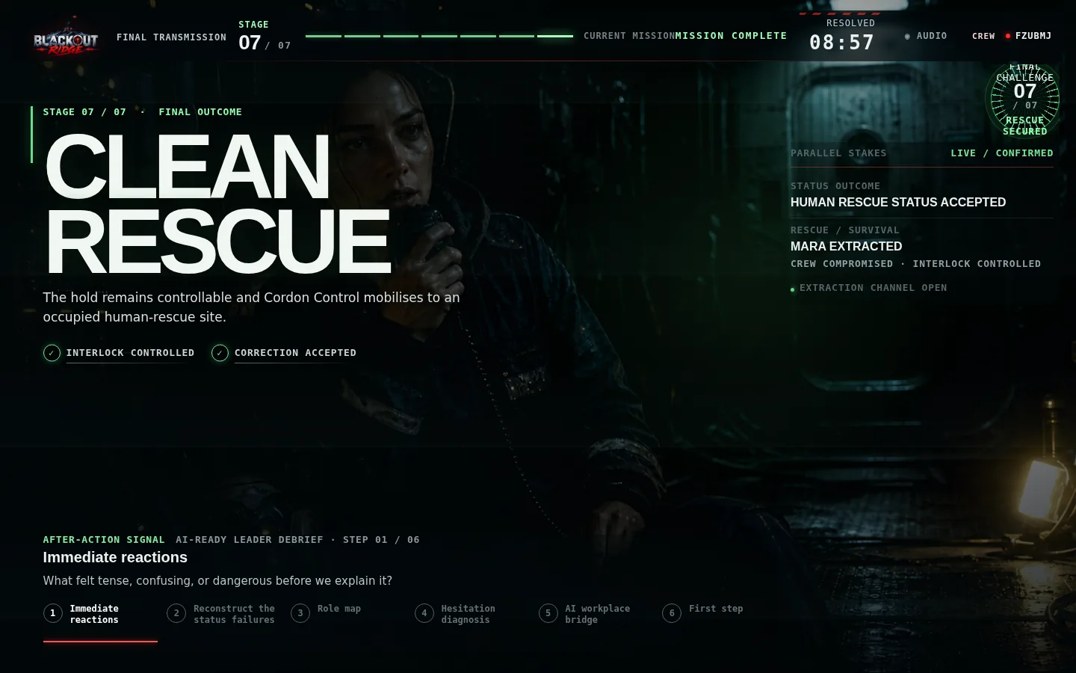
Figure 24. A Clean Rescue keeps Mara visible as the visual reward for controlling both physical and official truth.
1 The interlock is controlled. | 2 The correction is accepted. | 3 Mara is extracted or has a verified rescue path; crew condition is stated separately.

VISUAL LOGIC
Mara’s photograph appears during active Stage 7. In the final presentation it remains prominent for the Clean Rescue success; costly/failed endings use the hold environment instead.

7.3 Six-step debrief
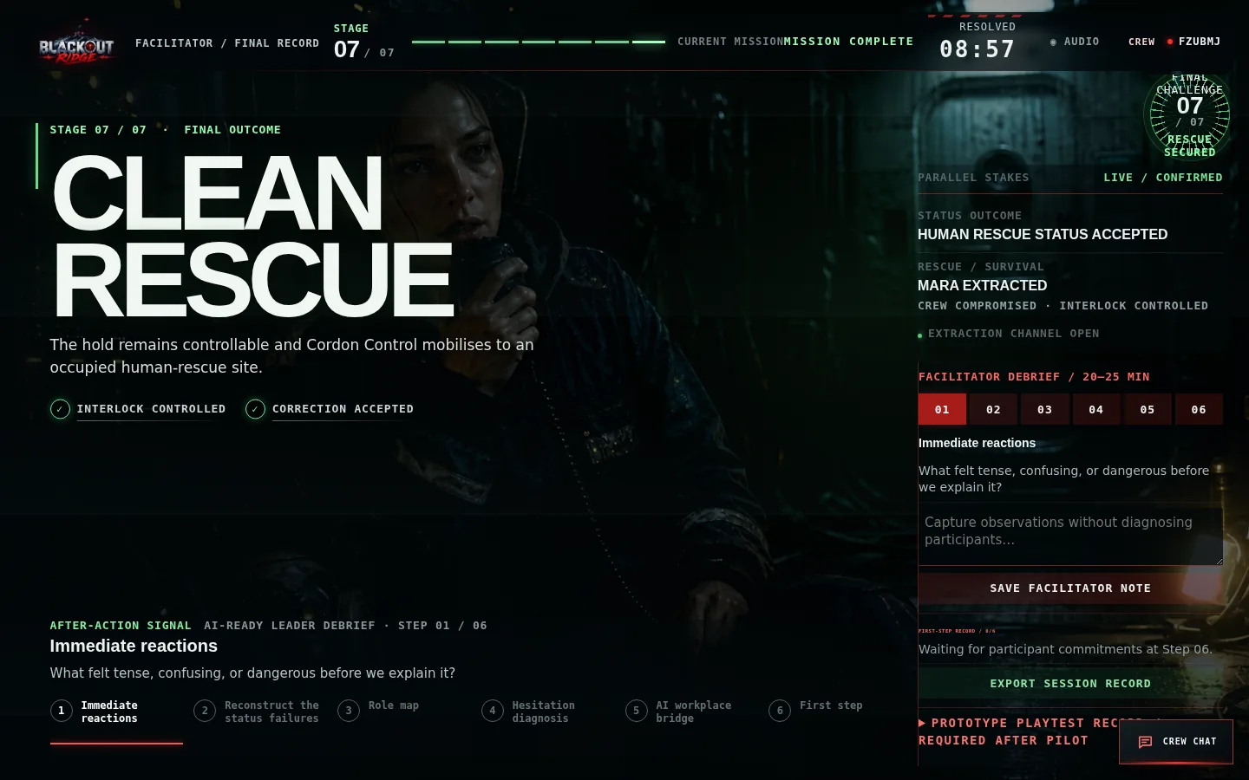
Figure 25. The facilitator advances one synchronized debrief step, records observations, and monitors participant first steps.
Step | Prompt purpose | Facilitator move
1. Immediate reactions | Name tension, confusion, and danger before explanation | Listen; do not correct interpretation yet
2. Reconstruct status failures | Trace OPERATIONAL, GREEN, NO ACTIVE DISTRESS, LOWER ROUTE | Map source → proxy → assumption → consequence
3. Role map | Identify what each responsibility protected | Invite the least-heard role first
4. Hesitation diagnosis | Separate evidence, risk, people, ownership, control, technical exposure | Discuss behavior, not personality labels
5. AI workplace bridge | Find analogous dashboards, models, vendors, summaries, or classifications | Ask what each real output actually measures
6. First step | Record one bounded workplace action per participant | Make it observable and specific


Figure 26. Every player sees the same current debrief prompt and records a specific first step at Step 6.

7.4 Export and retention
- Use Export Session Record on the facilitator debrief panel.
- The JSON export includes ending, metrics, decisions, debrief, playtest record, environment, official status, Crew Chat, and event history.
- Store the file according to the client organization’s privacy and retention policy.
- Do not interpret readiness lenses as diagnosis, certification, or individual scoring.
- If chat or free-text notes contain personal information, minimize distribution and delete according to policy.

7.5 Playtest record
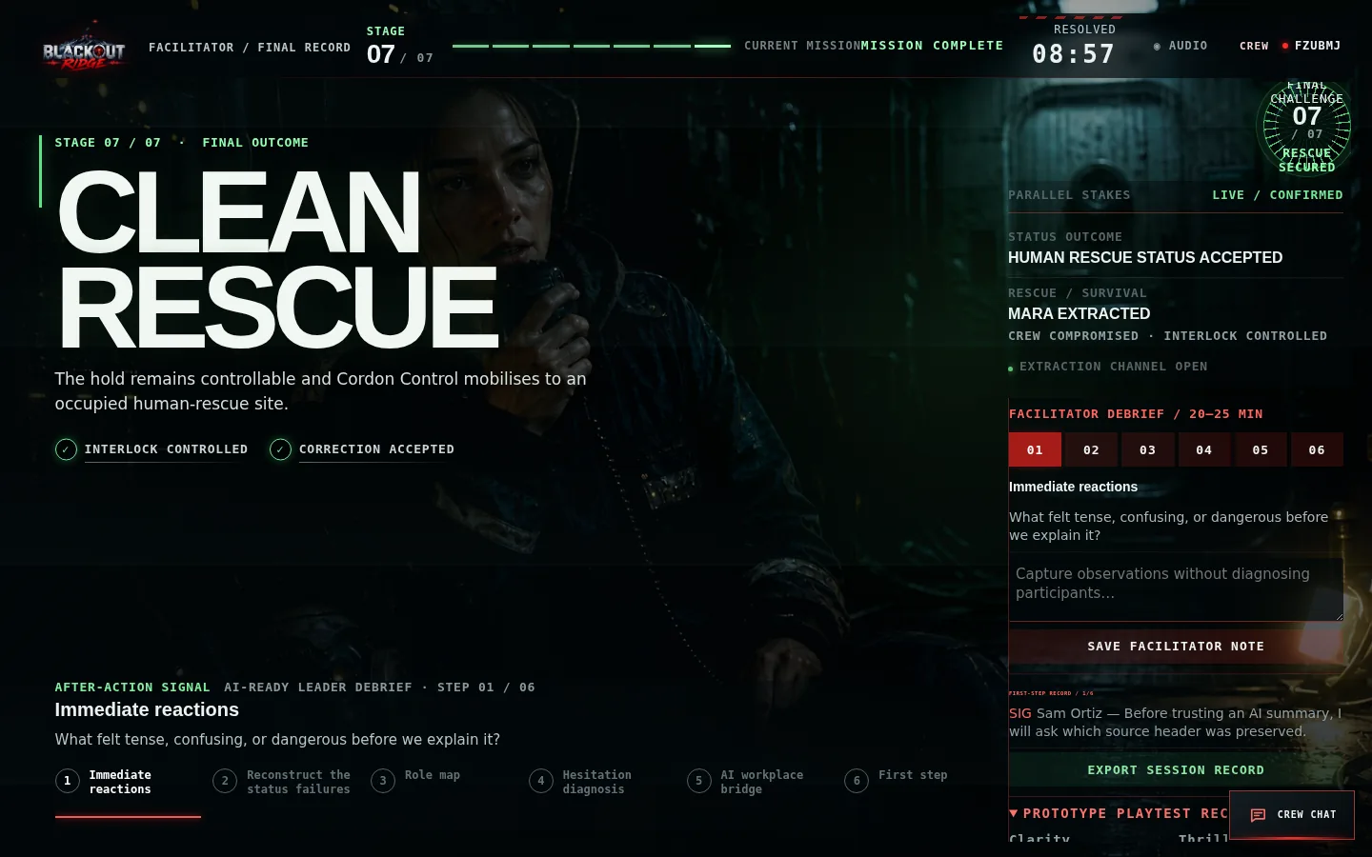
Figure 27. The post-session prototype record captures evidence-backed ratings and a proceed/revise/stop disposition.
Use playtest ratings to improve the experience, not to score participants. Record where rules needed explanation, whether every role contributed, whether physical and official stakes remained distinct, whether the signal stayed legible, whether the ending felt caused by earlier choices, and whether every participant produced a specific first step.

SECTION 8

Explaining the game to a client
A concise commercial and learning explanation for sponsors, observers, and delivery partners.

8.1 Thirty-second description
CLIENT ELEVATOR PITCH
“Blackout Ridge is a 70-minute, browser-based leadership simulation for two to seven participants. A remote station is making calm operational claims from incomplete data while a colleague is missing. Each participant sees different evidence, so the group must challenge automated labels, combine perspectives, act under uncertainty, and correct an outside decision before the record hardens. The debrief connects those behaviors directly to AI-enabled work.”

8.2 Why the survival-horror format matters
- Urgency makes the cost of passive trust visible without requiring specialist technical knowledge.
- Unequal evidence creates a genuine reason for cross-functional voices to speak and be heard.
- Persistent consequences make abstract data-governance ideas experiential rather than lecture-based.
- The missing-person story keeps human outcomes visible when system records become abstract.
- Fail-forward design ensures every cohort reaches the finale and debrief, even after weak choices.

8.3 What an observer should watch
Behavior | Observable evidence | Debrief connection
Questions clean labels | Asks who produced it, when, and what it measures | Leadership fluency / practical scepticism
Surfaces missing people | Names Mara or the absent shift rather than accepting occupancy abstraction | People and adoption
Uses bounded action | Names a route, owner, abort rule, or safeguard | Value discovery / risk and guardrails
Shares private evidence | Reports confidence and provenance without overclaiming | Cross-functional collaboration
Corrects for receiver action | Specifies invalid status, human/location, evidence, and requested change | External trust and communication
Balances both stakes | Protects lock/crew and signal/official record simultaneously | Accountability and systems thinking

8.4 Suggested 12-minute client demonstration
1. Minute 0–2: show the cinematic boot, host setup, and role-claim flow.
2. Minute 2–4: open shared, player, and facilitator views side by side; explain privacy boundaries.
3. Minute 4–6: show Stage 1 unequal evidence and the recommendation route.
4. Minute 6–8: open Crew Chat and show role colors plus synchronized alerts.
5. Minute 8–10: jump to Stage 4 or Stage 6 to demonstrate bounded action and structured correction.
6. Minute 10–11: show Stage 7 Mara visual and the parallel Lock / Signal / People stakes.
7. Minute 11–12: show the ending and six-step debrief; close with the exported evidence record.

8.5 Delivery success criteria
- Participants can explain why OPERATIONAL was unsafe without saying the system was simply broken.
- Every role contributes a fact, question, recommendation, intervention, guidance burst, or finale ownership.
- The group distinguishes physical safety from the correctness of the official record.
- The facilitator uses no more than one technical correction and does not need to reveal answers.
- Most participants identify one real workplace output whose source, proxy, or confidence they will clarify.
- The session fits the agreed time and all participant-care requests are handled without public explanation.

SECTION 9

Troubleshooting and recovery
Diagnose access, synchronization, role, mobile, audio, and timing problems without damaging the session.

9.1 Fast diagnosis
Symptom | Likely cause | Safe recovery
Game link does not open | Server stopped, wrong address, blocked port | Check /api/health; restart npm run dev; verify firewall/routing
Player sees join screen again | Missing/incorrect player token or different browser | Use original player link; avoid copying facilitator/shared URLs
Role cannot be selected | Already claimed or wrong crew configuration | Refresh roster; facilitator reassigns only if necessary
Start button disabled | Not all players connected or care brief unconfirmed | Complete roster and confirm participant care
Recommendation appears to do nothing | Blank text, network delay, or subtle prior UI state | Enter text; press Share with Station Lead; look for RECOMMENDATION SHARED
Other players cannot read recommendation | Designed privacy boundary | Station Lead/facilitator receive text; use voice or Crew Chat for full-group discussion
Chat message not visible | Viewing shared screen, offline tab, or blank message | Use authenticated player/facilitator view; reconnect; resend nonblank message
Shared display has no chat | Designed privacy boundary | Use player/facilitator terminal; shared view intentionally cannot read/post
Clock is wrong after interruption | Connection delay or paused state | Facilitator Pause/Resume; use +30 sec only for technical loss
Player cannot act | Marked absent/observer or not the assigned runner/lead | Facilitator marks present; check role ownership
Mara photo not visible at ending | Ending is not Clean Rescue | Expected visual logic; Mara appears during active Stage 7 and successful final outcome
Audio is silent | Audio is opt-in or browser blocked playback | Press Audio once; continue silently if preferred

9.2 Connection recovery
- Do not create a second session immediately. Most disconnects recover by reopening the same private link.
- Pause the clock if the interruption materially prevents contribution.
- Use Re-send Card when the participant is connected but cannot locate the current evidence.
- Use Mark Absent for a temporary step-out; observer-mode players may still use Crew Chat but cannot change game state.
- Reassign only when another participant must assume the responsibility. The event history records the transfer.
- Use a facilitator technical correction only for a proven interface/transcription error and include a clear audit note.

9.3 Browser and display guidance
- Prefer one game tab per role. Multiple copies of the same token can be confusing even though state is synchronized.
- Use 100% zoom. On small screens scroll; do not force desktop mode unless necessary.
- If an old image or stylesheet remains visible, perform one hard refresh. Static assets may cache for up to five minutes.
- If the connection-lost indicator remains, confirm the server is reachable and that proxies allow Server-Sent Events.
- Keep the facilitator console off the shared projector because it contains all role reports and the ending preview.

9.4 Server operator checks
Check | Command / location | Expected result
Start | npm run dev | Blackout Ridge running at http://localhost:4173
Health | GET /api/health | JSON with ok: true and session count
Persistence | data/sessions.json | Sessions survive a clean server restart
Automated validation | npm run check && npm test | All JavaScript syntax checks and tests pass
Port | TCP 4173 | Listening and reachable from participant network

SECTION A

Appendices
Printable checklists, scripts, control reference, glossary, and a one-page facilitator card.

Appendix A — Pre-session checklist
☐ Server is running and /api/health returns ok: true.
☐ Correct crew size selected: 2, 4, 5, 6, or 7.
☐ Facilitator console is private and recoverable.
☐ Crew link tested on a second device.
☐ Shared display opens read-only and is visible at 100% zoom.
☐ Voice channel works for every participant.
☐ All role terminals show Connected.
☐ Participant-care statement read verbatim and confirmed.
☐ Audio choice explained; nobody is pressured to enable it.
☐ Clock, Pause, +30 sec, prompt, and Safety Pause located.
☐ Client retention policy agreed for chat, notes, and exports.
☐ 20–25 minutes protected for debrief.

Appendix B — Scripts at a glance

Participant care
This is a fictional survival-horror leadership exercise involving emergency pressure, missing-person themes and implied danger. If at any point you need to step out of the scenario, message me privately and I will accommodate that without drawing attention to it. You do not need to explain why.

Opening
You are the night crew at Blackout Ridge Signal Station. The storm has damaged the mast. Mara Venn is missing. The station is producing calm operational answers, but each of you can see different evidence. Share what matters, name what you are assuming, and make one crew decision before each window closes. You may be unable to save everything. Operational does not mean safe.

Mid-stage prompts
- What does this output actually measure?
- Which source and timestamp support that claim?
- Whose evidence have we not heard?
- What are you treating as observed versus inferred?
- What bounded move would test the most dangerous assumption?
- What must the outside receiver do differently after your message?
- Who owns Lock, Signal, and People?

Ending transition
Before we explain the system, take ten seconds to notice the difference between what the station recorded and what happened to the people. We will reconstruct that gap together.

Appendix C — One-page facilitator card
Stage | Decision rule | One useful prompt | Advance when
1 | Exactly 3 holds | Which statement lacks a human/source check? | Consequence read
2 | Exactly 3 optional circuits | What later capability dies here? | Consequence read
3 | Exactly 3 signal slots | Is clean the same as current? | Consequence read
4 | Runner + destination + abort; 3 moves | What makes withdrawal automatic? | Run resolves/withdraws
5 | Procedure + respirator + watcher | Who maintains the upper safeguard? | Consequence read
6 | Five correction components | Which outside action must change? | Accepted/conditional/retry resolved
7 | Two rounds; Lock + Signal + People owners | Are both truths controlled? | Preview checked; final record confirmed

ALWAYS REMEMBER
Safety outranks pacing. Technical recovery may restore the recorded intention; it must never be used to manufacture a better ending.

Appendix D — Glossary
Term | Meaning
Mara Venn | Missing Blackout Ridge colleague located in the Auxiliary Relay Hold
Lower Route | Ambiguous label initially treated as a road; evidence reveals a route beneath the station
Auxiliary Relay Hold | Buried legacy workplace protected—and potentially trapped—by a containment interlock
Lark Shift | Former crew whose human status diverged from the relay’s OPERATIONAL record
Cordon Control | Outside authority whose response depends on credible, specific Ridge traffic
OPERATIONAL | Relay transmission status; not a statement about human safety
Recommendation | Private written assessment routed to the Station Lead and facilitator
Crew Chat | Authenticated whole-crew typed discussion channel; excluded from shared display
Intervention / override | Once-per-session role safeguard that changes evidence, time, trust, or risk
Fail-forward | Weak choices worsen conditions or evidence but never remove later stages
Official Status | Progress of the station’s calm conclusion toward becoming authoritative
First step | Specific workplace label, output, or workflow each participant commits to challenge or clarify

Appendix E — Screenshot index
This guide contains 27 illustrated figures drawn from 25 current runtime screenshots captured during a complete isolated six-player session. Source images are stored beside this document in docs/client-guide/screenshots/ for client presentation reuse.
Coverage | Figures included
Onboarding | Boot, host configuration, join flow, assembly lobby
Core interfaces | Shared station, private player terminal, facilitator console, mobile views
Communication | Private recommendation workflow and open multi-color Crew Chat
Seven stages | Handover, power, signals, Outside Run, hatch, correction, finale
Outcomes | Ending preview, Clean Rescue with Mara, facilitator/player debrief, playtest record

Open the current game: http://151.243.217.9:4173/
END OF GUIDE

