BLACKOUT RIDGE

Milestone 2 — Completion Report
UX/UI Prototype
Shared Blackout Ridge interface, individual role terminals, facilitator dashboard, and one fully interactive challenge
Prepared: 25 August 2026

Status: COMPLETE

1. Executive summary
Milestone 2 validates the three-view product architecture and the complete Stage 3 (Decide What to Trust) interaction loop — the highest-risk UX surface in the game: shared official traffic, role-specific fragments, voice collaboration, limited bandwidth, a committed decision, and a visible consequence.
This milestone is complete. The prototype demonstrates all four browser modes, responsive layouts, cinematic presentation, and deterministic consequence feedback. The current build has since exceeded the original Milestone 2 boundary (local-only sync) by incorporating the Milestone 3 server — but all Milestone 2 acceptance requirements are met and evidenced below.

2. Milestone 2 requirements vs delivery
Requirement | Implementation | Status
Shared Blackout Ridge interface | Shared station HUD, tracks, crew roster, system broadcast, consequences | Complete
Individual role terminals | Seven distinct private evidence views, assessments, interventions | Complete
Facilitator dashboard | Run controls, reports, hints, state, decision engine, event log | Complete
One fully interactive challenge | Stage 3: briefing → timer → reports → three-slot allocation → consequence | Complete
Unequal information validation | Each role receives unique source; only summary readiness is public | Complete
Earlier-choice consequence | Allocation quality changes transcript, ledger, Outside Run burden | Complete
Desktop and mobile-width layouts | Responsive breakpoints at 720px and 1100px | Complete
Accessibility baseline | Semantic controls, transcripts, reduced-motion, no color-only status | Complete

3. Four browser modes implemented
Mode | URL parameter | Purpose
Game start / host | view=home | Session creation, crew size selection, station startup
Shared station | view=shared | Room-facing world view, clock, crew state, consequences
Private role terminal | view=player | Evidence, crew report, role override, lead decisions
Facilitator console | view=facilitator | Stage control, reports, station state, debrief

4. Stage 3 validation slice

4.1 Interaction flow
- Facilitator starts Stage 3 from the console.
- Each role receives a private fragment with source metadata.
- Players submit short assessments to the crew channel.
- Station Lead allocates three bandwidth slots (Preserve, Replay, Quarantine, Discard).
- Lead commits; all views show the correlated consequence.
- Signal Analyst may use Recover Fragment once per session.

4.2 Review script (reproducible)
- Open shared console and facilitator dashboard.
- Open Station Lead, Signal Analyst, Systems Engineer, and Field Liaison terminals.
- Start the challenge; submit different role assessments.
- Set RX-04 to Replay & rebuild, CV-PUBLIC to Discard, AUX-04 to Preserve raw.
- Commit and confirm correlated outcome on every view.
- Reset, commit weak allocation, use Recover Fragment to confirm improvement.

5. Visual design and assets
- Full-viewport cinematic presentation — no website chrome during play.
- Industrial emergency-station aesthetic: calm, helpful, wrong.
- Integrated game art for lobby, shared console, private terminals, facilitator controls.
- Dedicated visual archive at /?view=gallery.
- Opt-in procedural station ambience (browser audio).

6. Screenshot evidence (current build — latest UI)
The captures below show the current Blackout Ridge interface as implemented today — not the original local-only prototype. Session 9TN9SP is shown mid-play at Stage 3 (Decide What to Trust), the Milestone 2 validation slice, with live server synchronization.

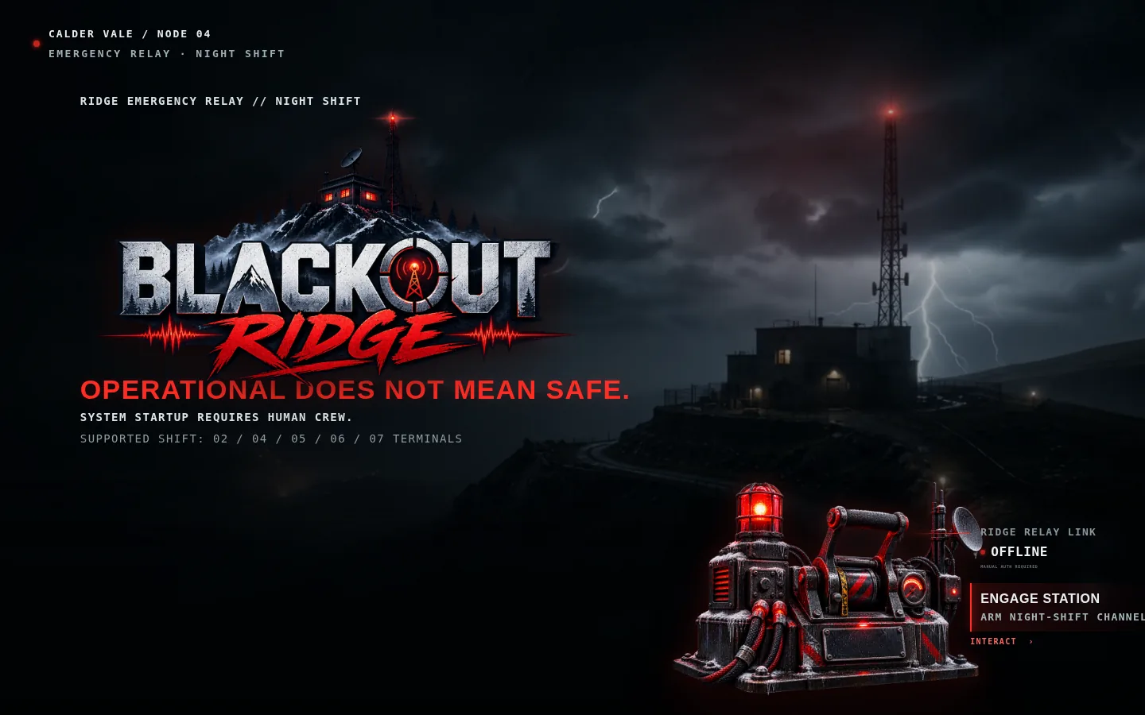
Figure 1 — Station engagement screen (current cinematic entry)

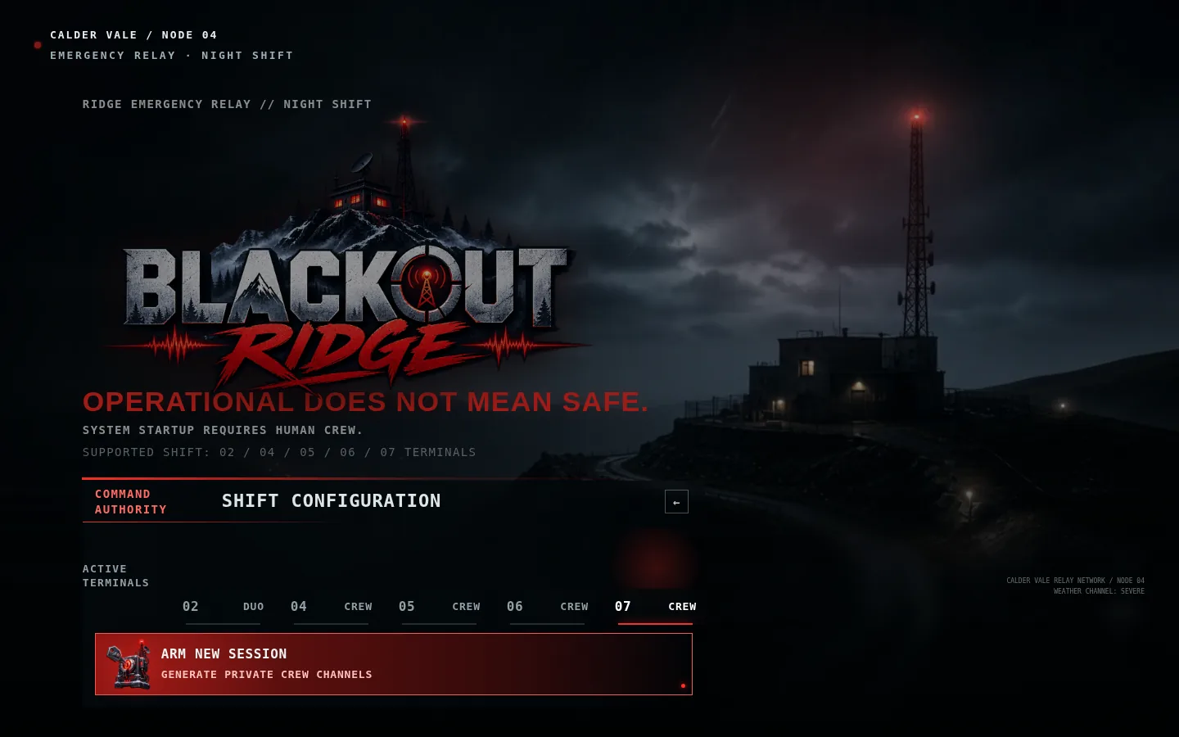
Figure 2 — Host shift configuration and crew size selection

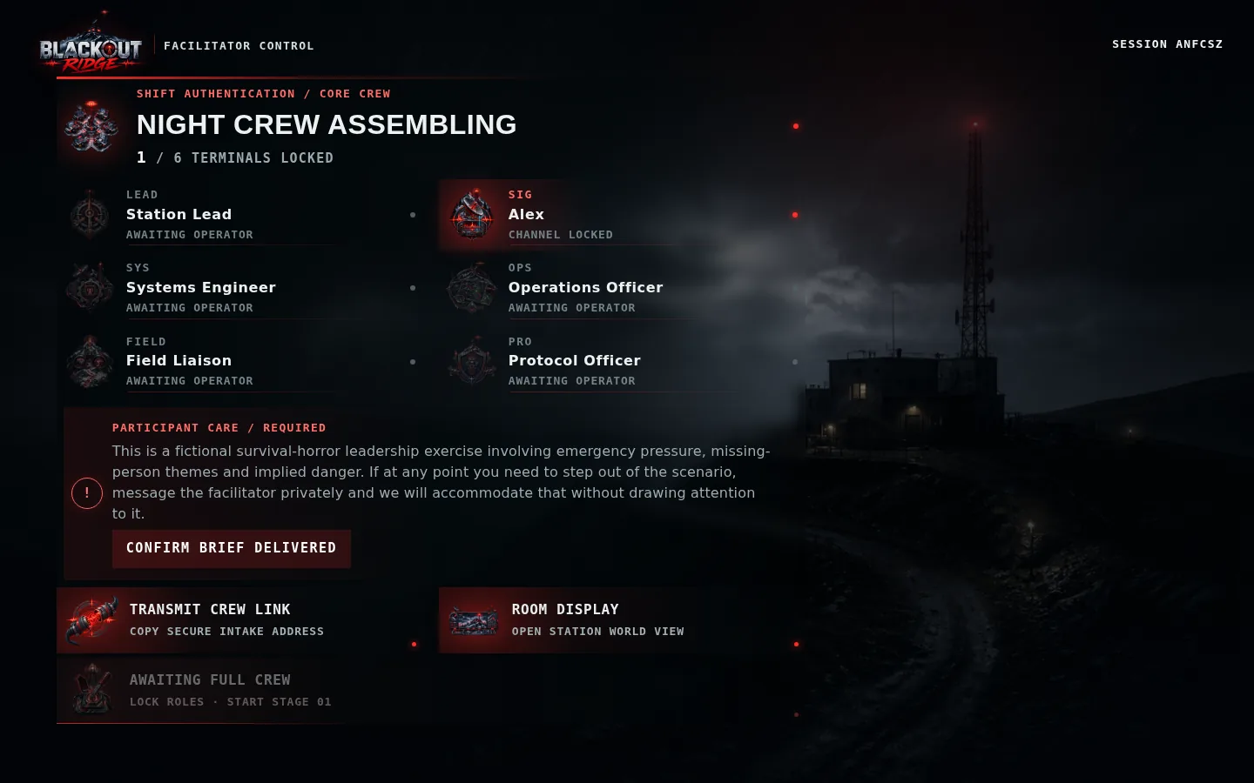
Figure 3 — Assembly lobby with roster and safety brief confirmation

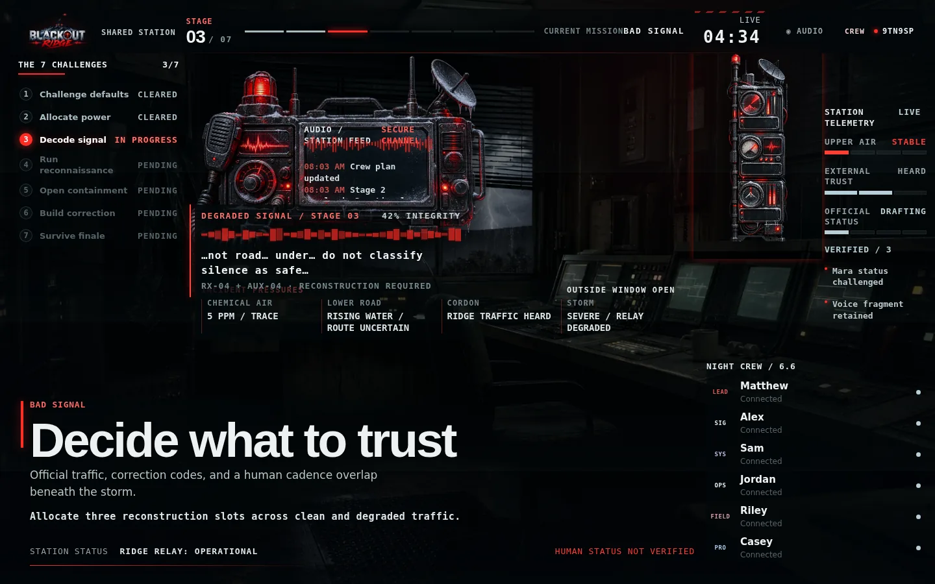
Figure 4 — Shared station console during Stage 3 (Decide What to Trust)

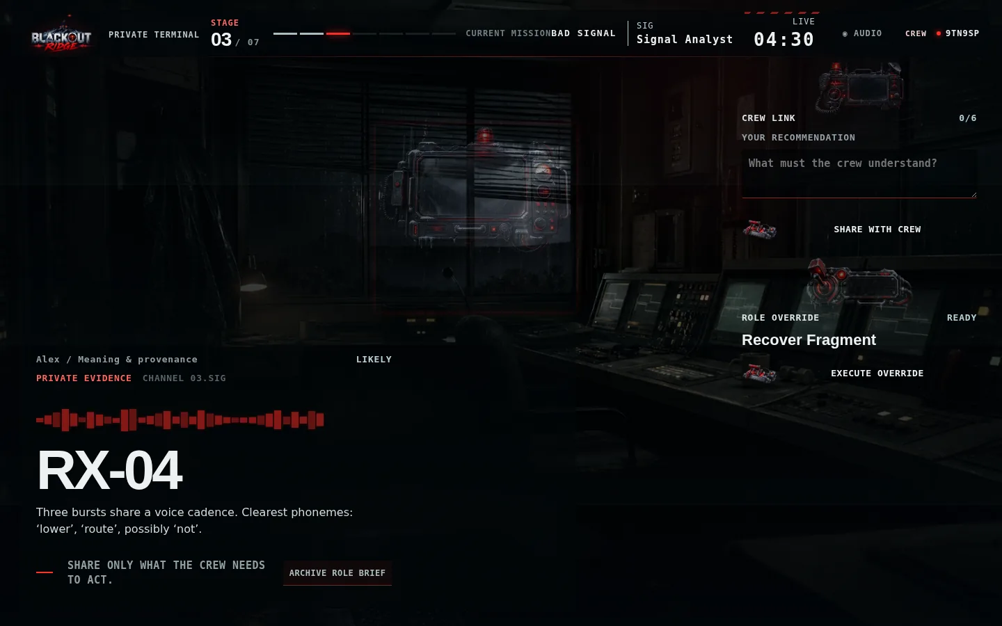
Figure 5 — Private role terminal (Signal Analyst evidence view)

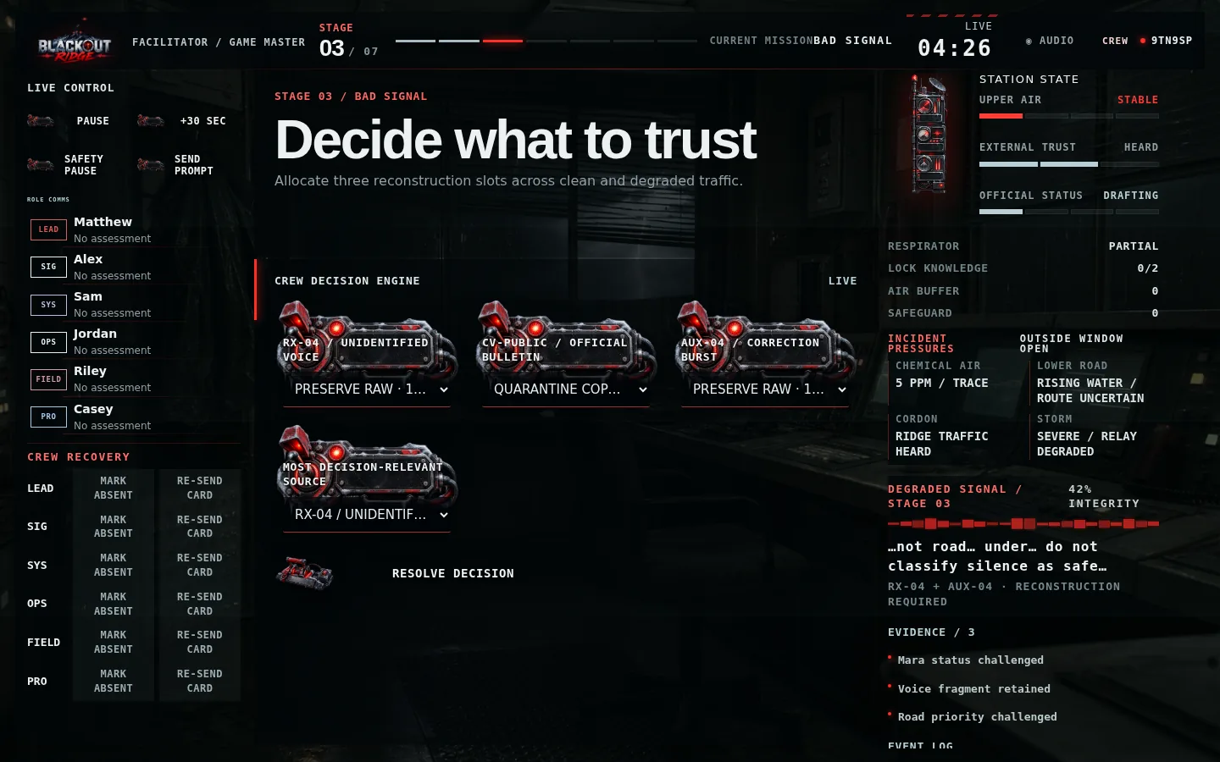
Figure 6 — Facilitator dashboard with live stage controls and station state

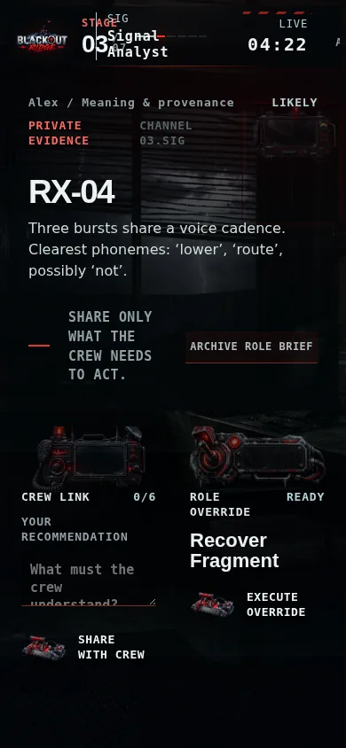
Figure 7 — Mobile-width private terminal layout

7. Technical implementation
- prototype/full-app.js — four browser modes and interaction routing.
- prototype/styles.css — cinematic full-viewport presentation and responsive layout.
- prototype/audio.js — opt-in procedural ambience and UI feedback cues.
- Automated state tests: npm test (29 passing checks).

8. Milestone 2 acceptance checklist
Criterion | Status
Shared console and private terminal visible simultaneously | Complete
Six- and seven-player information distribution designed | Complete
Recover Fragment intervention implemented | Complete
Timer with facilitator pause/hint | Complete
State update and Stage 4 transition teaser | Complete
Legible desktop and mobile private views | Complete
Restrained calm-helpful-wrong visual language | Complete

9. Handoff to Milestone 3
Milestone 2 validated screen hierarchy and the Stage 3 interaction loop. Milestone 3 extended this into true multiplayer: session codes, role tokens, server-authoritative state, and live synchronization across separate browsers and devices.

