BLACKOUT RIDGE

Milestone 3 — Completion Report
Core Multiplayer Build
Session creation/joining, role assignment, private information, shared state, timed events, facilitator controls, and persistent decisions
Prepared: 25 August 2026

Status: COMPLETE

1. Executive summary
Milestone 3 delivers the server-backed multiplayer foundation for Blackout Ridge. Multiple players on separate browsers join a session with private role tokens, receive role-specific information the server never exposes to other clients, share synchronized station state via live events, and commit decisions that persist across reconnects.
This milestone is complete. The Node.js server handles session lifecycle, authorization, timer logic, consequences, and persistence. The browser client connects via REST actions and Server-Sent Events (SSE). Automated tests cover complete-game paths, role privacy, authority rules, and timer expiry.

2. Milestone 3 requirements vs delivery
Requirement | Implementation | Status
Session creation | POST /api/sessions — code, facilitator token, crew link | Complete
Session joining | POST /api/sessions/:code/join — name, role, player token | Complete
Role assignment | First-come role claim; facilitator reassignment with audit | Complete
Private information | Server filters state per viewer token; no cross-role leakage | Complete
Shared state | Single authoritative session state broadcast to all clients | Complete
Timed events | Server-side clock; pause, resume, +30 s, expiry consequences | Complete
Facilitator controls | Full action set via authenticated facilitator token | Complete
Persistent decisions | Draft updates, commits, flags, history in sessions.json | Complete

3. Runtime architecture
Component | File | Responsibility
HTTP API + SSE + static delivery | server/server.js | Sessions, events stream, persistence, broadcast
Game engine | server/game-engine.js | Authorization, timers, consequences, endings, debrief
Game content | server/game-content.js | Roles, stages, evidence, decision options
Browser client | prototype/full-app.js | Four modes, rendering, interaction routing
Network layer | prototype/network.js | REST actions, state load, SSE reconnect

4. Session lifecycle

4.1 Facilitator creates a session
- Open http://localhost:4173 (or deployed host).
- Choose crew size: 2, 4, 5, 6, or 7 players.
- Receive session code, facilitator token, crew join link, and shared display link.
- Open facilitator console and shared station on separate tabs/devices.

4.2 Players join
- Open crew join link or enter session code.
- Enter display name and claim an unclaimed role.
- Browser stores private player token in localStorage for reconnect.
- Private terminal shows only that role's evidence and controls.

4.3 Live synchronization
- Server broadcasts state changes via SSE to all connected clients.
- Player actions POST to /api/sessions/:code/action with Bearer token.
- Reconnect restores same role and information after refresh or drop.
- Heartbeat and safe JSON parsing prevent crash loops on partial responses.

5. Authorization and privacy model
Token type | Access
Facilitator token | All controls, full state, debrief notes, playtest record, ending confirmation
Player token | Own role evidence, reports, interventions; lead commit if Station Lead
Shared view (no token) | Public station state only — no private evidence
Unauthenticated | Join flow only

Automated tests verify that player tokens cannot read other roles' private cards or perform facilitator-only actions.

6. Facilitator controls (implemented)
- Start shift, pause, resume, advance stage, add 30 seconds.
- Send and clear contextual hints.
- Safety pause with neutral holding screen.
- Mark role absent (observer mode) or present.
- Re-send current private card; reassign disconnected role.
- Commit/resolver crew decisions; field move controls in Stage 4.
- Confirm final record after Stage 7; export session JSON.
- Save debrief notes, profile signals, playtest ratings.

7. Persistent state and decisions
- Three visible tracks: Upper Air, External Trust, Official Status.
- Resource flags: respirator, lock knowledge, air buffer, safeguard.
- Evidence ledger with earned labels.
- Stage drafts updated incrementally; committed on lead/facilitator action.
- Full event history and decision record for debrief export.
- Sessions persisted to data/sessions.json (local deployment).

8. Crew configurations supported
Players | Role mapping
2 (duo) | Command & Field; Signal & Systems
4 | Command & Protocol; Signal; Systems; Operations & Field
5 | Lead; Signal; Systems; Operations; Field & Protocol
6 | Six core roles
7 | Six core roles + Comms Officer

9. Quality assurance
- npm run check — syntax validation of all JavaScript entry points.
- npm test — 29 automated tests covering strong/weak game paths, privacy, timers.
- Live session testing on remote host (e.g. session VFVVPT with 2-player duo).
- Visual review at 1440×900 for shared, facilitator, and player modes.

10. Screenshot evidence (live server — corrected captures)
Captures below show the current server-backed build. Figures 2–4 were re-captured using snapshot mode so join flow, shared station, and private player terminals render fully (earlier headless captures of SSE pages appeared blank). Live session 9TN9SP is shown at Stage 3; lobby session ANFCSZ illustrates the join flow.

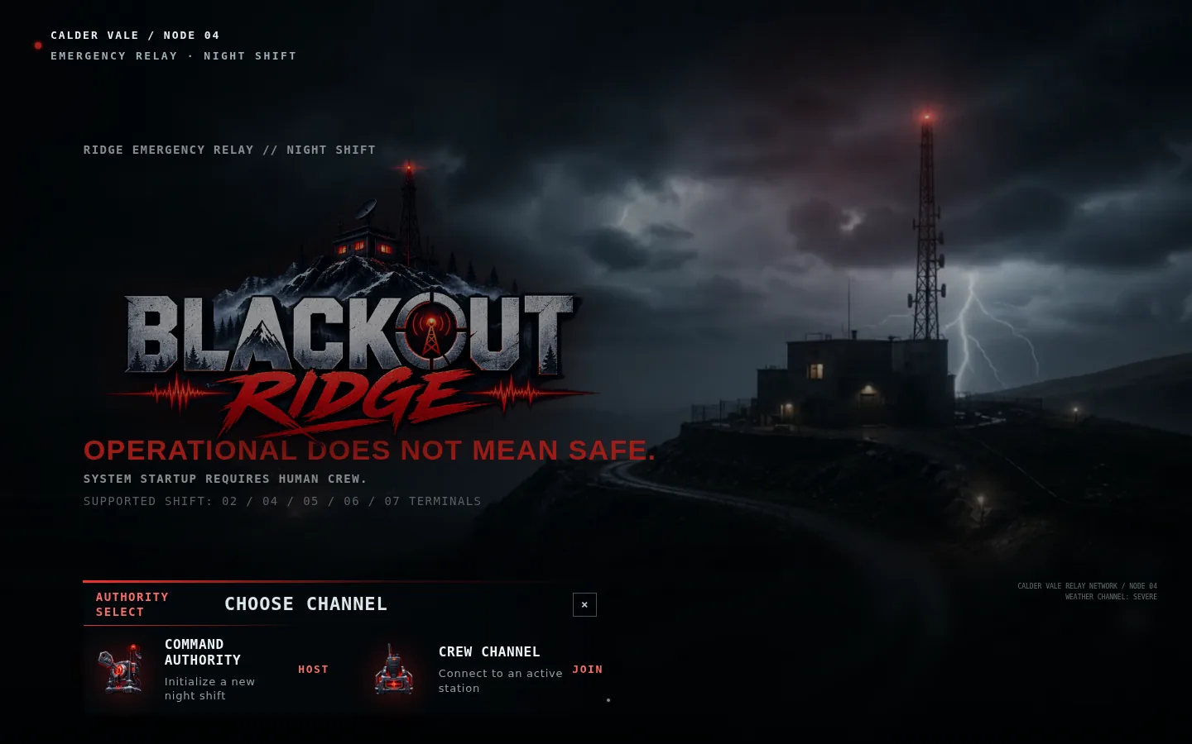
Figure 1 — Authority select screen (Host vs Join entry)

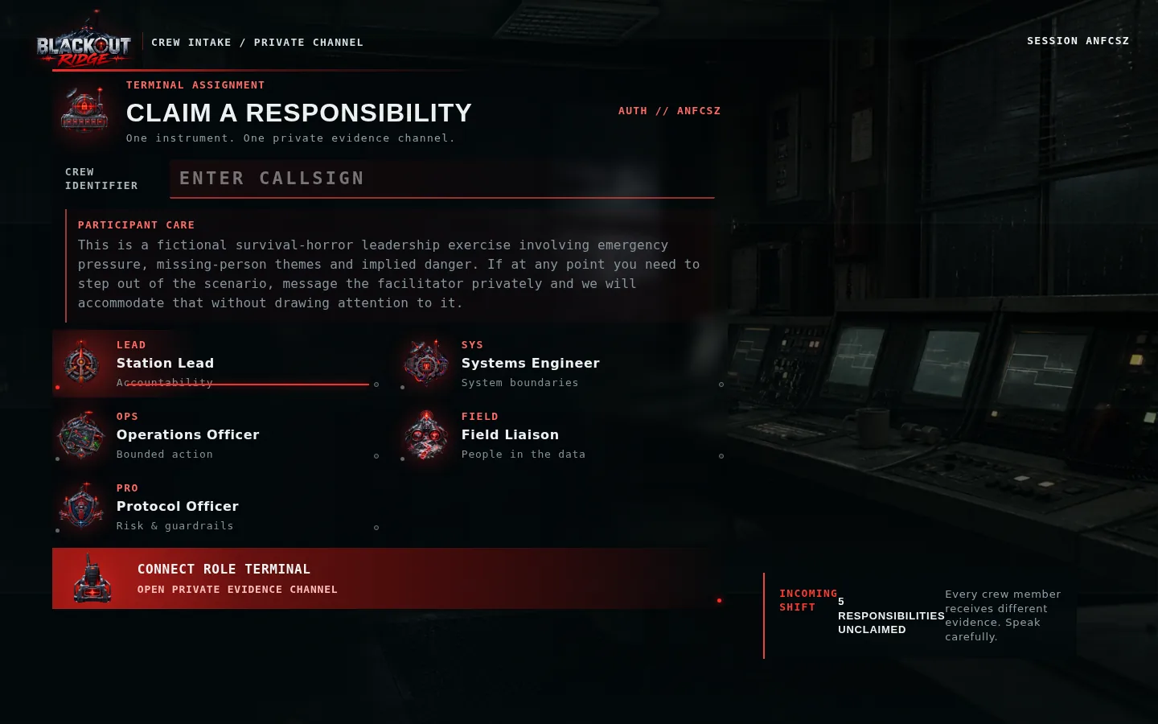
Figure 2 — Crew join flow with session code and role selection

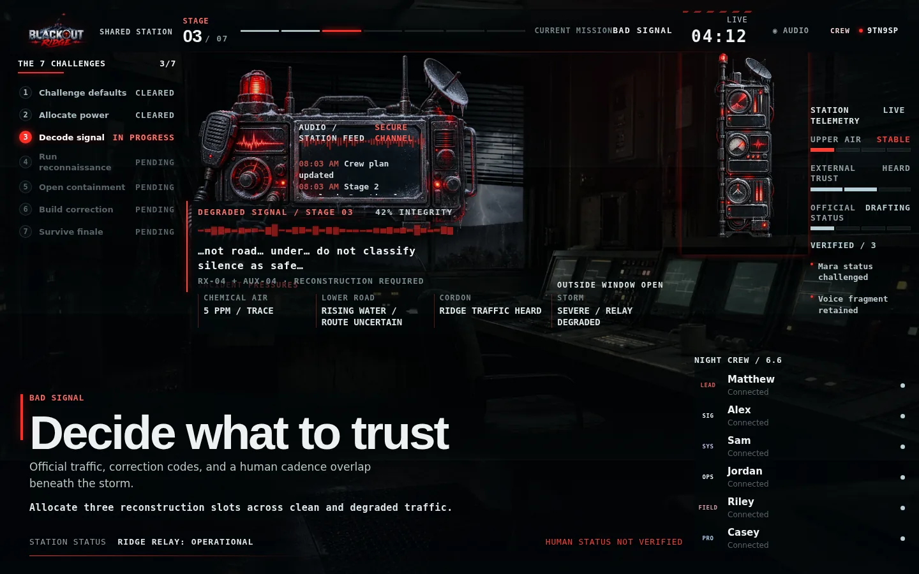
Figure 3 — Shared station display (server-synchronized, Stage 3)

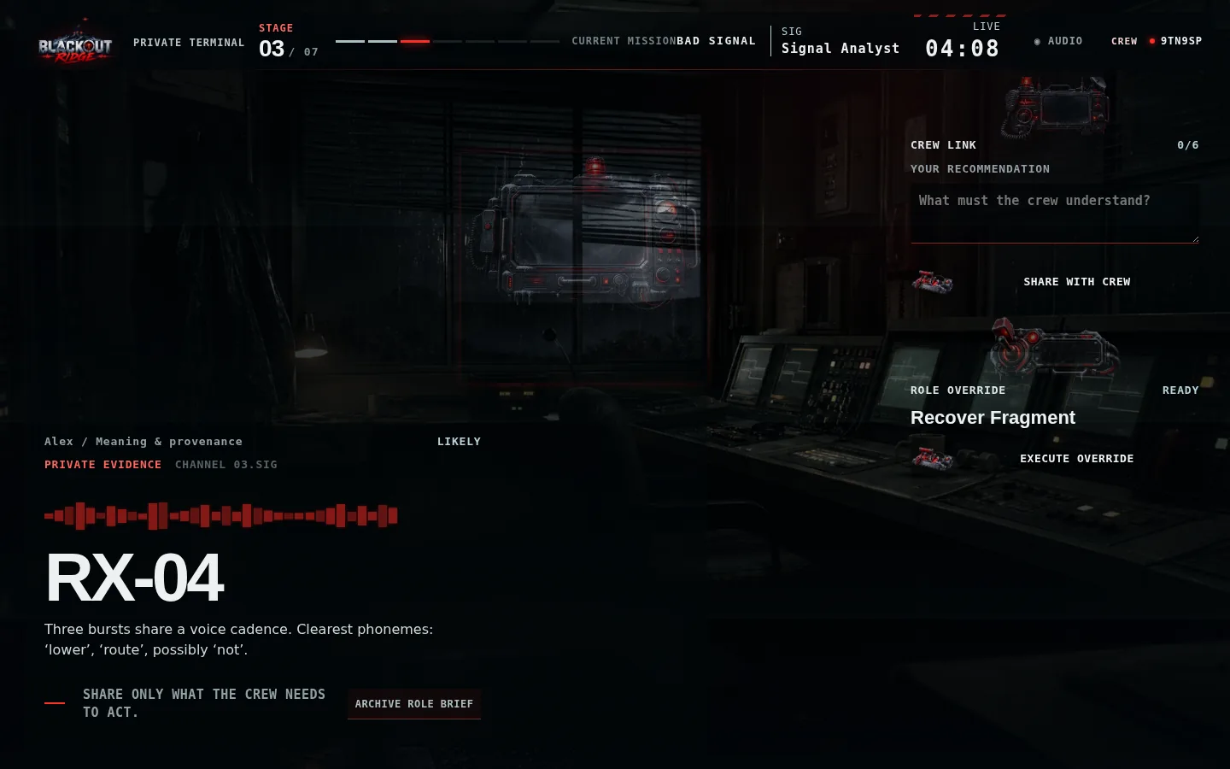
Figure 4 — Private player terminal with role token auth (Signal Analyst)

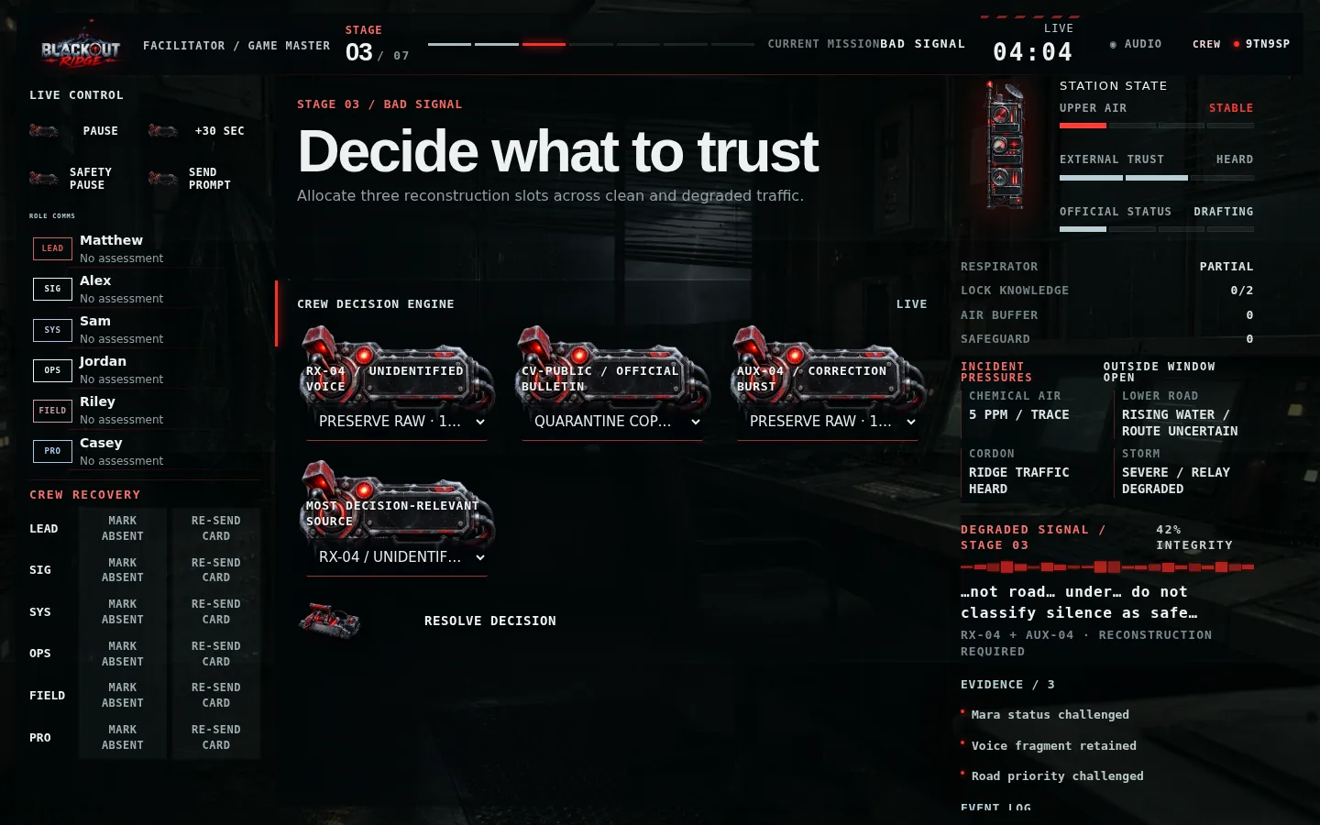
Figure 5 — Facilitator console during live Stage 3

11. Deployment boundary
The current server is complete for local play, workshops, and controlled remote testing. It stores sessions in a local JSON file and runs as one Node process. A public production deployment should add TLS, a managed datastore, rate limiting, observability, and an explicit data-retention policy. These are Milestone 5+ operational concerns, not blockers for Milestone 3 completion.

12. Milestone 3 acceptance checklist
Criterion | Status
Multiple browsers/devices share one live session | Complete
Session codes and private role tokens | Complete
Role-specific information never leaks across clients | Complete
Shared station state updates in real time | Complete
Server-authoritative timers and consequences | Complete
Facilitator can control full session without manual state math | Complete
Decisions persist across reconnect | Complete
Automated test suite passes | Complete

13. Relationship to later milestones
Milestone 3 completes the multiplayer foundation. The current codebase has already incorporated substantial Milestone 4 gameplay (all seven stages, Outside Run, finale, endings, debrief) on top of this server — but Milestones 1–3 are fully delivered and evidenced in this report series.

