BLACKOUT RIDGE

Milestone 4 — Completion Report
Complete Game Implementation
All challenges, audio/signals, Outside Run, Hold/interlock, finale, endings, and debrief capture
Prepared: 25 August 2026

Status: COMPLETE

1. Executive summary
Milestone 4 delivers the full playable Blackout Ridge experience on top of the Milestone 3 multiplayer foundation. Every timed challenge, progressive signal treatment, physical Outside Run, containment hatch and interlock sequence, evidence-backed correction, two-round finale, seven canonical endings, and synchronized debrief capture are implemented, server-authoritative, and covered by automated tests.
A facilitator can now run the complete 70-minute arc — 5 minutes briefing, 43 minutes gameplay, 20 minutes debrief, and 2 minutes operating buffer — across 2-, 4-, 5-, 6-, or 7-player crews without manual state calculation. Players receive role-specific private evidence; the shared station shows synchronized consequences; weak decisions fail forward rather than stopping the story.
This milestone is complete. The runtime matches the Milestone 1 design package and the playbook coverage audit in docs/full-system/PLAYBOOK-COVERAGE.md. Milestone 5 (live playtesting, pacing tuning, facilitator load testing, browser matrix, and production hardening) begins from this build.

2. Milestone 4 requirements vs delivery
Requirement | Implementation | Status
All seven challenges | Seven timed stages with distinct mechanics, consequences, and fail-forward resolution | Complete
Progressive audio/signals | Stage-aware degraded transmissions; viewer-specific clarity; opt-in procedural ambience | Complete
Outside Run | Runner assignment, destination, abort rule, three moves, three guidance bursts, air meter | Complete
Hold / interlock | Stage 1 audit holds; Stage 5 hatch procedure; interlock override in finale Lock lane | Complete
Finale | Two committed rounds across Lock, Signal, and People with named lane leads | Complete
Endings | Seven canonical outcomes with facilitator preview before final record confirmation | Complete
Debrief capture | Six synchronized steps, facilitator notes, first-step commitments, JSON export, playtest record | Complete

3. Seven-stage runtime (all challenges)
Each stage has one primary crew decision, persistent consequences, and a defined handoff to the next phase.
Stage | Title | Mechanic | Primary decision | Duration
1 | Challenge the handover | Audit holds | Three human holds on handover defaults | 4 min
2 | Keep the station alive | Power allocation | Power exactly three optional circuits | 5 min
3 | Decide what to trust | Signal bandwidth | Three reconstruction slots across competing sources | 6 min
4 | Test Lower Route | Outside Run | Runner, destination, abort rule; three field moves | 6 min
5 | Open the buried station | Hatch & hold | Containment procedure; respirator and watcher assignment | 7 min
6 | Build the truth | Emergency correction | Five-part evidence-backed Cordon correction | 6 min
7 | Survive the correction | Finale | Two rounds across Lock, Signal, and People lanes | 9 min

- Server resolves every commit; clients cannot forge decisions or skip stages.
- Timer expiry resolves the current legal draft and advances official pressure.
- Stage 6 opens one shortened retry if the first correction is rejected.
- Stage 7 requires facilitator confirmation before debrief and ending screens unlock.

4. Progressive signal and audio

4.1 Degraded transmissions
SIGNAL_TRANSMISSIONS in server/game-content.js defines stage-specific source headers, integrity percentages, and transcript variants. Early preservation choices in Stages 1–3 determine whether shared and public views stay ambiguous or sharpen; Signal, Systems, Comms, and facilitator views receive role-appropriate private clarity. Physical proof from Stage 4 can partially substitute for poor signal work.
Stage | Integrity (designed) | Narrative job
1 | 18% | Plant Lower Route ambiguity
2 | 24% | Legacy route beneath relay traffic
3 | 42% | Human cadence contradicts weather discard
4 | 57% | Physical corroboration toward foundations
5 | 71% | Mara live below; hold occupied
6 | 84% | Explicit correction evidence for Cordon
7 | 93% | Final readback window during lock sequence

4.2 Opt-in station audio
- prototype/audio.js — procedural relay hum, storm wind loop, and feedback cues (confirm, commit, error).
- Browser autoplay policy respected: players opt in via the AUDIO toggle on the shared station HUD.
- Cues fire on crew commits, field moves, debrief navigation, facilitator actions, and copy-link confirmation.
- Full recorded sound library and cinematic opening remain Milestone 6 scope per design package.

5. Outside Run (Stage 4)
- Station Lead locks runner, destination, and explicit abort rule before the sequence begins.
- Runner performs three moves: observe/verify, advance with exposure, or withdraw on abort rule.
- Non-runner crew may send exactly three short guidance bursts (90 characters each).
- Live air-meter telemetry rises with exposure; forced withdrawal at 18 ppm hard limit.
- Findings (tracks, repeater state, conduit beneath station) persist into Stage 5 hatch decisions.
- Partial respirator state carries forward into Mara allocation and finale People lane.

6. Hold, hatch, and interlock

6.1 Stage 1 — audit holds
The crew challenges up to three dangerous handover defaults (local fault, no wider risk, Mara on road, road priority, weather discard). Holds populate the evidence ledger and shape assumption flags that affect Official Status, signal clarity, and later correction strength.

6.2 Stage 5 — containment hatch
Four procedures — remote inspect, controlled crack with watcher, full override with descent, or delay — change Mara verification, lock knowledge, respirator assignment, and interlock override availability. The auxiliary relay hold reveal uses dedicated consequence imagery (auxiliary-relay-hold.webp).

6.3 Finale Lock lane
Stage 7 Lock lane options include remote stabilise, physical hold with watcher, full interlock override, or leaving the interlock. Lock knowledge from Stage 5, powered Lock Control from Stage 2, and interlock override resource state gate which actions succeed without raising lock risk.

7. Finale, endings, and confirmation gate

7.1 Two-round finale
- Round 1 and Round 2 each require Lock, Signal, and People lane actions with named leads.
- Duo mode (2 players) requires both operators to own at least one lane across the two rounds.
- Server computes a deterministic ending preview from lock control × correction acceptance × people action.

7.2 Seven canonical endings
Ending | Condition summary
Clean Rescue | Lock controlled; correction accepted; Mara and crew recoverable
Costly Rescue | Lock controlled; correction accepted; significant resource cost
Last Broadcast | Lock controlled; correction not fully accepted; truth still escapes
Joined Below | Lock not controlled; extraction attempt without interlock control
Flee Ridge | Surface evacuation without Mara extraction
Filed Safe | Lock seals while false OPERATIONAL status files
Station Loss | Lock and signal both fail under maximum pressure

The facilitator sees pendingEnding with rescue, survival, and status dimensions before confirming the final record. Players cannot enter debrief until CONFIRM_ENDING is executed.

8. Debrief capture and session evidence

8.1 Six-step synchronized debrief
Step | Title | Purpose
1 | Immediate reactions | Surface survival pressure and emotional read
2 | Status failure map | OPERATIONAL, GREEN, NO ACTIVE DISTRESS, LOWER ROUTE false proxies
3 | Role map | Responsibility areas and reflection questions per role
4 | Readiness behaviour lenses | Facilitator-observed patterns — not personality scores
5 | AI-ready workplace bridge | False proxy, missing source, bounded test
6 | First workplace action | Each player records a bounded commitment (private to facilitator export)

8.2 Facilitator-only capture
- Per-step facilitator notes (up to 1,200 characters) saved server-side.
- Readiness profile signal toggles for observed behaviour lenses.
- Prototype playtest record with seven rating criteria, disposition, and reframe warning.
- Contribution metrics: reports, interventions, guidance bursts, field moves.
- Full session JSON export including decisions, history, debrief data, and ending record.
- Private role brief download (.txt) for remote or accessibility workflows.

9. Unequal information enforcement
Milestone 4 includes server-enforced information partitioning so no single role can solo-solve the incident. Recent verification added INFORMATION_MATRIX, INFORMATION_JOINS, and PRIVATE_PHRASE_OWNERS in game-content.js, viewer-aware signalTransmission() in the engine, and six-player Comms clue redistribution.
Criterion | Status
Information matrix covers every stage and core role | Complete
Private phrases stay with owning role only | Complete
Shared public intercept cannot solo-solve Lower Route before Stage 5 | Complete
Field Stage 3 alone cannot name buried route under cabin | Complete
Six-player mode redistributes critical Comms occupancy clue | Complete
Private cards include speak prompts and confidence labels | Complete

10. Runtime architecture
Component | File | Responsibility
HTTP API + SSE + persistence | server/server.js | Sessions, live events, JSON store, static delivery
Game engine | server/game-engine.js | Authorization, timers, consequences, finale, debrief, export
Game content | server/game-content.js | Stages, roles, signals, debrief steps, playtest criteria
Browser client | prototype/full-app.js | Four modes, all stage UIs, debrief, playtest form
Network layer | prototype/network.js | REST actions, SSE reconnect, token storage
Audio | prototype/audio.js | Opt-in ambience and interaction cues
Presentation | prototype/styles.css | Cinematic full-viewport layout, responsive breakpoints

11. Quality assurance
- npm run check — syntax validation of all JavaScript entry points.
- npm test — 34 automated tests covering strong/weak paths, privacy, timers, Outside Run, finale, debrief, and information matrix.
- docs/full-system/PLAYBOOK-COVERAGE.md — section-by-section audit against source playbook.
- Crew configurations validated for 2, 4, 5, 6, and 7 players.

12. User guide — running a full session
This guide explains how to host, join, play, and debrief Blackout Ridge using the current build. Voice conversation stays on Teams or Zoom; the browser app supplies synchronized station state, private role evidence, timers, and facilitator controls. There is no personal score — the app records team decisions, station consequences, and a named ending for debrief.

12.1 Before you start
- Install Node.js 18+ and run npm run dev from the project root.
- Open http://localhost:4173 (or your deployed host) in a modern browser (Chrome, Edge, Firefox, Safari).
- Plan for 70 minutes total: ~5 min briefing, ~43 min gameplay, ~20 min debrief, ~2 min buffer.
- Each player needs their own device. One optional shared display (TV or screen-share tab) shows the room-facing station.
- Facilitator stays on the voice call but does not play a role.

12.2 Facilitator — create and open the session
- On the start screen, click ENGAGE STATION, then COMMAND AUTHORITY.
- Choose crew size: 2 (duo), 4, 5, 6, or 7 terminals. Commercial sessions typically use 6 or 7.
- Click ARM NEW SESSION. The facilitator console opens with a six-character session code.
- Copy the crew link (TRANSMIT CREW LINK) and paste it into Teams/Zoom chat.
- Open the room display (ROOM DISPLAY) on a projector or screen-shared tab.
- Wait until every configured role shows CHANNEL LOCKED on the assembly roster.
- Read the participant-care statement aloud, then click CONFIRM BRIEF DELIVERED.
- Click START SHIFT to unlock Stage 1.

12.3 Players — join and claim a role
- Open the crew link (or enter the six-character code under CREW CHANNEL).
- Enter a display name (callsign) and choose one unclaimed responsibility.
- First come, first served. The facilitator can reassign later if someone disconnects.
- Your browser becomes your private terminal — you only see your own evidence card.
- If you refresh or drop off, reopen the same link; your role and information are restored.
- Optional: click ARCHIVE ROLE BRIEF to download your current private card as a text file.

12.4 The four browser views
View | Who uses it | What it shows
Game start / host | Facilitator (once) | Session creation and crew size selection
Shared station | Room display or screen-share | Tracks, timer, official traffic, crew roster, consequences
Private role terminal | Each player | Role evidence, crew report channel, one-use override, lead controls
Facilitator console | Facilitator only | Decision engine, live reports, timers, hints, safety, debrief, export

12.5 How each stage works
Every stage follows the same loop: shared incident → private evidence → voice discussion → one crew commit → visible consequence.
Stage | Time | The problem | Team decision
1 — Challenge the handover | 4 min | Dangerous handover defaults are auto-filling | Hold exactly 3 of 5 audit items for human review
2 — Keep the station alive | 5 min | Backup power cannot run every circuit | Power Main Relay + exactly 3 optional circuits
3 — Decide what to trust | 6 min | Clean traffic and degraded signals overlap | Spend 3 bandwidth slots (preserve / replay / quarantine / discard)
4 — Test Lower Route | 6 min | Is Lower Route the flooded road? | Assign runner, destination, abort rule; runner makes 3 moves
5 — Open the buried station | 7 min | Hatch to the old hold beneath the cabin | Choose hatch procedure; assign respirator and watcher
6 — Build the truth | 6 min | Cordon Control needs evidence, not volume | Build a 5-part emergency correction (one retry if rejected)
7 — Survive the correction | 9 min | Hold is sealing; false status is filing | Two rounds: assign Lock, Signal, and People lanes with named leads

The Station Lead commits each decision from their private terminal. The facilitator can also commit or resolve from the console. When the clock hits zero, the server resolves the current legal draft — nobody is eliminated and the story always continues (fail-forward).

12.6 Stage 4 — Outside Run (special instructions)
- Lead locks runner, destination, and a clear abort rule (minimum 8 characters), then commits.
- The assigned runner sees three move buttons: Observe/Verify, Advance/Accept Exposure, Withdraw on Abort Rule.
- Other crew members may send exactly three short guidance bursts (90 characters each).
- Watch the live air meter on the runner screen. At 18 ppm the runner is forced to withdraw.
- Findings carry into Stage 5 hatch decisions and respirator state carries into the finale.

12.7 Facilitator controls during play
Control | When to use it
Pause / Resume | Technical issues, confusion, or a short break
+30 seconds | Connection failure only — not to rescue a slow debate
Send prompt / Clear prompt | Room is stuck on the rule, not the story (one hint per stage)
Safety pause | Participant distress — all screens go neutral; clocks stop
Re-send card | Player says their private evidence did not appear
Reassign role | Wrong seat taken or a player disconnected permanently
Mark absent / observer | Someone must step out; crew continues without them
Advance stage | Recovery only — if the app failed to move after a valid commit
Confirm final record | After Stage 7 — required before debrief unlocks

12.8 Role responsibilities and one-use overrides
Role | Lens during play | One-use override
Station Lead | Accountability; commits crew decisions | Hold the Clock (+60 s; official pressure advances)
Signal Analyst | Meaning and provenance of traffic | Recover Fragment (restore degraded source)
Systems Engineer | What a status actually measures | Trace Dependency (reveal subsystem behind a status)
Operations Officer | Bounded physical action | Controlled Test (preview cost, not outcome)
Field Liaison | People named in the data | Human Check (force named human into the record)
Protocol Officer | Risk and guardrails | Safety Condition (reduce worst physical cost once)
Comms Officer (7p) | Whether outsiders will believe the message | Request Readback (receiver interpretation)

No single role can solo-solve the incident. Major conclusions require information from at least two roles.

12.9 Ending, debrief, and export
- After Stage 7 Round 2, the facilitator sees an ending preview (title, rescue/survival/status dimensions).
- Click CONFIRM FINAL RECORD. All clients move to the ending screen and synchronized debrief.
- Advance debrief steps 1–6 together. Step 6 asks each player for one bounded workplace action.
- Facilitator saves notes per step and toggles observed behaviour lenses (not personality scores).
- Click EXPORT SESSION RECORD to download JSON with decisions, debrief, ending, and playtest data.
- After a pilot, complete the Prototype Playtest Record (seven ratings + disposition).

12.10 Troubleshooting
Issue | Fix
Player sees blank or stale screen | Hard refresh (Ctrl+Shift+R). Reopen the same crew link.
Cannot start shift | All terminals must be connected and participant care confirmed.
Wrong role taken | Facilitator uses Reassign on the assembly or live console.
Private card missing | Facilitator clicks Re-send card for that role.
Connection lost banner | Check network; app reconnects via SSE and restores token from localStorage.
Audio does not play | Click AUDIO on the shared station — browsers block autoplay until user gesture.

13. Screenshot evidence (current build — August 2026)
All figures below were captured from the live server-backed build on 25 August 2026 using snapshot mode and a full six-player demo session progressed through every stage. Screenshots are stored in docs/reports/screenshots/milestone-4-latest/. Regenerate with: npm run dev && node scripts/capture-milestone-4-screenshots.mjs

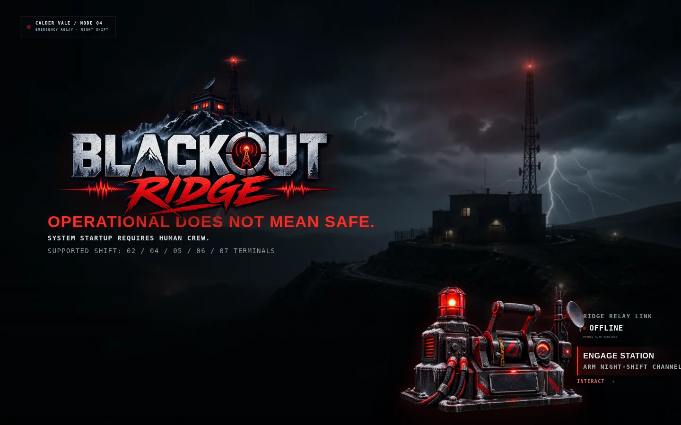
Figure 1 — Current station engagement screen (boot entry)

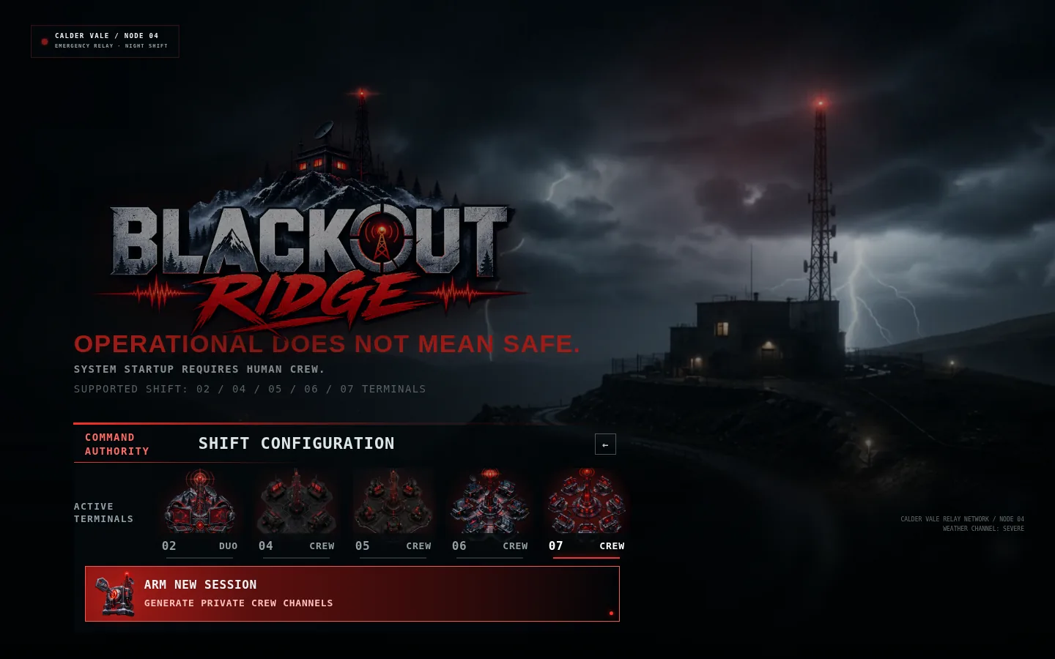
Figure 2 — Host shift configuration with distinct crew-size icons

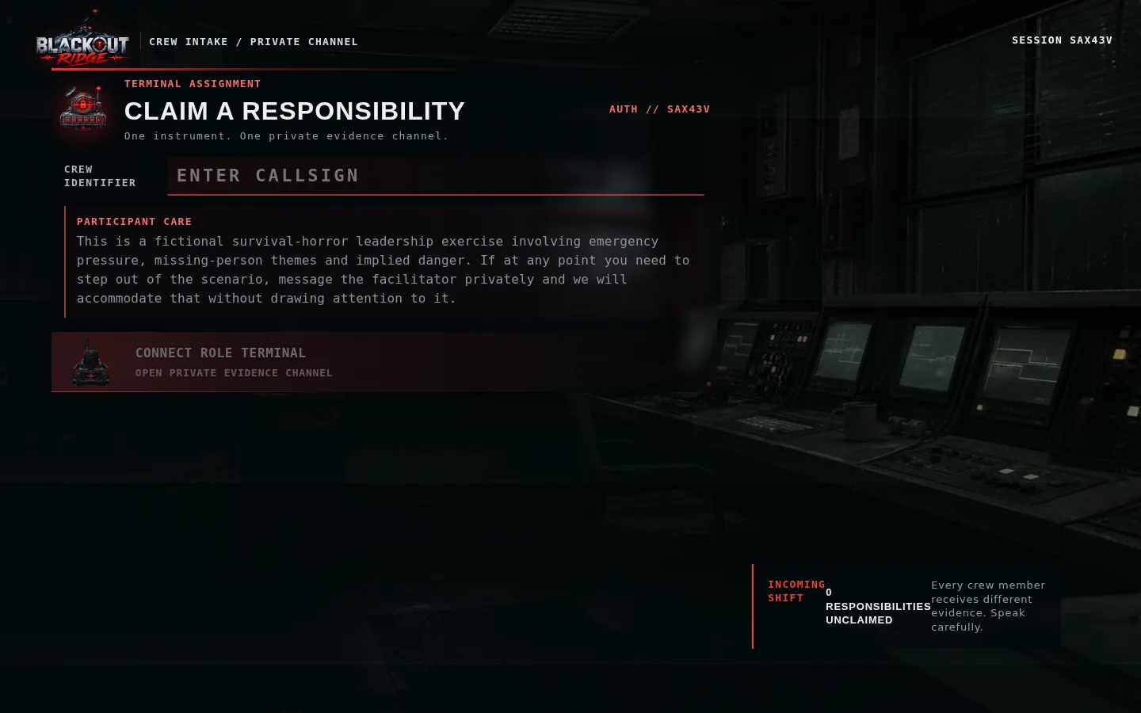
Figure 3 — Crew join flow with role instruments and participant care

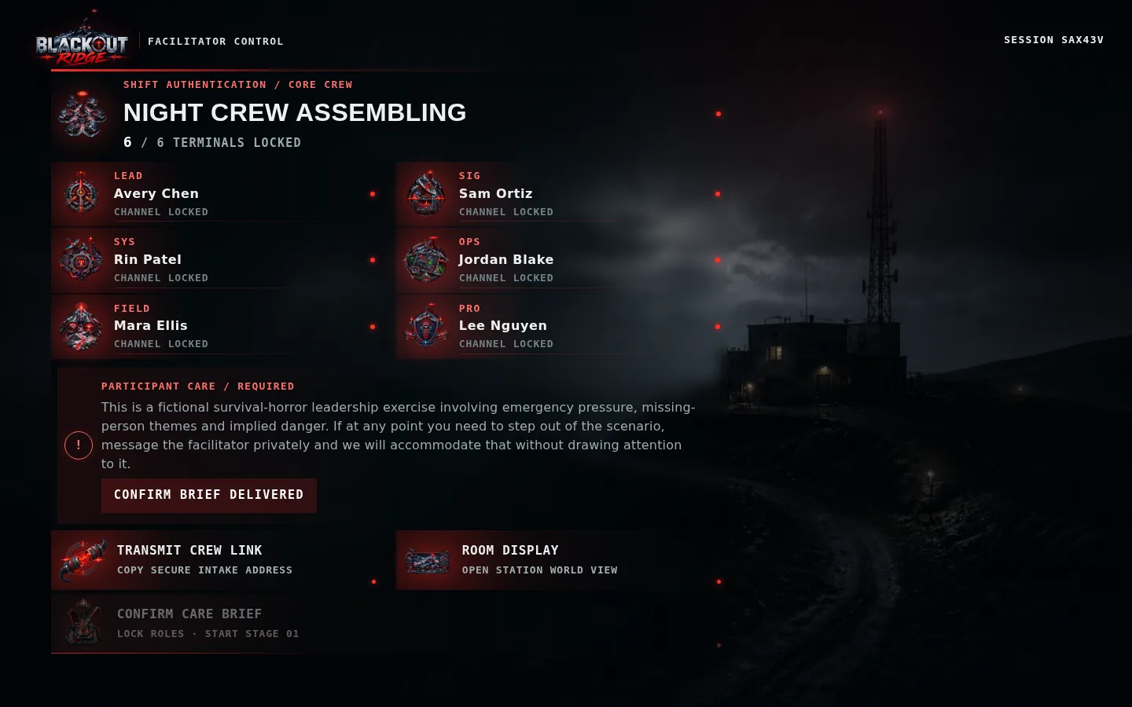
Figure 4 — Facilitator assembly lobby before shift start

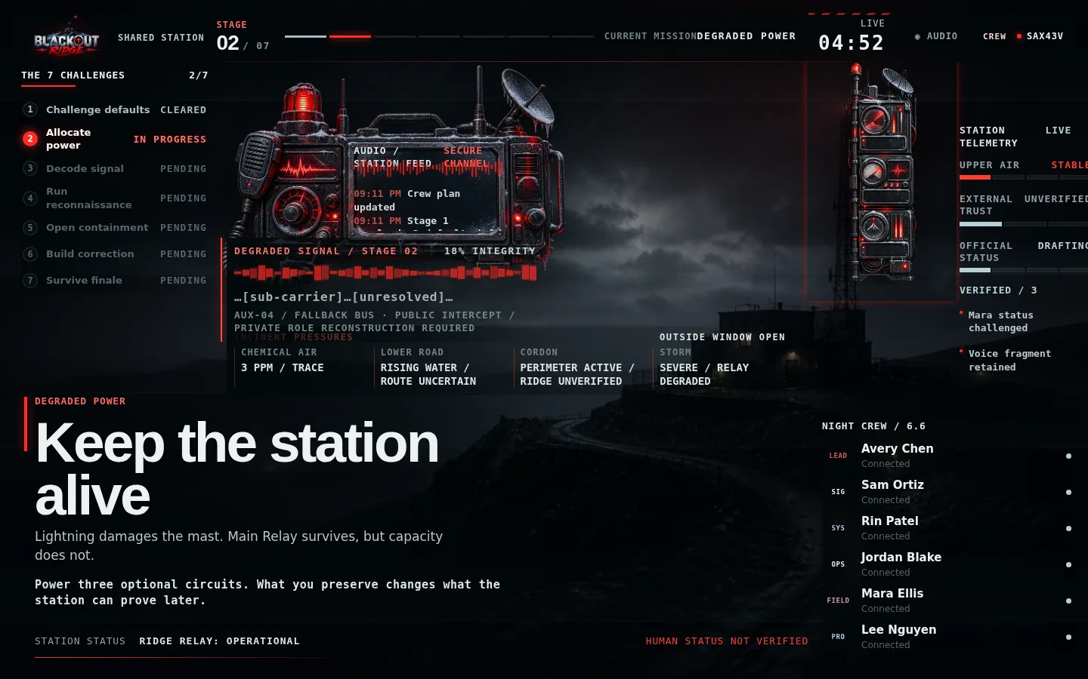
Figure 5 — Shared station during Stage 2 (Degraded Power)

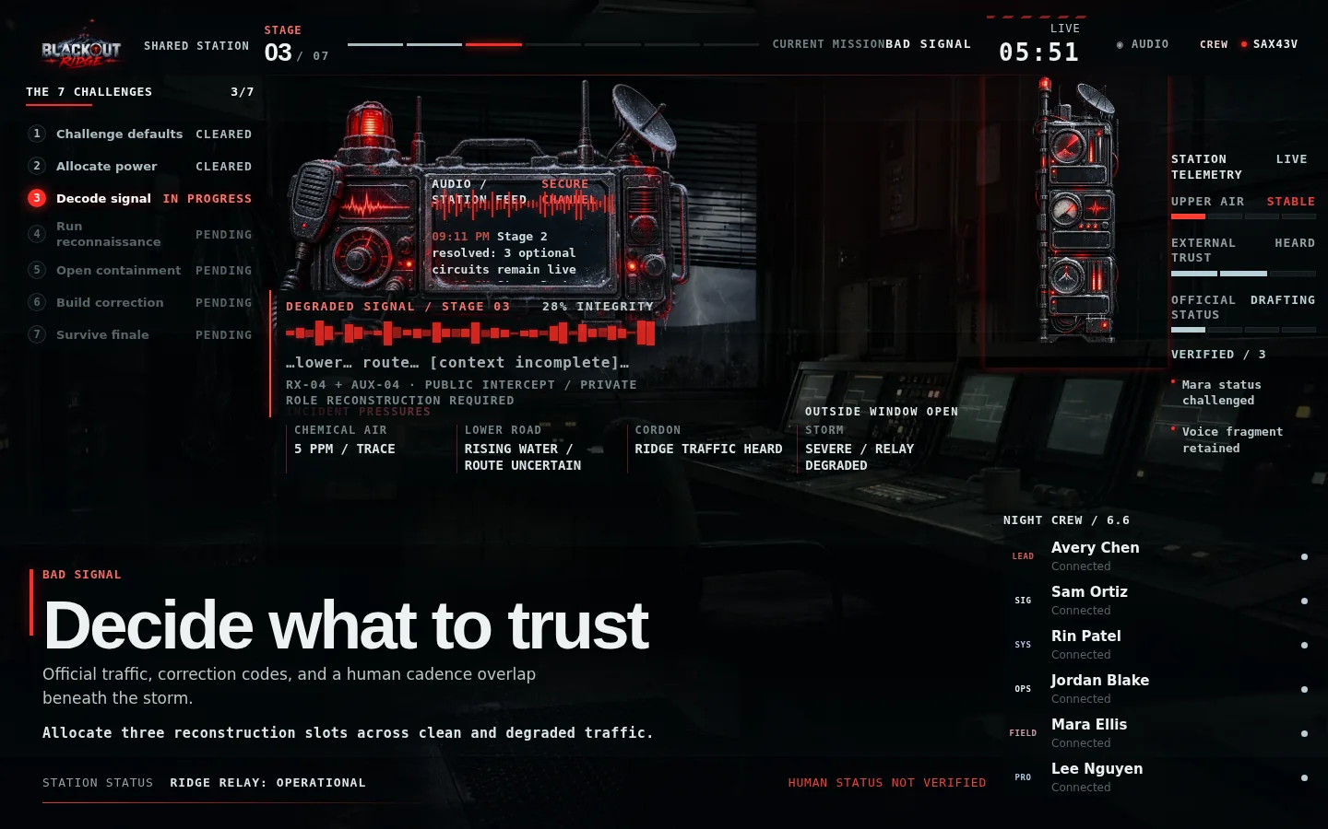
Figure 6 — Shared station during Stage 3 (Decide What to Trust)

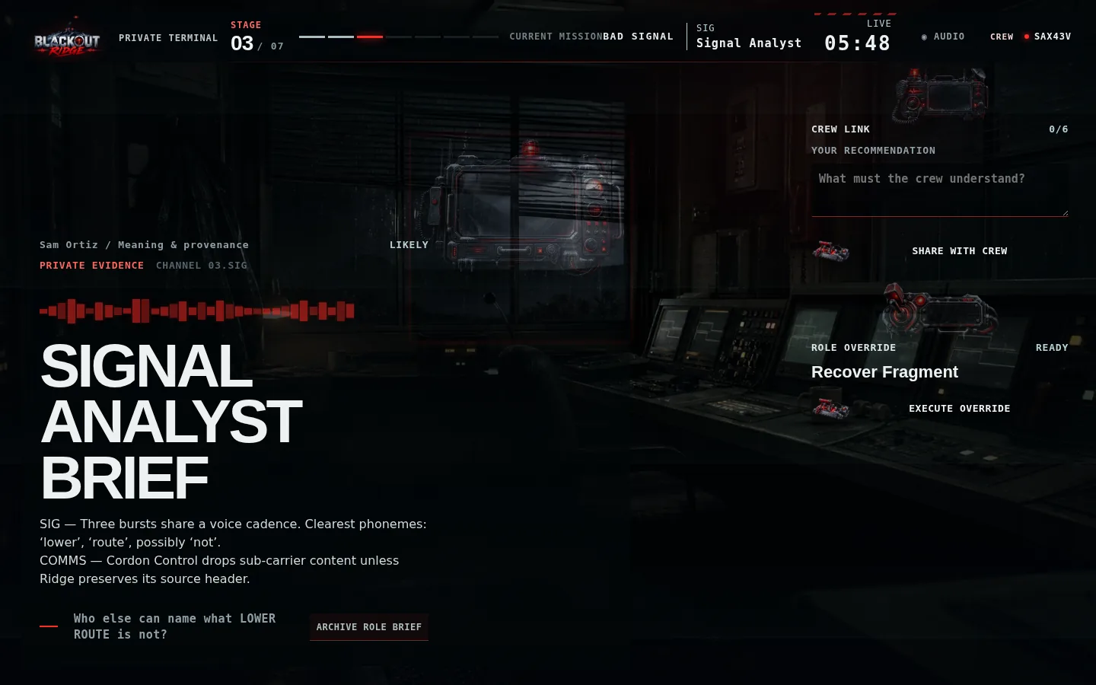
Figure 7 — Private Signal Analyst terminal with unequal-information card

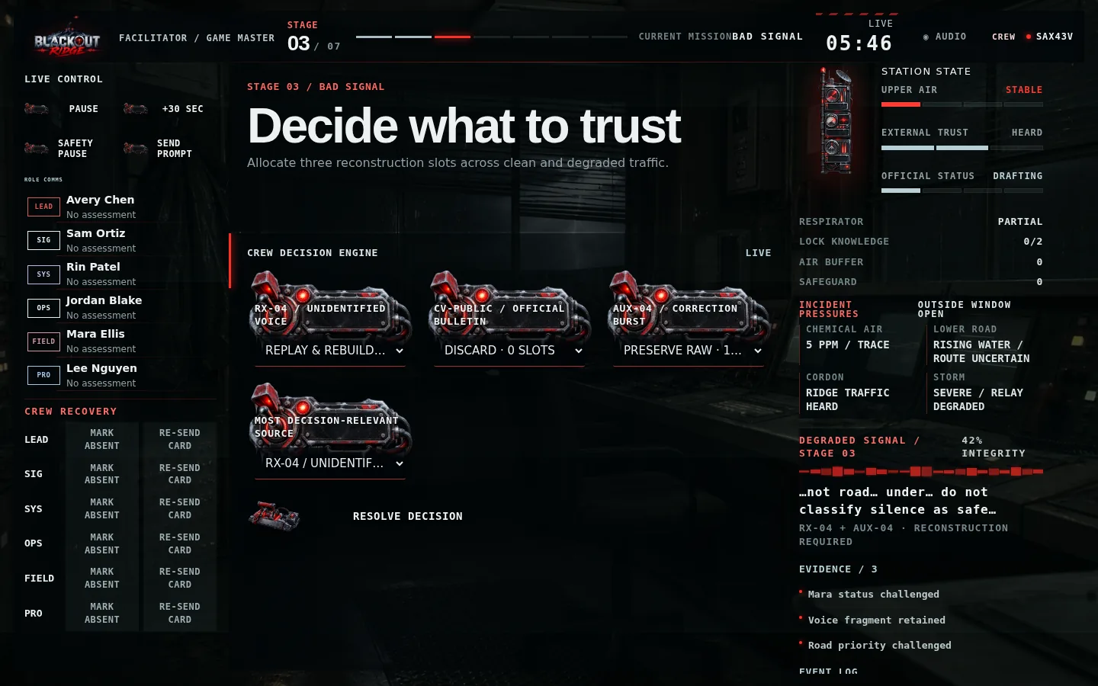
Figure 8 — Facilitator console with live decision engine

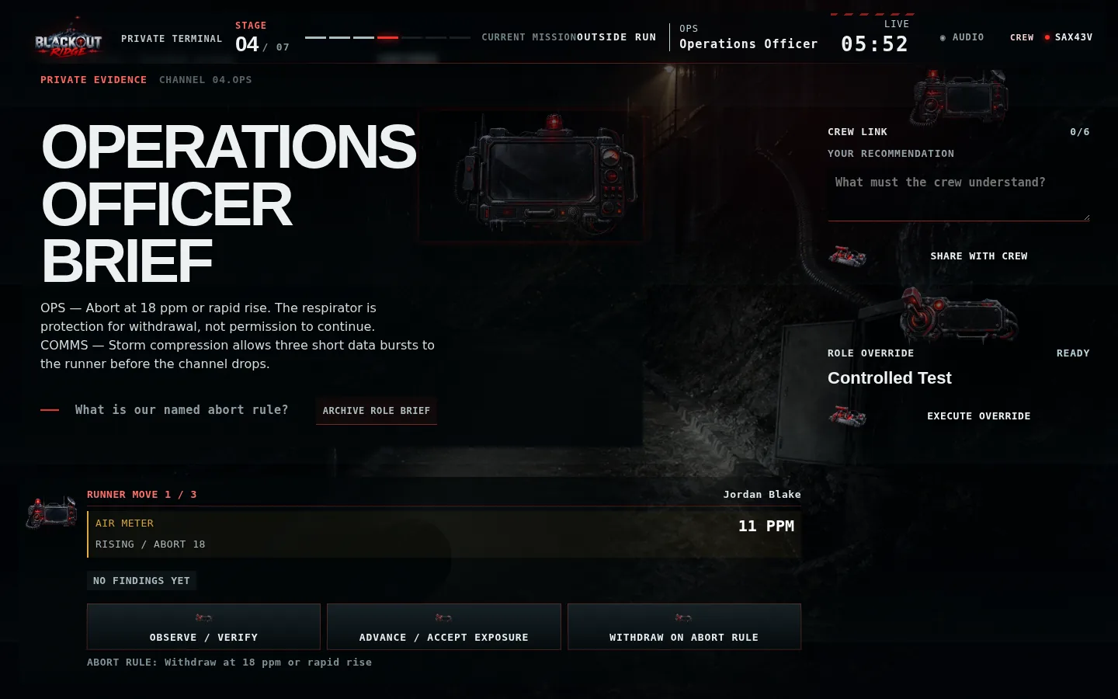
Figure 9 — Stage 4 Outside Run runner view with air meter

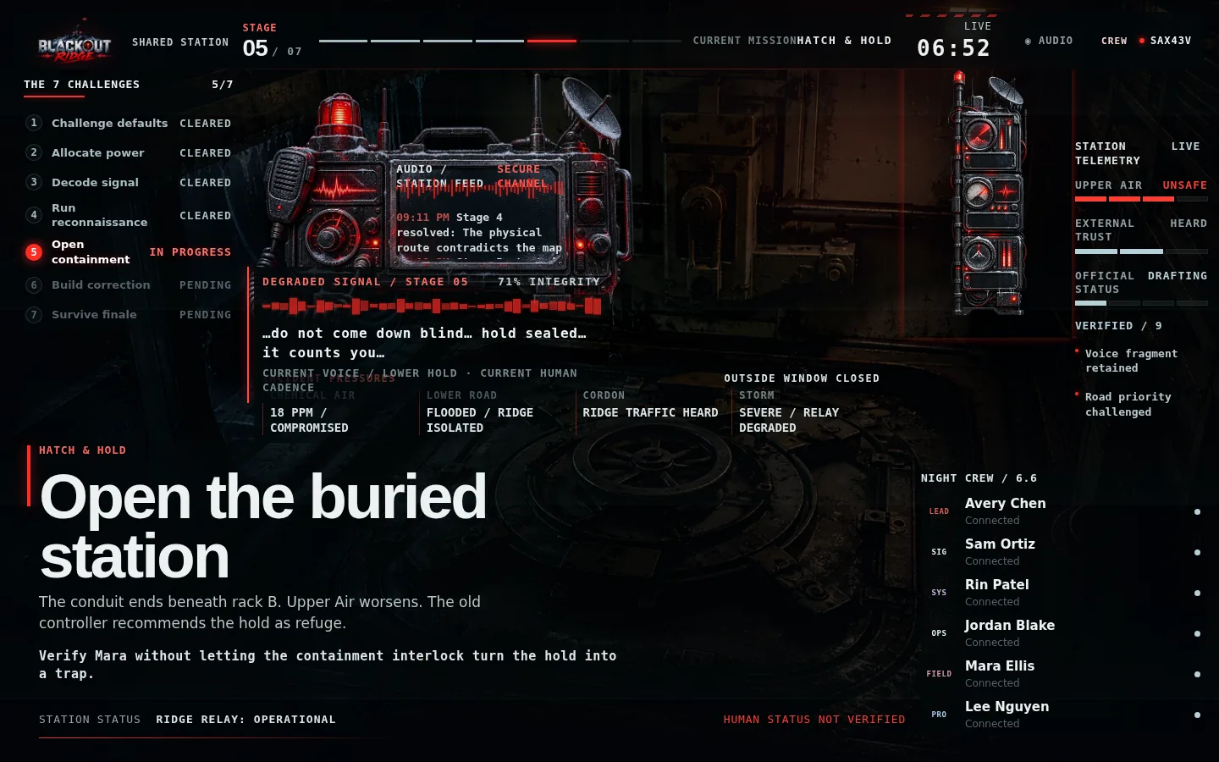
Figure 10 — Stage 5 shared station (Hatch & Hold)

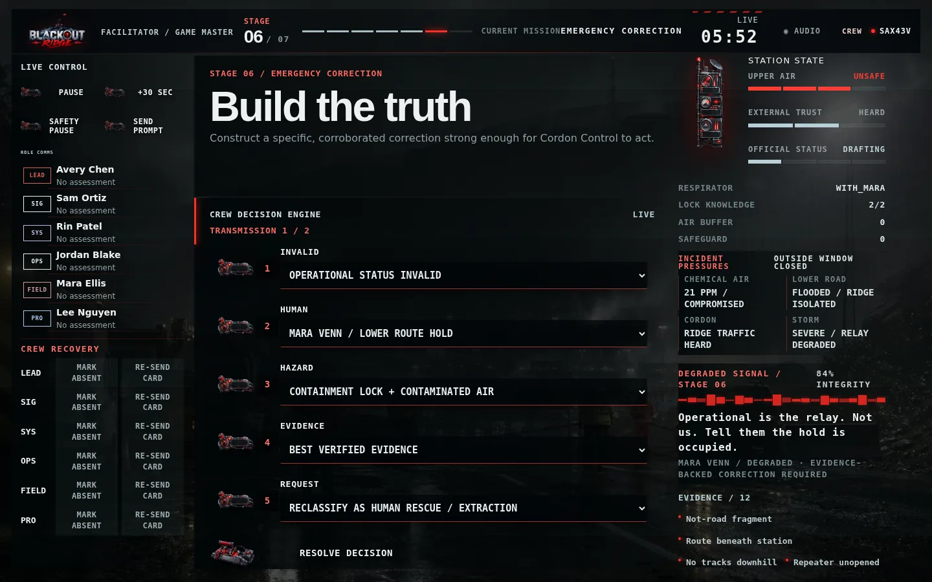
Figure 11 — Stage 6 emergency correction builder

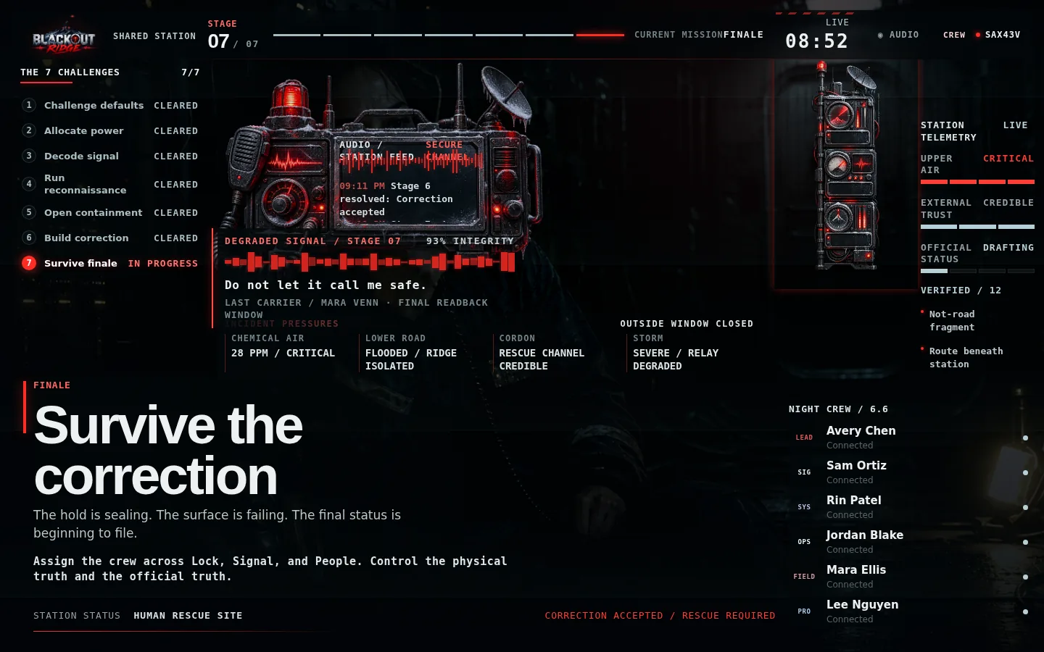
Figure 12 — Stage 7 finale on shared station

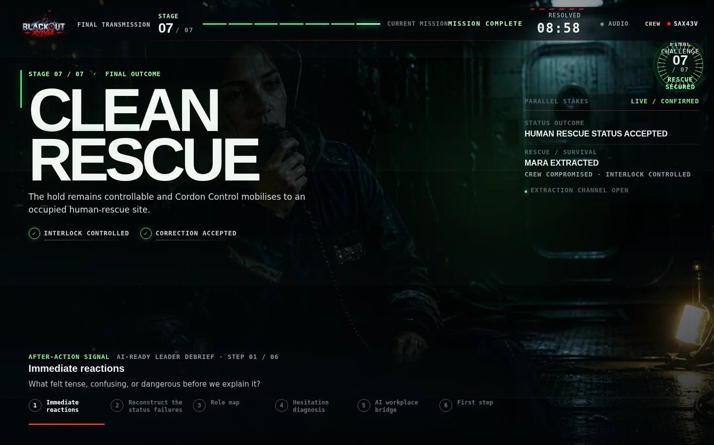
Figure 13 — Clean Rescue ending screen

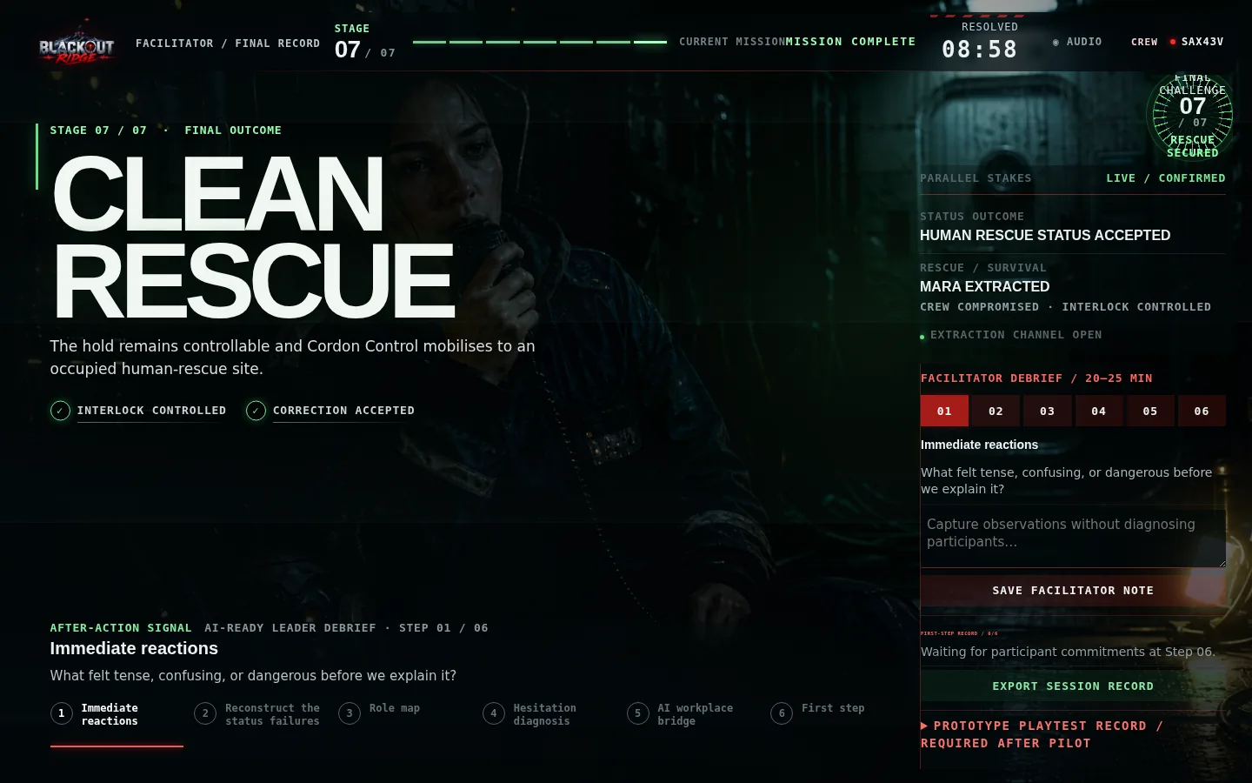
Figure 14 — Facilitator debrief console (six-step guide)

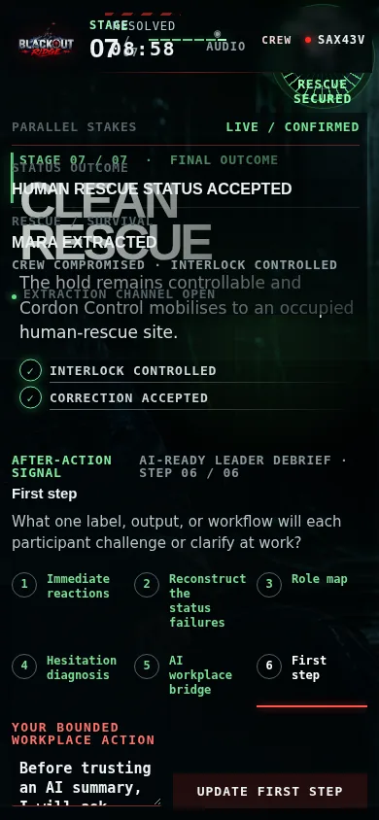
Figure 15 — Player debrief with first-step commitment (mobile)

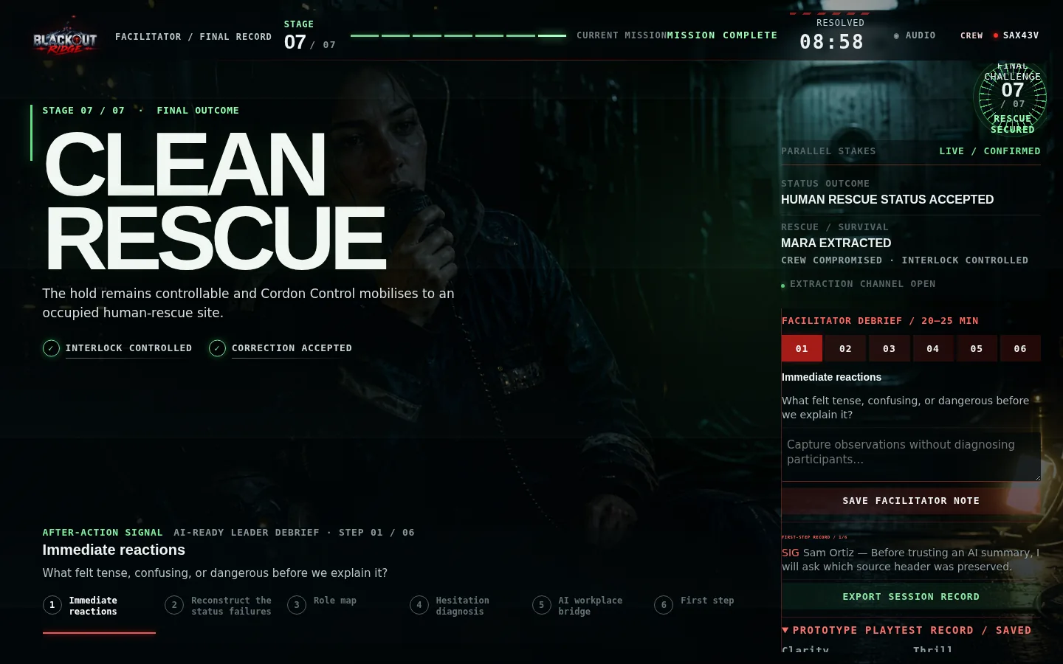
Figure 16 — Prototype playtest record after pilot session

14. Milestone 4 acceptance checklist
Criterion | Status
All seven challenges playable end-to-end | Complete
Progressive degraded signal responds to earlier preservation choices | Complete
Opt-in audio ambience and interaction cues | Complete
Outside Run: runner, moves, guidance, air meter, forced withdrawal | Complete
Stage 1 holds and Stage 5 hatch/interlock with persistent resources | Complete
Stage 6 correction builder with one retry on rejection | Complete
Two-round finale with named lane leads | Complete
Seven endings with facilitator preview and confirmation gate | Complete
Six-step debrief synchronized across all clients | Complete
Session JSON export with decisions, debrief, and playtest data | Complete
Unequal information enforced in server logic and tests | Complete
Automated test suite passes (34/34) | Complete

15. Explicitly deferred to later milestones
Item | Target milestone | Notes
Live 6–7 player playtesting and pacing tuning | Milestone 5 | Runtime captures playtest ratings; empirical validation required
Facilitator load testing across Teams/Zoom | Milestone 5 | One-console design complete; remote coordination untested at scale
Production deployment (TLS, managed DB, rate limits) | Milestone 5+ | Local JSON persistence sufficient for workshops
Full recorded sound library and cinematic opening | Milestone 6 | Procedural audio satisfies playable build requirement
Promotional video edit | Milestone 6 | Explicitly excluded from M1 design package

16. Handoff to Milestone 5
Milestone 4 completes the playable game. Milestone 5 should focus on facilitated pilot sessions (target: 6–7 players), difficulty and pacing adjustments from real crew behaviour, facilitator load under remote voice coordination, responsive/browser matrix testing, and facilitator documentation for external hosts. The playtest record and reframe warning in the runtime are ready to capture pilot outcomes.
Technical reference: docs/full-system/README.md and docs/full-system/PLAYBOOK-COVERAGE.md.

