PYTHON PROJECT – CA 3

Pre-Submission Report

GUI INTERFACE FOR PERFORMING

BITWISE AND, OR, NOT & XOR

OPERATION.

Project Members:

|  |  |  |
| --- | --- | --- |
| Roll No. | Registration No. | Name |
| RK21PBA28 | 12113509 | Aniruddha Das |
| RK21PBA30 | 12103093 | Jalluri Uday Bhaskar |
| RK21PBB58 | 12113020 | Pula Karthik |

1. Introduction

This mini project will be a simple yet robust implementation of bitwise operations such as bitwise or, and, not and xor that will be first implemented in CLI (Command Line Interface) then it will eventually be transformed into a GUI based application using buttons, icons and other GUI elements.

All of the GUI will be implemented using Tkinter API/Framework, a standard Python interface to the Tcl/Tk GUI toolkit. Tkinter is natively supported by python, one just needs to download it using pip install framework if not already available with the python installer.

2. Minimum Modules/Functions

* AND calculation
  + Function for displaying AND operation of two numbers and its binary equivalent.
* OR calculation
  + Function for displaying OR operation of two numbers and its binary equivalent.
* NOT calculation
  + Function for displaying NOT operation of either of the two numbers (based on user choice) and its binary equivalent.
* XOR calculation
  + Function for displaying XOR operation of two numbers and its binary equivalent.
* AND information
  + Displays information about how bitwise AND operation is done.
* OR information
  + Displays information about how bitwise OR operation is done.
* NOT information
  + Displays information about how bitwise NOT operation is done.
* XOR information
  + Displays information about how bitwise XOR operation is done.
* Tkinter module for custom buttons, icons and other GUI elements
  + Implements Tkinter using various GUI elements then implement those over all the other modules present in the program code.
* Main application start/termination loop function
  + Main function which allows the program to go into an application loop.
  + Also known as main event loop function.

More modules can be added, but these modules will be present in the final build of the project.

3. Flowchart

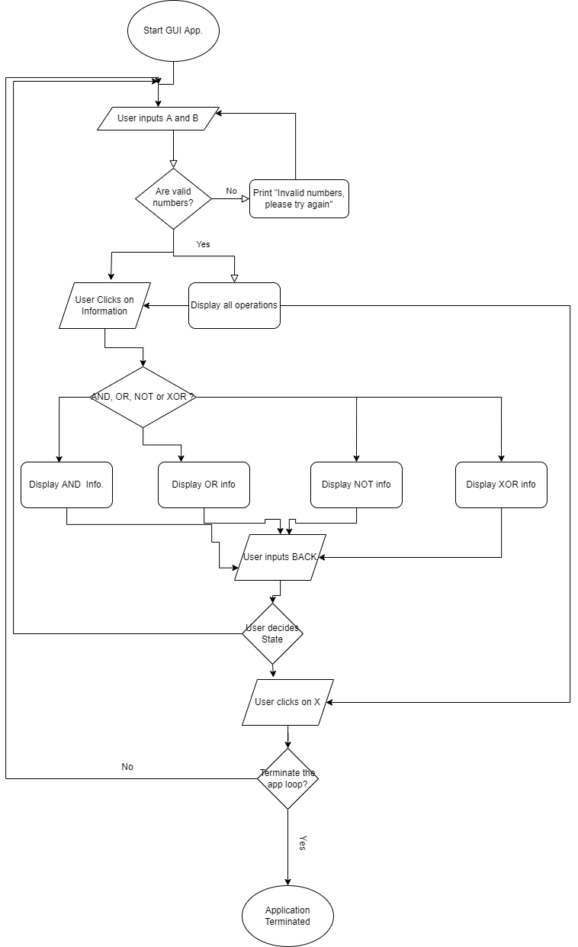

4. Roles & Responsibility

4.1. 12113509 - RK21PBA28 - Aniruddha Das

* Writing and editing final report:
  + Description of modules
  + Implementation
  + Description of activities done by the peer.
* Development of start/termination loop or main event loop
* AND module
* OR module
* OR information module

4.2. 12103093 - RK21PBA30 – Jalluri Uday Bhaskar

* Writing final report:
  + Introduction
  + Modules used
  + Use of Tkinter and its usability in making platform independent applications.
  + Description of activities done by the peer.
* XOR module
* NOT module
* AND information module
* NOT information module

4.2. 12113020 - RK21PBB58 – Pula Karthik

* Writing final report:
  + Module-wise description
  + Main event loop description
  + Methodology
  + First page
* XOR information module
* About page
* Layout and design of buttons
* Layout and design of tabs

5. GANTT Chart

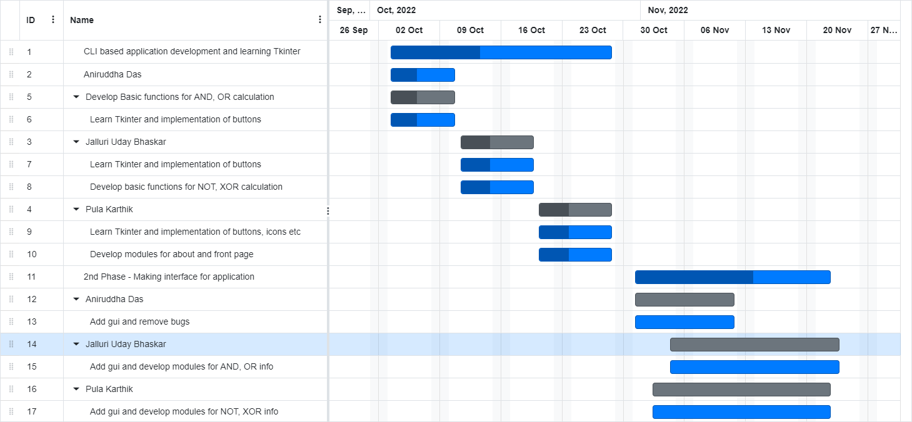

6. Framework

