# Preface:

Welcome to the Floe Navigation Android Application. The application can be installed on any Android tablet (For the MOSAiC expedition the tablet being used is [XSLATE D10](https://www.xploretech.com/downloads/Marketing_Brochures/D10/XSLATE_D10_Specsheet_EN.pdf)). This application uses the periodic data from AIS transponders installed on the Sea Ice to create a coordinate system which is fixed on a moving ice floe. It creates a visual representation of the coordinate system in the form of a grid which can be used to navigate on a moving Sea Ice. This guide describes how to use the Floe Navigation Application. It provides instructions for completing common tasks and provides descriptions of the fields, windows, buttons, and menus you will use to perform those tasks. The instructions and descriptions in this guide are based on the default product configuration.

## Audience:

This document is intended for users of the Floe Navigation System application.

# Pre-Requisites

Please read through the following necessary and important configurations that need to be done in the Android environment to ensure the smooth operation of the Floe Navigation App.

* The App needs an AIS Transponder to run. Ensure that the tablet is connected to the Wi-Fi network of an AIS transponder.
* Make sure that only one Tablet is connected to the Wi-Fi network of an AIS Transponder, as the AIS transponders do not support multiple client connections.
* Make sure that the location on the Android device is enabled. For details visit [Android documentation](https://support.google.com/accounts/answer/3467281?hl=en).
* Make sure that the Tablet is not connected to any other network interfaces such as Ethernet/GPRS and only a Wi-Fi network of an AIS Transponder is connected.
* For smooth operation, it is recommended that there are no other apps running on the device when the Floe Navigation App is running.

# Dashboard

The Dashboard is the main screen of the App. It is the first screen that you will see after launching the app. Using the Dashboard, you can navigate to all the sections of the app.

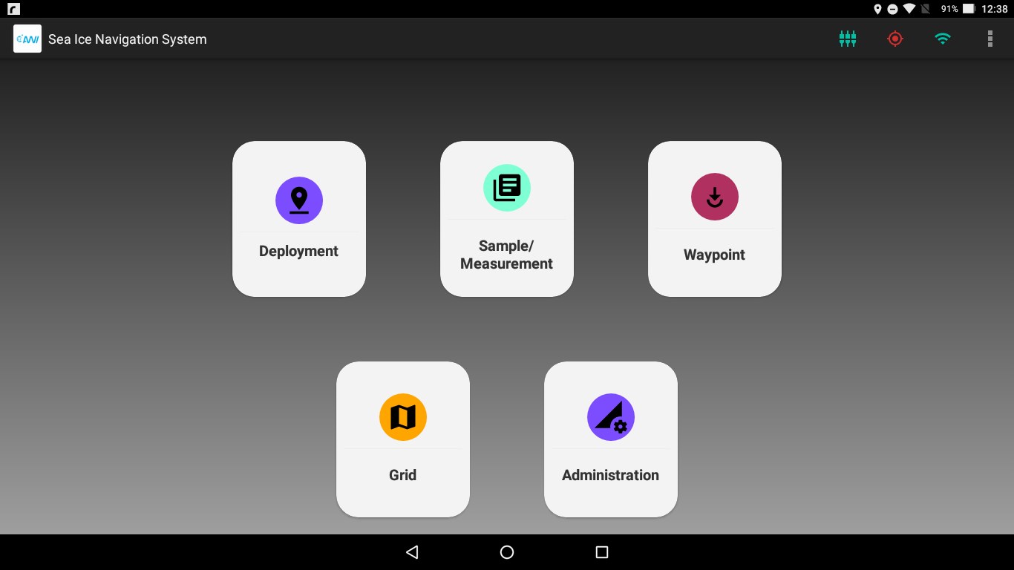

Figure 3.1 Dashboard as seen on Android Tablet

The following icons are visible on the Dashboard: (insert sections here later)

* **Deployment:** Can be used to deploy a static station.
* **Sample/Measurement:** To take a Sample/Measurement on the Ice.
* **Waypoint:** Insert a waypoint on the Grid.
* **Grid:** Show a visual representation of the whole coordinate system.
* **Administration:** For the administration of the App. Refer to Floe Navigation Administrator Guide.

## Status Bar

The status bar shows important indicator regarding the connectivity and configuration of the app.

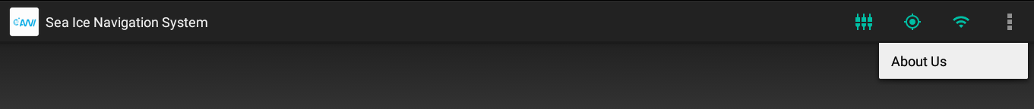

Figure 3.2 Status Bar on Android Device

The icons which are shown in the status bar are:

**Table 3.1 Status Bar Icons**

|  |  |  |
| --- | --- | --- |
| **Icon Name** | **State** | **Description** |
| Grid Setup Complete |  | Green: Grid Setup is complete and the App can be used completely. |
|  | Red: Grid Setup is not completed and you cannot access any of functionality of the App. Check Admin Guide for instructions on configuring the App. |
| Location Available |  | Green: The Device location is available. The App also uses the GPS time to record all the data. |
|  | Red: The device location is not available. Make sure that GPS is enabled. Refer to Chapter 2. |
| Wi-Fi Connection |  | Green: The Device is connected to a Wi-Fi network. |
|  | Red: The device is not connected to a Wi-Fi network. Make sure that Wi-Fi is enabled. Refer to Chapter 2. |
| About Us |  | Shows the About Us Dialog box containing Legal and Developer information. |

# Grid

This chapter describes the Floe Navigation Grid and the coordinate system on which it is established.

## Coordinate System:

The basic aim of the Floe Navigation system is to create a coordinate system which remains static with respect to a moving sea ice. To that end, it uses data from two AIS transponders to set up the coordinate system (For details about AIS see [here](https://en.wikipedia.org/wiki/Automatic_identification_system)). The coordinate system can only be established by an administrator of the system. For details see Floe Navigation Administrator Guide.

The custom coordinate system is created by fixing one AIS transponder as the origin and the other transponder is used to mark the x-Axis of the coordinate system. The y-Axis is then considered as perpendicular to the x-Axis. The custom coordinate system so created moves with the flowing sea ice as the transponders move with it. The positions of the points of interest on the sea ice can then be calculated relative to the custom coordinate system. So that each point of interest on the sea ice will have a {x, y} coordinate pair.



Figure 4.1 Coordinate System Concept at Setup

The Grid is a visual representation of all the above-mentioned coordinate system along with all the points of interests marked on it. The points of interest can be Waypoints, Static Stations (Stations without AIS), Mobile Stations (moving vehicles with AIS) and Fixed Stations (Stations with AIS). The grid also shows the tablet’s current position (own position) on the coordinate system for determining your position on the grid and the position of the mothership.



Figure 4.2 Coordinate System concept with all Points of Interest

## Map View

The Map View is the visual representation of the coordinate system established on the sea ice. The Map View shows all the points of interest that have been installed on the Sea Ice. The Map View shows all the stations and points of interest in a 100 km radius from the origin. There are vertical and horizontal scales on the left side and bottom of the Map View. The scales are in kilometers by default however when zoomed in, it automatically changes the scales to meters.

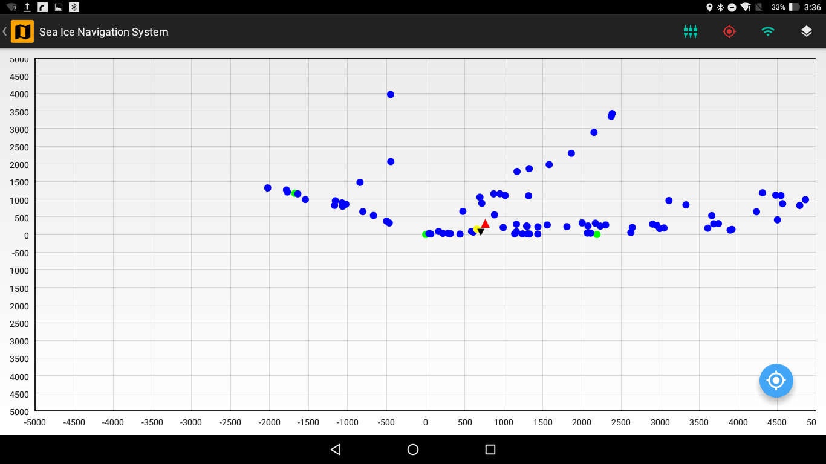

Figure 4.3 Map View of Coordinate System with Points of Interest

### Features

Several sophisticated features are available in the map view to aid you in visualizing the map view of the sea ice.

#### Layers

There are different layers on the Map View and you can set the visibility of each layer. The tablet location is always visible. By default, the visibility of all the layers is set on the Map View.

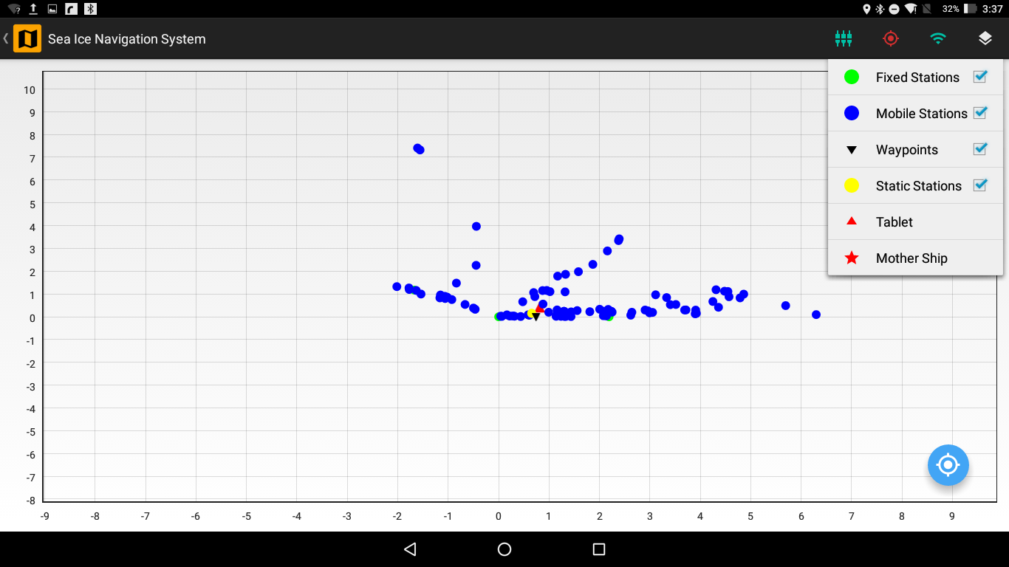

Figure 4.4 Map View with the available layers

The Layers that are visible on the Map View are:

**Table 4.1 Available Layers in Map View**

|  |  |  |
| --- | --- | --- |
| **Layer** | **Icon** | **Description** |
| Fixed Station |  | These are fixed position on the ice where AIS transponders have been mounted. Deployment of such station can only be done by an administrator (refer to Floe Navigation Administrator Guide for details). The periodic AIS data from these stations is used by the App to maintain the coordinate system. |
| Mobile Station |  | These are vehicles which are moving on the Sea Ice and have an AIS transponder mounted on them. The Map View will show all the mobile stations in a 100km radius. |
| Waypoints |  | These are points of interest on the Sea Ice. For details refer to (insert waypoint section). |
| Static Stations |  | These are fixed position on the ice without an AIS transponder. You can deploy such stations using the Deployment section (For details refer insert section here). |
| Own Position |  | This shows your current location on the Map View relative to the custom coordinate system. |
| Mother Ship |  | This is a special type of Mobile Station which shows the position of the Mother Ship. |

The screenshots of the different layers on the Map View are shown below:

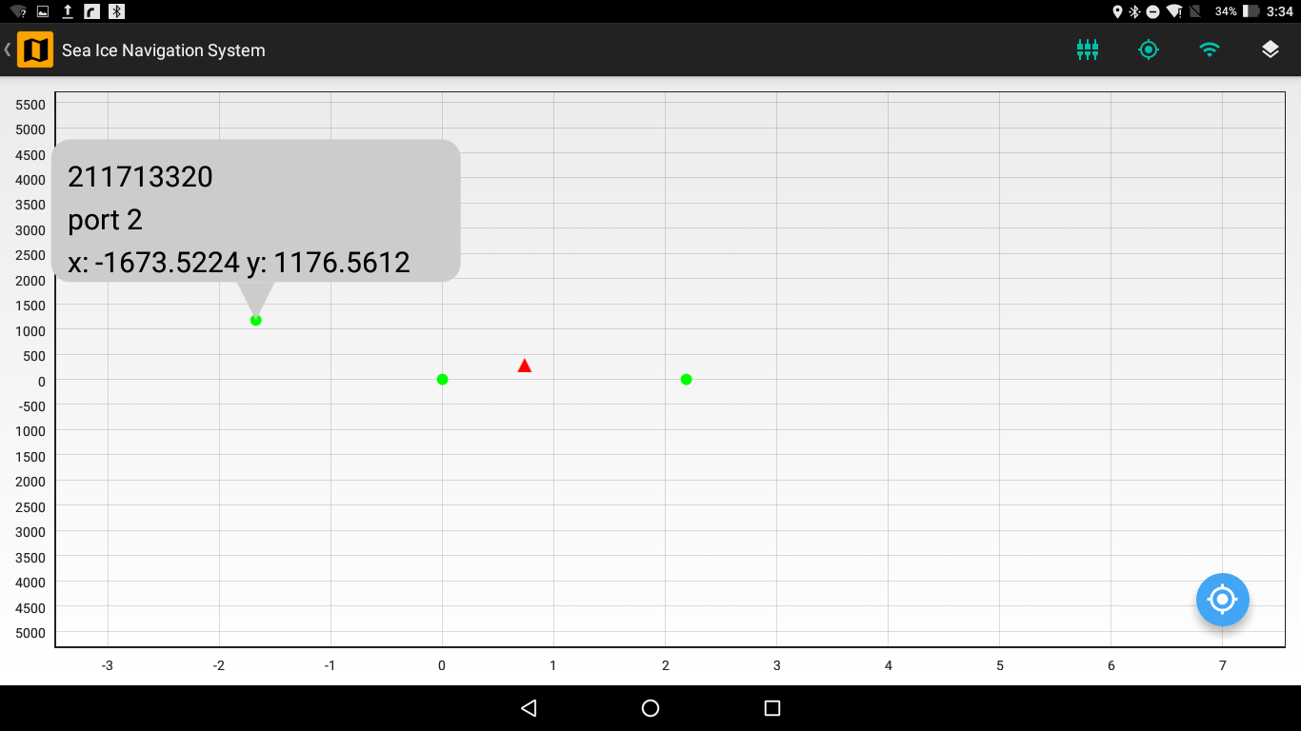

Figure 4.5 Fixed Stations on the Map View

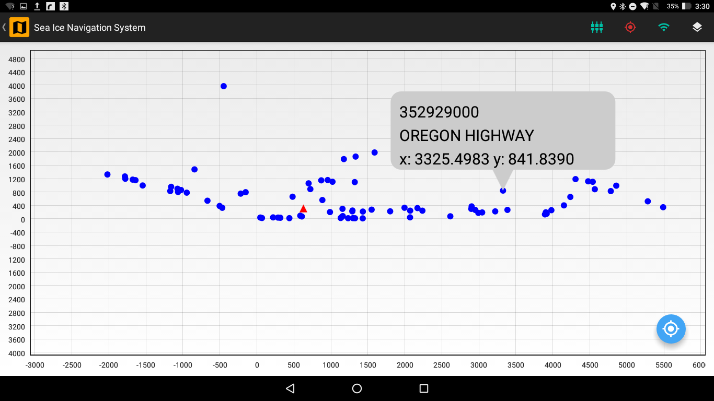

Figure 4.6 Mobile Stations on the Map View

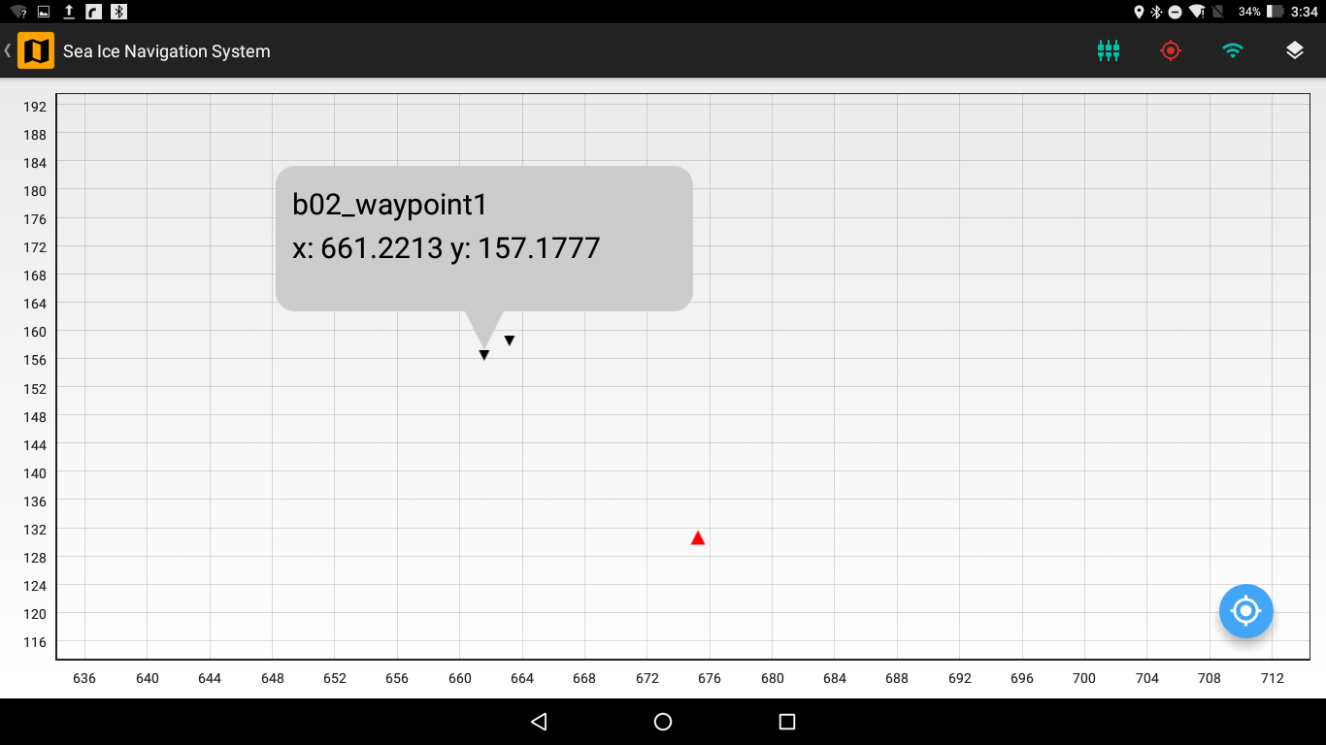

Figure 4.7 Waypoints on the Map View

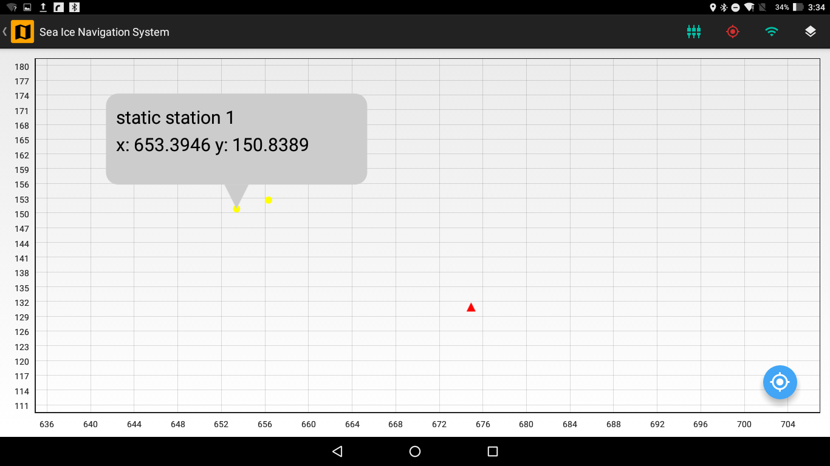

Figure 4.8 Static Stations on the Map View

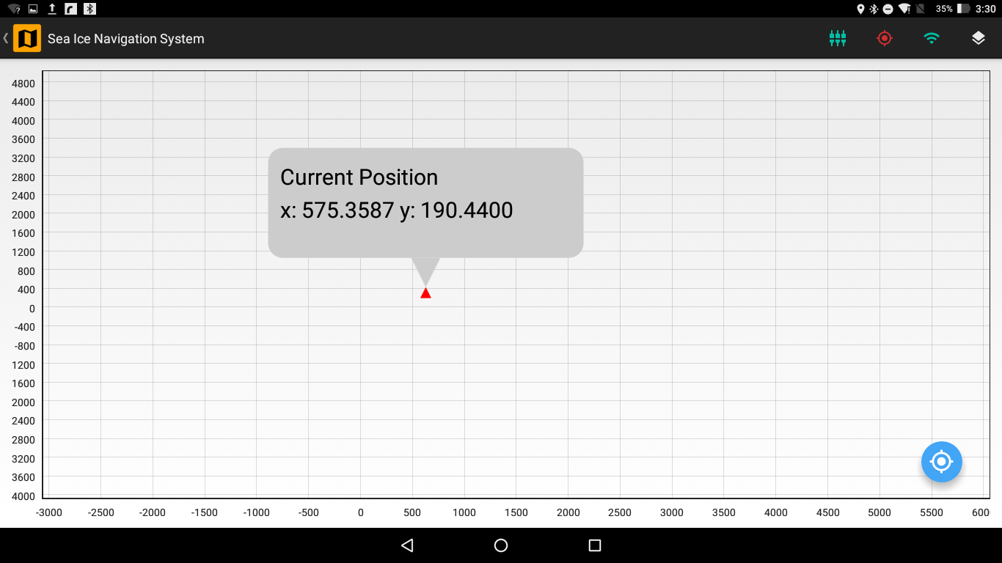

Figure 4.9 Own Position on the Map View

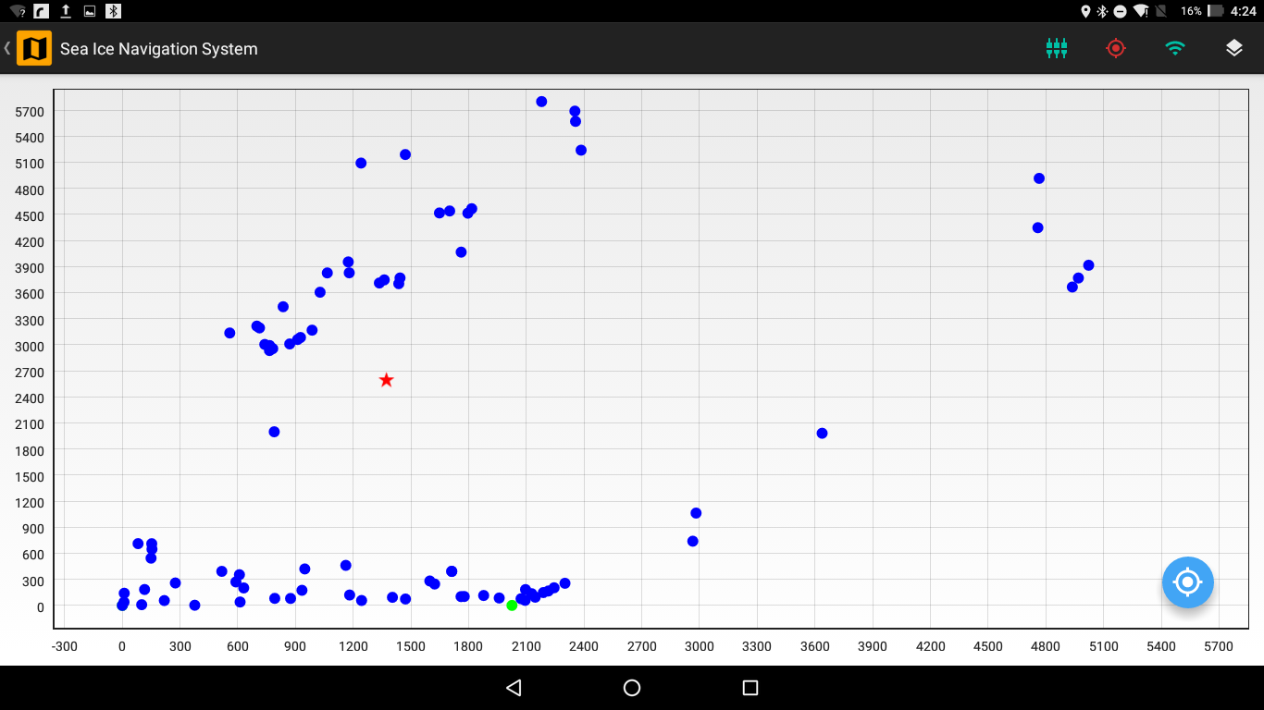

Figure 4.10 Mother Ship on the Map View

#### Details Box

When you tap a station or a point of interest the *Details Box* appear which shows the details of that station or point of interest. The *Details Box* displays the name of station/point of interest if exists, MMSI (only for a station with AIS such as Fixed Stations and Mobile Stations) and {x, y} coordinates of the station/point of interest in meters.

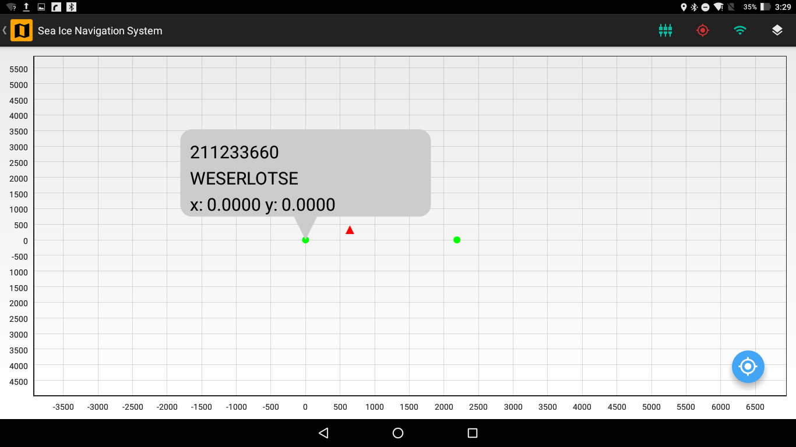

Figure 4.11 Details Box of a Fixed Station on the Map View

#### Zoom & Pan

You can zoom and pan on the map view. So as to locate a specific station/point of interest you can zoom in to the map view and tap that station/point of interest to see its *Details Box*. You can also move the map view when zoomed in using the pan feature.

#### Focus Button

There is a Focus Button on the Map View which will focus the map view either on your location if your location is available via GPS of the tablet or on the origin if GPS location is not available. The map view will be focused on a 5km radius of either your location or the origin.

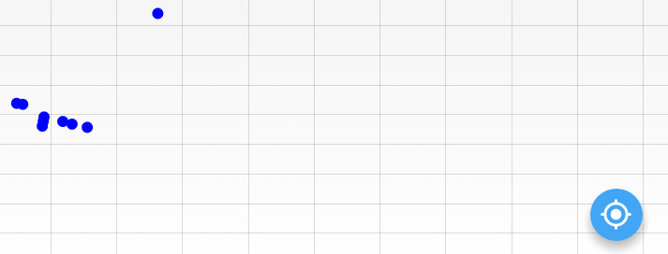

Figure 4.12 Focus Button on the Map View

# Deployment