Module 1 Lab Project
CWCT140
Python Essentials
There are two assignments below – Easy and Challenging. You only need to complete ONE of these assignments.
Easy:
Complete the three exercises below. Take a snapshot of your code and the result and paste into this document. Submit this document to the assignment basket.

Hint: If you are really, really stuck – you can find hints at https://holypython.com/beginner-python-exercises/exercise-1-print. Try to do the exercise before looking at the hints.

Exercise 1-A

# Replace "type here" with "Hello World!"

print("Hello World!")

Paste Snapshot of Code and Result Here
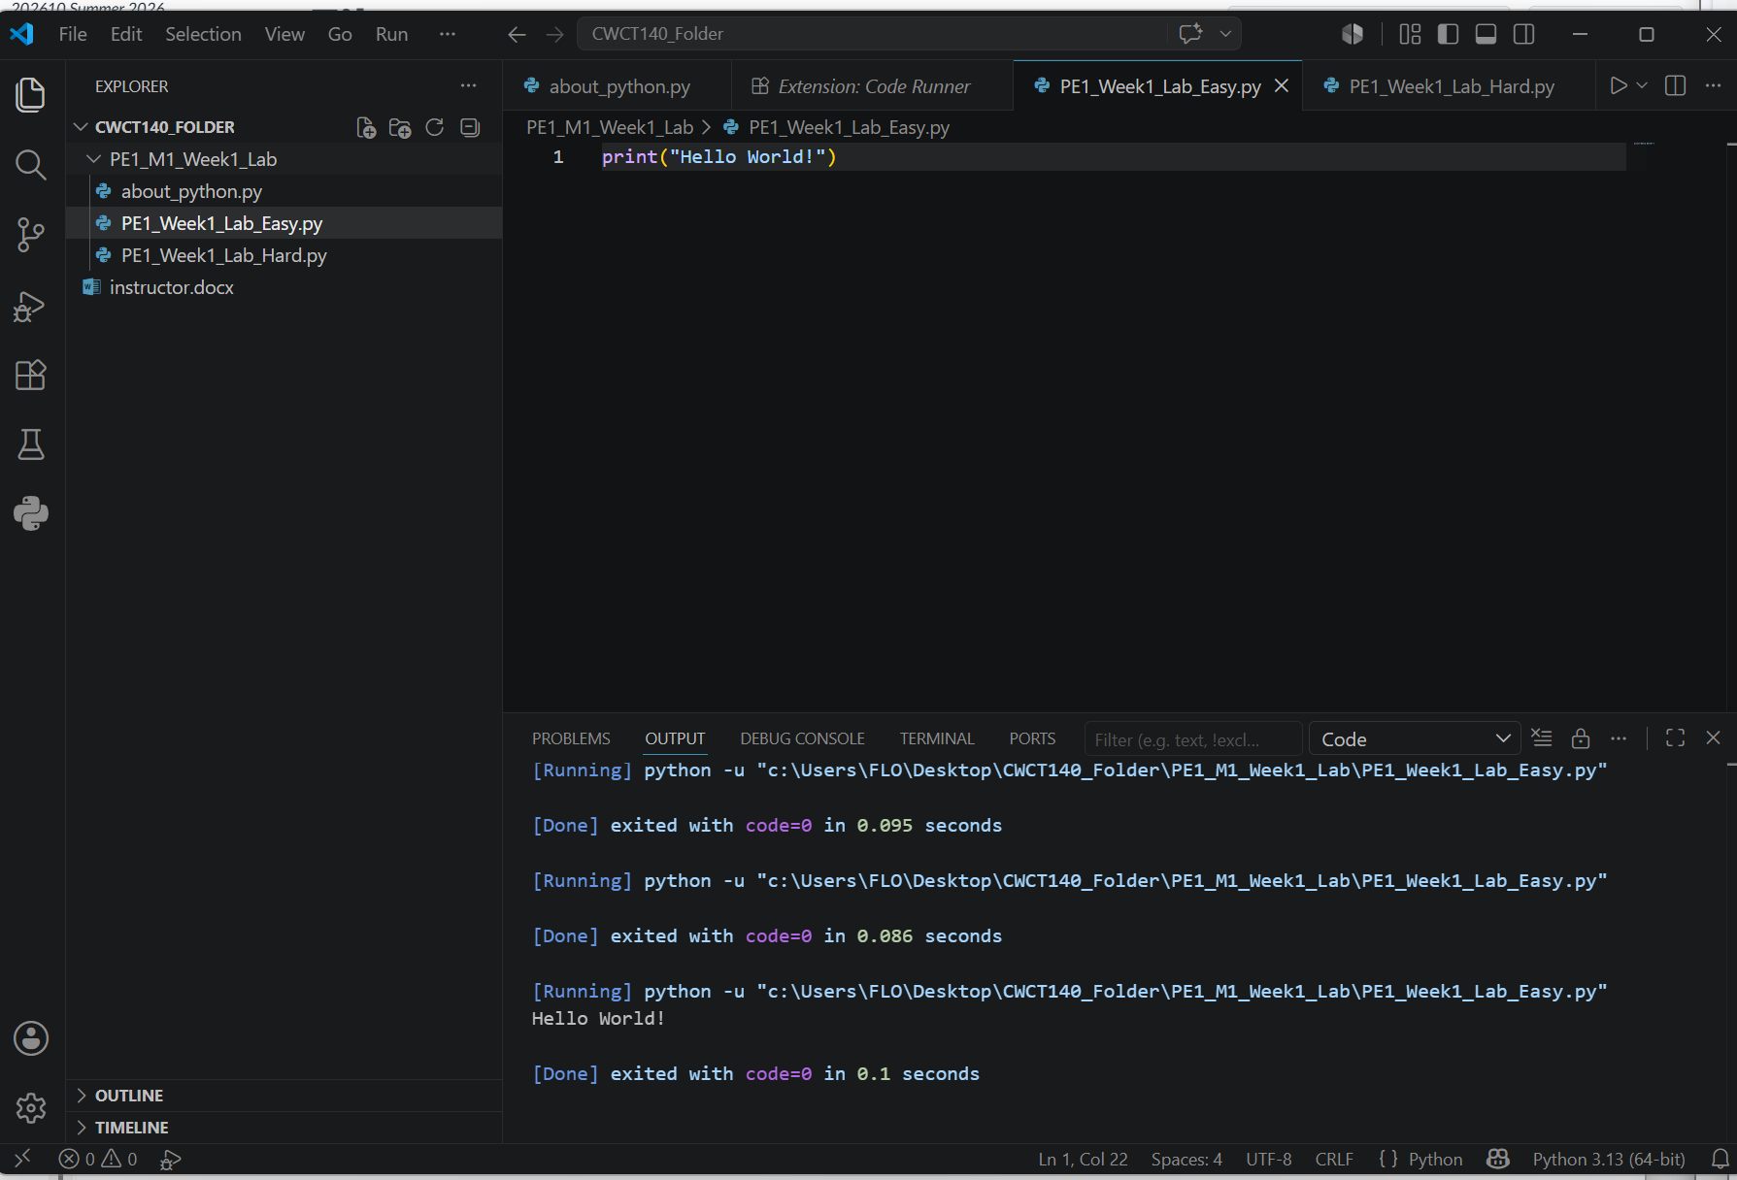

Exercise 1-B

# You can assign "Hello World!" to the variable below and print it.

my_text="Hello World!"
print(my_text)

Paste Snapshot of Code and Result Here
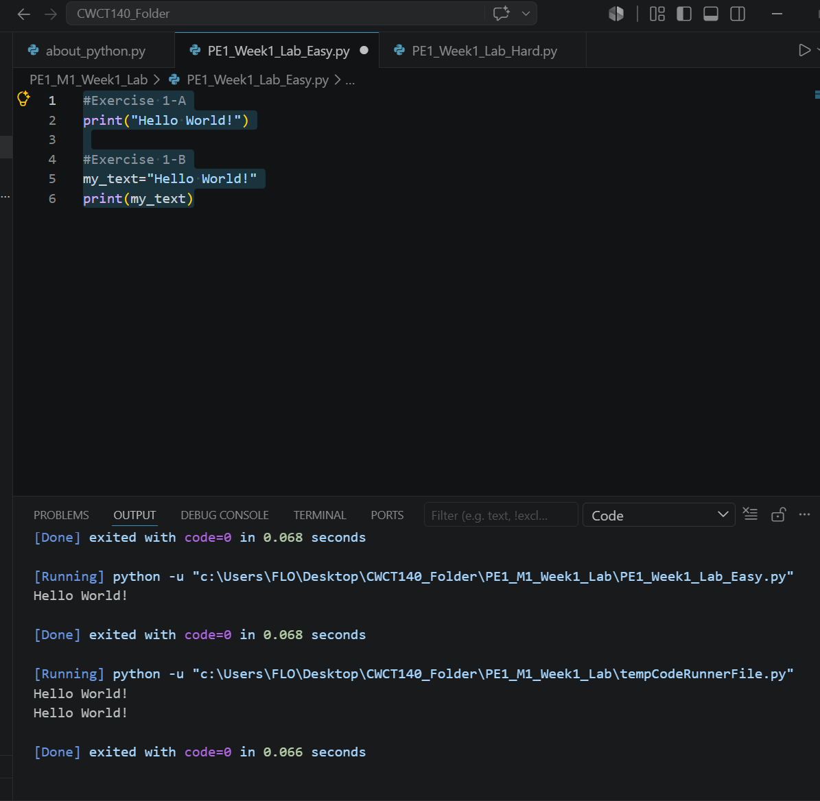

Exercise 1-C

# Type a couple of different values inside the print function. Make sure they are separated by commas.

print("Hello, World!, Goodbye, World!")

Paste Snapshot of Code and Result Here
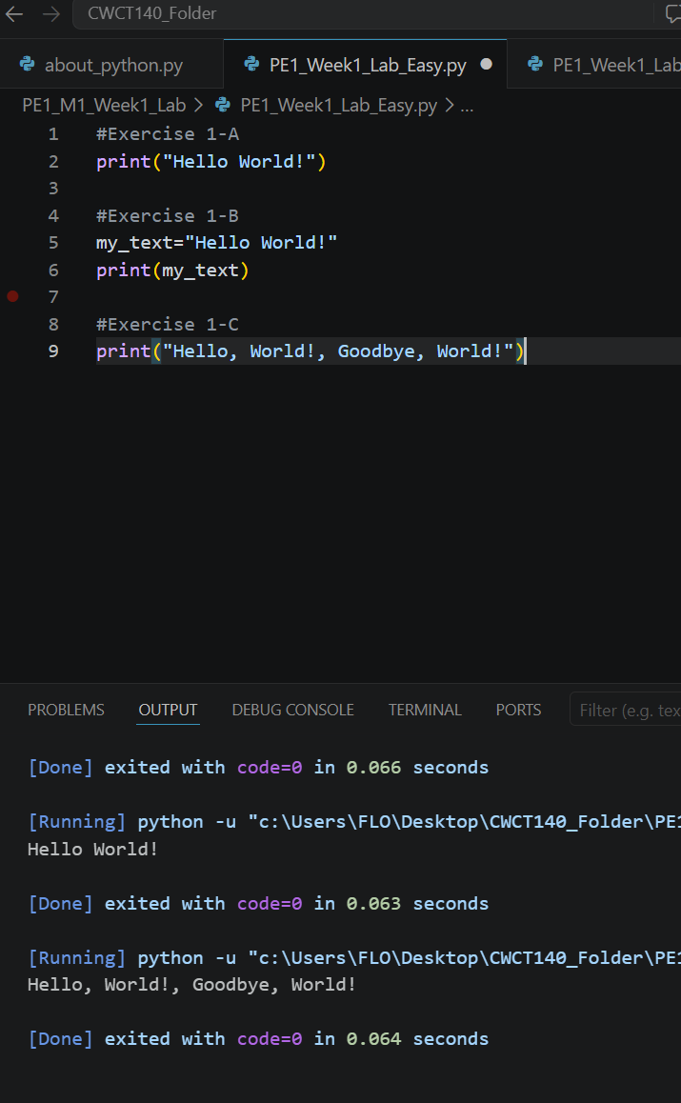

Challenging:
This assignment has a little more teeth to it. Modify the “sine wave” generator that was demonstrated in the lecture to display two sine waves that are out of phase by 180 degrees. Only two lines of code need to be added or modified – the hints are shown below. This is best done in an IDE like Spyder, IDLE or Visual Studio Code. The Netacad sandbox kind of works but is not as dynamic as one would hope for.

Exercise 2
# Sine Wave Generator two sine waves 180 degrees out of phase
# y = Offset + A * sin(angle_in_radians)
import math
import time

A = 40
Offset = 40

for y in range(2):
for x in range(0, 359, 15):
radians = 2 * math.pi * x / 360
index1 = round(Offset + (A * math.sin(radians)))
index2 = round(Offset + (A * math.sin(radians+math.pi)))

# calculate a second index by adding PI to the angle_in_radians
line = ""
for j in range(A*2 + 1):
if j == index1 or j==index2: # add OR comparison for the second index
line = line + "*"
else:
line = line + " "
print(line)
time.sleep(0.1)

Paste Snapshot of Code and Result Here
