 | 
-TRAVAUX PRATIQUES SC311-
TP : | 1-2 |  |  |  | 2016 – 2017

Sujet: | INSTRUMENTATION ET MESURES: Analyse temporelle et fréquentielle des signaux modulés

NAME: (1)
(2)

Goals:

To understand the utility of measurement equipment and exploit its functions on the analysis of signals in time and frequency domain.
To verify the concepts of AM and FM modulation, relating the theory with the experimental analysis.

PLANNING
No. | EXPERIENCE | APPROX.  DURATION | SCORE
1rst session
1 | Brief introduction | 20 min | -
2 | Measurement and analysis of signals in time and frequency domain | 60 min | 3
3 | AM modulation, measuring and analysis (time and frequency domain) | 85 min | 3.5
 | Total | 2h45min + break | 6.5
2nd session
4 | FM modulation, measuring and analysis (time and frequency domain) | 2H15 min | 3.5
6 | Final test (individual) | 30 min | 10
 | Total | 2h45min + break | 13.5

Equipements for this experience:

Generateur de signaux Metrix GX 1025 (arbitrary waveform generator) | Oscilloscope numerique (MemoryPrime Française instrumentation FI 33102)
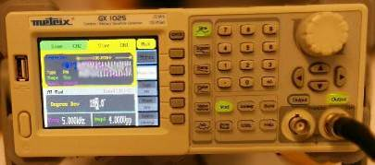 | 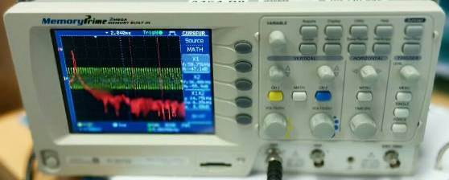

- Measurement and analysis of signals in time and frequency domain
The objectives of this experience are:
- To understand the equipment operation
- To domain the main functions for simple signal generation (frequency, amplitude, sinus, square, etc.) and to generate modulated signals (AM, FM, modulation index, etc)
- To domain the main functions for signal analysis in the oscilloscope (horizontal and vertical scale settings, markers, FFT calculation, etc.)

Setting up (1 point)
To begin, connect the output CH1 of the generator to the input CH1 of the oscilloscope using a BNC cable, follow the instructions of the responsible.

Procedure to follow in the generator:
- Generate a square signal with the following characteristics:
  - Frequency 2 kHz
  - Amplitude 5 v pp (peak to peak).
  - Cycle dutty of 50 %

Procedure to follow in the Oscilloscope:
- Visualize the shape and structure of the signal:
  - Properly set the horizontal and vertical scale to visualize a distinguishable square signal
  - Find the MATH function, to calculate the FFT of the shown signal.
  - Use the markers (button “Cursor”) to properly identify the amplitude and frequency of the carrier and its side lobes.

The following scheme can help you to understand the experience. Call the responsible when you finish the set-up.

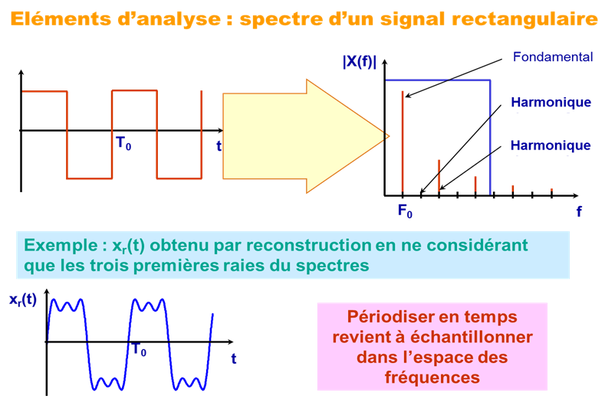

Figure 1.

  - From the frequency domain analysis.
Which are the dominant components (which frequencies) that contribute on the shaping of a square signal? Generalize your answer. (0.5p)

  - Explain the difference on the spectrum for each kind of window (Hamming, Hanning, Rectangular, Flattop, Blackman) considering Frequency resolution, amplitude, and width-narrowness of lobes. Explain its use. (1.5p)

- Generation of a AM signal, measuring and analysis
The objectives of this experience are:
- To understand the concept of AM modulation and link it to the theory of the course
- To interpret the spectral content of an AM signal.

Procedure to follow in the generator:
- Generate an AM modulated signal with the following characteristics:
  - Sinusoidal carrier frequency Fc =5 kHz
  - Amplitude of the carrier = 5 Volts pp (peak-to-peak)
  - A modulating frequency Fm=500 Hz.
  - A modulation index of 0.8 (80%) («AM Depth » option)

Procedure to follow in the Oscilloscope:
- Visualize the shape and structure of the signal:
  - Set properly the horizontal and vertical scale to visualize a distinguishable signal, as well as the spectral window
  - Calculate the FFT of the AM signal.
  - Use the markers to properly identify the amplitude and frequency of the carrier and its side lobes (the markers are available for X and Y axis).
  - Observe the influence of the signal parameters (amplitude, frequency, modulation index)

  - By properly setting the scalesscale on the screen of the oscilloscope, find the characteristic representation of an AM signal in the frequency domain (composed by three components). Explain each component (frequency, amplitude) (0.5p)

Horizontal scale = …………ms/division
Vertical scale = …………Volts/division.
Window used = …………
Components of the spectrum of an AM signal:
*make a rough sketch of the spectrum, considering vertical and horizontal axis


Figure 2. AM signal in frequency domain.

  - From the frequency domain analysis
Increase and decrease the frequency of the modulating signal. What happens with the bandwidth of the signal? When does the overlapping occur? (0.5p)

  - Set in the generator a modulation index (AM depth) of 60 %. An Fc=5KHz and Fm=500 Hz.
Regarding the scale displayed in the oscilloscope set 10 ms/div at the horizontal scale and 5V/division at the vertical scale. (0.5p)

From the frequency domain analysis
Choosing a specific window, find modulation index from the spectral analysis. Which window offers the more accuracy results compared to the pre-set value at the generator?

Carrier Frequency = …………….
Modulating Frequency = …………….
Window = …………….
Modulation index set on geneator=……………………..
Calculations:

  - Set the time scale and amplitude scale properly to easily positioned the markers and measure the amplitudes of the modulated signal. You can freeze the screen on the oscilloscope to facilitate the analysis (button “RUN/STOP”). (1.5p)

From the time and frequency domain analysis:
Keep the frequency of modulating signal constant and vary the modulation index on the generator (option: “AM Depth”).
Note: for the spectral analysis, you should choose the better window found in question 2.3

Frequency of modulating signal = …………….
Frequency of carrier signal = ……………..
Amplitude of carrier in volts (set at the generator) = ……………..

Pre-configured Modulation index (%) | V max in volts (measured in oscilloscope) | V min in volts (measured in oscilloscope) | Calculate the modulation index (%) from time domain analysis | Calculate the modulation index (%) from frequency analysis
100
80
50
10

If there were a difference between the pre-configured modulation index and theoretical modulation index, quantified the error (%) and justify your results.

General conclusions: (0.5p)

- Generation of a FM signal, measuring and analysis
The objectives of this experience are:
- To understand the concept of FM modulation and link it to the theory of the course
- To interpret the spectral content in of an FM signal and its relation with the Bessel series approximation.

Procedure to follow in the generator:
- Generate an FM modulated signal with the following characteristics:
  - Sinusoidal carrier frequency Fc =5 kHz
  - Amplitude carrier = 5 v pp (peak to peak)
  - A modulating signal of frequency Fm = 500 Hz
  - A FM deviation (Δf) of 4 KHz (Modulation index m_{φ} = Δf /Fm)
Procedure to follow in the Oscilloscope:
- Visualize the shape and structure of the signal:
  - Properly set the horizontal and vertical scale to visualize a distinguishable signal
  - Calculate the FFT of the FM signal using a Hanning window.
  - Use the markers to properly identify the amplitude and frequency of the carrier and its side lobes. And observe the influence of the signal parameters (amplitude, frequency, FM deviation, bandwidth )
The curves of Figure 3 show the relation (Bessel function) between the carrier and sideband amplitudes of the modulated wave as a function of the modulation index m_{φ}.

Note that the carrier component and its sidebands go to zero-amplitude at specific
Values of m_{φ}. From these curves we can determine the amplitudes of the carrier and the sideband components in relation to the carrier.

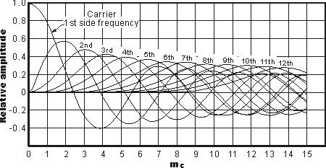
m_{φ}

Figure 3. Relative levels of carrier and sidebands for a frequency modulated signal

  - By properly setting the time scale in the oscilloscope, find the representation of an FM signal in the time domain. (0.5p)

Horizontal scale = …………ms/division
Vertical scale = …………Volts/division

By pressing the “RUN/STOP” button on the oscilloscope, freeze a temporal acquisition, and put the cursors (X1 and X2) en two consecutive peaks of wider duration. The difference between these two cursors will be called Δt.

Make a rough sketch of the frozen acquisition, considering the cursors position.
What is the corresponding value of “1/ Δt”, Explain the graphic (considering axis), justify your answer.

Figure 4. FM signal in time domain.

  - By setting an FM deviation (Δf) of 2 KHz and properly setting the scale on the screen in the oscilloscope, find the representation of an FM signal in the frequency domain, which components can you identify? (0.5p)

Horizontal scale = 5 ms/division
Vertical scale = 5 Volts/division

As you can note, the spectrum does not have a fix shape, but it depends on the FM deviation (related to the modulation index and the frequency of the modulating signal Fm), make a rough sketch of the spectrum, considering vertical and horizontal axis, when the modulation index is equal to one. Which is the corresponding “FM deviation”?

Figure 5. FM signal in frequency domain.

  - From the frequency domain analysis (0.5p)
Increase and decrease the frequency of the modulating signal. What happens with the bandwidth of the signal?
Horizontal scale = 5 ms/division
Vertical scale = 5 Volts/division

Carsons' Rule states that 98% of the signal power is contained within a bandwidth equal to ….

  - Given the scheme shown in Figure 3, and the initial conditions ( Fc=5KHz and Fm=500 Hz), set the marker to the position of the second component in the spectral analysis, and determine for which value of modulation index the second component is maximum (“second component” means the closer sideband to the carrier) (0.5p)

Fc = …………….
Fm = …………….
Window = …………….
Horizontal scale = …………ms/division
Vertical scale = …………Volts/division
Modulation index=……………………..
FM deviation=…………………

Make a rough sketch of the spectrum when the modulation index makes maximum the second component in the frequency analysis (considering vertical and horizontal axis).
Find the difference between the second component and the carrier (in dB) and compare it to its corresponding relation of Figure 3. Write the calculations
Figure 6. FM signal in frequency domain for a máximum second component (side lobe).

  - Given the scheme shown in Figure 3, and the initial conditions ( Fc=5KHz and Fm=500 Hz), set the marker to the position of the carrier in the spectral analysis and determine for which value(s) of modulation index, the carrier component is null or minimum (0.5p)

Fc = …………….
Fm = …………….
Window = …………….
Horizontal scale = …………ms/division
Vertical scale = …………Volts/division
Modulation index=……………………..
FM deviation=…………………

Make a rough sketch of the spectrum, considering vertical and horizontal axis, when the modulation index makes minimum (or null) the carrier.

Figure 7. FM signal in frequency domain for a null (minimum) carrier.

  - Compare AM and FM with respect to modulation index, number of sidebands, bandwidth requirement, carrier power. Justify your answers. (0.5p)
 | AM | FM
Modulation index | …
Number of sidebands
Bandwidth requirement
Carrier power

General conclusions: (0.5p)

