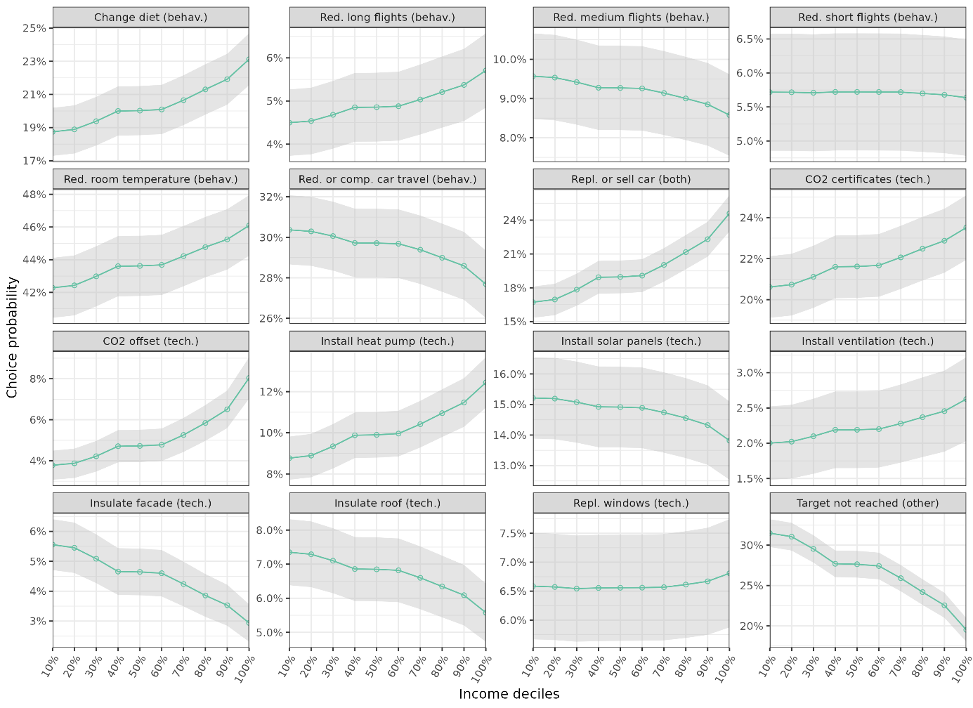

Predicted choice probabilities of emission reduction strategies across income groups. Predicted values are calculated from an MDCEV model (see Extended Data Table 4). We set all income levels to the respective decile values and predict choice probabilities while leaving the other variables unchanged. Error bars report 95% confidence intervals (n = 2’792). From top left to bottom right strategies necessitating behavioral change are shown first, followed by strategies implying a technological solution.

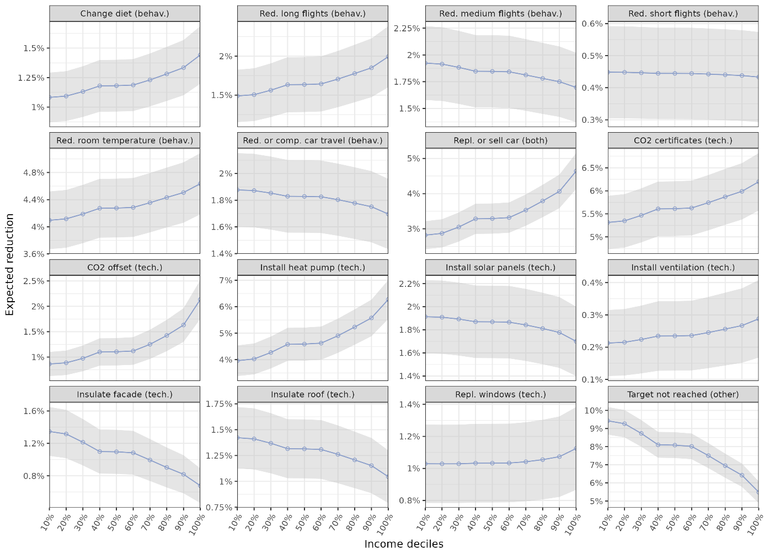

Expected emission reductions of emission reduction strategies across income groups. Predicted values are calculated from an MDCEV model (see Extended Data Table 4). We set all income levels to the respective decile values and predict emission reductions while leaving the other variables unchanged. Error bars report 95% confidence intervals (n = 2’792). From top left to bottom right strategies necessitating behavioral change are shown first, followed by strategies implying a technological solution.

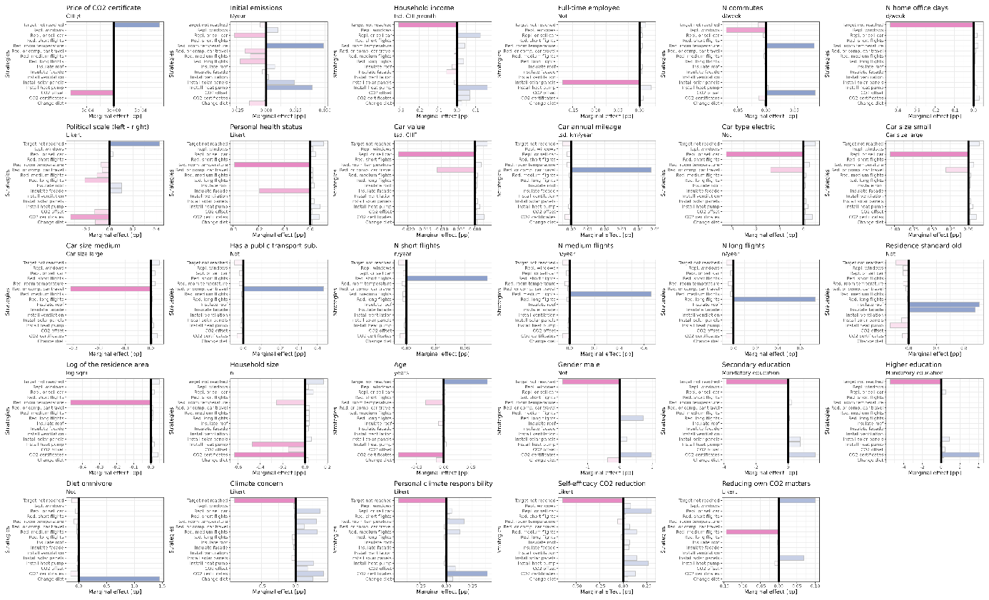

Extended Data Figure 3. Marginal effects for each variable: Model-based expected change in CO2 emissions [pp].} For continuous and Likert variables, we first predict emission reductions based on the original data and then increase all values of the respective variable marginally (by one unit as reported in facet caption) and predict again. For indicator variables we compare the predicted carbon emissions to the reference level (reported in the facet caption).

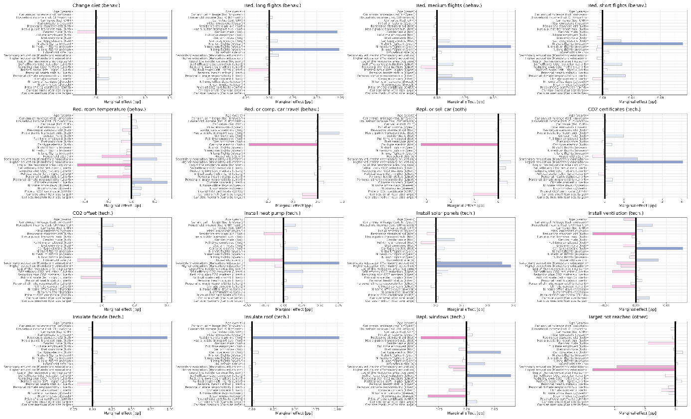

Marginal effects for each strategy: Model-based expected change in CO2 emissions [pp].} For continuous and Likert variables, we first predict emission reductions based on the original data and then increase all values of the respective variable marginally (by one unit as reported in brackets) and predict again. For indicator variables we compare the predicted carbon emissions to the reference level (reported in bracket). From top left to bottom right strategies necessitating behavioral change are shown first, followed by strategies implying a technological solution.