Brave green world: Simulating preferences and trade-offs for carbon footprint reducing behaviors using a priority evaluator

Extended abstract for the Environmental Politics and Governance (EPG) 10th Annual Conference, Québec City, Canada, June 18-21, 2024

Motivation and research question

Urgent action is needed in order to limit climate change (IPCC, 2022). Recent focus has increasingly shifted to the domestic political sphere to tackle climate change (Aklin and Mildenberger, 2020), where particularly the distributional dimension of climate policy has been picked up by both the electorate and politicians, and become highly salient for both elections and referenda on climate policy (Colantone et al., 2023; Schaffer, 2023; Stokes, 2016).

While cost of climate policies and their distributional consequences have become increasingly relevant, very little is currently known about how people across societal sub-groups evaluate and trade-off necessary behavioural changes and financial costs when faced with decisions about how to reduce individual carbon emissions. As individual emission reductions will become inevitable, it is imperative for policymakers to better understand the feasibility of individual adaptation options in order to develop policy instruments that will effectively foster changes, as well as provide support where such changes pose unfavorable distributional outcomes. Accordingly, this paper investigates the following: when tasked with reducing their personal carbon emissions to a level that is compatible with net-zero goals, how do people trade off behavioural adaptations and lifestyle changes with their related cost implications? How are these trade-offs conditioned by individual capacities to change and attitudinal priors?

Method

We study this question by developing a priority evaluator-based methodology: a highly individualized and interactive choice task that allows each respondent to develop a set of behavioural adaptations and mitigation pathways to reach a personalized carbon emission reduction target (Jäggi, 2015). The priority evaluator was fielded in an online survey amongst a population-representative sample in Switzerland (N = 5941) in 2022. First, respondents are asked about their CO2-relevant behaviours and living conditions (carbon calculator). These responses are utilized to calculate each respondent’s CO2 emission and populate a list of realistic adaptation options. The dynamic nature of the digital application then allows citizens to compare the effectiveness of these different behavioural adaptations, while at the same time, weigh their choices against behavioural and financial cost implications. The respondents are tasked with developing a 30% reduction in their carbon emissions, and are presented with the annual (over time) and one-time purchase costs or benefits of their behavioural changes (see Figure 1). Respondents can either reach their 30% reduction target or not. Lastly, respondents are asked to evaluate their cost and benefits perceptions of these changes. Here we are able to identify the preferred pathways for behavioural changes, which sub-groups of respondents are more or less likely to meet their emissions reduction targets (and how), and perceptions about how difficult and costly these behavioural changes are.

**Fig. 1. The Priority Evaluator (screenshot, annotations in red)**

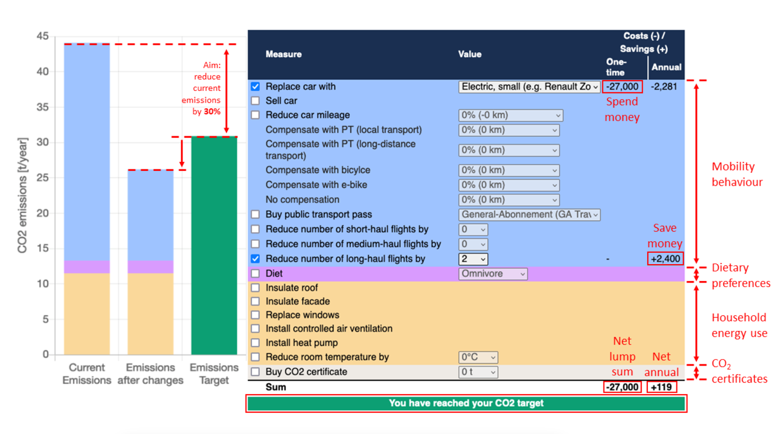

Expectations

Citizens usually lack information on the availability of different behavioural adaptations and lifestyle changes to reduce their emissions, and how they compare with regards to financial and behavioural costs and effectiveness (Attari et al., 2010). The priority evaluator serves here as an individualized tool that makes these trade-offs transparent.

Following a rational model of human behaviour (Becker, 1976), respondents could be expected to increase their utility by choosing the most effective strategy, i.e., a strategy that reduces emissions as much as possible while keeping financial and behavioural costs as low as possible. However, the availability of choices for behavioural adaptations and lifestyle changes are dependent on individual financial capabilities and constraints. While wealthier individuals are high emitters (Gössling and Humpe, 2023; Wiedmann et al., 2020) because they consume more as well as more energy intensive goods (Oswald et al., 2020), they also have a wider array of different options that are available to them in order to reduce emissions compared to less wealthy individuals. Additionally, wealthier individuals possess more financial capabilities to reduce their emissions.

* *Exp 1:* We expect high-income earners to have a higher likelihood to reach their emission reduction targets and be more willing to accept financially costly adaptations.

Further, behavioural choices can be expected to depend heavily on belief systems, norms, and attitudes of individuals (Ajzen, 1991; Stern et al., 1999). Respondents that that are environmentally concerned and have strong pro-environmental norms can be expected to show ex ante a higher willingness to engage in behaviours to reduce their carbon emissions. Further, they are also more willing to bear higher behavioural costs than others (Kaiser et al., 1999).

* *Exp 2:* We expect people with higher environmental concern and pro-environmental norms to have a higher likelihood to meet the emission reduction target and be more willing to accept the associated financial and behavioural changes.

Contribution

Our study exceeds existing studies of behavioural adaptations towards reducing individual carbon emissions (which commonly rely upon simple survey questions (Lange et al., 2023)), providing an interactive tool that simulates the ‘real-world’ trade-offs in behavioural and financial costs. These findings contribute to the questions of how individual climate action is shaped by attitudinal and material factors (Steg, 2023). Studying the willingness to adapt behaviours and lifestyles allows to identify perceived losers of such a transition which would need to be targeted most by compensatory measures (such as redistributive payments or support for low-cost alternatives to high-carbon lifestyles) in order to counteract unfavorable distributional outcomes of climate policy (Gaikwad et al., 2022). These insights are imperative to achieve winning coalitions that are necessary to successfully implement climate policy (Meckling et al., 2015).