Brave green world: Simulating preferences and trade-offs for carbon footprint reducing behaviors using a priority evaluator

Extended abstract

Motivation and research question

Urgent action is needed in order to limit climate change (IPCC, 2022). Recent focus has increasingly shifted to the domestic political sphere to tackle climate change (Aklin and Mildenberger, 2020), where particularly the distributional dimension of climate policy has been picked up by both the electorate and politicians, and become highly salient for both elections and referenda on climate policy (Colantone et al., 2023; Schaffer, 2023; Stokes, 2016).

While cost of climate policies and their distributional consequences have become increasingly relevant, very little is currently known about how people across societal sub-groups evaluate and trade-off necessary behavioural changes and financial costs when faced with decisions about how to reduce individual carbon emissions. As individual emission reductions will become inevitable, it is imperative for policymakers to better understand the feasibility of individual adaptation options in order to develop policy instruments that will effectively foster changes, as well as provide support where such changes pose unfavorable distributional outcomes. Accordingly, this paper investigates the following: when tasked with reducing their personal carbon emissions to a level that is compatible with net-zero goals, how do people trade off behavioural adaptations and lifestyle changes with their related cost implications? How are these trade-offs conditioned by individual capacities to change and attitudinal priors?

Method

We study this question by developing a priority evaluator-based methodology: a highly individualized and interactive choice task that allows each respondent to develop a set of behavioural adaptations and mitigation pathways to reach a personalized carbon emission reduction target (Jäggi, 2015). The priority evaluator was fielded in an online survey amongst a population-representative sample in Switzerland (N = 5941) in 2022. First, respondents are asked about their CO2-relevant behaviours and living conditions (carbon calculator). These responses are utilized to calculate each respondent’s CO2 emission and populate a list of realistic adaptation options. The dynamic nature of the digital application then allows citizens to compare the effectiveness of these different behavioural adaptations, while at the same time, weigh their choices against behavioural and financial cost implications. The respondents are tasked with developing a 30% reduction in their carbon emissions, and are presented with the annual (over time) and one-time purchase costs or benefits of their behavioural changes (see Figure 1). Respondents can either reach their 30% reduction target or not. Lastly, respondents are asked to evaluate their cost and benefits perceptions of these changes. Here we are able to identify the preferred pathways for behavioural changes, which sub-groups of respondents are more or less likely to meet their emissions reduction targets (and how), and perceptions about how difficult and costly these behavioural changes are.

**Fig. 1. The Priority Evaluator (screenshot, annotations in red)**

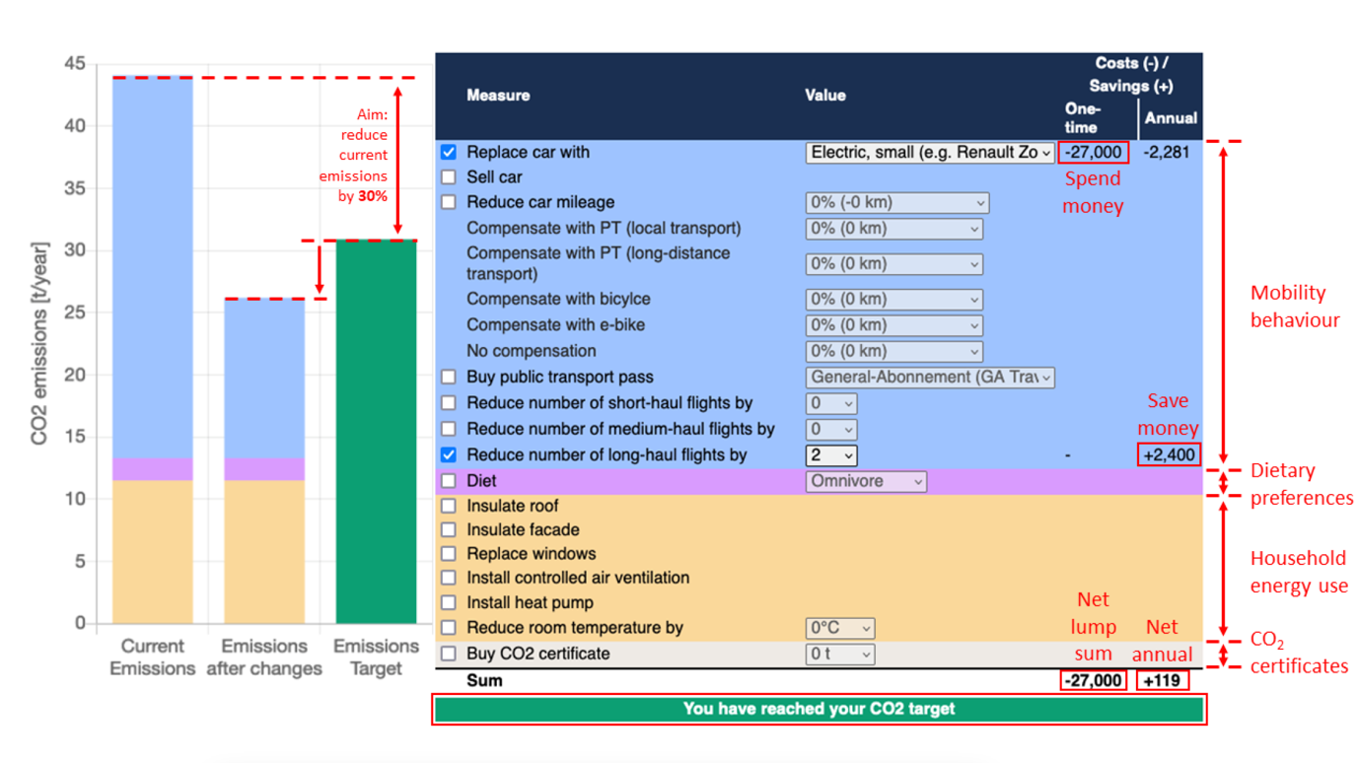

Analytic strategy

In order to answer the question who is more or less likely to reach the reduction target, we fit a binary logit model to identify what factors increase or decrease the likelihood to reach the emission reduction target and by how much.

In a second step, we want to shed light on how respondents did reach the target (or not). For this purpose, we separately analyse those respondents that reach the target and those who don’t. We fit Multiple Discrete-Continuous Extreme Value Models (Bhat, 2005) for both groups. These models allow us (opposed to traditional discrete choice models) to model the simultaneous choice of multiple reduction options (discrete dimension, e.g., reducing flights) and the corresponding continuous quantities of the reduction (continuous dimension, e.g., the number of flights reduced). While conventional multiple discrete models only allow the modelling of the selection of one alternative from a set of mutually exclusive alternatives, MDCEV models consider goods as imperfect substitutes and enable modeling of the choice of multiple alternatives simultaneously using additive utility functions. These model specifications are of a non-linear nature and assume diminishing marginal returns for each adaptation strategy (satiation). This problem framing is by design well suited to represent real-world and relevant choices such as in this case.

Using these models, we can estimate for both respondents that reached the target and those who didn’t’ a) the share of respondents choosing a certain adaption strategy, b) the resulting average of CO2 reduction when having chosen the respective strategy, c) the average money implications (how much money has been spent/been received on average given the respective strategy has been chosen as well as d) elasticities/marginal probability estimates, that indicates what individual characteristics influence the choice of the respective adaptation strategy. An example of how we intend to visualize these results can be found in the appendix (Figure A1).

In a third step, we want to identify different combinations of adaptations strategies chosen. For this we intend to conduct a cluster analysis, where we cluster based on the individuals' probability distribution over the strategies. I.e. the cluster will identify groups that are “more likely” to follow a given strategy mix. It would be interesting to scrutinize the number of groups and how far we can label the strategy mix.

Expectations

Citizens usually lack information on the availability of different behavioural adaptations and lifestyle changes to reduce their emissions, and how they compare with regards to financial and behavioural costs and effectiveness (Attari et al., 2010). The priority evaluator serves here as an individualized tool that makes these trade-offs transparent (see Figure A2 in the appendix for an overview).

Following a rational model of human behaviour (Becker, 1976), respondents could be expected to increase their utility by choosing the most effective strategy, i.e., a strategy that reduces emissions as much as possible while keeping financial and behavioural costs as low as possible. However, the availability of choices for behavioural adaptations and lifestyle changes are dependent on individual financial capabilities and constraints. While wealthier individuals are high emitters (Gössling and Humpe, 2023; Wiedmann et al., 2020) because they consume more as well as more energy intensive goods (Oswald et al., 2020), they also have a wider array of different options that are available to them in order to reduce emissions compared to less wealthy individuals. Additionally, wealthier individuals possess more financial capabilities to reduce their emissions.

* *Exp 1:* We expect high-income earners to have a higher likelihood to reach their emission reduction targets and be more willing to accept financially costly adaptations.

Further, behavioural choices can be expected to depend heavily on belief systems, norms, and attitudes of individuals (Ajzen, 1991; Stern et al., 1999). Respondents that that are environmentally concerned and have strong pro-environmental norms can be expected to show ex ante a higher willingness to engage in behaviours to reduce their carbon emissions. Further, they are also more willing to bear higher behavioural costs than others (Kaiser et al., 1999).

* *Exp 2:* We expect people with higher environmental concern and pro-environmental norms to have a higher likelihood to meet the emission reduction target and be more willing to accept the associated financial and behavioural changes.

Contribution

Our study exceeds existing studies of behavioural adaptations towards reducing individual carbon emissions (which commonly rely upon simple survey questions (Lange et al., 2023)), providing an interactive tool that simulates the ‘real-world’ trade-offs in behavioural and financial costs. These findings contribute to the questions of how individual climate action is shaped by attitudinal and material factors (Steg, 2023). Studying the willingness to adapt behaviours and lifestyles allows to identify perceived losers of such a transition which would need to be targeted most by compensatory measures (such as redistributive payments or support for low-cost alternatives to high-carbon lifestyles) in order to counteract unfavorable distributional outcomes of climate policy (Gaikwad et al., 2022). These insights are imperative to achieve winning coalitions that are necessary to successfully implement climate policy (Meckling et al., 2015).

References

Ajzen I (1991) The theory of planned behavior. *Organizational Behavior and Human Decision Processes* 50(2). 1 Oliver’s Yard, 55 City Road, London EC1Y 1SP United Kingdom: SAGE Publications Ltd: 179–211.

Aklin M and Mildenberger M (2020) Prisoners of the Wrong Dilemma: Why Distributive Conflict, Not Collective Action, Characterizes the Politics of Climate Change. *Global Environmental Politics* 20(4): 4–27.

Attari SZ, DeKay ML, Davidson CI, et al. (2010) Public perceptions of energy consumption and savings. *Proceedings of the National Academy of Sciences* 107(37): 16054–16059.

Becker GS (1976) *The Economic Approach to Human Behavior*. Chicaco: The University of Chicago Press.

Bhat CR (2005) A multiple discrete–continuous extreme value model: formulation and application to discretionary time-use decisions. *Transportation Research Part B: Methodological* 39(8): 679–707.

COLANTONE I, DI LONARDO L, MARGALIT Y, et al. (2023) The Political Consequences of Green Policies: Evidence from Italy. *American Political Science Review*: 1–19.

GAIKWAD N, GENOVESE F and TINGLEY D (2022) Creating Climate Coalitions: Mass Preferences for Compensating Vulnerability in the World’s Two Largest Democracies. *American Political Science Review* 116(4): 1165–1183.

Gössling S and Humpe A (2023) Millionaire spending incompatible with 1.5 °C ambitions. *Cleaner Production Letters* 4(July 2022): 100027.

IPCC (2022) Summary for Policymakers. In: Shukla, PR, Skea J, Slade R, et al. (eds) *Climate Change 2022: Mitigation of Climate Change. Contribution of Working Group III to the Sixth Assessment Report of the Intergovernmental Panel on Climate Change*. Cambridge, UK and New York, NY, USA: Cambridge University Press, pp. 1–52.

Jäggi B (2015) *Decision Modeling on the Household Level for Energy, Fleet Choice and Expenditure*.

Kaiser FG, Wölfing S and Fuhrer U (1999) ENVIRONMENTAL ATTITUDE AND ECOLOGICAL BEHAVIOUR. *Journal of Environmental Psychology* 19(1): 1–19.

Lange F, Berger S, Byrka K, et al. (2023) Beyond self-reports: A call for more behavior in environmental psychology. *Journal of Environmental Psychology* 86(October 2022): 101965.

Meckling J, Kelsey N, Biber E, et al. (2015) Winning coalitions for climate policy. *Science* 349(6253): 1170–1171.

Oswald Y, Owen A and Steinberger JK (2020) Large inequality in international and intranational energy footprints between income groups and across consumption categories. *Nature Energy* 5(3). Springer US: 231–239.

Schaffer LM (2023) Who’s afraid of more ambitious climate policy? How distributional implications shape policy support and compensatory preferences. *Environmental Politics* 00(00). Routledge: 1–24.

Steg L (2023) Psychology of Climate Change. *Annual Review of Psychology* 74(1): 391–421.

Stern PC, Dietz T, Abel T, et al. (1999) A value-belief-norm theory of support for social movements: The case of environmentalism. *Human Ecology Review* 6(2): 81–97.

Stokes LC (2016) Electoral Backlash against Climate Policy: A Natural Experiment on Retrospective Voting and Local Resistance to Public Policy. *American Journal of Political Science* 60(4): 958–974.

Wiedmann T, Lenzen M, Keyßer LT, et al. (2020) Scientists’ warning on affluence. *Nature Communications* 11(1): 3107.

Appendix

Figure A1: Example Visualization of Results

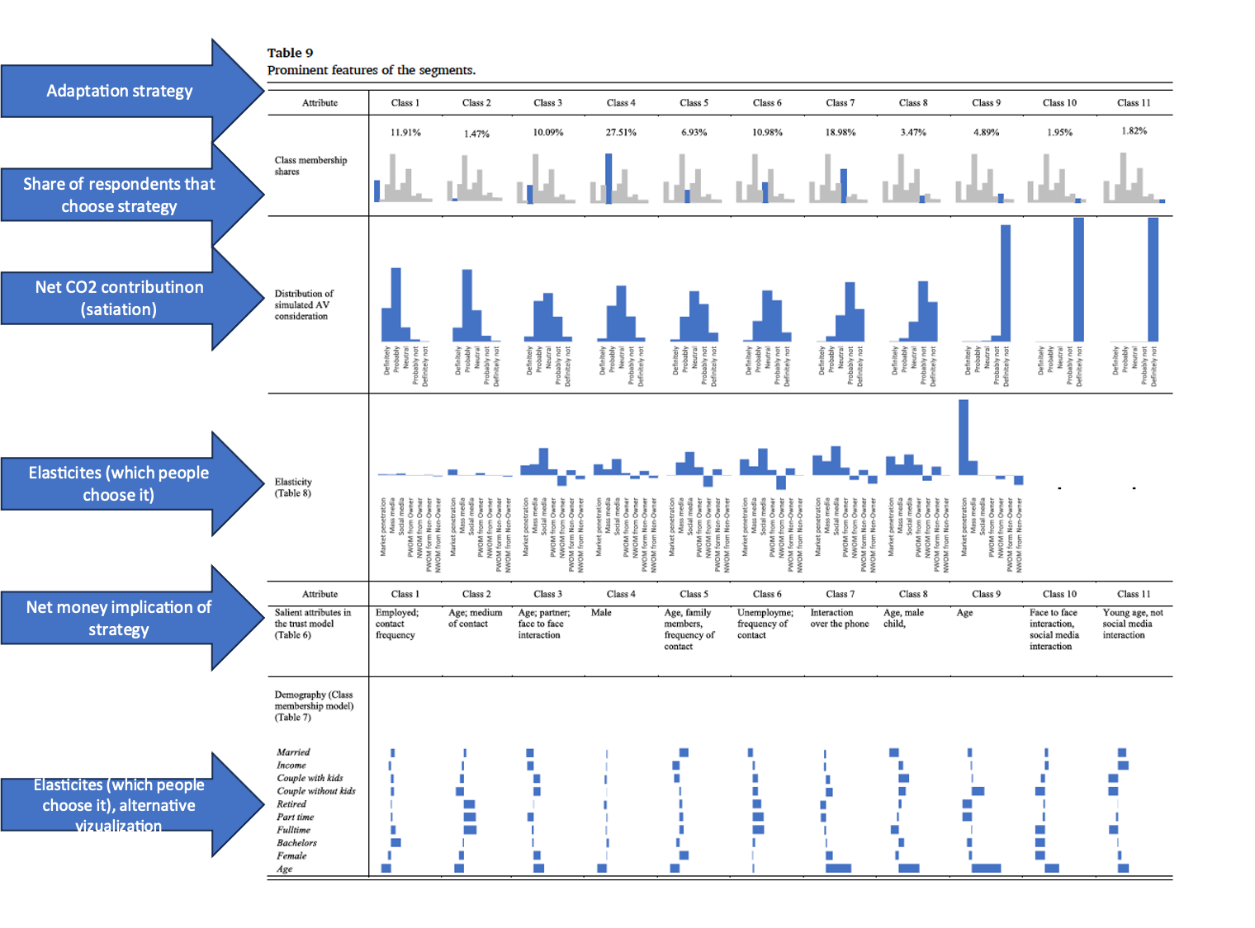

Figure A2: Overview of carbon mitigation measures and effects on carbon dioxide, costs and savings as well as behavioral costs

|  |  |  |  |
| --- | --- | --- | --- |
| Attribute | Impact on CO2 | Impact on costs (-) and saving (+) | Behavioral cost |
| Mobility behavior |  |  |  |
| Auto ersetzen durch |  | High (-) | Low |
| Auto verkaufen | negative | High (+) | High |
| Fahrleistung Auto reduzieren | negative |  | Low |
| Kompensation mit ÖV / Fahrrad / E-Bike | low (positive) | Low (-) | High |
| Kaufe Abo für den öffentlichen Verkehr |  |  |  |
| Anzahl Kurzstreckenflüge reduzieren | high | Low (+) | High |
| Anzahl Mittelstreckenflüge reduzieren | high | High (+) | High |
| Anzahl Langstreckenflüge reduzieren | high | High (+) | High |
| Diet |  |  |  |
| Ernährung ändern | low | No impact | High |
| Housing |  |  |  |
| Dach dämmen | Negative | High (-) | Low |
| Fassade dämmen | Negative | High (-) | Low |
| Fenster austauschen | Negative | High (-) | Low |
| Solaranlage installieren | Negative | High (-) | Low |
| Kontrollierte Lüftung installieren | Negative | High (-) | Low |
| Wärmepumpe installieren | Negative | High (-) | Low |
| Raumtemperatur reduzieren um | Negative | Low (+) | Low |
| Carbon offsetting |  |  |  |
| CO2-Zertifikat kaufen | negative | Depends on price level | Low |

A3: Priority evaluator survey items

|  |  |  |  |
| --- | --- | --- | --- |
| **Item** | **Scale** | **Concept** | **Source** |
| ***Before PE*** |  |  |  |
| *B1_text: Now, we would like to ask you some questions about climate change (global warming).*  **B1 Do you think that climate change is caused by natural processes, human activity, or both?** | From 1 entirely by natural processes to 5 entirely by human activity, incl. DK | Climate change beliefs – climate change cause | *ESS 2016* |
| **B2 How worried are you about climate change?** | From 1 not at all worried to 5 extremely worried, incl. DK | Climate concern | *ESS 2016* |
| **B3 To what extent do you feel you have a personal responsibility to try to reduce carbon dioxide (CO2) emissions that are contributing to climate change, where 0 is not at all and 10 is a great deal?** | From 0 not at all to 10 a great deal, incl. DK | Pro-environmental personal norm | *Own wording (based on ESS 2016)* |
| **B4 How much do you think the local area where you live will be affected by climate change in the next 100 years, where 0 is not at all and 10 is a great deal?** | From 0 not at all to 10 a great deal, incl. DK | Climate change impact – future impact | *?* |
| **B5 How much do you think the local area where you live is currently being affected by climate change, where 0 is not at all and 10 is a great deal?** | From 0 not at all to 10 a great deal, incl. DK | Climate change impact – current impact | *?* |
| **B10 How much do you agree or disagree with the following statement? Climate change is an unstoppable process, we cannot do anything about it.** | From 1 strongly agree to 5 strongly agree, incl. DK | ? | *Eurobarometer, LITSII* |
| ***Before & After PE*** |  |  |  |
| *B6_txt: The following two statements are about changes you could make to your current behaviours and living conditions that would reduce your carbon dioxide (CO2) emissions. Examples are driving/flying less, reducing personal energy usage, switching to an electric vehicle, or installing solar panels on your home.*  *Please state how confident you are in each of these statements, where 0 means not at all confident and 10 is completely confident.*  **B6 I could reduce my own carbon dioxide (CO2) emissions.** | From 0 not at all confident to 10 completely confident, incl. DK | Efficacy beliefs – self efficacy | *Own wording (based on ESS 2016)* |
| **B7 Reducing my own carbon dioxide (CO2) emissions will help limit climate change.** | From 0 not at all confident to 10 completely confident, incl. DK | Efficacy beliefs – personal outcome expectancy | *Own wording (based on ESS 2016)* |
| *B8_txt: Now, the following two statements are about new policies and regulations that the Swiss Government could institute with the aim of reducing carbon dioxide (CO2) emissions. Please state how confident you are in each of these statements, where 0 is not at all confident and 10 is completely confident.*  **B8 The Swiss Government will institute new policies and regulations aimed at reducing carbon dioxide (CO2) emissions.** | From 0 not at all confident to 10 completely confident, incl. DK | Efficacy beliefs – institutional efficacy | *Own wording (loosely based on ESS 2016)* |
| *Please state how confident you are in each of these statements, where 0 is not at all confident and 10 is completely confident.*  **B9 Now imagine that the Swiss Government does institute new policies and regulations aimed at reducing carbon dioxide (CO2) emissions: How confident are you that these policies and regulations will help limit climate change?** | From 0 not at all confident to 10 completely confident, incl. DK | Efficacy beliefs – institutional outcome expectancy | *Own wording (loosely based on ESS 2016)* |
| ***After PE*** |  |  |  |
| *D1_text: For the following questions, please think about the changes you made to your behaviours and living conditions in order to meet your carbon dioxide (CO2) emission reduction target in the previous exercise.*  **D1 How costly do you think these changes to your behaviours and living conditions would be for you to make, where 0 is not at all expensive and 10 is extremely expensive?** | From 0 not at all expensive to 10 extremely expensive | PE financial cost perception | *Own wording* |
| **D2 How difficult do you think these changes to your behaviours and living conditions would be for you to make, where 0 is not at all difficult and 10 is extremely difficult?** | From 0 not at all difficult to 10 extremely difficult | PE behavioral adaptation difficulty  perception | *Own wording* |
| **D7 In general, how would you rate the CO2 emission reduction target exercise, where 0 is lowest and 10 is highest?** | From 0 to 10 | PE rating | *Own wording* |
| **D8 Do you have any additional feedback that you would like to share with us about the CO2 emission reduction target exercise?** | - | PE additional feedback | *Own wording* |

Figure A4: additional theoretical expectations

|  |  |  |  |
| --- | --- | --- | --- |
| **Group** | **Original expectation** | **Additional theoretical framework / reasoning** | **Updated expectation (in yellow)** |
| **Left-enviro**  **low income**  **high emissions** | unlikely combo | unlikely combo | unlikely combo |
| **Left-enviro**  **low income**  **low emissions** | Target: not reached  Measures:  Perceptions: hard & costly | unfair | Target: not reached  Measures:  Perceptions: hard & costly, unfair |
| **Left-enviro**  **high income**  **high emissions** | Target: reached  Measures: financial & behavioural  Perceptions: easy & cheap | fair | Target: reached  Measures: financial & behavioural  Perceptions: easy & cheap, fair |
| **Left-enviro**  **high income**  **low emissions** | unlikely combo | unlikely combo | unlikely combo |
| **Right-brown**  **low income**  **high emissions** | unlikely combo | unlikely combo | unlikely combo |
| **Right-brown**  **low income**  **low emissions** | Target: not reached  Measures:  Perceptions: hard & costly | don’t care | Target: not reached  Measures:  Perceptions: hard & costly, don’t care |
| **Right-bown**  **high income**  **high emissions** | Target: reached  Measures: financial  Perceptions: easy & not costly | don’t care | Target: not reached  Measures:  Perceptions: easy & not costly, don’t care |
| **Right-brown**  **high income**  **low emissions** | unlikely combo | unlikely combo | unlikely combo |