### closeCurrent()

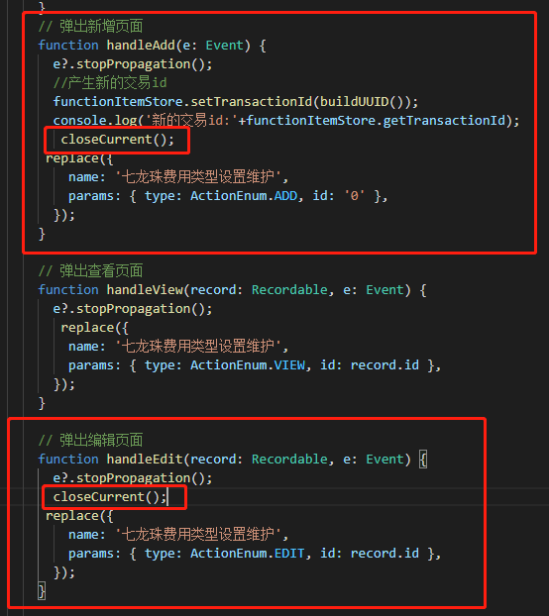主子表，新增后得刷新一下才看到新增内容;在主表index的弹出新增和跳转到编辑函数里，replace前加一个closeCurrent();

const { closeCurrent } = useTabs();

import { useTabs } from '/@/hooks/web/useTabs'