# **[Initialization failed for 'https://start.spring.io' Please check URL, network and proxy settings解决办法](https://www.cnblogs.com/Mr-Hou88888/p/15658715.html)**

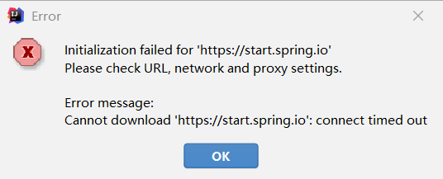

### **问题解决：**

搜索HTTP Proxy ---> 点击Auto-detect proxy settings ---> 勾选Automatic proxy configuration URL ---> 输入https://start.spring.io ---> 点击Check connection

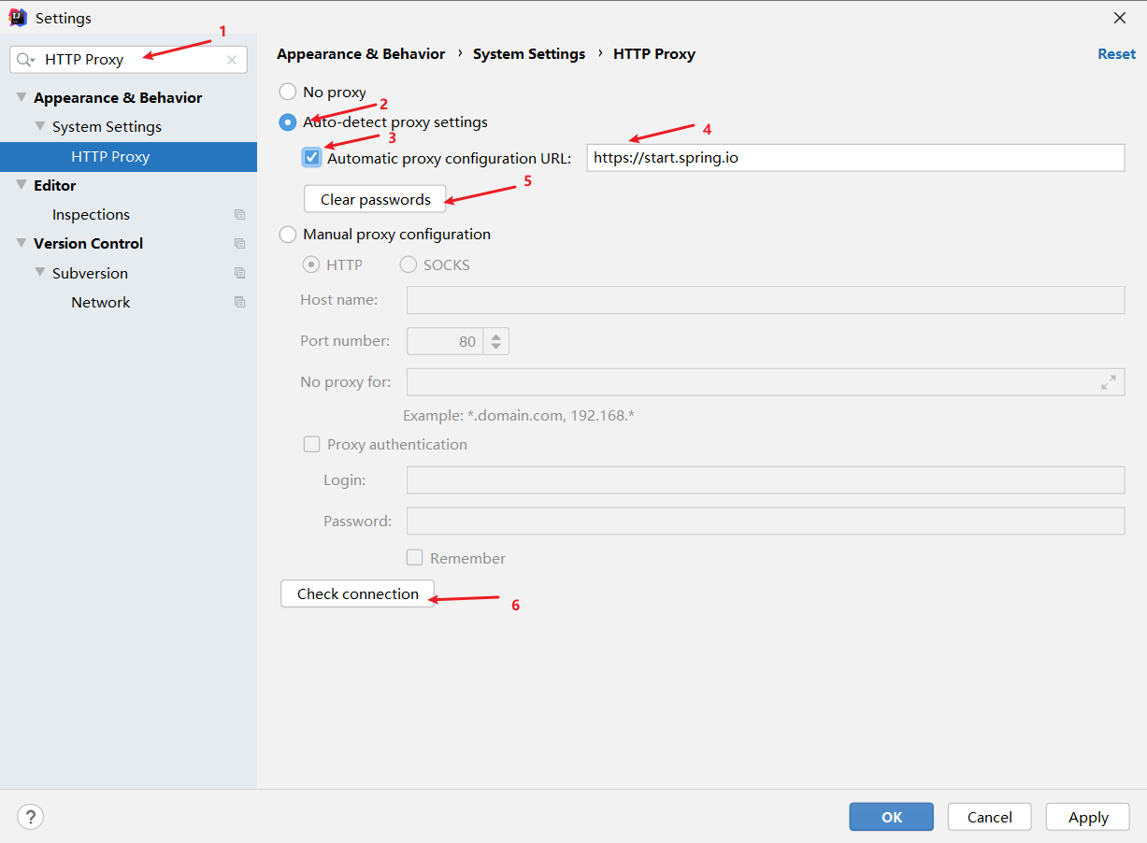

#### **解决方式二：**

把 https://start.spring.io 替换成 https://start.spring.io/

如果还是不行

#### **解决方式三：**

点击Custom 输入阿里云的地址 https://start.aliyun.com/