Having fun with OpenStreetMap data

Intro

OSM = Wikipedia for mapping

HOTOSM

Can edit in the browser, but JOSM == more control

DataStructure

Point

Line

Polygon

Relation

# They joy of maps, all by your self

Maps are awesome. And it turns out that making your own maps is a real joy too. Modern open and free software and data are there waiting for you.

As a hobby, it combines data-geekiness, problem solving, user experience and aesthetic design considerations. As an occupation? Well, it sounds wide open to possibilities.

If you enjoy creating that perfect chart or graph in Excel, or look on with mild envy at others’ charting styles (I’m looking at you, the Economist! <https://www.economist.com/graphic-detail/>), well, map making could be for you.

It’s the same fun of sharing data in an easily digestible manner, but with even more levers to pull and dials to tweak to get it *just* right.

And the great part of map making in 2020 is that all the data and tools are freely available to use.

The following is what I’ve learnt as a self-taught GIS-lover. I’m sure there are GIS experts out there who know tricks to speed the process up, but hopefully this will help newcomers on their way to GIS happiness.

Before we go into detail, there are three key parts to mapping

* **Data:** The data can come from anywhere, and there are a whole bunch of interoperable data standards that can be used — I mostly use OpenStreetMap, data.gov.uk and statistics.gov.uk data, but if you know of any other interesting datasets, let me know!  
  By the way, if you haven’t come across OpenStreetMap before, go check it out; in summary it’s Wikipedia but for maps. Maybe you could help improve the mapping in your local area by using the StreetsComplete app on your phone: <https://wiki.openstreetmap.org/wiki/StreetComplete>
* **User interface:** To generate the map itself, QGIS is brilliant. It’s a free and open source map generating system. It can do all manner of astonishing things, so can take a bit of getting used to, as the interface isn’t the most intuitive for the first-time user. But don’t be put off; there’s a logic behind it!
* **Styling:** The data tells you what is where, and the user interface lets you compose that data. The missing piece is how to make that data look like a map. It turns out that maps are filled with intricate complexity when it comes to colours, line thickness, occlusion, text positioning, etc. A style pack takes the raw geographical data and makes it *look* like a map.

Here’s a map that uses OpenStreetMap data to show the number of places where cycling isn’t permitted in London. I Call it “Bicycling No!”, which is a play on the underlying data used to create it. It’s a good example for us to dissect in order to understand how modern digital maps are made.

So let’s get dissecting… and once we know what makes up this map, we can go through the steps to recreate it.

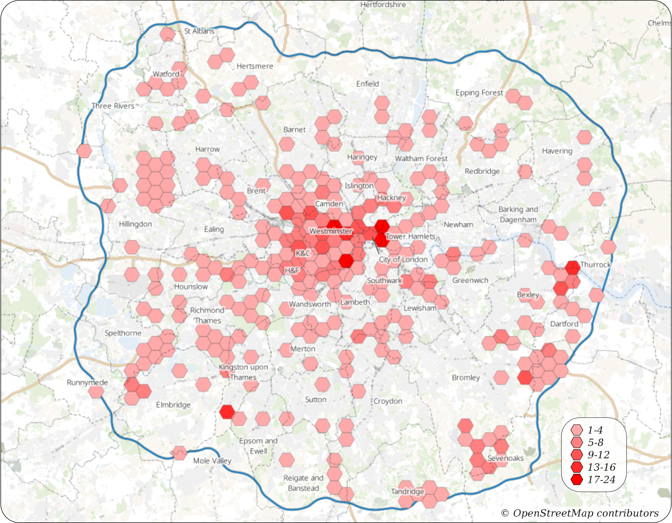

Maps are made up of layers, just like you’d see in a graphics editor. Well, unlike graphics editors, there *are* extra rules that allow parts of a layer to jump on top of others. More on that later… but for the most part, it’s just layer stacked on top of layer.

The map maker’s (my) aim for this map was to highlight the varying distribution of places where cycling is forbidden in London. I chose this as it was a fairly easy dataset to extract from OpenStreetMap. It’s easy to read too much into this map as it doesn’t factor population density into account, but it’s a nice dataset to play with.

So what’s in this specific map? Well, it’s made up of five layers:

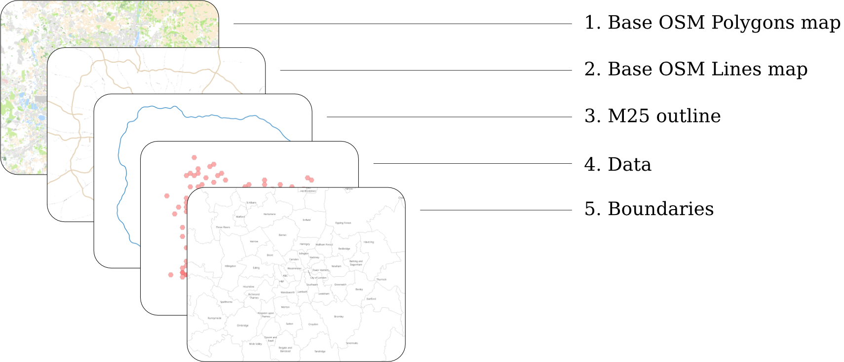

The two layers at the back (1 and 2) combine to create the underlying map. By the time this OpenStreetMap data arrives at QGIS, there are actually four sets of data that I could have used:

* **OSM Polygons** (Forests, buildings, river extents, residential areas…)
* **OSM Lines** (Roads, rivers, fences…)
* **OSM Roads** (Road names)
* **OSM Points** (Town names, churches, fire stations, post offices, bus stops…)

As the focus of this map is the data hexagons, not the underlying background map, I didn’t use the OSM Roads and OSM Points datasets, as that just added cognitive noise to the background. I had to desaturate the OSM Polygons layer quite a bit too to stop it popping out for attention.

Actually, there are two ways to get OpenStreetMap data into QGIS. The easy (but not very flexible way) is to use OpenStreetMap’s XYZ raster tiles. This will give you the equivalent of the OpenStreetMap slippy-map. The upside is it’s easy to set up and very quick to render. The downside is that you have no control over how the map looks. The tile you get is the tile you see. When I first started mapping, I found it a great way to try things out and learn QGIS without setting up anything else.

If you want more control over how your OpenStreetMap map looks, you need to download the data yourself into a Postgres database and give QGIS access to it. Here’s how it works:



Install the latest version of Postgres. Connect into it and create a new database. Log into the new database and install the PostGIS extensions into it. Then create a normal Postgres user that can access this database with read/write permissions.

Download the osm2pgsql tool. It runs on any modern operating system.

Use Geofabrik’s download server to download the latest “England” .pbf file. Run osm2pgsql to ingest it into your Postgres database. This might take some time. If you want to lower the amount you download or need to keep your database memory footprint low, you could download just the “London” and “South East” .pbf files and ingest both of them.

In QGIS, add a new PostGIS connection into your database. From here you can drag the OSM data into new layers. This is what you’ll end up with if you drag the *planet_osm_polygon* dataset into a layer:

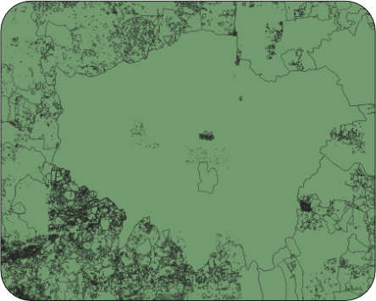

Well, it’s London-shaped, but is missing the styling. Clone GitHub user yannos’s “Beautiful OSM in QGIS” styling repository: <https://github.com/yannos/Beautiful_OSM_in_QGIS> and follow the instructions to apply this styling to your *planet_osm_\** layers.

For this map I lowered the saturation just a bit too. Success!

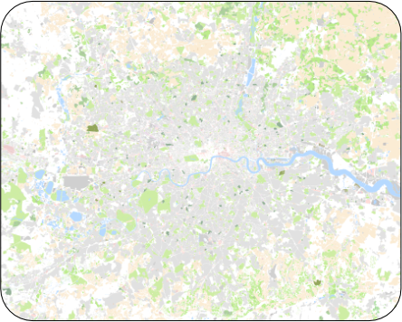

It can take a bit of time to render the OSM layers — there’s a lot of data there! On my Intel-i5 laptop it takes about 20 seconds. On my old Intel-M laptop, it took a *very* long time. By the way, it is possible to avoid Postgres entirely and use OSM data directly with shapefiles (another GIS standard file format) on your hard drive, but the rendering performance of these is terrible. Much better to get a database set up to do all the heavy lifting.

Next up is the outline of the M25 motorway. For the reader of the map, this helps define the scope of the data presented. For the map maker, it’s useful too, as we use its shape to filter away all the places where cycling is forbidden outside of London (because for this map, we’re only interested in the data inside the M25).

To get this polygon, we need to download the entire M25. You can use the OpenStreetMap web map’s data layer (or the brilliant map editing tool JOSM) to find how OpenStreetMap defines the M25. [To save you time, it’s a relation called “M25 motorway”]. Then use the overpass-turbo API (<http://overpass-turbo.eu/>) to download all OpenStreetMap objects that have this “M25 motorway” relation as a GeoJSON file.

Loading this file into QGIS, we need to do a bit of a manual tidyup, as we want a single, filled polygon. There are two problems with the M25 as we’ve downloaded it:

* It isn’t actually a complete ring around London (gasp!)
* It has two lines within it (the clockwise and anticlockwise carriageways) rather than just one.

QGIS can do its best to create a filled polygon, but doesn’t get it right until you fix these issues. So use QGIS’s Processing/Lines to Polygons function and then delete the inside (anticlockwise) lane.

This is what we’ll end up with:

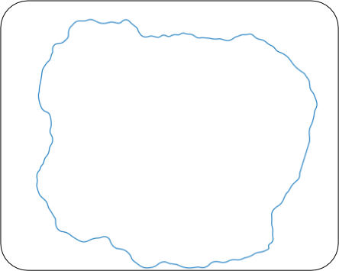

Layer 4 is the data layer. It looks like a sparsely populated grid of hexagons, but there are actually hexagons covering the whole of London, you just can’t see them all. We use the magic of QGIS’s “Graduated symbology” to set the colour of polygons with data underneath them and hide all the others. Here’s how it’s done:

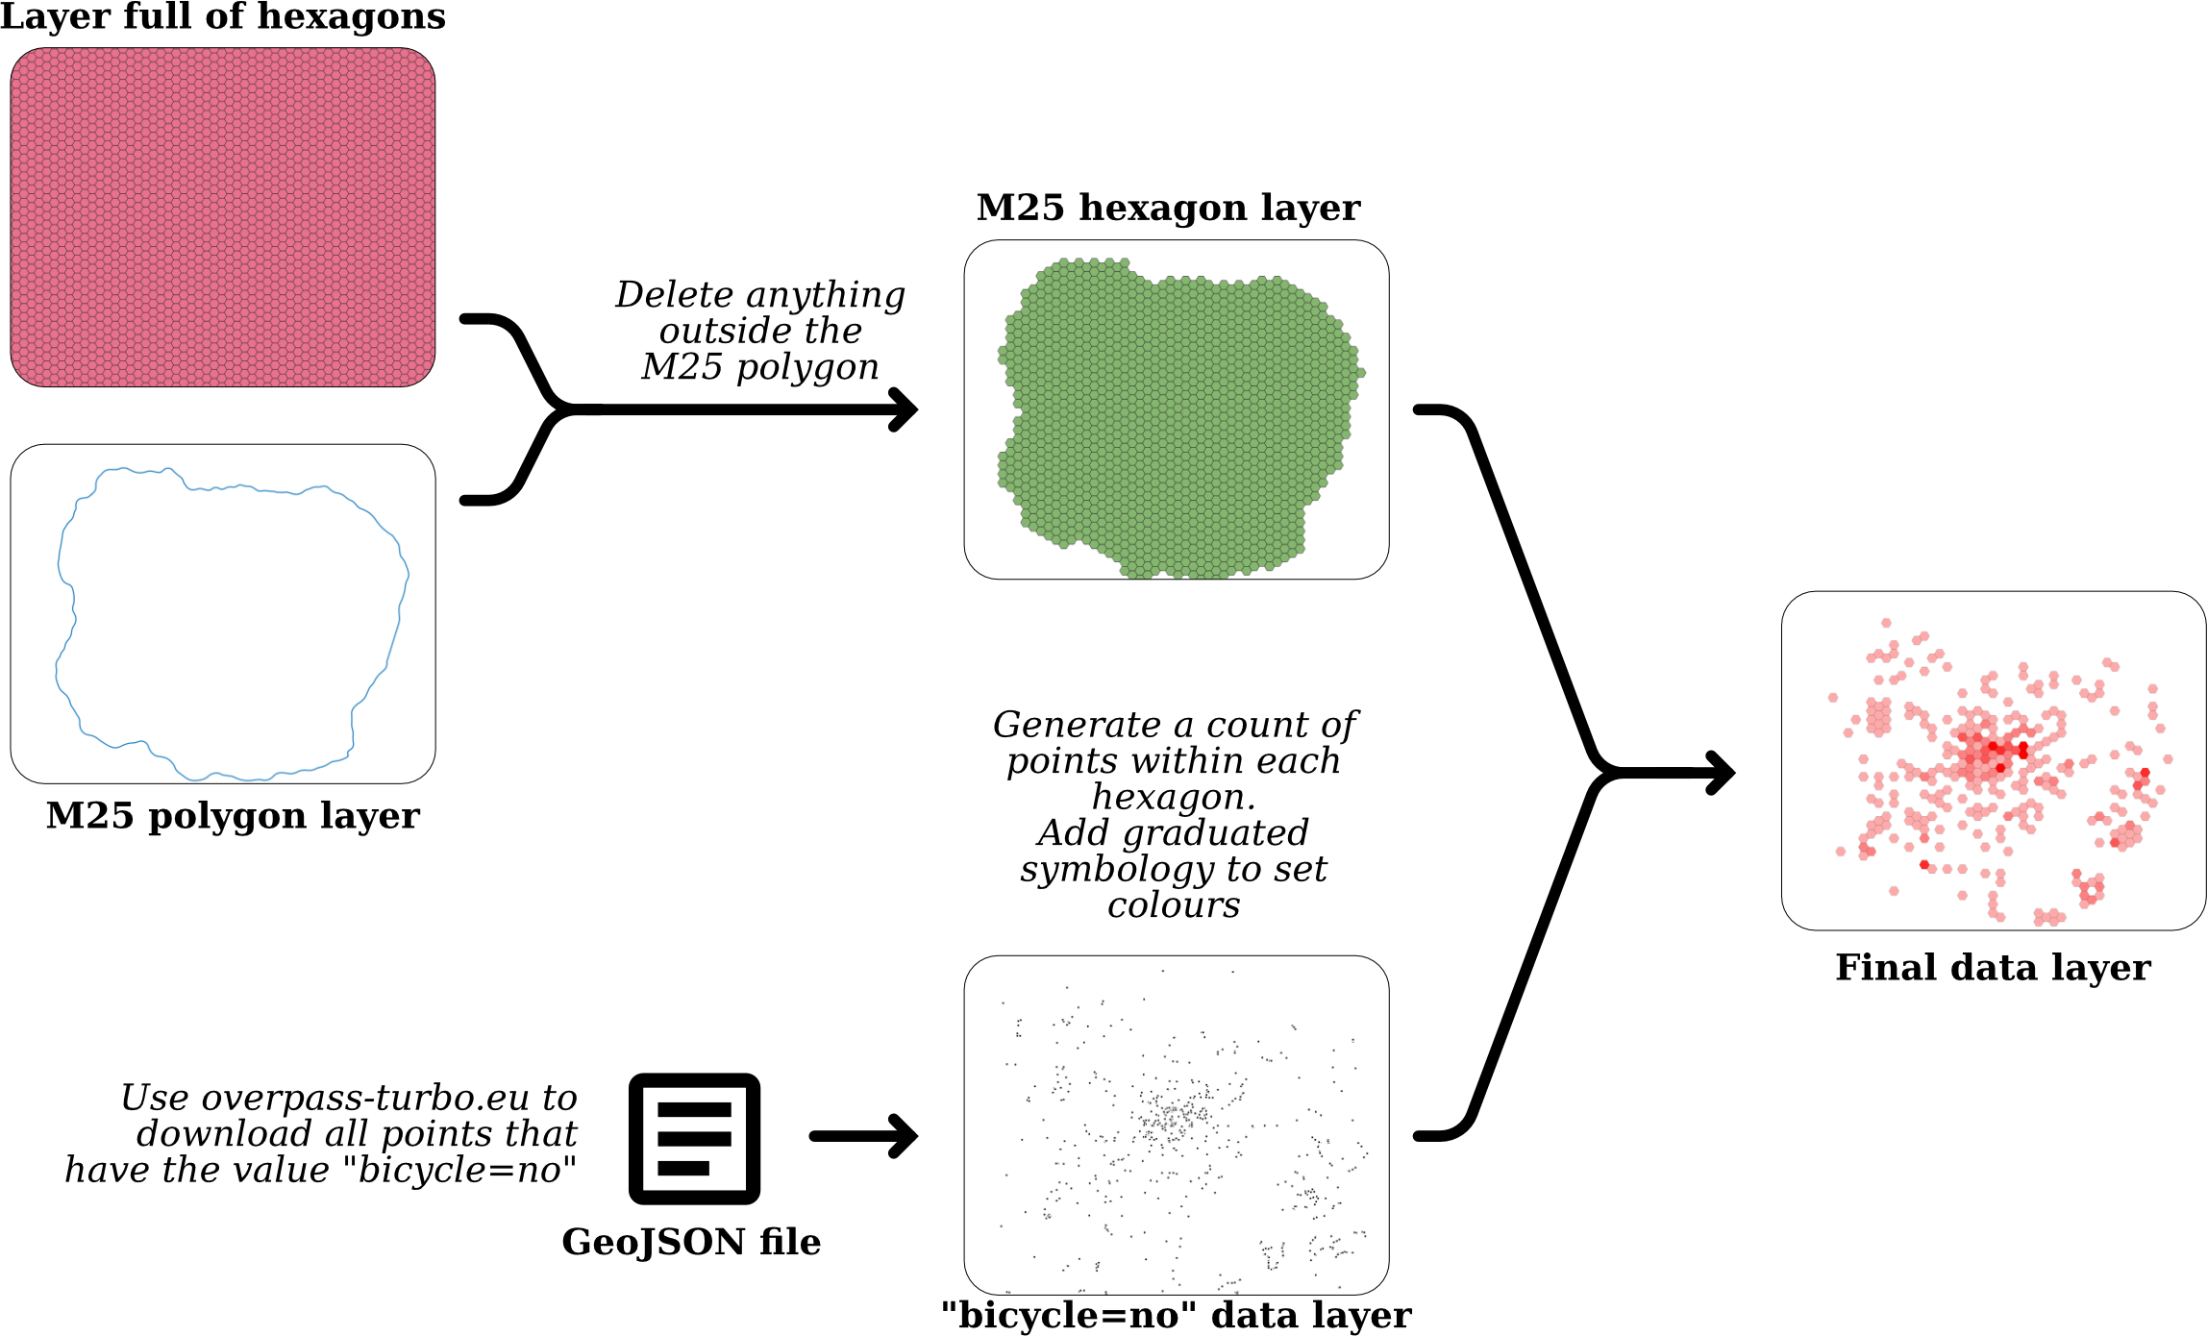

First off, we need hexagons. Lots of them. We can use the QGIS plugin MMQGIS to create a sea of hexagons covering the entire map.

Now we need to remove all the hexagons outside the M25. We could do this by hand, however QGIS has a great set of selection tools, so we just use QGIS’s vector research tools to select all hexagons that are within the M25 polygon. Then we copy/paste those hexagons into a new layer and delete the original hexagon layer. There are a few hexagons that have a tiny part inside the M25 but are mostly outside – delete these manually as you see fit.

Now that we have hexagons all over London, we need to give them data. At the moment they’re just hexagons with no idea what’s going on.

To get that data, we can filter it directly out of OpenStreetMap using the Overpass Turbo API. You could probably do the same by querying the data you have in your Postgres database, but the Overpass Turbo API makes it nice and easy.

Using <http://overpass-turbo.eu/> we can request all data points for a given region that have the key/value pair of “bicycle=no” as a GeoJSON file. Here’s what “bicycle=no” means: <https://wiki.openstreetmap.org/wiki/Tag:bicycle%3Dno>. To learn more about OpenStreetMap features, have a dive into <https://wiki.openstreetmap.org/wiki/Map_Features>.

Once the GeoJSON file has downloaded, drag and drop it into QGIS, and it will appear as a new layer. Go back and select your London Hexagons layer and use QGIS’s vector analysis tool to count all the datapoints within each polygon. Now each one of your hexagons will know how many “bicycle=no” points are within it. You can see this by opening up the Attribute Table:

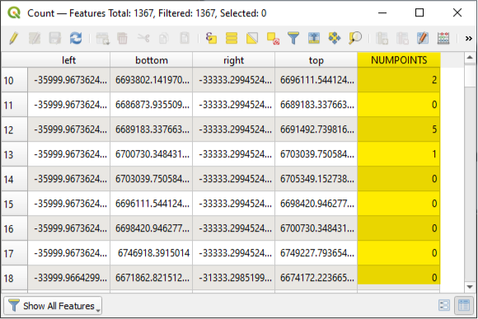

Set the Symbology of your hexagon layer to represent these values. Set the colours as you see fit, and set the opacity of any hexagon with “NUMPOINTS=0” to zero to hide them away. Success! You have your data layer.

The final steps are to tweak how the layers are rendered. It turns out that by default, OSM styles river names so that they push in front of all map layers, looking peculiar floating in front of the data hexagons. As we don’t need river names, we can simply deactivate them.

The last layer is a bit easer to create. Head over to statistics.gov.uk and download the latest local authority boundaries data (<https://geoportal.statistics.gov.uk/datasets/local-authority-districts-december-2019-boundaries-uk-bfe-1/data>) as a GeoJSON file. Import this into QGIS, adjust the transparency and line types. Add legends based on the “LAD19NM” field and tweak how the text looks until you’re happy. You may need to manually nudge some of the legends as it gets quite snug with boroughs the closer you get to the centre of town!

Once you have your map looking as you wish, you can export it out as a PDF or SVG file. QGIS doesn’t shine at this layout exporting, so you may need to do add in titles, legends and attributions using the vector editor of your choice. I use Affinity Designer as it’s cheap (about £50), filled with functionality but most important of all, great fun to use. I’m sure you can get the equivalent results with the Gimp and/or Inkscape.

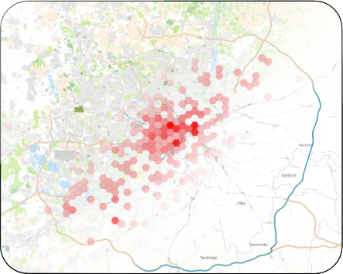

I hope that you have found this interesting. There’s a lot of detail covered, but also a whole layer of additional detail missed out, just to make this article a reasonable-length. You can find out more by watching YouTube tutorials on QGIS. That, combined with a healthy amount of Googling should put you in good stead.

To end, here’s the full tool chain that I use to create maps. Happy mapping!

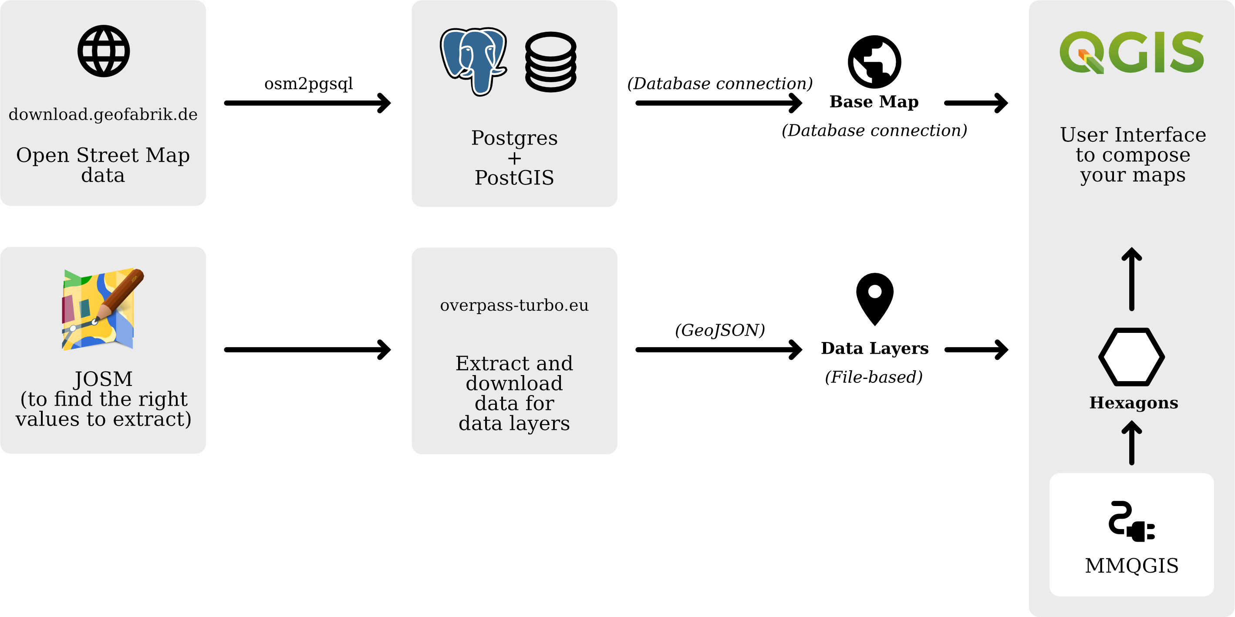

Are you a GIS expert with suggestions to improve this map making process? I’d love to hear from you.