
Ho Chi Minh City, December 2025
Instructor: Đo Nhu Tai
Students:
Pham Thanh Phong – 3122411151
Tran Huu Nam - 3122411131
Topic: Clothing Sales Website
PROJECT
SOFTWARE TESTING
(1st semester / 2025-2026)
FACULTY OF INFORMATION TECHNOLOGY

SAIGON UNIVERSITY

DECLARATION
Our group hereby declares that the course project Software testing with the topic “Software testing for a clothing sales website” is a research product directly carried out by our group during the study process, under the guidance of the lecturer in charge of the course.
The content of the project is developed based on the application of theoretical and practical knowledge learned about software testing, system requirements analysis, and software quality assurance. Our group proactively studied the business operations of the clothing sales website, designed test scenarios, performed functional testing, and seriously summarized the results.
All data, evaluation results, illustrative images, and comments in the project accurately reflect our group’s implementation process and are not copied from previously published works. Our group takes full responsibility if there are any violations related to academic ethics, copyright, or the integrity of the report content.
Through this project, our group aims to consolidate and enhance understanding of the practical software testing process, especially for e-commerce systems, thereby drawing necessary experience to serve future study and work.
Our group sincerely thanks the supervising lecturer TS. Đo Nhu Tai for always paying attention, guiding, and supporting our group throughout the project implementation process.

Table of Contents
DECLARATION i
INTRODUCTION vi
CHAPTER 1: OVERVIEW OF THE TOPIC 1
1.1 Topic description 1
1.2 Current situation survey 1
1.2.1 Business process 1
1.3 Implementation plan 2
1.3.1 Scope 2
1.3.2 Testing strategy 3
1.4 User Requirement 4
1.4.1 Functional requirement 4
4.2 Non-functional requirements 6
1.5 Testing objectives 7
CHAPTER 2 BUSINESS ANALYSIS AND ARCHITECTURE DESIGN 8
2.1 Business analysis 8
2.1.1 Business context 8
2.1.2 Business process diagram 10
2.1.3 Actors participating in the system 15
2.1.4 Context diagram 16
2.1.5 System use case 16
2.1.6 User story 23
2.1.9 Wireflow 28
2.1.10 Interface 30
2.2 System architecture design 38
2.2.1 Block diagram 38
2.2.2 Decomposition View 38
2.2.3 Communication view 44
2.2.4 Deployment view 45
CHAPTER 3: TEST PLAN 48
3.1. Introduction 48
3.1.1. Purpose 48
3.1.2. Scope 48
3.2 Testing Items within Scope 49
3.2.1 Backend API Testing 49
3.2.2. Frontend Testing 50
3.2.3 Database Testing 51
3.2.4. Integration Testing 51
3.2.5 Non-Functional Testing 52
3.3. Out-of-Scope Test Items 52
3.3.1. Functions Not Included in Scope 52
3.3.2. Testing Limitations within the Project Scope 53
3.4. Testing Methodology 53
3.4.1. Overall Methodology Framework 53
3.4.2. Testing Levels 54
3.4.3 Types of Testing 56
3.4.4. Test Case Design Techniques 57
3.5 Testing Strategy 58
3.5.1 Overall Strategy 58
3.5.2 Component-level Strategy 58
3.5.3. Test Automation Strategy 60
3.5.4. Test Data Management Strategy 61
3.6. Resources 61
3.6.2. Test Schedule 61
3.7. Test Environment 62
3.7.2. Software 62
3.7.3. Infrastructure 63
3.8. Deliverables 64
Chapter 4: TEST DESIGN 64
4.1. INTRODUCTION 64
4.2. TEST DESIGN PROCESS USING V-MODEL 65
4.2.1. Requirements Analysis - Acceptance Testing 65
4.2.2. System Design - System Testing 66
4.2.3. Architectural Design - Integration Testing 66
4.2.4. Module Design - Unit Testing 66
4.2.5. Code Execution - White-Box Testing 66
4.2.6. V-Model Process Summary 66
4.3. TEST DESIGN TECHNIQUES 67
4.3.1. Black-Box Testing 67
4.3.2. White-Box Testing 69
4.4. TEST DESIGN AND IMPLEMENTATION METHODOLOGY 73
4.4.1. Manual Testing 73
4.4.2. Automated Testing 74
4.5. APPLYING GENAI IN TEST CASE DESIGN 77
4.5.1. GenAI Application Process 78
4.5.2. Example of Applying GenAI to the Login Function 78
4.5.3. Editing and Finalizing 80
4.5.4. Benefits and Limitations 80
4.5.5. Application Results 80
Chapter 5: TEST REPORT 80
5.1. Test Process Overview 80
5.2. Test Case Report 81
5.2.1. Introduction 81
5.2.2. Coverage Scope 81
5.2.3. Execution Results 82
5.3. Bug Report 82
5.3.1. Bug Classification by Severity Level 82
5.3.2. Bug Statistics 83
5.3.3. Defect Handling Process 84
5.4. CI/CD Pipeline Execution Results 85
5.5. Quality Assessment and Conclusion 85
5.5.1. Quality Assessment 85
5.5.2. Lessons Learned 86
REFERENCES 87

INTRODUCTION
In the context of strong information technology development, e-commerce is increasingly playing an important role in economic life. Online sales websites not only help businesses reach customers quickly and conveniently but also provide flexible shopping experiences for consumers. In particular, the fashion and clothing business sector is one of the industries with a high level of competition and is strongly influenced by user experience on digital platforms. Therefore, ensuring the quality and stability of e-commerce websites is an extremely necessary requirement.
Software testing is an important stage in the software development life cycle, aiming to detect defects, evaluate the level of requirement fulfillment, and ensure that the system operates as expected. For a clothing sales website, functions such as registration, login, product search, category filtering, ordering, payment, and order management need to be thoroughly tested to minimize incidents that may affect user experience and business reputation. A system may have a beautiful interface, but if it contains many functional errors, it is still difficult to meet the actual needs of customers.
Stemming from this importance, our group chose the topic “Testing Website selling clothes” for the software testing course project. The objective of the project is to apply the knowledge learned about software testing, requirement analysis, and test case design to evaluate the quality of a real e-commerce website. Through business analysis, identification of main functions, and testing implementation, our group hopes to detect potential defects, thereby providing appropriate comments and improvement suggestions.
During the implementation of the project, our group conducted an overall study of the system, built functional testing scenarios, performed testing on the core functions of the clothing sales website, and summarized the obtained results. In addition, our group also referred to documents, textbooks, and reliable information sources to ensure the scientific nature and accuracy of the report content. Although there are still many limitations in experience and time, our group made efforts to complete the project with a serious attitude.
Through this project, our group not only consolidates theoretical knowledge about software testing but also has the opportunity to approach the testing process in a real environment, thereby enhancing analysis, evaluation, and teamwork skills. This is also an important foundation that helps our group better prepare for specialized courses as well as future work in the field of information technology.

CHAPTER 1: OVERVIEW OF THE TOPIC

1.1 Topic description
The topic “Software testing for a clothing sales website” focuses on researching, analyzing, and evaluating the quality of an online clothing sales website through software testing techniques. The e-commerce website within the scope of the topic plays the role of an online sales system, allowing users to perform basic functions such as viewing product categories, searching and filtering products by multiple criteria, viewing product details, placing orders, making payments, and tracking order status.
The main content of the topic is to perform functional testing on the core functions of the clothing sales website in order to determine the level of business requirement fulfillment and detect errors that may occur during use. Based on the analysis of system requirements, the group conducts the development of testing scenarios, designs appropriate test cases, and performs testing on each specific function of the system.
In addition, the topic also considers factors related to user experience and system stability, including checking the purchasing workflow, the consistency of displayed data, error handling capability, and system responses when users perform invalid operations. The testing results are recorded, summarized, and analyzed to evaluate the overall quality of the website.

1.2 Current situation survey

1.2.1 Business process
Product browsing and selection process:
The buyer accesses the website and browses clothing product categories by type, brand, or through the search function. The system allows filtering and sorting products according to different criteria. When selecting a product, the buyer can view detailed product information including images, description, size, selling price, available stock quantity, and previous reviews, thereby deciding whether to make a purchase.
Shopping cart processing process:
The buyer can add products to the shopping cart from the product list or the product detail page. The shopping cart displays the list of selected products, quantities, selling prices, and the total order value. The buyer is allowed to adjust quantities or remove products from the cart, and the system automatically updates the total amount. Before payment, the system checks stock quantities to ensure sufficient availability to fulfill the order.
Order placement process:
When the buyer clicks the “Payment” button, the system checks the cart and revalidates the stock quantity of each product. If the information is valid, the system requests the buyer to enter or confirm shipping information including full name, phone number, and delivery address. After that, the buyer selects a payment method and confirms the order.
Payment and order processing workflow:
Cash on delivery (COD): After the buyer confirms the order, the system creates an order with the status “Pending processing”. Store staff receive the order, prepare and pack the goods, then create a delivery order through the GHN API. The system stores the GHN tracking code and updates the order status to “Waiting for pickup”. When GHN updates the status to “Successfully delivered”, the system automatically changes the order status to “Completed”.
Online payment via VNPAY: After confirming the order, the system redirects the buyer to the VNPAY payment gateway. Upon receiving a successful payment response, the system updates the order status to “Paid – In delivery”. Store staff continue to pack the goods and create a delivery order via GHN. The delivery status update process is sent back to the system by GHN. When the order is successfully delivered, the order status is changed to “Completed” and the system sends a confirmation notification to the buyer.
Product review and customer feedback process:
After receiving the goods, the buyer can rate the product on a scale from 1 to 5 stars and submit comments. The reviews are displayed on the product detail page. In case of feedback or complaints, the administrator receives and handles exchange or refund requests according to the store’s policyng.
System administration process:
The administrator accesses the administration interface to manage products, orders, inventory, promotional programs, and monitor revenue reports.

1.3 Implementation plan

1.3.1 Scope
This document serves as the basis for performing testing, acceptance, and evaluation of the project “Website selling clothes”. The testing scope focuses on checking the main functions and features of the website, including the purchasing business workflow, user interface, and the validity of data as well as the system database.

1.3.2 Testing strategy
Personnel assignment
No. | Performer | Role | Specific tasks
1 | Tran Huu Nam | Tester/Developer | Create testing plan  Perform system testing  Write CI/CD code in GitHub Actions  Document testing materials
2 | Pham Thanh Phong | Tester/Developer | Design Test Case  Perform unit testing and integration testing  Create review checklist  Document testing materials

Testing environment
Purpose | Components
Browser environment | Chrome, Firefox
Frontend | Vite, ReactJS, TypeScript
Backend | Spring Boot, Maven
Source code management | GitHub
CI/CD | GitHub Actions
Deployment on Production environment | Frontend và Backend, Database MySQL được deploy trên railway

1.4 User Requirement

1.4.1 Functional requirement
Requirement ID | Requester | Requirement description | Priority
BR1 | Administrator (Admin) | Manage users in the system | High
BR1.1 | Administrator | Add, edit, delete user accounts (customer, saler) | High
BR1.2 | Administrator | Assign user roles: Admin, User, Saler | High
BR1.3 | Administrator | Lock / activate accounts when necessary | Medium
BR2 | Administrator | Product  management | High
BR2.1 | Administrator | Add, edit, delete products (name, price, description, images, quantity, brand, category) | High
BR2.2 | Administrator | Manage categories, brands, topics | Medium
BR2.3 | Administrator | Manage promotions, banners, news posts | Medium
BR3 | Customer (User) | Register, log in, log out of account | High
BR3.1 | Customer | Search, view product details | High
BR3.2 | Customer | Add/remove products in shopping cart | High
BR3.3 | Customer | Place orders, choose payment method (COD or online) | High
BR3.4 | Customer | View order details, purchase history | High
BR3.5 | Customer | Comment on and rate products | Medium
BR3.6 | Customer | Update personal information, change password, forgot password | Medium
BR4 | Saler (Nhân viên bán hàng) | Manage goods import and suppliers | High
BR4.1 | Saler | Create and update goods receipt records | High
BR4.2 | Saler | anage supplier list (contact information, supplied products) | High
BR4.3 | Saler | View and confirm customer orders | High
BR4.4 | Saler | Message to support customers during ordering process | Medium
BR5 | Administrator | Statistics and reporting | High
BR5.1 | Administrator | Statistics on revenue, number of orders, best-selling products, traffic | High
BR5.2 | Administrator | Export reports by time, category, or staff | Medium
BR6 | All users | Messaging and notifications | Medium
BR6.1 | All users | Send/receive internal messages within the system | Medium
BR6.2 | All users | Receive notifications for new orders and promotions | Medium

4.2 Non-functional requirements
Requirement ID | Requester | Requirement description | Priority
NFR1 | User | Simple, intuitive interface, easy to use for all users | High
NFR2 | User | System response time does not exceed 3 seconds for each operation | High
NFR3 | Administrator | System has scalability when the number of users increases | High
NFR4 | Administrator | User information security (password encryption, no direct storage of card information) | High
NFR5 | Administrator | System operates stably across multiple browsers and mobile devices | High
NFR6 | Administrator | Data is automatically backed up periodically on a daily basis | Medium
NFR7 | User | Multilingual support (Vietnamese, English) | Low
NFR8 | User | Interface friendly for people with disabilities (clear fonts, alt text for images) | Low

1.5 Testing objectives
The objective of the topic “Software testing for a clothing sales WEBSITE” is to apply the knowledge learned about software testing to evaluate the quality of a real e-commerce website. Through the analysis of requirements and business processes, the topic focuses on building testing scenarios and test cases to detect defects and assess the level of functional requirement fulfillment of the system.
In addition, the topic aims to verify the correctness of the purchasing business workflow, the validity of data, and the website’s error handling capability in common situations. The testing results are summarized and analyzed to provide comments on system quality, while also proposing appropriate improvement directions.

CHAPTER 2 BUSINESS ANALYSIS AND ARCHITECTURE DESIGN

2.1 Business analysis

2.1.1 Business context
The clothing sales website has basic business scenarios for Product catalog, Shopping cart, Invoice, Payment process, Inventory management, Product review, and Access control.
With Product catalog, buyers can browse the product list with filtering and sorting functions by category, brand, and name search. When clicking on a product in the list, buyers can view product details including: name, images, description, promotional price, stock quantity, and reviews. Administrators in the system can manage products and categories.
With Shopping cart, buyers can add any product to the cart by clicking the add-to-cart icon on each product. In addition, users can access the product detail page and click the add to cart or buy now button. After adding products, the shopping cart displays the selected products along with a summary table, including subtotal and total order value. Buyers can increase or decrease quantities, remove products, or update directly on the shopping cart interface, and the system will automatically calculate and update the total order value. The shopping cart is stored long-term via cookies or sessions for buyers who are not logged in and stored persistently in personal accounts for logged-in buyers, allowing them to return and continue shopping later. Before buyers proceed to checkout, the system rechecks the actual stock quantity of each product in the cart. If a product is out of stock or insufficient in quantity, the system notifies the buyer to update the cart before continuing. Buyers perform the checkout process by clicking the Payment button on the shopping cart page.
With Payment process, after the Buyer clicks Payment (Checkout), the system verifies product information, order details, and shipping address. When the information is valid, the system automatically creates a new order and records the initial status as “Pending processing”. The system supports two main payment methods: Cash on delivery (COD) and Online payment via VNPAY.
With Cash on delivery (COD), buyers only need to confirm the order and do not need to pay immediately. Store staff receive notifications of new orders, prepare and pack goods, then create shipping orders through the API of a third-party logistics provider. The system records the tracking code, shipping provider, and initial status as “Waiting for pickup”. When the logistics provider updates the status to “Successfully delivered”, the system automatically updates the order status to “Completed”, recording the successful delivery time and the responsible staff member.
With Payment via VNPAY, after buyers confirm the order, the system redirects to the VNPAY payment gateway to perform the electronic transaction. When payment is successfully confirmed by VNPAY, the system updates the order status to “Paid – In delivery” for the buyer. Store staff then prepare and pack the goods and create a shipping order through the logistics provider’s API. The logistics provider receives and updates delivery status through the system. When the order is successfully delivered, the status is automatically changed to “Completed”, the system records the completion time, and sends a delivery success confirmation email to the buyer.
When the order is completed, the system automatically deducts the corresponding stock quantity, records the transaction in the sales database, and stores payment information for reconciliation and revenue reporting. SysAdmin can look up, update, and monitor all customer orders.
With Inventory management, SysAdmin can manage inventory, including updating stock quantities, managing warehouses, and generating statistics of products by warehouse. The system also provides reporting and statistics functions for revenue, best-selling products, inventory levels, and successful order rates, helping administrators monitor business performance over different periods.
With Product review, buyers after receiving goods can rate products on a 1–5 star scale and submit comments. These reviews are displayed on the product detail page, supporting subsequent buyers in decision-making. In addition, the system supports buyers in submitting feedback or complaints related to orders. Administrators can receive and process return, exchange, or refund requests according to policy.
With Marketing and news, the system allows admin to create and manage Blog posts to attract customers. At the same time, Admin manages the Voucher system (discount codes), sets validity periods, quantity limits, and discount levels to stimulate purchases.
With Access control, the system allows buyers to log in when necessary to manage personal information and track orders. However, for buyers who have previously transacted (member), the system can automatically recognize information without requiring re-login. Administrators (SysAdmin), as operators and managers of the internal system, access the administration interface directly through the store’s internal network, without performing the login process in the normal business workflow.
Some one-time tasks need to be performed when accessing the clothing sales website during initial setup: creating a SysAdmin account, two sample Buyer accounts, and sample data for products, inventory, and reviews for some products.

2.1.2 Business process diagram
This section describes the core business processes of the e-commerce system in the KTPM project (React.js frontend, Node.js/Express backend, MySQL). The diagrams are presented in the direction of “actor – processing step – decision point – outcome”, thereby clarifying the main flow and exception branches that need attention when designing testing in later chapters.
In the project, the processes are implemented through backend API groups: shopping cart (/api/add-shopcart, /api/get-all-shopcart-by-userId, /api/delete-item-shopcart), order & payment (/api/create-new-order, /api/payment-order, /api/payment-order-success, /api/payment-order-vnpay, /api/vnpay_return, /api/confirm-order), and administration APIs (attached with authorization middleware verifyTokenAdmin, verifyTokenAdminOrUser). The full endpoint list is managed at ecomAPI/src/route/web.js.
2.1.2.1. Shopping cart processing process
The shopping cart process describes the typical behavior of customers from logging in, selecting products, adding them to the cart, and adjusting the cart before proceeding to order placement. This is a high-frequency and high-risk process (incorrect quantity, incorrect total amount, unsynchronized delete/adjust operations), therefore it is chosen as the foundational business flow for designing testing (Chapter 3–4) and summarizing results (Chapter 5).
- Primary actor: Customer
- Precondition: Customer has logged in and has a valid token
- Expected output: Shopping cart list is correct per user; add/delete/adjust operations are correctly reflected after reload
*Main processing flow:
- Customer logs into the system
- Customer browses/searches products and views product details
- Customer selects “Add to cart”. Backend records the item into the cart (API: POST /api/add-shopcart)
- Khách hàng truy cập màn hình giỏ hàng để xem danh sách item hiện có (API: GET /api/get-all-shopcart-by-userId)
- Customer accesses the shopping cart screen to view the current item list (API: GET /api/get-all-shopcart-by-userId)
- On the shopping cart screen, the customer decides whether to modify the cart:
- If yes: adjust quantity or delete products from the cart (API: DELETE /api/delete-item-shopcart)
- If no: proceed to the order placement step
- Customer clicks “Proceed to order” to move to the order placement and payment process
Exception branches and control points:
- Missing/invalid token: shopping cart APIs require authentication (verifyTokenUser)
- Invalid data (quantity, productId): the system needs to validate at the API/service layer
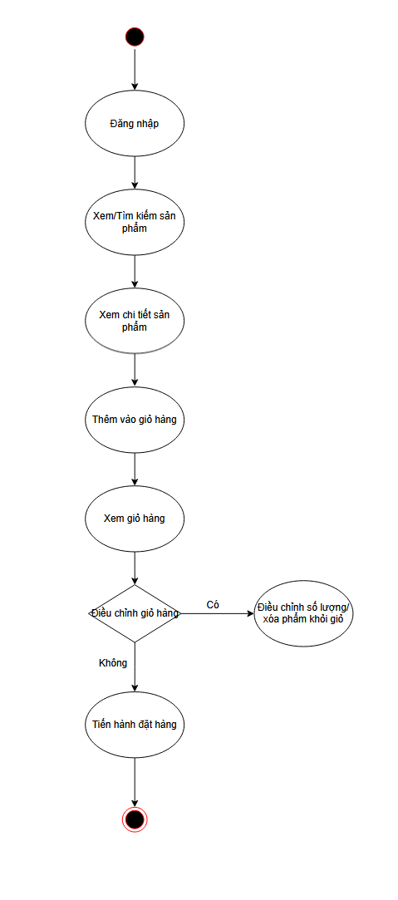
- UI ↔ API synchronization: after add/delete/adjust actions, the UI must reload or update state
Figure 2.1: Shopping cart processing ưorkflow diagram

2.1.2.2. Order placement and payment process
The order placement and payment process describes how the system transitions from the “shopping cart” state to the “order” state, while handling two common payment branches: COD and online payment (Paypal/VNPay). This process contains many decision points and integration points with third-party systems, therefore it is considered a high-risk business flow.
- Primary actor: Customer
- Secondary actors: Payment gateway, backend system
- Preconditions: Customer has logged in; has a valid shipping address; shopping cart contains products
*Main processing flow:
- Customer enters/selects shipping information (API: GET /api/get-all-address-user, POST /api/create-new-address-user)
- Customer selects a payment method.
- The system branches according to the selected payment method:
A. COD branch:
4. Customer confirms order placement
5. Backend creates the order (API: POST /api/create-new-order)
6. System checks conditions (address data, shipping fee, shopping cart)
7. If successful, customer receives confirmation (API: GET /api/get-all-order-by-user)
B. Online payment branch (Paypal/VNPay)):
4. Customer requests online payment initialization (API: POST /api/payment-order or POST /api/payment-order-vnpay)
5. Payment gateway generates a payment code (QR/redirect URL)
6. Customer performs payment
7. Payment gateway returns the result (API: POST /api/payment-order-success or POST /api/vnpay_return)
8. System branches based on the result:
- Failure: notify and allow returning to payment method selection
- Success: complete the order and update status (API: PUT /api/confirm-order)
Exception branches and control points:
Missing input data: validate at the service layer during order creation
Payment successful but order not completed: post-processing handling mechanism
GHN shipping webhook: endpoint POST /api/webhook/ghn receives delivery status updates
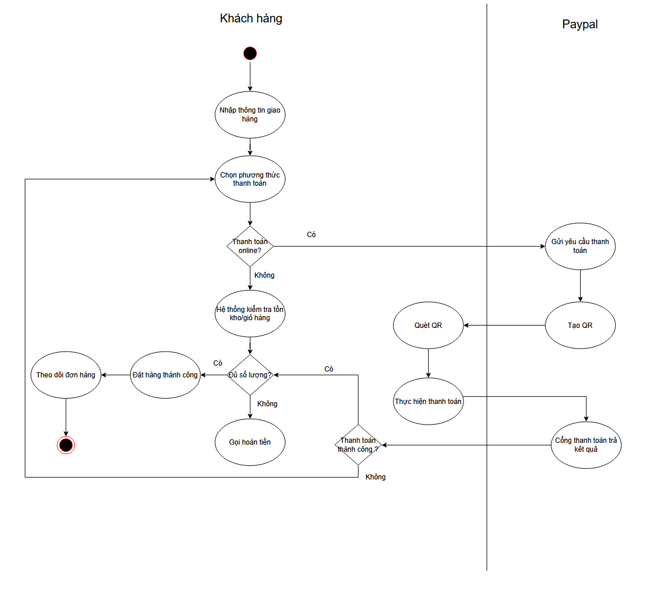
Figure 2.2: Order placement and payment process diagram

2.1.2.3. System administration process
The administration process describes the operations performed by administrators on management subsystems: user management, products, banners, shipping types, vouchers, orders, and statistics. The key point is authorization: only admin accounts are allowed to access administration APIs (middleware verifyTokenAdmin).
- Primary actor: Administrator
- Precondition: Logged in with an account having the admin role
*Main processing flow:
- Administrator logs into the system
- Administrator accesses the administration page and selects a management module
- Depending on the module, performs CRUD/search operations:
- User management (API: GET /api/get-all-user, DELETE /api/delete-user)
- Product management (API: POST /api/create-new-product, PUT /api/update-product)
- Banner, shipping type, voucher, blog, supplier management
- Order management (API: PUT /api/update-status-order, PUT /api/update-shipping-info)
- When processing online payment orders, if a “order cancellation/return” occurs, the system triggers the refund flow (API: PUT /api/update-refund-status)
Exception branches and control points:
- Insufficient permissions: middleware blocks requests if a normal user calls admin APIs
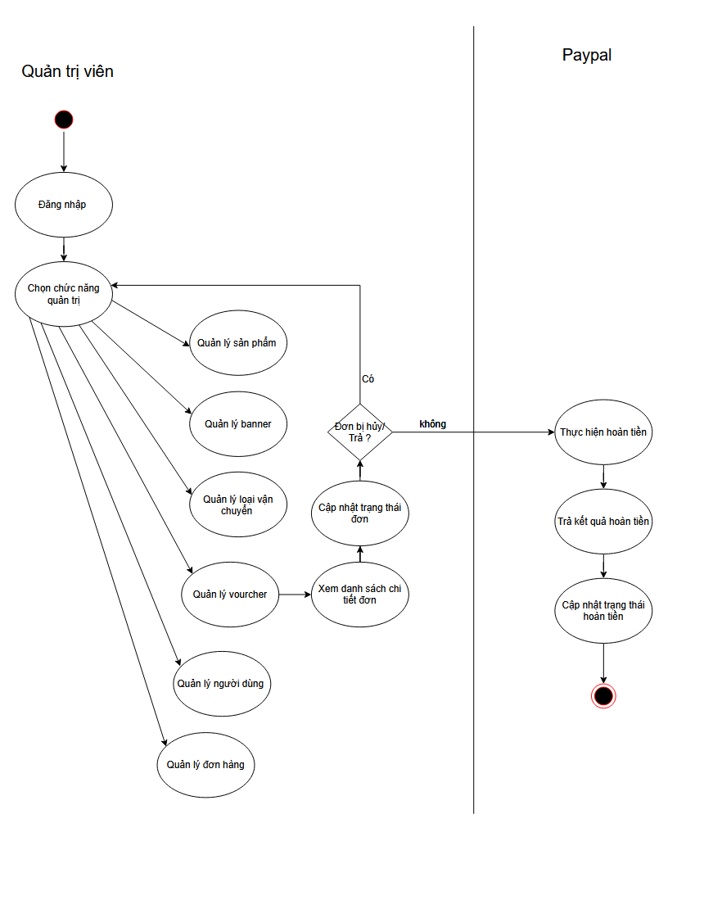
- State consistency: order status changes must comply with lifecycle rules

Figure 2.3: System administration process diagram

2.1.3 Actors participating in the system
Administrator has the highest authority in the system and is responsible for managing and operating the entire clothing sales website. Administrator has the right to manage users, assign access permissions, manage products, inventory, orders, configure the system, and monitor revenue reports.
Sales staff are internal actors of the system, responsible for handling order-related operations and supporting customers. Sales staff are provided with accounts with limited permissions and are only allowed to access and operate functions that support the sales process; they do not have system administration rights or user authorization permissions.
Customer is an external actor who uses the website to perform shopping activities such as viewing product categories, searching and viewing product details, adding products to the shopping cart, placing orders, selecting payment methods, tracking order status, and reviewing products after receiving goods. Customer can log in to manage personal information and purchase history.
Online payment gateways PayPal, VNPAY are third-party systems integrated into the website to support customers in making payments.
GHN is a third-party logistics provider integrated into the system to support delivery for online shopping orders.
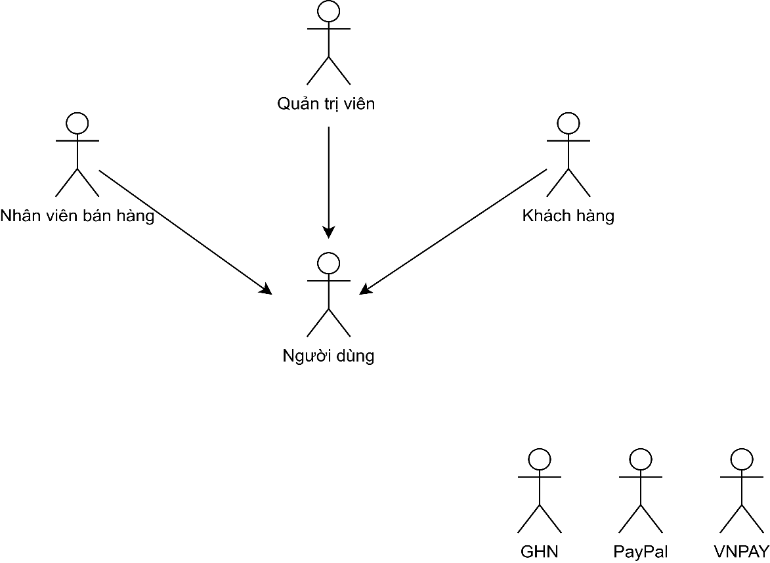
Figure 2.4: System participant actors diagram

2.1.4 Context diagram
Customer: Sends requests to view products, order information, and payment to the system. The system responds with the product list, order confirmation, and purchase history.
Staff: Provides inventory input data, supplier information, and updates order status. The system provides the list of orders to be processed and corresponding management data.
Administrator: Configures the system, manages users, and promotional campaigns. The system outputs revenue reports and statistics to support decision-making.
Integrated systems:
- Payment: The system sends payment requests and receives transaction results from the payment gateway.
- Shipping: The system sends delivery requests and receives tracking codes and shipping status from the express delivery provider (GHN).

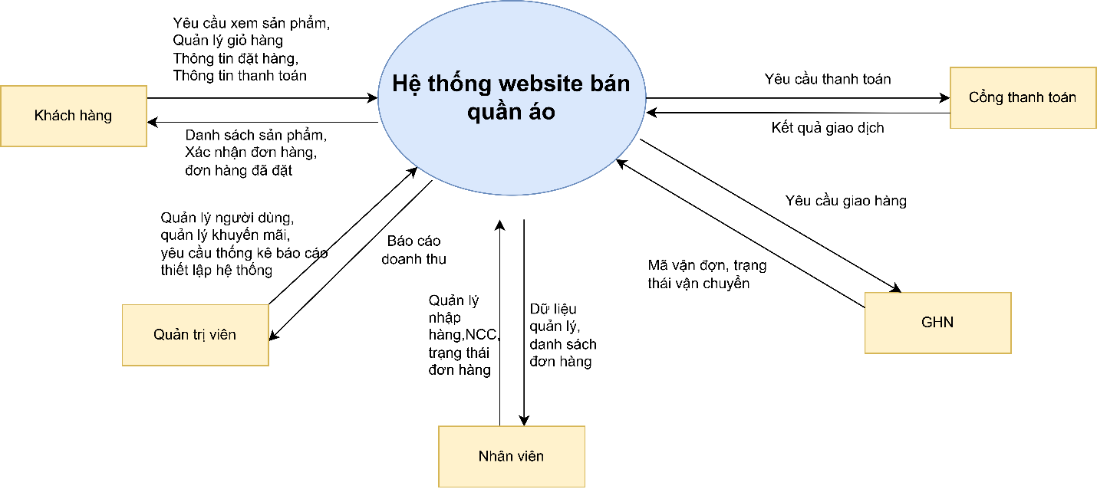
Figure 2.5: System context diagram

2.1.5 System use case
Use case summary
The diagram describes the main functions of the clothing shop management system, with the main actors being customer, sales staff, and administrator.
Customer mainly performs shopping cart management such as adding, editing, and deleting products in the cart.
Sales staff and administrator have access to most management functions: payment management, access control, product management, order management, post management, and reviews.
Administrator has the highest authority and can access all use cases.
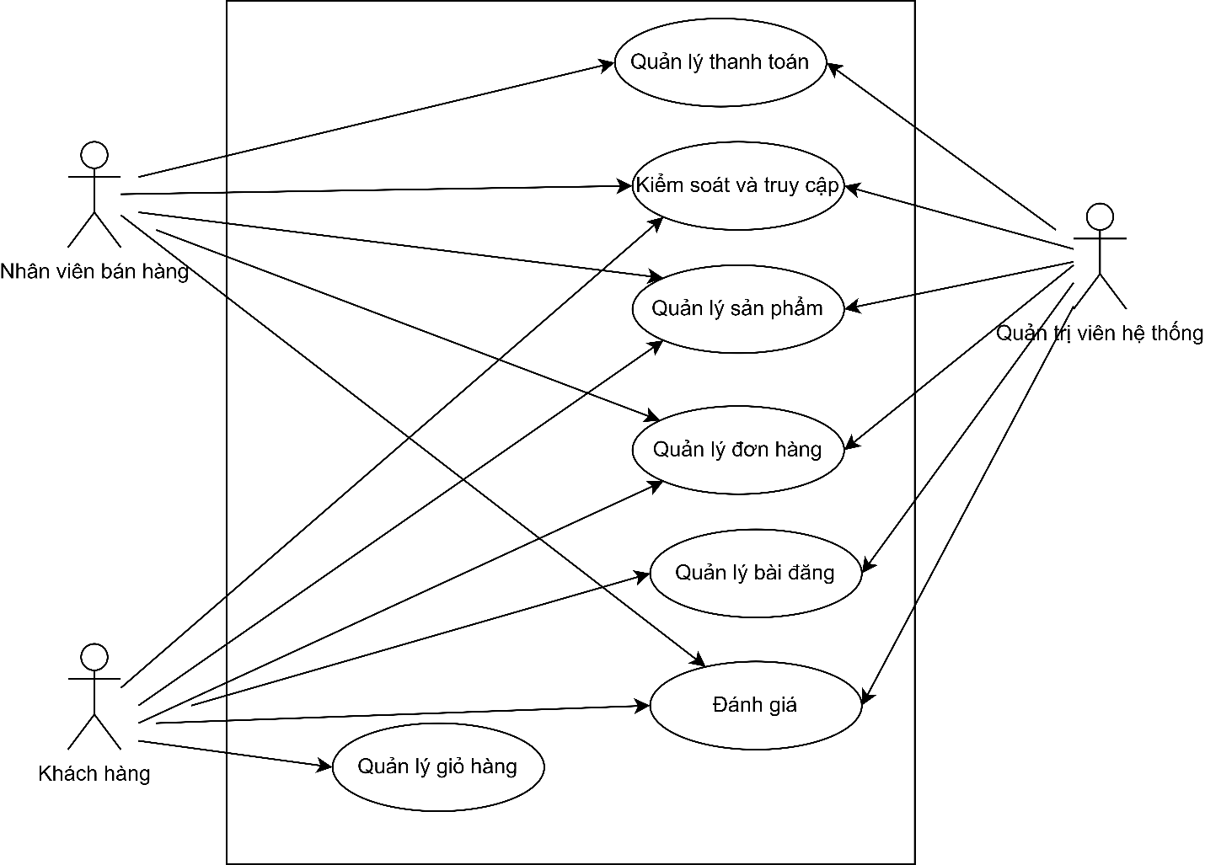
Figure 2.6: Use case summary diagram

UC1 Access control and authentication
The use case describes the main functions related to users including customer, staff, and administrator accessing the system.
System login is the core use case, including: access authorization, the system checks roles to grant appropriate permissions.
Forgot password users can recover their password if forgotten (optional).
Account registration requires OTP verification, sending an OTP code via phone number to confirm the new account.

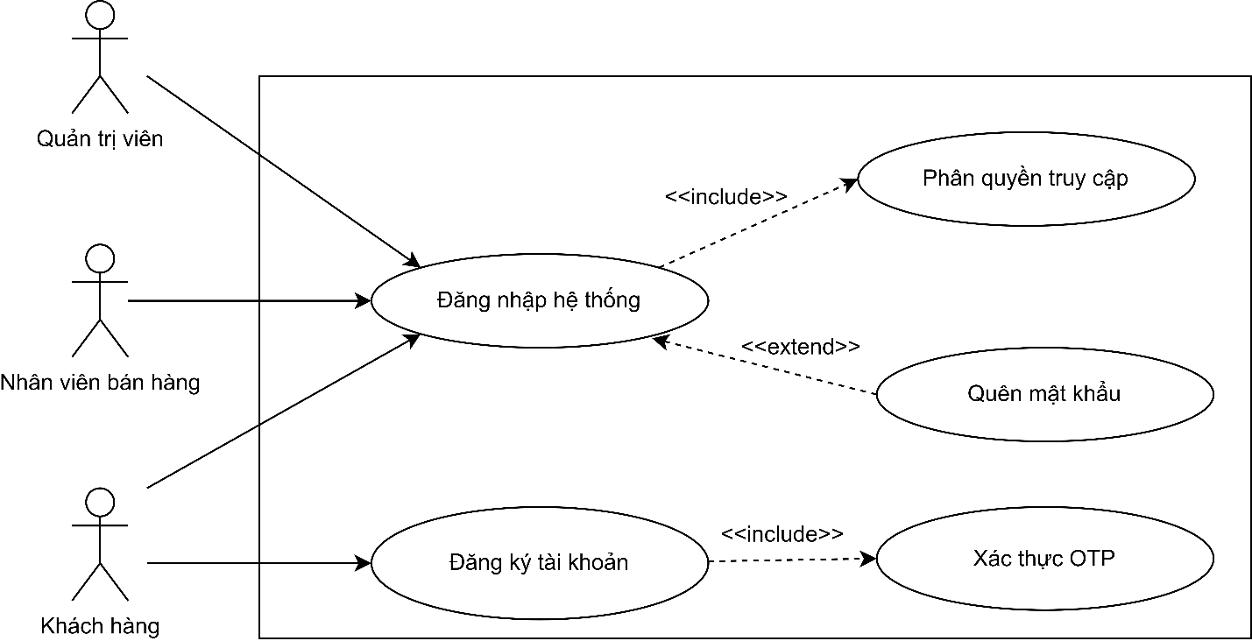
Figure 2.7: Use case control and access diagram

UC2 Product management
Administrator: Manage all products and goods import including suppliers, categories, and brands.
Customer: Search, filter, and view product details.
Sales staff: Manage products by adding, editing, deleting, updating, and managing goods import
.

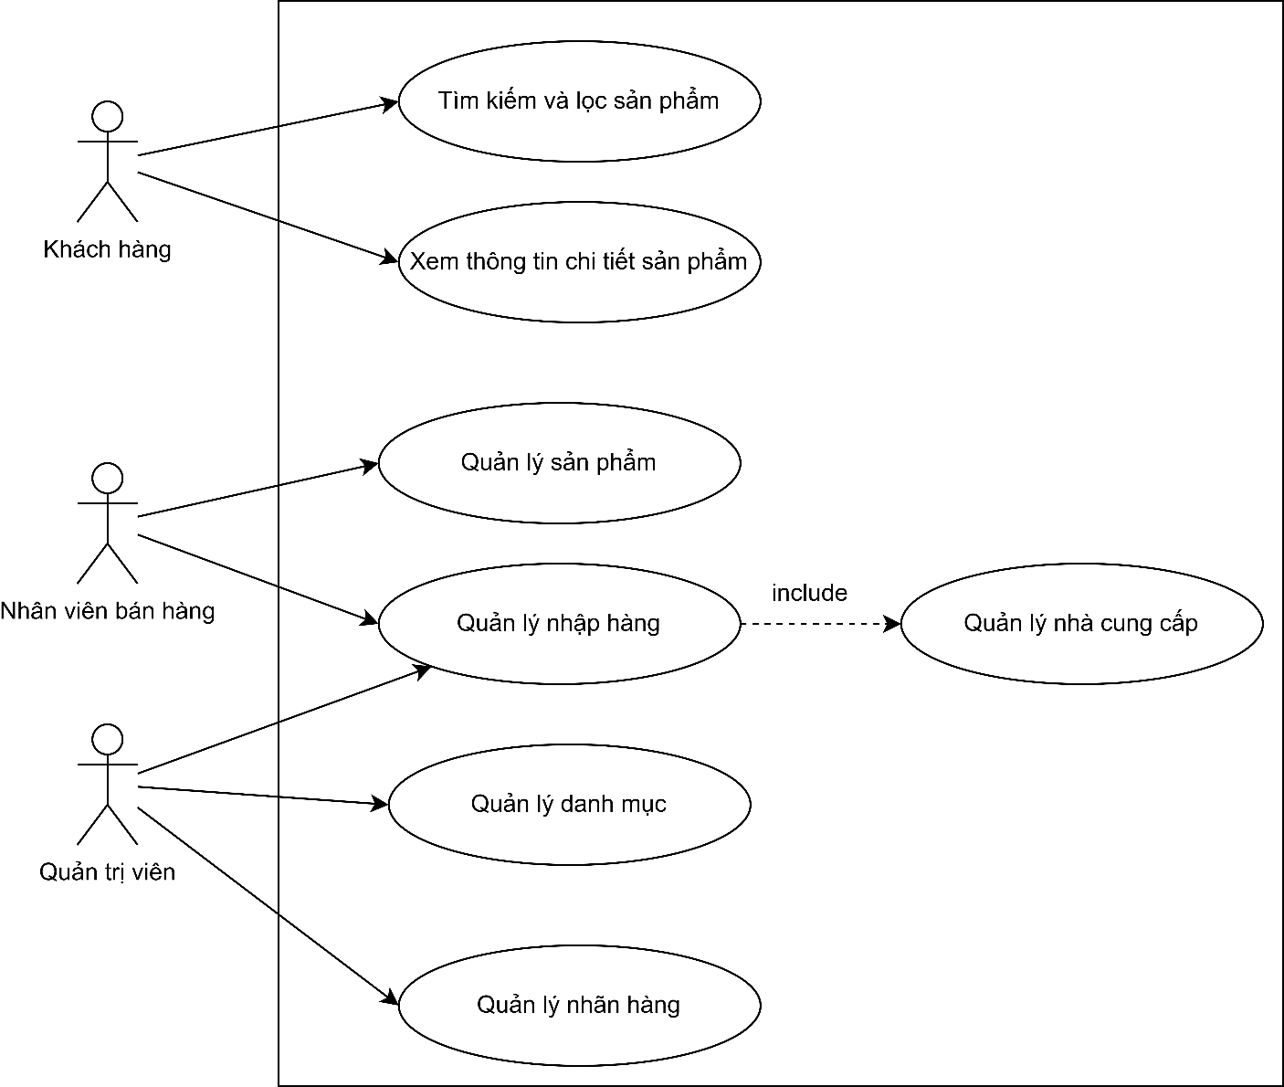
Figure 2.7: Use case product management diagram
UC3 Cart management
The use case diagram is intended for customer, with main functions including: adding products to the cart with mandatory quantity checking, updating product quantities in the cart, removing products from the cart, and viewing the cart to check the product list, quantities, and total amount.
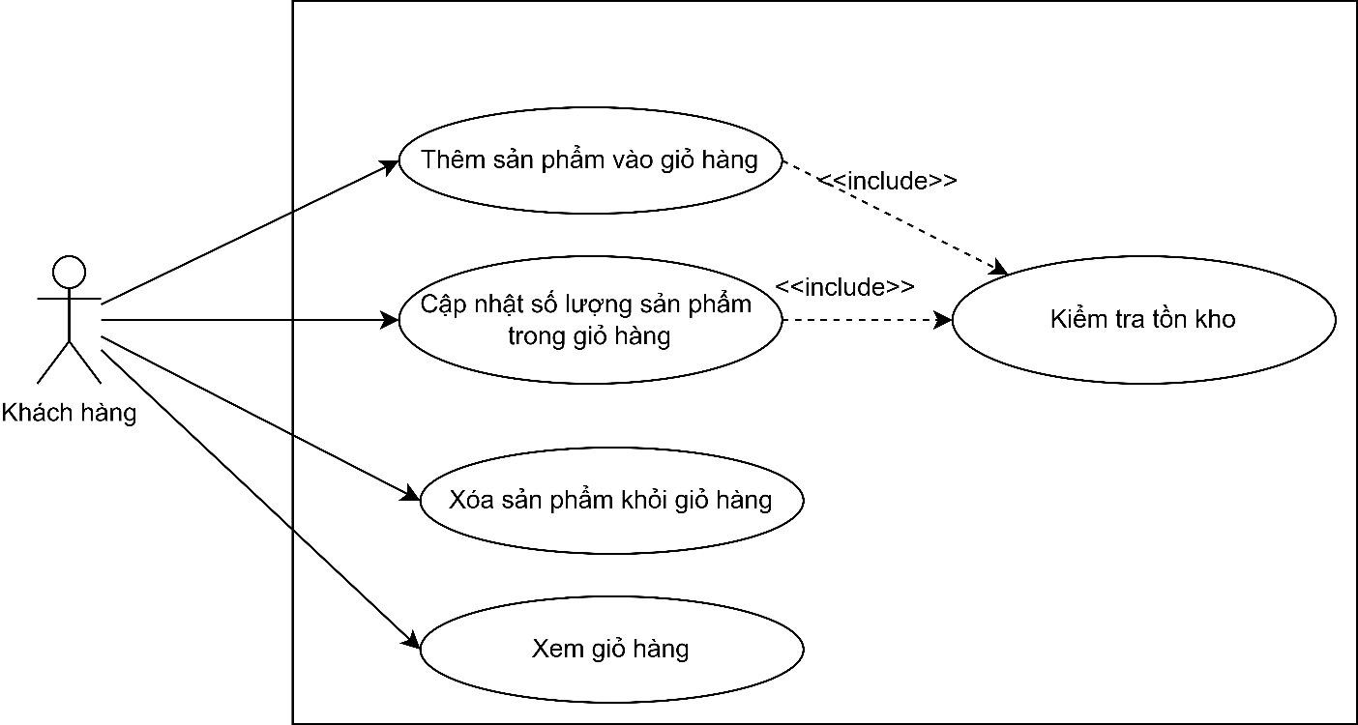
Figure 2.8: Use case cart management diagram

UC4 Order management
The diagram describes the use case for customer, sales staff, and administrator. Customer can view order details and cancel orders if still within the allowed time. Sales staff and administrator perform order management including: viewing the order list and updating order status.
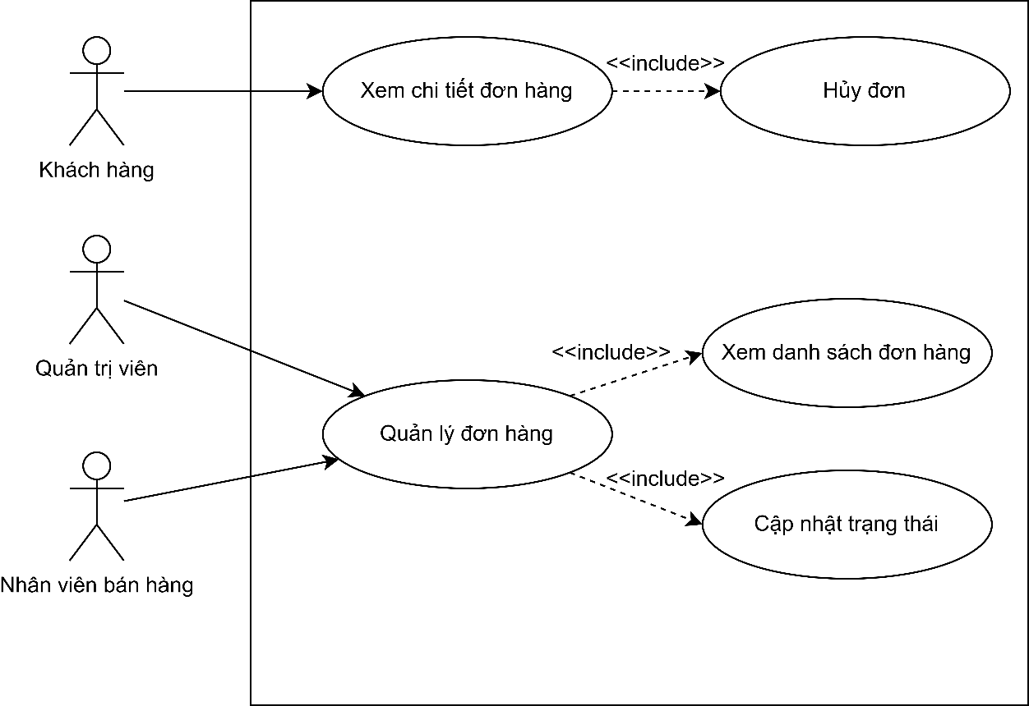
Figure 2.9: Use case order management diagram

UC5 Payment management
The diagram describes the use case for Customer and Administrator, Sales staff. Customer selects a payment method to perform payment and confirms product information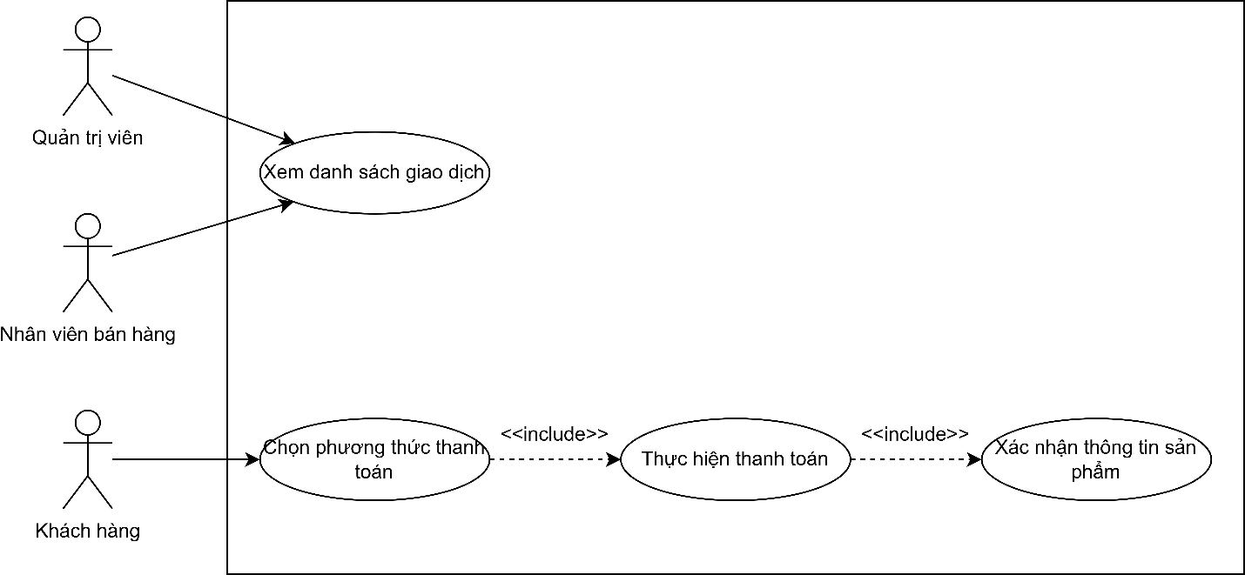
Figure 2.10: Use case payment management diagram
UC6 Review
Use case for customer, sales staff, and administrator.
Customer can comment on posts, create reviews, and edit/delete their own reviews.
Sales staff and administrator perform review responses, hide, and delete customer comments that violate rules.

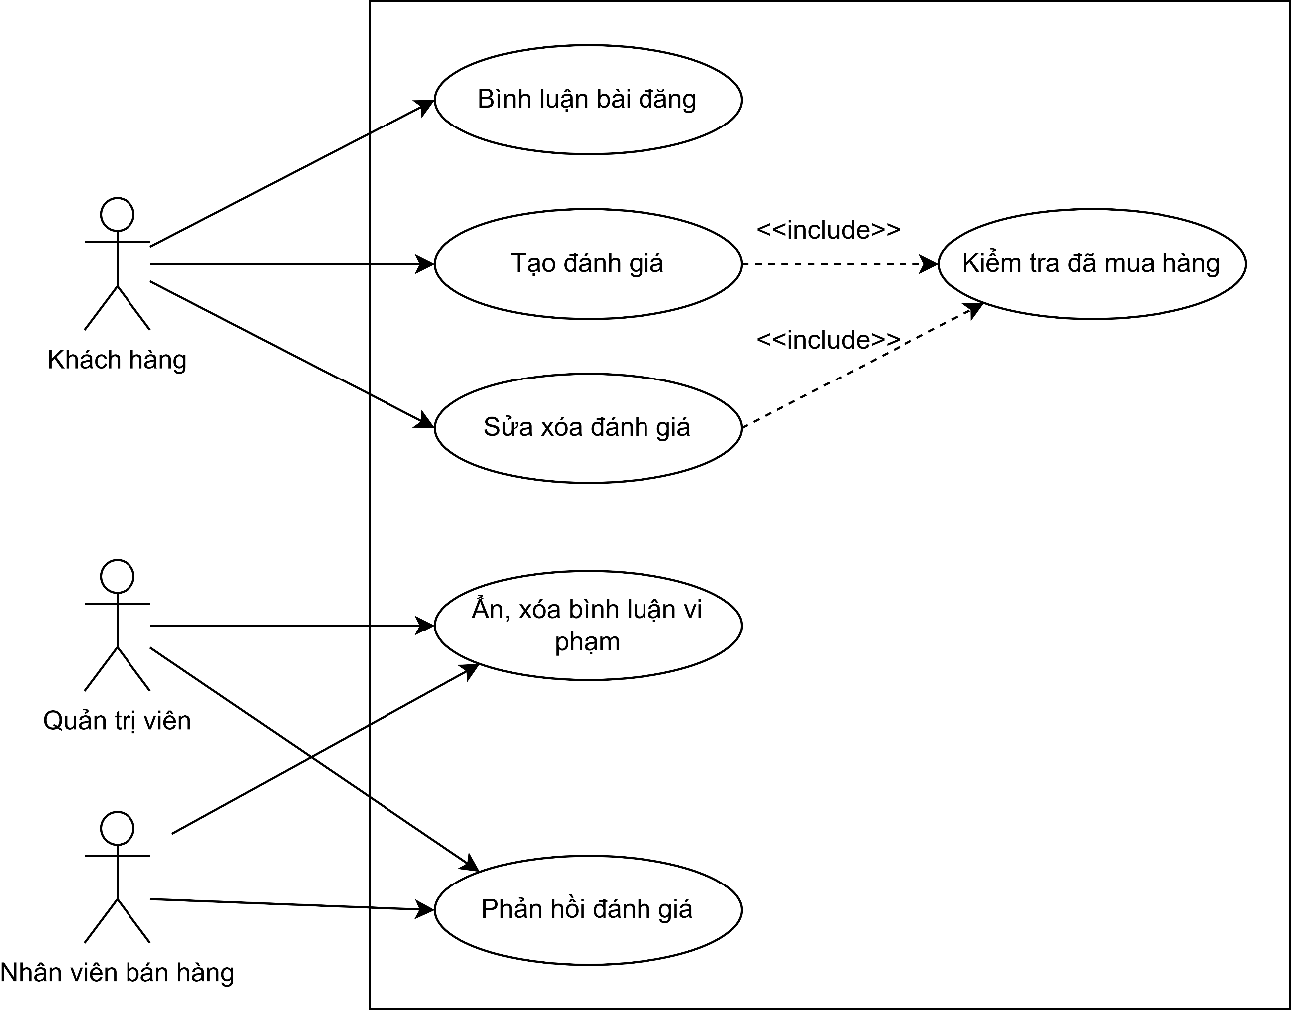
Figure 2.11: Use case review management diagram

UC7 Post management
The diagram describes the use case "Post management" for Administrator and Customer.
Administrator performs topic management including deleting, hiding posts, and managing posts.
Customer views the news list, sees post details, and searches for posts.
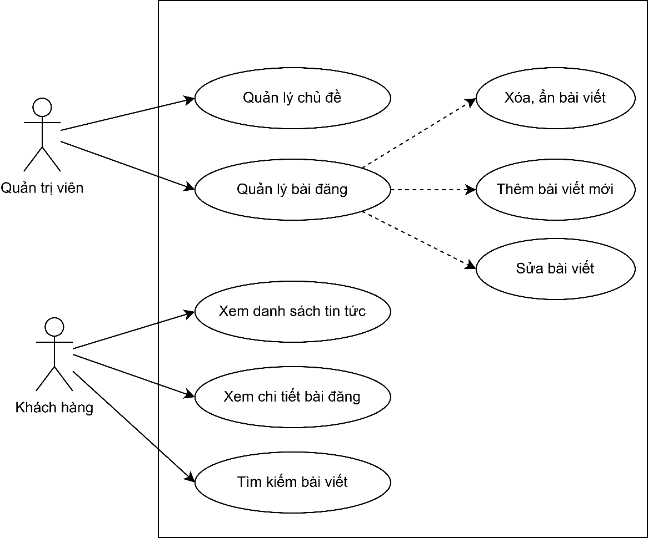
Figure 2.12: Use case post management diagram

2.1.6 User story
US Access control and authentication
As a customer, I want to register a new account and perform OTP verification to create a legitimate, secure identity before starting shopping on the system.
As an administrator, sales staff, or customer, I want to log in to my account so that the system can authenticate my identity and automatically grant access to the correct functional interface for my role.
As a system user, I want to use the forgot password function to reset my password and restore access if I forget my login information.

US Product management
As a customer, I want to search and filter the product list by name, price, or other criteria to quickly find items that meet my needs.
As a customer, I want to view detailed product information including images, specifications, and description to understand the product before making a purchase decision.
As a sales staff, I want to manage product information such as adding, editing, or deleting to ensure data on price, images, and stock quantity is always accurate.
As a sales staff, I want to manage the goods import process and supplier information to track product origin and replenish stock in time when items are running low.
As an administrator, I want to manage product categories to organize items on the website scientifically, helping users navigate and search easily.
As an administrator, I want to manage the list of brands to clearly classify products by brand, supporting more effective management and search.
US Cart management
As a customer, I want to add products to the cart with automatic stock checking to ensure the selected items are actually available and ready for purchase.
As a customer, I want to view the current cart details to review the selected products, unit prices, and total amount before proceeding to checkout.
As a customer, I want to update product quantities in the cart (increase or decrease) to adjust the order as needed, with the system checking stock availability if I increase the quantity.
As a customer, I want to remove products from the cart if I change my mind, helping me eliminate items I no longer intend to buy.
US Order management
As a customer, I want to view order details to check the products, delivery address, total amount, and track the current processing status.
As a customer, I want to cancel an order directly from the detail interface if the order has not been shipped to stop the purchase in time if I change my mind or order by mistake.
As a sales staff or administrator, I want to access order management to have full control of the sales process from customer order to successful delivery.
As a sales staff or administrator, I want to view the order list to get an overview of business status and quickly filter new orders that need processing.
As a sales staff or administrator, I want to update order statuses such as confirmed, in delivery, delivered, or canceled to ensure smooth operation and allow customers to track their packages.
US Payment management
As a customer, I want to select the most suitable payment method for convenience in paying my order.
As a customer, I want the system to display a final confirmation of product information and total amount before payment to ensure I am paying the correct amount for the chosen items.
As an administrator or sales staff, I want to view the transaction list to track payment history, check the status of received payments, and reconcile system revenue.
US Review
As a customer, I want to comment on news posts to discuss, ask questions, or share personal opinions about the content.
As a customer, I want to create product reviews after the system confirms I have purchased the item, ensuring authenticity and sharing real experiences with the community.
As a customer, I want to edit or delete my reviews to update content if my opinion about the product changes after usage.
As a sales staff or administrator, I want to respond to customer reviews to thank them for support or address complaints and questions about products.
As a sales staff or administrator, I want to hide or delete comments that violate community standards to maintain a civilized environment on the website.
US Post management
As a customer, I want to view the news list and search posts by title or keyword to quickly stay updated on events, announcements, and latest information.
As a customer, I want to view post details to read the full content, see illustrative images, and grasp all information conveyed by the post.
As an administrator, I want to perform post management actions such as adding, editing, deleting, or hiding posts to control displayed content and ensure the website information is accurate and up-to-date.
As an administrator, I want to manage topics and post categories to classify and organize news systematically, helping users easily find information by topic group

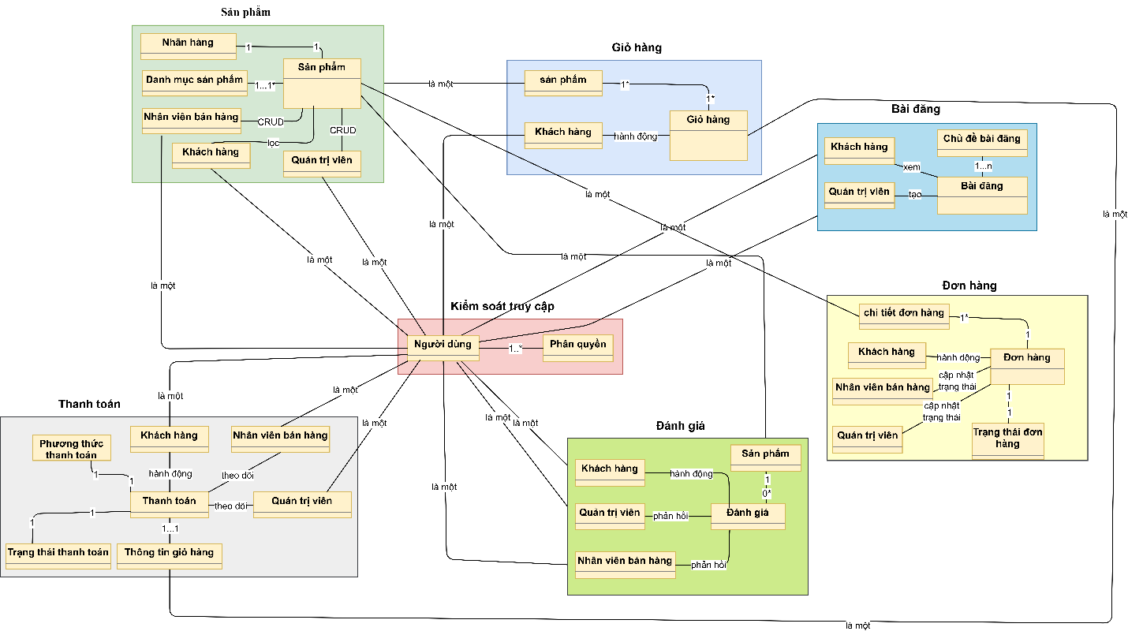
Figure 2.13: Conceptual model diagram
For the User and System data group, the User entity plays a central role, storing information for all roles from Administrator, Customer, to Sales Staff, closely integrated with AddressUser to manage the delivery address book. Notably, the Allcode table functions as a shared data dictionary, standardizing key configuration parameters such as order status, permissions, and product classifications across the entire system.
In the Product category group, data is organized hierarchically with the Product entity managing general information, while ProductDetail stores details of variations such as size, color, and prices (original and discounted). Product images are managed via ProductImage, alongside the goods source management from Supplier and tracking of warehouse import history through the Receipt entity.
For the Order and Sales process, the Order entity stores general transaction information such as the buyer, processing status, and applied vouchers, linked with TypeShip to determine the shipping method. Detailed data about items, quantity, and purchase price at the time of the order is recorded in OrderDetail, while the system maintains ShopCart to support temporary cart storage for buyers.
To support Marketing and Interaction, promotional programs are handled via the Voucher and TypeVoucher entities, combined with Banner and Blog to manage homepage advertising content and news guides. User interactions are recorded through the Comment entity for product reviews, together with the Message and RoomMessage system supporting real-time online chat between customers and staff.
Entity model combined with conceptual level
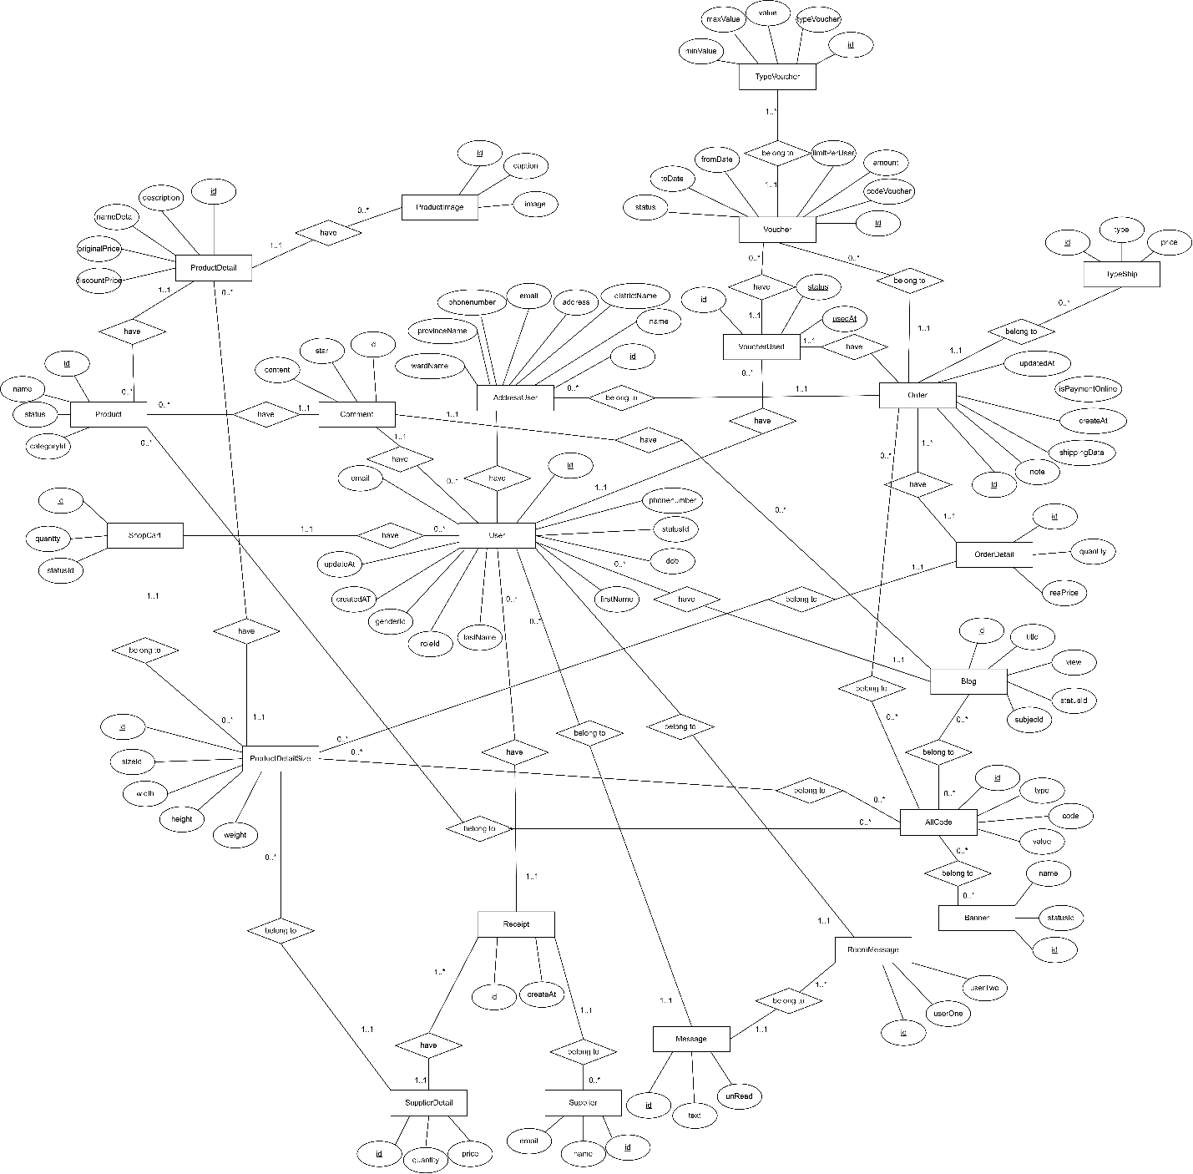
Figure 2.14: Conceptual level entity relationship model diagram

Mô hình thực thể kết hợp mức logic
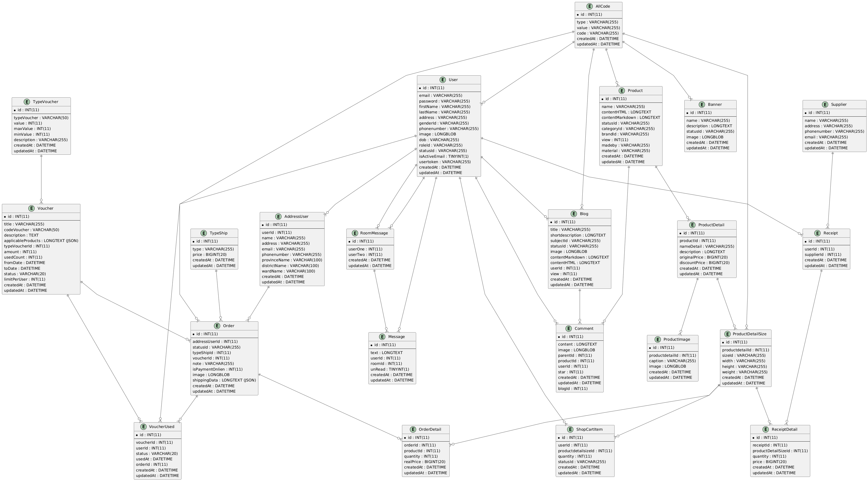
Figure 2.15: Logical level entity relationship model diagram

2.1.9 Wireflow
The customer accesses the main page of the CLOTHING E-COMMERCE WEBSITE to view product categories, featured products, and can search or filter by BRAND, desired category. When clicking on a product, the system displays the detail page with multi-angle images, product name, selling price, description, available sizes, colors, and customer reviews.
If they want to purchase, the customer selects “Add to cart” or “Buy now”. If not logged in, the system may require login or registration to continue. After logging in, the customer can add products to the cart and review the list, adjust quantities, or remove products if needed.
The customer goes to the cart to view an overview of selected products, apply discount codes, check estimated shipping fees, then clicks “Checkout” to proceed. On the checkout page, the customer enters shipping information, chooses a payment method, and then places the order.
The system displays order confirmation successfully. The customer can track the order status in the “Orders” section of their personal account.
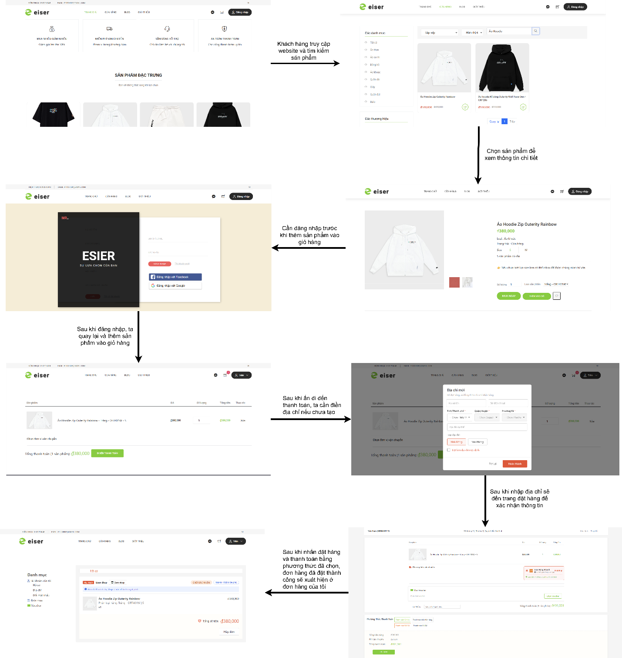
Figure 2.16: Wireflow diagram

2.1.10 Interface
Customer page interface:
Home page when the customer accesses the website
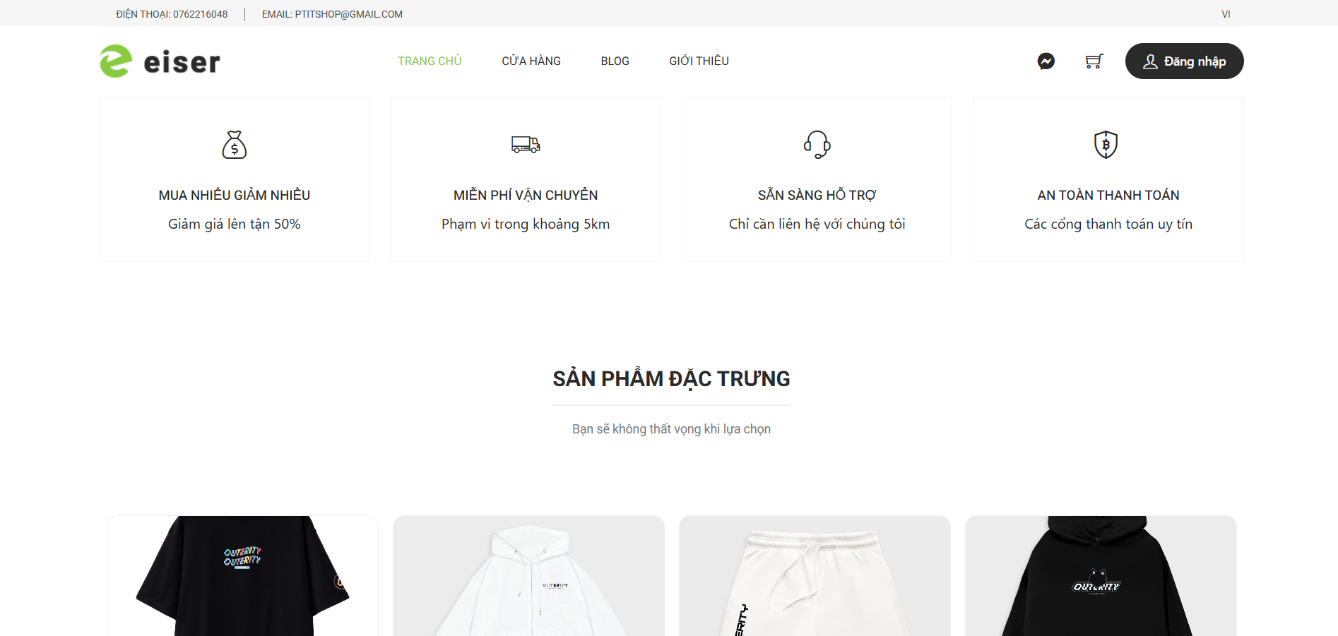
Figure 2.17: Home page

Login page when the customer needs to log in to purchase items or add products to the cart; they can log in via Facebook or Google account.
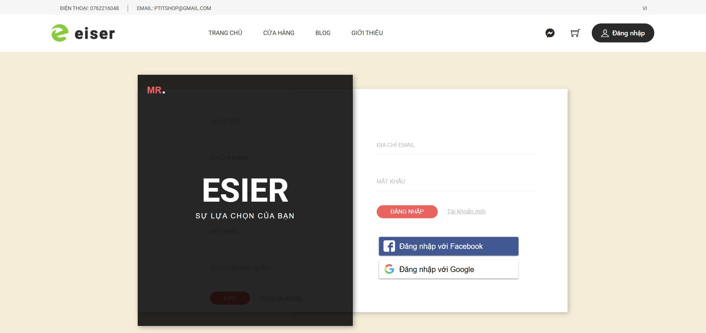
Figure 2.18: Login page

Shop page is the page where the customer can filter, search, and select a category to view the products they are looking for.
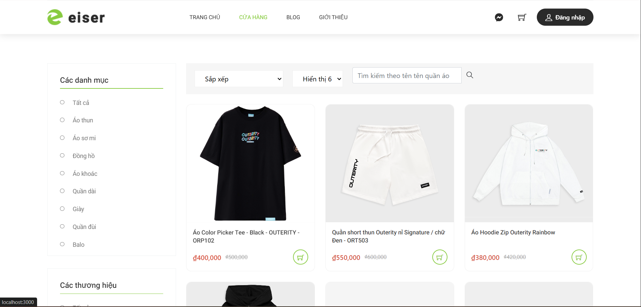
Figure 2.19: Store page

Product detail page displays complete information about a specific product, including images, product name, selling price, detailed description, available sizes/colors, stock quantity, and reviews and comments from other customers. The customer can easily add to cart or buy now from this page.
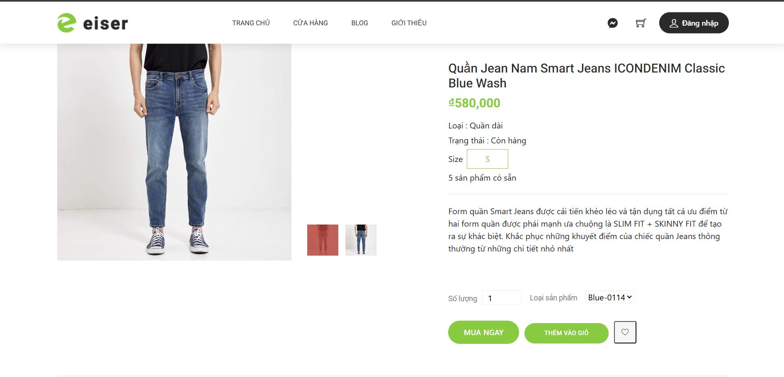
Figure 2.20: Product detail page

Shopping cart page displays the list of products the customer has selected and the total cart value. The customer can adjust quantities or remove products.
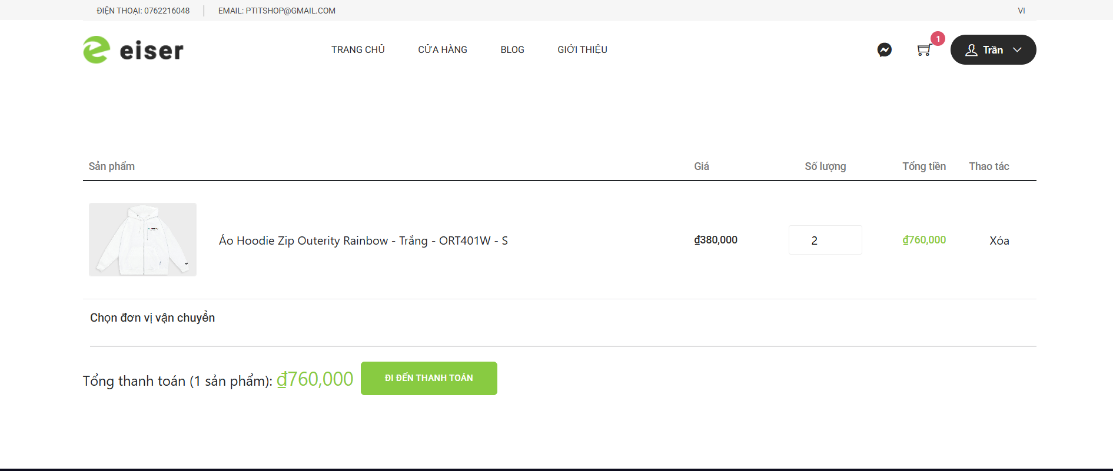
Figure 2.21: Cart page

Checkout page is the page where the customer confirms and enters information before placing an order.
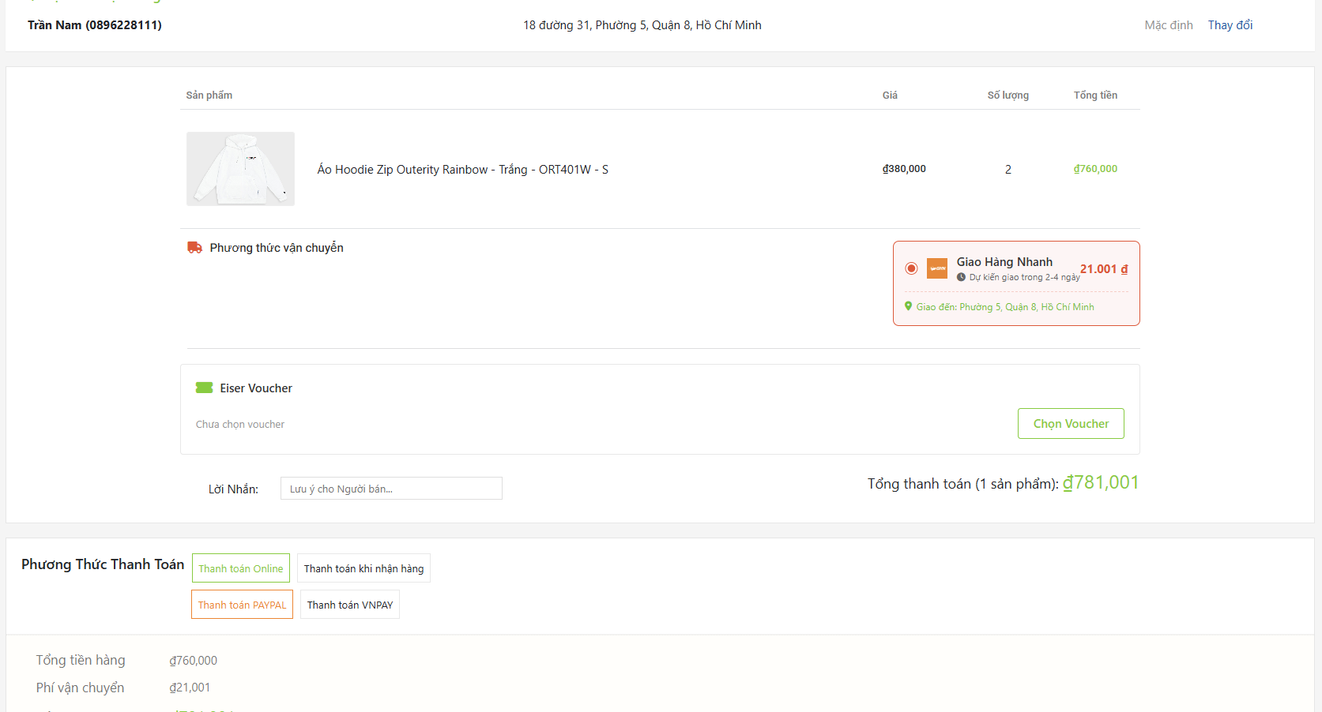
Figure 2.22: Order page

Customer order page displays the list of all orders placed by the customer, including order code, total value, and order status.
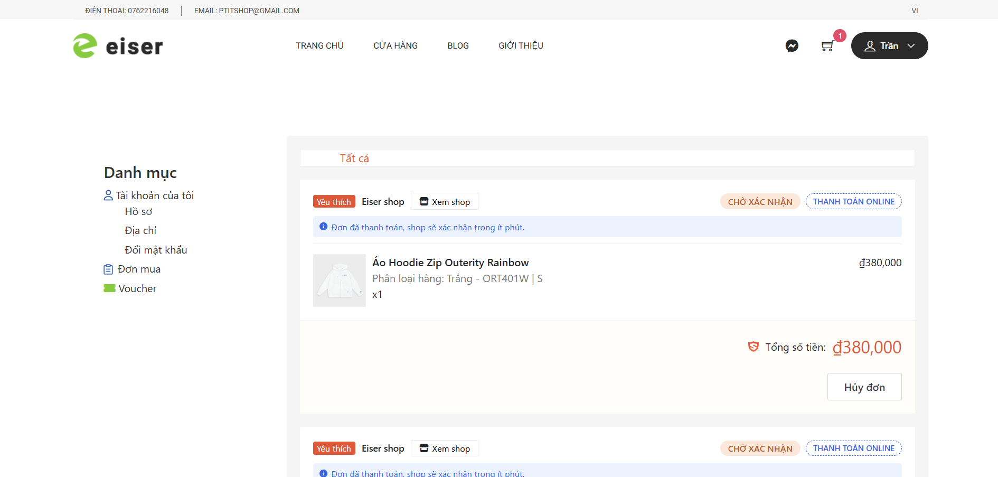
Figure 2.23: Purchase orders page

Customer address page allows viewing, adding, editing, and deleting saved shipping addresses. Each address includes recipient name, phone number, detailed address, and one address can be set as default. Customers can easily select the appropriate address when placing an order without re-entering it each time.
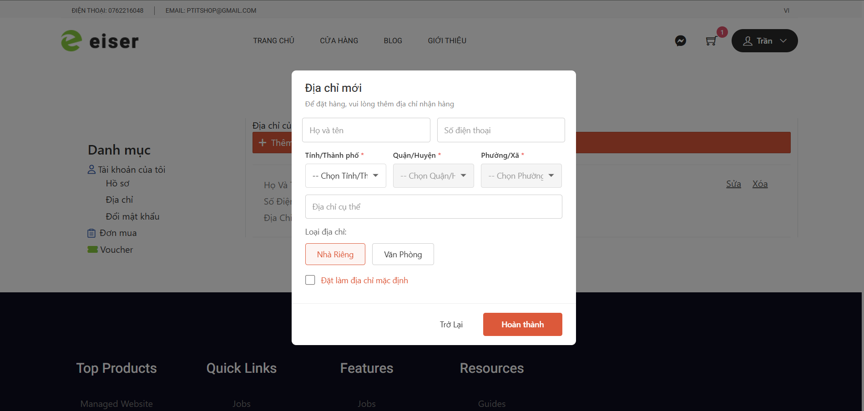
Figure 2.24: Address page

The clothing shop blog page displays a list of the latest posts or by categories such as fashion trends, outfit tips, clothing care advice… along with a featured image, title, summary, and posting date. Customers can read the full article, comment, share, or search by keywords to discover more useful content from the shop.
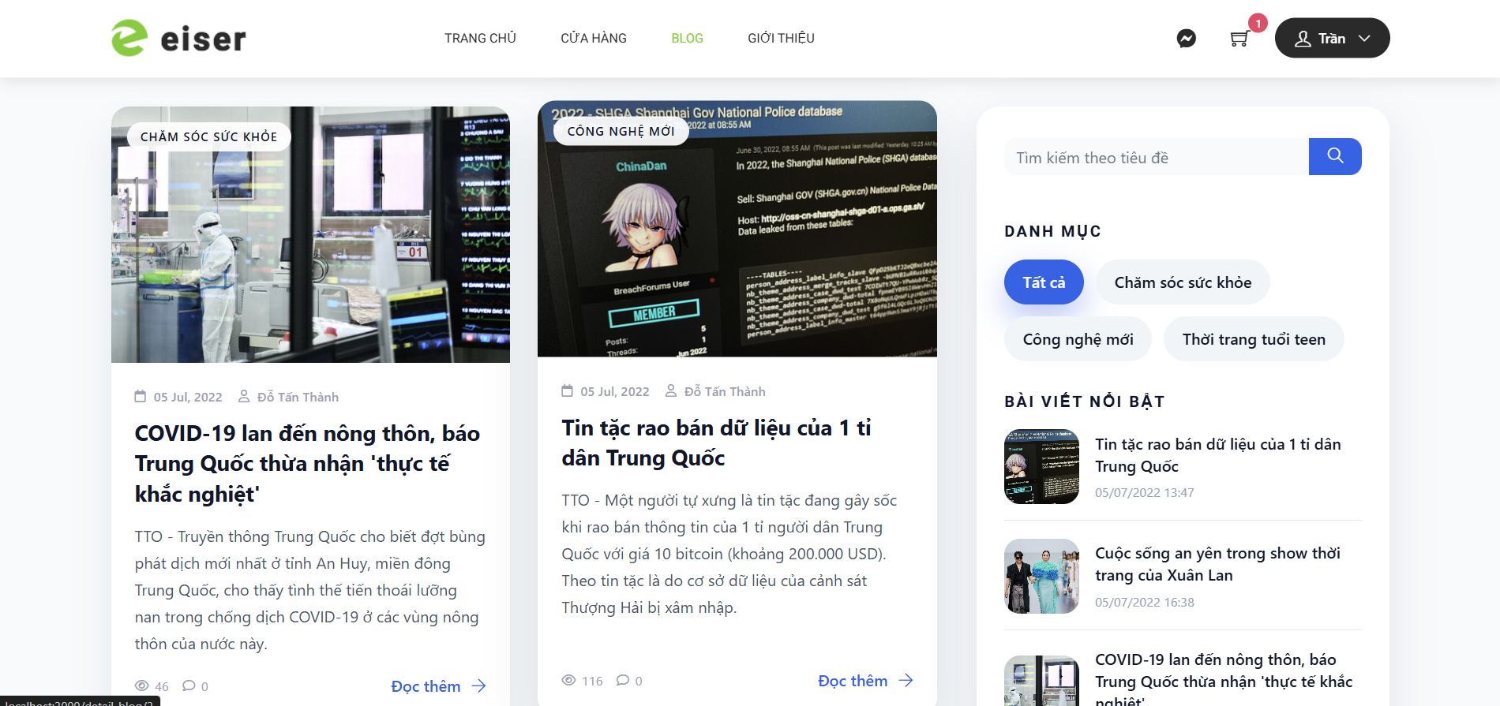
Figure 2.25: Blog page

The interface page for the administrator:
User management displays the full list of user information with columns such as email, full name, phone number, date of birth, gender, role, and actions for editing or deleting. Admin can search by phone number, export data to Excel, and add new users through a form to enter detailed information and select the appropriate role.
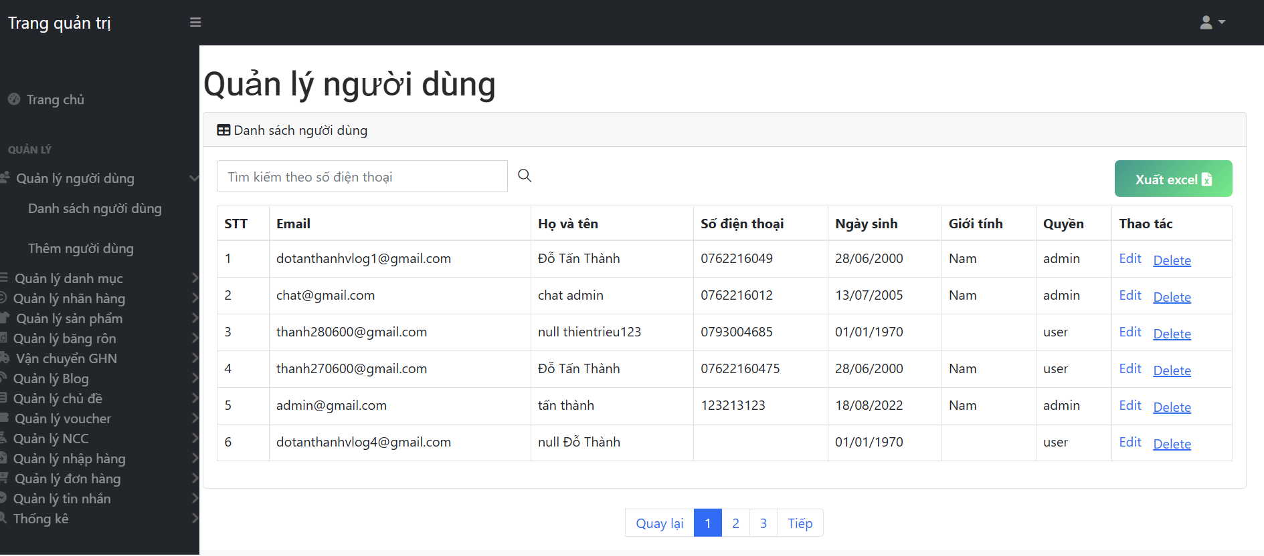
Figure 2.26: User list page
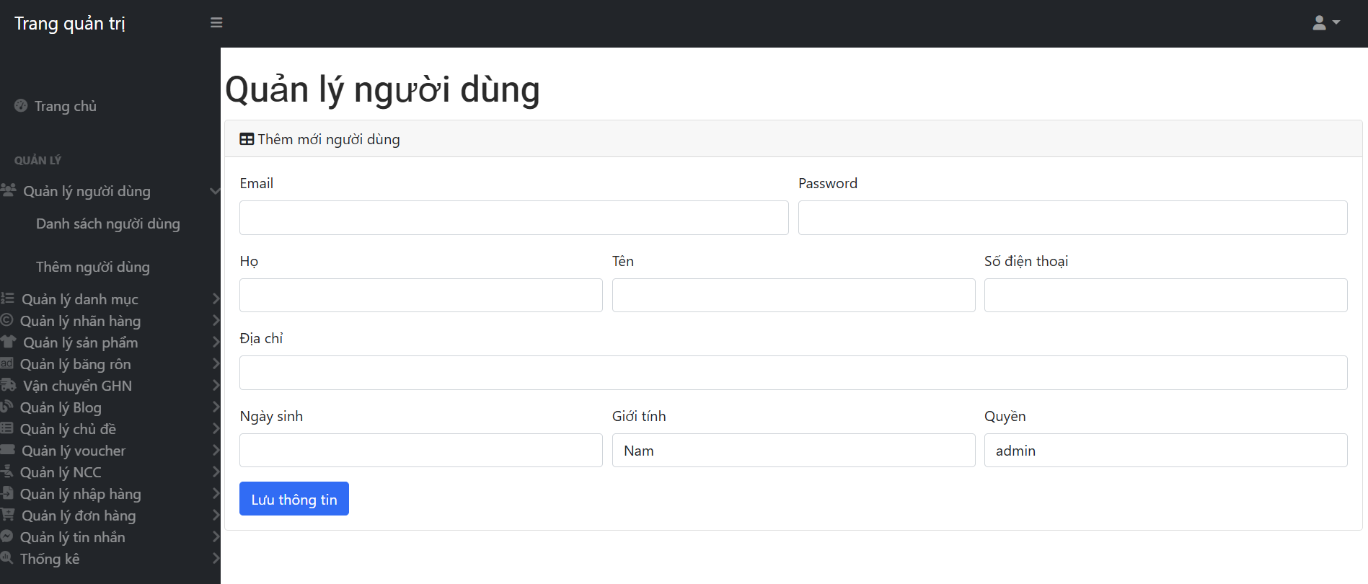
Figure 2.27: Add user page

Category management page displays the interface listing all product categories with information such as category name, code, along with quick edit and delete buttons.
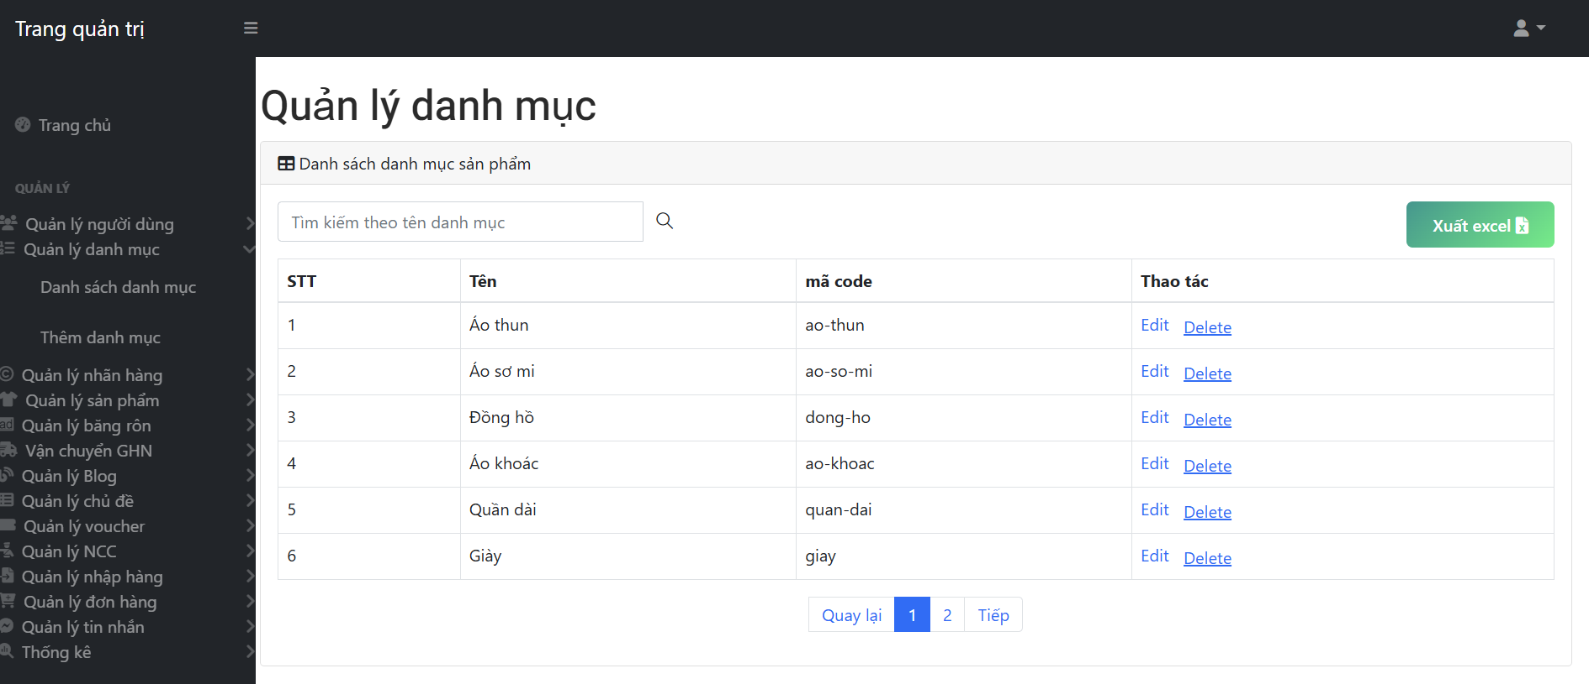
Figure 2.28: Category list page

Brand management page allows the admin to manage the list of brands that the shop is selling, enabling adding, editing, deleting brand information and linking products to the corresponding brand.
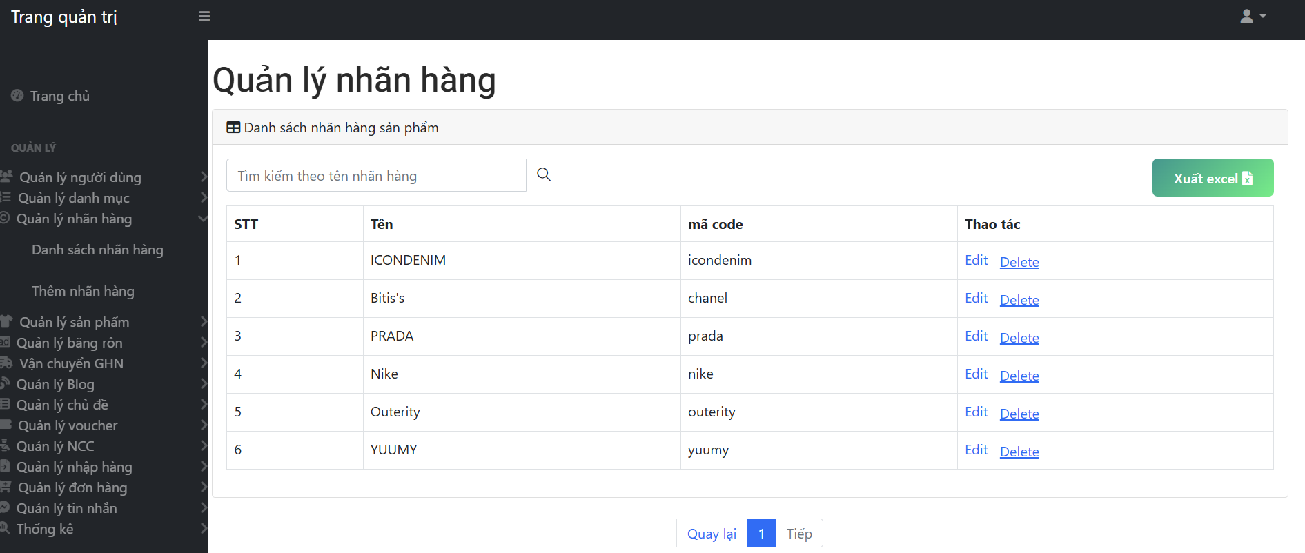
Figure 2.29: Brand list page

Product management in the admin section displays the full list of all shop products with detailed information.
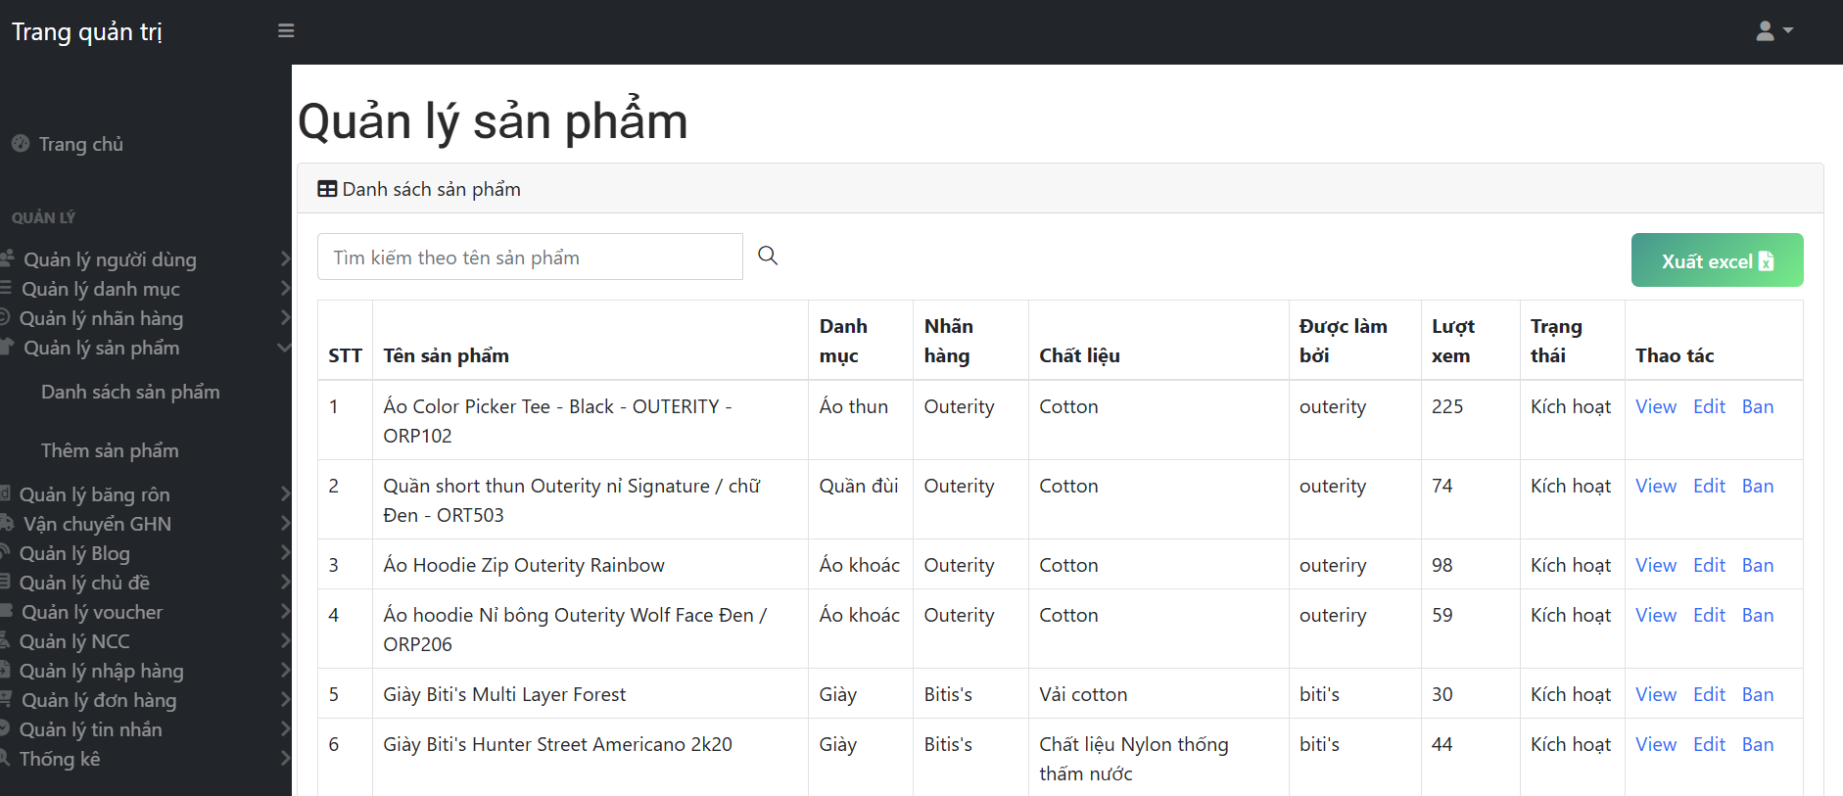
Figure 2.30: Product list page

The order management page in the admin section displays the full list of all shop orders with detailed information such as order ID, customer phone number, email, order date, type of shipping, shipping fee, applied voucher, payment method, order status, and tracking number.
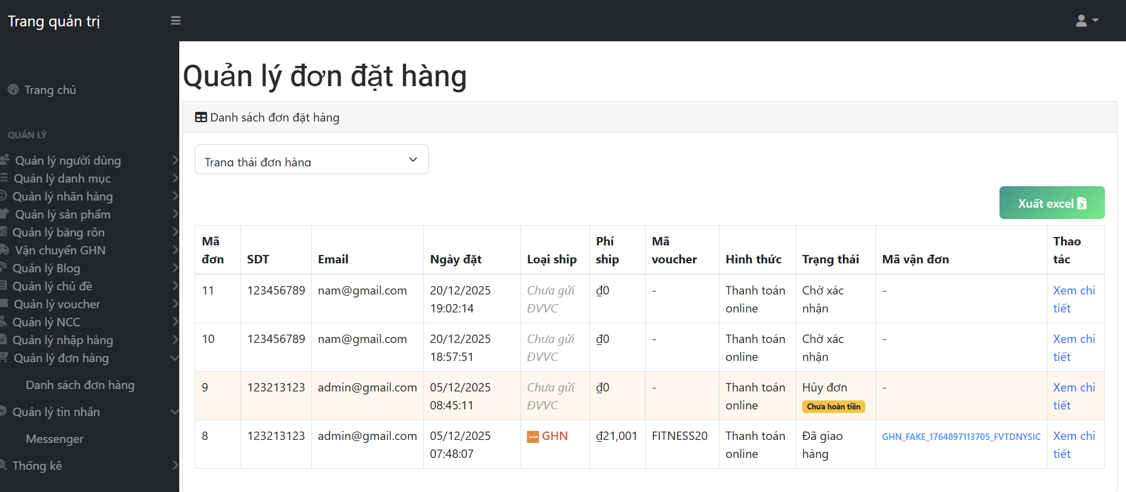
Figure 2.31: Order list page

The order detail page for the admin displays full information about a specific order, including the order ID and customer information. The admin can view details, update order status, cancel the order, or track shipping, supporting quick and accurate handling.
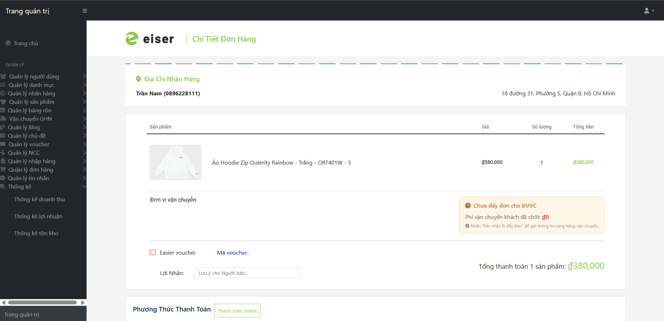
Figure 2.32: Order detail page

2.2 System architecture design

2.2.1 Block diagram
The clothing e-commerce web system is built as a SPA (Single Page Application) and follows a layered architecture consisting of Frontend, Backend, and Database. Applying this model helps optimize user experience, improve response speed, and at the same time enhance scalability and facilitate system maintenance. The figure below illustrates the overall architecture of the system.
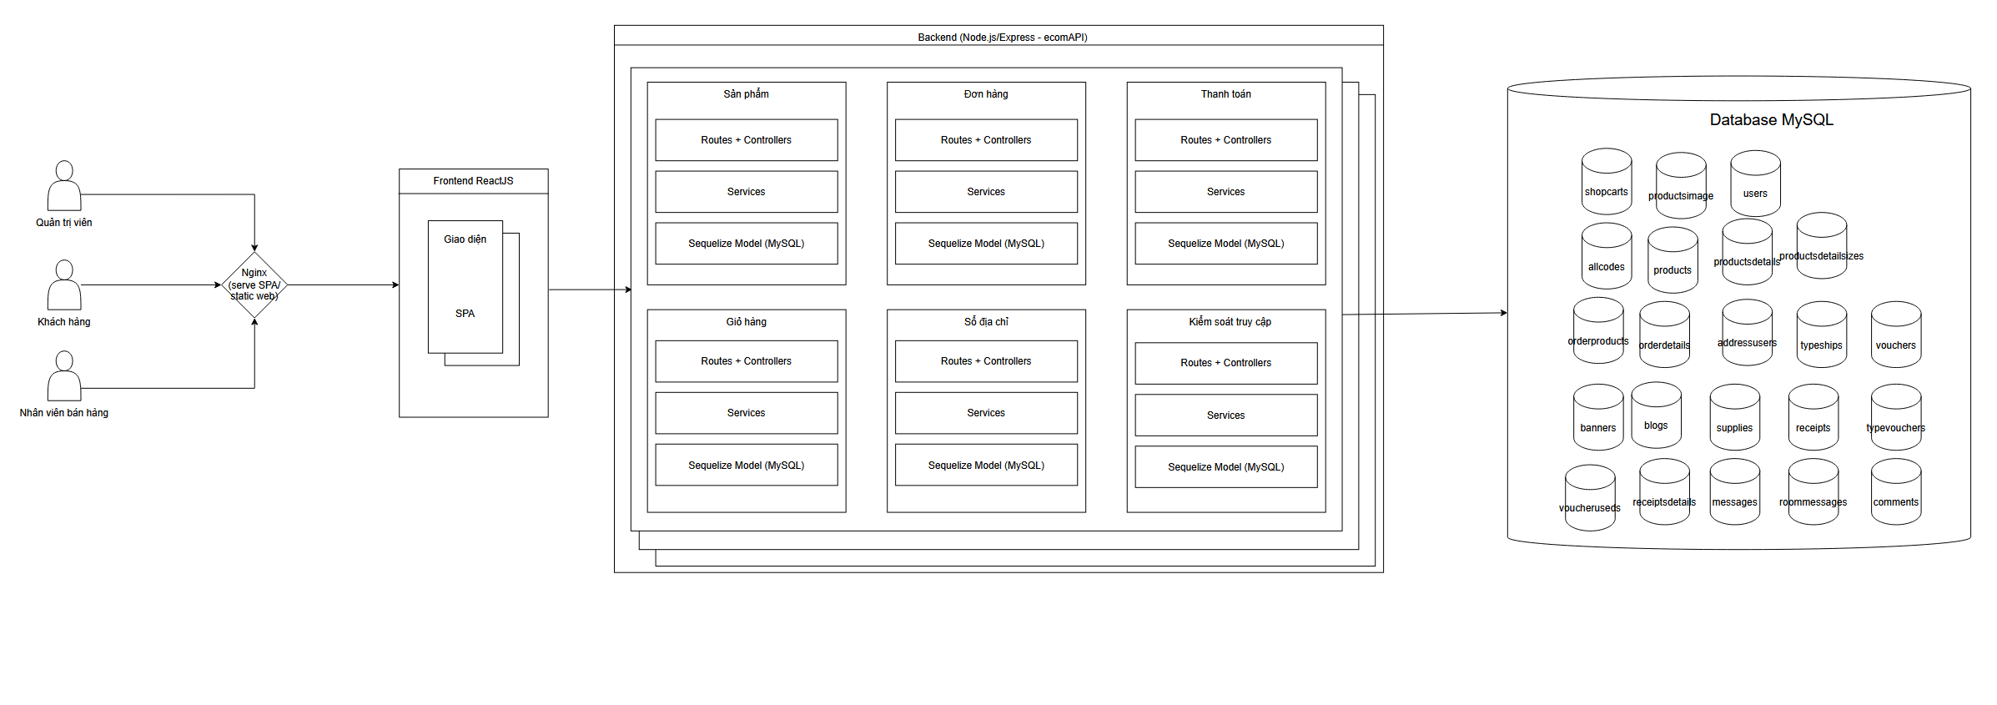
Figure 2.33: Block diagram

2.2.2 Decomposition View
C1 Context Diagram
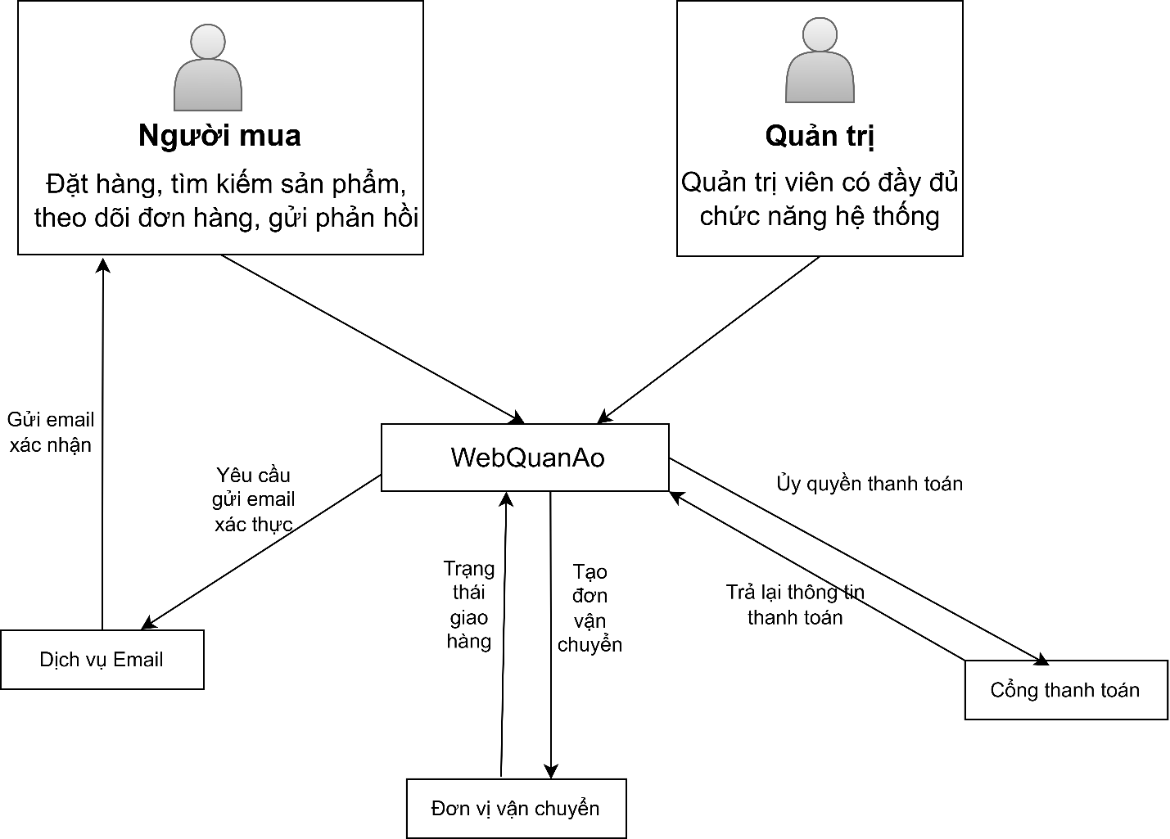
Hình 2.34: Context Diagram

The context diagram (Context Diagram) describes the boundary of the WebQuanAo system and the data exchange relationships between the system and external entities. The WebQuanAo system acts as the central hub, receiving and processing business requests of the online sales system.
External entities include buyers and administrators. Buyers use the system to search for products, place orders, track orders, and submit feedback. Administrators have the authority to manage all system activities such as products, orders, and users.
Additionally, WebQuanAo integrates with third-party services including the Email system to send verification emails and notifications, the Payment Gateway to process transactions and return payment results, and the Shipping Unit to create delivery orders and update shipping status.

C2 Container Diagram
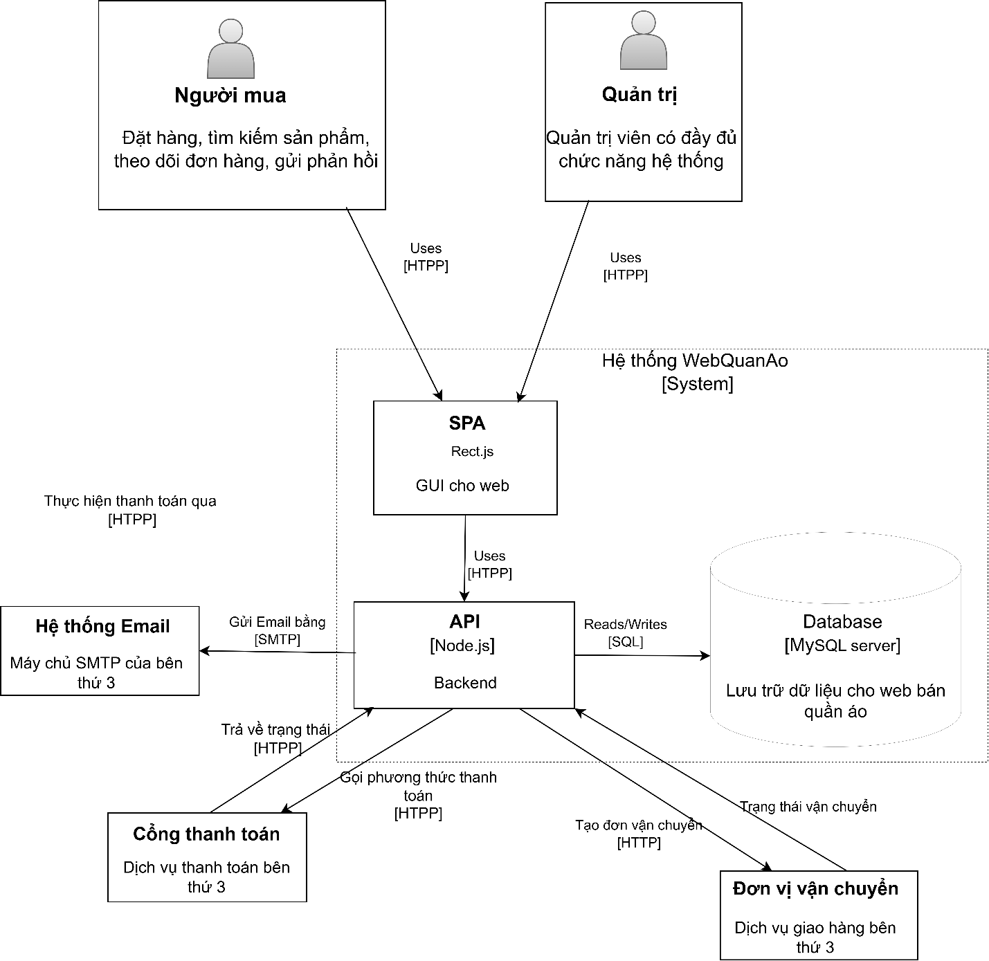
Hình 2.35 Container Diagram
The Container diagram describes the technical architecture of the WebQuanAo system, clarifying the main application components and how they coordinate during operation. The system is designed according to a client–server model, where the user interface and business logic are clearly separated.
The Web application is built as a single page application (SPA) using React.js technology, serving as the user interface layer for both Buyers and Administrators. The application allows users to perform actions such as browsing products, placing orders, and managing the system.
The Backend is an API Application built with Node.js and Express.js, responsible for handling all business logic of the system. The Backend receives requests from the SPA, performs authentication and authorization, processes data, and connects to the database to perform read and write operations. In addition, the Backend acts as a central integration point with third-party systems such as Email services, Payment Gateway, and Shipping Units.
The database uses MySQL Server, serving as the centralized data repository of the system, storing information on users, products, orders, and other related data. The Backend accesses the database through SQL queries or via the ORM layer to ensure efficient data management and retrieval.
C3 Component Diagram
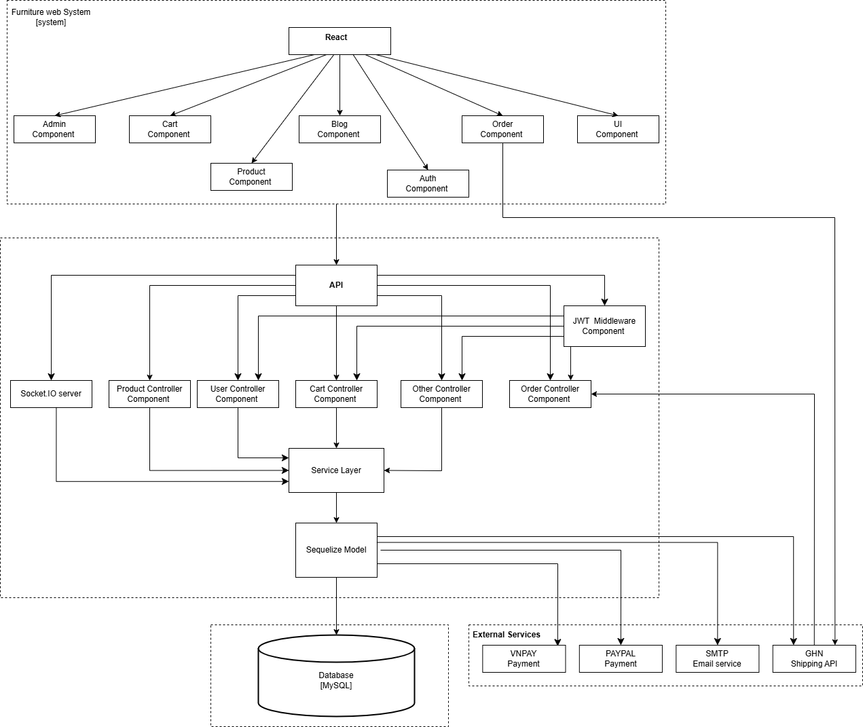
Hình 2.36: Component Diagram
The Component Diagram details the internal architecture of the Web application (SPA) and the Backend API, illustrating how functional modules are organized and interact to execute e-commerce business processes. The architecture is designed with a clear layered model.
Frontend Layer (React SPA): This layer directly interacts with users and is organized into Components:
- React Core: The main framework orchestrating the application
- Functional Modules: Includes Auth Component (authentication), Product Component (product display), Cart Component (shopping cart), Order Component (ordering), and Admin Component (administration).
- Data Flow: These components send HTTP requests to the Backend API to retrieve or update data.
Backend Layer: Handles all business logic and is divided into sequential processing layers:
- API Service: The entry point for all requests from the Frontend, responsible for routing to the appropriate handler.
- Middleware Component: Provides security by intercepting requests that require authentication, validating JSON Web Tokens (JWT) before allowing access to critical controllers such as ordering or viewing personal information.
- Controller Layer: Orchestrates request handling:
- Auth/User Controller: Handles registration, login, and profile management.
- Product Controller: Handles search, filtering, and detailed product display.
- Order/Cart Controller: Handles logic for adding to cart and creating new orders.
- Other Controllers: Handle additional auxiliary business processes.
. The Component Diagram details the internal architecture of the Web application (SPA) and the Backend API, illustrating how functional modules are organized and interact to execute e-commerce business processes. The architecture is designed with a clear layered model.
Frontend Layer (React SPA): This layer directly interacts with users and is organized into Components:
- React Core: The main framework orchestrating the application.
- Functional Modules: Includes Auth Component (authentication), Product Component (product display), Cart Component (shopping cart), Order Component (ordering), and Admin Component (administration).
- Data Flow: These components send HTTP requests to the Backend API to retrieve or update data.
Backend Layer: Handles all business logic and is divided into sequential processing layers:
- API Service: The entry point for all requests from the Frontend, responsible for routing to the appropriate handler.
- Middleware Component: Provides security by intercepting requests that require authentication, validating JSON Web Tokens (JWT) before allowing access to critical controllers such as ordering or viewing personal information.
- Controller Layer: Orchestrates request handling:
  - Auth/User Controller: Handles registration, login, and profile management.
  - Product Controller: Handles search, filtering, and detailed product display.
  - Order/Cart Controller: Handles logic for adding to cart and creating new orders.
  - Other Controllers: Handle additional auxiliary business processes.
Service Layer: Centralizes all business logic of the system. Here, business rules such as order calculation, stock verification, order status handling, and integration with external services are executed. The Service Layer interacts with Sequelize Models to query and manipulate data without directly using raw SQL.
Model Layer: Abstracts the database, mapping tables to objects within the application. This layer facilitates reading and writing data to the MySQL Database, which serves as the physical data storage for the entire system.
Additionally, at the Service Layer, the system integrates with external services including payment gateways like VNPAY and PayPal for transaction processing, email services via SMTP for notifications, and GHN shipping API to create shipments and update delivery status through a webhook mechanism returning to the Order Controller.
C4 Code Diagram
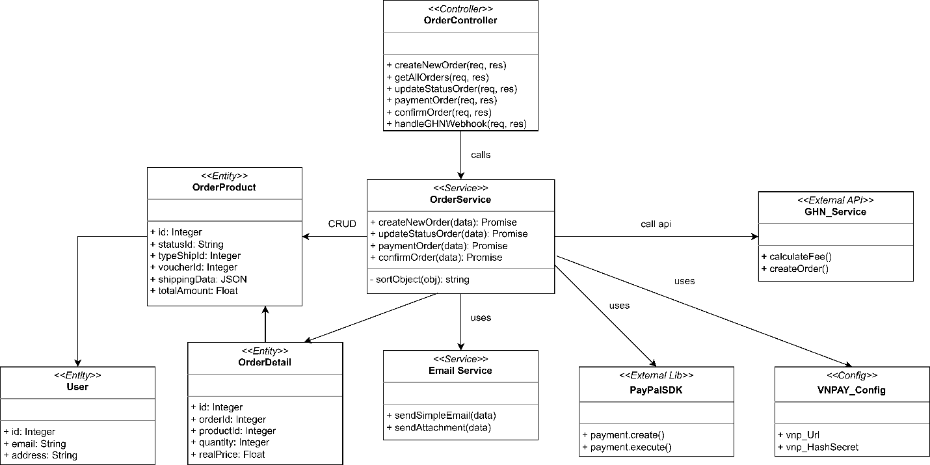
Hình 2.27 Code Diagram

2.2.3 Communication view
Users start interacting through a browser or mobile application, sending requests in JSON/HTML format via the secure HTTPS protocol (port 443), accompanied by JWT Cookies or Session to authenticate the session.
The frontend layer is built on ReactJS combined with Web UI technologies such as Bootstrap and jQuery, using the fetch() API as a bridge to handle user actions and send signals to the server.
The backend server runs on Node.js and ExpressJS, providing a comprehensive REST API system to handle core business processes such as Auth, Product, Order, Warehouse, and Report with JWT HttpOnly security mechanisms.
The system maintains a persistent connection to the MySQL Server database via TCP protocol on port 3306 (MySQL Wire Protocol), ensuring fast data storage and retrieval for the entire application.
For resource management, the application communicates with Local/Cloud Storage via HTTPS to perform upload or retrieval tasks for image files and necessary documents.
The notification service is integrated through the Gmail SMTP server (port 587, STARTTLS protocol), allowing the system to automatically send account verification emails or order status updates to users’ mailboxes.

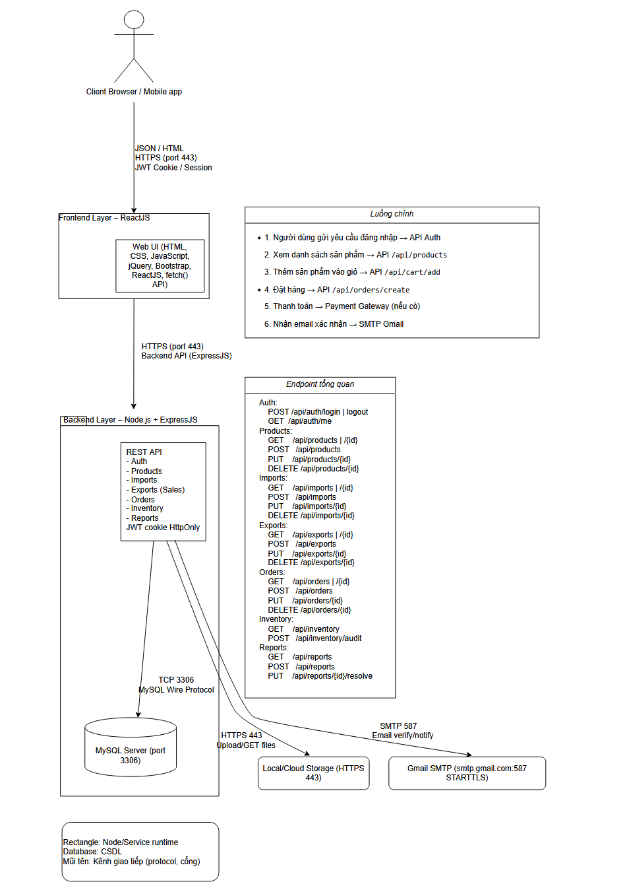
Figure 2.28: Communication flow diagram

2.2.4 Deployment view
At the user device side (Client), the system uses popular web browsers (such as Chrome, Firefox, Safari) to render the interface and connect to the server via the secure Internet HTTP/HTTPS protocol.
At the Web Server, the Frontend component is deployed using Reactjs (build version) to handle the user interface, communicating with the Backend through two methods: API calls (REST) for standard data and WebSocket (Socket.IO) for real-time features.
Also running on this server, the Backend component operates on Node.js combined with the Express Framework and Sequelize ORM, serving as the central hub for processing business logic and orchestrating data across the entire system.
At the Database Server, the system uses MySQL database management system to store data, connecting directly to the Backend via TCP/IP protocol on port 3306 using the mysql2 driver to ensure fast and stable data access.
Regarding integrated services, the system connects with PayPal through the Payment API to process online payments and uses the Nodemailer library to connect with the Email Server for automatic notification delivery.
For shipping, the system integrates with GHN (Giao Hàng Nhanh) via a Webhook mechanism, allowing orders to be automatically sent to the carrier and shipping status updated back to the system immediately.

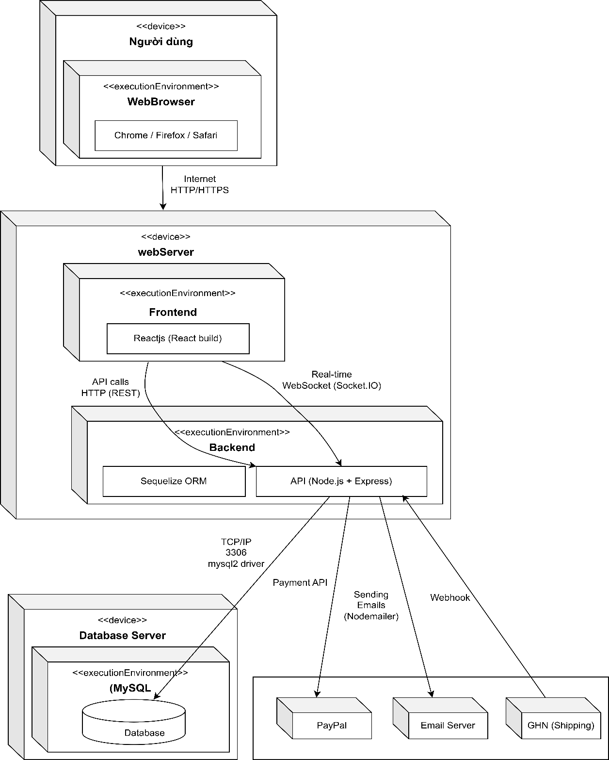
Figure 2.29: Deployment diagram

CHAPTER 3: TEST PLAN

3.1. Introduction

3.1.1. Purpose
This Test Plan document is developed for the eCommerce Full Stack system to define the strategy, methods, and testing processes throughout the software development lifecycle. The main objectives include:
- Defining the scope and limits of testing to focus resources on critical functions of the eCommerce system.
- Establishing a multi-level testing strategy (Unit → Integration → System → Acceptance) following the V-Model combined with a Risk-Based Testing approach.
- Standardizing the test execution process with clear Entry/Exit Criteria, ensuring consistency and repeatability.
- Defining the infrastructure, tools, and test data to support automated testing deployment within the CI/CD pipeline.
- Providing a framework for software quality management and tracking through metrics and test reports.
This document serves as a guiding framework for all testing activities, ensuring the final product meets functional, non-functional requirements and delivers a proper user experience in the online clothing retail domain.

3.1.2. Scope
The scope of this test plan covers the entire ecosystem of the eCommerce Full Stack software, including:
- Scope by architectural components:
+ Frontend: React.js application (directory eCommerce_Reactjs/) with modules for product presentation, cart management, order processing, and admin interface.
+ Backend: Node.js/Express API server (directory ecomAPI/) with services for user authentication, product catalog management, transaction processing, and payment integration.
+ Database: MySQL database management system with complex relational structures for products, orders, users, and promotions.
+ Infrastructure: Deployment environment using Docker Compose and CI/CD pipeline on GitHub Actions.
- Scope by testing type:
+ Functional testing: Verify all eCommerce business operations from product browsing to order completion.
+ Non-functional testing: Evaluate performance, security, compatibility, and user experience.
+ Integration testing: Check interactions between components (frontend-backend, backend-database, system-third-party services).
+ Regression testing: Ensure system stability after every code change.
- Scope by environment:
+ Development environment: Local Docker Compose setup.
+ Continuous Integration (CI) environment: GitHub Actions with test container database.
+ Staging environment: Deployment on cloud services (if applicable).
+ Acceptance environment: User acceptance testing with real data.

3.2 Testing Items within Scope

3.2.1 Backend API Testing
- Objective: Ensure that the APIs function according to specifications, handle business logic accurately, and secure sensitive information.
Nhóm API | Main Endpoints | Testing Objectives
Authentication | /api/auth/login, /api/auth/register, /api/auth/refresh | JWT authentication, refresh token, RBAC authorization
User Management | /api/users, /api/users/profile, /api/users/{id} | CRUD users, update profile, role-based access control
Product Catalog | /api/products, /api/products/{id}, /api/products/search | Display clothing products, filter by size/color, search functionality
Cart Management | /api/cart, /api/cart/items, /api/cart/clear | Add/remove/update cart items, calculate total price, validate quantity
Order Processing | /api/orders, /api/orders/{id}, /api/orders/{id}/status | Create orders, update status, cancel orders
Payment Integration | /api/payment/create, /api/payment/callback | Integrate Momo/VNPay, handle callbacks, update payment status
Promotion & Voucher | /api/vouchers, /api/vouchers/apply | CRUD voucher, validate điều kiện áp dụng
Shipping Management | /api/shipping/calculate, /api/shipping/track | Calculate shipping fees, track orders
Admin Dashboard | /api/admin/statistics, /api/admin/reports | Revenue statistics, inventory reports
- Testing Techniques:
+ Contract Testing: Verify request/response schemas using OpenAPI/Swagger.
+ Negative Testing: Test with invalid data, expired tokens, insufficient permissions.
+ Boundary Testing: Test quantity limits, boundary values.
+ Concurrency Testing: Handle simultaneous requests (cart, payment).

3.2.2. Frontend Testing
- Objective: Ensure the user interface functions correctly, provides smooth user experience, and is cross-platform compatible.
Frontend Module | Main Component | Test Objective
Product Listing | ProductGrid, ProductCard, FilterSidebar | Display product list, filter/sort, pagination
Product Detail | ProductGallery, SizeSelector, AddToCart | Display product details, select size/color, add to cart
Shopping Cart | CartItem, CartSummary, CheckoutButton | Manage shopping cart, calculate total, navigate to checkout
Checkout Flow | AddressForm, PaymentMethod, OrderReview | Multi-step checkout flow, validate forms, display summary
User Account | LoginForm, RegisterForm, ProfilePage | User authentication, account management, order history
Admin Panel | Dashboard, ProductManager, OrderManager | Admin interface, CRUD products, process orders
- Testing Techniques:
+ Component Testing: Test components independently using React Testing Library.
+ Integration Testing: Test interaction between components.
+ E2E Testing: Test complete user flows with Cypress.
+ Accessibility Testing: Verify support for users with disabilities (WCAG 2.1).

3.2.3 Database Testing
- Objective: Ensure database integrity, consistency, and performance.
Test Type | Objective | Tool/Method
Schema Validation | Check table structure, constraints, data types | SQL scripts, Sequelize migrations
Data Integrity | Ensure referential integrity consistency | Foreign key constraints, transaction testing
Performance | Optimize queries, indexes, response time | EXPLAIN queries, index analysis
Migration Testing | Verify compatibility when upgrading schema | Rollback testing, data migration validation

3.2.4. Integration Testing
- Objective: Ensure that all system components operate in synchronizatio.
Integration | Test Objective
Frontend-Backend | API calls, error handling, loading states
Backend-Database | ORM mapping, transaction handling, connection pooling
Third-party Services | Payment gateways, shipping providers, email services
Microservices | Service discovery, inter-service communication, fault tolerance

3.2.5 Non-Functional Testing
- Objective: Ensure the system meets requirements for performance, security, and reliability
Test Type | Objective | Target Metrics
Performance | Response time, throughput, resource utilization | Response time < 2s (p95), uptime 99.9%
Load Testing | Handle high load, scalability | 1000 concurrent users, 100 orders/minute
Security | Authentication, authorization, data protection | OWASP Top 10 compliance, no critical vulnerabilities
Compatibility | Multi-browser, multi-device, responsive design | Chrome, Firefox, Safari, Edge; mobile/tablet/desktop

3.3. Out-of-Scope Test Items

3.3.1. Functions Not Included in Scope
1. Internal third-party systems:
+ Internal business logic of Momo/VNPay payment gateways.
+ Partner shipping systems (GHN).
+ Third-party email marketing services.
2. In-depth testing:
+ Advanced penetration testing (only basic security scanning performed).
+ Usability testing with real users at large scale.
+ A/B testing for user interface.
+ Localization testing for multiple languages.
3. Complex infrastructure:
+ Disaster recovery testing (full system backup/restore).
+ Extreme load testing (stress testing beyond 10x expected load).
+ Detailed network failure simulation.

3.3.2. Testing Limitations within the Project Scope
Due to time and resource constraints of the project, some testing activities will be performed at a limited level:
Activity | Scope | Reason for Limitation
E2E Testing | 5 main flows (register → browse → cart → checkout → order tracking) | Limited time for designing and maintaining test cases
Performance Testing | 3 main scenarios (browse, search, checkout) with simulated load | Limited infrastructure resources for testing
Cross-browser Testing | 3 major browsers (Chrome, Firefox, Safari) | Limited access to multiple testing environments
Mobile Responsive | 3 breakpoints (mobile, tablet, desktop) | Priority given to desktop experience first

3.4. Testing Methodology

3.4.1. Overall Methodology Framework
The project applies a hybrid methodology combining the traditional V-Model with flexible Agile Testing, personalized for the eCommerce domain:
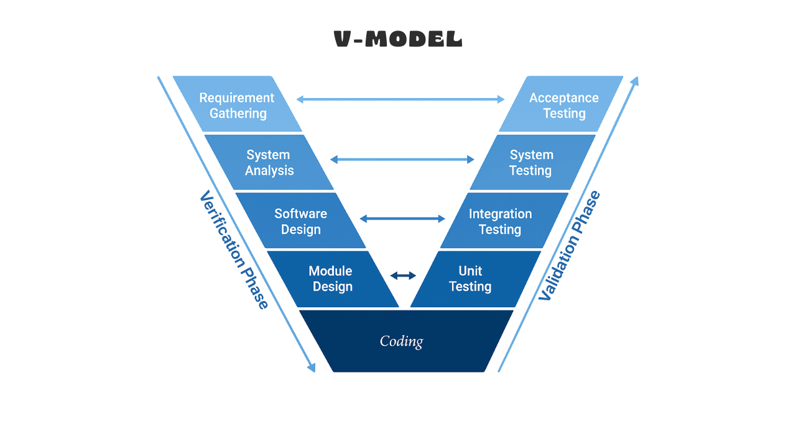

- Applied Philosophy:
+ "Testing Pyramid": Prioritize a large number of Unit Tests, a moderate number of Integration Tests, and few but comprehensive E2E Tests.
+ "Shift-Left": Introduce testing early in the development lifecycle to reduce the cost of change.
+ "Risk-Based": Allocate testing effort according to the risk level of each function.

3.4.2. Testing Levels

A. Unit Testing
- Objective: Verify that each smallest unit of source code works correctly.
- Scope:
+ Utility functions, helper functions.
+ Business logic in services.
+ Component logic (React hooks, helpers).
+ Model validators, transformers.
- Strategy:
+ Isolation: Mock all external dependencies (database, API calls, file system).
+ Coverage: Apply code coverage targets:
+ Statement coverage: ≥ 90%.
+ Branch coverage: ≥ 80%.
+ Function coverage: 100% for critical functions.
- Test Design:
+ Equivalence Partitioning cho input parameters.
+ Boundary Value Analysis cho numeric inputs.
+ Error Guessing for exception handling.
+ Tools: Jest, React Testing Library, Supertest (cho API unit tests).

B. Integration Testing
- Objective: Verify interaction between system components.
- Scope:
+ API endpoints with database (controller → service → model → database).
+ Frontend components with backend APIs.
+ Service-to-service communication.
+ Third-party service integrations.
- Strategy:
+ Incremental Integration: Bottom-up approach, starting from data layer up to API layer.
+ Database Integration: Use test database with transaction rollback.
+ API Contract Testing: Verify request/response schema consistency.
+ End-to-End Integration: Test business workflows across multiple services.
- Tools: Jest with test containers, Supertest, Cypress (for frontend-backend integration).

C. System Testing
- Objective: Verify that the entire system functions according to requirements.
- Scope:
+ End-to-end user journeys.
+ Complete business workflows.
+ Cross-module functionality.
+ Non-functional requirements.
- Strategy:
+ Scenario-Based Testing: Design test cases based on user stories.
+ Exploratory Testing: Supplement to discover scenarios not covered by scripted tests.
+ Regression Testing: Ensure current functionality is not affected by new changes.
- Tools: Cypress, k6 (performance), OWASP ZAP (security).

D. Acceptance Testing.
- Objective: Verify that the system meets business requirements and is ready for deployment.
- Scope:
+ User acceptance testing (UAT) with end-users.
+ Business acceptance testing (BAT) with stakeholders.
+ Operational acceptance testing (OAT) cho deployment.
- Strategy:
+ User Story Validation: Each user story must have at least one acceptance test.
+ Acceptance Criteria: Clearly define “Done” criteria.
+ Production-like Environment: Conduct tests in an environment as close to production as possible.

3.4.3 Types of Testing

A. Functional Testing
- Approach: Black-box testing using techniques:
- Equivalence Partitioning: Group inputs into equivalent classes.
- Boundary Value Analysis: Test at boundary points.
- Decision Table Testing: For complex business rules.
- State Transition Testing: For workflows with multiple states.
- Example application for eCommerce:
- Shopping Cart: Test quantity combinations (0, 1, max, >max).
- Checkout: Test combinations of payment method × shipping method × voucher.

B. Non-functional Testing
- Approach:
- Performance Testing:
- Load Testing: Simulate expected number of users.
- Stress Testing: Push system beyond limits to identify breaking point.
- Endurance Testing: Run stable load over extended time.
- Security Testing:
- Authentication/Authorization Testing: RBAC implementation.
- Input Validation Testing: SQL injection, XSS, CSRF.
- Data Protection Testing: Encryption, PII handling.
- Usability Testing:
- Heuristic Evaluation: Đánh giá theo Nielsen's 10 heuristics.
- Accessibility Testing: WCAG 2.1 compliance.

C. Regression Testing
- Strategy:
- Selective Regression: Run only test cases related to affected areas.
- Automated Regression Suite: Automate stable, critical test cases.
- Risk-Based Regression: Prioritize test cases for high-risk areas.

3.4.4. Test Case Design Techniques

A. Phương pháp hộp đen
- User Story Testing:
- GIVEN the user is logged in.
- AND has products in the cart.
- WHEN the user clicks “Checkout”.
- THEN the system displays the checkout page.
- AND total amount is calculated correctly.
- Use Case Testing: Each use case is mapped into multiple test scenarios.
- Exploratory Testing Charter:
- Charter: Explore checkout flow with vouchers.
- Time Box: 30 minutes.
- Test Data: User with valid voucher, expired voucher, ineligible voucher.
- Notes: Focus on error messages and edge cases.

B. White-box Approach
- Code Coverage Analysis:
- Statement coverage for critical business logic.
- Branch coverage for conditional logic.
- Path coverage for complex algorithms.
- Static Code Analysis:
- ESLint for code quality.
- SonarQube for code smells, bugs, vulnerabilities.

C. Gray-box Approach
- Combine knowledge of internal structure with external behavior:
- API Testing with knowledge of database schema.
- Database Testing with knowledge of application logic.
- Integration Testing with knowledge of component interfaces.

3.5 Testing Strategy

3.5.1 Overall Strategy
- The testing strategy is designed under the principle: Risk-Based, Automation-First, Shift-Left:
- Three main pillars:
- Prevention over Detection: Prioritize preventing defects rather than detecting them.
- Early Feedback: Provide fast feedback to developers.
- Business Risk Focus: Focus on areas with the highest business impact.
- Allocation of testing effort:
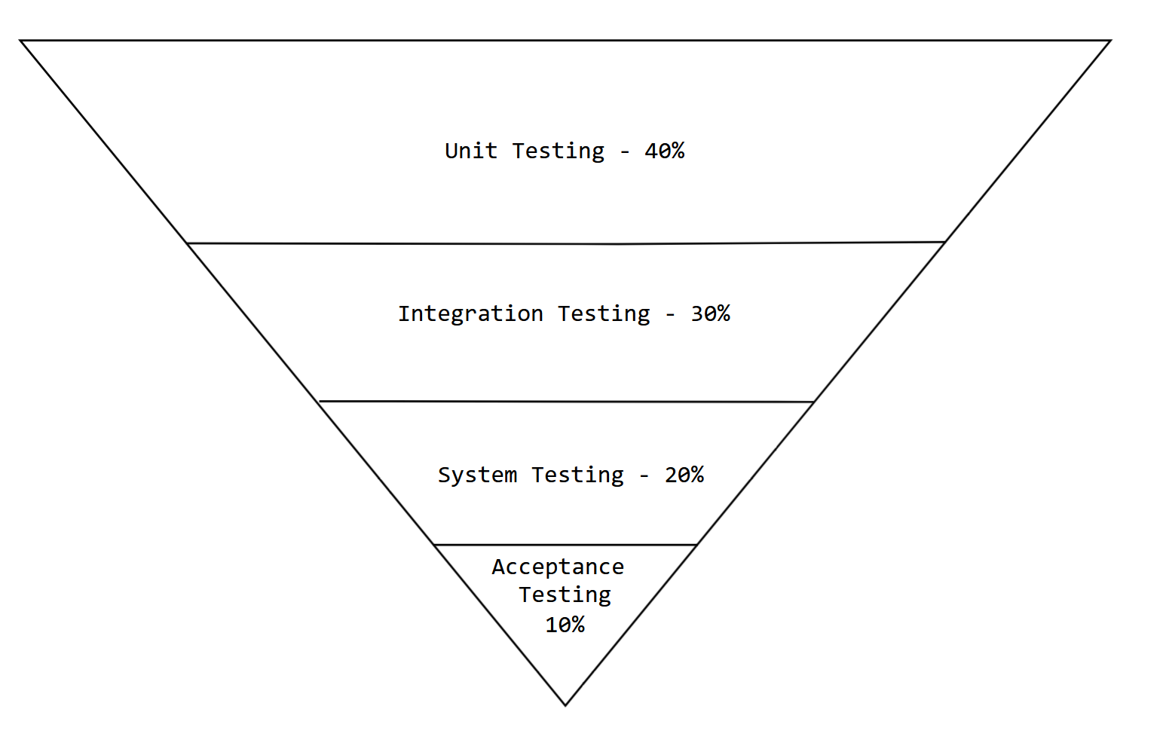

3.5.2 Component-level Strategy

A. Backend Testing Strategy
- Objective: Ensure API reliability, performance, and security
- Database Testing Strategy:
- Isolation Testing: Each test suite uses transactions with automatic rollback
- Test Data Management: Factory patterns to generate test data
- Migration Testing: Versioned database migration with backward compatibility checks
- API Testing Strategy:
- Contract Testing: Validate OpenAPI/Swagger specification
- Negative Testing: Invalid inputs, error conditions
- Security Testing: Authentication, authorization, injection attacks

B. Frontend Testing Strategy
- Objective: Ensure UI responsiveness, accessibility, and user experience
- Approach:
1. Component Testing Strategy:
- Isolation Testing: Test components independently with mocked dependencies
- Integration Testing: Test interaction between components
- Snapshot Testing: Detect unintended UI changes
2. End-to-End Testing Strategy:
- Critical User Journeys: Register → Browse → Cart → Checkout → Order Tracking
- Cross-browser Testing: Chrome, Firefox, Safari
- Mobile Responsive Testing: 3 breakpoints (mobile, tablet, desktop)
3. C Accessibility Testing Strateg:
- Automated Scanning: Integrate axe-core
- Manual Testing: Keyboard navigation, screen reader compatibility
- WCAG Compliance: Levels A, AA

C. Performance Testing Strategy
- Objective: Ensure the system meets performance requirements
- Approach:
- Load Test Scenarios:
- Scenario 1: Product browsing (80% read operations)
- Scenario 2: Add to cart (15% write operations)
- Scenario 3: Checkout flow (5% complex transactions)

3.5.3. Test Automation Strategy

A. Test Automation Pyramid
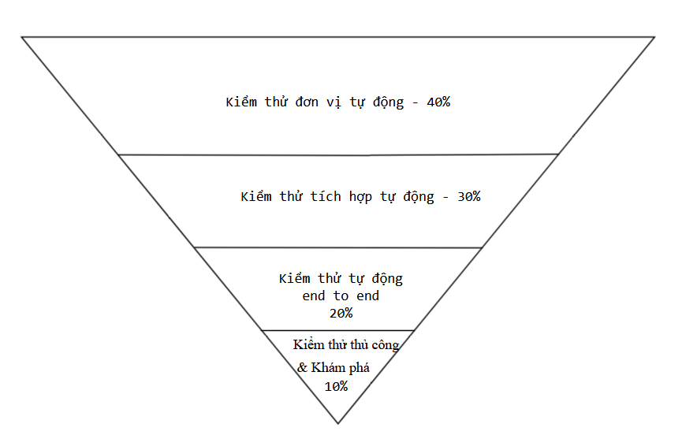

B. Test Automation Stack
Test Type | Tool | Purpose
Unit Testing | Jest, React Testing Library | Test components and functions
API Testing | Supertest, Jest | Validate backend APIs
End-to-End Testing | Cypress | Browser automation
Performance | k6 | Load and stress testing
Security | OWASP ZAP, npm audit | Vulnerability scanning
Static Analysis | ESLint, SonarQube | Check code quality

C. CI/CD Integration Strategy
+ The GitHub Actions CI/CD process must complete with a successful status.
+ No test errors should exist in the automated pipeline.

3.5.4. Test Data Management Strategy
A. Test Data Principles
+ Isolation: Each test case is independent and does not depend on execution order.
+ Consistency: Test data is created and cleaned up consistently.
+ Realism: Test data reflects actual production data.
+ Minimalism: Only create data necessary for the test case.

B. Test Data Management Approach
+ In-Memory Database: SQLite for unit testing.
+ Test Containers: Docker containers for integration testing.
+ Data Factory: Factory functions to create test data.
+ Fixed Dataset: Predefined datasets for common scenarios.
3.6. Resources
3.6.1. Human Resources
Person Performing | Role | Specific Tasks
Tran Huu Nam | Tester/Developer | Test planning, performing system testing, writing CI/CD code in GitHub Actions, documenting test artifacts.
Pham Thanh Phong | Tester/Developer | Test Case design, performing unit and integration testing, creating review checklists, documenting test artifacts.
Dr. Do Nhu Tai | Product Owner | Performing acceptance testing.

3.6.2. Test Schedule
Task | Person in Charge | Start Date | End Date
Test Planning | Tran Huu Nam | 20/10/2025 | 20/11/2025
Test Case Design | Pham Thanh Phong | 21/11/2025 | 28/11/2025
Create Review Checklist | Pham Thanh Phong | 22/11/2025 | 31/11/2025
Perform Unit & Integration Testing | Pham Thanh Phong | 01/12/2025 | 05/12/2025
Perform System Testing | Tran Huu Nam | 06/12/2025 | 8/12/2025
Write CI/CD Code in GitHub Actions | Tran Huu Nam | 30/11/2025 | 9/12/2025
Document Test Artifacts | Tran Huu Nam, Pham Thanh Phong | 03/12/2025 | 10/12/2025
Perform Acceptance Testing | Dr. Do Nhu Tai | 17/12/2025 | 24/12/2025
3.7. Test Environment
3.7.1. Hardware
Item | Component | Technical Specifications | Purpose
Local Development Environment | Personal Computer | CPU: 4+ cores, RAM: 8GB+, SSD: 256GB+ | Source code development, running unit and integration tests.
CI/CD Test Environment | GitHub Actions Runner | Ubuntu-latest, 4 vCPU, 16GB RAM | Automated execution of test pipelines.
Mobile Test Device | Android/iOS Phone | Android 11+, iOS 14+ | Testing UI and compatibility on mobile devices.
Tablet Test Device | iPad/Android Tablet | 9-11 inch screen | Testing responsive design.

3.7.2. Software
A. Development Tools
Tool | Version | Purpose
Visual Studio Code | 1.85+ | Primary IDE for frontend and backend development.
Node.js | 18.x LTS | Runtime for backend API and frontend build.
npm | 9.x | Package and dependency management.
Git | 2.40+ | Source code version control.
Docker Desktop | 4.24+ | Containerization for development environment.
DBeaver | 8.0+ | Database management and querying.

B. Testing Tools
Tool | Version | Testing Purpose
Jest | 29.x | Unit testing for JavaScript/TypeScript.
React Testing Library | 14.x | React component testing.
Supertest | 6.x | HTTP API testing.
Cypress | 13.x | Automated end-to-end testing.
k6 | 0.47+ | Performance and load testing.
Postman | 10.x | Manual and automated API testing.
OWASP ZAP | 2.13+ | Security testing.

3.7.3. Infrastructure
A. Deployment Infrastructure
Component | Service/Platform | Configuration | Purpose
Frontend Hosting | Railway | Free Tier | Deploy React.js application.
Backend API Hosting | Railway | Free Tier | Deploy Node.js server.
Database Hosting | Railway | MySQL 8.0, 1GB RAM | Store product, order, user data.

B. CI/CD Infrastructure
Component | Tool/Service | Configuration | Purpose
Version Control | GitHub | Private Repository | Source code management and collaboration.
CI/CD Pipeline | GitHub Actions | Ubuntu runner, Docker container | Automate build, test, deploy.
Container Registry | Docker Hub | Public/Private repository | Store Docker images.
Artifact Storage | GitHub Actions Artifacts | 90 days retention | Store test reports, coverage, logs.

C. Test Environment
Environment | Component | Configuration | Testing Purpose
Development Environment | Local Docker Compose | Frontend:3000, Backend:8080, MySQL:3306 | Local unit, integration testing.
CI Environment | GitHub Actions Containers | MySQL test container, Node.js runner | Automated testing in pipeline.
Staging Environment | Cloud Deployment | Subdomain: staging.ecommerce-ktpm.com | System, performance, security testing.
Acceptance Environment | Cloud Deployment | Subdomain: uat.ecommerce-ktpm.com | User acceptance testing.
3.8. Deliverables
Create Word documents including Architecture Design, Database Design, Test Plan, Software Requirements Specification, Bug Report, and overall software and testing report.
Create Excel documents including all interface specifications, Use Case specifications, Review Checklist, Test Report, Test Case, Test Design.
Project source code stored on GitHub including unit test, integration test, system test files, and CI/CD pipeline on GitHub Actions (.github/workflows/ci-cd.yml).

Chapter 4: TEST DESIGN

4.1. INTRODUCTION
The KTPM project is an e-commerce web-based system, serving two main user groups: customers and administrators. The deployment architecture consists of a user interface developed with React, an API service developed with Node.js/Express, and a MySQL database. Related technical artifacts are located in the eCommerce_Reactjs/, ecomAPI/ folders and initialization data in ecom.sql.
From a methodological perspective, Chapter 4 serves as the "bridge" between the test plan (Chapter 3) and test execution activities. The content of this chapter goes beyond listing test cases; it describes how the team transforms requirements and risks into executable test scenarios while ensuring traceability from requirements to test cases and from test cases to test code.
The primary inputs for test design activities include: (1) requirements and business flows analyzed in Chapters 1-2, (2) the level-based and risk-based test strategy from Chapter 3, and (3) existing system artifacts such as endpoint lists, UI flows, and data constraints. The outputs of test design activities include: a baseline test case list, a traceability matrix, and a catalog of test scenarios by level.
In the repository, artifacts supporting traceability and test case management are organized for "easy inspection, easy automation": (1) baseline test case list at: + docs/PHU_LUC_A_TEST_CASES.md + (2) requirement - test case - test code mapping at docs/tests/test-cases.csv + (3) requirement - CI workflow mapping at docs/tests/traceability.csv + (4) evidence collection guide at docs/EVIDENCE_CAPTURE.md.

4.2. TEST DESIGN PROCESS USING V-MODEL
The team uses the V-Model as an organizing framework to ensure symmetry between development artifacts and corresponding testing activities. The reason for choosing the V-Model for this project is that the system has many clear points of interaction between the interface, API, and database; without a verification mechanism, it's easy to have "features without tests" or "tests without traceability to requirements". The V-Model helps systematize layered test design while enabling early defect detection as planned in
Chapter 3.
The symmetry framework is understood as a principle: business requirements must have acceptance criteria; system design must have system test scenarios; architectural design must have integration testing; and module design must have unit testing. In the project, the team implements this principle by linking test groups to real artifacts in the repository.

4.2.1. Requirements Analysis - Acceptance Testing
At this stage, the team focuses on analyzing business requirements from system specifications and user stories to formulate acceptance criteria. Inputs include requirement documents, use case diagrams, and feature lists by module. From the requirements analysis, the team identifies key business flows such as registration/login, product browsing, cart management, ordering, payment, and account management. Each business requirement is transformed into verifiable acceptance test criteria, forming the basis for system-level test case design.

4.2.2. System Design - System Testing
Based on requirements analysis, the team proceeds with overall system architecture design including user interface (frontend), API service (backend), and database. System design describes how components interact through API contracts and data flows. From this design, the team defines end-to-end system test scenarios, focusing on verifying complete business flows from the interface to the backend and vice versa. System test cases are designed to test system integrity and component interoperability.

4.2.3. Architectural Design - Integration Testing
At the architecture level, the team focuses on detailed design of each component and their communication. Architectural design includes API structure diagrams, data models, and interfaces between modules. From architectural design, the team identifies integration points to be tested such as communication between controller-service-repository, between backend and database, and between services. Integration testing is designed to verify the correctness of these communications, ensuring data is transmitted and processed correctly across architectural layers.

4.2.4. Module Design - Unit Testing
Module design focuses on breaking down each component into smaller, independently testable units. Each module is designed with specific functions, methods, and input/output constraints. From module design, the team identifies necessary test units for each utility function, service, controller, and repository. Unit testing is designed to control logic inside each function, including conditional branches, error handling, and business calculations.

4.2.5. Code Execution - White-Box Testing
During the code execution phase, modules are implemented according to the defined design. This is the stage where white-box testing is most strongly applied, using knowledge of the source code structure to design test cases that control execution paths, conditional branches, and code coverage. The team uses control flow graph (CFG) analysis and cyclomatic complexity techniques to determine the minimum number of test cases needed for adequate testing.

4.2.6. V-Model Process Summary
The V-Model test design process creates a highly systematic structure, ensuring each development phase has corresponding testing activities. The symmetry of the V-Model helps the team maintain consistency between requirements and testing while facilitating early defect detection in the development lifecycle. Test artifacts created at each stage form a complete traceability chain from requirements to test code.

4.3. TEST DESIGN TECHNIQUES

4.3.1. Black-Box Testing
Black-box testing focuses on verifying system behavior based on requirement specifications without concern for internal structure. In the project, the team applies the following black-box techniques:
Equivalence Partitioning
This technique is applied to divide input values into equivalence classes, reducing the number of required test cases while ensuring coverage. For example, with the login function:
+ Valid class: correctly formatted email, correct password.
+ Invalid class: incorrectly formatted email, wrong password, missing information.
Test cases are designed to take at least one representative value from each class, ensuring system behavior is tested for each data group.
Boundary Value Analysis
Boundary value analysis focuses on testing values at the boundaries between classes. In the eCommerce system, fields with boundary values include:
+ Product quantity (minimum, maximum values).
+ Product price (negative values, zero, large values).
+ Pagination (first page, last page, non-existent page).
Test cases are designed to test values at and just beyond boundaries, as these are most error-prone locations.
Decision Table
Decision tables are used to test complex business rules, particularly authorization systems. With an eCommerce system having multiple roles (admin, user, guest) and various access conditions, decision tables help systematize all condition combinations and corresponding actions.
ID | Has Token | Token Valid | Role | Requested Endpoint | Expected Result
1 | No | - | Guest | Public API | Success (200)
2 | No | - | Guest | User API | 401 Unauthorized
3 | No | - | Guest | Admin API | 401 Unauthorized
4 | Yes | Invalid | User | User API | 403 Forbidden
5 | Yes | Valid | User | User API | Success (200)
6 | Yes | Valid | User | Admin API | 403 Forbidden
7 | Yes | Valid | Admin | Admin API | Success (200)
Table 4.1. Decision Table for API Access Authorization
From the decision table, the team identifies 7 necessary test cases to test all authorization scenarios. Each row in the table corresponds to a specific test case.
State Transition
State transition technique is applied to objects with complex lifecycles such as orders. Order states in the system include: pending, confirmed, processing, shipped, delivered, cancelled. Valid and invalid state transitions are identified for test case design.
From State | To State | Valid | Description
Pending | Confirmed | Yes | Admin confirms order.
Pending | Cancelled | Yes | Cancel order before confirmation.
Confirmed | Processing | Yes | Begin processing order.
Confirmed | Cancelled | Yes | Cancel order after confirmation.
Processing | Shipped | Yes | Handed over to shipping provider.
Processing | Cancelled | No | Cannot cancel while processing.
Shipped | Delivered | Yes | Delivery successful.
Shipped | Cancelled | No | Cannot cancel after shipping.
Table 4.2. Order State Transition Matrix
Based on this matrix, the team designs test cases to test each state transition, ensuring the system only allows valid transitions and rejects invalid ones.
This method ensures the eCommerce system handles state transitions accurately and consistently, especially important for complex workflows like order processing and payment handling.

4.3.2. White-Box Testing
White-box testing focuses on the internal structure of source code, using knowledge of program logic to design test cases. In the project, the team applies the following white-box techniques:
Control Flow Graph (CFG) Analysis
Control flow graphs are used to represent program execution flow. The team selects the calculateTotalWithDiscount function in the order processing service for illustration.
Source code of the calculateTotalWithDiscount() function:
function calculateTotalWithDiscount(items, voucher) {
// Node 1: Kiểm tra đầu vào
if (!items || items.length === 0) {
throw new Error('Danh sách sản phẩm không được trống');
}
// Node 2: Tính tổng tiền
let subtotal = 0;
for (const item of items) {
if (item.price < 0 || item.quantity <= 0) {
throw new Error('Giá hoặc số lượng không hợp lệ');
}
subtotal += item.price * item.quantity;
}
// Node 3: Áp dụng giảm giá nếu có
let discount = 0;
if (voucher) {
if (voucher.type === 'percentage') {
// Node 4: Giảm giá theo phần trăm
discount = subtotal * (voucher.value / 100);
if (discount > voucher.maxAmount) {
discount = voucher.maxAmount;
}
} else if (voucher.type === 'fixed') {
// Node 5: Giảm giá cố định
discount = voucher.value;
if (discount > subtotal) {
discount = subtotal;
}
}
}
// Node 6: Tính tổng cuối cùng
const total = subtotal - discount;
if (total < 0) {
return 0;
}
// Node 7: Trả về kết quả
return {
subtotal,
discount,
total
};
}
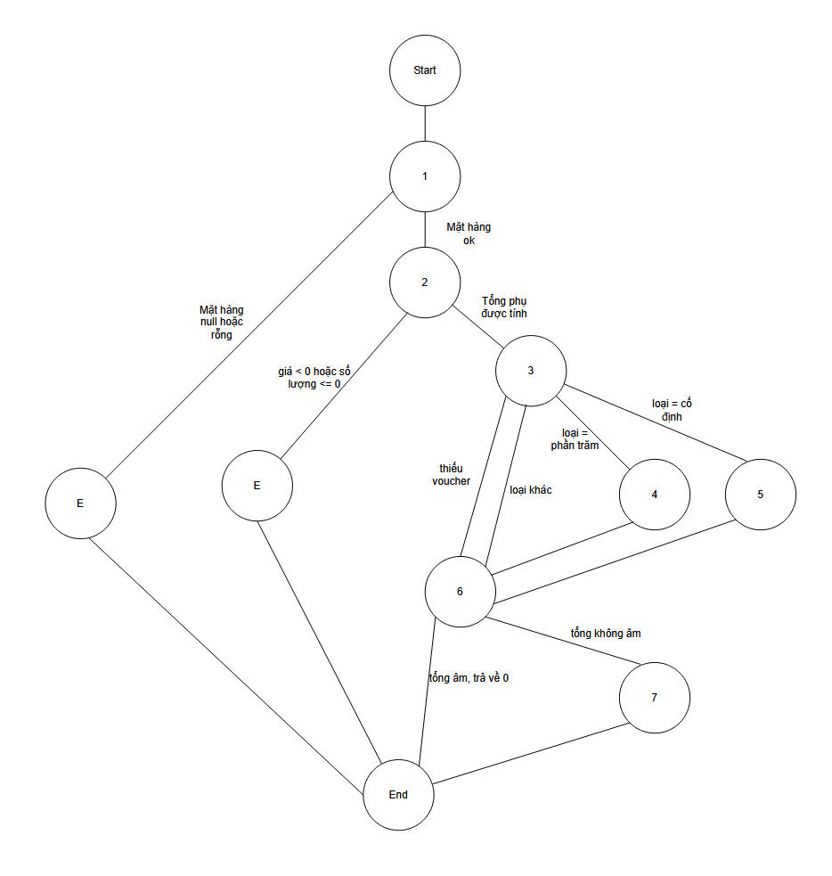
Control Flow Graph (CFG)
From the source code above, the team builds a control flow graph with nodes and edges as follows:
Figure 4.1: Control Flow Graph of the calculateTotalWithDiscount() function.
Graph description:
+ Node 1 → Node 2: Check product list
+ Node 2 → Node 3: Calculate subtotal
+ Node 3 → Node 4: Apply percentage discount
+ Node 3 → Node 5: Apply fixed discount
+ Node 3 → Node 6: No voucher
+ Node 4 → Node 6: Percentage discount (with/without max limit)
+ Node 5 → Node 6: Fixed discount (whether it exceeds subtotal)
+ Node 6 → Node 7: Calculate final total
Cyclomatic Complexity
Cyclomatic complexity is calculated to determine the minimum number of test cases required.
Calculation:
+ Number of edges (E): 11
+ Number of nodes (N): 9
+ Number of connected components (P): 1
+ Cyclomatic complexity: M = E - N + 2P = 11 - 9 + 2 = 4
The result shows that at least 4 test cases are needed to cover all independent paths in the function.
Basis Paths
Based on the CFG, the team identifies the following 4 basis paths:
Path 1: 1 → 2 (empty list error)
Path 2: 1 → 2 → 3 → 6 → 7 (no voucher, simple total calculation)
Path 3: 1 → 2 → 3 → 4 → 6 → 7 (percentage voucher, not exceeding max)
Path 4: 1 → 2 → 3 → 5 → 6 → 7 (fixed voucher, not exceeding subtotal)
Designing Test Cases from Basis Paths
From the basis paths, the team designs corresponding test cases:
Test Case ID | Đường đi | Đầu vào | Kết quả mong đợi
TC-WH-01 | Đường 1 | items = [] | Lỗi: "Danh sách sản phẩm không được trống"
TC-WH-02 | Đường 2 | items = [{price: 100, quantity: 2}], voucher = null | subtotal: 200, discount: 0, total: 200
TC-WH-03 | Đường 3 | items = [{price: 100, quantity: 2}], voucher = {type: 'percentage', value: 10, maxAmount: 50} | subtotal: 200, discount: 20, total: 180
TC-WH-04 | Đường 4 | items = [{price: 100, quantity: 2}], voucher = {type: 'fixed', value: 50} | subtotal: 200, discount: 50, total: 150
Table 4.3. White-box Test Cases for the calculateTotalWithDiscount Function
Test Case ID | Basis Path | Input Data | Expected Output
TC-UNIT-CALC-01 | Path 1 (1→2) | items: null or empty array, voucher: any | Throws Error: "Product list cannot be empty"
TC-UNIT-CALC-02 | Path 2 (1→2→3→6→7) | items: [{price: 100, quantity: 2}], voucher: null | Returns: {subtotal: 200, discount: 0, total: 200}
TC-UNIT-CALC-03 | Path 3 (1→2→3→4→6→7) | items: [{price: 100, quantity: 3}], voucher: {type: 'percentage', value: 10, maxAmount: 25} | Returns: {subtotal: 300, discount: 25, total: 275} (Discount capped at maxAmount)
TC-UNIT-CALC-04 | Path 4 (1→2→3→5→6→7) | items: [{price: 50, quantity: 2}], voucher: {type: 'fixed', value: 30} | Returns: {subtotal: 100, discount: 30, total: 70}
These test cases are implemented in the file ecomAPI/tests/unit/orderUtils.test.js and run automatically in the CI/CD process.

4.4. TEST DESIGN AND IMPLEMENTATION METHODOLOGY

4.4.1. Manual Testing
Manual testing is applied for complex scenarios that are difficult to automate or require the subjective evaluation of the tester. In the project, manual testing focuses on:
User Interface Testing
+ Layout and Responsive Testing: Ensure the interface displays correctly on different screen sizes.
+ User Experience Testing: Evaluate the intuitiveness and ease of use of the interface.
+ Browser Compatibility Testing: Ensure the system works on popular browsers.
User Acceptance Testing
+ End-to-End Business Flow Testing: From login to order completion.
+ Business Correctness Evaluation: Compare actual results with business requirements.
+ Data Consistency Testing: Ensure data is displayed correctly across different pages.

Exploratory Testing
+ Detecting Potential Bugs: Testing scenarios not covered in test cases.
+ Basic Security Testing: Trying simple attacks like SQL injection, XSS.
+ Error Handling Testing: Evaluating how the system handles abnormal situations.

4.4.2. Automated Testing
Automated testing is the focus of the project's testing strategy, helping to ensure continuous quality and early bug detection.
Unit Testing
+ Tools: Jest for backend, Jest + React Testing Library for frontend.
+ Scope: Utility functions, services, React components.
+ Goal: Achieve minimum 80% coverage for important files.
Example unit test case for the validateEmail() function:
test('validateEmail trả về true cho email hợp lệ', () => {
expect(validateEmail('test@example.com')).toBe(true);
});
test('validateEmail trả về false cho email không có @', () => {
expect(validateEmail('testexample.com')).toBe(false);
});
test('validateEmail trả về false cho email không có domain', () => {
expect(validateEmail('test@')).toBe(false);
});
Integration Testing
+ Tool: Supertest for API testing, Jest for service integration
+ Scope: Integration between controller-service-repository, API endpoints
+ Goal: Test the accuracy of data flow across layers
Example integration test case for login API:

test('POST /api/login thành công với thông tin hợp lệ', async () => {
const response = await request(app)
.post('/api/login')
.send({ email: 'user@example.com', password: 'password123' });
expect(response.statusCode).toBe(200);
expect(response.body).toHaveProperty('token');
expect(response.body).toHaveProperty('user');
});
test('POST /api/login thất bại với password sai', async () => {
const response = await request(app)
.post('/api/login')
.send({ email: 'user@example.com', password: 'wrongpassword' });
expect(response.statusCode).toBe(401);

expect(response.body).toHaveProperty('message', 'Thông tin đăng nhập không chính xác');
});
System Testing
+ Tool: Cypress for end-to-end testing
+ Scope: Main business flows from interface to backend
+ Goal: Ensure the system functions correctly as a unified entity
Example system test case for the purchase flow:
describe('Luồng mua hàng', () => {
it('Người dùng có thể thêm sản phẩm vào giỏ và đặt hàng', () => {
cy.visit('/');
cy.login('user@example.com', 'password123');
cy.get('.product-card:first').click();
cy.get('.add-to-cart').click();
cy.get('.cart-icon').click();
cy.get('.checkout-button').click();
cy.get('.confirm-order').click();
cy.get('.order-success').should('be.visible');
});
});
CI/CD Integration
All automated testing is integrated into the CI/CD process through GitHub Actions. Whenever new code is pushed to the repository, the CI/CD workflow automatically runs test suites and reports results.
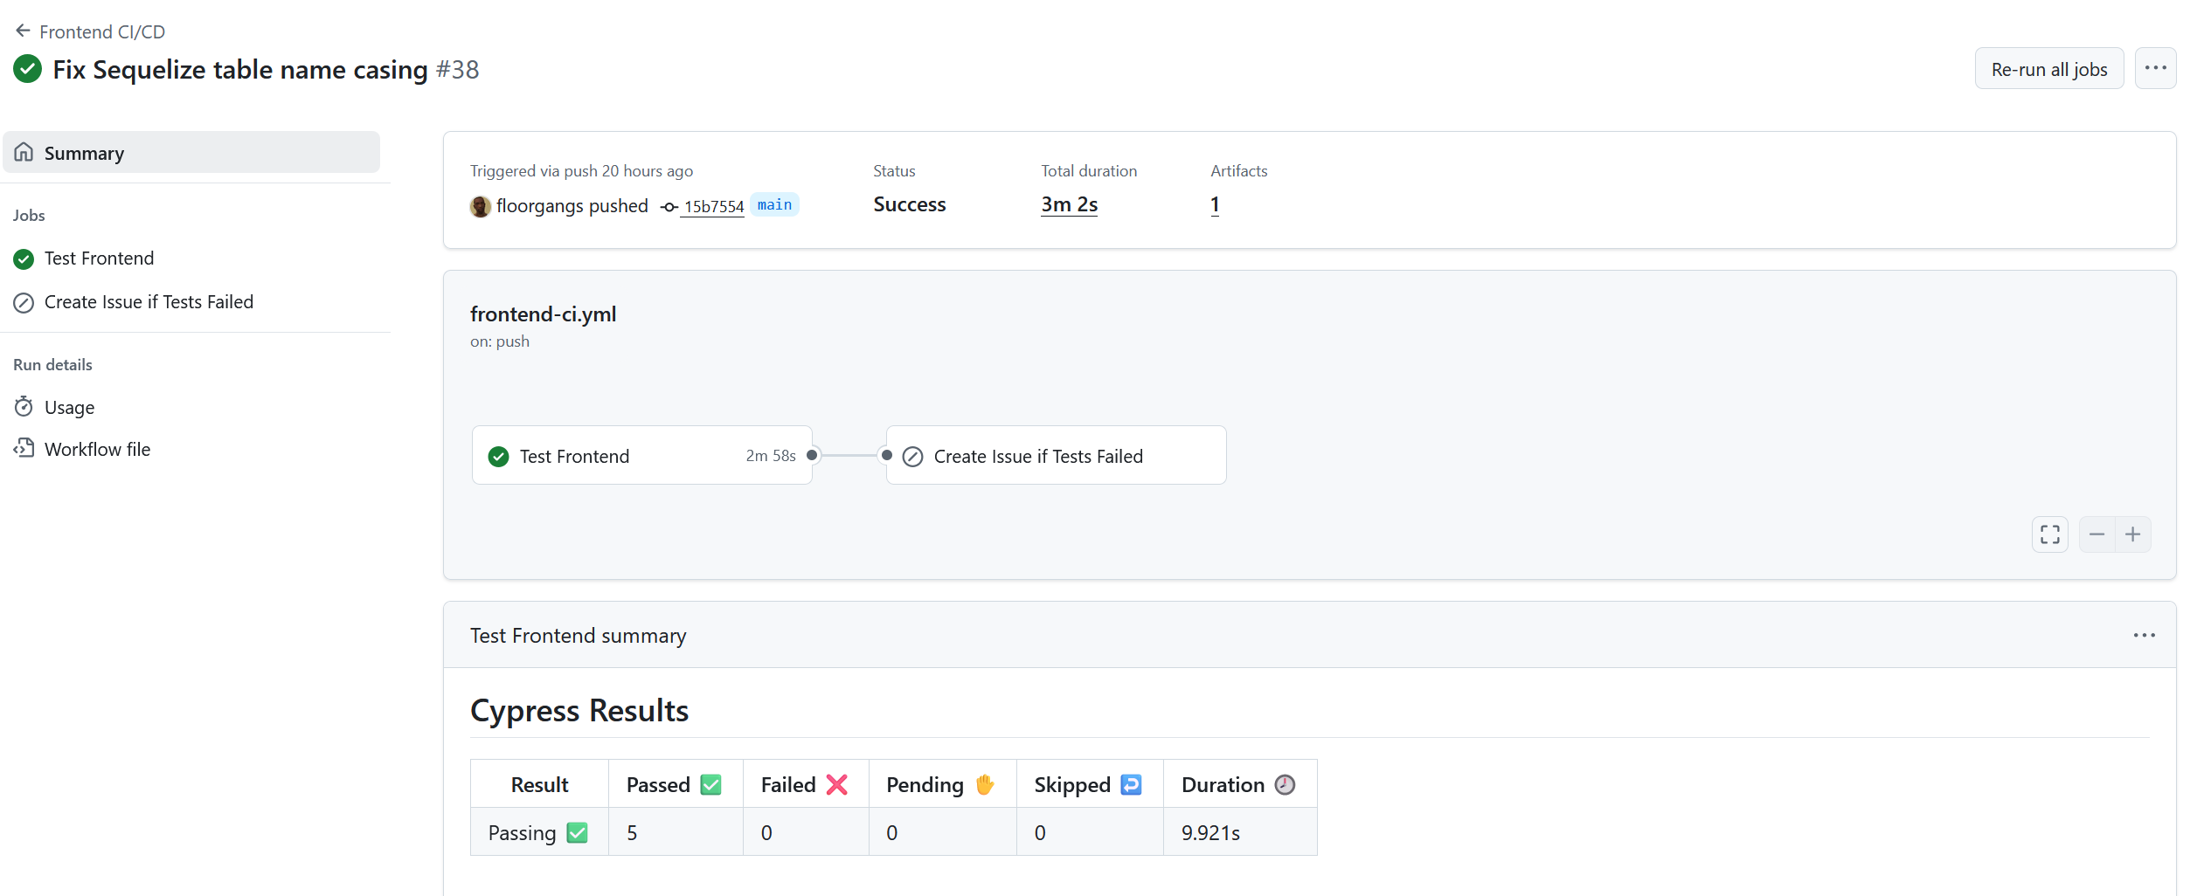
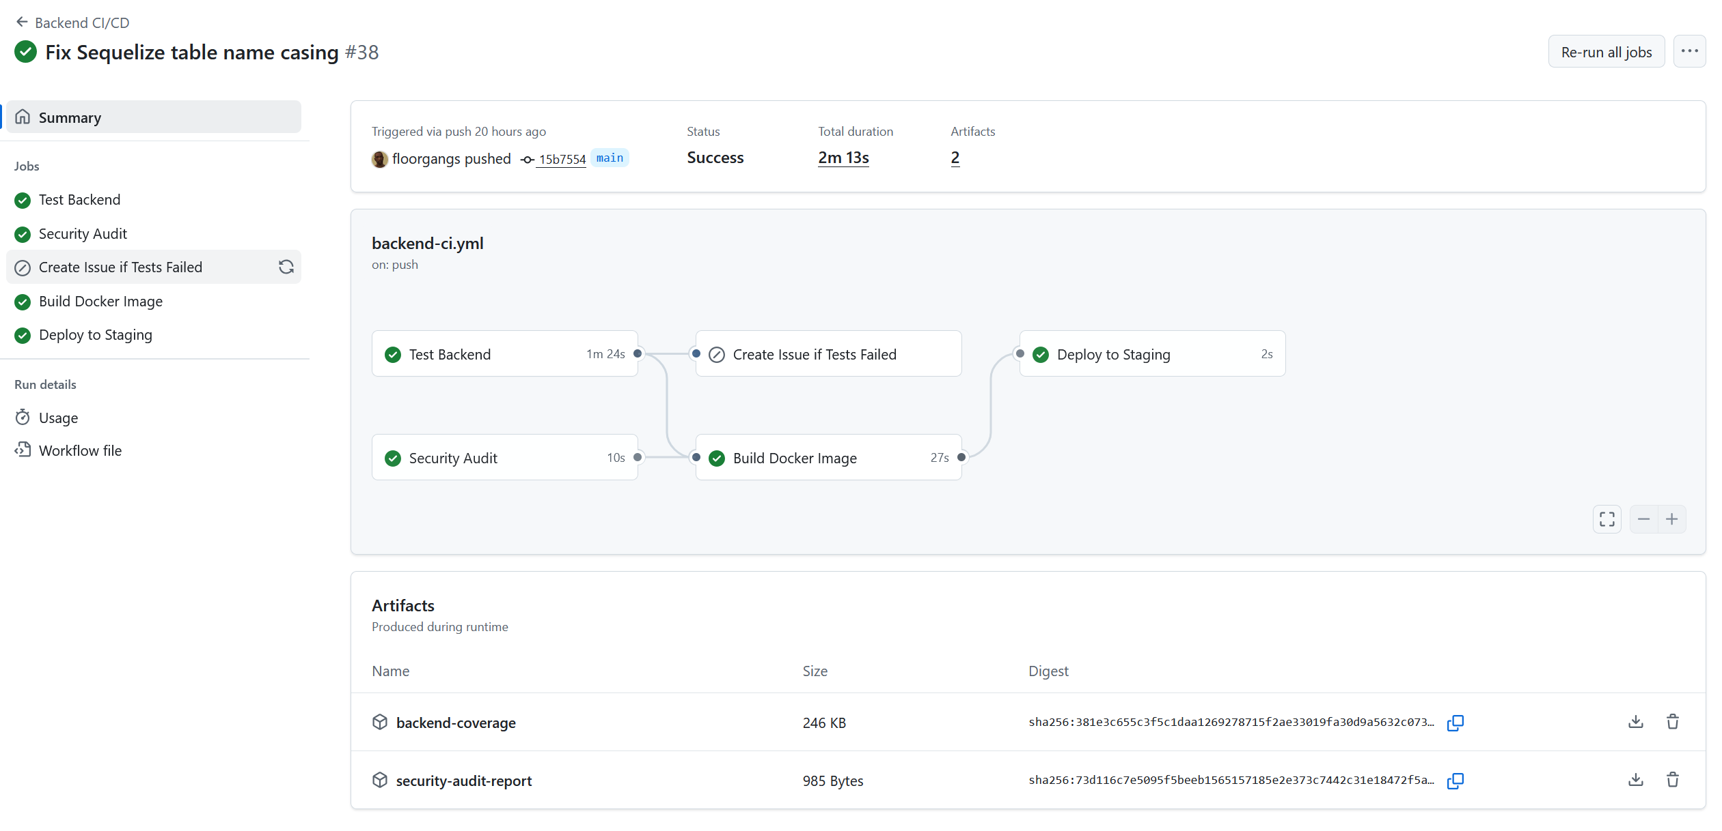
Figure 4.2: Project CI/CD Pipeline
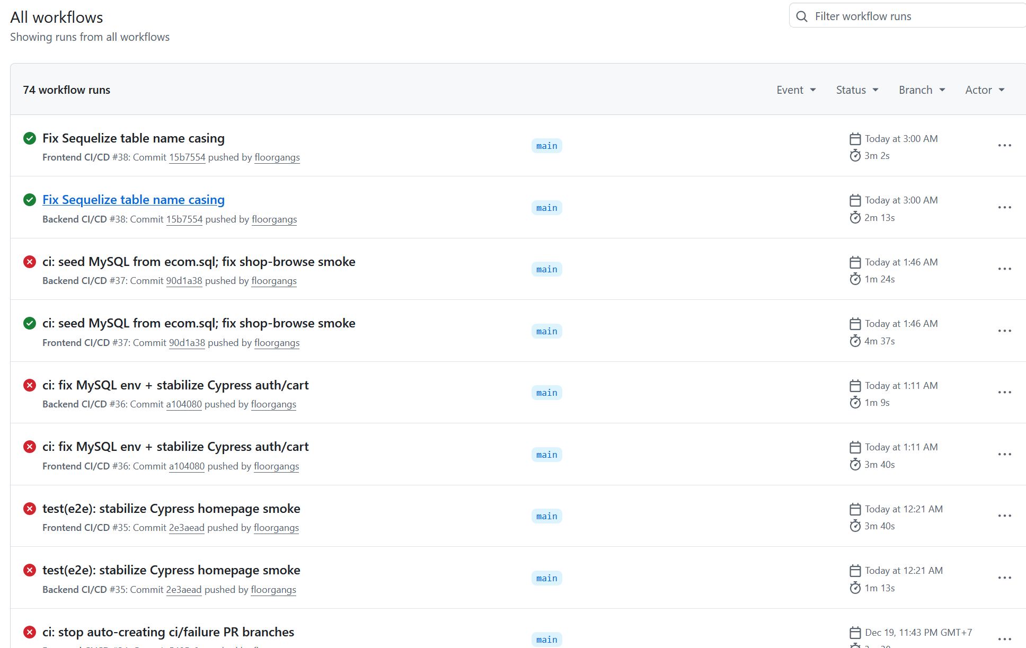
Figure 4.3: List of Github Action Runs
CI/CD Flow:
- Trigger: Code push or pull request
- Setup: Checkout code, install dependencies
- Backend Testing: Run unit tests, integration tests for backend
- Frontend Testing: Run unit tests, component tests for frontend
- E2E Testing: Run Cypress tests for main flows
- Build: Build frontend and backend applications
- Deploy: Automatically deploy to staging environment if tests pass
Advantages of CI/CD Integration:
+ Detect errors immediately when new code is added
+ Ensure codebase stability
+ Automate testing process, saving time
+ Provide quick feedback to developers

4.5. APPLYING GENAI IN TEST CASE DESIGN

In this project, Generative AI (GenAI) is used as a supporting tool in the test case design phase, helping to increase productivity and test coverage.

4.5.1. GenAI Application Process
The process of applying GenAI in test case design includes 4 main steps:

Figure 4.4: Test Case Generation Process with GenAI
Step 1: Prepare Input
+ Detailed requirement specifications for the feature
+ User stories and acceptance criteria
+ API design documentation (if available)
+ Business and technical constraints
Step 2: Interact with GenAI
+ Provide full context about the feature to be tested
+ Request GenAI to propose test cases using different techniques
+ Provide feedback and refine GenAI's suggestions
Step 3: Evaluate and Edit
+ Assess the validity of proposed test cases
+ Modify to fit the project context
+ Add specific test cases that GenAI might have missed
Step 4: Consolidate and Standardize
+ Consolidate test cases into the official list
+ Standardize format according to project template
+ Add to the test case management system

4.5.2. Example of Applying GenAI to the Login Function
Input provided to GenAI:
− Function: Login to the eCommerce system
− Input: email (string), password (string)
− Output: JWT token and user information if successful, error message if failed
− Requirements:
+ Email must be in correct format
+ Password must be at least 6 characters
+ Account must exist and not be locked
+ Password must match the account
Suggestions from GenAI:
Proposed test cases:
Successful login:
Input: valid email, correct password
Expected: HTTP 200, includes token and user info
Invalid email format:
Input: email without @, any password
Expected: HTTP 400, message "Invalid email"
Password too short:
Input: valid email, password less than 6 characters
Expected: HTTP 400, message "Password must be at least 6 characters"
Non-existent account:
Input: unregistered email, any password
Expected: HTTP 401, message "Login information is incorrect"
Locked account:
Input: email of a locked account, correct password
Expected: HTTP 403, message "Account is locked"
Incorrect password:
Input: valid email, wrong password
Expected: HTTP 401, message "Login information is incorrect"
Missing email:
Input: only password
Expected: HTTP 400, message "Email is required"
Missing password:
Input: only email
Expected: HTTP 400, message "Password is required"

4.5.3. Editing and Finalizing
From GenAI's suggestions, the team proceeded with editing to align with actual implementation:
- Add test case for SQL injection: GenAI didn't propose security test cases
- Adjust error codes: According to the actual implementation in the project
- Add performance test case: Check response time with multiple requests
- Standardize format: According to the project's test case template

4.5.4. Benefits and Limitations
Benefits:
+ Accelerates test case design, especially for complex features
+ Proposes test cases that testers might overlook
+ Supports brainstorming and expands test coverage
+ Reduces bias in test case design
Limitations:
+ Need to verify the accuracy of proposed test cases
+ May propose infeasible or context-inappropriate test cases
+ Cannot replace tester experience and intuition
+ Needs supplementation with project-specific test cases

4.5.5. Application Results
After applying GenAI, the team designed a total of 90 baseline test cases, of which:
+ 40 test cases were proposed and refined from GenAI
+ 50 test cases were manually designed based on experience and risk analysis
The test cases are stored in docs/PHU_LUC_A_TEST_CASES.md and mapped to automated test code in docs/tests/test-cases.csv.

Chapter 5: TEST REPORT

5.1. Test Process Overview

After completing the test design phase in Chapter 4, the team proceeded with testing the eCommerce system according to the established plan. The testing process was implemented in stages from unit testing, integration testing to system testing through the CI/CD Pipeline set up on GitHub Actions.
The team focused on testing all major business functions of the Full Stack eCommerce system. Test Cases were automated through workflows and results were fully documented in reports and artifacts.

5.2. Test Case Report

5.2.1. Introduction
Test cases were built in two main directions: Positive Testing (testing expected correct behavior) and Negative Testing (testing error handling and boundary conditions). The test suite was designed to cover 6 main functional modules of the e-commerce system.
Summary of Test Case Execution Results (Baseline TC01–TC90):
Module | Code | Number of TCs | Result (PASS) | Notes
Access Control | AUTH/ADMIN | 21 | 17 | TC01–09, TC28–39 (4 TC planned)
Products | PROD | 24 | 24 | TC10–21, TC40–51
Shopping Cart | CART | 8 | 7 | TC52–59 (TC56 planned)
Orders | ORD | 17 | 17 | TC22–27, TC60–68, TC73–74
Payment | PAY | 4 | 4 | TC69–72
Voucher/Promotion | VOUCH | 8 | 8 | TC75–82
System E2E | E2E | 6 | 0 | TC83–88 (Planned)
Non-Functional | NONFUNC | 2 | 1 | TC89–90 (TC90 Performance Planned)
Total |  | 90 | 78

5.2.2. Coverage Scope
The team built 90 Test Cases (according to baseline docs/PHU_LUC_A_TEST_CASES.md) covering key business functions of the system. Among these, 78 Test Cases were implemented and executed (Passed), achieving an implementation rate of 86.7%. The remaining 12 Test Cases are kept in design status (Planned) for subsequent development phases. Testing scope focused on main functions (functional testing), with 2 non-functional test cases designed, of which 1 test case (AuthZ) was executed.

5.2.3. Execution Results
Summary results from automated execution for Backend (snapshot from ecomAPI/jest-results.json) are as follows:
+ Total automated tests: 116 tests
+ PASS: 109 tests (≈ 94.0%)
+ FAIL: 0 tests
Not run (Pending): 7 test (≈ 6.0%)
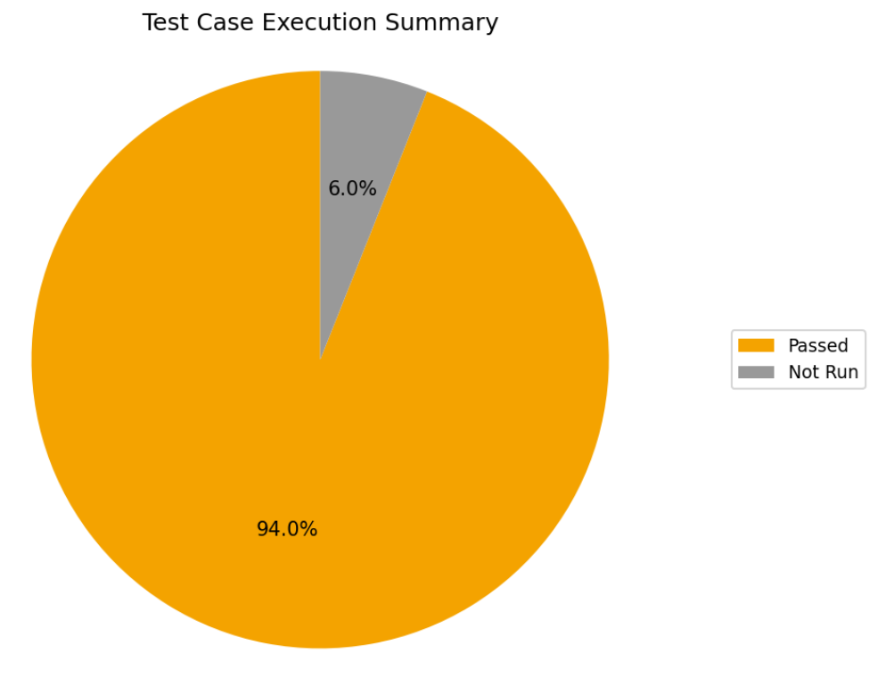
Figure 5.1: Pie chart of Test Case Execution Percentage
The chart above shows a very high success rate (94%) for the implemented automated test cases, indicating that the main source code is stable and meets test specifications.

5.3. Bug Report

5.3.1. Bug Classification by Severity Level
During the testing process and CI/CD Pipeline operation, the team discovered, recorded, and resolved 2 defects. The defects are classified into 4 severity levels based on their impact on the system and users. Details of each defect are as follows:
Defect D-01 (High Level): Database-related error in CI.
Symptom: Integration tests in CI returned errCode: -1 errors in batches.
+ Root Cause: Inconsistency in table name case-sensitivity between the database seed file (ecom.sql - uses lowercase) and the default configuration of the Sequelize ORM in the Linux environment.
+ Fix: Standardized all table names in the Sequelize model and database seed file to lowercase.
Defect D-02 (Medium Level): E2E testing error on Frontend.
+ Symptom: Cypress smoke tests failed with Network Error messages.
+ Root Cause: Lack of stubs or intercepts for background API calls in some business flows, leading to unstable (flaky) test results.
+ Fix: Added sufficient intercepts/stubs for API endpoints called within the scope of smoke testing, ensuring test stability and independence.

5.3.2. Bug Statistics
Summary statistics of 2 defects discovered and resolved in the project:
+ Critical: 0 defects.
+ High: 1 defect (50%).
+ Medium: 1 defect (50%).
+ Low: 0 defects.
Number of fixed defects: 2 defects (1 High and 1 Medium).
Number of remaining/open defects: 0 defects at any level.
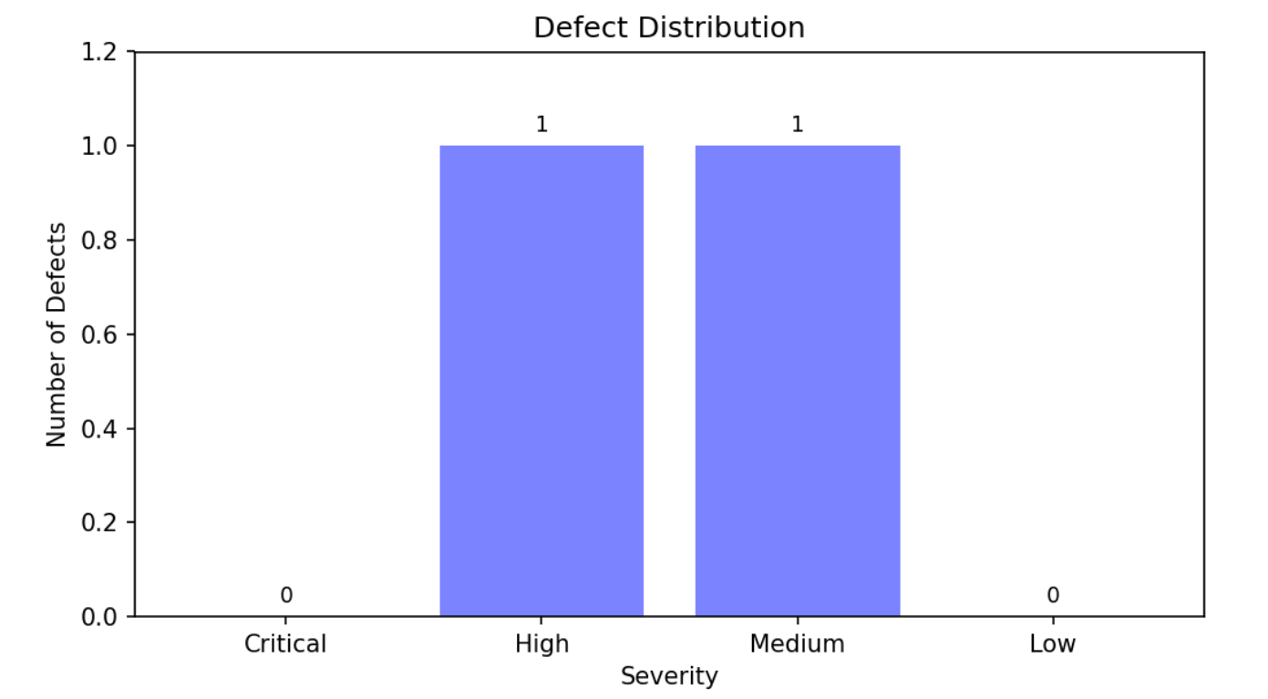
Figure 5.2. Bar chart showing defect distribution by severity level.

5.3.3. Defect Handling Process
The defect handling process follows a standard 7-step procedure, ensuring all discovered defects are tracked and resolved thoroughly:
+ Step 1: Defect Recording
Defect information is recorded immediately upon discovery through CI automatic results or manual testing, including: description, module, related test case, severity level, and evidence (log, screenshot, workflow link).
+ Step 2: Defect Classification
Defects are classified by severity level (Critical, High, Medium, Low) based on their impact, helping determine processing priority.
+ Step 3: Assignment
Defects are assigned to the developer responsible for the related module, with status "Assigned".
+ Step 4: Fixing
The developer analyzes the root cause and implements the fix, ensuring the fix doesn't affect other functionalities.
+ Step 5: Re-testing
The testing team re-executes related test cases and regression testing to confirm the defect is completely resolved.
+ Step 6: Closing Defect
When successfully confirmed as fixed, the defect is marked with status "Closed" in the report (docs/tests/defects.csv).
+ Step 7: Reporting and Tracking
Defect information is periodically summarized to assess software quality, defect trends, and derive improvement lessons for the development process.

5.4. CI/CD Pipeline Execution Results

The CI/CD Pipeline on GitHub Actions was automatically triggered and ran stably. Overview results from the latest run show:
+ Overall Status: PASS (All jobs in the workflow completed without errors).
+ Backend Tests: Unit, API, and integration test jobs all passed.
+ Frontend Tests: Unit test (Jest) and smoke test (Cypress) jobs all passed.
+ Code Coverage: Coverage report is automatically generated and stored as an artifact.
+ Stability: The pipeline demonstrates repeatable execution capability, detecting errors early upon code integration.

Figure 5.3. GitHub Actions CI/CD Pipeline.

5.5. Quality Assessment and Conclusion

5.5.1. Quality Assessment
Based on the aggregated test results, the following assessments can be made about the system's quality:
− High Functional Stability: 94% of automated test cases executed successfully, and 100% of detected defects (including 1 High) were thoroughly resolved.
− Effective Testing Process: The CI/CD Pipeline operates stably, serving as an automated "quality gate" that prevents faulty code from being integrated.
− Reasonable Coverage Scope: 78/90 test cases have been implemented, focusing on main business flows (risk-based testing), ensuring core functions operate correctly.
− Repeatability and Transparency: All test results, defects, and evidence are systematically stored (JSON, CSV files, artifacts), allowing easy retrieval and evaluation.

5.5.2. Lessons Learned
− Early Automation is Key: Setting up CI/CD and writing automated tests from the beginning helps detect environment-related errors (like D-01) and code compatibility issues very early, significantly saving time on later fixes.
− Prioritize Root Cause Fixes: Instead of temporary workarounds, finding and fixing the root cause – such as standardizing table names – helps resolve the problem thoroughly and prevents recurrence.
− Stabilizing E2E Tests in CI: E2E tests in the CI environment need to be "isolated" by stubbing external dependencies (APIs, databases) to increase reliability and avoid "flaky" test phenomena (sometimes pass, sometimes fail without clear reason).

REFERENCES
[1] Beizer, B. (1995). Software Testing Techniques (2nd Edition). International Thomson Computer Press.
[2] Kaner, C., Falk, J., & Nguyen, H. Q. (1999). Testing Computer Software (2nd Edition). Wiley.
[3] Myers, G. J., Sandler, C., & Badgett, T. (2011). The Art of Software Testing (3rd Edition). Wiley.
[4] Simon Brown (2018). Software Architecture for Developers: Visualising Software Architecture with the C4 Model. Leanpub.
[5] Simon Brown. The C4 model for software architecture. https://c4model.com
[6] Fowler, M. (2004). UML Distilled: A Brief Guide to the Standard Object Modeling Language (3rd Edition). Addison-Wesley.

