Sentinel Program
Incremental Implementation Review (IIR) #2 Government Assessment Guide
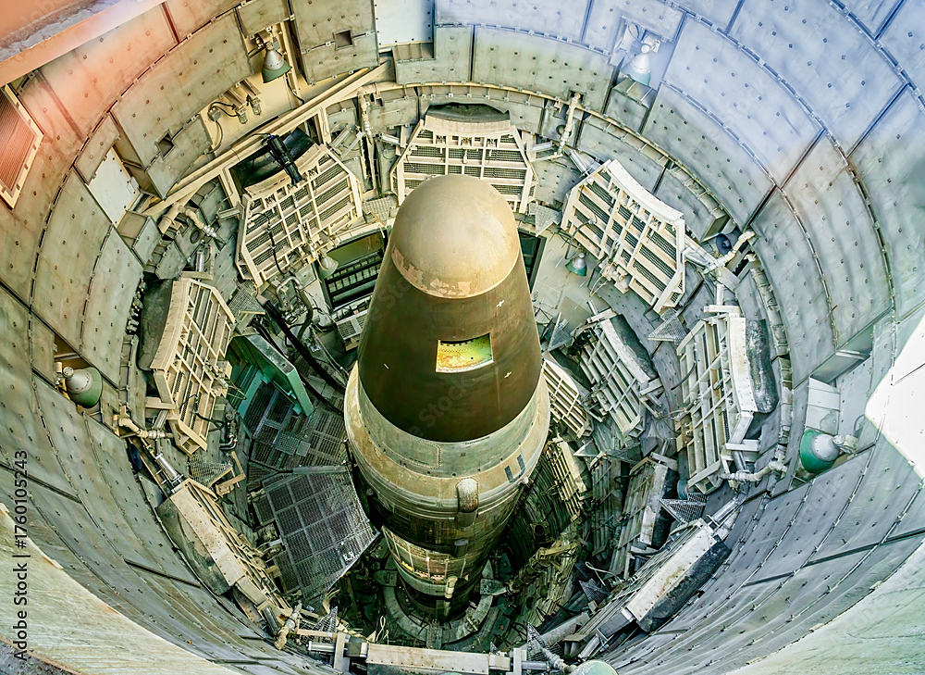
Guide Purpose:
This guide provides the Sentinel Program Government Review Team with a consistent framework for assessing the maturity of the contractor's planning architecture and scheduling readiness during IIR #2. It promotes evidence-based assessments, supports consistent completion of the IIR #2 Assessment Worksheet, and helps develop a common understanding of planning strengths, concerns, risks, and readiness.

Table of Contents
1. Introduction
2. IIR #2 Assessment Process
3. Assessment Philosophy
4. Using This Guide
5. Sentinel Program Product Structure
6. Assessment Area 1 - Scope and Deliverables Definition
7. Assessment Area 2 - Schedule Planning and IMS-Loading Readiness
8. Assessment Area 3 - Cross-Product/Cross-Function Integration
9. Completing the IIR #2 Assessment Worksheet

Appendix A - Overall Confidence Rating Definitions
Appendix B - Suggested Evidence and Artifacts
Appendix C – IIR #2 Assessment Worksheet
Appendix D – IIR #2 Participant Pulse Form

1. Introduction
The purpose of this guide is to provide the Government Review Team with a consistent framework and clear instructions for assessing the contractor's planning architecture and scheduling readiness during Incremental Implementation Review (IIR) #2. This guide implements the IIR #2 execution portion of the Sentinel IIR Government Assessment Strategy and Operating Concept. If terminology or process interpretation differs, the Strategy provides the controlling Government assessment architecture, and this guide provides the practical IIR #2 assessment instructions.
It is not intended to determine whether the contractor "passes" or "fails." Rather, it is intended to develop a common understanding of planning strengths, concerns, risks, open questions, and cross-product/cross-function dependencies that could affect the development of the Integrated Master Schedule (IMS) and Performance Measurement Baseline (PMB), and to provide a strong foundation for successful program execution.
For the purposes of IIR #2, planning architecture is the integrated framework of planning structures, processes, products, and management relationships used to define, organize, assign, trace, and manage the remaining contract scope. The planning architecture establishes how contractual requirements are translated into planned work, how responsibilities are assigned, how work is organized and integrated, and how future planning and execution activities will be managed.
The primary objective of IIR #2 is to evaluate whether the contractor has established a sufficiently mature planning architecture and approach to support IMS loading, continued PMB development, PMB implementation, and follow-on IIR activities. Specifically, the Government Review Team should determine whether the contractor can demonstrate that the remaining contract scope has been:
- Identified and accounted for;
- Organized into a logical planning structure;
- Assigned to responsible organizations;
- Integrated across product/functional elements and planning workflows; and
- Translated into planning products that support the continued development of the PMB.
To promote a consistent and integrated Government assessment, all Government review teams—including both Segment and Functional teams—should evaluate their assigned product elements using the three IIR #2 assessment areas presented in this guide. Although each team brings a unique technical or functional perspective, all teams should apply the same assessment framework and confidence criteria. This common approach promotes consistent evaluations, supports collaboration across Government review teams, and contributes to a single, evidence-based Government assessment.
In addition to the structured assessment worksheet, this guide includes an IIR #2 Participant Pulse Form in Appendix D. The Pulse Form provides a non-attributed individual input path for Government participants to capture observations, confidence indicators, concerns, risks, opportunities, organizational concerns, leadership concerns, environmental observations, and recommended follow-up items that may not be fully documented through the worksheet.
The Pulse Form is not a substitute for the IIR #2 Assessment Worksheet. The worksheet remains the primary structured record of the Government Review Team’s evidence-based assessment for the assigned review area. The Pulse Form provides a complementary observation stream that may help identify themes, disconnects, confidence trends, environmental factors, organizational barriers, and carry-forward items for AI-assisted theme mining, Government readout preparation, and follow-on review planning.
The Pulse Form is intended to be completed quickly after IIR #2 review activities. Responses may be brief bullets and do not need to be polished narratives. The objective is to capture useful observations while they are fresh, not to create an additional reporting burden. Participants should generally be able to complete the form in approximately 20–30 minutes, with 45 minutes as an upper bound if they have more detailed observations.
The three IIR #2 assessment areas are:
- Scope and Deliverables Definition
- Schedule Planning and IMS-Loading Readiness
- Cross-Product/Cross-Function Integration
Each assessment area includes defined assessment criteria, recommended discussion questions, guidance for reviewers, and definitions of confidence ratings. The recommended questions are intended to guide discussions with contractor counterparts and are not intended to limit the Government Review Team's inquiry. Following the guidance of the Government Materiel Lead (ML), Government reviewers are encouraged to ask follow-up questions whenever clarification or additional evidence is needed to support an informed assessment of confidence.
The Government leads the IIR #2 assessment and is responsible for conducting an objective, evidence-based evaluation of the contractor's planning maturity and scheduling readiness. Throughout the review, Government and contractor team members are expected to work collaboratively to examine planning evidence, discuss observations, and develop a shared understanding of planning strengths, concerns, risks, open questions, and cross-product/cross-function dependencies. This collaborative exchange is intended to improve understanding and evidence quality. However, the completed worksheet and confidence ratings remain Government assessment products and should not be treated as joint Government / contractor conclusions unless specifically agreed. While the assessment is collaborative, MLs are ultimately responsible for the Government's assessment. MLs should exercise independent judgment, consider all available evidence and inputs, resolve differing viewpoints as appropriate, and complete the IIR #2 Assessment Worksheet to accurately reflect the Government's documented assessment for product elements.

2. IIR #2 Assessment Process
The IIR #2 assessment follows a structured, evidence-based process designed to promote consistency across Government review teams and product elements. The process guides reviewers from examining planning evidence through documenting the Government's point-in-time assessment. Although the review is conducted collaboratively with the contractor, the Government leads the assessment, evaluates the evidence, and independently determines the confidence ratings and assessment conclusions.
- Step 1: Review planning artifacts.
- Step 2: Discuss the planning architecture and scheduling readiness with contractor counterparts.
- Step 3: Evaluate the three IIR #2 assessment areas.
- Step 4: Assign Strong, Moderate, or Low confidence ratings.
- Step 5: Complete the IIR #2 Assessment Worksheet.
- Step 6: Complete the IIR #2 Participant Pulse Form.
- Step 7: Support the Government readout, hotwash preparation, and leadership messaging.

3. Assessment Philosophy
IIR #2 is a government-led, evidence-based assessment of the contractor's planning architecture and scheduling readiness. The assessment may be organized by Program Work Breakdown Structure (WBS) product element, program organizational structure, or Government ML responsibility area, enabling the Government to evaluate contractor planning maturity at the level where scope, planning, scheduling, and cross-product/cross-function integration are developed and managed. Within that review structure, the Government Review Team should evaluate contractor artifacts such as the CWBS, CWBS Dictionary, OBS, RAM, value streams, and planning outputs to determine whether contractor scope is complete, traceable, integrated, and ready to support continued IMS loading and PMB development.
The Government leads the assessment and is responsible for developing the point-in-time Government evaluation. Throughout the assessment, Government and contractor personnel are expected to work collaboratively to review planning artifacts, examine supporting evidence, discuss observations, clarify planning assumptions, and develop a shared understanding of planning strengths, concerns, risks, open questions, and cross-product/cross-function integration. This collaborative approach improves the quality of the assessment while ensuring that conclusions are supported by objective evidence.
Government reviewers should use this guide to structure discussions with contractor counterparts, evaluate planning products and supporting documentation, understand the contractor's planning architecture and scheduling readiness, and identify where additional clarification, demonstrations, or evidence are needed to support an informed assessment.
Each product element should be assessed independently using the common assessment framework provided in this guide. Although the assessment is organized by product element, reviewers should not evaluate product elements in isolation. Confidence should also consider the maturity of interfaces, dependencies, assumptions, and coordination with other product elements to determine whether the planning architecture supports an integrated and executable program.
Differences in perspective among Government reviewers are expected and should be openly discussed as part of developing a well-informed Government assessment. The objective is to promote a common understanding, support consistent leadership messaging, and identify appropriate follow-up actions—not to assign blame or conduct a compliance inspection. While discussions with the contractor are collaborative, the Government is responsible for exercising independent professional judgment and preparing the documented Government assessment.
Point-in-Time Assessment of Planning Maturity and Readiness: IIR #2 represents a point-in-time assessment of the contractor's planning maturity and readiness based on the evidence available at the time of the review. The assessment reflects the Government's current level of confidence that the contractor has established a sufficiently mature planning foundation to continue progressing toward IMS loading, PMB implementation, and subsequent IIR activities. It is not a final determination that the IMS or PMB is complete, executable, or ready for approval, nor is it intended to predict the outcome of future planning or execution activities.

4. Using This Guide
For each of the three assessment areas, reviewers should examine the applicable planning and scheduling artifacts, discuss the contractor's methods and techniques, evaluate the assessment factors and supporting evidence, and assign an overall confidence rating of Strong, Moderate, or Low. The recommended questions for each assessment factor are intended to guide the discussion and not to limit the scope of the assessment.
Reviewers are encouraged to ask additional follow-up questions whenever clarification is needed, the supporting evidence is incomplete or inconclusive, or further discussion would improve the team's understanding and confidence in the assessment. Under the guidance of the Government ML, reviewers should request additional demonstrations, documentation, or explanations as necessary to ensure the assessment is complete, well-supported, and evidence-based.
Recommended Assessment Factor Questions: These prompts are intended to support consistent assessment. They are not a script and are not intended to restrict Government MLs or Government Review Teams. Government Reviewers may expand, refine, or add questions based on the contractor's discussion, the complexity of product elements, the evidence reviewed, and areas of uncertainty.

5. Sentinel Program Product Structure
Each Government ML and Government review team member should use this guide to assess the assigned product element. This section identifies the product element under review and the Government ML who is responsible for leading the assessment and preparing the Government's point-in-time assessment. The following table should be validated and updated for the IIR #2 review areas before use by MLs and Government Review Teams.
WBS |  | Product Element |  | Government SML/ML
1.0 |  | Strategic Missile Weapon System
1.1 |  | Missile System |  | SML
1.1.1 |  | Airframe and Structures |  | ML
 |  | >>Missile Airframe
 |  | >>Structural Components
 |  | >>Mechanical Assemblies
1.1.2 |  | Propulsion System |  | ML
1.1.3 |  | Guidance, Navigation, and Control |  | ML
1.1.4 |  | Flight Software |  | ML
1.1.5 |  | Electrical Power System |  | ML
1.1.6 |  | Missile Communications |  | ML
1.1.7 |  | Missile Mechanical Systems |  | ML
1.2 |  | Launch System |  | SML
1.2.1 |  | Launch Facility Equipment |  | ML
1.2.2 |  | Launch Support Equipment |  | ML
1.2.3 |  | Launch Control Interfaces |  | ML
1.2.4 |  | Environmental Control Equipment |  | ML
1.3 |  | Command and Control System |  | SML
1.4 |  | Ground Systems |  | SML
1.5 |  | System Integration |  | SML
1.6 |  | System Test and Evaluation (Flight Test) |  | SML
1.7 |  | Peculiar Support Equipment |  | SML
1.8 |  | Training |  | SML
Integration Reminder: Although each Government review team is responsible for assessing a specific product element, the assessment should not be performed in isolation. Government MLs and Government review team members should continually consider how the assigned product element interfaces with, depends upon, and affects other product elements. Key interfaces, dependencies, assumptions, coordination needs, and cross-product/cross-function observations should be documented in the IIR #2 Assessment Worksheet and considered when determining the overall confidence assessment.

6. Assessment Area 1 - Scope and Deliverables Definition
Purpose: Assess whether the contractor has identified, organized, assigned, and traced the remaining contract scope and associated deliverables necessary to support future planning, IMS loading, PMB development, and program execution.
- Suggested evidence may include the Statement of Work (SOW), Contract Data Requirements Lists (CDRLs), Work Breakdown Structure (WBS), Contract Work Breakdown Structure (CWBS) Dictionary, Organizational Breakdown Structure (OBS), Responsibility Assignment Matrix (RAM), Integrated Master Plan (IMP), technical baseline documentation, requirements traceability products, supplier statements of work, interface documentation, and planning packages. See Appendix B for additional examples of supporting evidence.
- Evaluate the seven assessment factors that follow and use the associated confidence rating criteria to determine an overall Strong, Moderate, or Low confidence rating for this assessment area.
1. Remaining Contractor Scope and Requirements Traceability
Purpose: Determine whether all remaining contractual work has been identified, translated into planned scope, and incorporated into the planning architecture.
Recommended Question | Reviewer Guidance
- Has all remaining contractor scope been identified and incorporated into the planning architecture? | - Look for evidence that all remaining contractual work is represented in planning products and that no significant work has been omitted, deferred without justification, or left undefined.
- Can contractual requirements be traced to planned work scope and expected deliverables? | - Look for traceability from contract requirements, technical requirements, and deliverable expectations to planned work scope and products.
- Are any scope gaps, overlaps, or unassigned contractual responsibilities evident? | - Evaluate whether work responsibilities are complete and mutually exclusive. Identify missing scope, duplicated responsibilities, or scope that lacks a clear owner.

2. CWBS Maturity
Purpose: Determine whether the contractor has organized the work using a logical product-oriented structure that supports planning and management.
Recommended Question | Reviewer Guidance
- Does the CWBS provide a logical, product-oriented structure for organizing the work? | - Consider whether the CWBS is organized around products, deliverables, or outcomes rather than solely around organizations or functions.
- Does the CWBS decompose the work to an appropriate level for planning, management, and execution? | - Determine whether the decomposition is detailed enough to support estimating, scheduling, budgeting, and management without becoming unnecessarily fragmented.
- Does the CWBS support effective planning, management visibility, and performance reporting throughout the program lifecycle? | - Evaluate whether the CWBS provides a stable structure for status, reporting, performance measurement, and management decision-making.

3. CWBS Dictionary Maturity
Purpose: Determine whether the CWBS Dictionary provides a sufficient definition of work content, boundaries, deliverables, and completion expectations.
Recommended Question | Reviewer Guidance
- Does the CWBS Dictionary clearly define the scope and expected deliverables for each element? | - Look for clear descriptions of the work to be performed and the deliverables or outcomes expected for each CWBS element.
- Are scope boundaries and interfaces between CWBS elements clearly documented? | - Determine whether boundaries between work elements are clear enough to reduce ambiguity, duplication, or gaps.
- Does the CWBS Dictionary define clear completion criteria or expected outcomes for each work element? | - Evaluate whether reviewers can understand when the work is complete and what outcome should be produced.

4. Organizational Ownership and Accountability
Purpose: Determine whether the contractor has clearly assigned responsibility for the planned work and established accountability across the planning architecture.
Recommended Question | Reviewer Guidance
- Is responsibility for each work scope clearly assigned to the appropriate organization, product team , or supplier? | - Look for evidence that every planned work element has an accountable organization or responsible owner.
- Are the CWBS, OBS, and RAM aligned to establish clear ownership and accountability? | - Evaluate whether ownership is consistently reflected across the product/function structure, organizational structure, and responsibility matrix.
- Are organizational interfaces and shared responsibilities clearly defined to minimize ambiguity? | - Identify where multiple organizations contribute to a work element and determine whether coordination responsibilities are clear.

5. Value Stream Alignment
Purpose: Determine whether planning structures reflect how recurring or repeatable work is expected to flow through the program.
Recommended Question | Reviewer Guidance
- Have value streams or planning structures been identified to support execution of the planned work? | - Look for evidence that the contractor understands major workflows and has organized repeatable planning activities accordingly.
- Do the value streams reflect how work will actually be executed and transitioned between organizations or functions? | - Determine whether the planning structure reflects realistic handoffs, work sequencing, and organizational responsibilities.
- Are interfaces between value streams and product elements clearly defined and integrated? | - Evaluate whether transitions between workflows and product elements are coordinated within the overall planning architecture.

6. Non-Standard Planning Approach
Purpose: Determine whether unique, one-time, or non-recurring work has been identified and planned appropriately.
Recommended Question | Reviewer Guidance
- Have unique, one-time, or non-recurring work activities been identified? | - Look for special efforts, unique activities, or non-standard work that may not fit normal planning structures.
- Has an appropriate planning approach been established for work that does not follow standard planning structures? | - Evaluate whether the contractor has a credible approach for planning unique work based on its complexity, risk, and execution characteristics.
- Are special planning assumptions, constraints, or dependencies documented for these non-standard activities? | - Determine whether unique planning considerations are documented so execution risks and assumptions are understood.

7. Supplier Scope Boundaries
Purpose: Determine whether supplier responsibilities, deliverables, interfaces, dependencies, and risks are clearly defined and integrated.
Recommended Question | Reviewer Guidance
- Are supplier scope boundaries and responsibilities clearly defined? | - Look for a clear distinction between contractor and supplier responsibilities, including where supplier work begins and ends.
- Are supplier deliverables and interfaces fully integrated with the overall planning architecture? | - Evaluate whether supplier products, schedules, interfaces, and required inputs are reflected in planning products.
- Are supplier planning assumptions, dependencies, and risks clearly reflected within the overall planning architecture? | - Determine whether supplier-related assumptions, constraints, dependencies, and risk areas are visible and actively considered in planning.

Overall Confidence Rating Definitions for Scope and Deliverables Definition
Strong | Moderate | Low
Scope and deliverables are complete, clearly defined, logically organized, traceable, and assigned. Planning artifacts consistently demonstrate a mature understanding of the remaining contract scope and provide a credible foundation for IMS loading, PMB implementation, and program execution. | Scope and deliverables are generally defined and organized, with only isolated gaps, ambiguities, or traceability issues. The planning architecture provides a reasonable foundation for continued planning; however, additional refinement, clarification, or evidence is needed before the Government can establish stronger confidence. | Scope definition is incomplete or inconsistently documented, with significant gaps, unclear boundaries, weak traceability, or unresolved ownership. The planning architecture has not yet demonstrated a sufficiently mature foundation to support reliable IMS loading or PMB implementation without substantial additional planning effort.

7. Assessment Area 2 - Schedule Planning and IMS-Loading Readiness
Purpose: Assess whether the contractor has established a sufficiently mature schedule planning approach to support future IMS loading, integration, statusing, analysis, and management use.
- Suggested evidence may include the Integrated Master Plan (IMP), draft or developmental IMS products, schedule architecture documentation, milestone plans, activity development guidance, schedule coding structures, dependency logs, critical path planning products, supplier schedule information, and schedule health planning criteria. See Appendix B for additional examples of supporting evidence.
- This assessment area evaluates the maturity of the contractor's schedule planning approach and its readiness to support IMS development and loading. It is not intended to assess whether the final IMS has already achieved full maturity.
- Evaluate the six assessment factors that follow and use the associated confidence rating criteria to determine an overall Strong, Moderate, or Low confidence rating for this assessment area.

1. IMP Alignment and Vertical Traceability
Purpose: Assess whether the Integrated Master Plan (IMP) establishes a logical planning framework for organizing program accomplishments, planning objectives, and future IMS development.
Recommended Question | Reviewer Guidance
- Can the contractor demonstrate that the IMP establishes a logical framework for organizing the remaining product scope? | - Evaluate whether the IMP identifies significant accomplishments, accomplishment criteria, and planning objectives needed to organize the remaining work.
- Can the contractor demonstrate that IMP accomplishments align with contractual commitments and expected program outcomes? | - Determine whether the planned accomplishments support the successful completion of the assigned product scope and contract deliverables.
- Can the contractor demonstrate that the IMP provides a logical foundation for developing the IMS? | - Assess whether the IMP provides sufficient planning structure and vertical traceability to support development of a detailed, executable schedule.

2. Planning Structure and Task Definition Maturity
Purpose: Assess whether the contractor has established a logical planning hierarchy and sufficiently defined planning tasks to support detailed IMS development.
Recommended Question | Reviewer Guidance
- Can the contractor demonstrate that a logical planning hierarchy has been established for organizing the remaining work? | - Evaluate whether planning products are organized into a consistent hierarchy that supports decomposition into executable schedule activities.
- Can the contractor demonstrate that planning tasks are sufficiently defined to support IMS development? | - Assess whether planning activities are clearly described, appropriately bounded, and capable of being translated into executable schedule tasks.
- Can the contractor demonstrate that planning is sufficiently mature to support detailed IMS development? | - Determine whether additional planning or decomposition is needed before detailed IMS development can begin.

3. Workflow, Dependencies, and Handoffs Logic
Purpose: Assess whether the contractor has established a logical execution strategy that defines workflow, identifies dependencies, and clearly describes organizational interfaces.
Recommended Question | Reviewer Guidance
- Can the contractor demonstrate how work is expected to progress from start to finish? | - Evaluate whether the planning products describe a logical execution strategy rather than simply listing planned activities.
- Can the contractor demonstrate that the major dependencies between planning activities have been identified and understood? | - Determine whether logical predecessor and successor relationships have been identified and are sufficient to support future schedule logic development.
- Can the contractor demonstrate that organizational handoffs and interfaces have been clearly identified? | - Assess whether transfers of work, information, deliverables, and responsibility between organizations are clearly understood and reflected in the planning approach.

4. Planning Constructs
Purpose: Assess whether planning constructs provide a practical and repeatable framework for organizing work and supporting future IMS development.
Recommended Question | Reviewer Guidance
- Can the contractor demonstrate how planning constructs (such as value streams, fragnets, planning packages, or similar planning methods) are used to organize the remaining work? | - Evaluate whether appropriate planning constructs have been established to organize the remaining work in a logical and repeatable manner.
- Can the contractor demonstrate that these planning constructs are being applied consistently across the product/function element? | - Assess whether planning constructs provide a common framework for planning across organizations and disciplines.
- Can the contractor demonstrate that these planning constructs provide a practical foundation for IMS development? | - Determine whether the planning constructs provide a consistent, repeatable framework for developing the IMS rather than serving solely as documentation.

5. Duration and Assumption Basis
Purpose: Assess whether planned durations are supported by reasonable assumptions and documented planning rationale.
Recommended Question | Reviewer Guidance
- Can the contractor demonstrate that planned durations are supported by documented planning rationale? | - Evaluate whether duration estimates are based on defined planning assumptions rather than unsupported judgment.
- Can the contractor demonstrate that key planning assumptions have been identified and documented? | - Determine whether key planning assumptions affecting durations and execution have been identified, documented, and are reasonable.
- Can the contractor demonstrate how planned durations were developed? | - Assess whether duration estimates can be traced to engineering analyses, historical performance, production assumptions, or other documented planning information.

6. Quantity-Based Data (QBD)
Purpose: Assess whether objective quantities and production rates support the planned durations.
Recommended Question | Reviewer Guidance
- Can the contractor demonstrate that objective quantity-based data support planning assumptions? | - Evaluate whether measurable quantities, production rates, installation rates, manufacturing rates, or similar objective data support planning decisions.
- Can the contractor demonstrate that planned durations are consistent with the quantity-based data presented? | - Assess whether planned activity durations reasonably reflect the quantities of work to be accomplished and expected production performance.
- Can the contractor demonstrate how quantity-based data supports planned durations and the development of future schedules? | - Determine whether objective planning data provides a credible basis for future IMS development and schedule realism.

Overall Confidence Rating Definitions for Schedule Planning and IMS-Loading Readiness
Strong | Moderate | Low
Schedule planning demonstrates a mature and well-developed planning architecture. The IMP, planning hierarchy, workflows, task definitions, planning assumptions, durations, and supporting planning data are complete, internally consistent, and provide strong Government confidence that the contractor is prepared to continue progressing toward credible IMS loading and PMB implementation. | Schedule planning is substantially developed and provides a reasonable foundation for continued planning. The IMP, planning hierarchy, workflows, task definitions, durations, and supporting planning data are generally established; however, additional refinement, clarification, or supporting evidence is needed before the Government can establish stronger confidence in the contractor's scheduling readiness and planning maturity. | Schedule planning has not yet demonstrated sufficient maturity to support continued progression toward IMS loading with confidence. Significant gaps, inconsistencies, or weaknesses remain in the planning architecture, including planning logic, task definitions, workflows, planning assumptions, durations, or supporting planning data. Additional planning and maturation are needed before the Government can conclude that the contractor has established a credible foundation for IMS loading and PMB implementation.

8. Assessment Area 3 - Cross-Product/Cross-Function Integration
Purpose: Assess whether the contractor has established a sufficiently mature cross-product/cross-function integration approach to identify interfaces, manage dependencies, coordinate planning activities, and support successful program integration.
- Suggested evidence may include Interface Control Documents (ICDs), interface matrices, integration plans, dependency logs, cross-product/cross-function action registers, integrated milestone plans, integration meeting minutes, supplier integration plans, risk registers, and other cross-product/cross-function planning artifacts. See Appendix B for additional examples of supporting evidence.
- This assessment area evaluates the maturity of the contractor's cross-product/cross-function integration approach and its readiness to support integrated planning, future IMS development, and coordinated program execution. It is not intended to assess whether all technical interfaces have been fully implemented, tested, or verified.
- Evaluate the five assessment factors that follow and use the associated confidence rating criteria to determine an overall Strong, Moderate, or Low confidence rating for this assessment area.

1. Interface Identification
Purpose: Assess whether key technical, schedule, organizational, and supplier interfaces have been identified and documented.
Recommended Question | Reviewer Guidance
- Can the contractor demonstrate that key interfaces with other product elements, suppliers, functions, facilities, or supporting organizations have been identified? | - Evaluate whether the product element clearly identifies where it exchanges information, deliverables, services, or technical products with other organizations.
- Can the contractor demonstrate that interface requirements and expected deliverables are documented? | - Assess whether interface expectations are defined in planning products or interface documentation rather than relying solely on informal understanding.
- Can the contractor demonstrate that unresolved or evolving interfaces have been identified? | - Determine whether incomplete or developing interfaces are visible and tracked for continued planning maturity.

2. Dependency Management
Purpose: Assess whether execution dependencies between product elements are identified, understood, and incorporated into planning.
Recommended Question | Reviewer Guidance
- Can the contractor demonstrate the key upstream dependencies required to execute this product element? | - Evaluate whether required inputs, decisions, designs, facilities, supplier products, approvals, or other enabling items have been identified.
- Can the contractor demonstrate the downstream activities or product elements that depend on this work? | - Assess whether the contractor understands how completing this product element affects subsequent work across the program.
- Can the contractor demonstrate that significant dependencies have been incorporated into planning? | - Determine whether execution dependencies have been reflected in planning activities rather than existing only as informal knowledge.

3. Cross-Product/Cross-Function Schedule Alignment
Purpose: Assess whether cross-product/cross-function schedules are logically aligned to support integrated program execution.
Recommended Question | Reviewer Guidance
- Can the contractor demonstrate that major cross-product/cross-function milestones and integration events are aligned across the program? | - Evaluate whether significant milestones and integration events occur in a logical sequence across product/functional elements.
- Can the contractor demonstrate that planned timing supports required cross-product/cross-function coordination? | - Assess whether planned completion dates, integration events, and external commitments are aligned with those of dependent organizations.
- Can the contractor demonstrate that schedule misalignments or timing conflicts have been identified? | - Determine whether timing issues are visible and being addressed before they affect program execution.

4. Roles, Responsibilities, and Coordination
Purpose: Assess whether responsibilities for managing cross-product/cross-function integration are clearly assigned and consistently executed.
Recommended Question | Reviewer Guidance
- Can the contractor demonstrate that ownership of interfaces and dependencies has been clearly assigned? | - Evaluate whether responsible organizations or individuals have been identified for managing integration activities.
- Can the contractor demonstrate that routine cross-product/cross-function coordination processes have been established? | - Assess whether integration activities are managed through recurring meetings, action tracking, planning reviews, or other structured management processes.
- Can the contractor demonstrate that decision authority for cross-product/cross-function issues is clearly understood? | - Determine whether decision-making responsibilities are clearly defined when multiple organizations share responsibility.

5. Integration Risk and Follow-up
Purpose: Assess whether unresolved integration issues are evaluated, prioritized, and managed to support continued planning maturity.
Recommended Question | Reviewer Guidance
- Can the contractor demonstrate that significant integration risks and uncertainties have been identified? | - Evaluate whether unresolved interfaces, dependencies, assumptions, or coordination issues have been recognized and documented.
- Can the contractor demonstrate that the potential impact of unresolved integration issues has been evaluated? | - Assess whether potential cost, schedule, technical, or performance impacts have been considered and understood.
- Can the contractor demonstrate that follow-up actions have been established to resolve integration issues? | - Determine whether integration issues have assigned owners, planned resolution actions, and management visibility to support continued planning maturity.

Overall Confidence Rating Definitions for Cross-Product/Cross-Function Integration
Strong | Moderate | Low
Cross-product/cross-function integration planning demonstrates a mature and well-coordinated planning architecture. Key interfaces, dependencies, schedule relationships, coordination responsibilities, and integration risks are clearly identified, understood, and incorporated into planning activities. Collectively, the evidence provides strong confidence that the product element can be effectively integrated into the overall program during IMS loading and subsequent planning activities. | Cross-product/cross-function integration planning is generally well developed and demonstrates an understanding of major interfaces, dependencies, and coordination needs. Most integration activities have been identified and incorporated into the planning architecture; however, additional clarification, documentation, or coordination is needed before the Government can establish stronger confidence in cross-product/cross-function integration maturity and readiness. | Cross-product/cross-function integration planning has not yet demonstrated sufficient maturity to support integrated program planning. Significant interfaces, dependencies, coordination responsibilities, schedule relationships, or integration activities remain incomplete, unclear, or unsupported by objective evidence. Additional planning and integration are required before the Government can have confidence that the product element can be effectively integrated into the overall program.

9. Completing the IIR #2 Assessment Worksheet
After completing the three IIR #2 assessment areas, the Government ML and Government Review Team should complete the IIR #2 Assessment Worksheet. The worksheet is the primary mechanism for capturing the Government team’s observations, confidence assessments, reviewed evidence, and follow-up needs.

Administrative Information
Complete the administrative information at the beginning of the worksheet before documenting the assessment results. This information identifies the assessment participants, the product element reviewed, and the date the assessment was conducted.
- Assessment Date: Select the date the assessment was conducted using the worksheet's drop-down calendar.
- Control Account: Enter the Control Account identifier under review.
- Product Element Owner Designation.: Select the assigned product element owner from the worksheet's drop-down list.
- Government Assessment Team Members: List the names and organizations of all Government personnel who participated in the assessment and contributed to the Government's evaluation.
- Contractor Participants: List the names, organizations, and, when applicable, functional roles of the contractor personnel who participated in the assessment discussions or demonstrations.
The administrative information provides the documented record of who participated in the assessment and establishes the context for the Government's point-in-time evaluation of the assigned product element.

Section 1 - Leadership Summary and Confidence Ratings
Definition: This section captures the Government MLs' most important messages for leadership and documents the confidence ratings for the product element. It includes the top three messages for leadership, the Overall Confidence Rating, and the confidence ratings for each of the three assessment areas. Document the three most important messages that Government leadership should take away from the assessment. If leadership only remembers three things from this review, what should they be? The Overall Confidence Rating should reflect the collective results of all assessment areas, while the assessment area ratings should be based on the applicable confidence criteria provided in this guide.
What to Record: Record concise, high-value messages that summarize what is working, what requires attention, what remains uncertain, and what could affect future planning, integration, or program execution. Select an Overall Confidence Rating (Strong, Moderate, or Low) using the definitions in Appendix A, and provide a brief rationale based on the totality of evidence reviewed. Record a confidence rating for each of the three assessment areas using the applicable Confidence Rating Criteria provided in Sections 6, 7, and 8. Assessment area ratings should reflect the collective results of all assessment factors and supporting evidence rather than any single observation.
Avoid: Long narratives, minor details, averaging the three assessment area ratings to determine the overall confidence rating, relying on a single observation unless it is significant enough to dominate the assessment, or repeating observations documented elsewhere in the worksheet.

Section 2 - Products and Artifacts Reviewed
Definition: This section documents the evidence base supporting the Government’s assessment. It identifies the products, artifacts, demonstrations, data, and discussions reviewed during IIR #2 that informed the team's observations, confidence ratings, and overall assessment.
What to Record: List the specific products, artifacts, technical documentation, schedules, planning data, demonstrations, briefings, data extracts, and contractor discussions that were reviewed or observed. When practical, identify the document title, version, revision, date, or other distinguishing information to establish a clear record of the evidence supporting the assessment.
Avoid: Avoid listing generic artifact names without sufficient identifying information, including documents or discussions that did not materially inform the assessment, or omitting significant evidence that influenced the Government’s conclusions. The documented evidence should be sufficient to support the assessment findings and to provide traceability to the observations and confidence ratings.

Documenting Assessment Observations
All comments recorded in the Strengths Observed, Concerns and Risks Observed, Open Questions and Follow-Up Items, and Cross-Product/Cross-Function Integration Observations sections should be traceable to one or more of the three IIR #2 assessment areas.
To improve consistency and facilitate Government analysis, reviewers should begin each comment by identifying the applicable assessment area and the specific factor that the observation addresses. This enables reviewers and leadership to readily understand the basis for each observation and how it supports the associated confidence ratings.
Use the following Assessment Area Designations followed by the Factor Designations:
- (Assessment Area 1) Scope and Deliverables Definition (S) | (Factor) Value Stream Alignment (5)
- (Assessment Area 2) Schedule Planning and IMS-Loading Readiness (P) | (Factor) IMP Alignment and Vertical Traceability (1)
- (Assessment Area 3) Cross-Product/Cross-Function Integration (I) | Dependency Management (2)
“Strengths Observed” example:
- Strength 1: P – 2 The planning artifacts demonstrate a consistent planning methodology and well-defined task structures, providing a credible foundation for future IMS loading.
- Strength 2: I – 3 The planning artifacts demonstrate a well-defined approach for identifying and managing cross-product interfaces and dependencies, providing increased Government confidence that the assigned product element can be effectively integrated into the overall program planning architecture.

Section 3 - Strengths Observed
Definition: Strengths are evidence-based observations that increase confidence in the contractor's planning architecture, scheduling maturity, integration approach, and ability to support future Integrated Master Schedule (IMS) loading, Performance Measurement Baseline (PMB) development, and successful program execution.
What to Record: Document practices, products, or behaviors that demonstrate planning maturity or provide confidence that the contractor has established a sound foundation for future planning and integration activities. Describe the observed condition, explain why it is a strength, and identify its significance to planning quality, schedule readiness, management visibility, cross-product/cross-function integration, or execution confidence.
Avoid: Avoid citing routine contractual compliance, expected business practices, or isolated positive observations as strengths unless the evidence demonstrates a meaningful level of maturity, discipline, effectiveness, or repeatability. Ensure each strength is supported by objective evidence and clearly explains why it increases confidence in the contractor's planning and scheduling capability.

Section 4 - Concerns and Risks Observed
Definition: Concerns are evidence-based issues, weaknesses, gaps, or inconsistencies identified during the review that reduce confidence in the contractor's planning architecture, scheduling maturity, or integration approach. Risks are the potential future consequences if those concerns, assumptions, dependencies, or uncertainties are not adequately addressed or managed.
What to Record: For each concern or risk, describe the observed condition, explain why it is significant, and identify its potential impact on scope, schedule, cost, technical performance, cross-product/cross-function integration, management visibility, IMS loading, PMB development, or successful program execution. Where appropriate, describe the relationship between the concern and the resulting risk.
Avoid: Avoid vague or unsupported statements (e.g., "schedule concern" or "needs improvement") without explaining the underlying condition and its potential impact. Do not speculate beyond the available evidence or identify a risk without first describing the concern or condition that gives rise to it. Each concern and risk should be supported by objective evidence and clearly linked to its potential effect on planning or program outcomes.

Section 5 - Open Questions and Follow-up Items
Definition: Open questions and follow-up items are areas where the Government does not yet have sufficient information or evidence to reach a fully supported conclusion. They identify information gaps, unresolved assumptions, or topics requiring additional evidence, demonstrations, analysis, or discussion before planning maturity or scheduling readiness can be confidently assessed.
What to Record: Document unanswered questions, requested contractor demonstrations, missing or incomplete artifacts, unresolved assumptions, data requiring clarification, or topics requiring additional Government or contractor follow-up. Clearly describe what additional information is needed and how it will help resolve the question or improve confidence in the assessment.
Avoid: Avoid treating an information gap or an unknown as a concern unless objective evidence indicates a weakness or deficiency. Likewise, avoid using this section to restate concerns or risks already identified elsewhere in the worksheet. Each follow-up item should have a clear purpose and be directed toward resolving an uncertainty or strengthening the evidence supporting the assessment.

Section 6 - Cross-Product/Cross-Function Integration Observations
Definition: This section identifies the external interfaces, dependencies, assumptions, and coordination needs that extend beyond the assigned product element and require collaboration with other products, suppliers, facilities, or supporting organizations. Unlike other worksheet sections, which focus on the maturity of the assigned product element, this section focuses on the relationships and interactions that could affect planning integration, IMS development, PMB implementation, or the coordinated execution of the program.
What to Record: Document significant upstream and downstream dependencies, giver/receiver relationships, work handoffs, shared resources, interface assumptions, integration risks, and coordination needs that require action or alignment with other products or organizations. Clearly describe the dependency, identify the affected organizations or product elements, and explain why coordination is important to maintaining an integrated and executable IMS and PMB.

Cross-Product/Cross-Function Integration examples include:
Missile Guidance
⬇
Flight Software
⬇
System Integration
⬇
System Test
< or >
Launch System
⬇
Ground Systems
⬇
Command & Control
⬇
Flight Test
Reviewers should examine:
- Interface Identification
- Dependency Management
- Cross-Product/Cross-Function Schedule Alignment
- Handoffs
- Supplier Integration
- Integration Milestones
Avoid: Avoid limiting this section to technical interfaces or repeating concerns already documented elsewhere in the worksheet. Instead, focus on dependencies and coordination needs that require cross-product/cross-function communication, alignment, or management attention, including schedule, supplier, facility, data, decision, resource, and organizational dependencies that could influence overall program integration.

Appendix A – Overall Confidence Rating Definitions
The Overall Confidence Rating should reflect the collective results of all assessment areas, and balance observed strengths, concerns, risks, uncertainties, and integration considerations. Use the following definitions when determining the Overall Confidence Rating for the product element assessment.
Strong | Moderate | Low
The evidence reviewed demonstrates a mature and well-developed planning architecture. Scope, planning, scheduling readiness, and cross-product/cross-function integration collectively provide strong Government confidence that the contractor has established a credible planning foundation to continue progressing toward IMS loading, PMB implementation, and subsequent IIR activities. | The evidence reviewed demonstrates a generally sound planning architecture that provides a reasonable foundation for continued planning. While the contractor has made substantial progress, additional planning maturation, clarification, or integration is needed in one or more assessment areas before the Government can establish stronger confidence in the contractor's planning maturity and readiness. | The evidence reviewed does not yet demonstrate a sufficiently mature planning architecture to support continued progression with confidence. Significant planning gaps, inconsistencies, or integration challenges remain, reducing the Government's confidence that the contractor has established an adequate foundation for IMS loading, PMB implementation, and subsequent IIR activities without substantial additional planning effort.

Appendix B - Suggested Evidence and Artifacts

The artifacts and evidence sources listed below are intended to assist Government MLs and Government Review Teams in evaluating the contractor’s planning architecture and scheduling maturity during IIR #2. They should be used, as appropriate, based on the assigned product element, the approved IIR #2 review scope, and the artifacts, demonstrations, and discussions provided by Northrop.

These lists are intended as evaluation aids and should not be interpreted as creating new contractor deliverables, expanding the approved IIR #2 artifact request, or requiring every artifact to be available for every product element. The primary focus of IIR #2 remains the contractor's artifacts, demonstrations, and discussions supporting the Sentinel Program's planning architecture and scheduling maturity, including remaining scope definition, CWBS and CWBS Dictionary, OBS and RAM, value streams, discrete planning, supplier interfaces and handoffs, giver/receiver relationships, duration basis and Quantity-Based Data (QBD), one-off work, and initial IMS planning outputs.

Review teams may also use supporting evaluation aids—such as artifact quality criteria, scope and traceability assessment worksheets, and other review tools—to evaluate the completeness, consistency, traceability, credibility, and integration of the evidence presented during IIR #2. These aids are intended to promote consistent, evidence-based assessments while allowing flexibility to account for differences in product elements, planning maturity, and the evidence available during the review.

A. Government and Contractual Reference Basis
The following Government and contractual documents may be used as reference sources when evaluating the contractor's planning architecture and scheduling maturity. These documents establish the program's contractual, technical, and planning basis against which contractor artifacts may be assessed. Unless specifically maintained by the contractor as part of its planning documentation, they are not considered IIR #2 contractor deliverables.

Suggested reference sources include:
- CARD
- Program requirements baseline and allocated requirements
- Requirements traceability information
- Statement of Work (SOW)
- Contract Data Requirements Lists (CDRLs)
- Data Item Descriptions (DIDs)
- Contract modifications, including OMNIMOD scope changes
- Applicable Milestone B planning objectives and program direction
- Prior IIR #1 observations, action items, and planning-related follow-up actions

These reference documents should be used to determine whether the contractor's artifacts adequately account for contractual scope, technical requirements, deliverables, interfaces, and planning expectations. They should not be treated as products to be developed or matured during IIR #2.

B. Contractor Artifacts and Supporting Evidence
The following artifacts, demonstrations, and supporting evidence may be reviewed, as applicable, to evaluate the Sentinel Program's planning architecture and scheduling maturity. The relevance of individual artifacts will vary by product element, review scope, and the contractor's planning approach. Many artifacts support more than one assessment area and may therefore be considered during multiple portions of the review.

Assessment Area 1 – Scope and Deliverables Definition
Suggested evidence may include:
- CWBS
- CWBS Dictionary
- Organizational Breakdown Structure (OBS)
- Responsibility Assignment Matrix (RAM)
- Tier 1–3 planning architecture, as applicable
- Value stream definitions
- Value stream library and fragnets
- Value stream-to-CWBS mapping
- Planning structure and task definition methodology
- Discrete planning methodology for non-value-stream work
- One-off work identification and disposition methodology
- Supplier integration structure
- Supplier boundary and handoff documentation
- Supplier planning information or Statements of Work, where available
- Giver/Receiver relationships
- Interface documentation affecting scope ownership, deliverables, or handoffs
- Systems engineering products or design review packages that provide context for scope definition, interfaces, or planning integration

Assessment Area 2 – Schedule Planning and IMS-Loading Readiness
Suggested evidence may include:
- Integrated Master Plan (IMP) or equivalent planning framework, where available
- Tier 1–3 planning architecture, as applicable
- Draft IMS or IMS development products
- Initial IMS task outputs, planning data, task lists, exports, or schedule load files
- Schedule architecture documentation
- Activity development guidance
- Schedule coding structure
- Value stream and fragnet scheduling logic
- Discrete planning logic for non-value-stream work
- Dependency logs
- Giver/Receiver planning relationships
- Supplier schedule inputs, where available
- Duration basis documentation
- Quantity-Based Data (QBD) supporting durations, planning logic, and task assumptions
- Milestone plans and key planning milestones
- Critical path or driving path planning products, where available and appropriate
- Schedule health criteria or related planning measures supporting IMS-loading readiness

Assessment Area 3 – Cross-Product/Cross-Function Integration
Suggested evidence may include:
- Supplier integration structure
- Supplier boundary and handoff documentation
- Supplier integration plans
- Supplier schedule inputs, where available
- Giver/Receiver relationships
- Cross-Product/Cross-Function and cross-business-unit dependency information
- Dependency logs
- Interface Control Documents (ICDs) or interface matrices
- Integration plans and integration schedules
- Cross-Product/Cross-Function action item logs
- Product meeting minutes or coordination records, where available
- Risk and opportunity registers identifying interface, supplier, dependency, or integration risks
- Systems engineering products or design review packages that provide context for interface management and integration planning

Appendix C - IIR #2 Assessment Worksheet

Reviewer Instructions
This worksheet is intended to document the Government's assessment results for product elements. Before completing this worksheet, reviewers should read Section 9 – Completing the IIR #2 Assessment Worksheet, which provides detailed instructions for completing each section, applying the Confidence Rating Criteria, and documenting evidence-based observations and conclusions. Use the worksheet tabs to navigate to the next section and continue the assessment.

Date:
7/6/2026
Control Account:
Enter
Product Element Owner Designation:
Blank
Government Participants:
Enter
Contractor Participants:
Enter

1. Leadership Summary & Confidence Ratings
Top Three Messages for Leadership
If leadership only remembers three things from this assessment, what should they be?
Enter

Confidence Ratings

Overall Confidence Rating (Select One)
Strong: ☐ Moderate: ☐ Low: ☐

The Overall Confidence Rating represents the Government's professional judgment of the contractor's current planning maturity and readiness based on the evidence reviewed during IIR #2. It reflects the Government's point-in-time assessment of the contractor's planning architecture and its readiness to continue progressing toward Integrated Master Schedule (IMS) loading, Performance Measurement Baseline (PMB) implementation, and subsequent IIR activities.

Importantly, this rating is not a determination that the IMS or PMB is fully mature, executable, or ready for approval. Instead, it reflects the Government's current confidence that the contractor has established a sufficiently mature planning foundation to support continued planning, integration, and progressive maturation toward Milestone B.

Overall Confidence Rating Rationale
Enter

Next, record the confidence rating for each assessment area using the applicable Confidence Rating Criteria from the IIR #2 Government Assessment Guide. For each assessment area, provide a brief rationale explaining the basis for the assigned rating. The rationale should summarize the key evidence, observations, strengths, concerns, and uncertainties that most influenced the Government’s judgment. The purpose is not to document every observation, but to clearly explain why the Government reviewers concluded that the assessment area warranted a Strong, Moderate, or Low confidence rating. The rationale should focus on the most significant factors influencing the rating rather than attempting to summarize every discussion, planning artifact, or piece of evidence reviewed.

Assessment Area 1 – Scope and Deliverables Definition Confidence Rating (Select One)
Strong: ☐ Moderate: ☐ Low: ☐
Enter

Assessment Area 2 – Schedule Planning and IMS-Loading Readiness Confidence Rating (Select One)
Strong: ☐ Moderate: ☐ Low: ☐
Enter

Assessment Area 3 – Cross-Product/Cross-Function Integration Confidence Rating (Select One)
Strong: ☐ Moderate: ☐ Low: ☐
Enter

2. Products & Artifacts Reviewed
Document the planning artifacts, technical products, and supporting documentation reviewed by the ML / Government Review Team to support its assessment and confidence determinations.

The list should identify the primary sources of evidence used during the assessment and demonstrate that conclusions were based on documented information, supplemented by discussions with contractor counterparts as appropriate. When available, include the applicable revision, version, or date of each artifact reviewed.

Enter

3. Strengths Observed
Document the most significant strengths identified during the assessment that increase confidence in the contractor's planning maturity and readiness. Strengths should be supported by objective evidence and highlight effective planning practices, planning artifacts, integration activities, or management disciplines that demonstrate a well-developed planning architecture and increase confidence in the contractor's planning maturity and readiness to support future Integrated Master Schedule (IMS) development, Performance Measurement Baseline (PMB) implementation, and program execution.

Enter

4. Concerns and Risks Observed
Document the most significant concerns identified during the assessment and any associated risks that could reduce confidence in the contractor's planning maturity and readiness or adversely affect future planning, integration, or program execution if not addressed.

Concerns should be supported by objective evidence and identify observed weaknesses, gaps, inconsistencies, or uncertainties that warrant additional management attention. Risks should describe the potential consequences if those concerns remain unresolved. Not every concern creates a program risk, and not every identified risk is currently affecting program execution. The purpose of this section is to identify issues that warrant Government visibility, follow-up, or corrective action as planning continues to mature.

Definitions
- Concern: An observed weakness, gap, inconsistency, or uncertainty that may reduce confidence in the contractor's planning maturity and readiness.
- Risk: A potential future consequence that could adversely affect planning, cost, schedule, technical performance, integration, PMB implementation, or program execution if a concern is not addressed.

Enter

5. Open Questions and Follow-Up Items
Document questions that remain unanswered during the assessment and identify the additional evidence, clarification, documentation, or demonstrations needed from the contractor to complete the evaluation or increase confidence in the assessment findings.

Open Questions and Follow-Up Items identify areas where the available evidence was incomplete, unclear, or inconsistent. These items represent information gaps that should be resolved through additional discussions, demonstrations, or artifact reviews before the Government can fully assess the contractor's planning maturity and readiness. They are not, by themselves, concerns, deficiencies, or risks.

Enter

6. Cross-Product/Cross-Function Integration Observations

Document observations regarding the extent to which the assessed product element is integrated with other product elements and Government assessment areas, including the identification, coordination, and management of technical, planning, schedule, and deliverable interfaces necessary to support planning maturity and program execution.

Cross-Product/Cross-Function Integration Observations should summarize how effectively the contractor has identified, coordinated, and incorporated cross-product/cross-function interfaces, dependencies, and integration activities into its planning architecture. Observations should be supported by objective evidence and reflect the maturity of cross-functional planning, the visibility of interdependencies, and the Government's confidence that the assigned product element can be successfully integrated into the overall program.

Enter

Appendix C - IIR #2 Assessment Worksheet (Example)

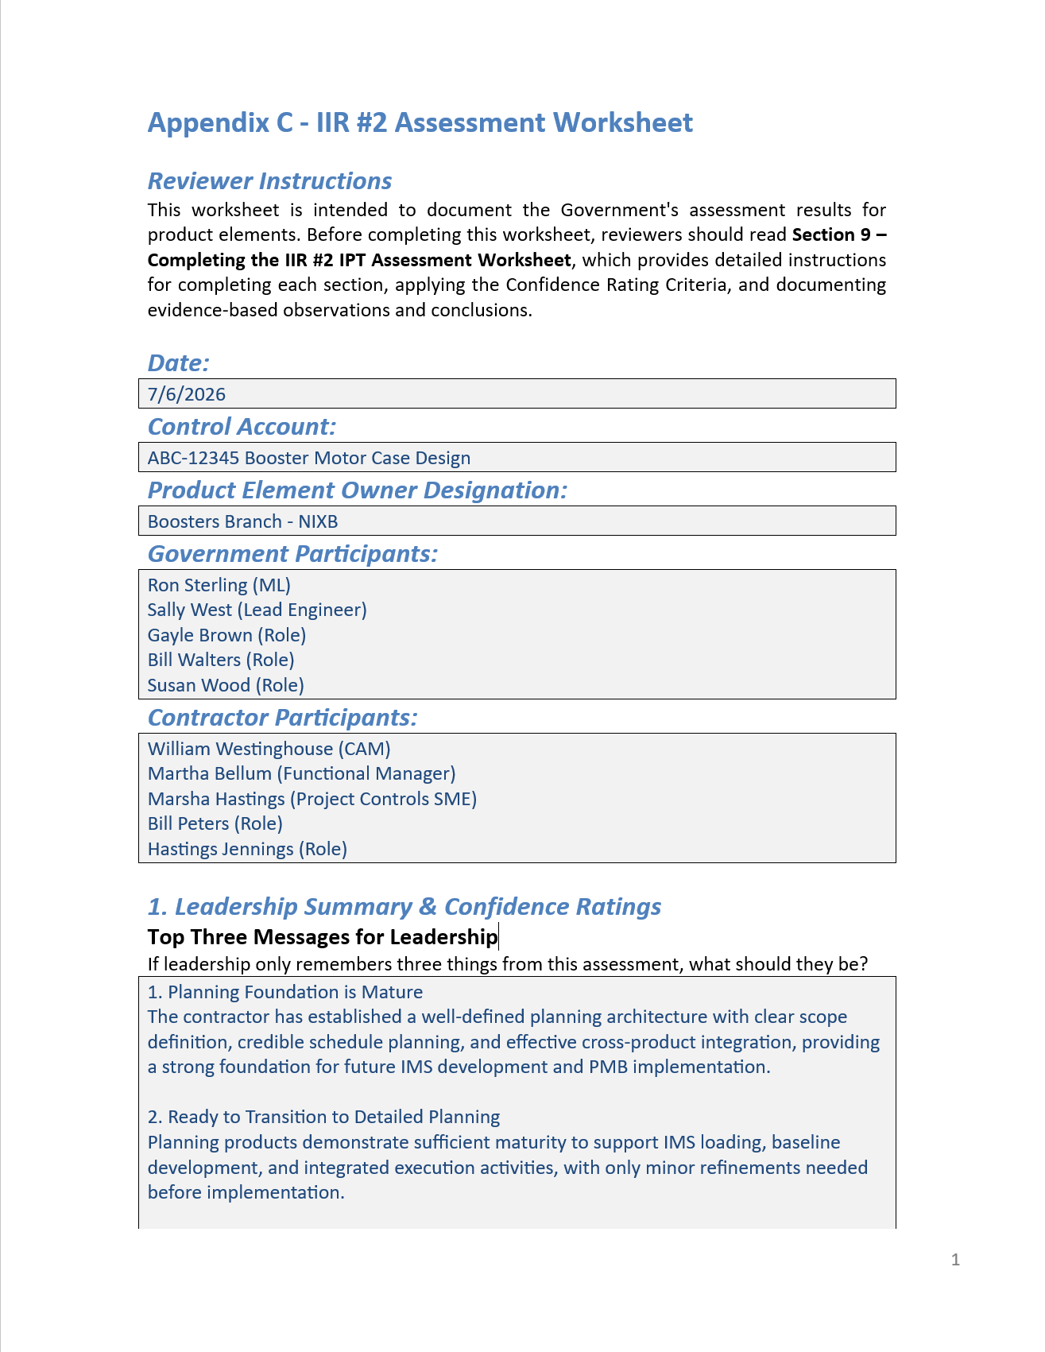

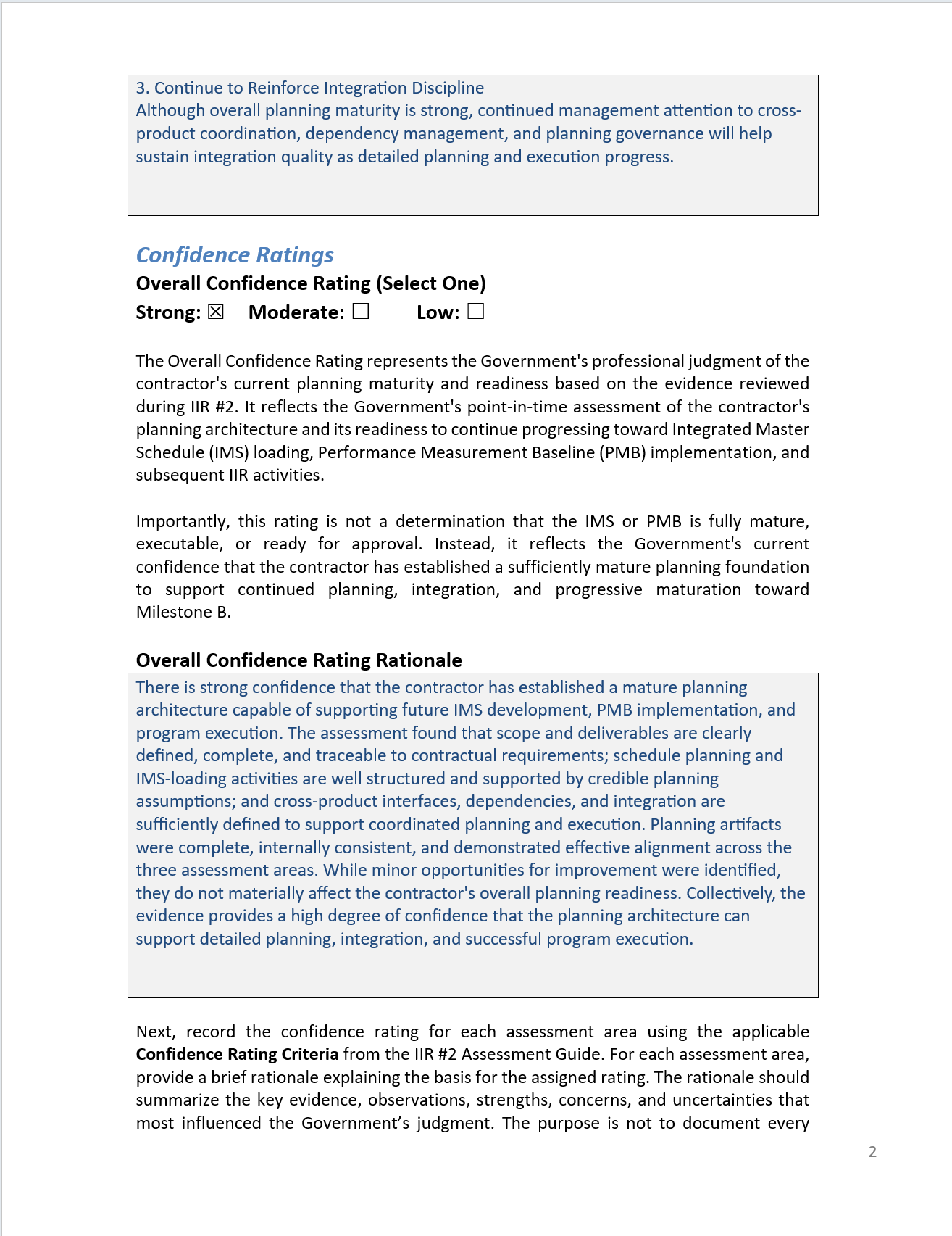

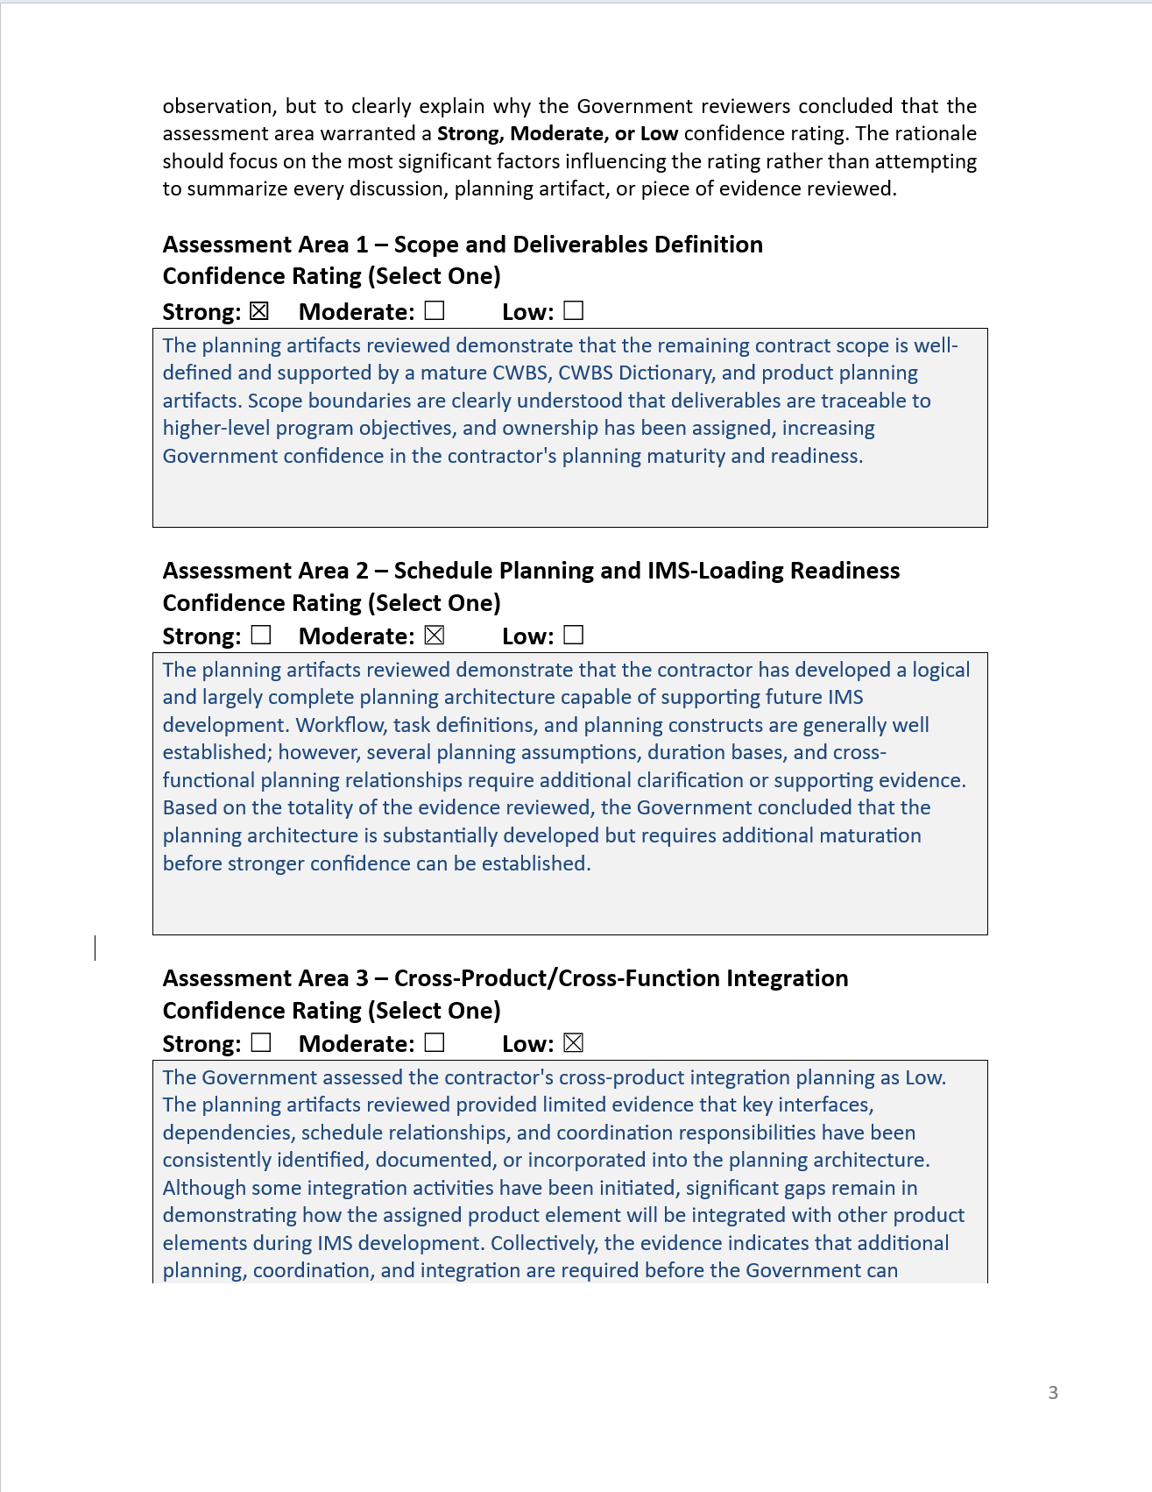

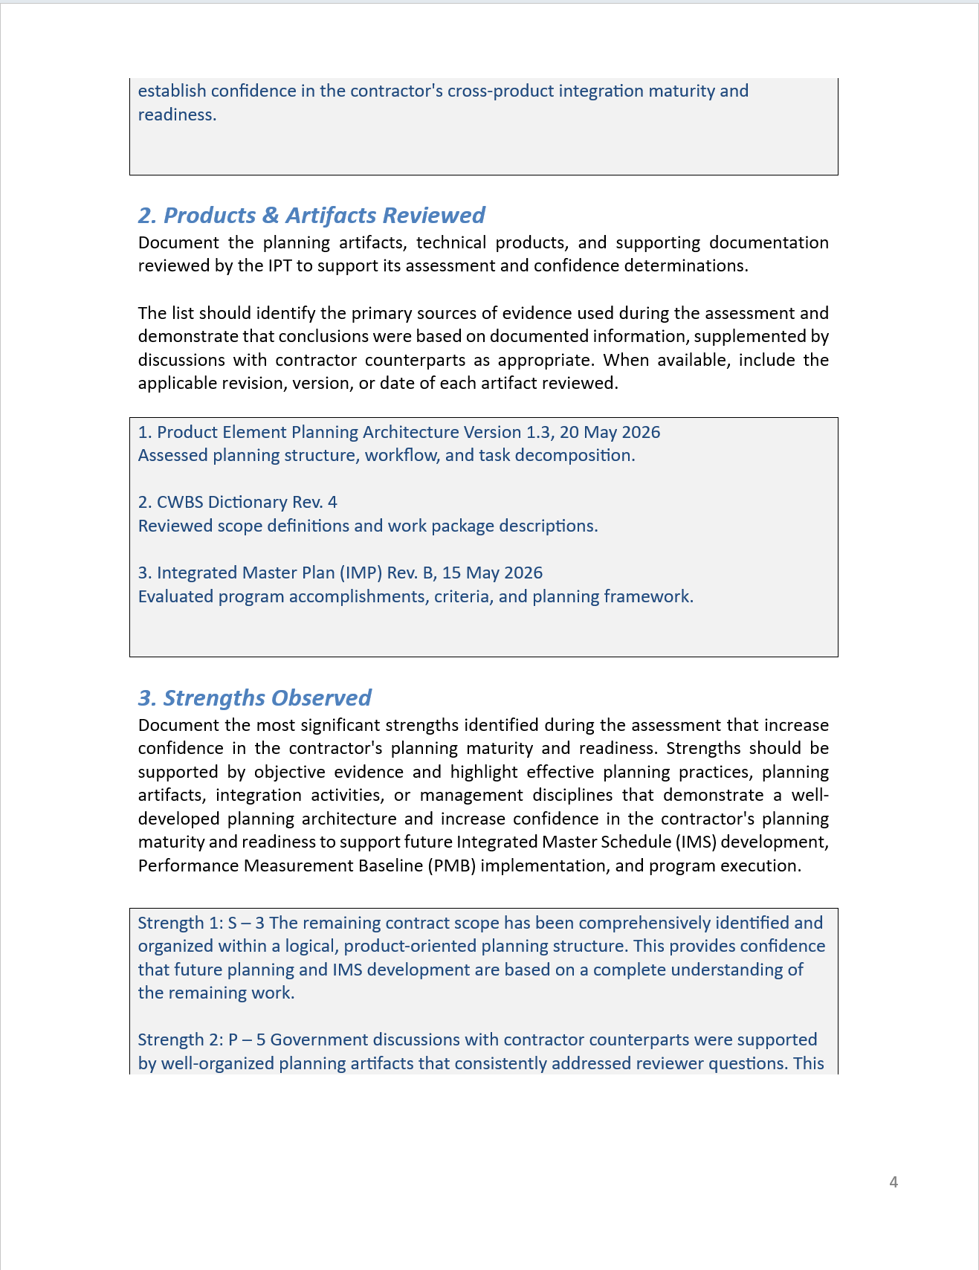

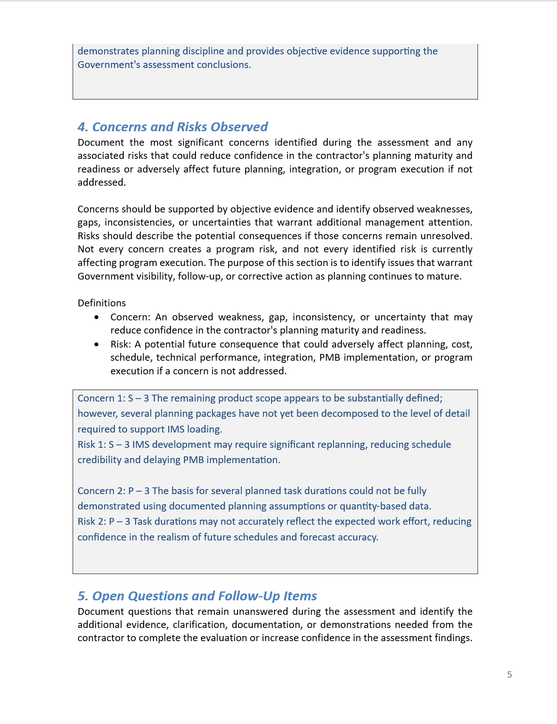

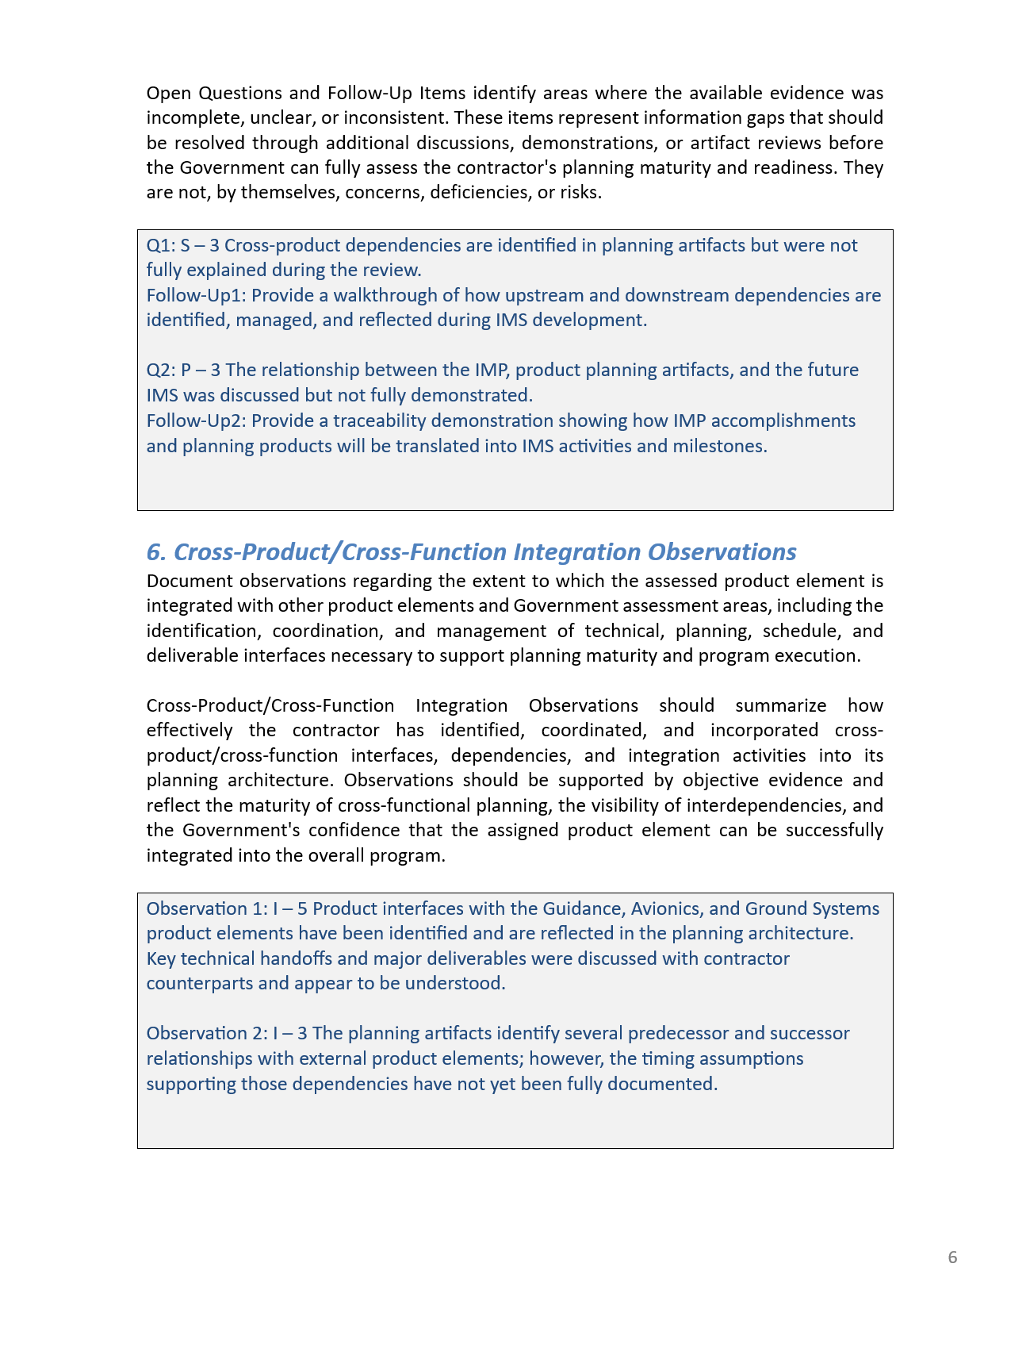

Appendix D - IIR #2 Participant Pulse Form

D.1 Purpose
The IIR #2 Participant Pulse Form provides a non-attributed input path for Government participants to capture individual observations, confidence indicators, concerns, risks, opportunities, organizational concerns, leadership concerns, environmental observations, and recommended follow-up items that may not be fully documented through the ML / Government Review Team Assessment Worksheet.
The Pulse Form is not a substitute for the structured worksheet but is a complementary input mechanism intended to help the Government identify themes, disconnects, confidence trends, environmental factors, organizational barriers, and carry-forward items that may otherwise remain fragmented or undocumented through the structured review process.
The IIR #2 Pulse questions are tailored to the IIR #2 focus on planning architecture and IMS-loading readiness while also capturing the environment and behaviors that influence whether the planning architecture can mature into a credible PMB.
The Pulse Form is an individual observation mechanism. It is not a consensus assessment, maturity scoring tool, or substitute for the facilitated Government hotwash and consensus PMB maturity discussion. Responses should reflect the participant’s professional observations based on IIR #2 artifacts, demonstrations, discussions, interactions, and review participation.
D.2 Response Guidance
This form is intended to be completed quickly. Participants should be able to complete it in approximately 20–30 minutes, with 45 minutes as an upper bound if they have more detailed observations. Responses may be brief bullets. Complete sentences are not required. The objective is to capture useful observations, not polished narratives.
For each question, participants should select a confidence response and provide short comments. Comments should address what was observed, what increased or reduced confidence, and whether any organizational, communication, leadership, decision-making, supplier, resource, tool, data, or integration factors may affect continued planning maturation.
Participants should distinguish between:
- What was demonstrated.
- What was asserted but not fully evidenced.
- What remains unclear.
- What may require follow-up.
- What environmental or organizational condition may affect progress.

D.3 Suggested Response Scale
Response | Meaning
High Confidence | Evidence and observed behaviors provide strong confidence in the condition described.
Moderate Confidence | Evidence and observed behaviors provide partial confidence, but additional clarification, maturation, alignment, or follow-up is needed.
Low Confidence | Evidence or observed behaviors do not yet provide confidence, or significant gaps, inconsistencies, barriers, or uncertainties remain.
Not Observed / Insufficient Basis | Participant did not observe enough information to provide an informed response.

D.4 IIR #2 Participant Pulse Questions
1. Planning Architecture and Common Understanding
Question:
Does the emerging planning architecture appear to provide a clear and credible foundation for organizing remaining scope, and did IIR #2 participants across Government, contractor, product, and functional organizations appear to share a common understanding of how that architecture supports IMS loading, PMB development, and recovery priorities?
Response:
☐ High Confidence
☐ Moderate Confidence
☐ Low Confidence
☐ Not Observed / Insufficient Basis
Prompts:
- What evidence increased or reduced confidence in the planning architecture?
- Did Government and contractor participants appear aligned on the purpose, structure, and use of the architecture?
- Were there areas where terminology, expectations, or understanding appeared inconsistent?
- Did governance and decision-making arrangements appear clear enough to support continued architecture maturation?
Comments / Observations:
[Text response]

2. Scope, Ownership, and Accountability
Question:
Does the review provide confidence that remaining contractor scope is identified, organized, assigned, and traceable to requirements, deliverables, program commitments, and responsible organizations, and did the discussion show clear ownership, accountability, and willingness to resolve scope gaps or ambiguities?
Prompts:
- Were scope boundaries, ownership, and responsibilities clear?
- Were major program commitments, objectives, and deliverable expectations traceable through the planning architecture and understood consistently?
- Did participants acknowledge scope gaps, overlaps, or uncertainties where they existed?
- Did the review environment support candid discussion of unresolved scope or ownership issues?
Response:
☐ High Confidence
☐ Moderate Confidence
☐ Low Confidence
☐ Not Observed / Insufficient Basis
Comments / Observations:
[Text response]

3. Planning Logic, Assumptions, and Evidence Quality
Question:
Did the contractor provide credible planning logic, duration rationale, QBD / quantity-based data, and task-development assumptions, and did the review discussion demonstrate openness to challenging, clarifying, or improving unsupported assumptions?
Prompts:
- Were planning assumptions and duration bases understandable and traceable?
- Were unsupported assumptions challenged or clarified?
- Did participants demonstrate a disciplined approach to improving planning evidence before IMS loading?
- Were there signs of pressure to accept weak rationale, incomplete evidence, or optimistic assumptions?
Response:
☐ High Confidence
☐ Moderate Confidence
☐ Low Confidence
☐ Not Observed / Insufficient Basis
Comments / Observations:
[Text response]

4. Cross-Product / Cross-Function Integration and Coordination
Question:
Are major execution flows, interfaces, dependencies, supplier boundaries, Giver / Receiver relationships, and handoffs sufficiently visible, and did the review demonstrate effective cross-product / cross-function coordination to manage them?
Prompts:
- Were cross-product, cross-function, supplier, business-unit, or organizational dependencies clearly identified?
- Did the right participants appear to be engaged in resolving integration issues?
- Were handoffs and interfaces managed as shared execution issues rather than isolated product-team concerns?
- Were coordination needs, decision points, or unresolved dependencies visible enough to support follow-up?
Response:
☐ High Confidence
☐ Moderate Confidence
☐ Low Confidence
☐ Not Observed / Insufficient Basis
Comments / Observations:
[Text response]

5. Risk, Assumption, Constraint, and Barrier Visibility
Question:
Were significant risks, assumptions, constraints, opportunities, supplier uncertainties, and organizational barriers made visible during IIR #2, and did participants appear willing and able to communicate them clearly for follow-up?
Prompts:
- Were risks and assumptions connected to planning decisions?
- Were organizational or communication barriers affecting planning maturity visible?
- Were supplier uncertainties, change-control implications, or unresolved dependencies discussed candidly?
- Were opportunities for improvement identified, or did the discussion focus only on problems?
Response:
☐ High Confidence
☐ Moderate Confidence
☐ Low Confidence
☐ Not Observed / Insufficient Basis
Comments / Observations:
[Text response]

6. Leadership, Governance, Stakeholder Engagement, and Decision Environment
Question:
Did leadership actions, organizational priorities, governance mechanisms, stakeholder participation, and decision processes appear to support timely issue resolution, planning alignment, recovery progress, and continued maturation toward IMS loading and PMB implementation?
Prompts:
- Were priorities, decision paths, and expectations clear?
- Did leadership reinforce realism, integration, and issue resolution?
- Were the right Government, contractor, functional, supplier, and decision-making stakeholders engaged at the right level?
- Were any governance, participation, or decision-making barriers observed that could slow planning maturation?
Response:
☐ High Confidence
☐ Moderate Confidence
☐ Low Confidence
☐ Not Observed / Insufficient Basis
Comments / Observations:
[Text response]

7. Overall Confidence and Recovery Environment
Question:
Overall, do the IIR #2 evidence, discussions, behaviors, organizational conditions, and recovery environment provide confidence that the contractor and Government are positioned to continue maturing the planning architecture toward IMS loading, PMB implementation, and follow-on IIRs?
Prompts:
- What most increased confidence?
- What most reduced confidence?
- What should leadership understand about the environment affecting planning maturation?
- Did the teams appear to have the people, data, tools, and analytical support needed to continue maturing the planning architecture after IIR #2?
- What should be carried forward into IIR #3, IIR #4, IIR #5, or IBR preparation?
Response:
☐ High Confidence
☐ Moderate Confidence
☐ Low Confidence
☐ Not Observed / Insufficient Basis
Comments / Observations:
[Text response]

D.5 Optional Open-Ended Inputs
A. Top Strengths
Identify up to three strengths observed during IIR #2. These may include technical, planning, integration, leadership, communication, organizational, or environmental strengths.
- [Text response]
- [Text response]
- [Text response]

B. Top Concerns / Unknowns
Identify up to three concerns, unknowns, barriers, or issues requiring follow-up. These may include planning gaps, integration concerns, supplier uncertainties, communication issues, leadership concerns, organizational barriers, unresolved assumptions, or resource / tool / data limitations.
- [Text response]
- [Text response]
- [Text response]

C. Recommended Carry-Forward Items
Identify items that should remain visible after IIR #2.
Carry-Forward Item | Suggested Destination
1. [Text response] | ☐ IIR #3 ☐ IIR #4 ☐ IIR #5 ☐ IBR Prep ☐ Other
2. [Text response] | ☐ IIR #3 ☐ IIR #4 ☐ IIR #5 ☐ IBR Prep ☐ Other
3. [Text response] | ☐ IIR #3 ☐ IIR #4 ☐ IIR #5 ☐ IBR Prep ☐ Other

D. Other Observations
Provide any additional observations that may help the Government understand planning maturity, integration risk, organizational readiness, communication effectiveness, leadership alignment, resource adequacy, tool / data limitations, or future review focus areas.
- [Text response]
- [Text response]
- [Text response]

D.6 AI-Assisted Analysis Note
Pulse responses may be analyzed with AI-assisted theme mining to identify recurring themes, areas of agreement or divergence, confidence trends, risks, unknowns, organizational barriers, communication issues, leadership concerns, resource or tool limitations, and carry-forward items.
AI-assisted outputs are draft analytical inputs only. Results must be reviewed and validated by the responsible Government Review Team members before being used in readouts, hotwashes, assessment summaries, executive summaries, or leadership discussions.

