ECET 292 Assignment #1  
JLC INstruction Manual



Cameron Gillingham

Aaron Huinink

Tella Osler

Table of Contents

Manufacturing Capabilities 2

Number of layers 2

Lead Times 2

Tolerances 3

Available PC board Composites 3

Maximum PCB Size 3

Colours (Solder Mask and Silkscreen) 3

Trace Size 3

Copper thickness 4

Via Size 4

Current Pricing 4

Payment options 5

Panelization options 5

Type(s) of testing available 5

AOI (Automated Optical Inspection) 5

Flying Probe Testing 5

Final Quality Checking 6

Spacing 6

Clearance 6

Standard Order Specifications (Cheapest PCB) 7

File Requirements for a successful Altium PCB submission 7

Generating a Gerber File 7

GeneratingNC Drill File 8

FR-4 9

Return Policy 10

References 10

# Manufacturing Capabilities

All JLCPCB manufacturing capabilities can be found at [1].

## Number of layers

1-32 layers

## Lead Times

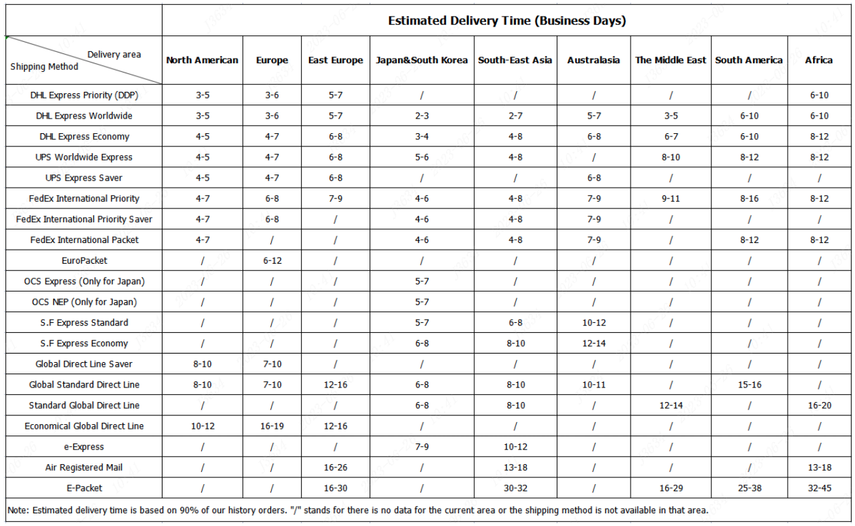

Figure : JLCPCB shipping times [2].

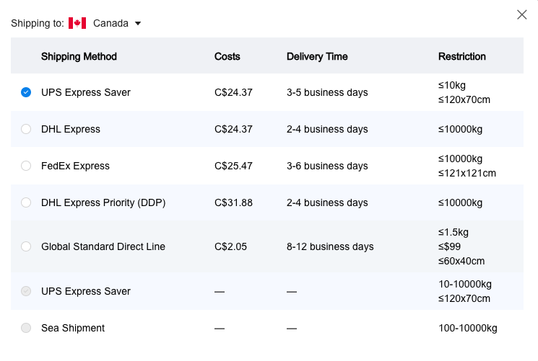

Figure : JLCPCB shipping costs to Canada [2].

## Tolerances

**Dimension Tolerance** ±0.1mm

**Thickness Tolerance (Thickness≥1.0mm)** ± 10%

**Thickness Tolerance (Thickness<1.0mm)** ± 0.1mm

**Hole size Tolerance (Plated):**

Through-holes: +0.13 / -0.08 mm

Press-fit holes：±0.05 mm (multilayer ENIG boards only – mention the specific holes in PCB Remark)

**Hole size Tolerance (Non-Plated)** ±0.2mm

**Track width tolerance** ±20%

## Available PC board Composites

**FR-4** ( FR4 dielectric constants): 7628 Prepreg 4.4, 3313 Prepreg 4.1, 2116 Prepreg 4.16

**Aluminum-Core** 1-layer Aluminum-core PCBs

**Copper-Core**1-layer copper-core PCBs with direct heatsink contacts to core (≥ 1 × 1 mm)

**RF PCB** (1 oz copper, 2-layer RF PCBs with Rogers and PTFE cores)

## Maximum PCB Size

**Maximum Dimensions**

FR4 PCB: 670 × 600 mm

Rogers / PTFE Teflon PCB: 590 × 438 mm

Aluminum PCB: 602 × 506 mm

Copper PCB: 480 × 286 mm

## Colours (Solder Mask and Silkscreen)

**Solder Mask:** Green, Purple, Red, Yellow, Blue, White, and Black.

**Silkscreen:** White

## Trace Size

**Min. track width and spacing (1 oz):**

1- and 2-layer: 0.10 / 0.10 mm (4 / 4 mil)

Multilayer: 0.09 / 0.09 mm (3.5 / 3.5 mil). 3 mil is acceptable in BGA fan-outs.

**Min. track width and spacing (2 oz):** 2-layer: 0.16 / 0.16 mm (6.5 / 6.5 mil)

Multilayer: 0.16 / 0.20 mm (6.5 / 8 mil)

## Copper thickness

**Finished Outer Layer Copper** 1 oz / 2 oz (35um / 70um)

**Finished Inner Layer Copper** 0.5 oz / 1 oz / 2 oz (17.5um / 35um / 70um)

(Finished copper weight of inner layer is 0.5oz by default)

## Via Size

**Min. Via hole size/diameter** 0.15mm / 0.25mm

**1-layer** (NPTH only): 0.3 mm hole size / 0.5 mm via diameter

**2-layer** 0.15mm hole size / 0.25mm via diameter

**Multilayer** 0.15 mm hole size / 0.25 mm via diameter

a. Via diameter should be 0.1mm(0.15mm preferred) larger than Via hole size.

b. Preferred Min. Via hole size: 0.2mm

## Current Pricing

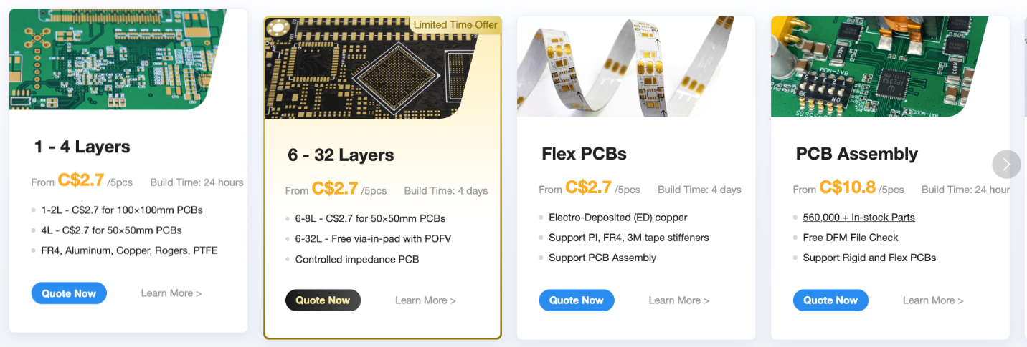

Figure : Current JLCPCB pricing estimates from their website [3].

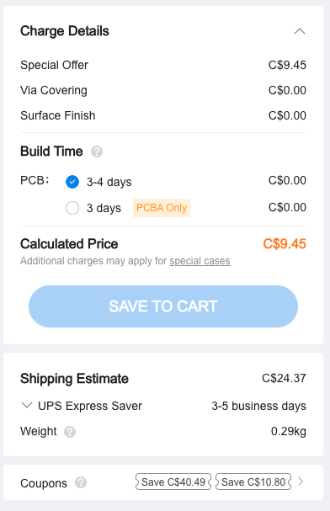

Figure : Pricing for a mock basic PCB order from JLCPCB.

## Payment options

PayPal, Credit Card and Wire Transfer payment methods.

## Panelization options

V-Cut, Mouse-bite Panels

## Type(s) of testing available

Pre-shipping Testing

### AOI (Automated Optical Inspection)

AOI uses a camera to closely inspect the PCB for missing components or manufacturing defects.

### Flying Probe Testing

Robotic probes test each connection on the board to ensure there are no electrical violations or missing connections.

### Final Quality Checking

#### Electrical Testing:

Electrical testing involves evaluating the continuity, resistance, capacitance, and other electrical characteristics of the PCB. This is typically done using automated test equipment (ATE) or flying probe testing to verify the integrity of circuit connections and the absence of short circuits or open circuits.

#### Functional Testing:

Functional testing evaluates the PCB's performance by subjecting it to real-world operating conditions. This testing ensures that the PCB functions as intended, meets desired specifications, and performs expected tasks. It involves simulating inputs and outputs, analyzing responses, and verifying the overall functionality of the circuit.

#### Reliability Testing

Reliability testing assesses the PCB's ability to withstand various environmental and operational stresses over its intended lifespan. This includes temperature cycling, thermal shock, vibration testing, humidity testing, and accelerated aging tests. Reliability testing helps identify potential weaknesses, predict failure rates, and ensure the durability of the PCB under adverse conditions.

## Spacing

**Via Hole-to-Hole Spacing** 0.2mm

**Pad Hole-to-Hole Spacing** 0.45mm

**Min. track width and spacing (1 oz):**

1- and 2-layer: 0.10 / 0.10 mm (4 / 4 mil)

Multilayer: 0.09 / 0.09 mm (3.5 / 3.5 mil). 3 mil is acceptable in BGA fan-outs.

**Min. track width and spacing (2 oz):** 2-layer: 0.16 / 0.16 mm (6.5 / 6.5 mil)

Multilayer: 0.16 / 0.20 mm (6.5 / 8 mil)

**Hatched grid width and spacing** 0.25 mm

**Same-net track spacing** 0.25mm

**Soldermask bridge** 0.10mm

2-layer (1 oz): Min. pad spacing: 0.20 mm (green, red, yellow, blue, purple)

Min. pad spacing: 0.23 mm (black, white)

Multilayer (1 oz): Min. pad spacing: 0.10 mm (green, red, yellow, blue, purple)

Min. pad spacing: 0.13 mm (black, white)

**Pad To Silkscreen** 0.15mm

## Clearance

**Inner layer via hole to copper clearance** 0.2mm

**Inner layer PTH pad hole to copper clearance** 0.3mm

**Pad to track clearance** 0.1mm

**SMD pad to pad clearance (different nets)** 0.15mm

**Via hole to Track** 0.2mm

**PTH to Track** 0.28mm (0.35mm is recommended, minimum 0.28mm)

**NPTH to Track** 0.2mm

## Standard Order Specifications (Cheapest PCB)

Base Material: FR-4

Layers: 2

Product Type: Industrial/Consumer electronics

**Standard PCB specifications**

Different Design: 1

Delivery Format: Single PCB

PCB Thickness: 1.6

PCB Color: Green

Silkscreen: White

Surface Finish: HASL(with lead)

## File Requirements for a successful Altium PCB submission

### Generating a Gerber File

Each element of the PCB has a shape and location, and this is stored in the Gerber file generated for each layer.

1. Open your .PCB design files on Altium designer software

Select File -> Fabrication Outputs -> Gerber Files.

1. General Setting

In the General Setting set the precision to 2:5 (0.01 mill resolution)

1. Layers Setting

Please make sure you have the clear outline in mechanical layer.

If your board are 2-layer, there will be no inner layer(G1,G2,G3....)

Include the layers that you want to export by marking these, select “Used On” in Plot Layers, Select “All Off” in Mirror Layers.

1. Aperture Setting

Be sure to mark “Embedded apertures (RS274X)”

1. Advanced Setting

When you make sure all configurations are fine. Please click the OK to generate the gerber files.

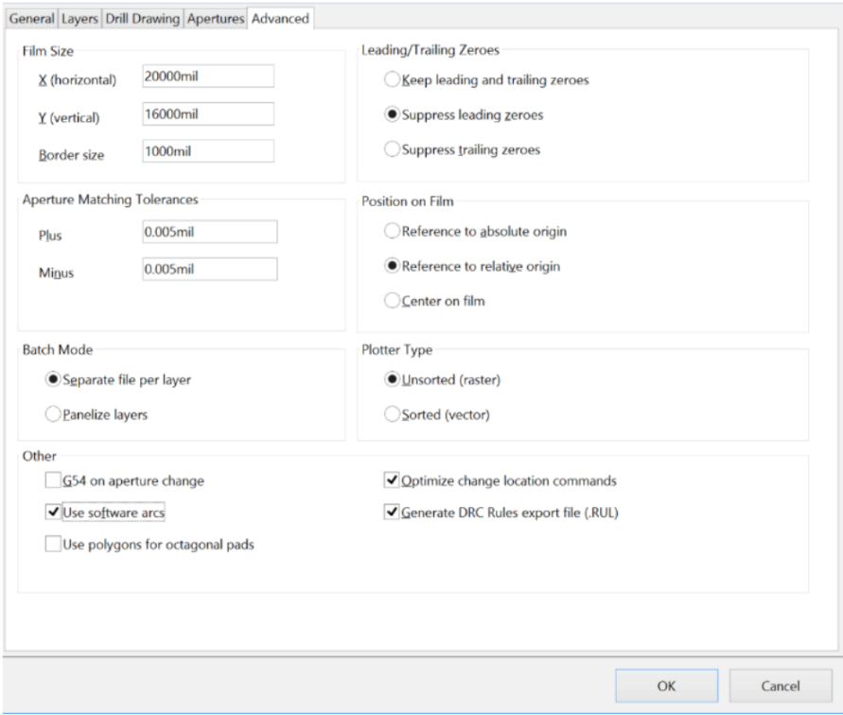

Figure : Altium CAM viewer dialogue.

Gerber Files are automatically loaded in the Altium cam viewer. This tool allows you to verify that all layers have been generated correctly and that they are all in positive mode.

### GeneratingNC Drill File

NC drill files contain the information about each hole that needs to be drilled in the PCB by the manufacturer, including size, shape, and location.

1. Generate the Drilling layer in Excellon format.

File -> Fabrication Outputs -> NC Drill Files

Include a one sentence description of each file type

1. Set the precision to 2:4. Then click OK.

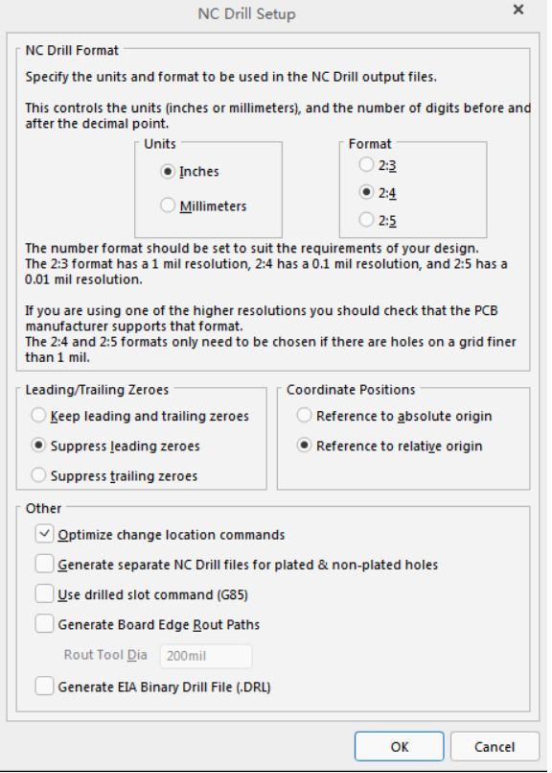

Figure : Altium NC Drill setup dialogue.

Then you get all files. Please put them into a single .zip/.rar file.

Altium has published a guide on producing those files here:

http://wiki.altium.com/display/ADOH/NC+Drill+Output+Options

If everything looks OK, upload the zip file to JLCPCB order page.

A **Gerber file** stores shape and location data for every element in a PCB layout [4].

An **NC Drill file** stores PCB drilling and routing information [5].

# FR-4

FR-4 is a Grade A laminate (suppliers including Nan Ya, KB, Shengyi). The dielectric constants are 4.4 for 7628 prepreg, 4.1 for 3313 prepreg, and 4.16 for 2116 prepreg.  
FR4 substrate stands for "flame retardant 4" which indicates that FR4 substrate is made to resist the propagation of flames and meets certain fire safety standards. This type of substrate has fiberglass as one of its components which provides mechanical strength along with epoxy resin. The combination of the two materials acts as an insulating matrix. FR4 substrates provide excellent electrical insulation, mechanical strength and protection for the electrical components on the board.

The FR4 substrate won’t work when your device requires very high-speed signals or microwave frequencies range, in this case substrate options like a ceramic-based substrate would be better.

The maximum bandwidth of FR-4 is 7GHz, above this, a special high frequency material should be used [6].

# Return Policy

If any issues with the ordered product are found and confirmed to be due to JLCPCB’s error, they will refund or redo the order. If no feedback is provided and the order is placed again, any issues with the initial order and the reorder will only be covered for the first order.

# References

|  |  |
| --- | --- |
| [1] | JLCPCB, "Manufacturing Capabilities," [Online]. Available: https://jlcpcb.com/capabilities/pcb-capabilities. |
| [2] | JLCPCB, "Shipping Methods and Delivery Time," [Online]. Available: https://jlcpcb.com/help/article/Shipping-Methods-and-Delivery-Time. |
| [3] | JLCPCB, "Home page," [Online]. Available: https://jlcpcb.com/. |
| [4] | Altium, "Gerber Files," [Online]. Available: https://resources.altium.com/p/what-gerber-file-pcb-fabrication-process. |
| [5] | Altium, "NC Drill Files," [Online]. Available: https://www.altium.com/documentation/altium-designer/workspacemanager-dlg-drillsetup-formnc-drill-setup-ad?version=21&srsltid=AfmBOorANUiSF5ihPoUjXa7zRK7g00bY7jPaLmrSkY_EHJgs5cjzskTG. |
| [6] | JLCPCB, "FR4 Board Material," [Online]. Available: https://jlcpcb.com/blog/is-fr4-the-best-board-material-for-your-design. |