ECET 292 Assignment#1 Project overview

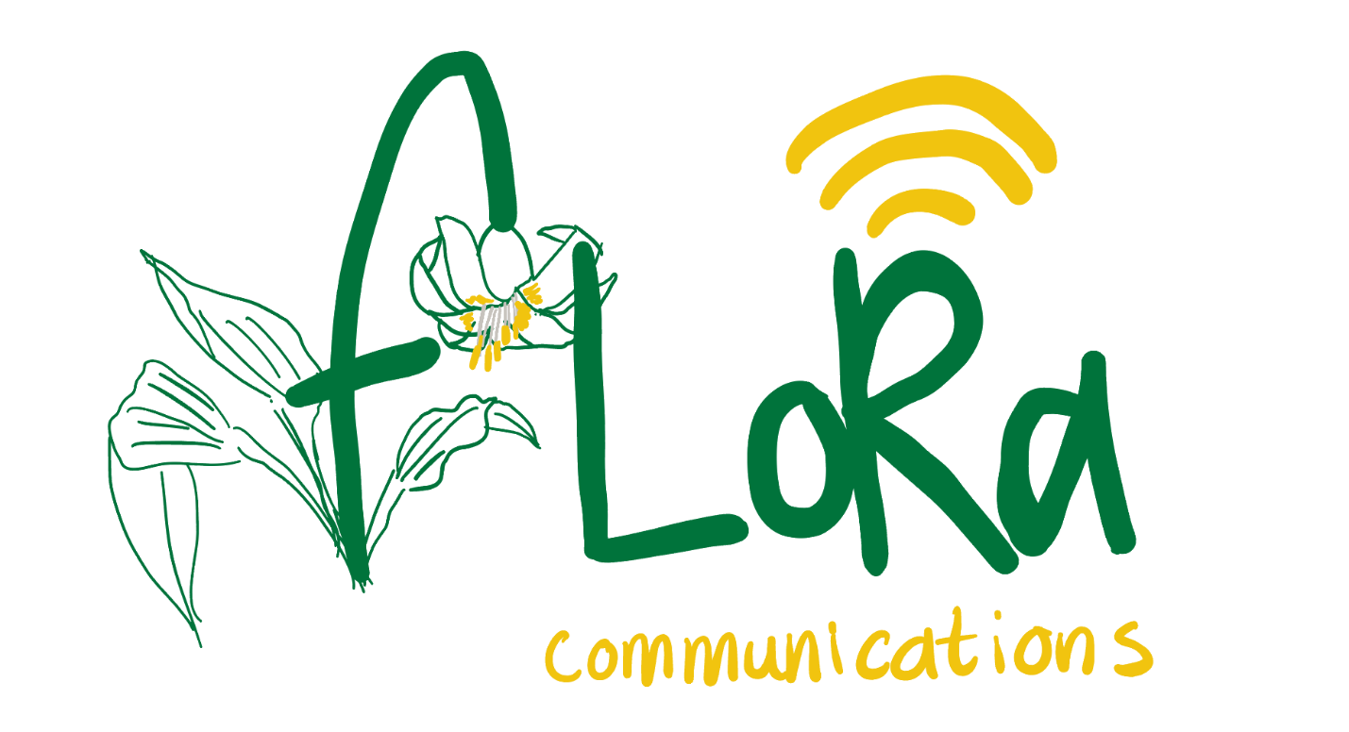

Cameron Gillingham

Aaron Huinink

Tella Osler

Table of Contents

Project Description 3

Functional Diagrams 4

Hardware Overview 4

Software Overview 5

Design Specifications 6

Power Audit 6

Power Supply 7

Pin Map 8

Table of Figures

Figure 1 - Petal V0.0 Hardware Diagram 4

Figure 2 - AVAlink V1.0 Top Level Diagram 5

# Project Description

Outside the bounds of cellular service, there are a lack of affordable communication choices for the average outdoors recreationalist. Expensive satellite subscription devices are a safety essential for seasoned and technical outdoors people, but for casual hikers this can be a prohibitively expensive option. We aim to provide an inexpensive means of communication with the ease of scanning a QR code on your own smartphone. In 2022 a fatality occurred on the Kludahk trail in Jordan River. This tragedy highlights the importance having accessible communication in remote areas.

Our prototype LoRa (Long Range) radio mesh network will be released December 13th, 2024 as a first step towards a future implementation on the 48 km Kludahk trail outside of Jordan River, BC. LoRa is the perfect long range digital radio transmission choice for this low-noise, backcountry environment. It operates on the unlicensed 915MHz band and has low power requirements, allowing for off-grid, solar powered applications. Users will connect to our web application via Wi-Fi access points at LoRa mesh network nodes along the trail and will be able to post public messages on the user-friendly interface. It is our goal to develop the trail’s LoRa network in the future to include cellular integration with emergency services.

# Functional Diagrams

## Hardware Overview

Figure - Petal V0.0 Hardware Diagram

## Software Overview

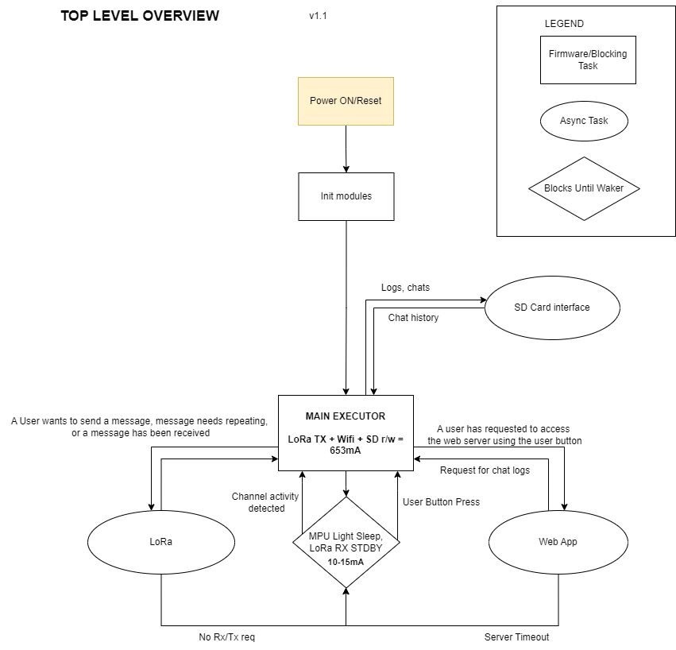

Figure - AVAlink V1.0 Top Level Diagram

# Design Specifications

## Power Audit

Table : High level description of the repeater current and power requirements at 3.3V.

|  |  |  |
| --- | --- | --- |
| **Device** | **Mode** | **Current Draw [mA]** |
| *Esp32-S3* | Wi-fi TX | 355 |
|  | Wi-fi RX | 97 |
|  | Modem Sleep (40 MHz) | 21.8 |
|  | Modem Sleep(80Hz) | 47.3 |
|  | Modem Sleep(160 MHz) | 64.1 |
|  | Modem Sleep (240MHz) | 81.3 |
|  | Light Sleep | 0.24 |
|  | Deep Sleep | 0.008 |
| *LoRa Core-1262* | TX at 14dBm | 45 |
|  | TX at 22dBm | 118 |
|  | RX | 5.3 |
|  | Sleep | 0.0012 |
|  | TCXO TX | 2.36 |
|  | TCXO RX | 0.106 |
|  | TCXO Sleep | 0.07 |
| *SD Card* | R/W | 100 |
|  | idle | 0.4 |
| *Standard LED* | Max | 80 |
|  | Reverse Current | 0.01 |
| **Total** | **Sleep Current Draw** | **0.6512** |
|  | **Max Current Draw** | **653** |
|  | **Max Power Requirement** | **2.15 W** |

## Power Supply

Table : Description of power supplies for each repeater node.

|  |  |  |  |  |
| --- | --- | --- | --- | --- |
| **Supply** | **(Net) Voltage** | **Max Current** | **Ripple** | **Type** |
| *Solar + Battery Input* | (V_SUPPLY) 3.8V-30V | >10A | >90dB | Battery |
| *Power Plane: Texas Instruments TPS62933P* | (3V3)  3.3V ±0.05V | 3A | >45dB | Switching (adjustable 200-2100kHz, spread spectrum) |

Notes:

* Power plane and surrounding ground polygon pour used as heat sink for 3.3V supply. 3A power supply provides us plenty of overhead for our expected 653mA peak draw.
* We chose a switching supply (TPS62933P) with high efficiency (>90%) and low quiescent current (~2μA) at a low output current to extend battery life when the node is in a standby receive mode. The power supply also uses spread spectrum techniques to reduce switching noise. The switching frequency is also adjustable based on the resistor value on the RT pin, so we can choose a frequency whose harmonics won’t interfere with the 32MHz reference used by the LoRa radio module.
* Production releases will incorporate a metal shield around the power supply region of the board to decrease emissions from the power supply.
* The peak current draw of 653mA will only occur when the LoRa module is transmitting, the Wi-Fi access point is on, and the SD card is being read or written to simultaneously. The device will spend most of its time in a low power standby mode which is why high efficiency at low current was a deciding factor in choosing a power supply.

## Pin Map

Table : Pin map descriptions and functions.

|  |  |  |  |  |  |  |  |  |
| --- | --- | --- | --- | --- | --- | --- | --- | --- |
| **Component** | **Name** | **Net Assignment** | **Pin Number** | | **Protocol** | | **Description** | |
| ESP32-S3-MINI-N8 | GND | GND | | 1,2,42,43,46-65 | | Power | | ESP32 Ground connections | |
| 3V3 | 3V3 | | 3 | | Power | | ESP32 Power connection | |
| IO0 | BOOT_BUTTON | | 4 | | GPIO | | Used to set the ESP32 into bootloader mode to load new firmware | |
| IO1 | SPARE_GPIO | | 5 | | GPIO | | Unused GPIO broken out to female headers | |
| IO2 | SPARE_GPIO | | 6 | | GPIO | | Unused GPIO broken out to female headers | |
| IO3 | SPARE_GPIO | | 7 | | GPIO | | Unused GPIO broken out to female headers | |
| IO4 | SPARE_GPIO | | 8 | | GPIO | | Unused GPIO broken out to female headers | |
| IO5 | SPARE_GPIO | | 9 | | GPIO | | Unused GPIO broken out to female headers | |
| IO6 | SPARE_GPIO | | 10 | | GPIO | | Unused GPIO broken out to female headers | |
| IO7 | SPARE_GPIO | | 11 | | GPIO | | Unused GPIO broken out to female headers | |
| IO8 | SPARE_GPIO | | 12 | | GPIO | | Unused GPIO broken out to female headers | |
| IO9 | SPARE_GPIO | | 13 | | GPIO | | Unused GPIO broken out to female headers | |
| IO10 | FSPI_CHIP_SELECT | | 14 | | SPI | | FAST SPI: Determines which device to write on SPI bus | |
| IO11 | FSPI_MOSI | | 15 | | SPI | | FAST SPI: Master out slave in | |
| IO12 | FSPI_CLK | | 16 | | SPI | | FAST SPI: Clock signal | |
| IO13 | FSPI_MISO | | 17 | | SPI | | FAST SPI: Master in slave out | |
| IO14 | USER_BUTTON | | 18 | | GPIO | | Button for user to interact with the digital radio, will wake from sleep to allow for file transfer | |
| IO15 | CARD_DETECT | | 19 | | SPI | | Card detection switch for SD card reader | |
| IO16 | BLUE_LED | | 20 | | GPIO | | Blue pin for RGB indicator LED | |
| IO17 | RED_LED | | 21 | | GPIO | | Red pin for RGB indicator LED | |
| IO18 | GREEN_LED | | 22 | | GPIO | | Green in for RGB indicator LED | |
| IO19 | DATA_NEGATIVE | | 23 | | USB_OTG | | Negative line of the Data line coming from the USB port, routed as differential pair | |
| IO20 | DATA_POSITIVE | | 24 | | USB_OTG | | Positive line of the Data line coming from the USB port, routed as differential pair | |
| IO21 | SPARE_GPIO | | 25 | | GPIO | | Unused GPIO broken out to female headers | |
| IO26 | SPARE_GPIO | | 26 | | GPIO | | Unused GPIO broken out to female headers | |
| IO47 | SPARE_GPIO | | 27 | | GPIO | | Unused GPIO broken out to female headers | |
| IO33 | SPARE_GPIO | | 28 | | GPIO | | Unused GPIO broken out to female headers | |
| IO34 | SUBSPI_CHIP_SELECT | | 29 | | SPI | | SUB SPI: Determines which device to write to on SPI bus | |
| IO48 | LORA_RESET | | 30 | | GPIO | | Ability to reset the Semtech 1262 chip with the ESP32 | |
| IO35 | SUBSPI_MOSI | | 31 | | SPI | | SUB SPI: Master out slave in | |
| IO36 | SUBSPI_CLK | | 32 | | SPI | | SUB SPI: Clock signal | |
| IO37 | SUBSPI_MISO | | 33 | | SPI | | SUB SPI: Master in slave out | |
| IO38 | LORA_BUSY | | 34 | | GPIO | | Communicates to the ESP32 that the Semtech 1262 chip is busy | |
| IO39 | LORA_IRQ | | 35 | | GPIO | | Sends an interupt signal to the ESP32, can be used to wake the microprocessor before sending data | |
| IO40 | SPARE_GPIO | | 36 | | GPIO | | Unused GPIO broken out to female headers | |
| IO41 | SPARE_GPIO | | 37 | | GPIO | | Unused GPIO broken out to female headers | |
| IO42 | SPARE_GPIO | | 38 | | GPIO | | Unused GPIO broken out to female headers | |
| TXDO | U0TXD | | 39 | | UART | | Transmit line for the UART header | |
| RXDO | U0RXD | | 40 | | UART | | Receive line for the UART header | |
| IO45 | SPARE_GPIO | | 41 | | GPIO | | Unused GPIO broken out to female headers | |
| IO46 | SPARE_GPIO | | 44 | | GPIO | | Unused GPIO broken out to female headers | |
| EN | CHIP_PU | | 45 | | Chip Enable | | Pulled High through time delayed cicuit to to enable chip slightly after power is applied | |
| SD Card Reader | GND_1 | GND | | G1 | | Power | | SD card ground | |
| GND_2 | GND | | G2 | | Power | | SD card ground | |
| DAT2 | ~ | | P1 | | ~ | | Unused since using single-line SPI | |
| CD/Dat3 | SD_CS | | P2 | | SPI | | SD card chip select | |
| CMD | FSPI_MOSI | | P3 | | SPI | | SD card Fast SPI MOSI | |
| VDD | 3V3 | | P4 | | Power | | SD card 3.3V power | |
| CLK | FSPI_CLK | | P5 | | SPI | | SD card Fast SPI clock | |
| VSS | GND | | P6 | | Power | | SD card ground | |
| DAT0 | FSPI_MISO | | P7 | | SPI | | SD card Fast SPI MISO | |
| DAT1 | ~ | | P8 | | ~ | | Unused since using single-line SPI | |
| CARD_DETECT_1 | SD_CD | | CD1 | | GPIO | | Detects the presence of a card in the reader. Uses internal pull-up resistor on ESP32 input | |
| CARD_DETECT_2 | GND | | CD2 | | ~ | | Unused so pulled to ground | |
| Micro USB Port | VBUS | V_SUPPLY | | 1 | | Power | | 5V input going to switching regulator through protection diode | |
| D- | DATA_NEGATIVE | | 2 | | USB_OTG | | Negative line of the Data line coming from the USB port, routed as differential pair | |
| D+ | DATA_POSITIVE | | 3 | | USB_OTG | | Positive line of the Data line coming from the USB port, routed as differential pair | |
| ID | ~ | | 4 | | ~ | | No connection | |
| GND | GND | | 5 | | Power | | USB ground connection | |
| SHLD1 | ~ | | 6 | | ~ | | USB shield grounded at master to prevent ground loop between master and node. | |
| SHLD2 | ~ | | 7 | | ~ | | USB shield grounded at master to prevent ground loop between master and node. | |
| SHLD3 | ~ | | 8 | | ~ | | USB shield grounded at master to prevent ground loop between master and node. | |
| SHLD4 | ~ | | 9 | | ~ | | USB shield grounded at master to prevent ground loop between master and node. | |
| SHLD5 | ~ | | 10 | | ~ | | USB shield grounded at master to prevent ground loop between master and node. | |
| SHLD6 | ~ | | 11 | | ~ | | USB shield grounded at master to prevent ground loop between master and node. | |
| WAVE Core-1262 |  |  | |  | |  | |  | |
| GND | GND | | GND | | Power | | LoRa module ground | |
| RXEN | RX_EN | | RXEN | | GPIO | | RF switch control output for half-duplex mode. Connected to ANT_SW through 100R resistors. | |
| TXEN | TX_EN | | TXEN | | GPIO | | RF switch control output for half-duplex mode. Connected to ANT_SW through 100R resistors. | |
| IRQ | LoRa_IRQ | | DIO1 | | GPIO | | Sends an interupt signal to the ESP32, can be used to wake the microprocessor before sending data | |
| GND | GND | | GND | | Power | | LoRa module ground | |
| 3V3 | 3V3 | | 3V3 | | Power | | LoRa module 3.3V power input | |
| BUSY | LoRa_BUSY | | BUSY | | GPIO | | Communicates to the ESP32 that the Semtech 1262 chip is busy | |
| RESET | LORA_RESET | | RESET | | GPIO | | Ability to reset the Semtech 1262 chip with the ESP32 | |
| MISO | SUBSPI_MISO | | MISO | | SPI | | SUB SPI: Master in slave out | |
| MOSI | SUBSPI_MOSI | | MOSI | | SPI | | SUB SPI: Master out slave in | |
| CLK | SUBSPI_CLK | | CLK | | SPI | | Sub SPI: clock | |
| NSS/CS | SUBSSPI_CS | | NSS | | SPI | | SUB SPI: LoRa module chip select | |
| GND | GND | | GND | | Power | | LoRa module ground | |
| ANT | ANT | | ANT | | Analog | | Secondary antenna output, not connected to anything. Using the build in IPEX connector of the module to connect our antenna. | |
| TPS62933P - Power Supply | RT | RT | | 1 | | Analog | | Frequency selection pin. Left floating for the default switching frequency to be 500kHz. Broken out to a header allowing us to add a resistor to change the frequency if needed. | |
| EN | PSU_EN | | 2 | | Analog DC | | Power supply enable pin. Connected to a voltage divider that provides the low voltage disconnect functionality. Requires a highly stable voltage with little noise to prevent false disconnects or reconnects. Use star grounding and proper PCB layout techniques to prevent coupling with digital circuits. | |
| VIN | V_SUPPLY | | 3 | | Power | | Input battery voltage | |
| GND | GND | | 4 | | Power | | Power supply ground | |
| SW | SW_OUT | | 5 | | Power | | Switch output that goes into the LC switching filter | |
| BST | SW_OUT | | 6 | | AC coupled power | | Bootstrap pin that monitors the AC portion of the power output. | |
| PG | V_PG | | 7 | | GPIO | | Power good pin indicating the power output is stable | |
| FB | FB | | 8 | | Analog DC | | Voltage feedback pin | |