Florabel Ituralde HW 3B - SQL 03 - Joins

1. In general, why would you even want to join two (or more) tables together? This is a good time to think about the nature of relational algebra.
   * It is helpful to join two or more tables together when trying to understand the relation between the tables to compare results within the database
2. Describe in your own words the output from an inner join.
   * Inner joins compare the data between tables to get all the values in which both tables have. It is a comparison tool to find which values exists on both tables.
3. Describe in your own words the output from an outer join.
   * Outer join compares all the data from the tables and return all rows that satisfies the condition and those that are not.
4. Describe in your own words the output from a cross join.
   * Cross join creates a combination of every row from the specified tables that results to a cartesian product.
5. Give an example of a composite join.
   * 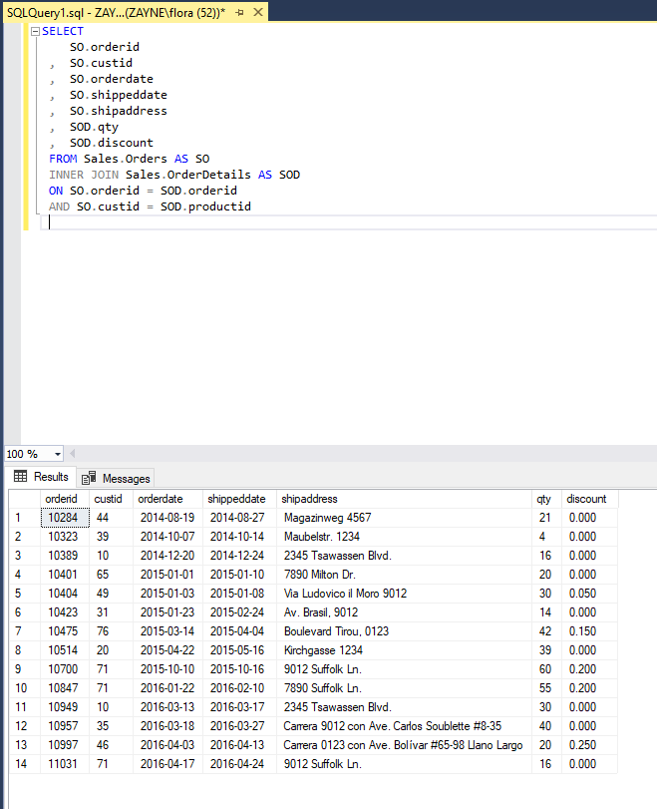
6. What is the difference between the following two queries? The business problem is “How many orders do we have from each customer?”
   * The results from the two queries are the same. The only difference is using the \* symbol instead of writing out the name O.orderid.
7. What might be one reason the following query does not return the column custID in this query?
   * When I ran the query, in which I copy pasted from the question, the result returned the column CustID because it was called from the SELECT Clause. But it was not called using the GROUP BY clause unlike the previous queries from number 6.

