1. Who are our customers in North America?

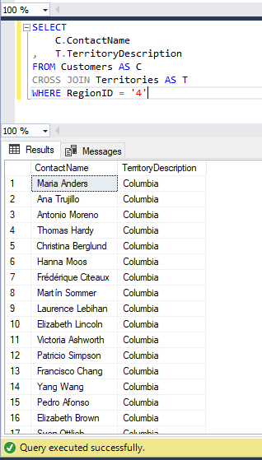

1. What orders were placed in April, 1998?

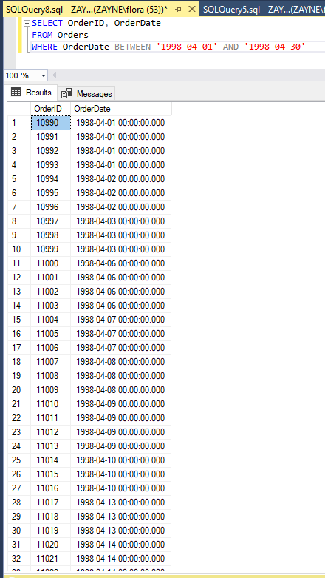

1. What sauces do we sell?

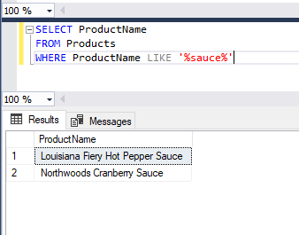

1. You sell some kind of dried fruit that I liked very much. What is its name?

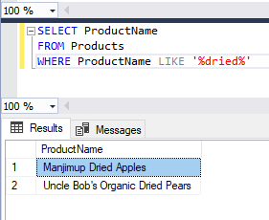

1. What employees ship products to Germany in December?

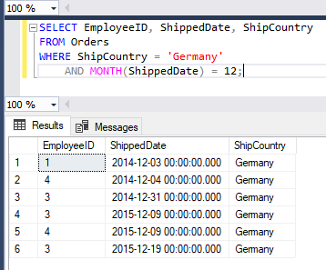

1. We have an issue with product 19. I need to know the total amount and the net amount of all orders for product 19 where the customer took a discount.

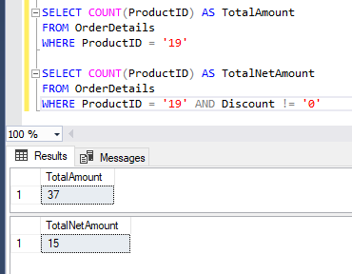

1. I need a list of employees by title, first name, and last name, with the employee’s position under their names, and a line separating each employee.
   * I have tried to research everything to get the answer to the “Employee’s position under their names” but it’s very confusing and I don’t know how to construct it.
2. I need a list of our customers and the first name only of the customer representative.

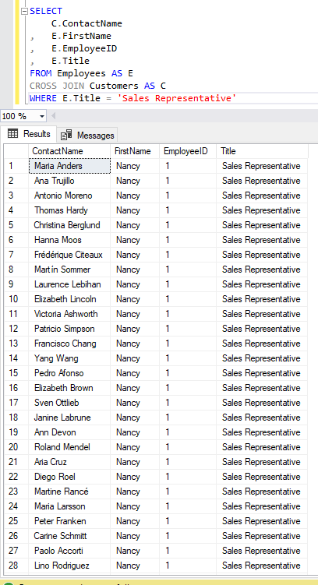

1. Give me a list of our customer contacts alphabetically by last name.

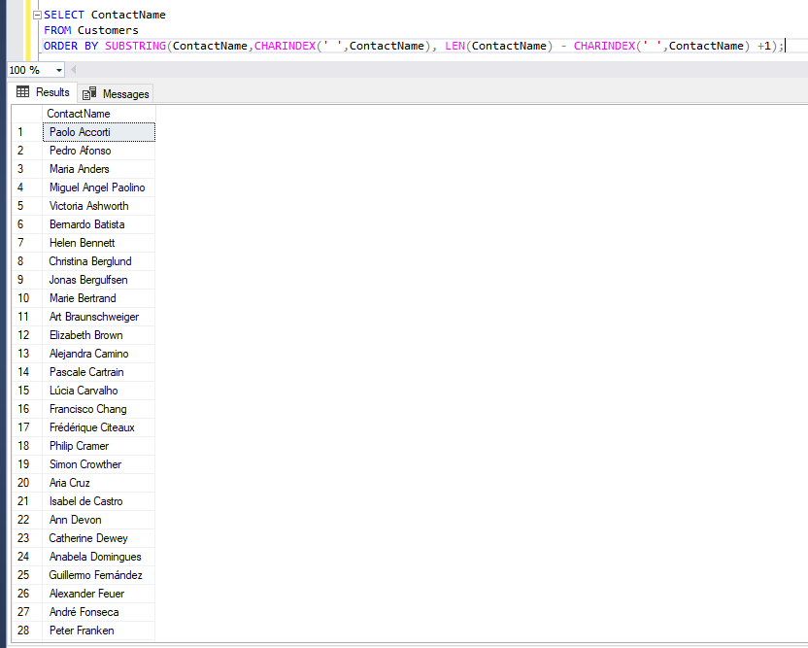

1. How many days old are you today?

