(localdb)\MSSQLLocalDB

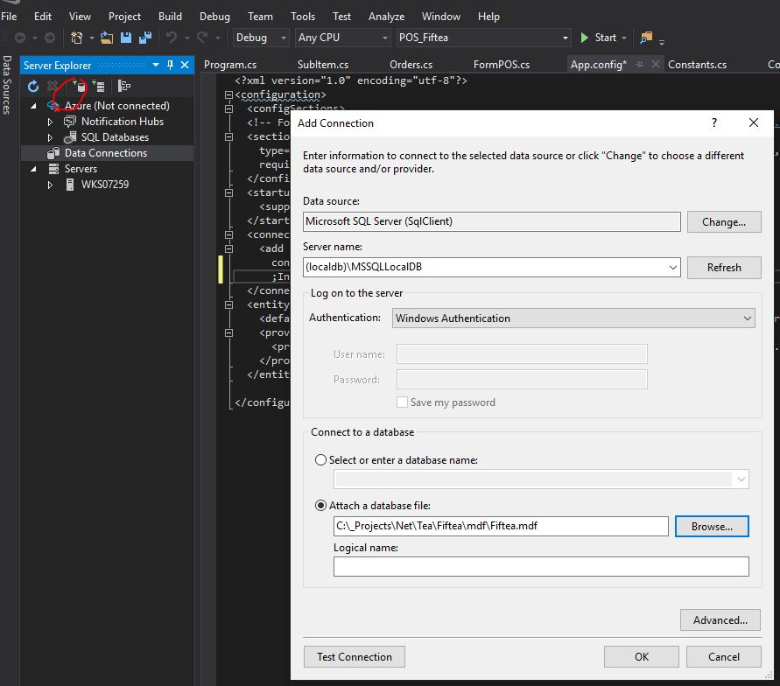

PM> Enable-Migrations -force

Checking if the context targets an existing database...

PM> Add-Migration

cmdlet Add-Migration at command pipeline position 1

Supply values for the following parameters:

Name: Migrations1

Scaffolding migration 'Migrations1'.

The Designer Code for this migration file includes a snapshot of your current Code First model. This snapshot is used to calculate the changes to your model when you scaffold the next migration. If you make additional changes to your model that you want to include in this migration, then you can re-scaffold it by running 'Add-Migration Migrations1' again.

PM> Update-Database -verbose –force

