Polynomial fitting

case of study: Florida
We can collect data signal Cases in New Work using covidcast.signal("jhu-csse", "confirmed_incidence_num", date(2020, 2, 1), date(2020, 10, 2), "state")
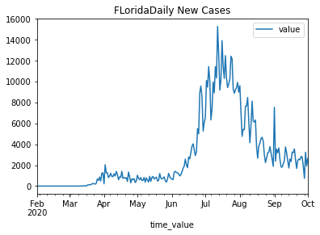
first data appears on 2020-03-02, but there is an oscillation 1-0-1-0-1
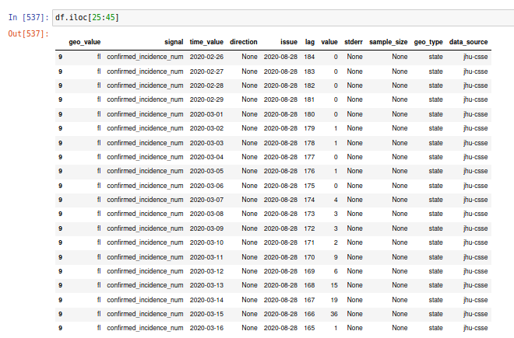
The data for Florida has 244 points, 214 points if we start counting since first data (2020-03-02). The min number of cases is 0, and the max is 15282, which occurred during '2020-07-12', 3M after NY max peak.
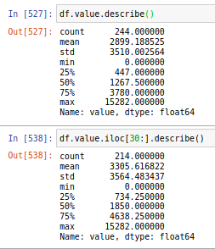

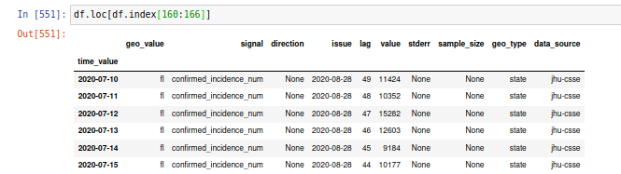
we will do only convolve FIT 3 with the rolled7D:

CONVOLVE FIT

def smooth(y, box_pts):
box = np.ones(box_pts)/box_pts
y_smooth = np.convolve(y, box, mode='same')
return y_smooth
fig = plt.figure(figsize=(8,6))
plt.plot(x, y,'b-', label='data')
plt.plot(x, smooth(y,3), 'r-', label='smooth1')
plt.xlabel("days")
plt.ylabel("{}".format('value'))
plt.title(" convolve fits ")
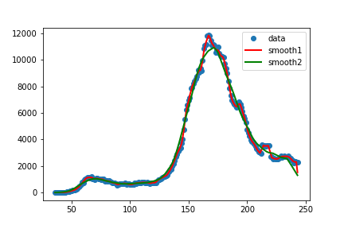

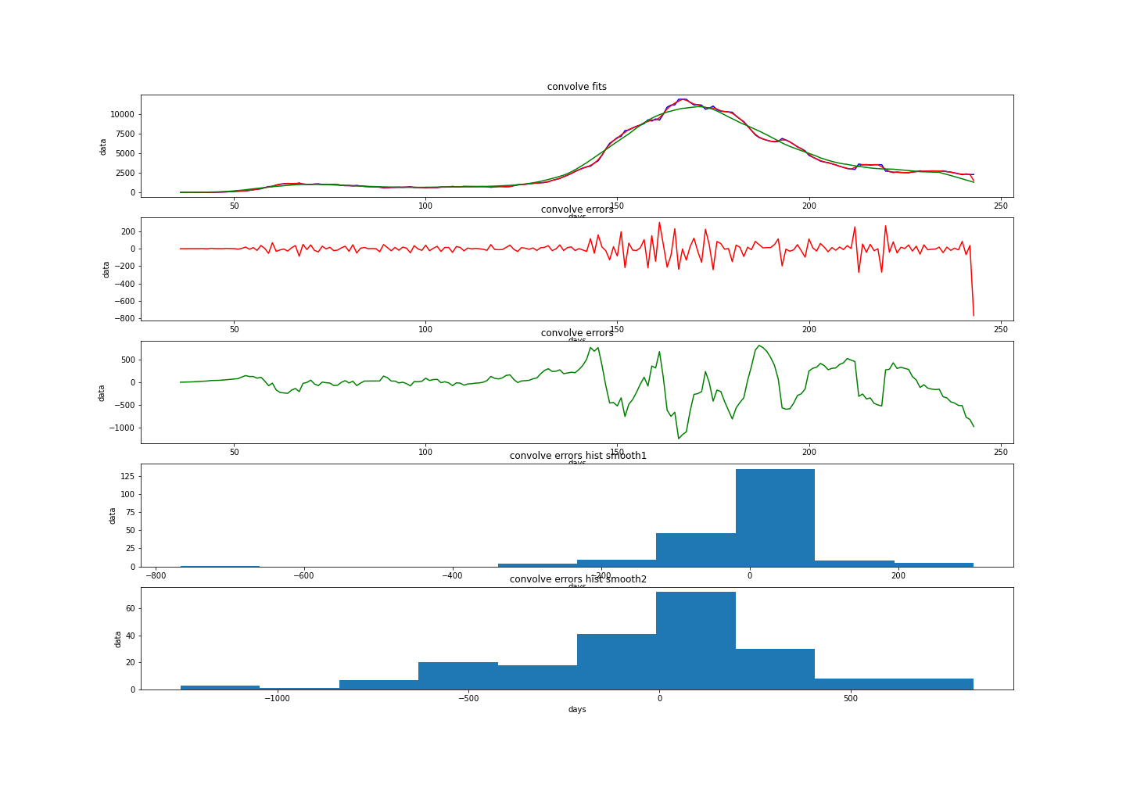
the errors may underestimate the number of cases up to 200 cases using smooth1 smooth(y,3) (not considering the last point).

How would the train and test go?
Let’s try to give the model the first 200 points to “train the model” and see if it predicts the last 8 points (y rolled 7d have 208 points given that 214-6=208, the first 6 values were removed and the first value appears on 2020-03-08 being an average from 2020-03-02 to 2020-03-08 inclusive).
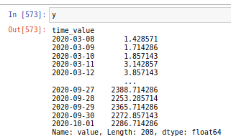

For that porpoise, we will use scipy.interpolate.interp1d
super fit
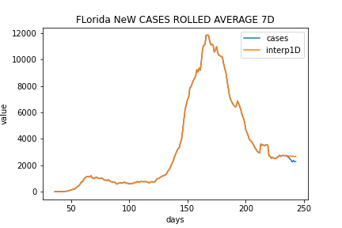
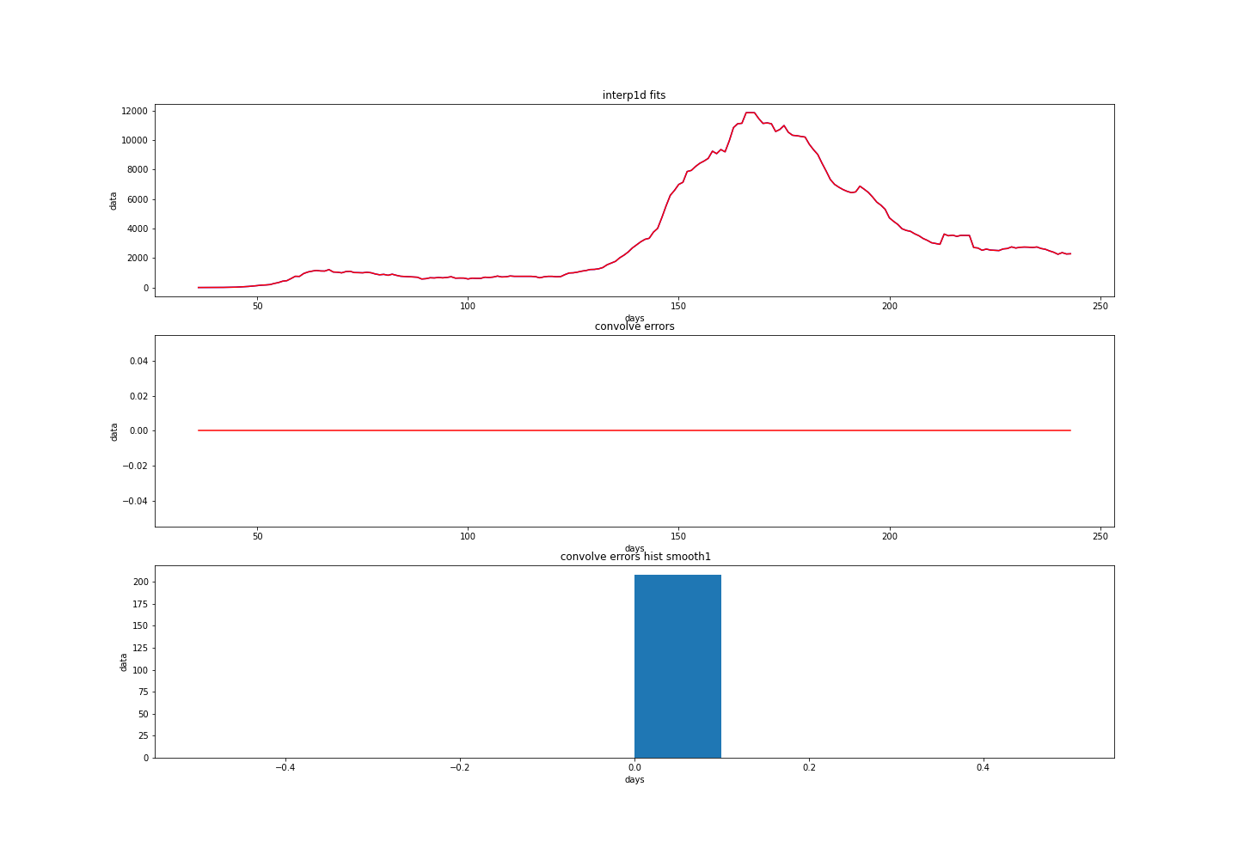
how does it go when we extrapolate?

Con el polinomio se va al carajo la extrapolacion

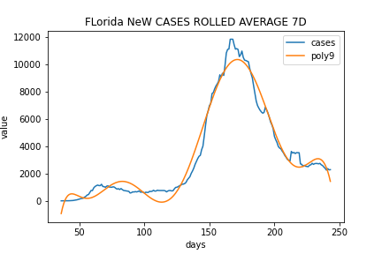
poly15
