Polynomial fitting

case of study: New York
We can collect data signal Cases in New Work using covidcast.signal("jhu-csse", "confirmed_incidence_num", date(2020, 2, 1), date(2020, 10, 2), "state")
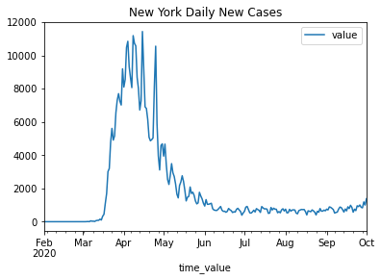
first data appears on 2020-03-03
was is this data actually?
This data source of confirmed COVID-19 cases and deaths is based on reports made available by the Center for Systems Science and Engineering at Johns Hopkins University. We downloaded confirmed_incidence_num. JHU’s data reports cumulative cases and deaths, so the incidence signals are calculated by subtracting each day’s cumulative count from the previous day. Since cumulative figures are sometimes corrected or amended by health authorities, this can sometimes result in negative incidence. Health authorities can also change reporting standards in ways that dramatically increase the number of cumulative deaths, resulting in an apparent spike in incidence. This should be interpreted purely as an artifact of data reporting and correction.
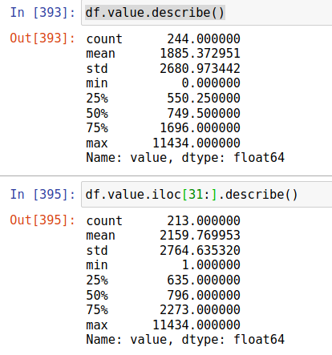
The data for New York has 244 points, 213 points if we start counting since first data (2020-03-03). The min number of cases is 1, and the max is 11434, which occurred during '2020-04-15'.

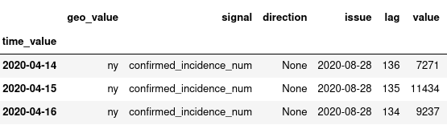
we tried several polynomial adjustments with different results:

CONVOLVE FIT

def smooth(y, box_pts):
box = np.ones(box_pts)/box_pts
y_smooth = np.convolve(y, box, mode='same')
return y_smooth
fig = plt.figure(figsize=(8,6))
plt.plot(x, y,'b-', label='data')
plt.plot(x, smooth(y,3), 'r-', label='smooth1')
plt.plot(x, smooth(y,19), 'g-',label='smooth2')
plt.xlabel("days")
plt.ylabel("{}".format('value'))
plt.title(" convolve fits ")
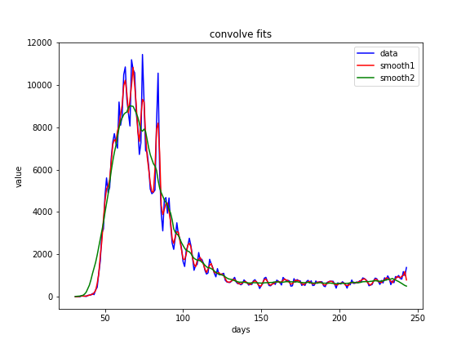

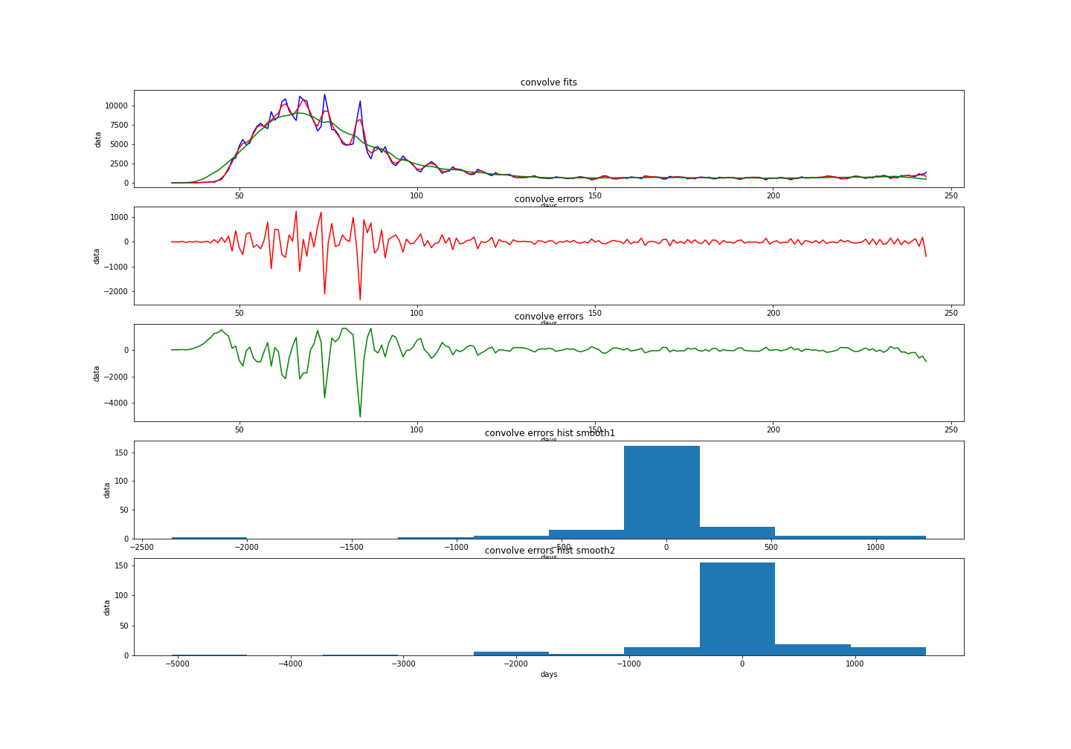
the errors may underestimate the number of cases up to 5,000 cases using smooth2 smooth(y,19) and up to 2,500 cases using smooth1 smooth(y,3) .

savgol_filter
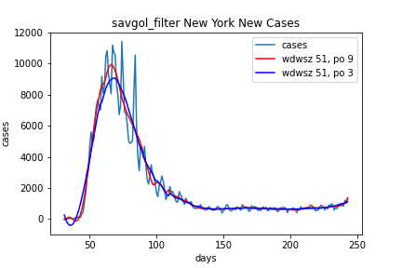
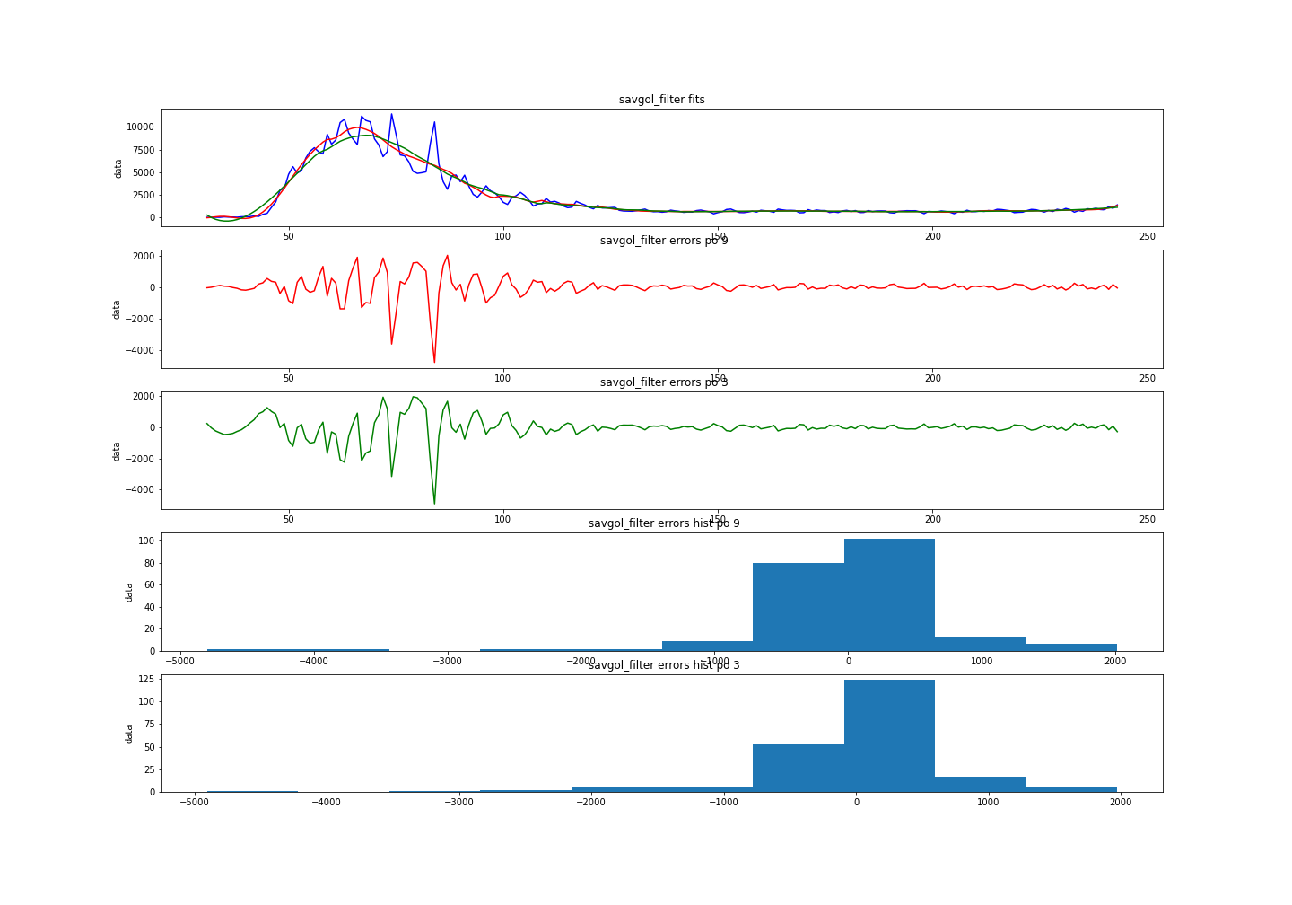
Not an improvement compared to the convolve fit since it also may underestimate the number of cases up to 5,000.

polynomial fit

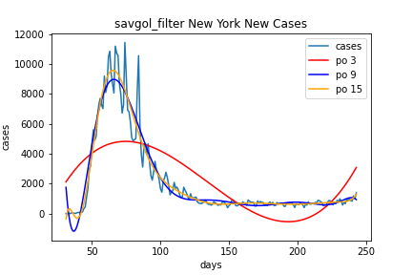
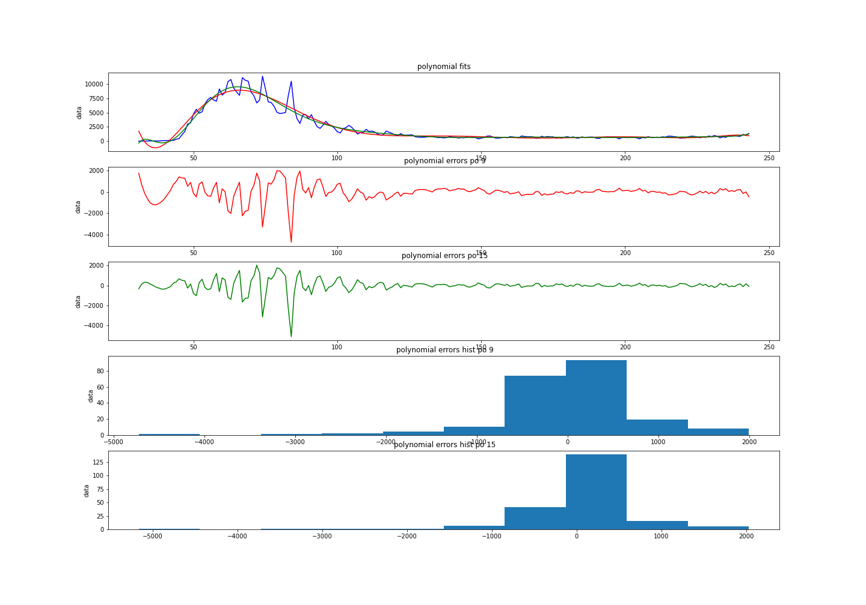

Again, not an improvement.

What if we have rolled the data and found an average?
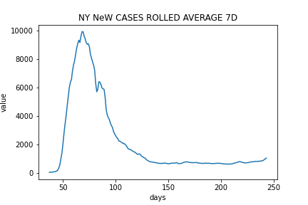
Data looks much more smoothed
how about the fits?

CONVOLVE

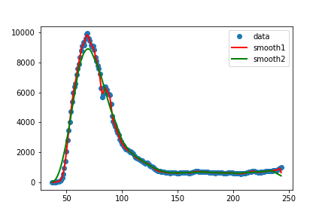

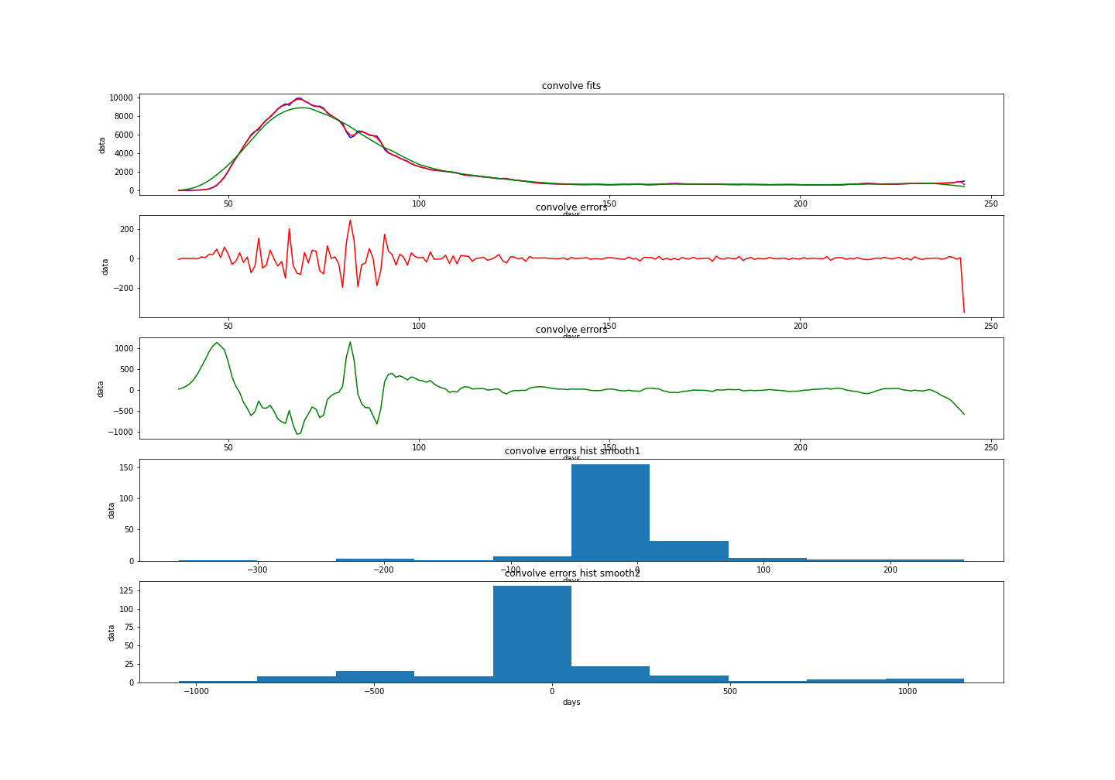
An improvement is shown. Now the Convolve with smooth(y,3) gives a max error of 200.

savgol_filter

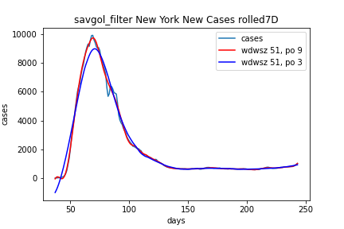

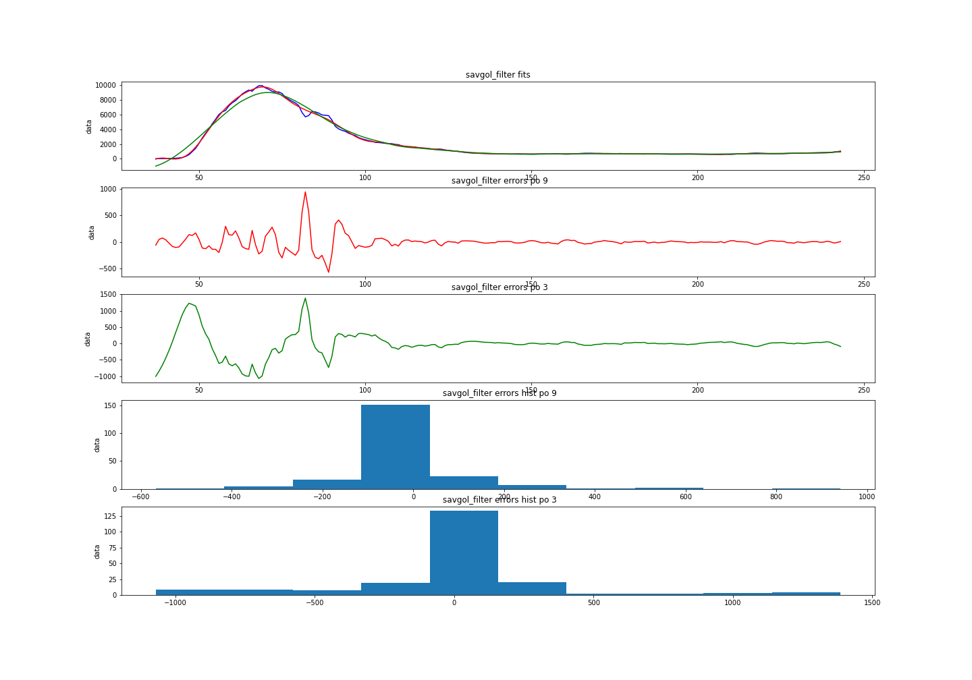
The savgol_filter gives errors up to a 1000. but the distribution of errors looks like normal.
The polynomial fit resulted worse.

CONCLUSION:
THE BEST FIT TO THE NY CASES BOTH WITH RAW DATA AND ROLLED 7D AVERAGE DATA IS THE CONVOLVE FUNCTION WITH 3 BOX.

