Name | 1 | 2
Specificity | 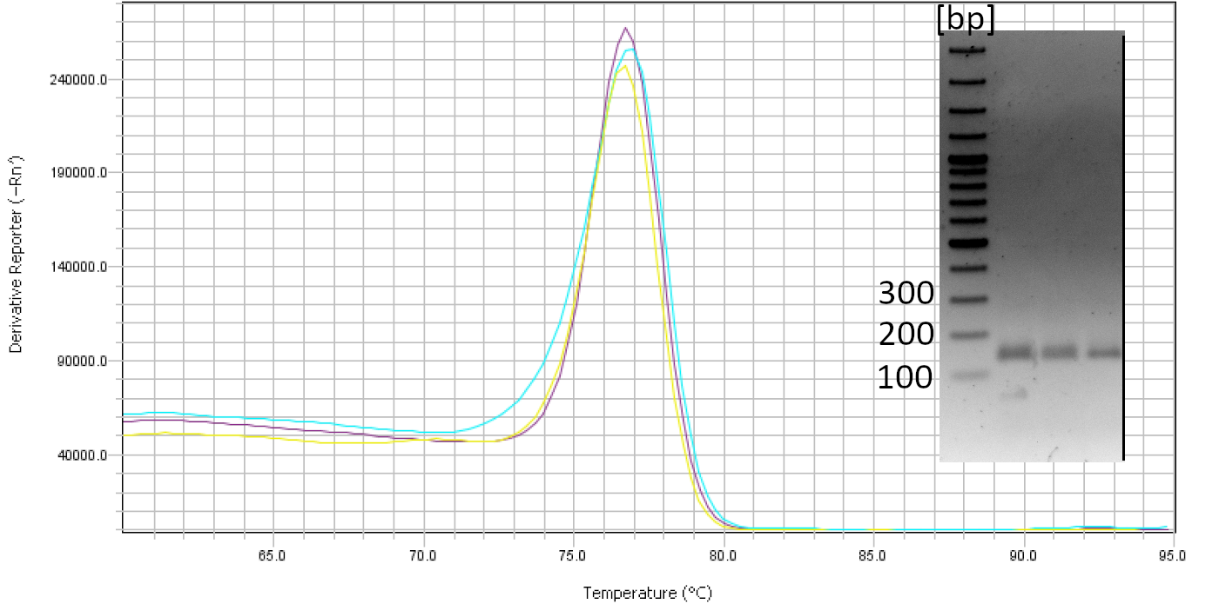  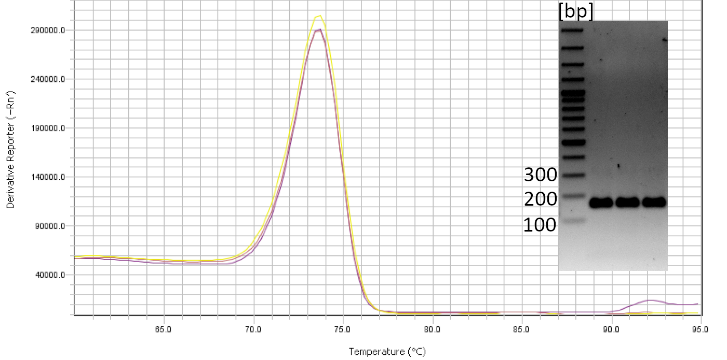
Name | 3 | 4
Specificity | 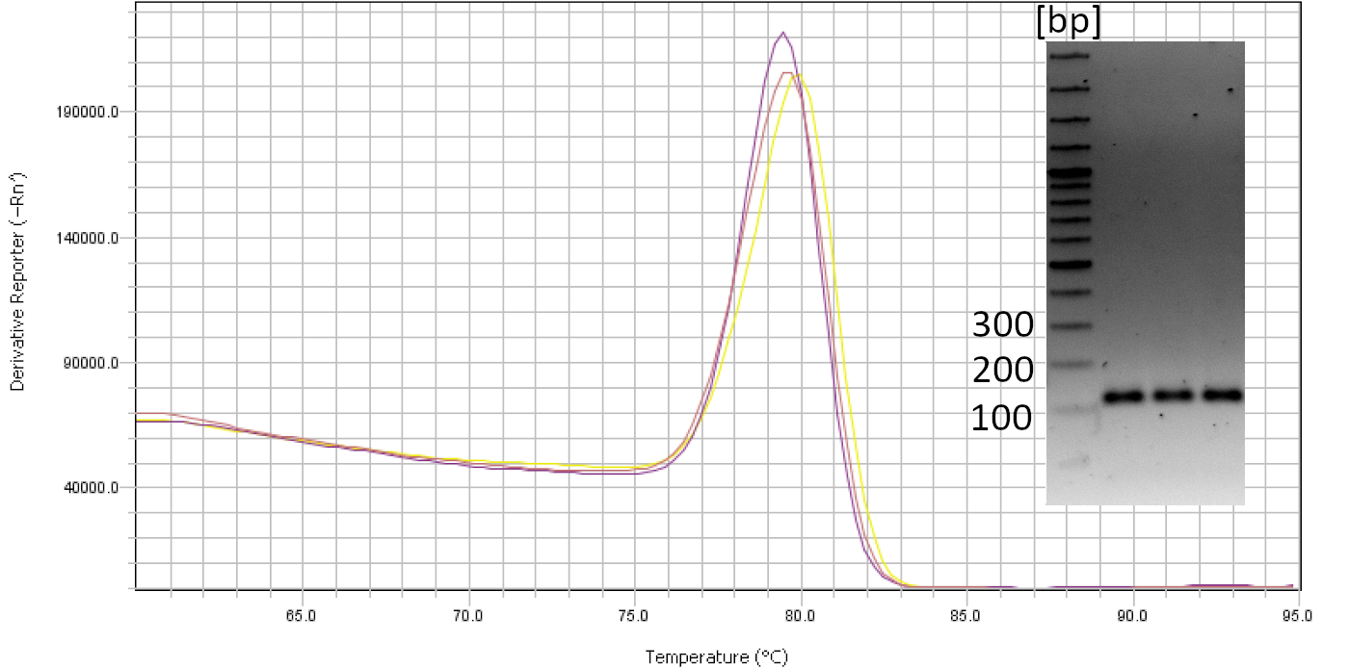  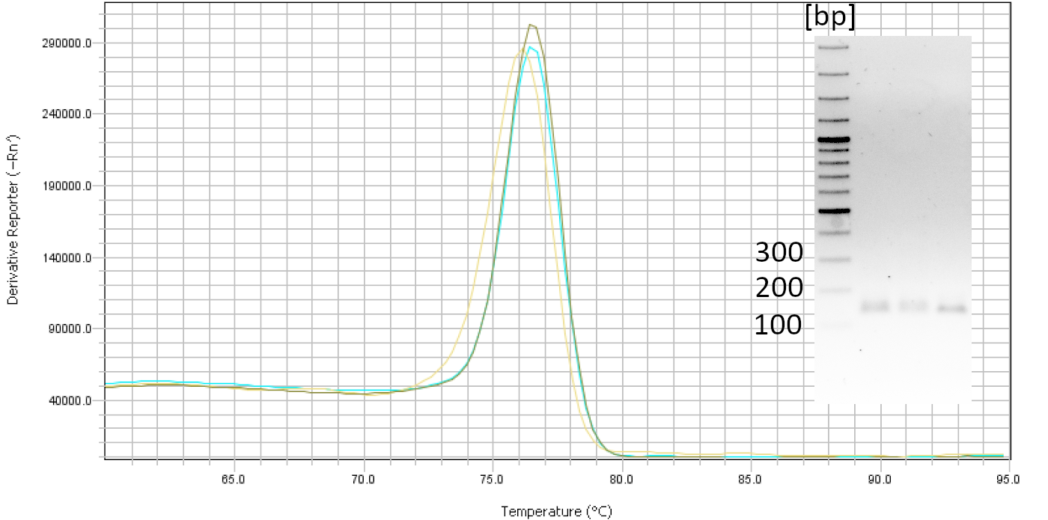
Name | 5 | 6
Specificity | 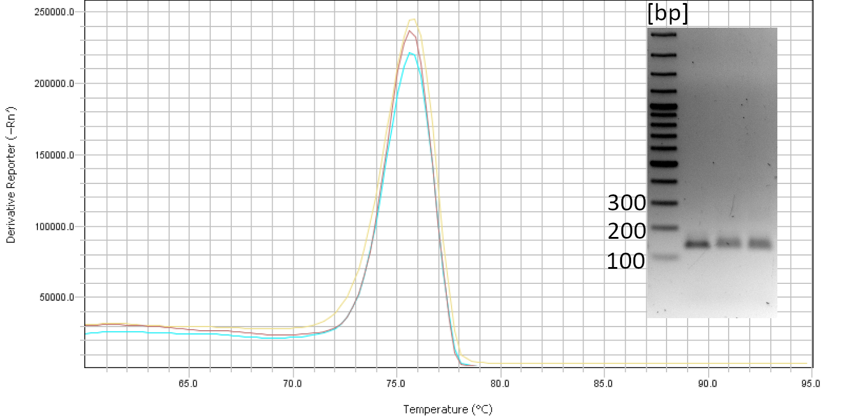
Name | 7 | 8
Specificity
Name | 9 | 10
Specificity
Name | X | x
Specificity
Name | x | Norm
Specificity |  | 