MÓDULO 3 · 01 · CLASE 1 DE 2 · WORKSHEET  The Verb System  The Big Picture · presente y pasado  No son doce fórmulas. Son cuatro patrones que se repiten. | 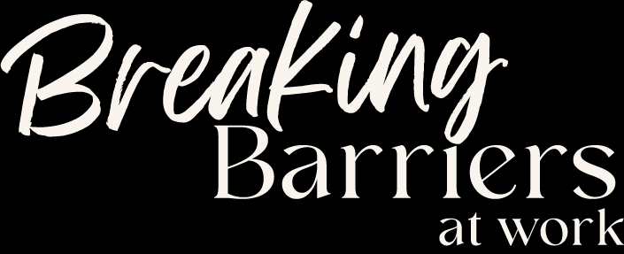

Nombre: ______________________ Fecha: ____________
Cómo usar esta hoja. La hacemos juntas en la clase grabada. Después, vuelve a hacerla sola, sin mirar las respuestas, y guárdala en 04 · MIS PRÁCTICAS de tu Drive. Las respuestas están al final.
1 · Tres momentos en una línea

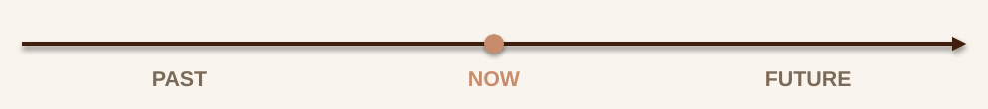
Todo lo que dices lo ubicas primero en uno de estos tres momentos: presente, pasado o futuro.
2 · Cuatro maneras de mirar

Dentro de cada momento puedes mirar la situación de cuatro maneras. Cada una tiene su dibujo: si recuerdas el dibujo, recuerdas cuándo se usa.
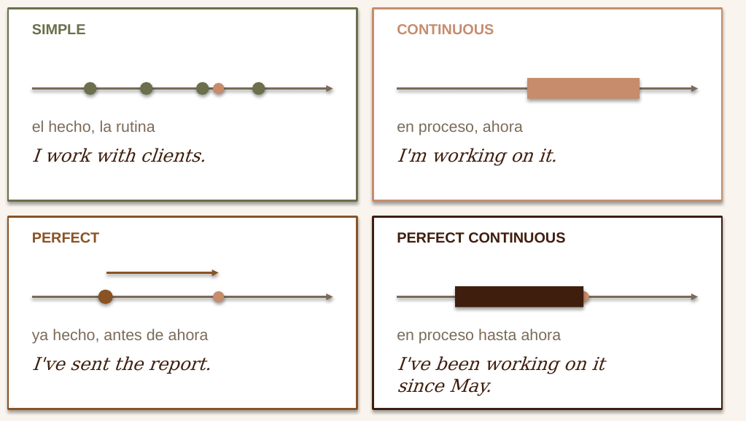

3 · Tu grilla, sin mirar

3 momentos × 4 miradas = 12. Completa con el verbo work (sujeto: I). Marca con ? lo que dudes.
 | SIMPLE | CONTINUOUS | PERFECT | PERFECT CONT.
PRESENT
PAST
FUTURE

¿Cuántas completaste? ____ / 12 ¿Cuáles marcaste con ? _____________________
4 · El mapa: mírala por columnas

Cada color es un patrón. Lo que se repite en cada columna es lo único que tienes que aprender.
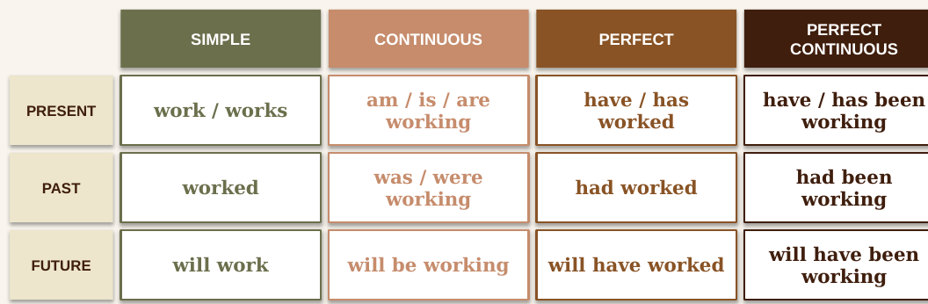
 | LAS 4 REGLAS | CÓMO SE VE
1 | Continuous = BE + -ing | Solo se mueve BE: am / is / are → was / were → will be
2 | Perfect = HAVE + participio | Solo se mueve HAVE: have / has → had → will have
3 | Perfect continuous = HAVE + been + -ing | Perfect + continuous. Been es el participio de BE.
4 | Después de will, forma base | will work · will be · will have

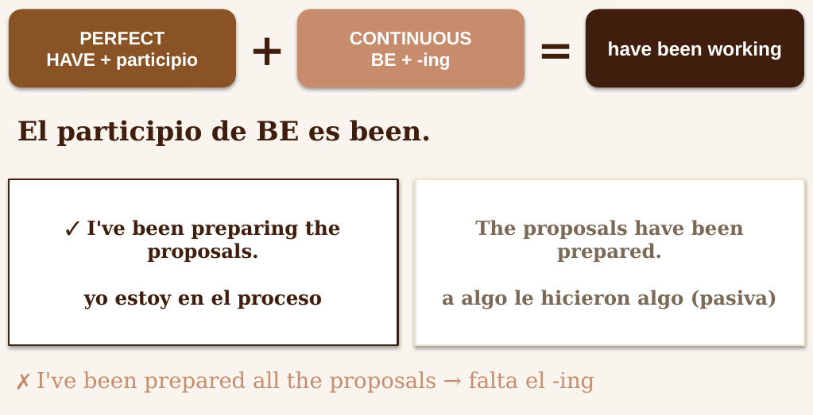

5 · La información viaja en el auxiliar

Si el auxiliar ya lleva el tiempo o la -s, el verbo vuelve a la forma base. Para negar: auxiliar + not.
 | AFIRMATIVA | PREGUNTA | NEGATIVA
Present simple | She works in finance. | Does she work in finance? | She doesn't work in finance.
Past simple | She felt worried. | Did she feel worried? | She didn't feel worried.
Present perfect | We have finished. | Have we finished? | We haven't finished.
Past continuous | They were working. | Were they working? | They weren't working.
Future | I will send it. | Will you send it? | I won't send it.

Ahora con tu propio ejemplo de trabajo:
 | AFIRMATIVA | PREGUNTA | NEGATIVA
Present simple
Past simple
Present perfect

6 · Detective de errores

Corrige cada frase y anota qué regla se rompió (1, 2, 3, 4 o «el auxiliar ya lleva la información»).
# | FRASE CON ERROR | TU VERSIÓN | REGLA
1 | ✗ I am work with international clients.
2 | ✗ Does she works in finance?
3 | ✗ She didn't felt worried about the audit.
4 | ✗ We don't have finished the report.
5 | ✗ Did you sent the file to the client?
6 | ✗ I did working on the budget when he called.
7 | ✗ They was reviewing the data yesterday.
8 | ✗ He doesn't has access to the system yet.
9 | ✗ She will sends the update tomorrow.
10 | ✗ By Friday, we will has finished the migration.
11 | ✗ This time next week, I will be work from Madrid.
12 | ✗ I have been prepared all the proposals this week. (vienes preparándolas)

7 · Past simple o present perfect

¿Un momento terminado que puedes señalar, o algo que pasó antes y está conectado con ahora?
PAST SIMPLE · tiempo terminado | PRESENT PERFECT · conectado con ahora
yesterday · last week / month · in 2023 · in March · two days ago · When…? | already · yet · just · ever · never · since May · for two years · this week · today · so far · How long…?
I sent the report yesterday.  She joined the team three months ago. | I've sent the report.  We've worked with them for two years.

✗ I have sent the report yesterday → ✓ I sent the report yesterday
✗ I work here since 2020 → ✓ I've worked / I've been working here since 2020
# | FRASE | TU RESPUESTA
1 | I ______ (send) the report yesterday.
2 | I ______ already ______ (send) the report.
3 | We ______ (work) with this client since 2021.
4 | She ______ (join) the team three months ago.
5 | ______ you ______ (finish) the slides yet?
6 | Last quarter, sales ______ (increase) by 12%.
7 | This is the first time I ______ (present) to the board.
8 | When ______ you ______ (start) in this role?

8 · Been + -ing o been + participio

been + -ing → tú estás en el proceso: I've been preparing the proposals.
been + participio → a algo le hicieron algo: The proposals have been prepared.
1. I've been ______________ (prepare) the proposals all week.
2. The proposals have been ______________ (prepare) by the team.
3. We've been ______________ (test) the new system since Monday.
4. The new system has been ______________ (test) and approved.
5. She's been ______________ (review) the contracts this morning.
6. All the contracts have been ______________ (review) by Legal.

9 · Tu fila con un verbo de trabajo

Ejemplo: send → I send · I'm sending · I've sent · I've been sending. Ahora tu verbo (send, review, prepare, test, approve…).
Mi verbo: ________________ Participio: ________________
 | SIMPLE | CONTINUOUS | PERFECT | PERFECT CONT.
PRESENT
PAST
FUTURE

Dila en voz alta en afirmativa, pregunta y negativa:
Present perfect: _______________________________________________________________________
Past simple: ___________________________________________________________________________
Future continuous: _____________________________________________________________________
10 · Reconstrúyelo

Si te olvidas una forma, no la busques: ármala con tres preguntas.
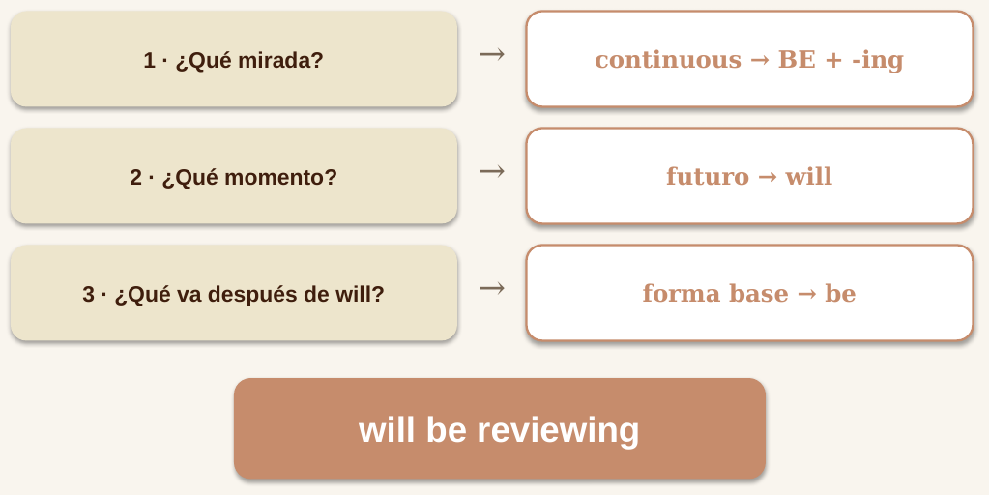
FORMA | ¿QUÉ MIRADA? | ¿QUÉ MOMENTO? | RESULTADO
past perfect · approve
present perfect continuous · manage (she)
future perfect · finish
past continuous · test (we)

11 · Llévalo a tu trabajo

Un proyecto real de esta semana. Usa el dibujo de cada mirada para elegir.
¿Qué haces normalmente? (present simple)
________________________________________________________________________________________
¿Qué estás haciendo ahora? (present continuous)
________________________________________________________________________________________
¿Qué ya está hecho? (present perfect)
________________________________________________________________________________________
¿Qué vienes haciendo hace un tiempo? (present perfect continuous)
________________________________________________________________________________________
¿Qué vas a hacer después? (will)
________________________________________________________________________________________
12 · Practícalo con tu Role Play

Copia este prompt en tu Role Play:
Act as my manager. Ask me about a real project I'm working on: what I usually do, what I'm doing now, what is already done, what I've been working on lately and what comes next. Ask one question at a time. After my answers, check only these errors: "I am + base verb" (I am work), "did + past verb" (didn't sent), "been" without -ing when I mean an ongoing action, and the wrong form after "will" (will sends, will has). List each error with the correct version. Then ask me the same question again so I can retry.

¿Qué error apareció? ___________________________________________________________________
¿Te salió en el Retry? _________________________________________________________________
13 · Retry

¿Qué te salió más fácil que antes?
________________________________________________________________________________________
¿Qué todavía se rompe cuando hay presión?
________________________________________________________________________________________
Foco de tu próxima práctica (uno solo):
________________________________________________________________________________________
Comparte tu biggest win en Weekly Reports y trae esta hoja a tu sesión si quieres feedback.
Respuestas

6 · Detective
1. I work with international clients.
2. Does she work in finance?
3. She didn't feel worried about the audit.
4. We haven't finished the report.
5. Did you send the file to the client?
6. I was working on the budget when he called.
7. They were reviewing the data yesterday.
8. He doesn't have access to the system yet.
9. She will send the update tomorrow.
10. By Friday, we will have finished the migration.
11. This time next week, I will be working from Madrid.
12. I've been preparing all the proposals this week.
7 · Past simple / present perfect: 1 sent · 2 have already sent · 3 have worked / have been working · 4 joined · 5 Have you finished · 6 increased · 7 have presented · 8 did you start
8 · Been: 1 preparing · 2 prepared · 3 testing · 4 tested · 5 reviewing · 6 reviewed
10 · Reconstrúyelo: had approved · she has been managing · will have finished · we were testing

